Exercise 1: Implementing the Singleton Pattern (Mandatory)
Code:
public class SingletonPattern {
public static void main(String[] args) {
Logger logger1 = Logger.getInstance();
logger1.log("Log from logger1");

Logger logger2 = Logger.getInstance();
logger2.log("Log from logger2");

if (logger1 == logger2) {
System.out.println("Singleton works! Only one instance.");
} else {
System.out.println("Singleton failed.");
}
}
}

class Logger {
private static Logger instance;

private Logger() {
System.out.println("Logger initialized.");
}

public static Logger getInstance() {
if (instance == null) {
instance = new Logger();
}
return instance;
}
public void log(String message) {
System.out.println("[LOG] " + message);
}
}

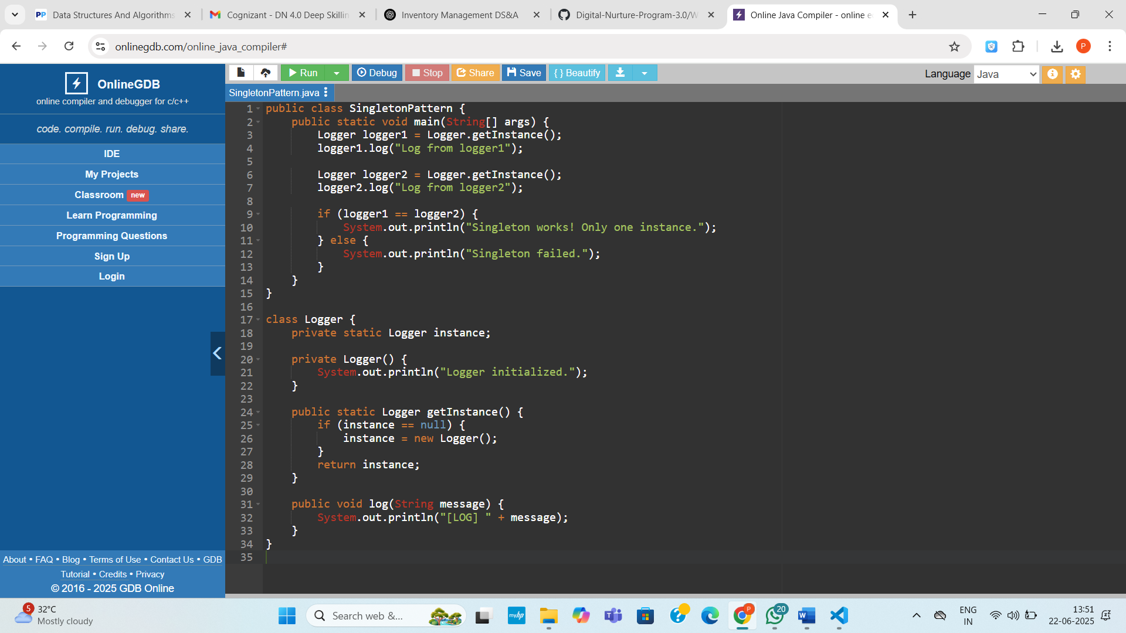

Output:
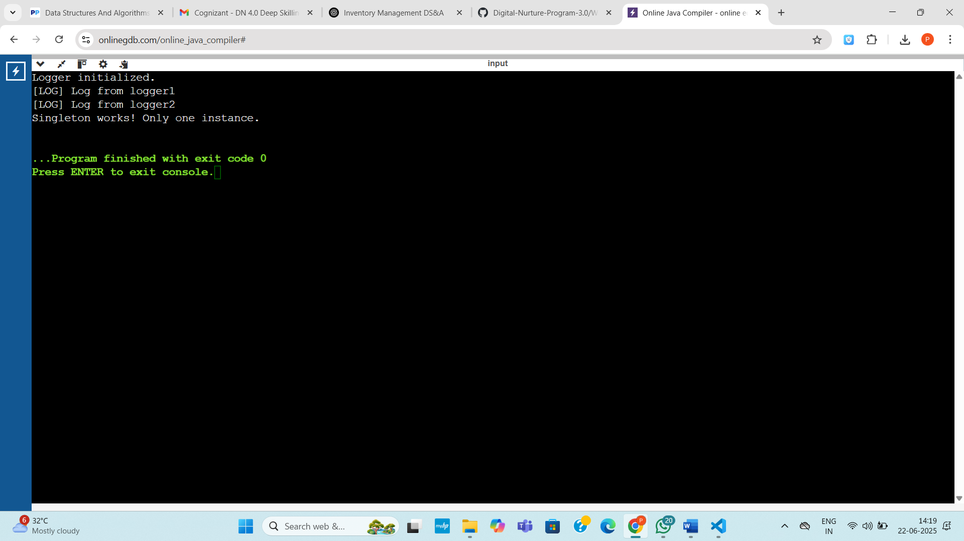
Exercise 2: Implementing the Factory Method Pattern (Mandatory)
Code:
interface Document {
void open();
void save();
void close();
}

class WordDocument implements Document {
public void open() {
System.out.println("Opening Word document...");
}
public void save() {
System.out.println("Saving Word document...");
}
public void close() {
System.out.println("Closing Word document...");
}
}

class PdfDocument implements Document {
public void open() {
System.out.println("Opening PDF document...");
}
public void save() {
System.out.println("Saving PDF document...");
}
public void close() {
System.out.println("Closing PDF document...");
}
}

class ExcelDocument implements Document {
public void open() {
System.out.println("Opening Excel document...");
}
public void save() {
System.out.println("Saving Excel document...");
}
public void close() {
System.out.println("Closing Excel document...");
}
}

// Abstract Factory
abstract class DocumentFactory {
public abstract Document createDocument();
}

// Concrete Factories
class WordDocumentFactory extends DocumentFactory {
public Document createDocument() {
return new WordDocument();
}
}

class PdfDocumentFactory extends DocumentFactory {
public Document createDocument() {
return new PdfDocument();
}
}

class ExcelDocumentFactory extends DocumentFactory {
public Document createDocument() {
return new ExcelDocument();
}
}
public class Main {
public static void main(String[] args) {
DocumentFactory wordFactory = new WordDocumentFactory();
Document word = wordFactory.createDocument();
word.open();
word.save();
word.close();

System.out.println();

DocumentFactory pdfFactory = new PdfDocumentFactory();
Document pdf = pdfFactory.createDocument();
pdf.open();
pdf.save();
pdf.close();

System.out.println();

DocumentFactory excelFactory = new ExcelDocumentFactory();
Document excel = excelFactory.createDocument();
excel.open();
excel.save();
excel.close();
}
}

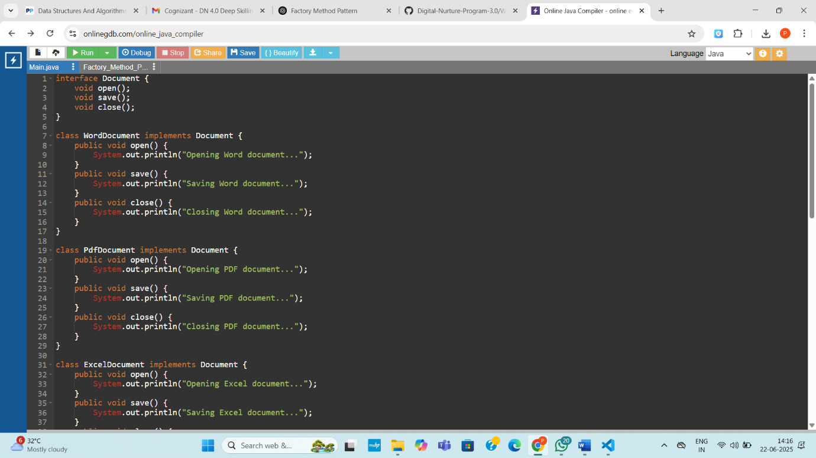
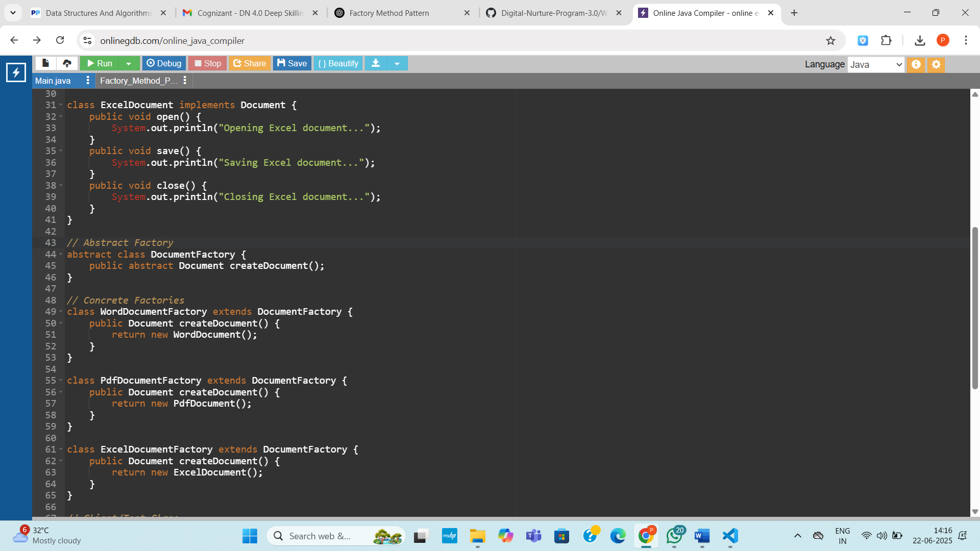

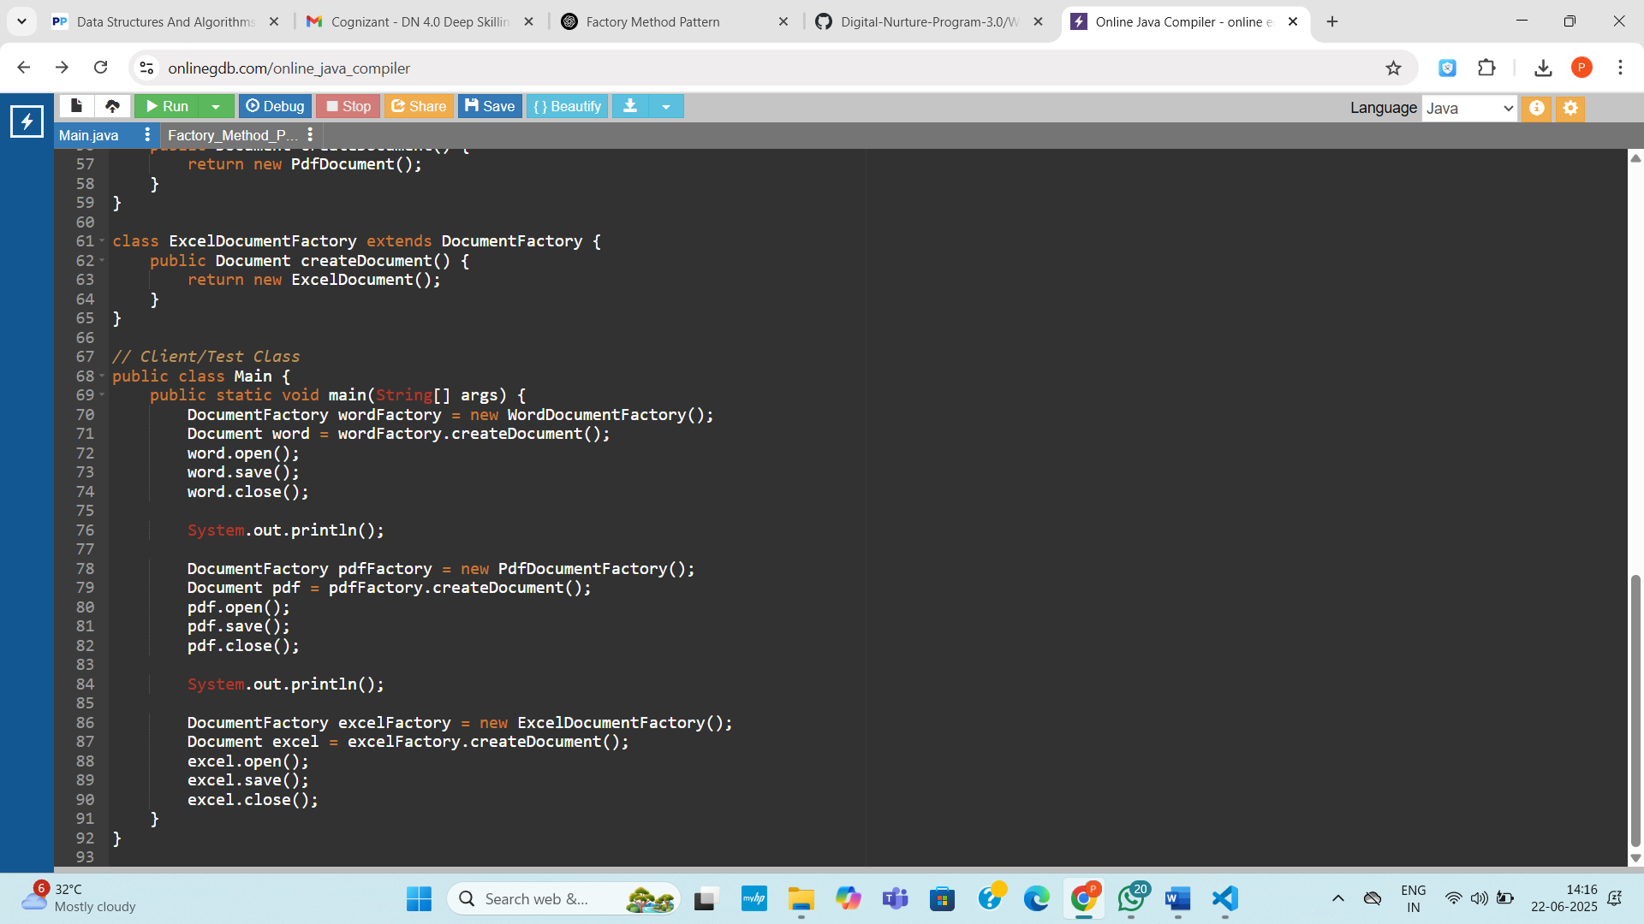
Output:
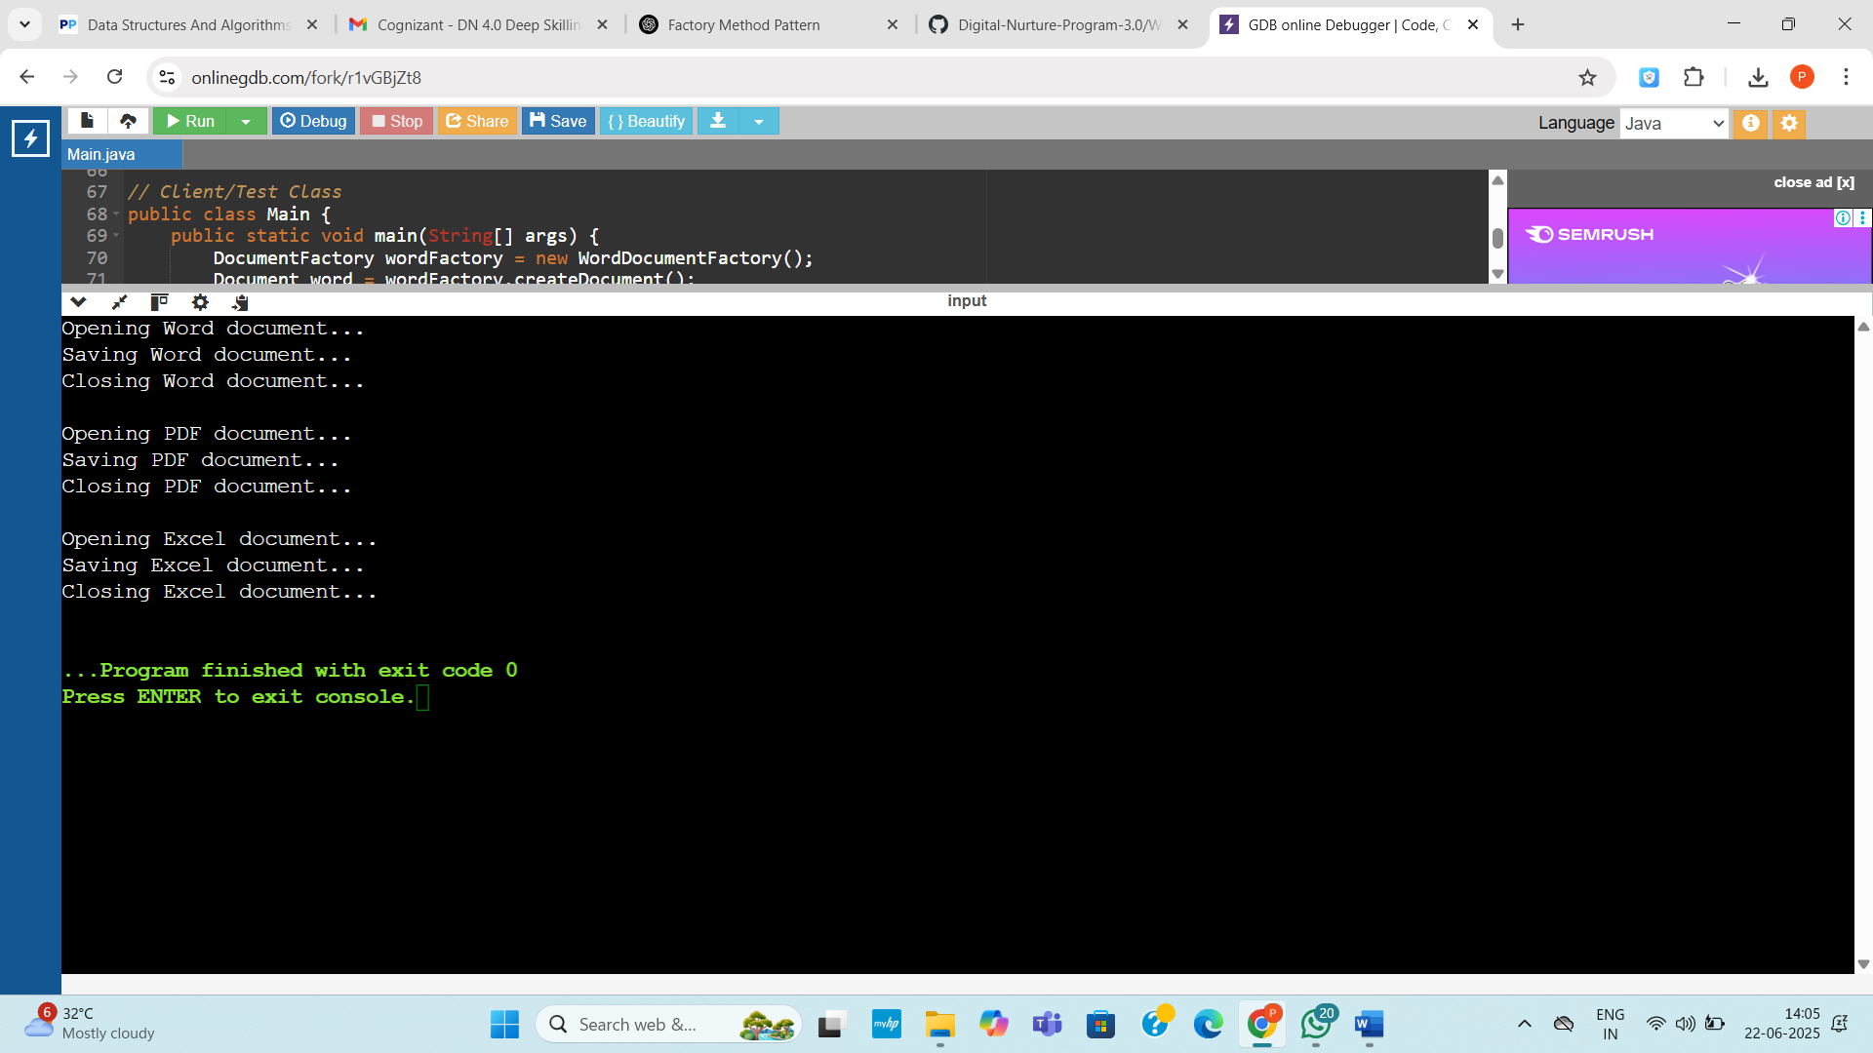

Exercise 3: Implementing the Builder Pattern
Code:
public class Main {
// Product class
static class Computer {
private String cpu;
private int ram;
private int storage;
private boolean hasGraphicsCard;
private String operatingSystem;
private boolean isSSD; // New field

// Private constructor
private Computer(Builder builder) {
this.cpu = builder.cpu;
this.ram = builder.ram;
this.storage = builder.storage;
this.hasGraphicsCard = builder.hasGraphicsCard;
this.operatingSystem = builder.operatingSystem;
this.isSSD = builder.isSSD;
}

// Display configuration
public void displayConfiguration() {
System.out.println("CPU: " + cpu);
System.out.println("RAM: " + ram + " GB");
System.out.println("Storage: " + storage + " GB");
System.out.println("SSD: " + (isSSD ? "Yes" : "No"));
System.out.println("Graphics Card: " + (hasGraphicsCard ? "Yes" : "No"));
System.out.println("Operating System: " + (operatingSystem != null ? operatingSystem : "Not Installed"));
}

// Builder class
static class Builder {
private String cpu;
private int ram;
private int storage;
private boolean hasGraphicsCard;
private String operatingSystem;
private boolean isSSD; // New field

public Builder setCpu(String cpu) {
this.cpu = cpu;
return this;
}

public Builder setRam(int ram) {
this.ram = ram;
return this;
}
public Builder setStorage(int storage) {
this.storage = storage;
return this;
}

public Builder setGraphicsCard(boolean hasGraphicsCard) {
this.hasGraphicsCard = hasGraphicsCard;
return this;
}

public Builder setOperatingSystem(String os) {
this.operatingSystem = os;
return this;
}

public Builder setSSD(boolean isSSD) {
this.isSSD = isSSD;
return this;
}

// Build method
public Computer build() {
return new Computer(this);
}
}
}

// Main method to test
public static void main(String[] args) {
// Gaming PC
Computer gamingPC = new Computer.Builder()
.setCpu("Intel Core i9")
.setRam(32)
.setStorage(1000)
.setSSD(true)
.setGraphicsCard(true)
.setOperatingSystem("Windows 11")
.build();

// Office PC
Computer officePC = new Computer.Builder()
.setCpu("Intel Core i5")
.setRam(16)
.setStorage(512)
.setSSD(false)
.setGraphicsCard(false)
.setOperatingSystem("Ubuntu")
.build();

// Print configurations
System.out.println("Gaming PC Configuration:");
gamingPC.displayConfiguration();
System.out.println("\nOffice PC Configuration:");
officePC.displayConfiguration();
}
}
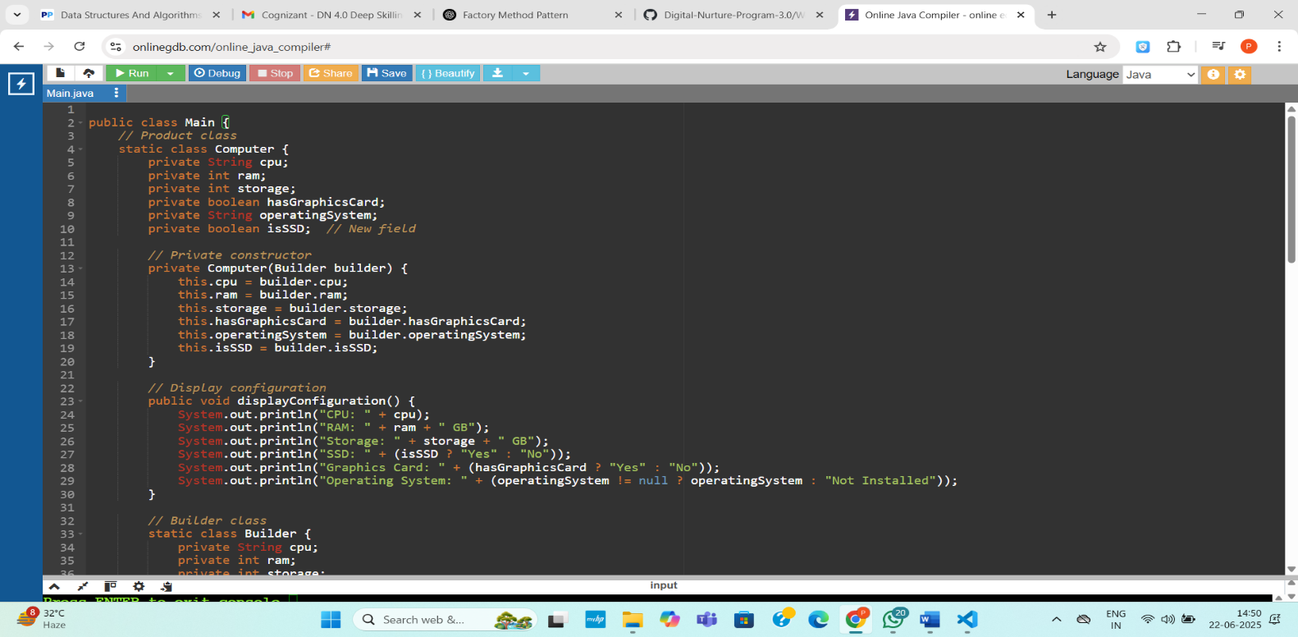

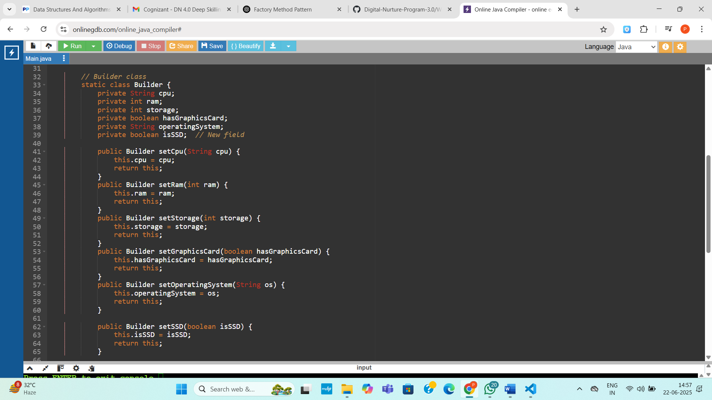

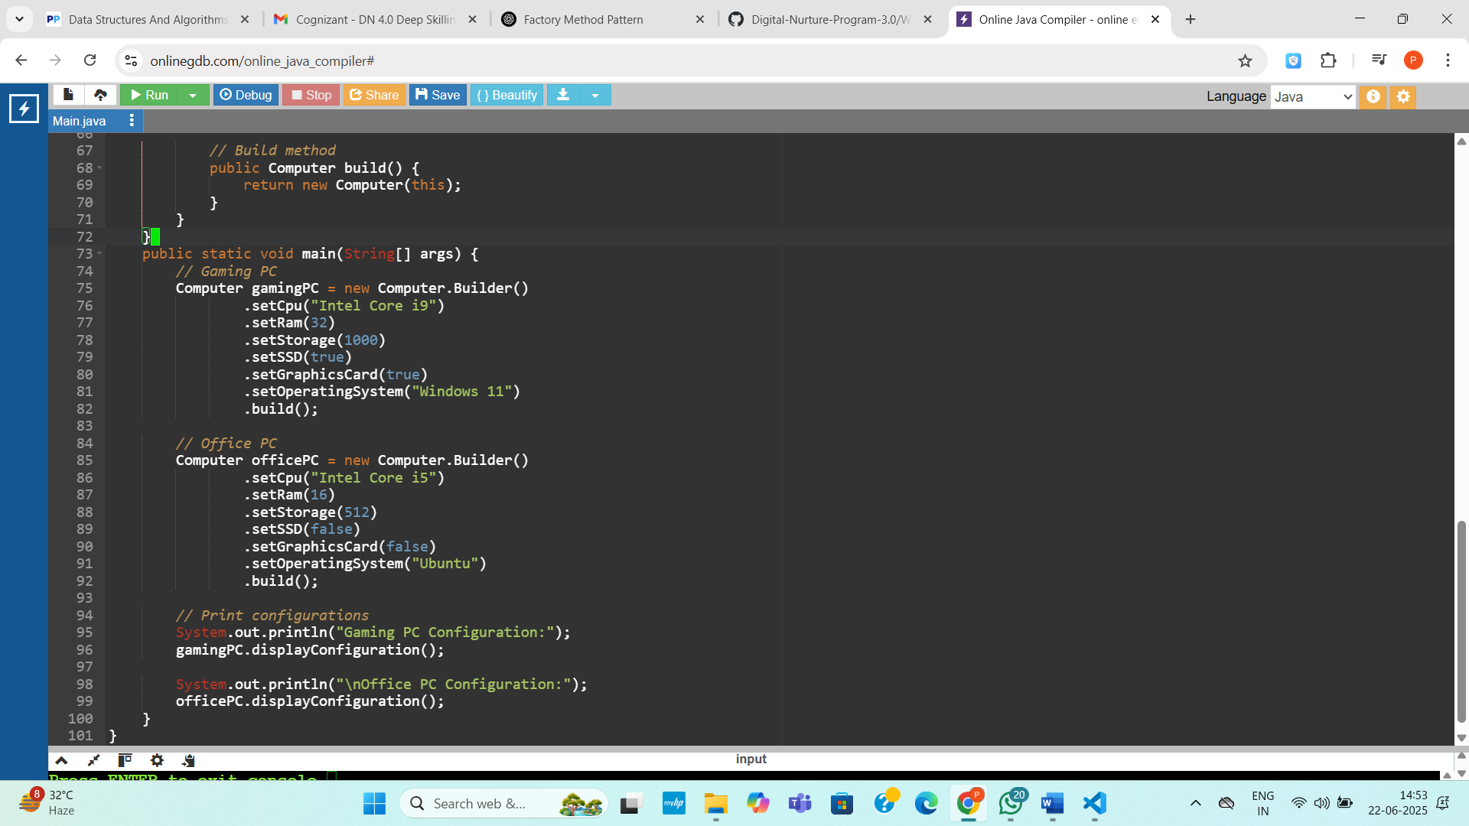

Output:
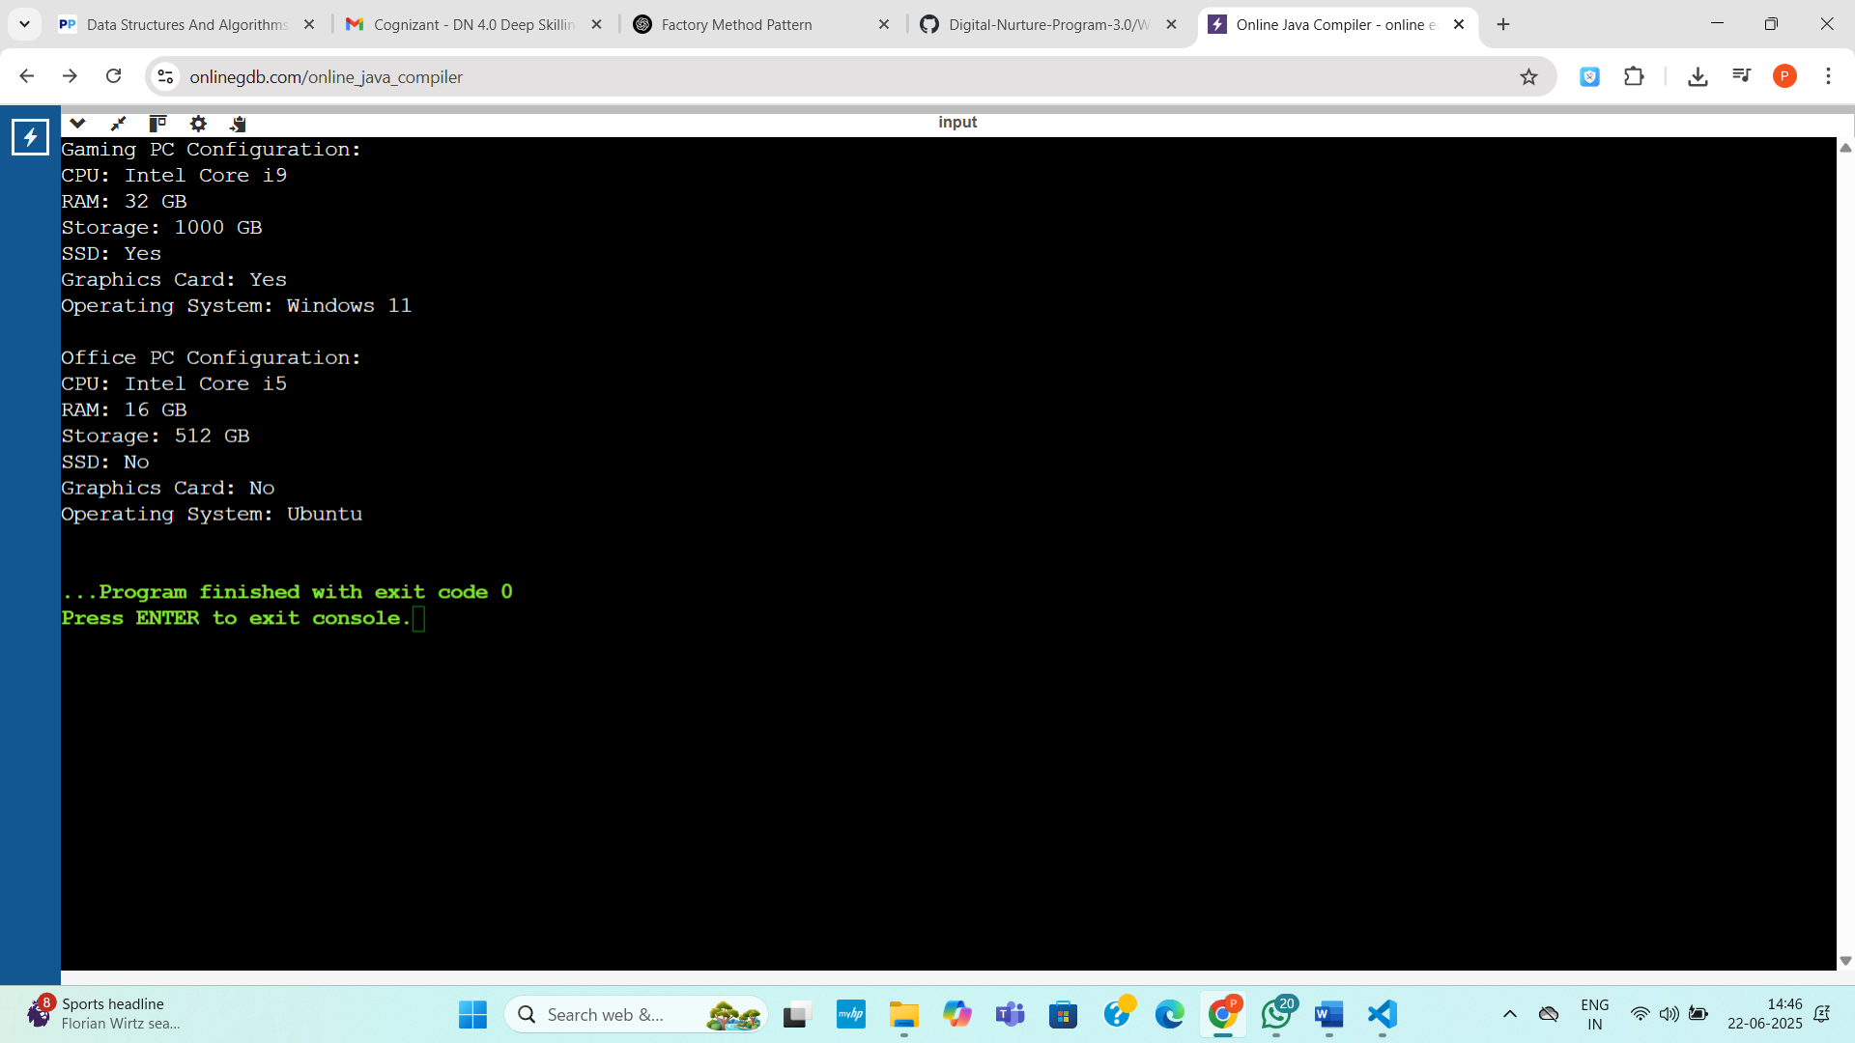

Exercise 3: Implementing the Builder Pattern
Code:
public class BuilderPatternExample {

public static void main(String[] args) {
// Basic configuration
Computer basicComputer = new Computer.Builder("Intel i5", "8GB")
.build();

// Advanced configuration
Computer gamingComputer = new Computer.Builder("Intel i9", "32GB")
.setStorage("1TB")
.setGraphicsCard("NVIDIA RTX 4080")
.setIsSSD(true)
.build();

// Custom configuration
Computer officeComputer = new Computer.Builder("AMD Ryzen 5", "16GB")
.setStorage("512GB")
.setIsSSD(true)
.build();

System.out.println(basicComputer);
System.out.println(gamingComputer);
System.out.println(officeComputer);
}
}

class Computer {
private String CPU;
private String RAM;
private String storage;
private String graphicsCard;
private boolean isSSD;

private Computer(Builder builder) {
this.CPU = builder.CPU;
this.RAM = builder.RAM;
this.storage = builder.storage;
this.graphicsCard = builder.graphicsCard;
this.isSSD = builder.isSSD;
}

public static class Builder {
private String CPU;
private String RAM;
private String storage;
private String graphicsCard;
private boolean isSSD;

public Builder(String CPU, String RAM) {
this.CPU = CPU;
this.RAM = RAM;
}

public Builder setStorage(String storage) {
this.storage = storage;
return this;
}

public Builder setGraphicsCard(String graphicsCard) {
this.graphicsCard = graphicsCard;
return this;
}
public Builder setIsSSD(boolean isSSD) {
this.isSSD = isSSD;
return this;
}
public Computer build() {
return new Computer(this);
}
}
@Override
public String toString() {
return "Computer [CPU=" + CPU + ", RAM=" + RAM + ", Storage=" + storage +
", GraphicsCard=" + graphicsCard + ", SSD=" + isSSD + "]";
}
}

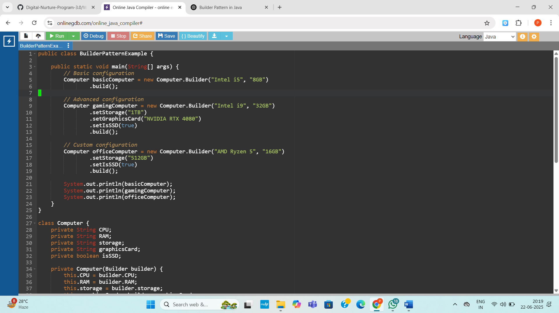

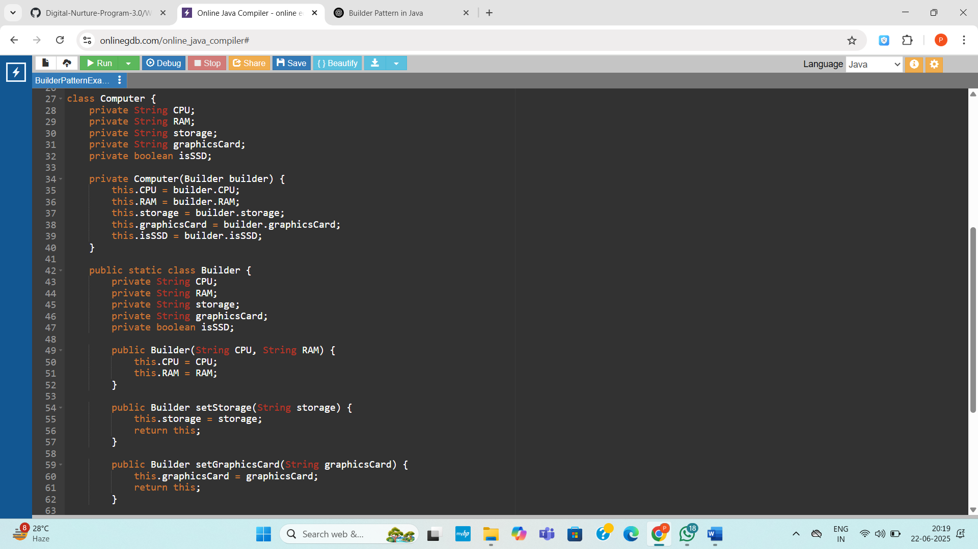

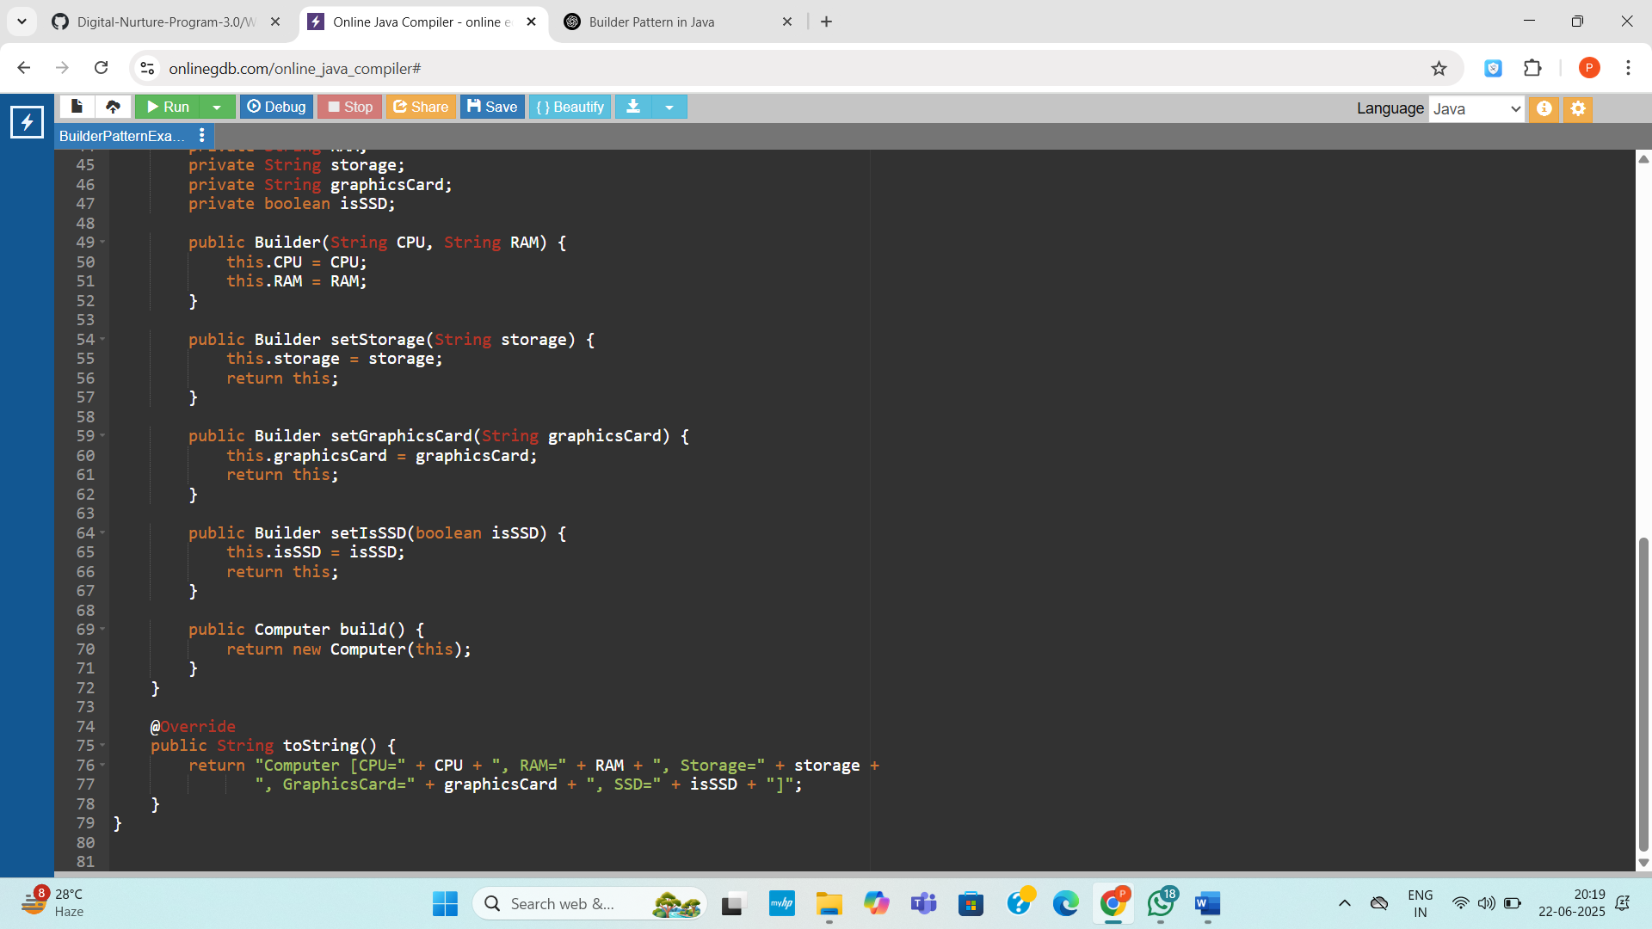
Output:
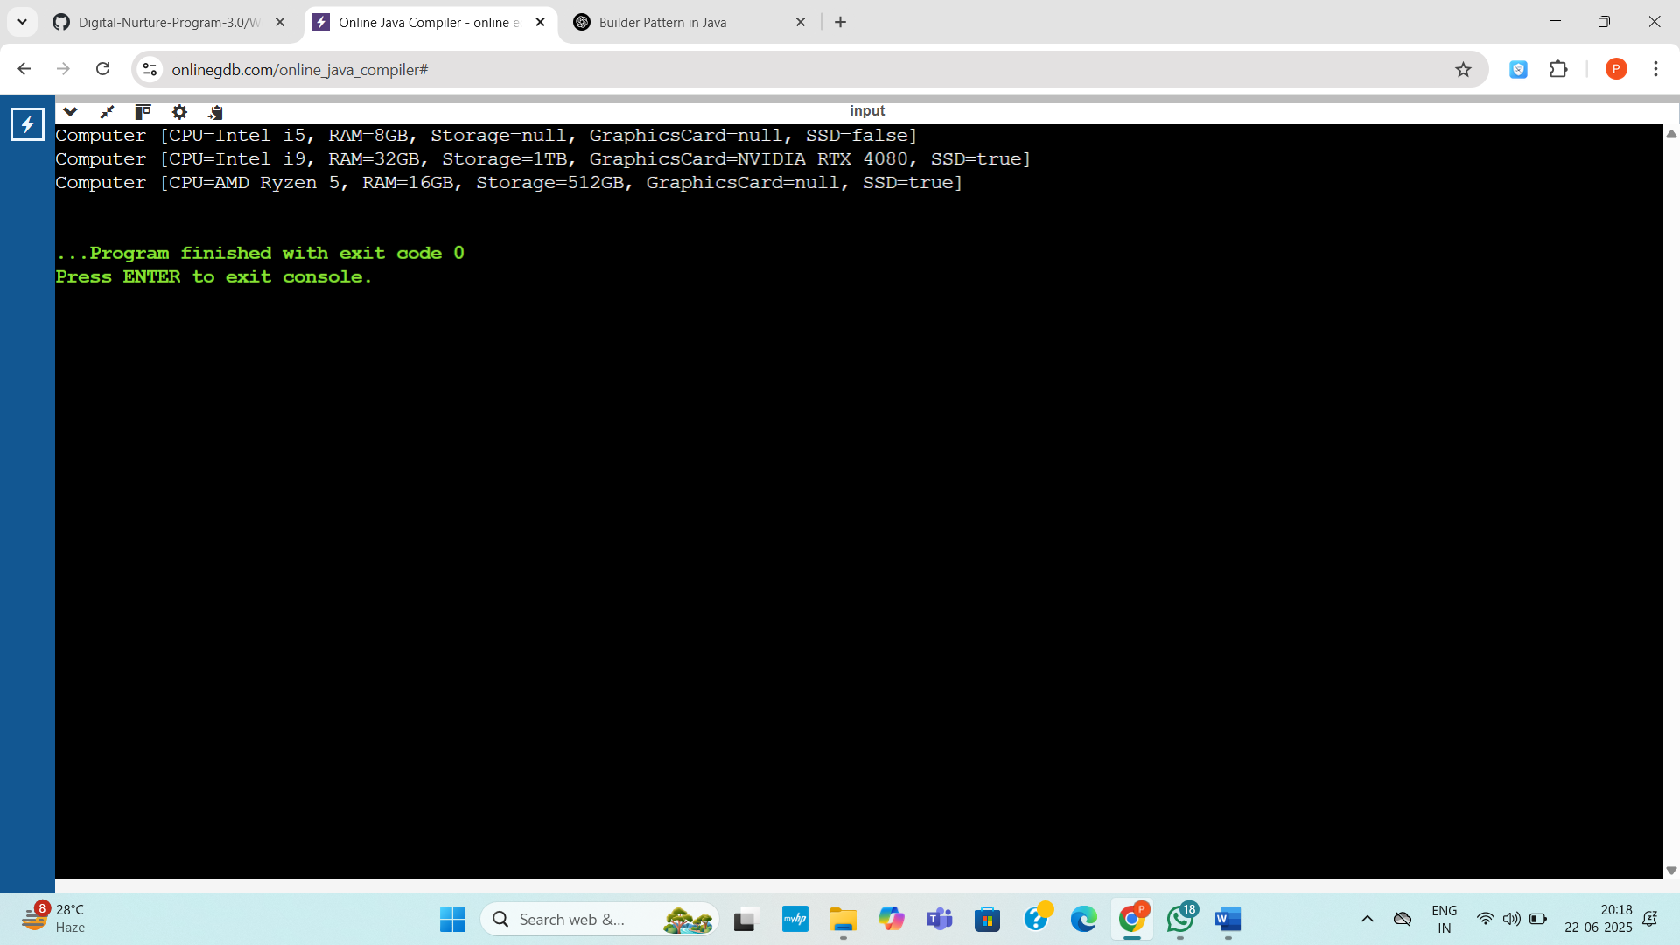

Exercise 4: Implementing the Adapter Pattern
Code:
public class AdapterPatternExample {
public static void main(String[] args) {
PaymentProcessor paypalProcessor = new PayPalAdapter(new PayPalGateway());
PaymentProcessor stripeProcessor = new StripeAdapter(new StripeGateway());

paypalProcessor.processPayment(99.99);
stripeProcessor.processPayment(149.49);
}
}

interface PaymentProcessor {
void processPayment(double amount);
}

class PayPalGateway {
public void sendPayment(double amountUSD) {
System.out.println("PayPal processed $" + amountUSD);
}
}

class StripeGateway {
public void charge(double amountUSD) {
System.out.println("Stripe charged $" + amountUSD);
}
}

class PayPalAdapter implements PaymentProcessor {
private final PayPalGateway payPal;

public PayPalAdapter(PayPalGateway payPal) {
this.payPal = payPal;
}

public void processPayment(double amount) {
payPal.sendPayment(amount);
}
}

class StripeAdapter implements PaymentProcessor {
private final StripeGateway stripe;

public StripeAdapter(StripeGateway stripe) {
this.stripe = stripe;
}

public void processPayment(double amount) {
stripe.charge(amount);
}
}
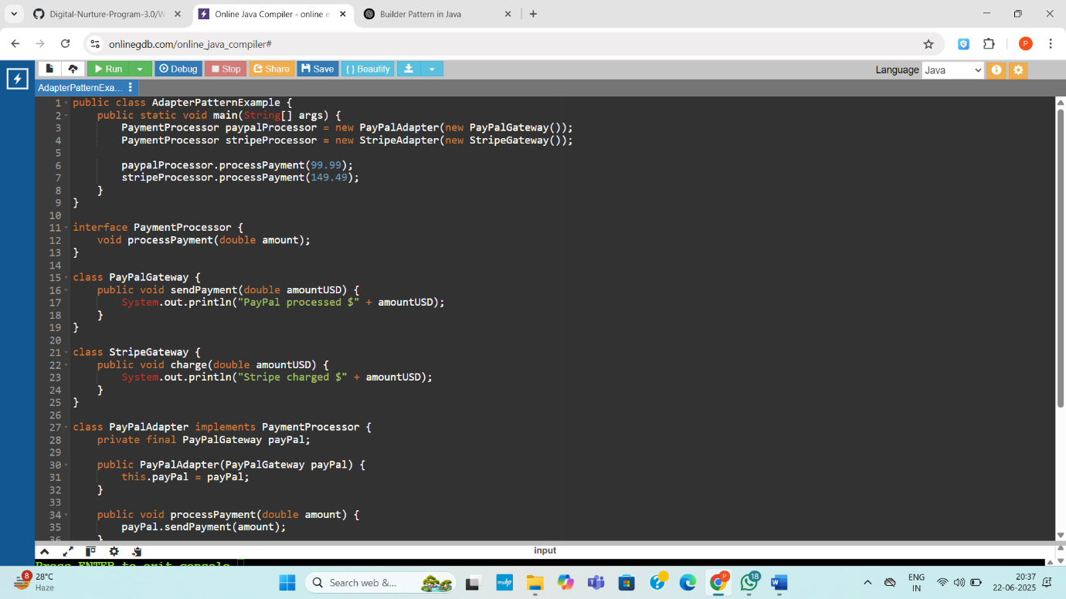

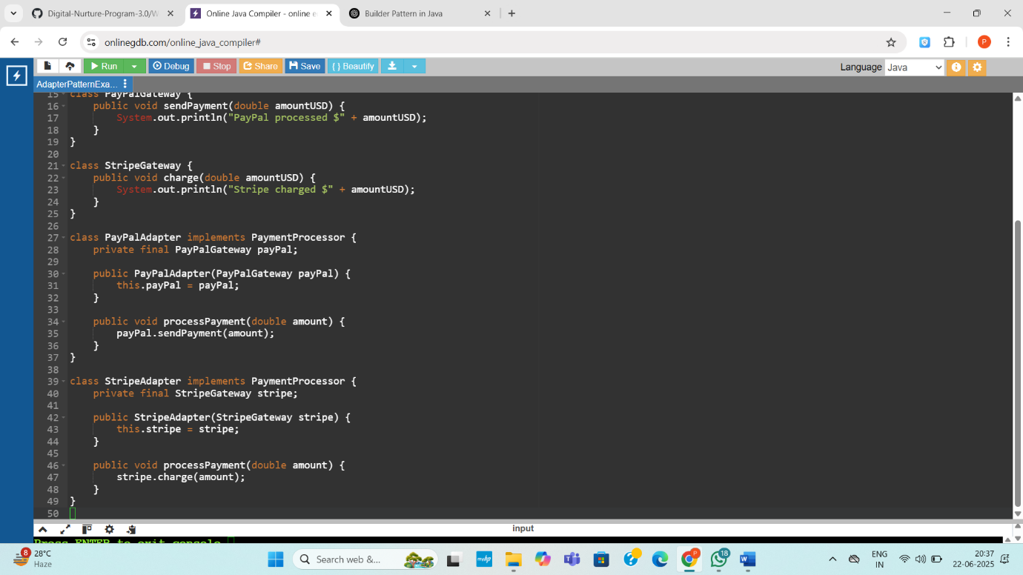
Output:
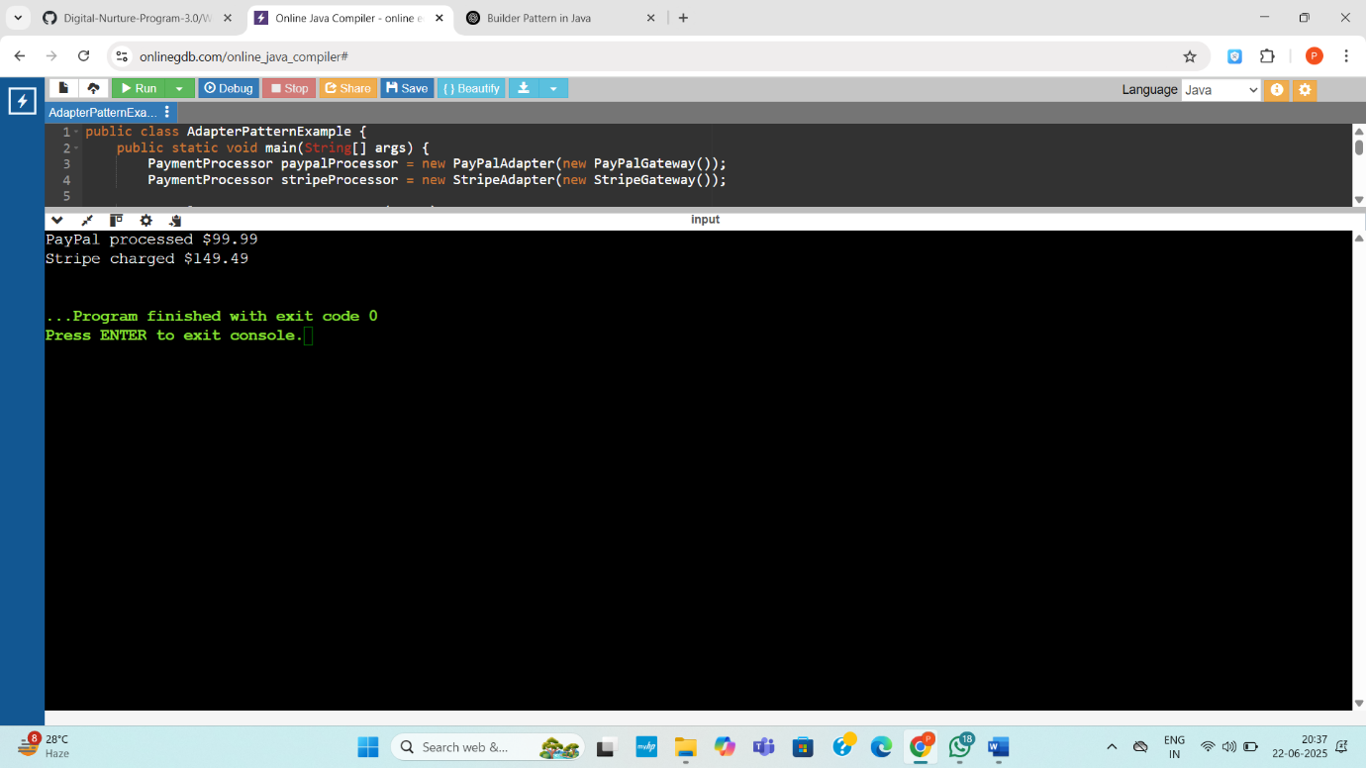

Exercise 5: Implementing the Decorator Pattern
Code:
public class DecoratorPatternExample {
public static void main(String[] args) {
Notifier basicNotifier = new EmailNotifier();
Notifier smsNotifier = new SMSNotifierDecorator(basicNotifier);
Notifier fullNotifier = new SlackNotifierDecorator(smsNotifier);

System.out.println("=== Only Email ===");
basicNotifier.send();

System.out.println("\n=== Email + SMS ===");
smsNotifier.send();

System.out.println("\n=== Email + SMS + Slack ===");
fullNotifier.send();
}
}

interface Notifier {
void send();
}

class EmailNotifier implements Notifier {
public void send() {
System.out.println("Sending Email Notification");
}
}

abstract class NotifierDecorator implements Notifier {
protected Notifier wrappedNotifier;

public NotifierDecorator(Notifier notifier) {
this.wrappedNotifier = notifier;
}

public void send() {
wrappedNotifier.send();
}
}

class SMSNotifierDecorator extends NotifierDecorator {
public SMSNotifierDecorator(Notifier notifier) {
super(notifier);
}

public void send() {
super.send();
System.out.println("Sending SMS Notification");
}
}

class SlackNotifierDecorator extends NotifierDecorator {
public SlackNotifierDecorator(Notifier notifier) {
super(notifier);
}

public void send() {
super.send();
System.out.println("Sending Slack Notification");
}
}
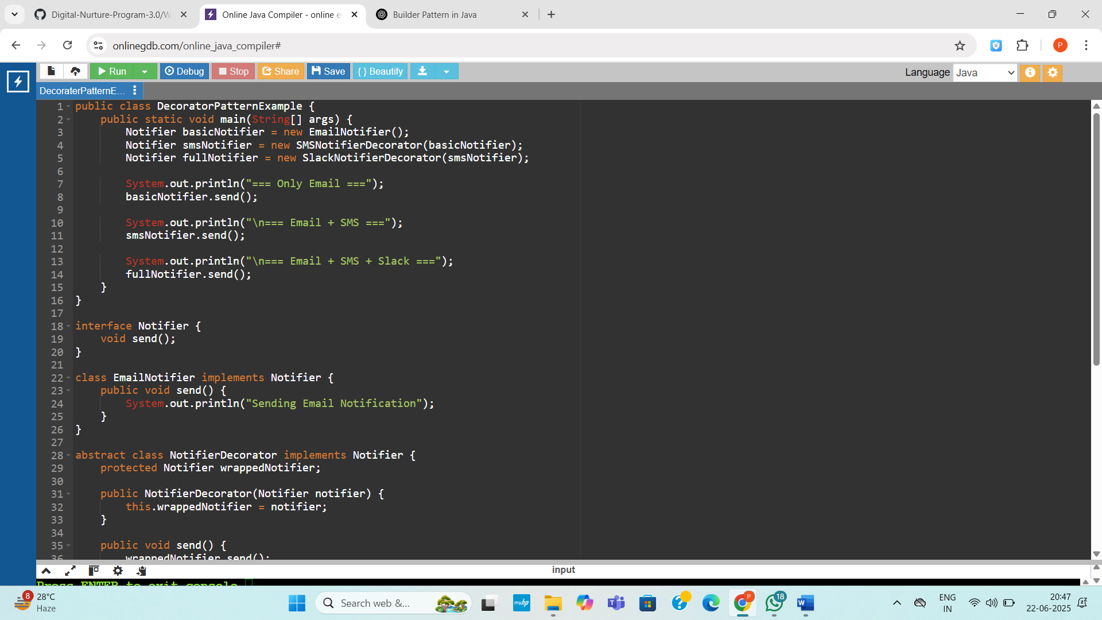
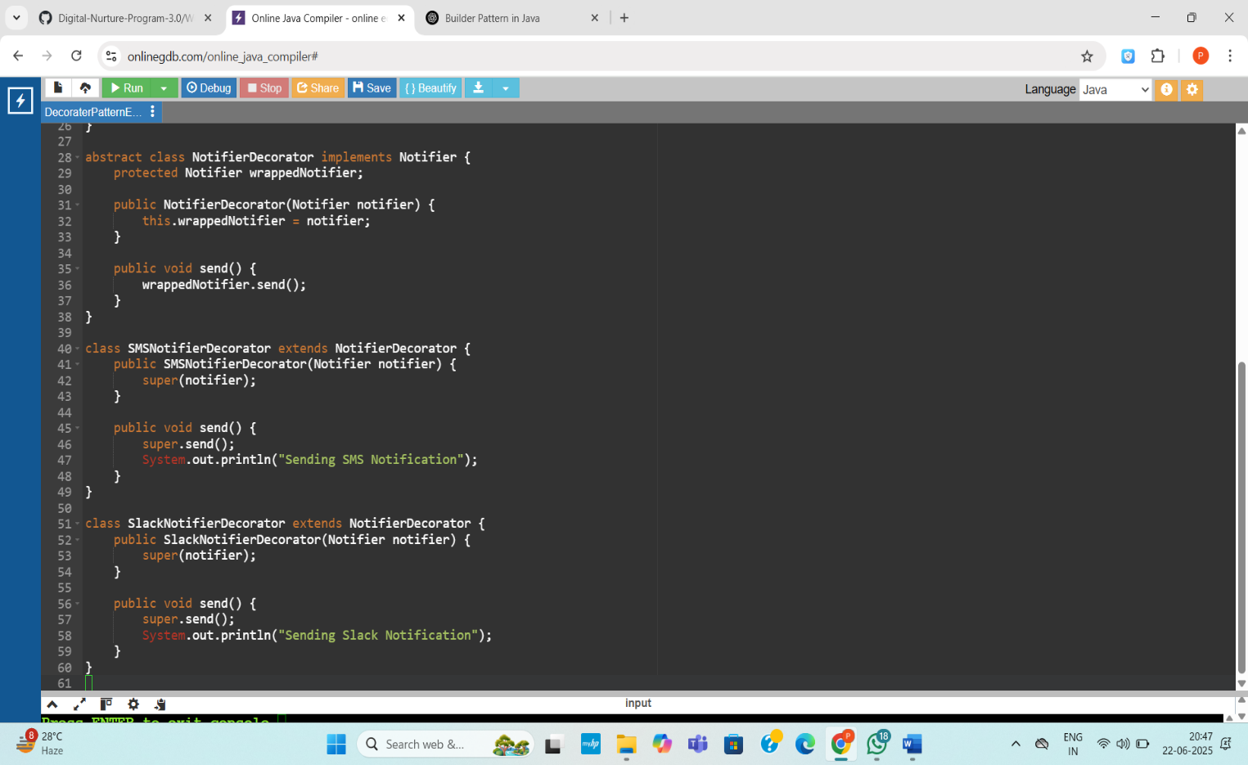
Output:

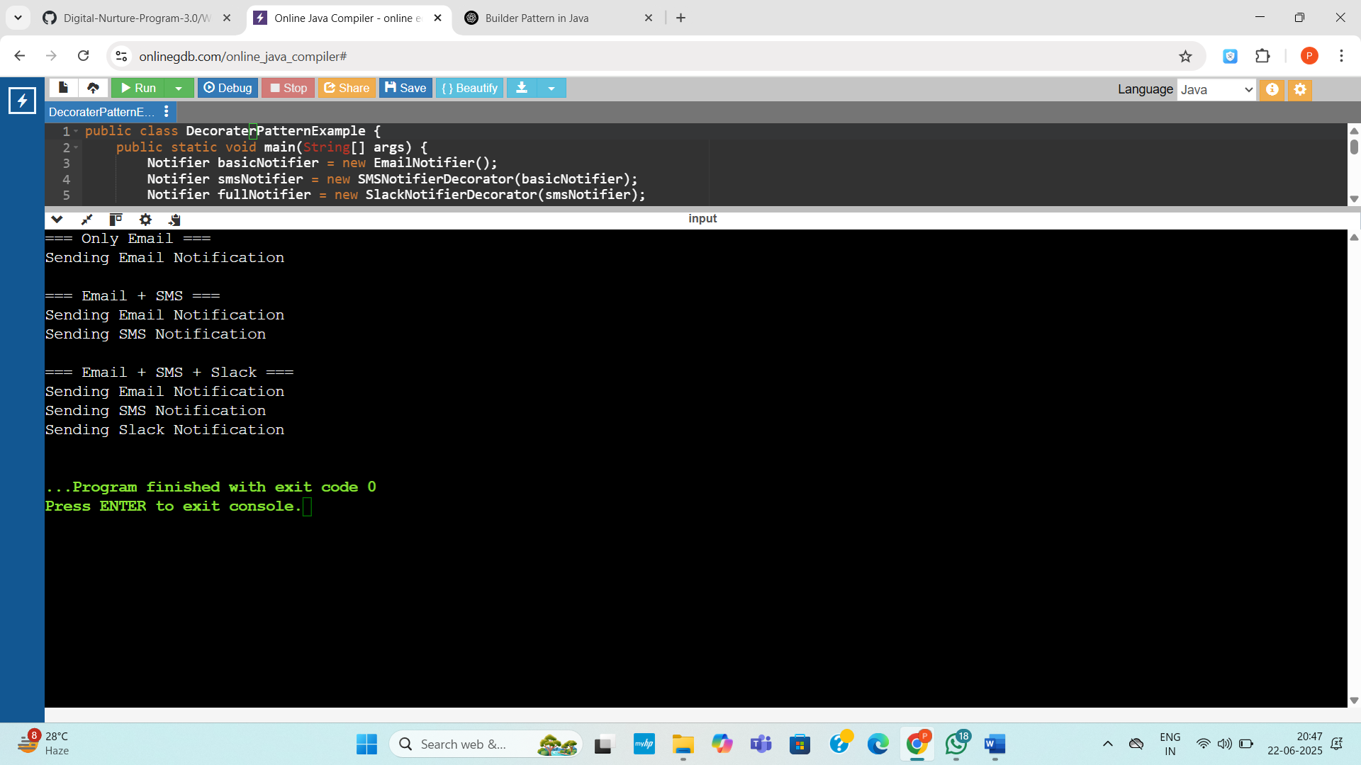

Exercise 6: Implementing the Proxy Pattern
Code:
public class ProxyPatternExample {
public static void main(String[] args) {
Image img1 = new ProxyImage("photo1.jpg");
Image img2 = new ProxyImage("photo2.jpg");

System.out.println("First call to img1:");
img1.display();

System.out.println("\nSecond call to img1 (cached):");
img1.display();

System.out.println("\nFirst call to img2:");
img2.display();
}
}

interface Image {
void display();
}

class RealImage implements Image {
private String filename;

public RealImage(String filename) {
this.filename = filename;
loadFromRemoteServer();
}

private void loadFromRemoteServer() {
System.out.println("Loading image from server: " + filename);
}

public void display() {
System.out.println("Displaying image: " + filename);
}
}
class ProxyImage implements Image {
private RealImage realImage;
private String filename;
public ProxyImage(String filename) {
this.filename = filename;
}
public void display() {
if (realImage == null) {
realImage = new RealImage(filename);
}
realImage.display();
}
}
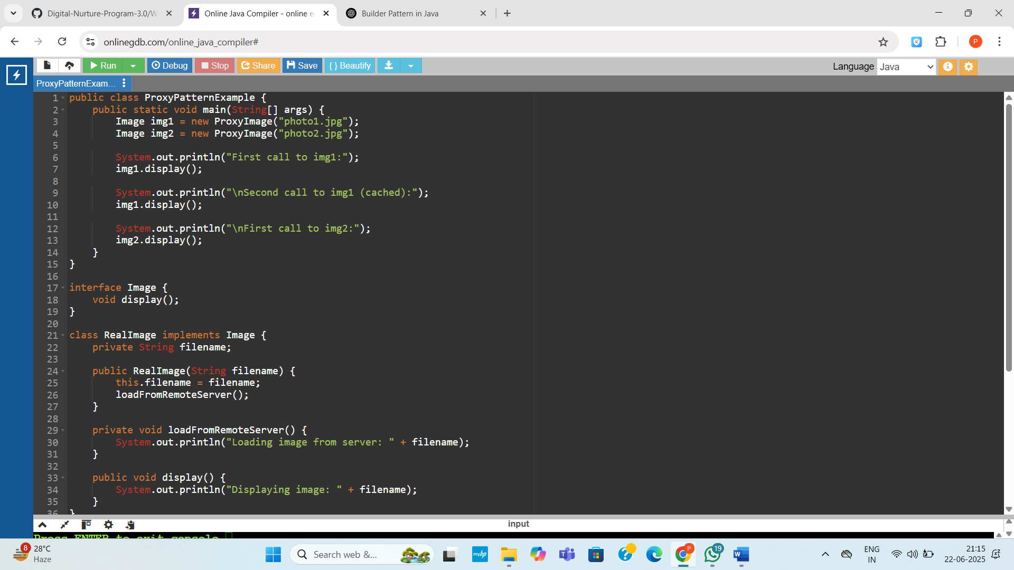

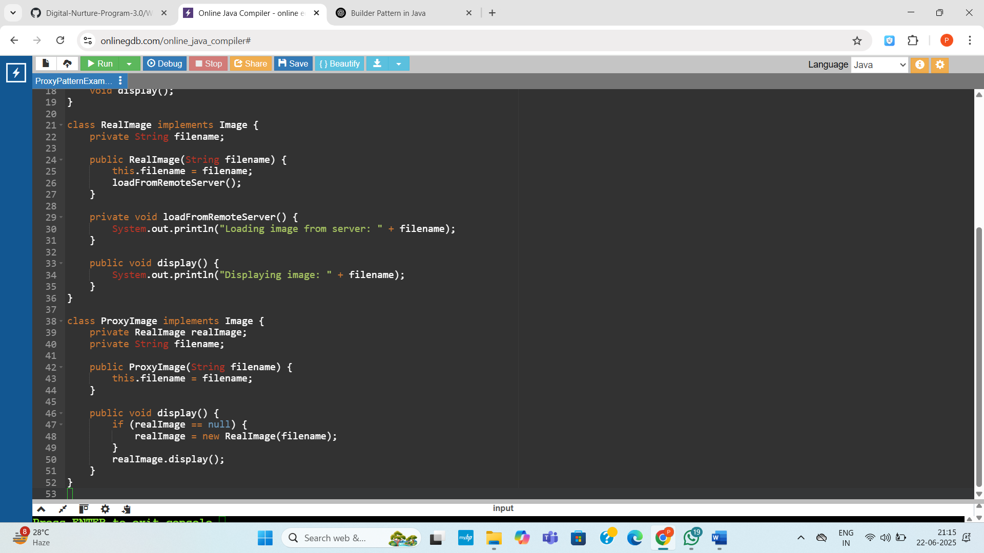

Output:
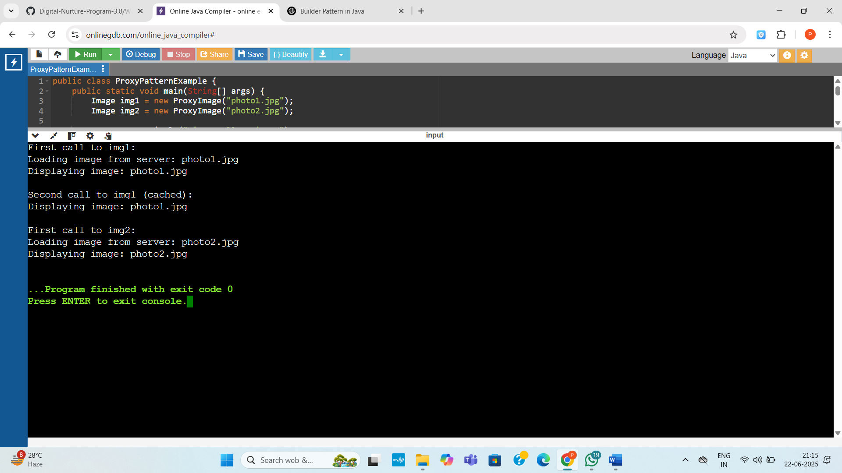
Exercise 7: Implementing the Observer Pattern
Code:
import java.util.*;

public class ObserverPatternExample {
public static void main(String[] args) {
StockMarket stockMarket = new StockMarket();

Observer mobileApp = new MobileApp("MobileApp 1");
Observer webApp = new WebApp("WebApp 1");

stockMarket.registerObserver(mobileApp);
stockMarket.registerObserver(webApp);

System.out.println("Updating stock price...");
stockMarket.setStockPrice("AAPL", 185.50);

System.out.println("Updating stock price again...");
stockMarket.setStockPrice("GOOG", 2760.25);

stockMarket.removeObserver(webApp);

System.out.println("Updating stock price again...");
stockMarket.setStockPrice("AAPL", 190.75);
}
}

interface Stock {
void registerObserver(Observer o);
void removeObserver(Observer o);
void notifyObservers(String stock, double price);
}

class StockMarket implements Stock {
private List<Observer> observers = new ArrayList<>();
private Map<String, Double> stockPrices = new HashMap<>();

public void registerObserver(Observer o) {
observers.add(o);
}

public void removeObserver(Observer o) {
observers.remove(o);
}

public void notifyObservers(String stock, double price) {
for (Observer o : observers) {
o.update(stock, price);
}
}

public void setStockPrice(String stock, double price) {
stockPrices.put(stock, price);
notifyObservers(stock, price);
}
}

interface Observer {
void update(String stock, double price);
}

class MobileApp implements Observer {
private String name;

public MobileApp(String name) {
this.name = name;
}

public void update(String stock, double price) {
System.out.println(name + " received update: " + stock + " = $" + price);
}
}
class WebApp implements Observer {
private String name;
public WebApp(String name) {
this.name = name;
}
public void update(String stock, double price) {
System.out.println(name + " received update: " + stock + " = $" + price);
}
}
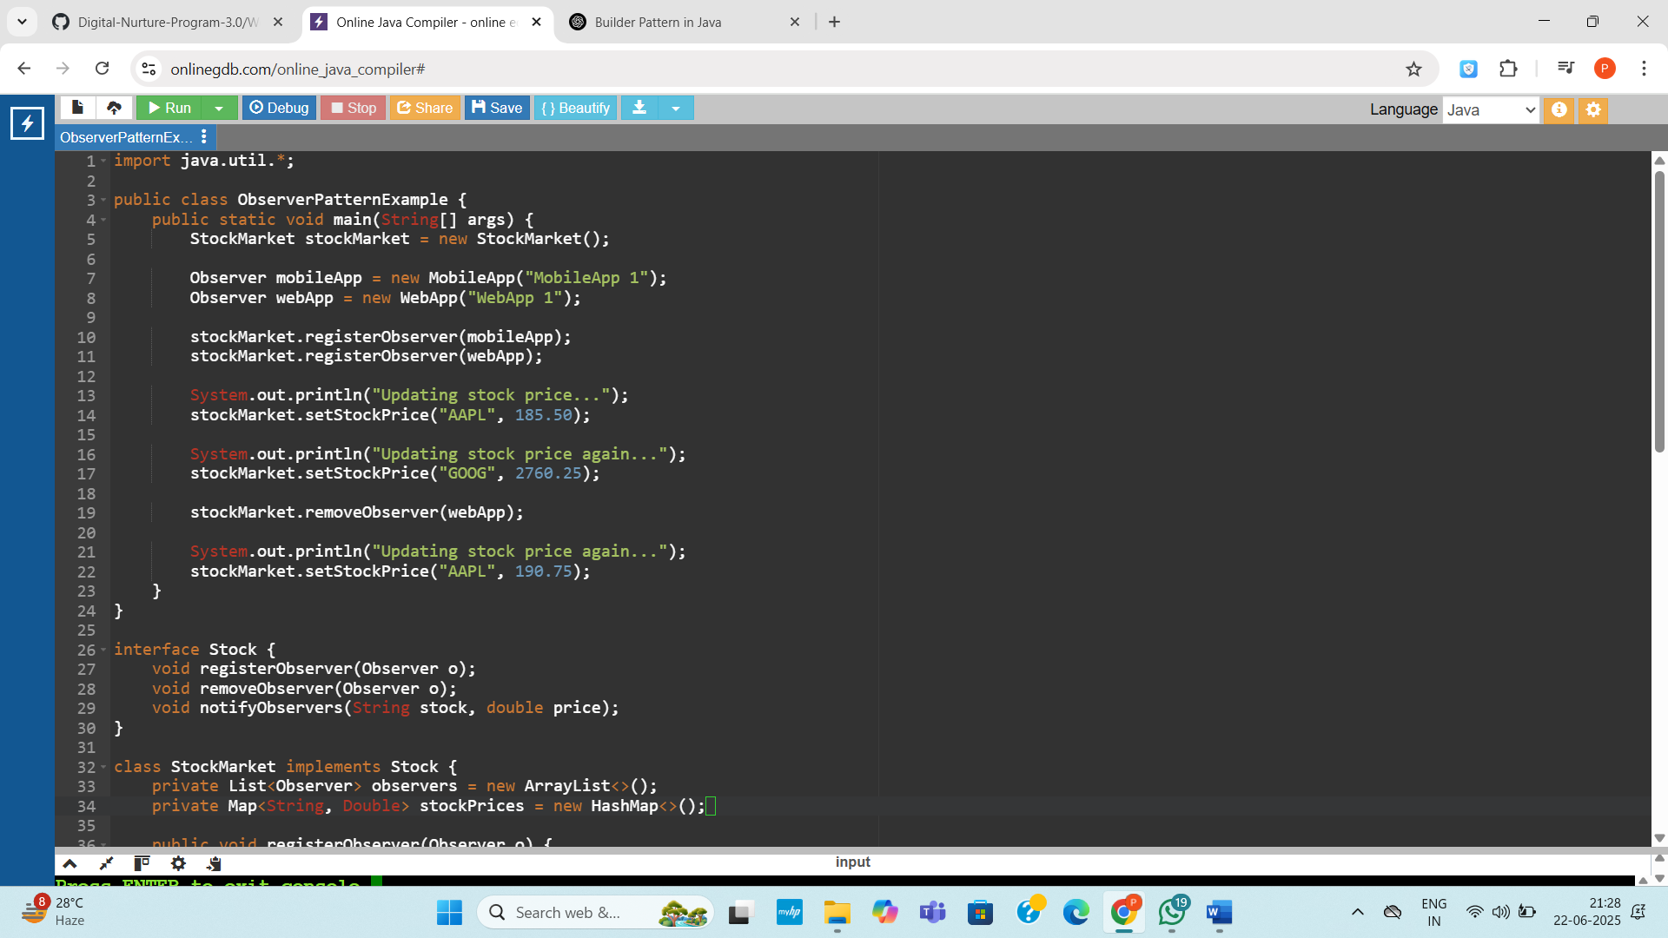

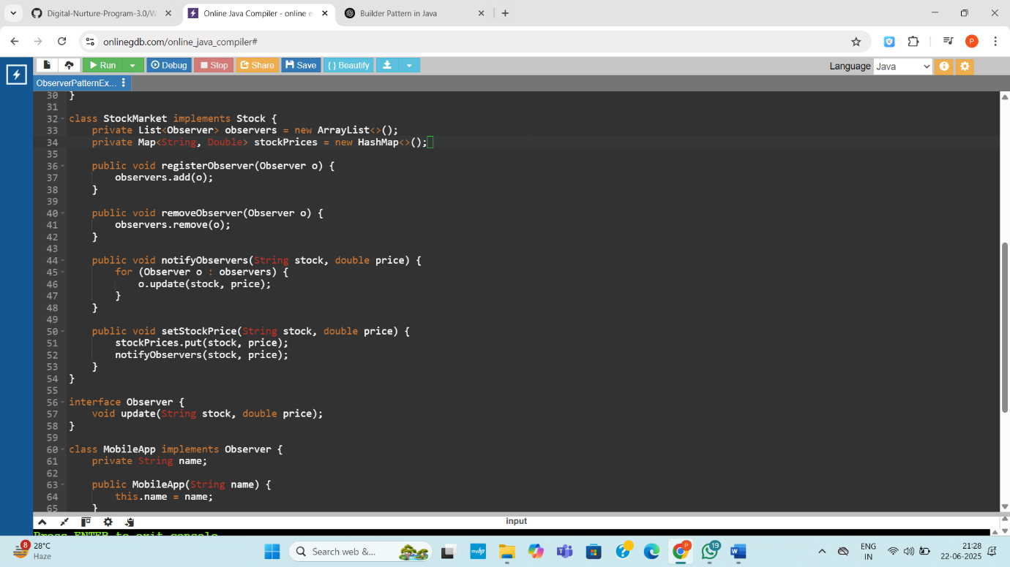
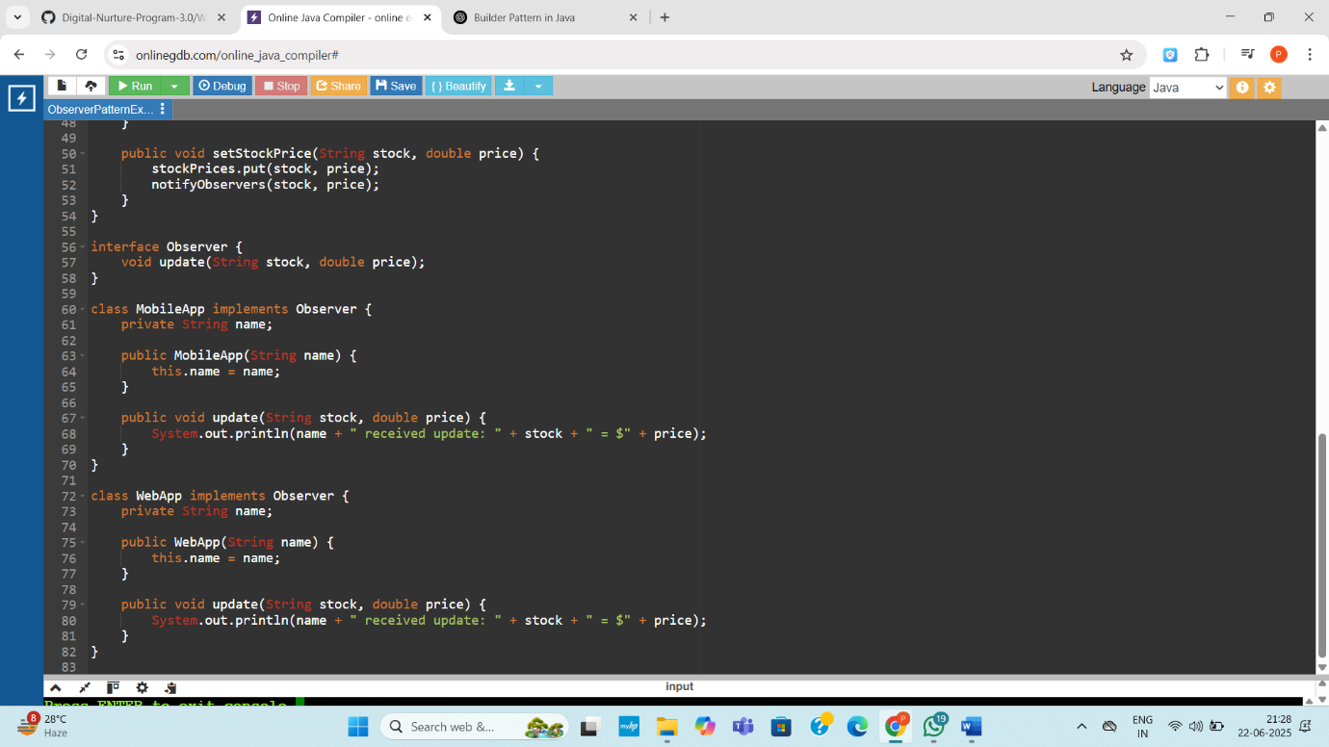
Output:
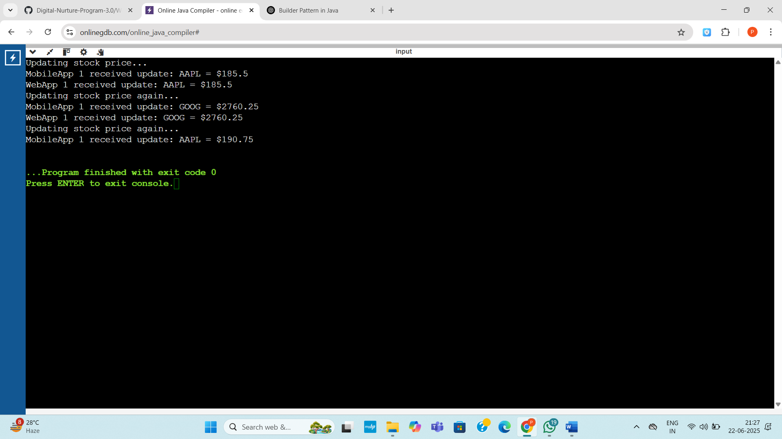
Exercise 8: Implementing the Strategy Pattern
Code:
public class StrategyPatternExample {
public static void main(String[] args) {
PaymentContext context = new PaymentContext();
System.out.println("Paying with Credit Card:");
context.setPaymentStrategy(new CreditCardPayment());
context.pay(100.0);
System.out.println("\nPaying with PayPal:");
context.setPaymentStrategy(new PayPalPayment());
context.pay(250.5);
}
}

interface PaymentStrategy {
void pay(double amount);
}

class CreditCardPayment implements PaymentStrategy {
public void pay(double amount) {
System.out.println("Paid ₹" + amount + " using Credit Card.");
}
}

class PayPalPayment implements PaymentStrategy {
public void pay(double amount) {
System.out.println("Paid ₹" + amount + " using PayPal.");
}
}

class PaymentContext {
private PaymentStrategy strategy;

public void setPaymentStrategy(PaymentStrategy strategy) {
this.strategy = strategy;
}

public void pay(double amount) {
if (strategy != null) {
strategy.pay(amount);
} else {
System.out.println("Payment method not selected.");
}
}
}
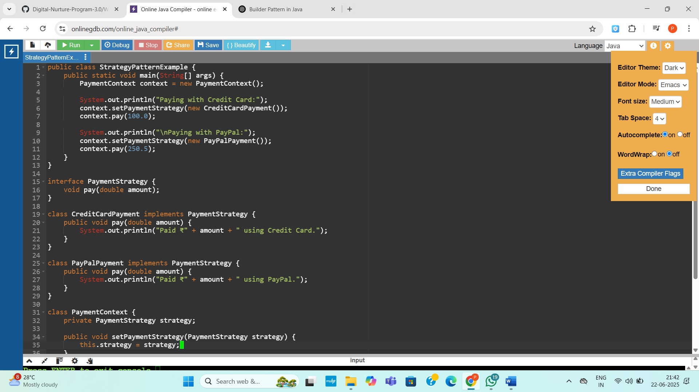
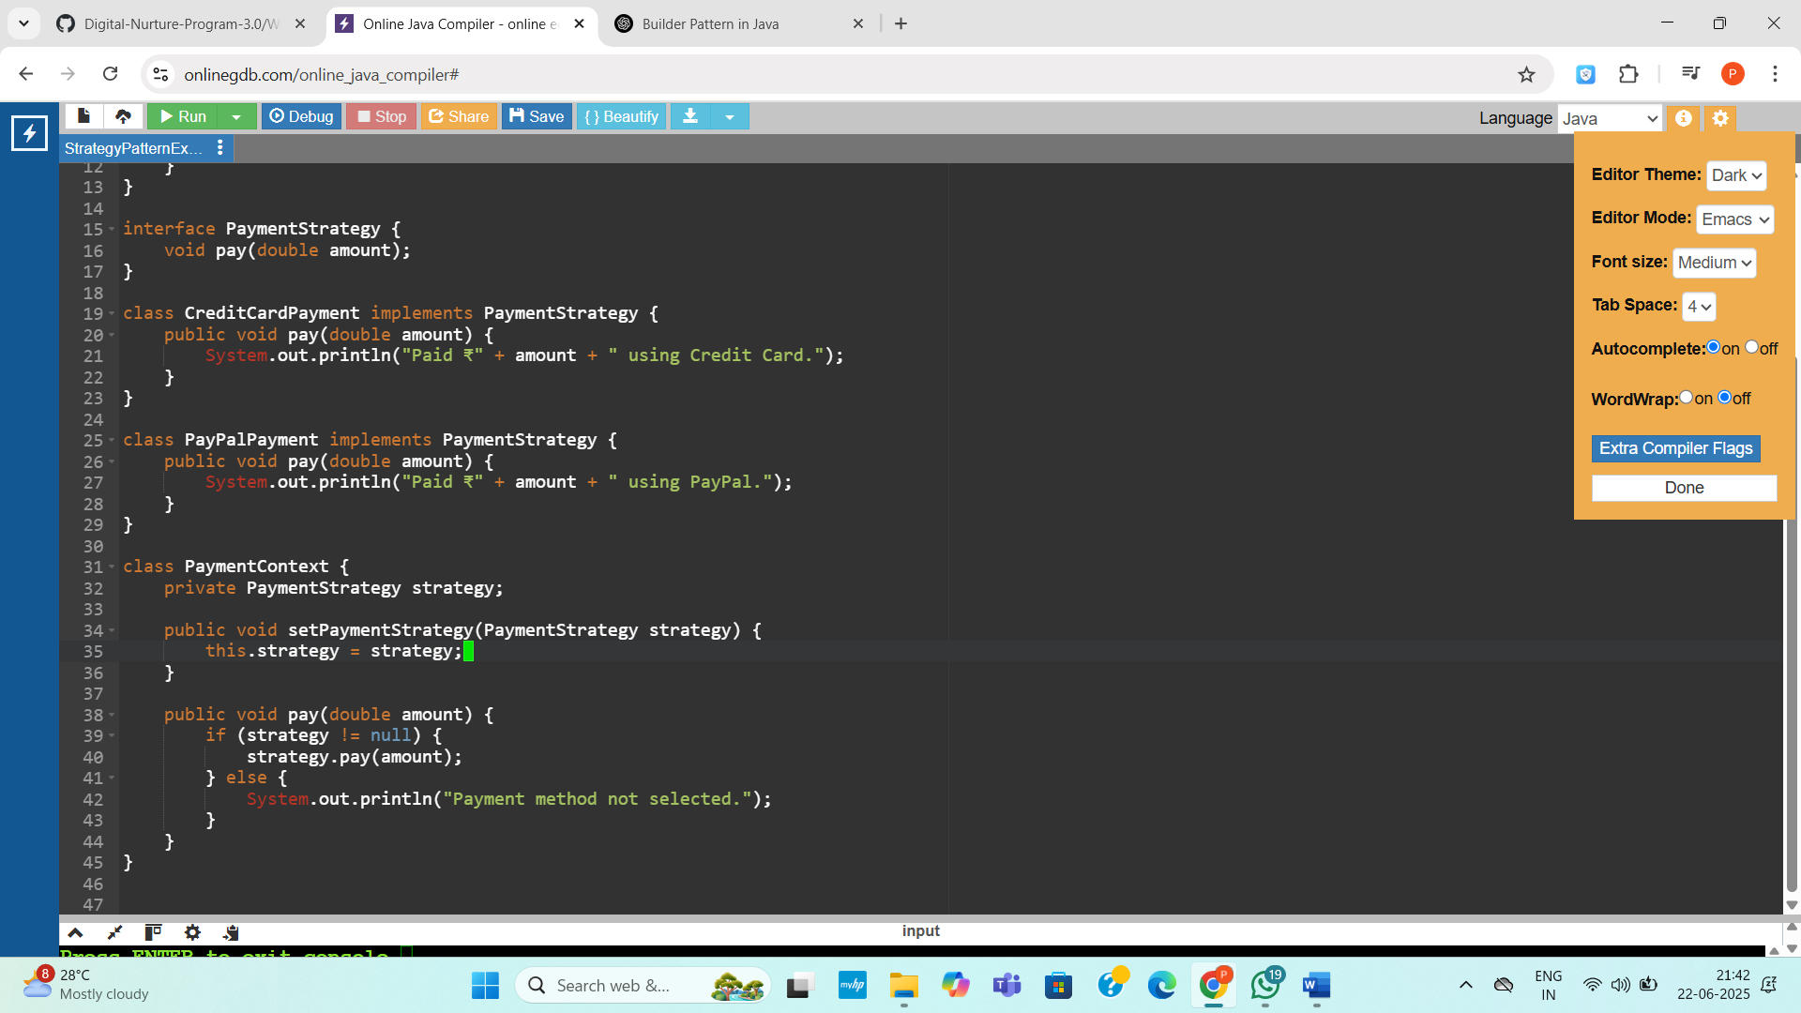
Output:
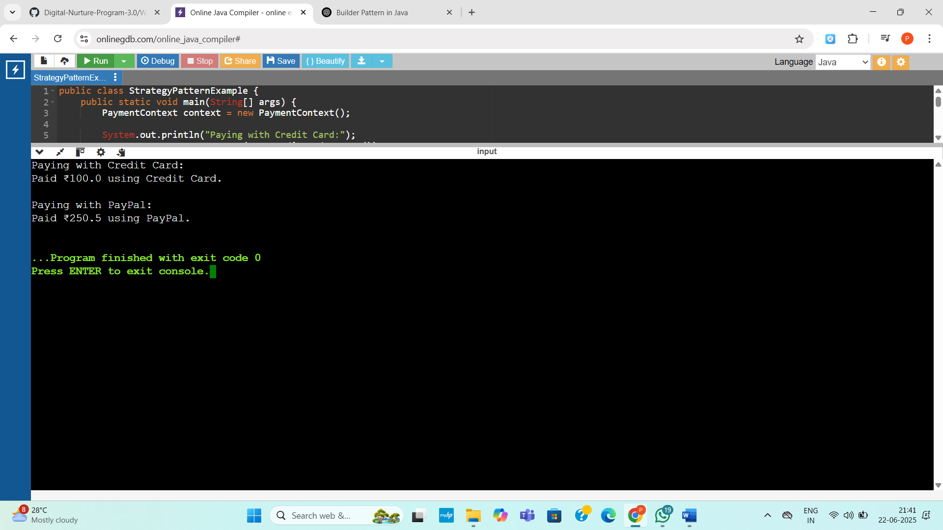

Exercise 9: Implementing the Command Pattern
Code:
public class CommandPatternExample {
public static void main(String[] args) {
Light livingRoomLight = new Light();

Command lightOn = new LightOnCommand(livingRoomLight);
Command lightOff = new LightOffCommand(livingRoomLight);

RemoteControl remote = new RemoteControl();

remote.setCommand(lightOn);
remote.pressButton();

remote.setCommand(lightOff);
remote.pressButton();
}
}

interface Command {
void execute();
}

class Light {
public void turnOn() {
System.out.println("Light is ON");
}

public void turnOff() {
System.out.println("Light is OFF");
}
}
class LightOnCommand implements Command {
private Light light;
public LightOnCommand(Light light) {
this.light = light;
}

public void execute() {
light.turnOn();
}
}

class LightOffCommand implements Command {
private Light light;

public LightOffCommand(Light light) {
this.light = light;
}

public void execute() {
light.turnOff();
}
}
class RemoteControl {
private Command command;
public void setCommand(Command command) {
this.command = command;
}
public void pressButton() {
if (command != null) {
command.execute();
} else {
System.out.println("No command assigned.");
}
}
}
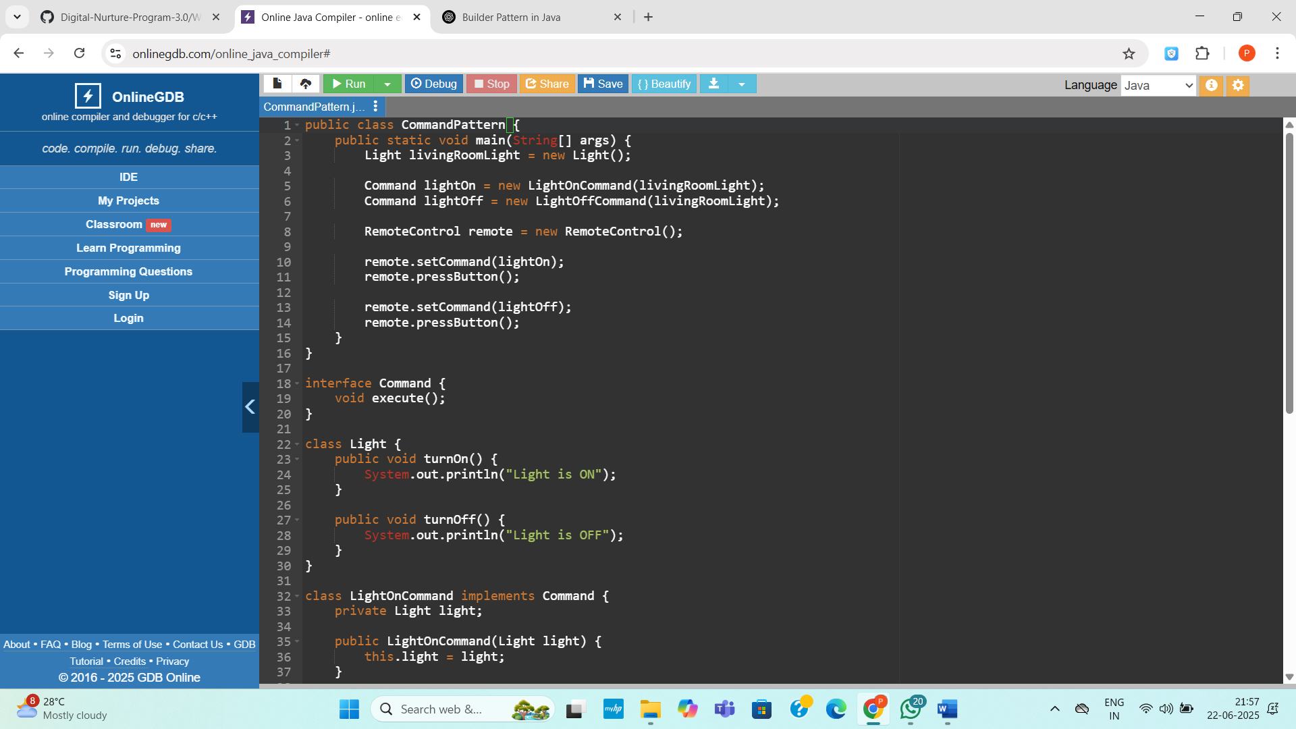

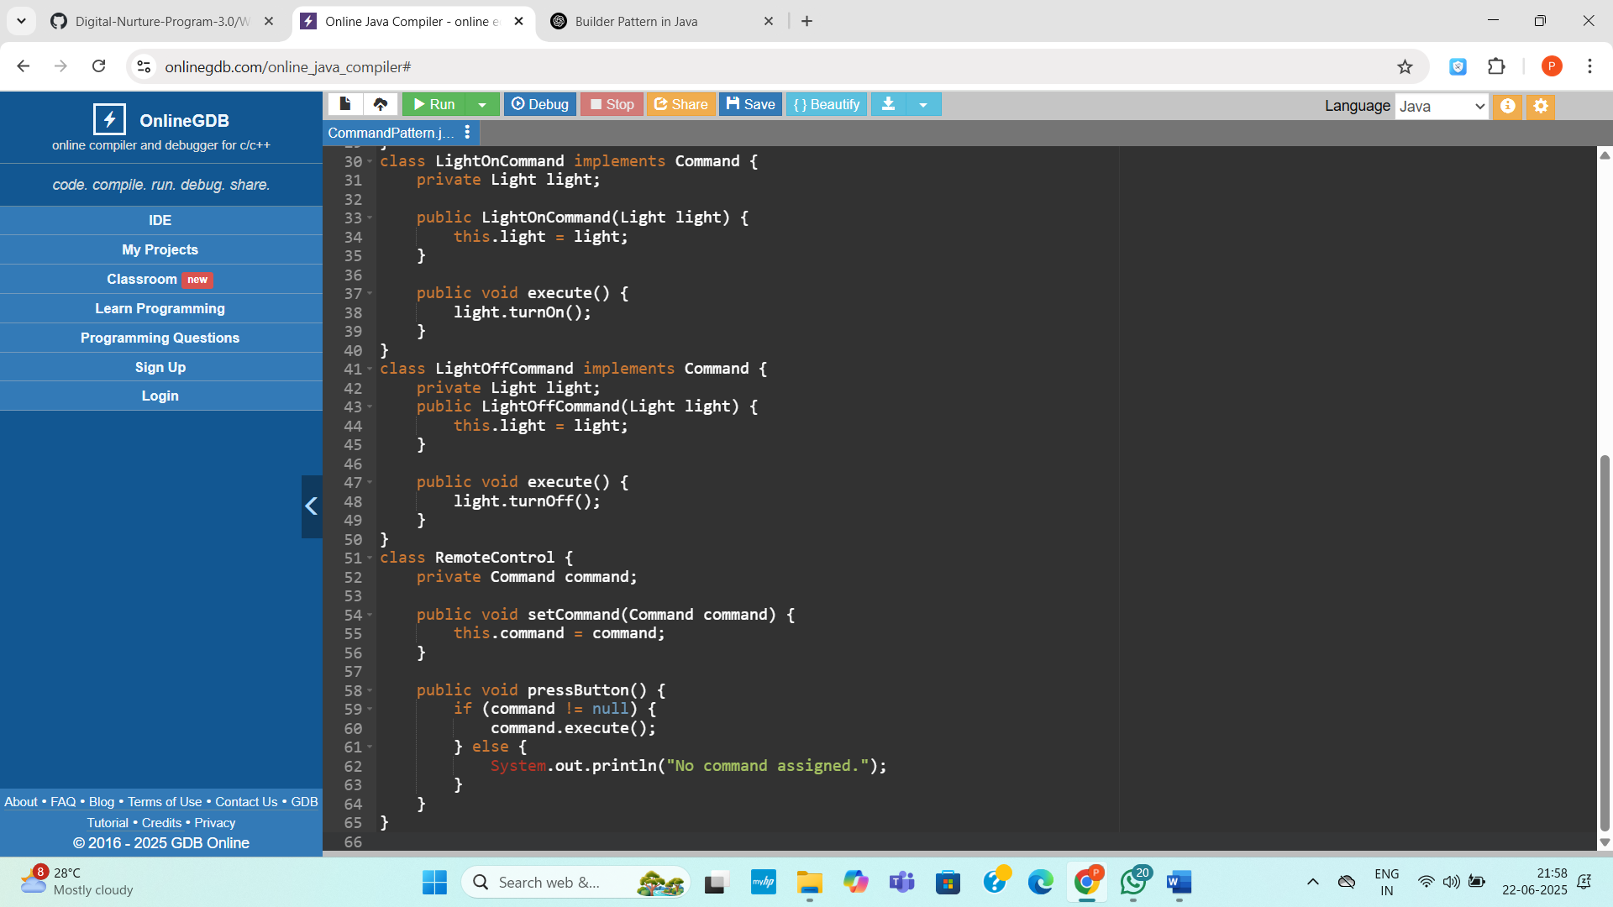
Output:
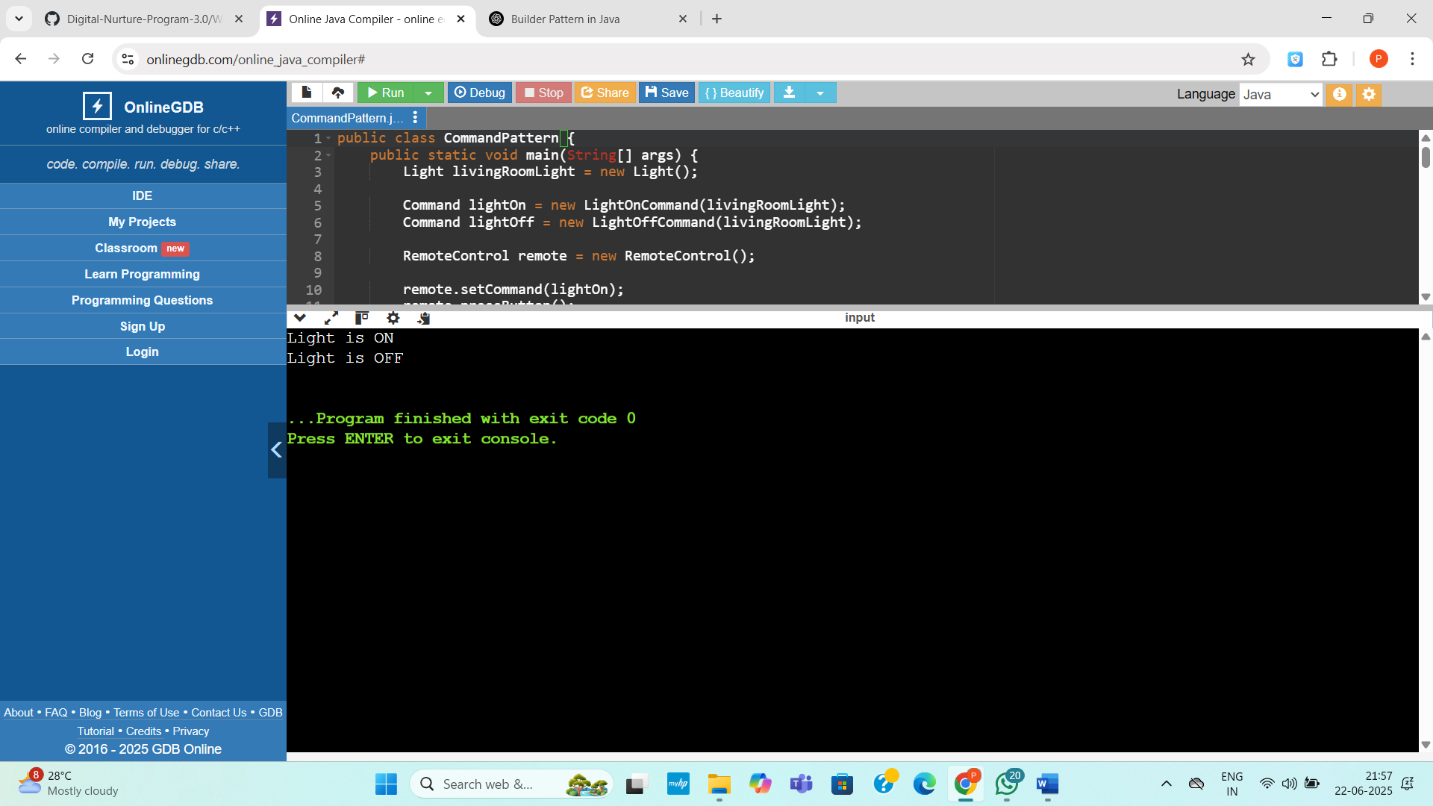

Exercise 10: Implementing the MVC Pattern
Code:
public class MVCPatternExample {
public static void main(String[] args) {
Student model = new Student("Priya", "S101", "A");
StudentView view = new StudentView();
StudentController controller = new StudentController(model, view);

controller.updateView();

controller.setStudentName("Anita");
controller.setStudentGrade("A+");

controller.updateView();
}
}

class Student {
private String name;
private String id;
private String grade;

public Student(String name, String id, String grade) {
this.name = name;
this.id = id;
this.grade = grade;
}

public String getName() {
return name;
}

public String getId() {
return id;
}

public String getGrade() {
return grade;
}

public void setName(String name) {
this.name = name;
}

public void setId(String id) {
this.id = id;
}

public void setGrade(String grade) {
this.grade = grade;
}
}

class StudentView {
public void displayStudentDetails(String name, String id, String grade) {
System.out.println("Student Details:");
System.out.println("Name: " + name);
System.out.println("ID: " + id);
System.out.println("Grade: " + grade);
System.out.println();
}
}

class StudentController {
private Student model;
private StudentView view;

public StudentController(Student model, StudentView view) {
this.model = model;
this.view = view;
}

public void setStudentName(String name) {
model.setName(name);
}

public void setStudentId(String id) {
model.setId(id);
}

public void setStudentGrade(String grade) {
model.setGrade(grade);
}

public String getStudentName() {
return model.getName();
}

public String getStudentId() {
return model.getId();
}

public String getStudentGrade() {
return model.getGrade();
}

public void updateView() {
view.displayStudentDetails(model.getName(), model.getId(), model.getGrade());
}
}
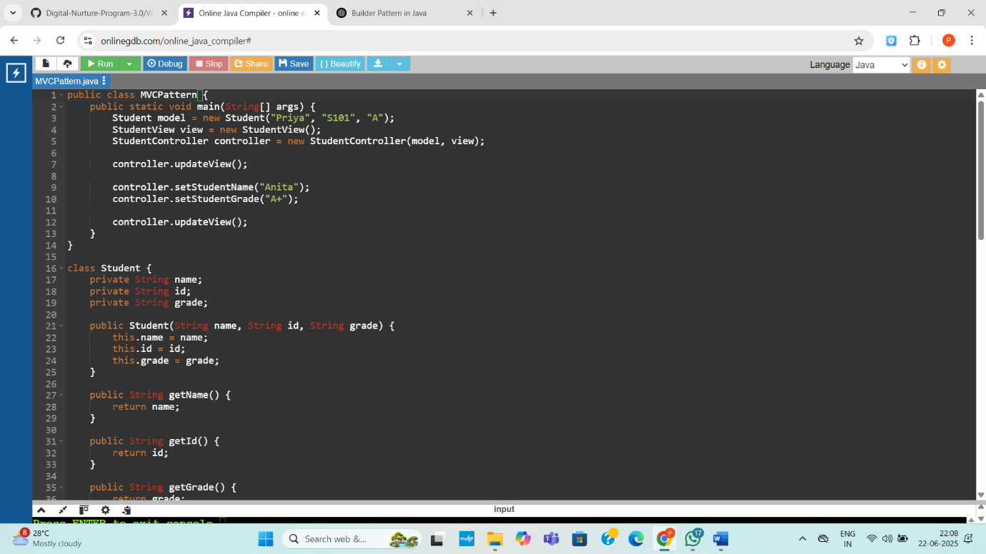
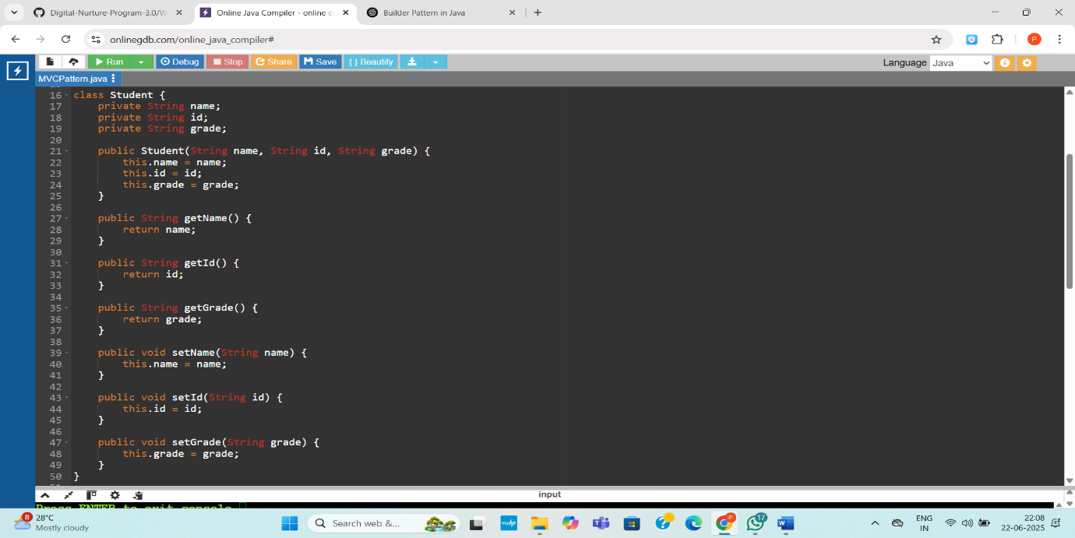

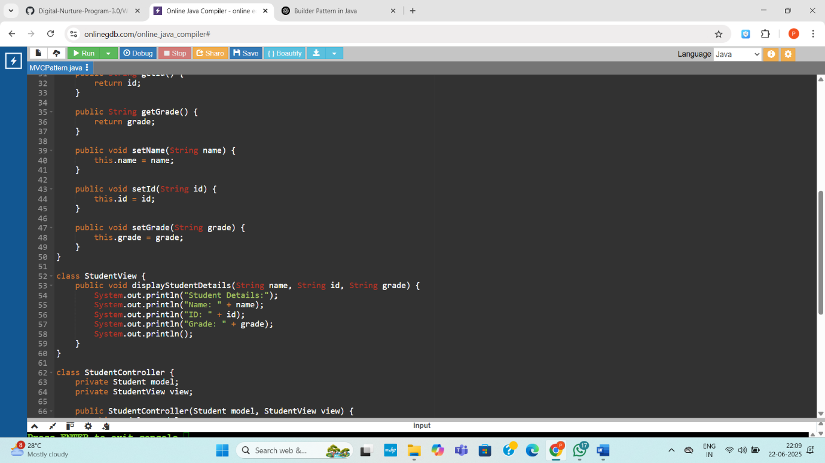

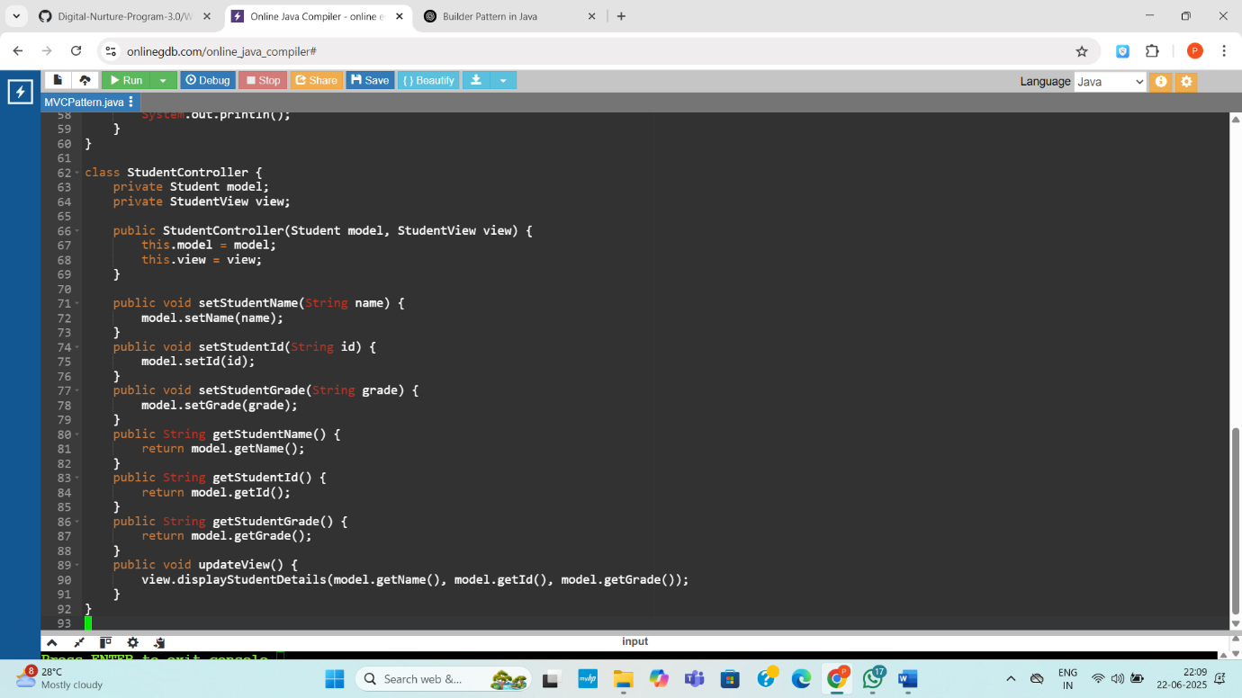
Output:
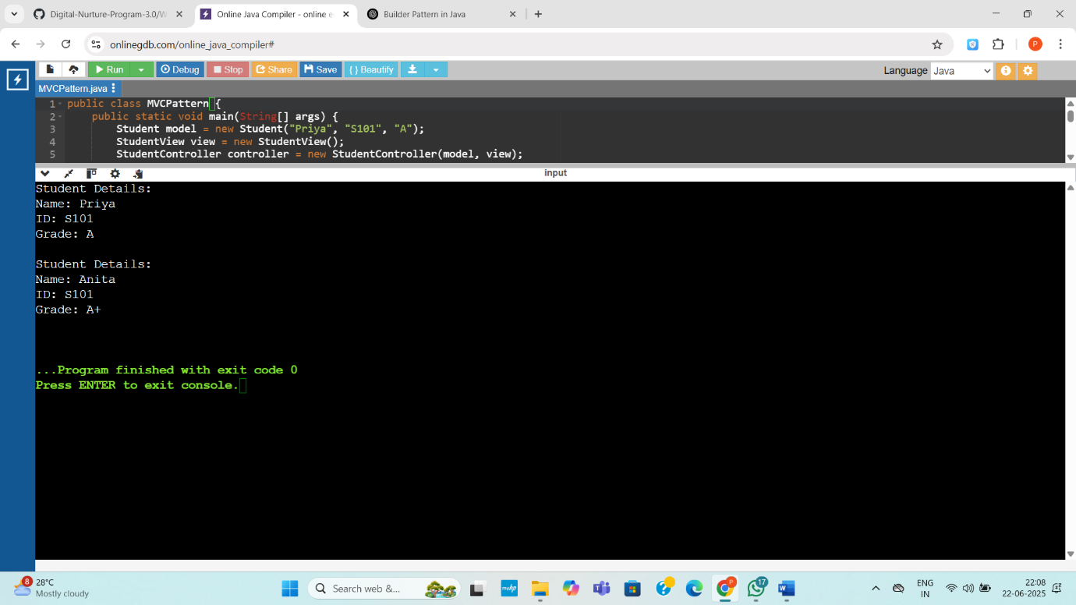
Exercise 11: Implementing Dependency Injection
Code:
import java.util.*;

public class DependencyInjectionExample {
public static void main(String[] args) {
CustomerRepository repository = new CustomerRepositoryImpl();
CustomerService service = new CustomerService(repository);

Customer customer1 = service.findCustomerById("C001");
Customer customer2 = service.findCustomerById("C999");

System.out.println(customer1);
System.out.println(customer2);
}
}

class Customer {
private String id;
private String name;

public Customer(String id, String name) {
this.id = id;
this.name = name;
}

public String toString() {
if (id == null || name == null) {
return "Customer not found";
}
return "Customer[id=" + id + ", name=" + name + "]";
}
}

interface CustomerRepository {
Customer findCustomerById(String id);
}

class CustomerRepositoryImpl implements CustomerRepository {
private Map<String, Customer> database = new HashMap<>();

public CustomerRepositoryImpl() {
database.put("C001", new Customer("C001", "Alice"));
database.put("C002", new Customer("C002", "Bob"));
}

public Customer findCustomerById(String id) {
return database.getOrDefault(id, new Customer(null, null));
}
}

class CustomerService {
private final CustomerRepository repository;

public CustomerService(CustomerRepository repository) {
this.repository = repository;
}

public Customer findCustomerById(String id) {
return repository.findCustomerById(id);
}
}
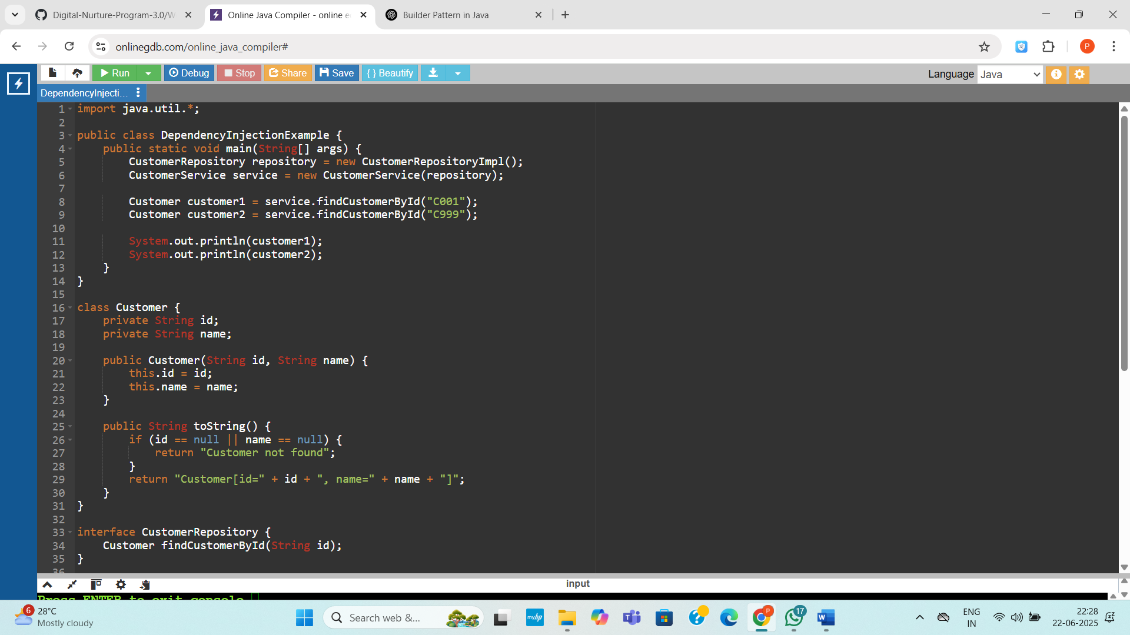
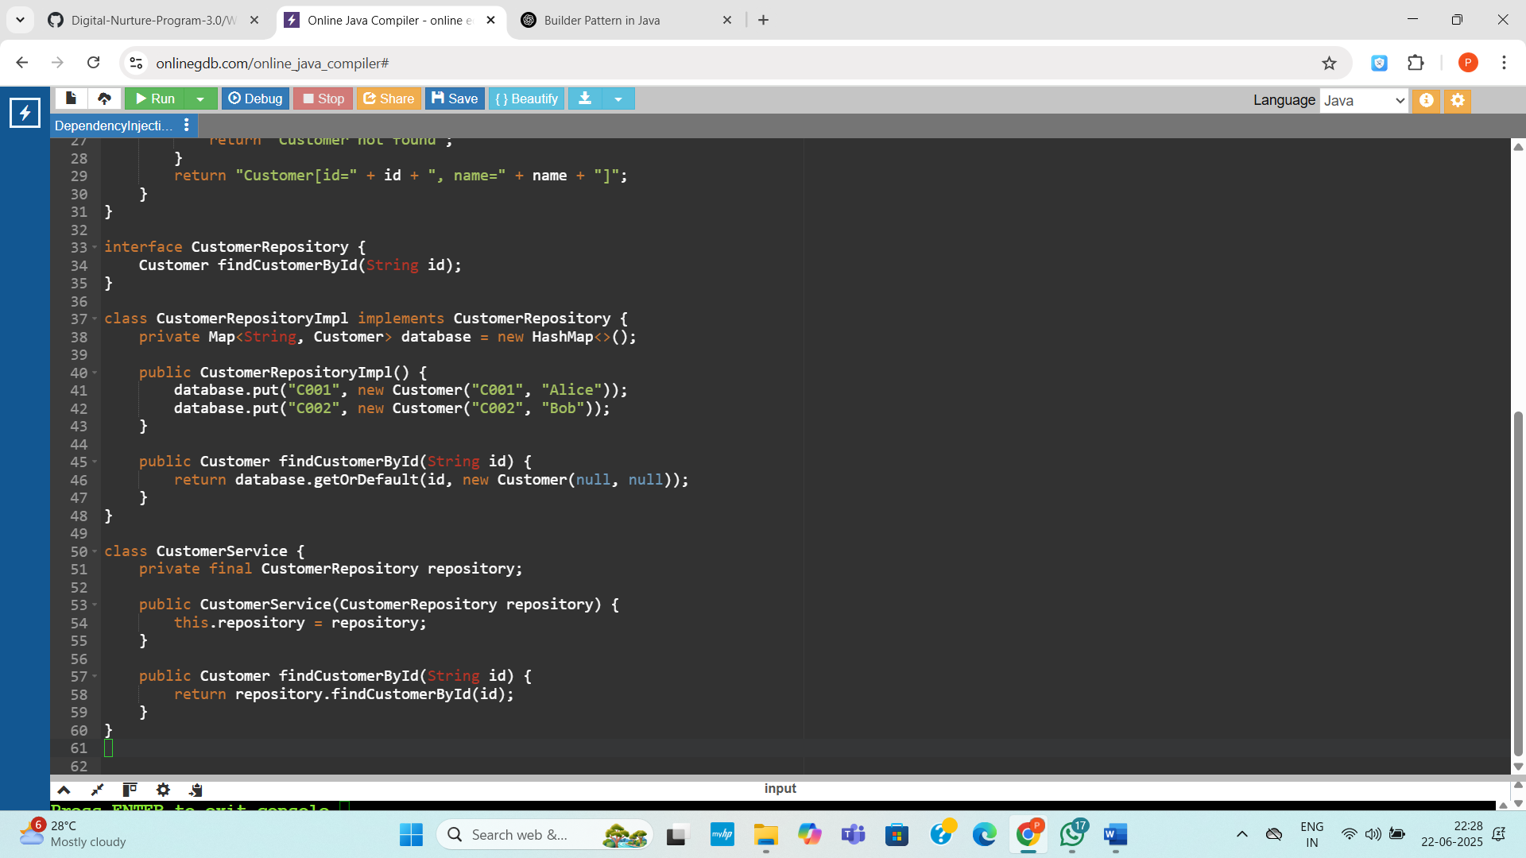

Output:
