Practical 2

Part 1: The Prisoner’s Dilemma

Question 1
The act() method takes a list of observations for each agent, and following the epsilon-greedy strategy, it samples a random action based on a % of times controlled by epsilon, which decays over time. Otherwise it computes the greedy action that obtains the highest Q value in the learned Q-tables.
The learn() method implements the Independent Learning algorithm, which updates the Q table based on the agent experience acting on itself.

Question 3
Since for both agents the dominant strategy is defecting, we can see how the returns for both quickly stabilize at -3 (the reward given when both agents defect). (Figure 1). Figure 2 shows the Q value for each action (left vs right) for each agent (top vs bottom). For action 0 (cooperate), Q becomes -5 for both agents, while action 1 (defect), Q becomes -3, so a better value. The red dashed line represents the best case scenario, if the other agent played the best move for the current agent.

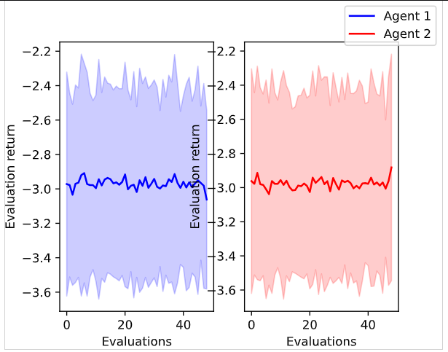
Figure 1: Evaluation Returns for IQL

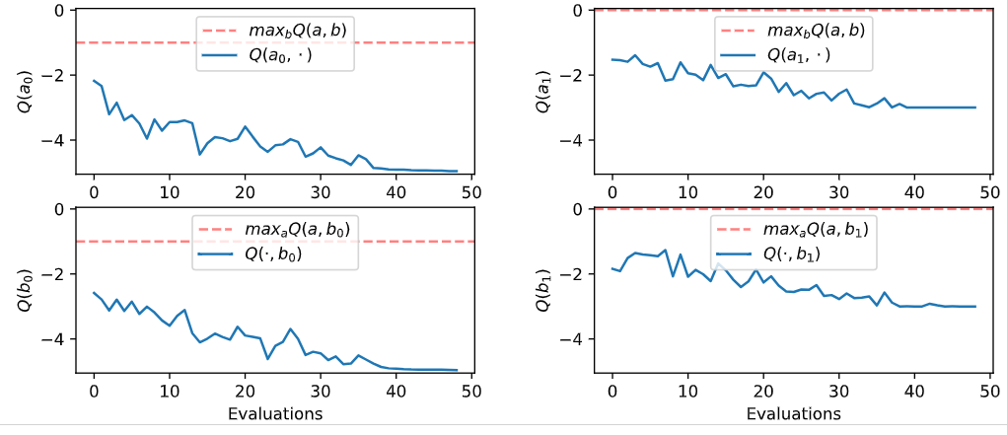
Figure 2: Q convergence for IQL

The solution concept we can identify is the Nash Equilirbium, since no agent can improve their reward by changing their action alone.

Question 4
In this case, both agents converge to the action of cooperating, which corresponds to a return of -1 for both, as seen in Figure 4. Since in this case we optimize for the sum of rewards, the agent doesn’t see that it could get a better individual reward by defecting while the other cooperates, but instead it optimizes the reward for both. As seen in Figure 5, this sum is reflected in the learned Q values, where the higher Q is for when both cooperate and get -1 reward each (a total of -2).
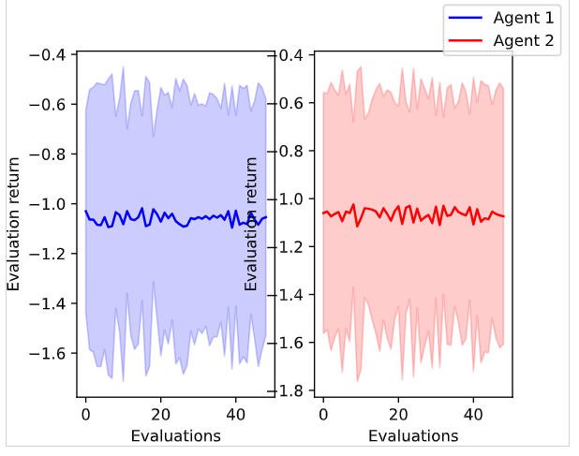
Figure 4: Evaluation Returns for CQL

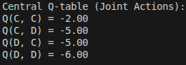
Figure 5: Central Q-table

The solution concept we can identify is the Pareto Optimality. This means there is no other outcome where both agents can be better, which is different from the Nash equilibrium we had before, which refered to the individual agent gain.

