CPE334 Lab 4 Final Submission Package
Course: CPE 334 Software Engineering — Lab 4 (Sprint 4)
Student Name: Pilaiwan Churdchu • Student ID: 67070503492 • GitHub:@Pilaiwan3492
Peer Reviewer: Aphichaya Klinhual • Student ID: 67070503447 • GitHub:@Apichaya251400
Author Repository:https://github.com/Pilaiwan3492/TokTickIT
Partner Repository:https://github.com/Apichaya251400/TokTickIT
Target Release:lab4-staging → main • Release PR: #91

Answer Part 1: Git Use with Engineering Workflow

1.1 Git Commit History & Branching Model
The TokTickIT engineering workflow strictly enforces isolated feature branching: feature/* → lab4-staging → main. Every feature branch corresponds to an authorized GitHub Issue, includes automated unit and integration tests, passes peer review by @Apichaya251400, and is merged to staging before final release:
* 9c7c941 (origin/lab4-staging, lab4-staging) Merge pull request #90 from feature/38-playwright-e2e-responsive |\ | * 4e24bad docs(test): add E2E-10 scope note and align Ticket 8 seed comment (#38) | * 18f3513 fix(e2e): align tablet viewport to 768px per AC-23 specification (#38) | * 996b223 feat(e2e): add resolution gate modal, link touch target checks, visual layer separation (#38) | * 5996566 feat(e2e): implement Lab 4 Playwright test suites and responsive visual evidence (#38) |/ * aed679f Merge pull request #89 from feature/37-dashboard-react-frontend |\ | * 334c89b test: verify dashboard metric counts against filtered queues and update test checklist (#37) | * c587ba7 Resolve Lab 4 test documentation merge conflict | * 0bc8891 test(e2e): verify keyboard Tab traversal to target link without programmatic focus (#37) | * fe36ade test(e2e): add keyboard Tab navigation and visible focus ring E2E tests (#37) | * d544681 test(e2e): add dashboard drill-down E2E tests, requester empty-state tests (#37) |/ * 746092b Merge pull request #87 from feature/36-dashboard-backend-sql

1.2 GitHub Project Kanban Board
All 10 Lab 4 Issues (Issues #30 through #39 / GitHub #72 through #81) have been executed and moved to the Done column:
Sprint Issue | GitHub Ref | Scope / Deliverables | Feature Branch | Kanban Status
Issue 30 | #72 | Project Setup, Baseline Environment & Lab 4 Planning | feature/30-project-setup | Done
Issue 31 | #73 | Sprint 4 Specification, Contracts & Planned Test Catalog | feature/31-specification-test-plan | Done
Issue 32 | #74 | Database Schema Migration, Idempotent Seed & Compatibility | feature/32-schema-migration-seed | Done
Issue 33 | #75 | Actions Taken Backend REST API & Concurrency Control | feature/33-actions-taken-backend-api | Done
Issue 34 | #76 | Ticket Lifecycle State Machine & Resolution Gate API | feature/34-ticket-workflow-resolution-gate-api | Done
Issue 35 | #77 | Actions Taken Frontend React Section, Modals & Visual Fidelity | feature/35-actions-taken-frontend-react | Done
Issue 36 | #78 | Role Dashboards Backend SQL Aggregation API | feature/36-dashboard-backend-sql | Done
Issue 37 | #79 | Role Dashboards React Frontend UI & Drill-Down Navigation | feature/37-dashboard-react-frontend | Done
Issue 38 | #80 | Playwright E2E Multi-Device Testing & Visual Inspection | feature/38-playwright-e2e-responsive | Done
Issue 39 | #81 | Final Product Hardening, Full Regression & Submission Package | feature/39-final-regression-submission | Done

1.3 Rendered Peer Review Record
Review Document Link:docs/lab-04/reviewer.md
Documents the bi-directional code review records between Author Pilaiwan Churdchu (@Pilaiwan3492) and Peer Reviewer Aphichaya Klinhual (@Apichaya251400) for PRs #82 through #91. Includes reviewer feedback, technical revisions (e.g. keyboard Tab traversal without synthetic focus, tablet viewport alignment to 768px, seed data consistency), and formal approvals.

1.4 README.md and .gitignore Content Evidence
The repository root contains updated README.md with comprehensive Sprint 4 feature descriptions, live seed account credentials (Alice, Bob, David, Carol, Eve), test execution instructions, and complete .gitignore rules.

1.5 Repository Directory Structure
Modular full-stack architecture separated into client/ (React 18 + Vite), server/ (Express + Prisma ORM), e2e/ (Playwright test suites), artifacts/lab-04/ (screenshot artifacts), and docs/lab-04/ (engineering specifications).

Answer Part 2: Spec DD
Specification Document Link:docs/lab-04/specification.md

1. Requirements Decomposition & Coverage
The engineering specification establishes 20 Functional Requirements (FR-01..20), 19 Business Rules (BR-01..19), and 25 Acceptance Criteria (AC-01..25) in Given-When-Then format.

Permitted Status Transition Matrix (18 Valid Transitions):
Current Status | Permitted Next Statuses | Lifecycle Invariant Enforced
NEW | OPEN, CANCELLED | Cannot jump directly to RESOLVED or CLOSED
OPEN | IN_PROGRESS, WAITING_FOR_REQUESTER, RESOLVED, CANCELLED | Can transition to Resolution Gate
IN_PROGRESS | WAITING_FOR_REQUESTER, RESOLVED, CANCELLED | Active staff work transition
WAITING_FOR_REQUESTER | IN_PROGRESS, RESOLVED, CANCELLED | Awaiting user feedback
RESOLVED | CLOSED, REOPENED | Resolution Gate gatekeeper; can close or reopen
REOPENED | IN_PROGRESS, WAITING_FOR_REQUESTER, RESOLVED, CANCELLED | Resumes active operational handling
CLOSED | (None — Terminal State) | Immutable; action logging and status updates locked
CANCELLED | (None — Terminal State) | Immutable; action logging and status updates locked

2. Specification Existence Evidence Prior to Implementation
$ git log --format="Commit: %h | Date: %ad | Message: %s" --date=iso -- docs/lab-04/specification.md Commit: 57d6d56 | Date: 2026-10-04 23:02:07 +0700 | Message: docs(issue-30): sprint 4 engineering specification, ui-spec, and api-spec contracts
Commit 57d6d56 proves that the specification existed and was approved on 2026-10-04, prior to database migrations (PR #83), Actions Taken API development (PR #84), and dashboard UI implementations (PRs #86–#89).

Answer Part 3: Test DD and Traceability
Test Catalog Link:docs/lab-04/tests.md

Dual Traceability Matrix Summary Excerpt
Test ID | Level | Ref | Test Description | Automated Test File | Status
API-01 | API | AC-01 | Create Action Taken auto-attributes performedById | server/tests/lab-04/actions-taken.api.test.ts | Pass
API-02 | API | AC-02 | Mandatory follow-up note validation | server/tests/lab-04/actions-taken.api.test.ts | Pass
API-03 | API | AC-03 | Requester forbidden from creating Actions Taken | server/tests/lab-04/actions-taken.api.test.ts | Pass
API-06 | API | AC-07 | Action logging locked on CLOSED/CANCELLED tickets | server/tests/lab-04/actions-taken.api.test.ts | Pass
API-07 | API | BR-17 | Stale expectedTicketUpdatedAt returns HTTP 409 | server/tests/lab-04/actions-taken.api.test.ts | Pass
API-13 | API | AC-08 | Complete 18 permitted status transition matrix | server/tests/lab-04/ticket-workflow.api.test.ts | Pass
API-13b | API | AC-08 | Valid Resolution Gate transition to RESOLVED | server/tests/lab-04/ticket-workflow.api.test.ts | Pass
API-15 | API | AC-10 | Requester advisory "Problem Appears Resolved" flag | server/tests/lab-04/ticket-workflow.api.test.ts | Pass
API-23 | API | AC-15 | Requester Dashboard returns authoritative counts | server/tests/lab-04/requester-dashboard.api.test.ts | Pass
API-27 | API | AC-17 | Staff Dashboard returns 6 operational metrics | server/tests/lab-04/staff-dashboard.api.test.ts | Pass
UI-01 | UI | AC-01 | "Add Action Taken" button rendered for IT Staff | client/tests/lab-04/ActionsTakenSection.test.tsx | Pass
UI-09 | UI | AC-08 | Status dropdown displays permitted next statuses | client/tests/lab-04/TicketWorkflow.test.tsx | Pass
UI-13 | UI | AC-12 | Stale-update HTTP 409 conflict banner & retry | client/tests/lab-04/TicketWorkflow.test.tsx | Pass
UI-16 | UI | AC-15 | Requester Dashboard renders 4 primary metric cards | client/tests/lab-04/RequesterDashboard.test.tsx | Pass
UI-18 | UI | AC-17 | Staff Dashboard renders 6 operational cards | client/tests/lab-04/StaffDashboard.test.tsx | Pass
E2E-01 | E2E | AC-01 | Staff creates & edits Action Taken; double-click guard | e2e/lab-04/actions-taken-flow.spec.ts | Pass
E2E-04 | E2E | AC-08 | Full Resolution Gate flow: Advisory → Formal | e2e/lab-04/ticket-resolution.spec.ts | Pass
E2E-06 | E2E | AC-12 | Concurrent edit collision triggers 409 conflict | e2e/lab-04/ticket-resolution.spec.ts | Pass
E2E-07 | E2E | AC-15 | Requester Dashboard journey & drill-down filters | e2e/lab-04/dashboards.spec.ts | Pass
E2E-08 | E2E | AC-17 | Staff Dashboard journey & Queue drill-down filters | e2e/lab-04/dashboards.spec.ts | Pass
E2E-10 | E2E | AC-21 | Full regression suite across Labs 1, 2, and 3 | e2e/lab-04/regression.spec.ts | Pass

Clean Execution Summary (547 / 547 Passed — 100% Pass Rate)
- Server Unit, API & Migration Tests: 22 test files, 309 passed, 0 failed
- Client Component & Style Tests: 22 test files, 181 passed, 0 failed
- Playwright Multi-Device E2E: 4 test files across Desktop, Tablet, and Mobile, 57 passed
- Total Automated Test Battery:547 / 547 Passed (100%)

Answer Part 4: AI Use with Reflection
AI Documentation Link:docs/lab-04/ai-use.md
Primary Model: Google Gemini (Gemini 2.5 Flash / Pro via Antigravity Agent).

Key Prompts Summary (Selected 9 Prompts)
- Sprint 4 Contract Decomposition: Formalized 20 FRs, 19 BRs, 25 ACs, 18-transition matrix, and optimistic concurrency.
- Planned Test Catalog & Traceability: Established dual AC/BR matrices mapping to unit, API, UI, and E2E tests.
- Database Migration & Seeding: Modeled ActionTaken in Prisma, maintained backward compatibility, and seeded 8 statuses.
- Actions Taken REST API: Built REST endpoints with RBAC, follow-up validation, and timestamp concurrency.
- Ticket Workflow & Resolution Gate: Developed 18-transition state validator and advisory resolution indicator.
- Actions Taken Frontend & Visual Polish: Created React section with Zen Green styling, Amber pills, and form preservation.
- Role Dashboards SQL API & Frontend: Developed SQL aggregations (< 300ms) and responsive metric cards.
- Playwright Multi-Device E2E Suite: Verified Desktop, Tablet, and Mobile with 24 screenshots and zero horizontal overflow.
- Full Regression Suite across Labs 1–3 (E2E-10): Proved 100% backward compatibility with zero legacy regressions.

My Reflection on AI Use
Developing TokTickIT Lab 4 with an AI coding partner demonstrated the great power of Specification-Driven Development (Spec DD). When rigorous constraints and state machine matrices were provided upfront, the AI agent executed complex full-stack features with remarkable velocity, maintaining 100% test coverage across 547 tests without legacy regressions.
Crucially, human engineering oversight remained irreplaceable in concurrency modeling and authentic accessibility. In optimistic concurrency, human analysis ensured that adding an Action Taken checked the parent ticket's updatedAt timestamp, preventing race conditions where work was logged against concurrently closed tickets. Similarly, peer review challenged synthetic .focus() calls in keyboard tests, directing the transition to real sequential Tab traversal. AI empowers rapid execution, but human engineers remain the essential architects of system reliability.

Answer Part 5: Working IT Staff Dashboard UI

1. IT Staff Dashboard Across Viewports
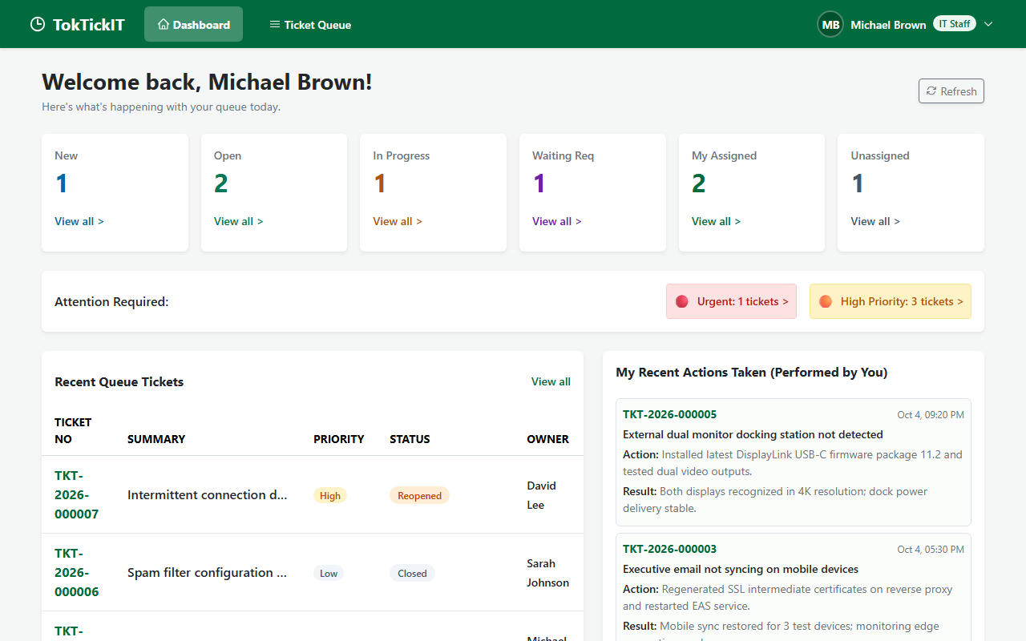
Figure 5.1: Desktop Viewport (1280 × 800) — 6 operational metric cards, Priority Attention strip, and My Recent Actions table.
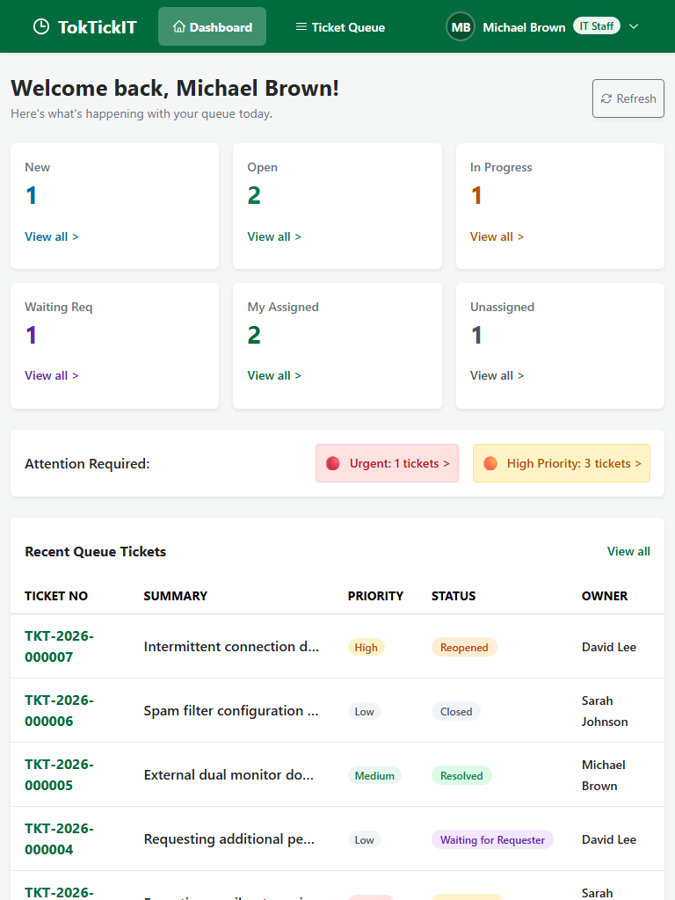
Figure 5.2: Tablet Viewport (768 × 1024) — 2-column responsive grid conforming to AC-23.
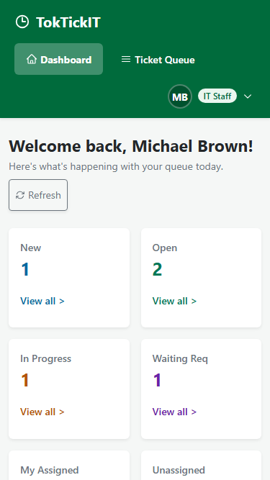
Figure 5.3: Mobile Viewport (375 × 667) — 1-column stacked cards with ≥ 44px touch targets.

2. Operational Metrics & Priority Strip
Displays 6 primary operational metric cards (New, Open, In Progress, Waiting for Requester, My Assigned, Unassigned) plus the Priority Attention strip highlighting urgent and high tickets requiring immediate attention.

3. Drill-Down Filter Navigation
Clicking any metric card immediately navigates to /staff/tickets with the corresponding status or ownership filter active.

4. Database Query Parity
All metrics are computed via backend SQL aggregations (Prisma groupBy and count) ensuring exact parity with queue queries without N+1 overhead.

Answer Part 6: Working Actions Taken UI

1. Actions Taken List on Ticket Detail
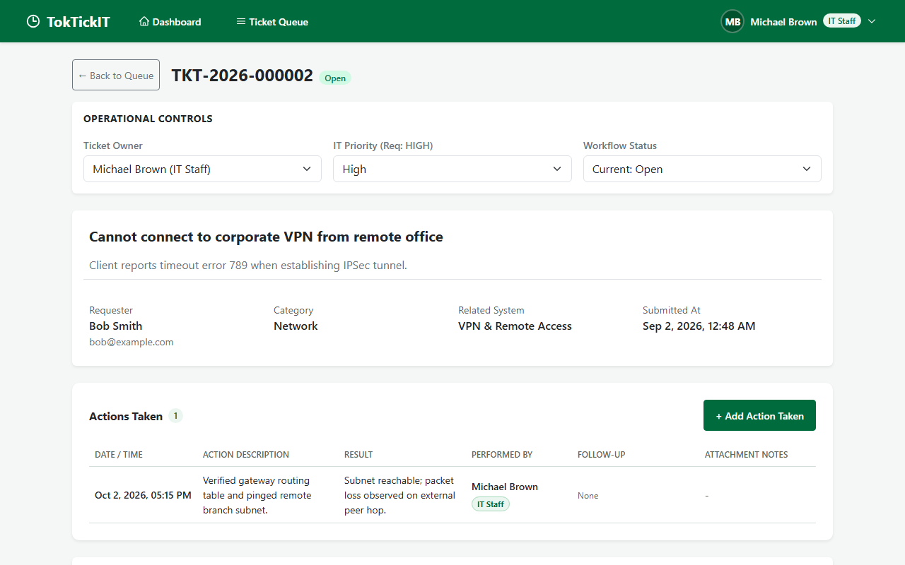
Figure 6.1: Actions Taken section on Desktop (1280 × 800) with chronological entries and contributor badges.
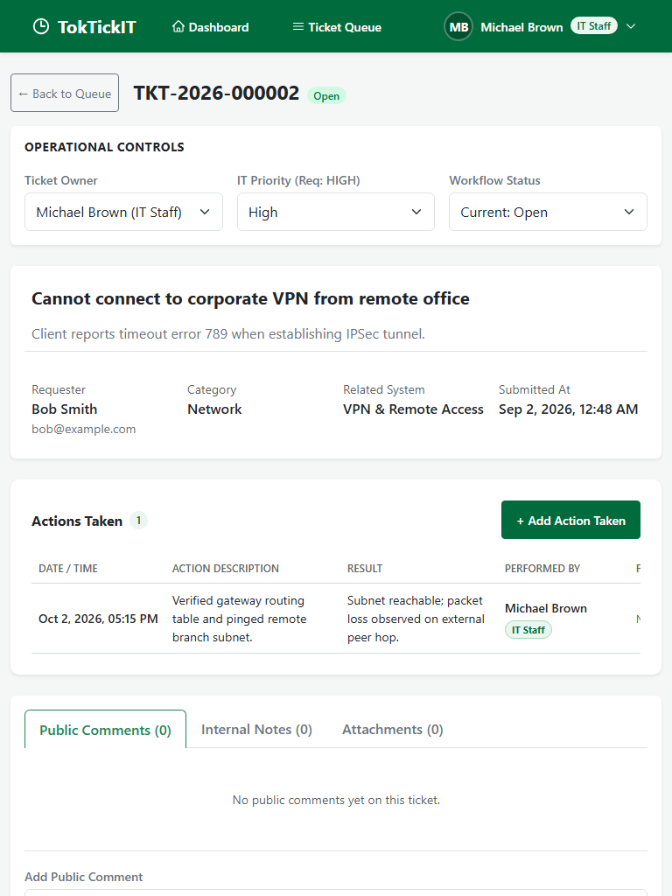
Figure 6.2: Actions Taken section on Tablet viewport (768 × 1024).
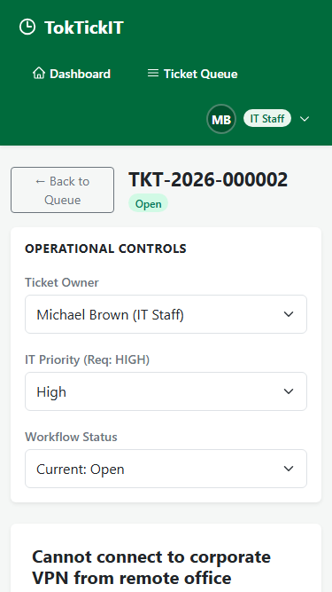
Figure 6.3: Actions Taken section on Mobile viewport (375 × 667) with full touch-target compliance.

2. Create/Edit Action Taken Modal
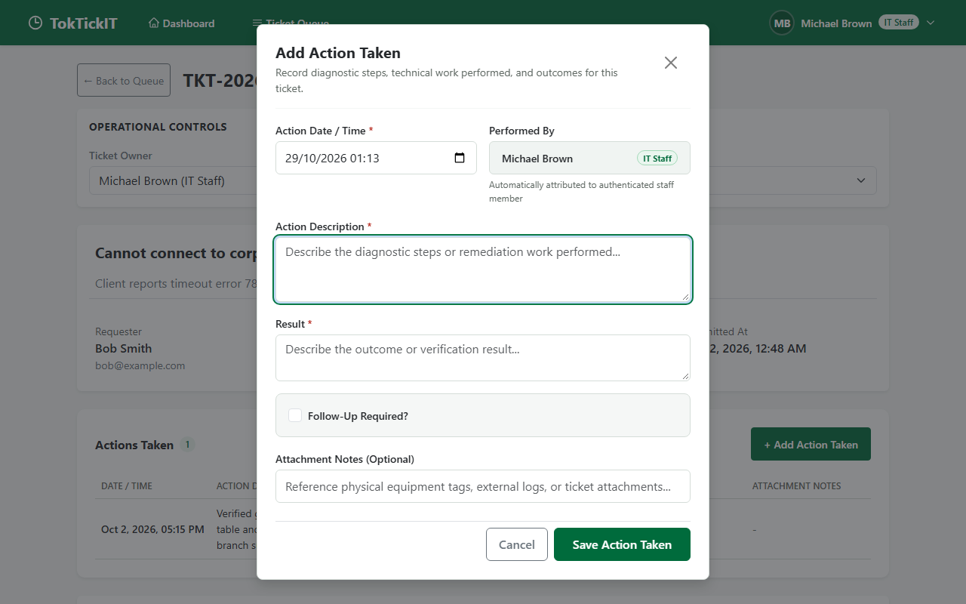
Figure 6.4: Modal overlay with read-only Performer auto-attribution and follow-up validation.
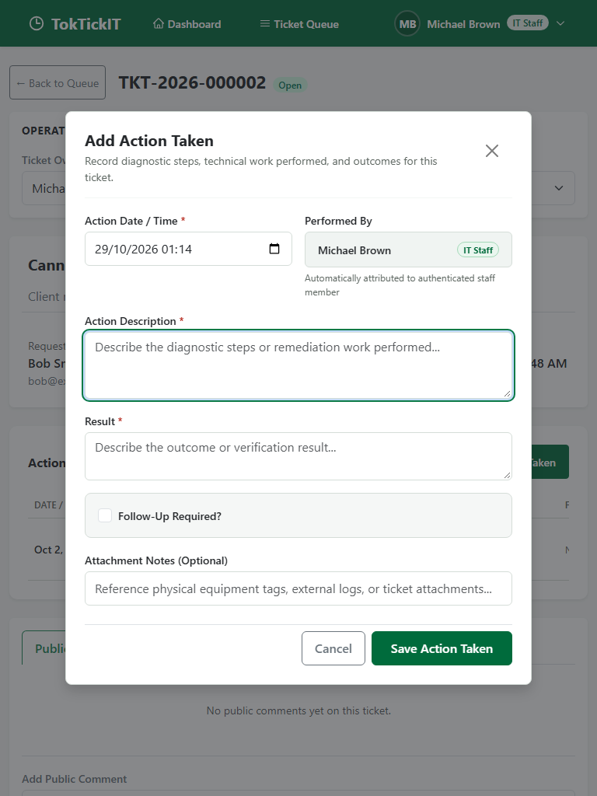
Figure 6.5: Action Taken Modal on Tablet viewport.
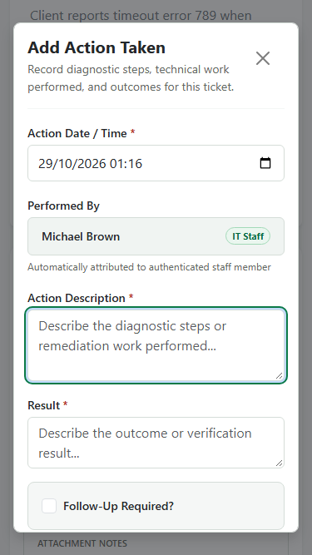
Figure 6.6: Action Taken Modal on Mobile viewport.

3. Mandatory Follow-up Validation & Amber Pill
Follow-up Invariant (BR-05 / VIS-02):
When "Follow-up Required" is checked, a non-empty note is strictly mandatory. Saved actions render a distinct Amber badge (
#D97706
/
#FEF3C7
).

4. Requester Read-Only Visibility & Terminal Lock
Requesters see Actions Taken in read-only mode without write buttons. Closed and Cancelled tickets lock further action logging.

Answer Part 7: Working Ticket Workflow

1. Resolution Gate & Status Dropdown
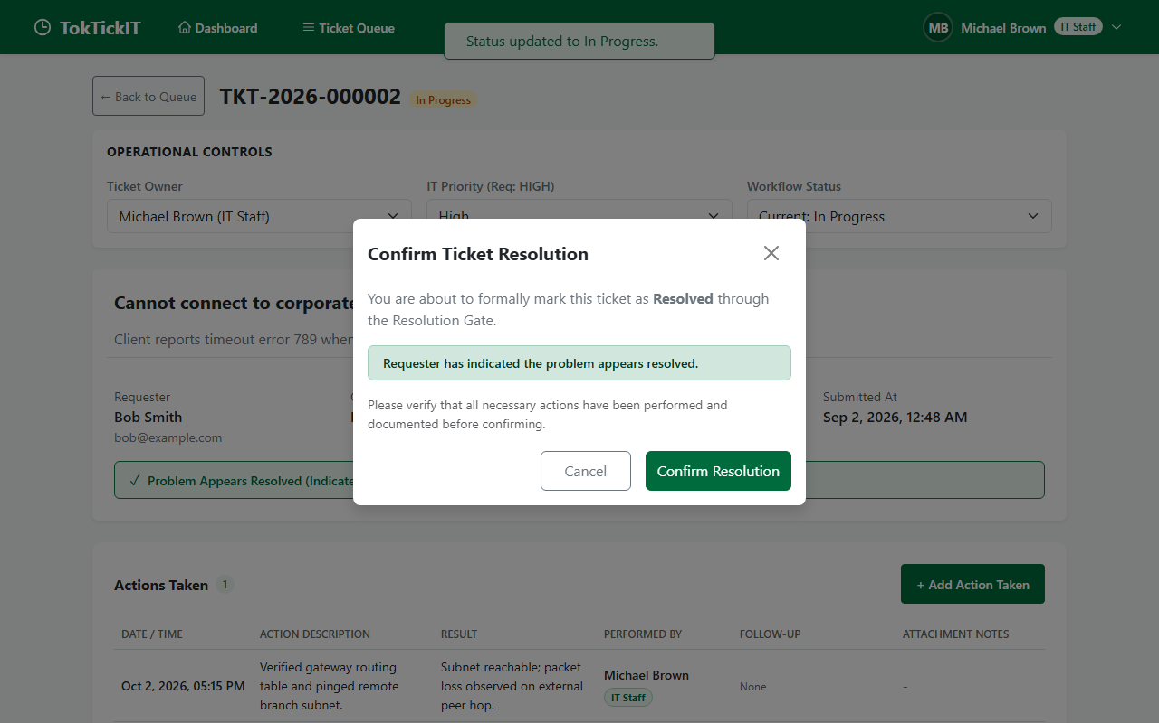
Figure 7.1: Status dropdown restricted to permitted next choices and Resolution Gate confirmation dialog.
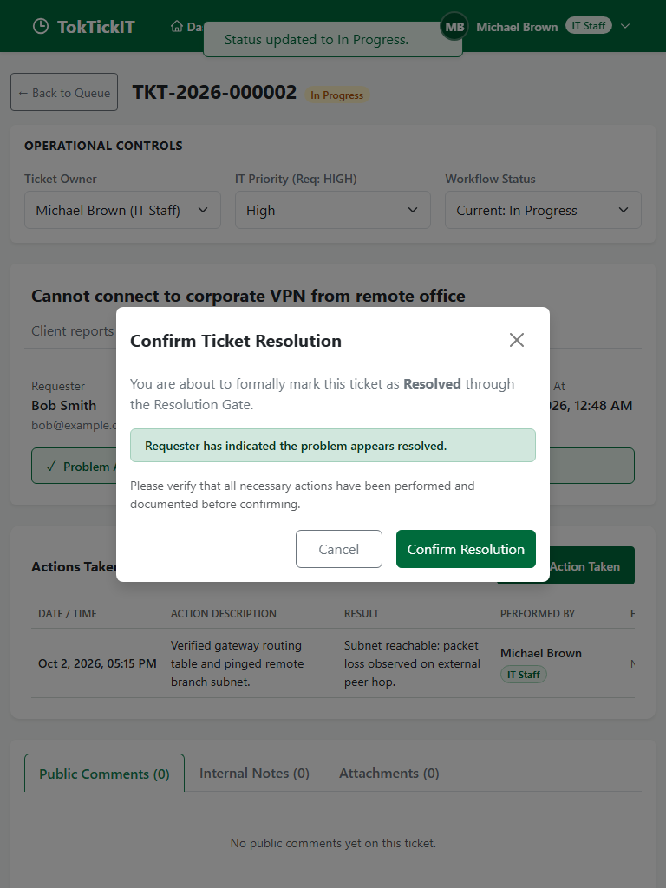
Figure 7.2: Resolution Gate controls on Tablet viewport.
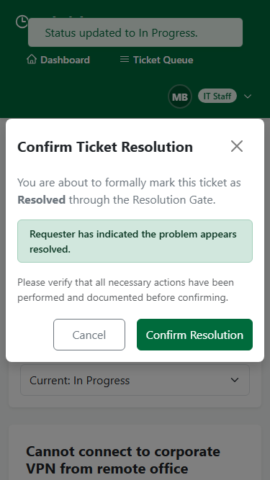
Figure 7.3: Resolution Gate controls on Mobile viewport.

2. Requester Advisory Resolution Indicator
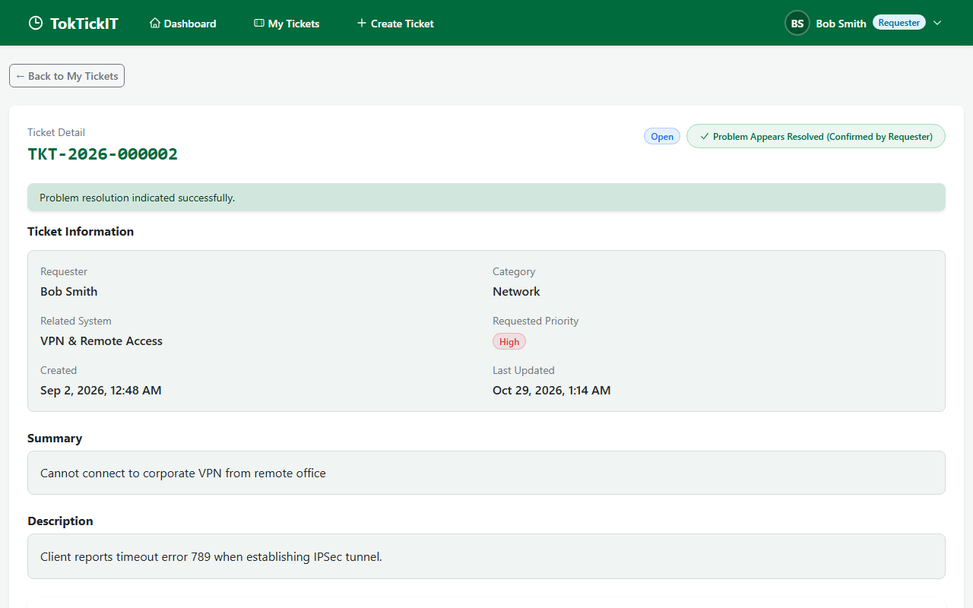
Figure 7.4: Requester indicates "Problem Appears Resolved" — sets advisory flag without altering official status.
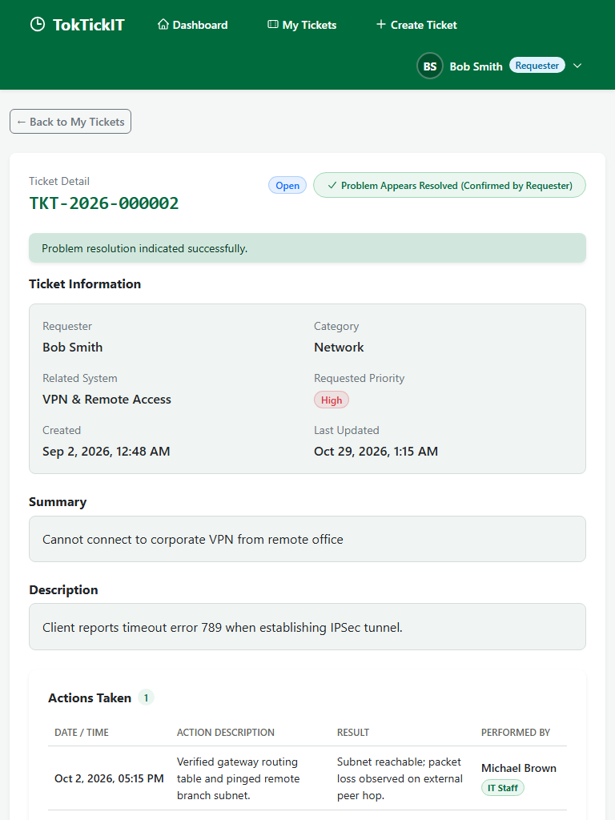
Figure 7.5: Advisory resolution banner on Tablet viewport.
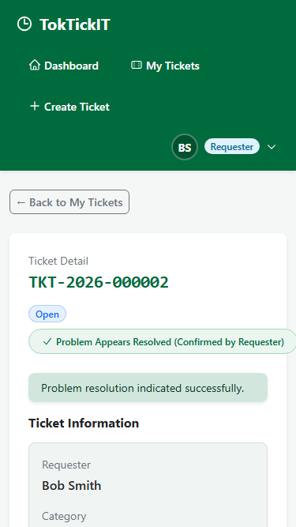
Figure 7.6: Advisory resolution banner on Mobile viewport.

3. Optimistic Concurrency Conflict Banner (HTTP 409)
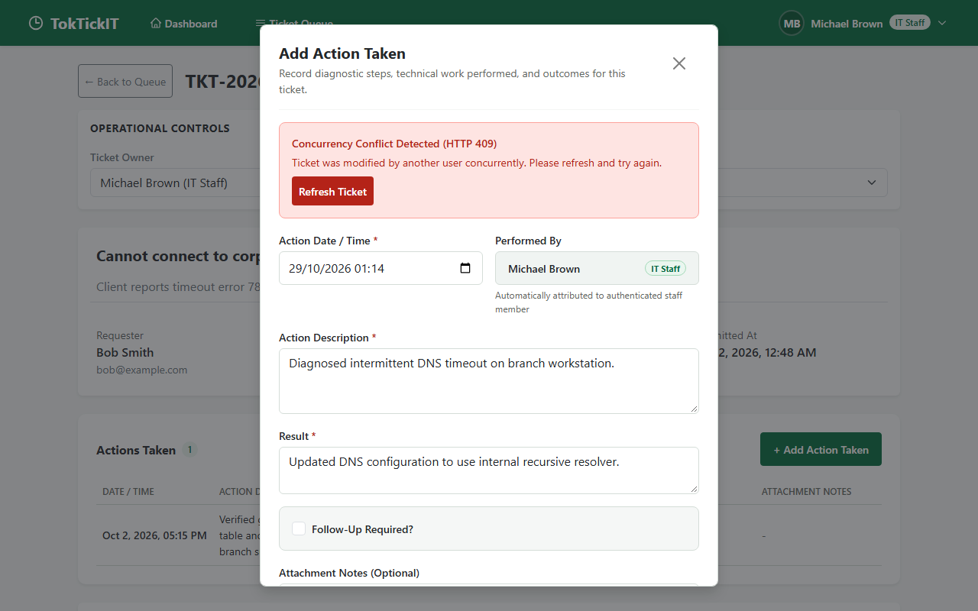
Figure 7.7: Non-destructive conflict banner with "Refresh Ticket" CTA, preserving uncommitted inputs.
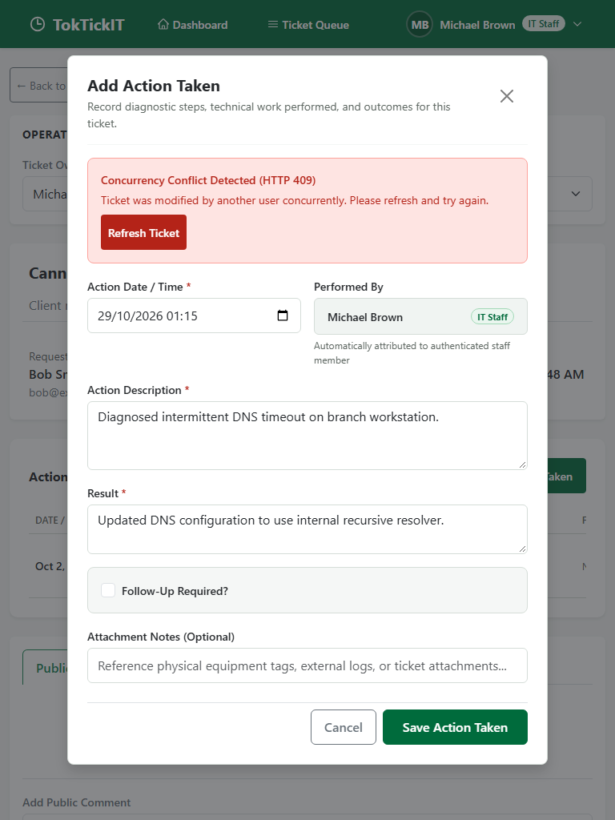
Figure 7.8: Concurrency conflict banner on Tablet viewport.
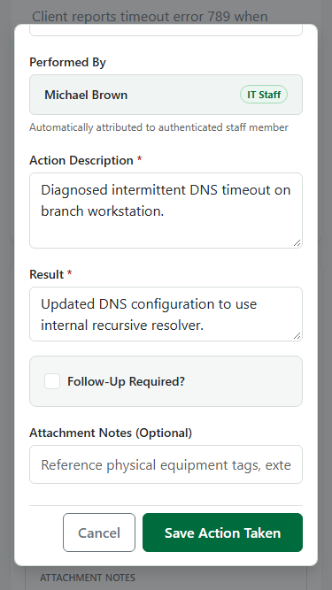
Figure 7.9: Concurrency conflict banner on Mobile viewport.

Answer Part 8: Working Requester Dashboard & Final Regression UI

1. Requester Dashboard Across Viewports
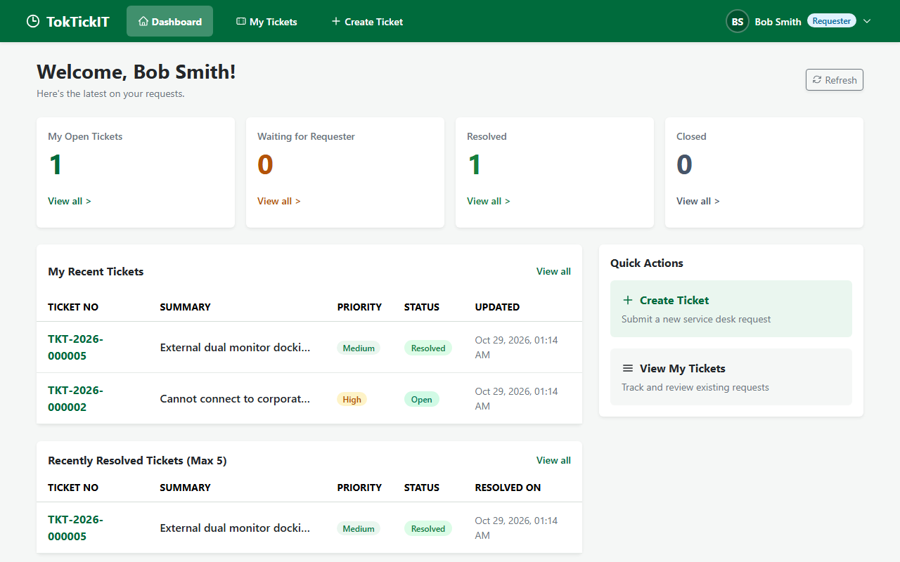
Figure 8.1: Requester Dashboard on Desktop (1280 × 800) with 4 primary metric cards and Recent Tickets table.
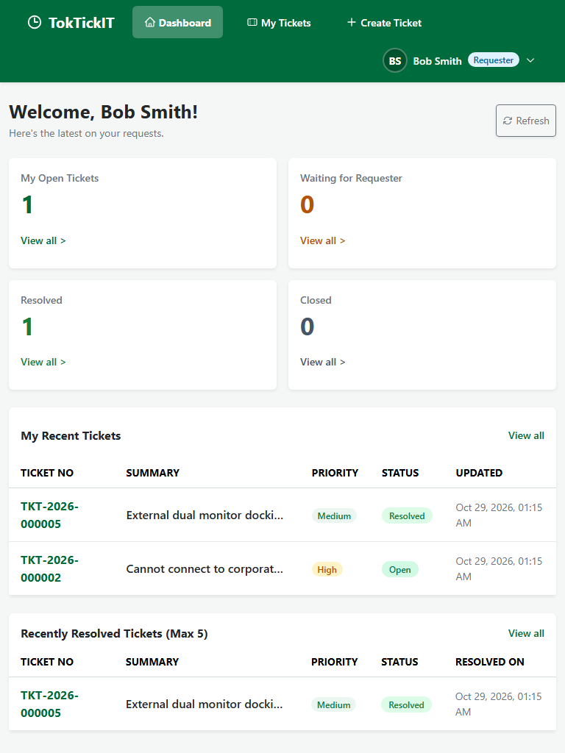
Figure 8.2: Requester Dashboard on Tablet viewport (768 × 1024).
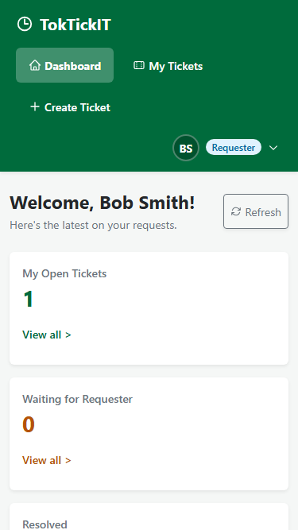
Figure 8.3: Requester Dashboard on Mobile viewport (375 × 667).

2. Administrator Dashboard System User Metrics
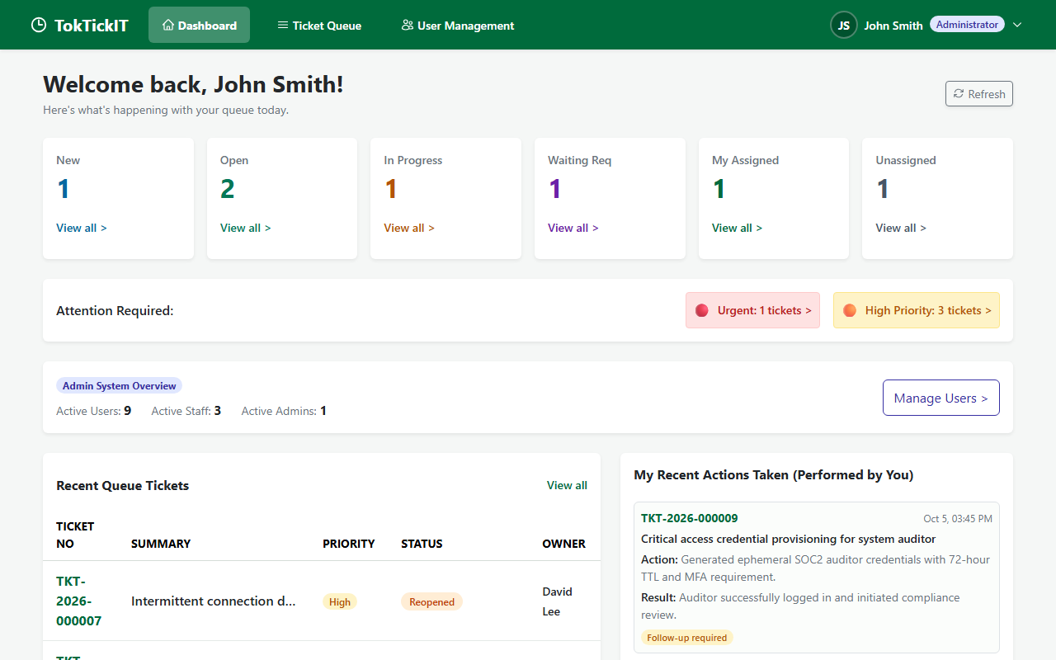
Figure 8.4: Administrator Dashboard displaying staff operational metrics plus System User Accounts summary.
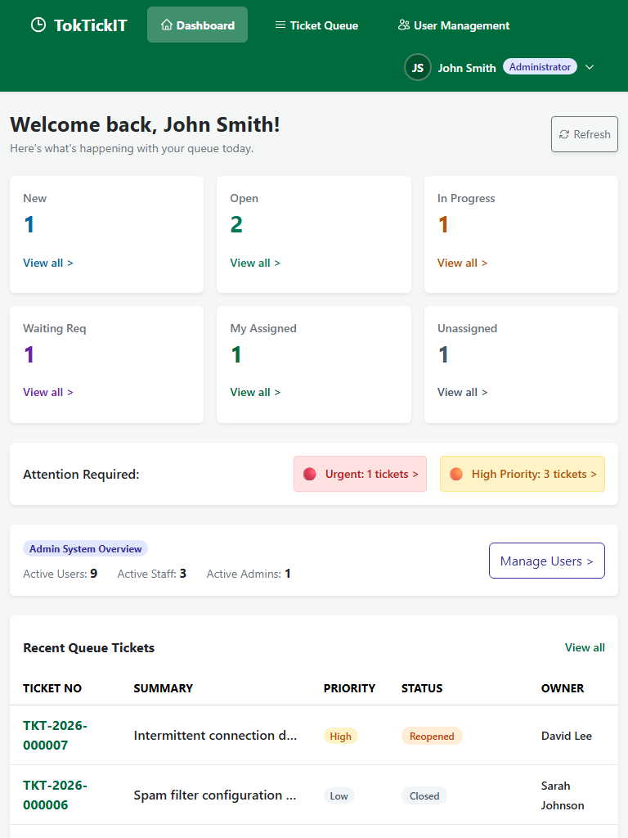
Figure 8.5: Administrator Dashboard on Tablet viewport.
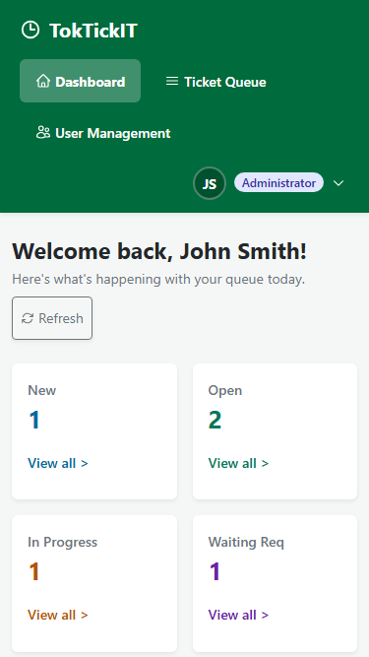
Figure 8.6: Administrator Dashboard on Mobile viewport.

3. Full Regression Suite across Labs 1–3 (E2E-10)
Automated test suite e2e/lab-04/regression.spec.ts executes 12 multi-viewport regression scenarios covering Lab 1 (health check, categories), Lab 2 (requester creation, My Tickets, detail, attachments), and Lab 3 (auth, forced password change, queue claiming, comments, notes, admin safety) with 100% pass rate.

Answer Part 9: Zen Green UI, Responsive, Accessibility & Final Polish
UI Specification Link:docs/lab-04/ui-spec.md

Design Tokens & Invariant Compliance
- Zen Green Brand Tokens: Primary #006B3C, Hover #0B7A46, Tint #EAF6EF, Canvas #F5F7F6, White #FFFFFF.
- Amber Follow-up & Notes: Border #D97706, Surface #FEF3C7, Text #92400E.
- Editable vs. Readonly: White inputs (#FFFFFF) for active forms; soft gray-green (#F0F4F2) for read-only displays.

Completed Responsive Visual Checklist
Requirement | Inspection Standard | Verification Method | Compliance Status
Zero Horizontal Overflow (RESP-04) | scrollWidth ≤ innerWidth  across all devices | Automated  assertNoHorizontalOverflow() | Pass
Minimum Touch Targets (RESP-03) | Buttons/inputs ≥ 44 × 44px on tablet/mobile | Automated  assertMinimumTouchTargets() | Pass
Brand Color Tokens (VIS-01) | Strict adherence to #006B3C Zen Green | Automated CSS token assertions | Pass
Badge Semantic Contrast (VIS-02) | WCAG AA contrast for Role, Status, and Priority | Automated style tests in  ui-style.test.tsx | Pass
Visible Focus Rings (VIS-03) | Visible #0B7A46 focus outline on Tab navigation | Sequential Tab traversal in Playwright & RTL | Pass
Zero Text Clipping (VIS-04) | Natural word wrapping without truncation | E2E responsive multi-device assertions | Pass
Form State Preservation (BR-18) | Preserves inputs upon error or 409 conflict | Component tests in  ActionsTakenSection.test.tsx | Pass
Double-Click Protection (BR-19) | Disables submit button and shows spinner in-flight | E2E and component race condition tests | Pass

Complete 24 Screenshot Evidence Inventory
All 24 screenshot evidence artifacts captured across Desktop ($1280 \times 800$), Tablet ($768 \times 1024$), and Mobile ($375 \times 667$) are committed and verified under artifacts/lab-04/screenshots/.
TokTickIT • CPE334 Software Engineering • Lab 4 Final Submission Package

