作业1报告
- 题目内容
由于无法连接到谷歌，所以选择做天气预报：
1 使用Request 库解析json，得到天气预报
2 使用HTTP 连接，解析json 得到天气预报
3 使用底层socket编程，得到报文，解析成json,得到天气预报

- 开发过程
包括下面几部分：
      - 系统结构，C/S，通信过程（请求，应答）
      - 通信协议

- 系统测试
客户服务器测试的测试用例、流程及截图。(要求多一些测试用例)

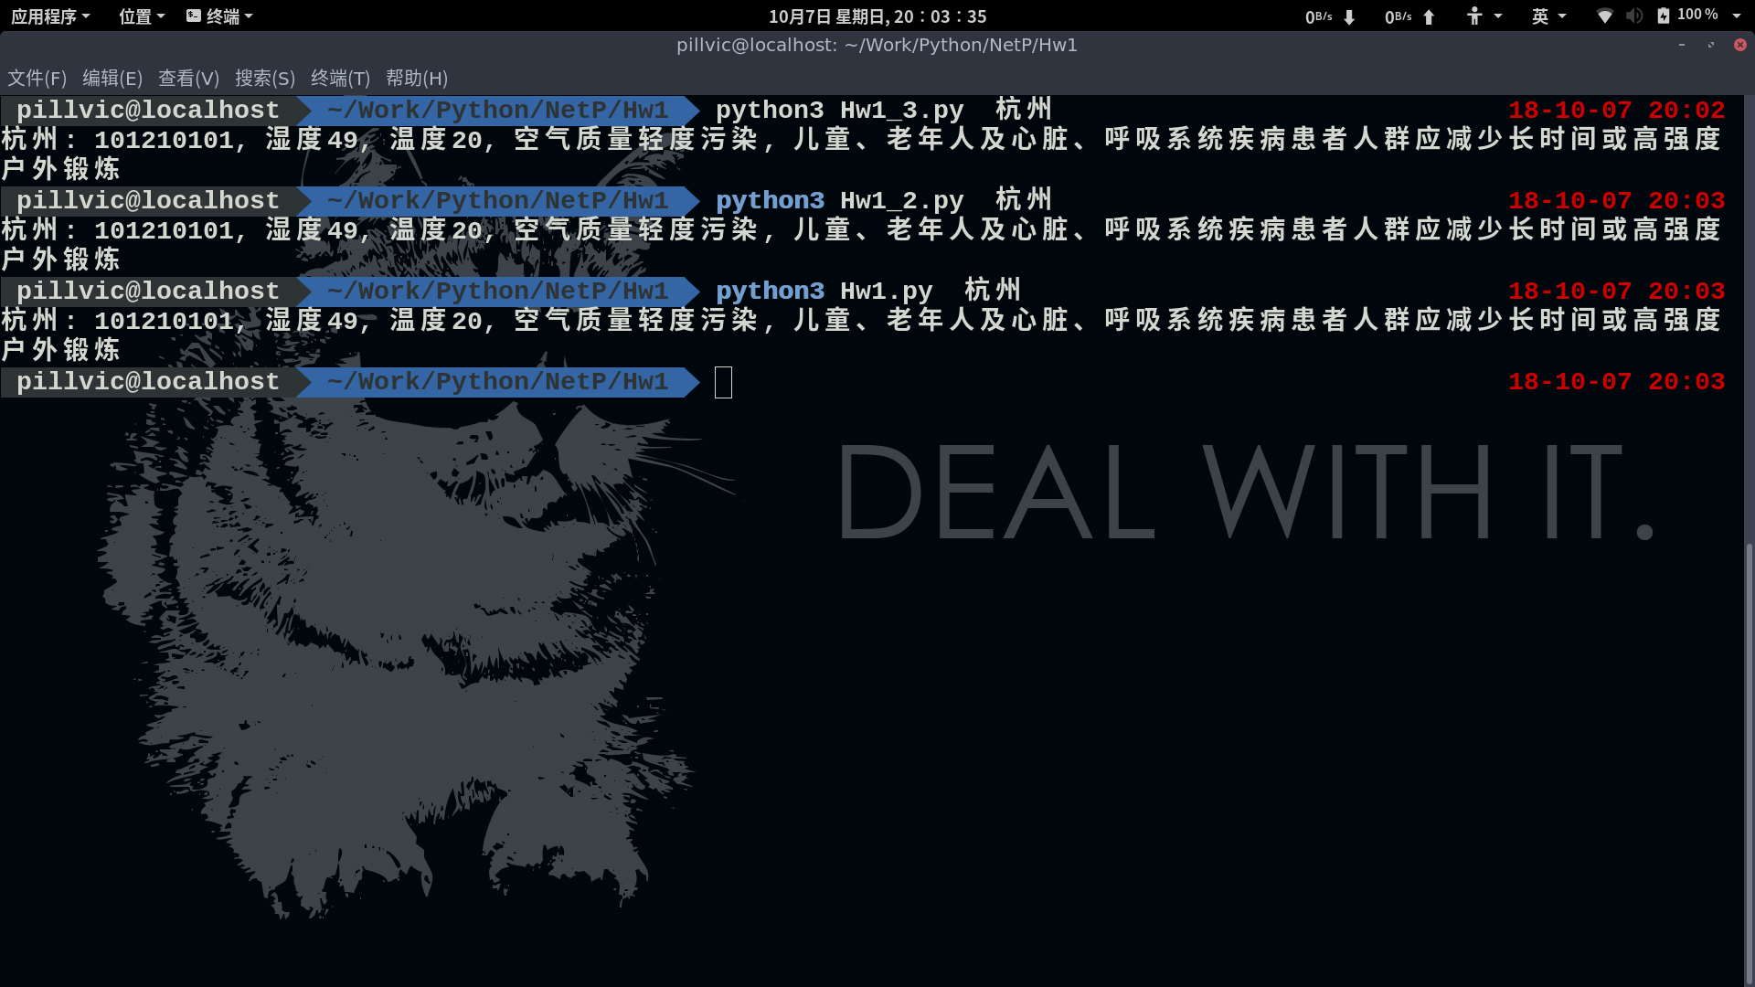
- 心得体会
在socket编程时，需要写一个GET报文，由于我不是很了解GET报文的写法，所以只能直接通过wireshark抓取了一个现成的报文，改成需要的内容。网络编程过程中，最重要的的是与网络相关的知识，编程的技巧只能起到辅助的作用，只有对网络具有良好的理解，才能编写出优秀的网络程序
- 源码
# HW1_3.py
#!/usr/bin/env python3
#-*- coding: utf-8 -*-

import sys
import requests
import socket
import json

def getCode(city):
#解析json文件得到指定城市的编号并返回
base = 'http://cdn.sojson.com/_city.json'
r = requests.get(base)
answer = r.json()
code = -1
for i in answer:
if i['city_name'] == city:
code = i['city_code']
break
return code

def getWeather(city):
s = socket.socket(socket.AF_INET,socket.SOCK_STREAM)
host = 't.weather.sojson.com'
s.connect((host , 80))
request = '''GET /api/weather/city/%s HTTP/1.1
Host: t.weather.sojson.com
User-Agent: Local Host
Accept: text/html,application/xhtml+xml,application/xml;q=0.9,*/*;q=0.8
Accept-Language: zh-CN,en-US;q=0.7,en;q=0.3
Cookie: _ga=GA1.2.77648417.1538467909; _gid=GA1.2.1865341186.1538824031
DNT: 1
Connection: keep-alive
Upgrade-Insecure-Requests: 1

''' % (getCode(city))
s.sendall(request.encode('ascii'))
rawReply = b''
while True:
more = s.recv(4096)
if not more:
break
rawReply += more
s.close()

reply = rawReply.decode('utf-8')
reply = reply[reply.find('{'):reply.rfind('}')+1]
jsonRes = json.loads(reply)
data = jsonRes['data']
return '%s: %s, 湿度%s, 温度%s, 空气质量%s, %s' % \
(city, getCode(city), data['shidu'][:-1], data['wendu'], data['quality'], data['ganmao'])

if __name__ == '__main__':
if len(sys.argv) == 2:
print(getWeather(sys.argv[1]))
else:
city = input('Please input the city:')
print(getWeather(city))

#HW1_2.py
#!/usr/bin/env python3
#-*- coding:utf-8 -*-

'''
使用http.client等库来获取天气信息
'''

import sys
import requests
import json
import http.client

def getCode(city):
#解析json文件得到指定城市的编号并返回
base = 'http://cdn.sojson.com/_city.json'
r = requests.get(base)
answer = r.json()
code = -1
for i in answer:
if i['city_name'] == city:
code = i['city_code']
break
return code
def getWeather(city):
code = getCode(city)
connection = http.client.HTTPConnection('t.weather.sojson.com')
connection.request('GET', '/api/weather/city/'+code)
rawreply = connection.getresponse().read()
reply = json.loads(rawreply.decode('utf-8'))
data = reply['data']
return '%s: %s, 湿度%s, 温度%s, 空气质量%s, %s' % \
(city, code, data['shidu'][:-1], data['wendu'], data['quality'], data['ganmao'])

if __name__ == '__main__':
if len(sys.argv) >=2:
print(getWeather(sys.argv[1]))
else :
city = input('Please input the city:')
print(getWeather(city))

#!/usr/bin/env python3
#-*- coding:utf-8 -*-

"""
使用Requests库获取天气信息
"""

import requests
import sys

def getWeather(city):
#根据城市名称查询API 并解析返回的JSON对象

#查询城市对应的内部编码
base = 'http://cdn.sojson.com/_city.json'
response = requests.get(base)
answer = response.json()
code = -1
for i in answer:
if i['city_name'] == city:
code = i['city_code']
break
if code == -1:
return 'City %s Not Found'%(city)
#根据内部编码找到对应城市的URL
base = 'http://t.weather.sojson.com/api/weather/city/'
response = requests.get(base+code)
answer = response.json()
#杭州：20180920，湿度95， 温度24， 空气质量优，各类人群可自由活动
data = answer['data']
return '%s: %s, 湿度%s, 温度%s, 空气质量%s, %s' % \
(city, code, data['shidu'][:-1], data['wendu'], data['quality'], data['ganmao'])

#以字符串形式返回
if __name__ == '__main__':
if len(sys.argv) >=2:
print(getWeather(sys.argv[1]))
else :
city = input('Please input the city:')
print(getWeather(city))

