TRAFFICSENSE: COOPERATIVE LLM AGENTS FOR TRAFFIC SIGNAL CONTROL ON INDIAN URBAN ROADS
A Project Report
submitted in partial fulfilment of the requirements for the award of the degree of
{{DEGREE}}
in
{{BRANCH}}
by
{{STUDENT_NAME_1}} ({{ROLL_NUMBER_1}})
{{STUDENT_NAME_2}} ({{ROLL_NUMBER_2}})
{{STUDENT_NAME_3}} ({{ROLL_NUMBER_3}})
Under the guidance of
{{GUIDE_NAME}}
{{GUIDE_DESIGNATION}}
{{COLLEGE_LOGO}}
{{DEPARTMENT}}
{{COLLEGE}}
{{UNIVERSITY}}
{{CITY}}
{{MONTH}} {{YEAR}}

Certificate
{{DEPARTMENT}}
{{COLLEGE}}
This is to certify that the project report entitled “TrafficSense: Cooperative LLM Agents for Traffic Signal Control on Indian Urban Roads” is a bonafide record of the work carried out by {{STUDENT_NAME_1}} ({{ROLL_NUMBER_1}}), {{STUDENT_NAME_2}} ({{ROLL_NUMBER_2}}) and {{STUDENT_NAME_3}} ({{ROLL_NUMBER_3}}) in partial fulfilment of the requirements for the award of the degree of {{DEGREE}} in {{BRANCH}} of {{UNIVERSITY}}, during the academic year {{ACADEMIC_YEAR}}, under my supervision.

{{GUIDE_NAME}} | {{HOD_NAME}}
{{GUIDE_DESIGNATION}} | Head of the Department
Project Guide | {{DEPARTMENT}}

External Examiner: ____________________ Date of viva voce: {{VIVA_DATE}}

Declaration
We declare that this project report, “TrafficSense: Cooperative LLM Agents for Traffic Signal Control on Indian Urban Roads”, is our own work, carried out under the guidance of {{GUIDE_NAME}}, {{GUIDE_DESIGNATION}}, {{DEPARTMENT}}, {{COLLEGE}}. It has not been submitted, in part or in full, for any other degree or diploma. Wherever the work of others is used, it is acknowledged and cited. Every number reported here was measured in our own experiments and can be regenerated from the result files in the project repository (Appendix C).

Place: {{PLACE}}
Date: {{DATE}}
{{STUDENT_NAME_1}} | {{STUDENT_NAME_2}} | {{STUDENT_NAME_3}}
{{ROLL_NUMBER_1}} | {{ROLL_NUMBER_2}} | {{ROLL_NUMBER_3}}

Acknowledgement
We thank our guide, {{GUIDE_NAME}}, {{GUIDE_DESIGNATION}}, for {{GUIDE_THANKS}}. We thank {{HOD_NAME}}, Head of the {{DEPARTMENT}}, and {{PRINCIPAL_NAME}}, Principal of {{COLLEGE}}, for the facilities and support of the department and the college. We thank the project review committee, {{REVIEW_COMMITTEE}}, for their questions and suggestions at each review.
We are grateful to the authors of CoLLMLight, whose open code made it possible to validate our simulator against theirs; to the CityFlow developers; to IIIT Hyderabad and Intel for the India Driving Dataset; and to the developers of Ultralytics YOLOv8 and Ollama.
{{PERSONAL_THANKS}}

Abstract
Signalised junctions in Indian cities carry a mixed stream of two-wheelers, auto-rickshaws, cars, buses and trucks, and many still run fixed signal plans. Large language models (LLMs) have recently been proposed as traffic-signal agents that can explain their choices and use extra information, such as an approaching ambulance. This project asks whether such agents, running a small model on a laptop GPU, can control signals as well as the best classical method, and how they cope with vehicle counts from a real camera detector instead of exact simulator counts.
We built TrafficSense on the CityFlow simulator and validated it against the CoLLMLight authors’ own code, whose baseline results it reproduces to within the simulator’s own run-to-run noise; along the way we found a bug in their fixed-time baseline. We built a 2x2 network with an Indian vehicle mix, calibrated its demand, and tuned MaxPressure and a Webster fixed-time plan before any LLM run. The LLM controller, its selection rule and the experiment plan were fixed in advance (pre-registration).
The selected controller, llama3.2:3b guided and guarded by MaxPressure, matched MaxPressure’s average travel time to within 0.5–0.9% but did not improve on it. With ambulances listed in its prompt, their mean travel time fell from 130.1 s to 88.9 s, close to rule-based preemption (81.2 s), at no measurable cost to other traffic. A YOLOv8n detector trained on the India Driving Dataset reached mAP50 0.563 on held-out drives. Feeding its measured errors into the controllers’ counts raised MaxPressure’s travel time by 2.3–4.8%, mainly through false detections, while the fixed-time plan was unaffected. An exploratory study found that 3 B models make the guided controller much worse, and larger models only bring it back to MaxPressure’s level. An LLM agent is therefore best used as a safe layer that adds context MaxPressure cannot use, not as its replacement.
Keywords: traffic signal control, large language models, multi-agent systems, MaxPressure, emergency vehicle priority, YOLOv8, India Driving Dataset, CityFlow, pre-registration.

Contents
Right-click and choose Update Field to build this list.

List of Figures
Right-click and choose Update Field to build this list.

List of Tables
Right-click and choose Update Field to build this list.

List of Abbreviations
Abbreviation | Meaning
ATT | Average travel time (CityFlow’s definition, Section 6.3)
CoLLMLight | Cooperative LLM agents for network-wide traffic signal control (the base paper)
COCO | Common Objects in Context, the dataset whose object-size buckets we use
CVD | Colour vision deficiency
FT | Fixed-time signal control
GPU / VRAM | Graphics processing unit / its memory
IDD | India Driving Dataset (IIIT Hyderabad and Intel)
IoU | Intersection over union of two bounding boxes
JSON | JavaScript Object Notation, the format of the LLM’s answer
LLM | Large language model
mAP50, mAP50-95 | Mean average precision at IoU $≥0.5$, and averaged over IoU thresholds from $0.5$ to $0.95$
MP | MaxPressure signal control
NIM | NVIDIA Inference Microservices (hosted model API)
NMS | Non-maximum suppression
PCU | Passenger car unit
RL | Reinforcement learning
SCATS / SCOOT | Sydney Coordinated Adaptive Traffic System / Split Cycle Offset Optimisation Technique
TSC | Traffic signal control
V2X | Vehicle-to-everything communication
YOLO | You Only Look Once, a family of one-stage object detectors

Chapter 1: Introduction

1.1 Background
A traffic signal decides, many times an hour, which movements at a junction may go. Each decision has a cost: a green given to one approach is a red for the others, and every change of phase loses a few seconds to the amber and all-red interval in which no conflicting traffic moves. Over a network of junctions these small decisions add up to the delay that millions of people experience every day. A large part of the urban traffic-engineering literature is therefore about one question: which phase should be green next, and for how long?
The classical answers fall into three groups. Fixed-time control repeats a timing plan computed in advance from traffic counts; Webster’s method [1] is still the textbook way to compute such a plan. Actuated and adaptive control changes the plan using detectors, from simple gap-out logic to city-wide systems such as SCATS and SCOOT [2], [3]. MaxPressure control [4] gives green, at each decision, to the phase whose waiting vehicles exceed the vehicles queued downstream of them by the most. It needs no training and no demand forecast, and it has a proof of maximum stability. In the last decade, reinforcement learning (RL) has been applied to the same problem [5], and since 2023 large language models (LLMs) have been tried as signal agents [6], [7], [8].
The appeal of an LLM agent is not raw optimisation power. It is that the agent works with information in the form people use: it can be told, in words, what its neighbours are doing, that an ambulance is approaching, or that a road is closed, and it can say why it chose a phase. The base paper of this project, CoLLMLight [8], places one LLM agent at each intersection and lets the agents cooperate by sharing their neighbours’ states in the prompt.

1.2 Why Indian roads
Indian urban traffic differs from the traffic for which most signal-control methods were developed in three ways that matter here.
- The vehicle mix is heterogeneous. Two-wheelers and three-wheelers make up most of the stream. In the modal-share data we use for the simulation (Chennai, as reported in [9]), motorised two-wheelers are 45.1% of vehicles after normalisation, and auto-rickshaws 17.6%. Vehicles differ widely in length, acceleration and the space they occupy, which changes how fast a queue discharges [10], [11].
- Lane discipline is weak. Two-wheelers filter between larger vehicles and queue several abreast at the stop line [12]. Loop detectors that count vehicles per lane work poorly; cameras are the natural sensor.
- Many junctions still run fixed plans or manual control, and emergency vehicles are delayed at signals with no priority system.
These points shape the project. The controllers are tested on a network with an Indian vehicle mix; the counts they receive are, in one experiment, degraded with the errors of a real detector trained on Indian street images; and emergency vehicles are part of the evaluation. They also limit it: the simulator we use, CityFlow [13], is lane-based and cannot reproduce lane-free driving. This is stated wherever it matters (Section 4.1, Section 8.4).

1.3 Objectives
- Build a multi-agent signal-control system in which each intersection is controlled by a local LLM agent that observes its own state and its neighbours’, reasons, and acts, adapted from CoLLMLight to run on a 4 GB laptop GPU.
- Validate the simulation pipeline against an independent implementation before trusting any result from it.
- Build an Indian-style test network with a documented source for every parameter, and tune strong classical baselines (MaxPressure, a Webster fixed-time plan) on it before the LLM controllers are compared with them.
- Compare the LLM agents with these baselines under a plan fixed in advance, on normal traffic and on traffic with ambulances.
- Train a vehicle detector on Indian street images, measure its errors, and test how much those errors hurt each controller when they are injected into its observations.
- Present the results in a dashboard that reads only the result files.

1.4 Contributions
- A validated simulation pipeline. Driven the way CoLLMLight’s own code drives CityFlow, our environment reproduces their FixedTime and MaxPressure throughput and queue length exactly on all three of their datasets, and their waiting time to within CityFlow’s own run-to-run noise (Section 4.2). We also found that CoLLMLight’s FixedTime baseline never gives north–south traffic a green (Section 4.3).
- A local, guarded LLM controller with honest results. Six controller designs and four local models were compared under a pre-registered rule; the selected design reaches MaxPressure’s performance but not better (Section 7.2). We report this negative result as it is, together with the analysis of why small models misread pressure (Section 8.1).
- A clear benefit for ambulances. Listing approaching ambulances in the prompt cuts their mean travel time by 31.7% compared with MaxPressure, close to a hand-written preemption rule (Section 7.3).
- A measured camera-error study. The detector’s own error rates, measured on held-out drives, are injected into the controllers’ counts while the simulator stays exact. A post-hoc decomposition separates misses, false detections and class confusion (Section 7.5).
- Reproducibility by construction. Every run records its provenance; every table and number in this report is generated from, or checked against, the result files by a script (Appendix C).

1.5 Scope
This is a simulation study. No signal in the field was controlled, no footage from a fixed junction camera was used (the detector is trained and tested on dash-camera images), and the demand on the Indian network is synthetic, calibrated against measured capacity rather than counted at a real junction. CoLLMLight’s fine-tuning stages (reasoning refinement and policy optimisation) are not reproduced: all models are used as released, without training, because the project’s question is what an off-the-shelf local model can do.

1.6 Organisation of the report
Chapter 2 reviews signal control from fixed-time plans to LLM agents, and vision-based traffic sensing. Chapter 3 describes the system and the multi-agent decision loop. Chapter 4 covers the simulator, its validation and the Indian scenario. Chapter 5 describes the detector and its error model. Chapter 6 sets out the experimental method, including the pre-registration and the metrics. Chapter 7 presents the results and Chapter 8 interprets them. Chapter 9 concludes and lists future work. The appendices give the configuration, the prompts, the reproduction steps, the hardware and the full tables.

Chapter 2: Literature Review
This chapter follows the history of signal control in the order the methods are used later as baselines and as the controller under test: fixed-time plans, actuated and adaptive systems, MaxPressure, reinforcement learning, and LLM agents. It then reviews vision-based traffic sensing and studies of Indian traffic, which motivate the perception part and the scenario.

2.1 Fixed-time control and Webster’s method
A fixed-time controller repeats a cycle of phases with fixed green times. It is cheap, needs no detectors and is predictable, which is why it remains common. Its weakness is equally simple: the plan cannot react to the traffic actually present, so green is wasted on empty approaches while queues grow elsewhere.
Webster [1] gave the standard way to compute a good fixed plan. For each phase i the flow ratio $y_{i}=q_{i}/s_{i}$ compares the demand $q_{i}$ on its critical lane with the lane’s saturation flow $s_{i}$ (the rate at which a queue discharges during green). With Y=i​yi and $L$ the total lost time per cycle, the delay-minimising cycle length is
$$C_{0}=\frac{1.5 L+5}{1−Y},$$
and the effective green is shared between phases in proportion to $y_{i}$. The formula assumes steady, random arrivals; when demand changes during the period, a plan computed from average counts is no longer optimal. We use Webster’s method as a strong fixed-time baseline and give it an unfair advantage: its plan is computed from the exact demand of the simulated hour (Section 4.6).

2.2 Actuated and adaptive control
Actuated controllers extend or end a green using detectors at the stop line, within minimum and maximum green limits [14]. They respond to the current queue but decide each junction on its own. Adaptive systems coordinate many junctions. SCATS [2] selects and adjusts plans from detector data at the stop line; SCOOT [3] models the traffic in each link from upstream detectors and adjusts splits, cycle times and offsets continuously. Both depend on dense, well-maintained detector networks and on lane-based traffic models. These assumptions are hard to meet on Indian roads, where loop detectors are rare and lanes are not followed (Section 2.7).

2.3 MaxPressure
MaxPressure comes from the theory of scheduling in queueing networks. Tassiulas and Ephremides [15] showed that serving, at every step, the set of queues with the largest “back-pressure” (the difference between a queue and the queue downstream of it) keeps a network stable whenever any policy can. Varaiya [4] carried this result to traffic signals. For a phase $p$ that serves movements $(l,m)$ from incoming lane $l$ to outgoing lane $m$, the pressure is
P(p)=(l,m)∈p​xl−xm,
where $x$ is the number of queued vehicles. At each decision the controller gives green to the phase with the highest pressure. MaxPressure is local (each junction needs only its own and its immediate downstream queues), needs no demand forecast and no training, and maximises the throughput the network can sustain. It does not by itself choose how often to decide or how short a green may be; those timing parameters matter in practice, and we tune them (Section 4.6). MaxPressure is the main baseline of this project, and the hybrid LLM controllers use its ranking of phases.

2.4 Reinforcement learning
RL learns a policy that maps an observed traffic state to a phase by trial and error in a simulator, rewarded for short queues or delays. Early work used tabular methods on single junctions [16]; deep RL followed [17]. IntelliLight [18] tested deep RL on real traffic data. PressLight [19] used MaxPressure’s pressure as the reward and coordinated an arterial; CoLight [20] used graph attention so that each agent weighs information from its neighbours; MPLight [21] scaled pressure-based RL to thousands of signals by sharing parameters. These methods were developed on CityFlow [13], the simulator used here, and on the same Jinan and Hangzhou datasets. The survey by Wei et al. [5] summarises the field.
RL controllers can outperform hand-designed rules in simulation, but they need long training per network, their decisions are hard to explain, and they may not transfer to traffic unlike the training traffic. These limits motivated the move to language models.

2.5 LLM-based signal control
LLMs bring general knowledge and the ability to follow instructions written in natural language. LLMLight [6] described the traffic state of one intersection in a prompt and asked an LLM to choose a phase with step-by-step reasoning; it also fine-tuned a model for the task. LA-Light [7] placed an LLM over a set of tools (perception, decision support, evaluation) so that the model could handle rare situations such as emergencies or sensor faults, while conventional algorithms handled normal operation.
CoLLMLight [8], the base paper of this project, argues that independent LLM agents ignore the interaction between neighbouring intersections. It gives each intersection an LLM agent with a spatiotemporal-aware cooperative reasoning module that analyses the neighbours’ states and produces cooperative suggestions, runs this reasoning in an asynchronous decision architecture so that multi-step reasoning does not delay real-time decisions, and trains the model with a cost-aware cooperation optimisation: adaptive reasoning optimisation teaches the model to reason concisely, and policy refinement rewards both good decisions and short reasoning. Their code (which we use for validation, Section 4.2) runs on CityFlow with the Jinan, Hangzhou, New York and Synthetic networks.
What we take from CoLLMLight is the multi-agent structure (one agent per intersection), the cooperation through neighbour information in each agent’s prompt, and its datasets and simulator. What we do not take is the trained model and the fine-tuning: our agents use off-the-shelf models of 3–4 B parameters through Ollama [22] on a 4 GB GPU, because the question here is what a deployable local model can do without training. A second difference is in evaluation: we compare with tuned baselines under a plan fixed in advance (Section 6.1).

2.6 Vision-based traffic sensing
Cameras can count, classify and track vehicles without cutting the road surface, which makes them the usual sensor for adaptive control in mixed traffic [23]. One-stage detectors of the YOLO family [24] are fast enough for real-time use on modest hardware; YOLOv8 [25] is the version used here. Detectors are evaluated with mean average precision (mAP) over intersection-over-union thresholds, and their accuracy falls sharply for small objects, which COCO [26] measures with its small / medium / large size buckets. For signal control the relevant quantity is not mAP but the error in the counts a controller receives: missed vehicles, invented vehicles and wrong classes. Visual sensing has also been proposed to detect emergency vehicles and give them priority [27]. Our perception study measures these count errors on Indian images and then measures their effect on control, a link that the detection literature usually does not test.

2.7 Indian traffic studies
The India Driving Dataset (IDD) [28] was collected to study autonomous driving in unstructured Indian traffic. It contains classes absent from most Western datasets, such as auto-rickshaws, and many partly occluded, densely packed road users. Traffic-engineering studies of Indian roads show that heterogeneous vehicles change capacity and passenger-car equivalents with road width [10], that microsimulation models must be calibrated for non-lane-based traffic at signals [12], and the Indian Highway Capacity Manual [11] provides capacity and level-of-service methods developed for these conditions. The vehicle mix and dimensions of our scenario come from Indian sources [9], [29] (Section 4.4).

2.8 Summary and gap
Table 2.1: How the families of signal controllers compare on the properties this project cares about.
Method | Reacts to traffic | Coordinates neighbours | Needs training | Explains decisions | Uses extra context, e.g. an ambulance
Fixed time, Webster | no | through offsets only | no | the plan is fixed | no
Actuated, SCATS, SCOOT | yes | SCATS and SCOOT do | calibration | partly | through special modules
MaxPressure | yes | implicitly, through downstream queues | no | the pressures | no
RL: PressLight, CoLight, MPLight | yes | CoLight does | yes, per network | no | only if in the state
LLM agents: LLMLight, CoLLMLight | yes | CoLLMLight does | optional fine-tuning | yes, in words | yes, in the prompt
Published LLM controllers are usually evaluated with large hosted or fine-tuned models, against baselines whose settings are not tuned for the test network, and with exact simulator counts as input. Three questions are therefore open, and this project addresses them: whether a small local model, without fine-tuning, matches a tuned MaxPressure under a fixed evaluation plan; whether the LLM’s ability to use extra context helps in a concrete case (ambulances); and how realistic camera errors change the comparison.

Chapter 3: System Design
This chapter describes what TrafficSense is made of and how a decision is made at one intersection. The design follows from three rules the project set itself before any code was written, because the results will be examined and must be trusted:
- No invented data in the results path. Every number in a result file is measured from the simulator or from a real model’s answer. Test doubles exist only inside the test suite.
- Fail loudly. If the LLM server is down, an answer cannot be parsed, a file is missing or a setting is invalid, the run stops with an error or, where a fallback is part of the design, the fallback is counted and reported. Nothing silently falls back to a default.
- Every result records where it came from: controller, model as reported by the server, seed, scenario, run length, git commit and time, and for LLM runs the number of calls, failures and the latency.

3.1 Architecture
Figure 3.1 shows the components. The CityFlow engine simulates every vehicle and is the only place where metrics are measured. An environment wrapper around it parses the road network, enforces signal timing and computes metrics. Controllers do not read the engine directly; they read lane counts through an observation layer, which returns either the exact counts or, in the camera experiment, counts degraded by the detector’s measured errors (Section 3.7). A controller decides the next phase for each intersection. The LLM controllers are built on top of MaxPressure’s ranking of phases, ask an LLM agent per intersection, and pass its answer through a guard and the timing rules. Each run writes its results to outputs/, from which the dashboard, the documentation and this report are generated.
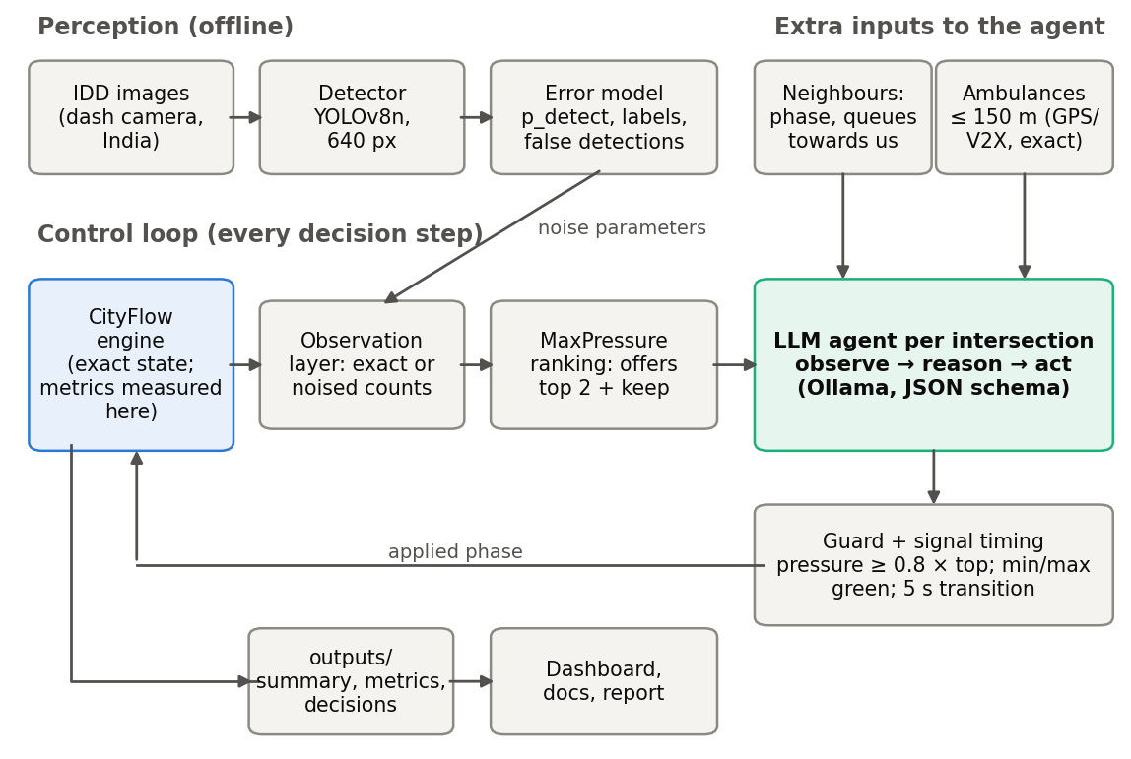
Figure 3.1: System architecture. The simulator holds the exact state; controllers see it only through the observation layer, which can add camera errors measured offline. Ambulance positions reach the agent through a separate channel and are never noised.
The code is a Python package, trafficsense, with sub-packages for the simulator wrapper (sim), the controllers (control), the LLM clients and prompts (llm), perception (perception), the dashboard (dashboard) and the report tooling (report). Settings and paths come from YAML files in configs/; no path is hard-coded.

3.2 Simulation layer
Road network and phases. The wrapper reads a CityFlow road network and builds, for each intersection, its incoming lanes, the movements (straight, left, right) and which movements each phase serves. In the CoLLMLight networks and in ours, phase 0 is a 5 s transition phase in which only the kerb-side free turn may move, and phases 1–8 are green phases. The transition phase is detected from the network, not assumed.
Signal timing. CityFlow switches a signal instantly when told to, so the wrapper inserts the transition phase on every change and enforces a minimum green of 10 s and a maximum green of 60 s for every controller. The tuned MaxPressure and all LLM controllers use their own, longer minimum green of 15 s (Section 4.6).
Metrics are measured from the engine at every second (Section 6.3).

3.3 The multi-agent decision loop
Each signalised intersection is controlled by its own agent. Every 5 s of simulated time, every intersection whose current green has lasted at least the minimum green is asked for its next phase. One decision goes through five steps (Figure 3.2):
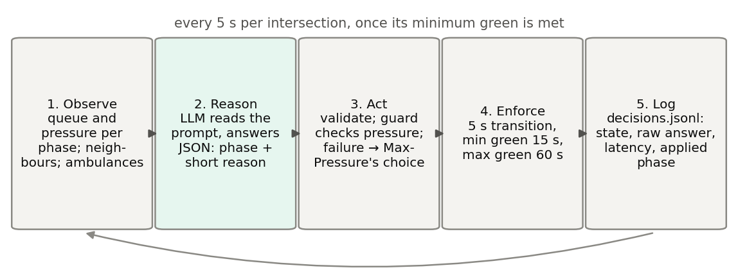
Figure 3.2: One decision of one agent. The simulator is paused during the LLM call, so slow answers cost wall-clock time, not simulated traffic.
- Observe. The agent receives a short text describing its own intersection and its neighbours (Section 3.4). For each phase it may choose, it is given the phase’s pressure (stopped vehicles the phase would serve minus stopped vehicles on their exit roads) and its queue (stopped vehicles it would serve), so that it needs no arithmetic. The pre-registered controller’s prompts averaged 277 tokens in the benchmark.
- Reason. The prompt is sent to a local model through Ollama’s native /api/chat endpoint with a JSON schema that restricts the answer to the allowed phase numbers and a short reason. Sampling uses temperature 0 and a fixed seed, a context of 2048 tokens, at most 128 answer tokens and a timeout of 60 s; the model’s “thinking” mode is switched off.
- Act. The answer is parsed and checked: the phase must be one of those offered and the reason must be at most 15 words. A failure (timeout, invalid JSON, a phase not offered, a reason that is too long) is counted by type. In the hybrid controllers, a failed call applies MaxPressure’s choice for that decision and is reported as such.
- Enforce. The chosen phase is requested from the wrapper, which inserts the transition and applies the green limits.
- Log. The decision is written to the run’s decisions.jsonl: the state the agent saw, MaxPressure’s ranking and pressures, the raw answer, its latency and token counts, whether the guard intervened, and the phase applied.
All agents share one GPU, so the calls of one decision round run one after another. The pre-registered selection rule therefore sets the decision interval to the shortest multiple of the transition time that is at least the model’s 95th-percentile latency times the number of intersections (Section 7.1.1). The simulator waits during calls; slow models make a run take longer in wall-clock time but do not change the simulated traffic.

3.4 Cooperation through neighbour information
Following CoLLMLight, cooperation is through the prompt. For each neighbouring intersection, the agent is told the neighbour’s current phase, how many vehicles are stopped on the neighbour’s approaches heading towards this intersection and how many of those have green, and how many vehicles are stopped on this intersection’s road into the neighbour. The agent can thus see a platoon about to be released towards it, or a neighbour whose approach from this intersection is full. An example prompt, rendered by the controller’s own code from a real simulator state, is in Appendix B.

3.5 Controller variants
The project compared six LLM controller designs (“arms”). They differ in how much the LLM decides and in the prompt version (Appendix B).
Table 3.1: The LLM controller designs. The pre-registered final design round compared the last three.
Arm | Controller | What the LLM chooses | Prompt
v1 | llm_v1 | any green phase | v1: per-movement counts, vehicle types, neighbours
v2 | llm_cooperative | any green phase | v2: shorter; pressure and queue per phase
hybrid | llm_guided_mp | MaxPressure’s top 2 or keep current | guided
v3 | llm_v3 | any green phase | v3 = v2 with two lines fixed
hybrid_v3 | llm_guided_mp_v3 | MaxPressure’s top 2 or keep current | guided_v3
guarded_v3 | llm_guarded_mp | as hybrid_v3, then the guard | guided_v3
Plain arms (v1, v2, v3) let the LLM choose any green phase. Hybrid arms let MaxPressure propose and the LLM decide: MaxPressure ranks the phases by pressure, and the LLM is offered MaxPressure’s two best phases and keeping the current phase. The guarded arm adds a check: the LLM’s choice is applied only if its pressure is close enough to the best phase’s,
$$P(\text{LLM’s phase})≥P_{\text{top}}−(1−r) |P_{\text{top}}|,$$
with $r$ = 0.8 in the configuration, i.e. within 20% of the top pressure. The absolute value keeps the top phase acceptable when every pressure is negative. Otherwise MaxPressure’s choice is applied and the override is counted. The guard was added because the small models in the earlier rounds preferred low-pressure phases (Section 7.1); it limits how much harm such a choice can do.

3.6 Ambulance handling
In the emergency scenarios, ambulances are part of the traffic (Section 4.5). An ambulance on an incoming lane within 150 m of the stop line is detected. For the hybrid and guarded arms:
- the prompt lists each detected ambulance with its movement, its distance to the stop line and the phases that serve it, and the system prompt adds one sentence: “Ambulances, if listed, must get through quickly: give green to a phase that serves them.”;
- if no offered phase serves the ambulance, the best-ranked phase that does is added to the options;
- in the guarded arm, a phase that serves a listed ambulance is exempt from the guard, so the guard cannot block priority.
The non-LLM competitor, preemption_mp, is MaxPressure with a rule: when an ambulance is detected in the same way, the phase that serves it with the highest pressure is given green, within the same minimum and maximum green. Ambulance positions are assumed to come from a separate channel (GPS or V2X) and are not passed through the camera-noise layer.

3.7 Camera-noise observation layer
To test controllers on realistic counts without changing the traffic, the observation layer can replace the engine’s lane counts with noisy ones. Every time a controller observes, a fresh snapshot is drawn for the whole network: each vehicle is detected with a class-dependent probability, a detected vehicle may be given another class (a vehicle labelled as a pedestrian is lost from the count), and each road gains a random number of phantom stopped vehicles. All the rates come from the detector’s measured errors (Section 5.4). The simulator itself stays exact, so every metric is still measured from the true traffic.

3.8 Dashboard
A Streamlit dashboard presents the results. It reads only files in outputs/ (and the detector weights), and every chart and number carries a source chip naming the file it came from. Its four pages show the headline result (Figure 3.3), live detection on video with the trained detector, a side-by-side replay of two controllers on the same traffic (Figure 3.4) and the result tables. A test renders every page and fails if any number shown does not appear in the files the page read.
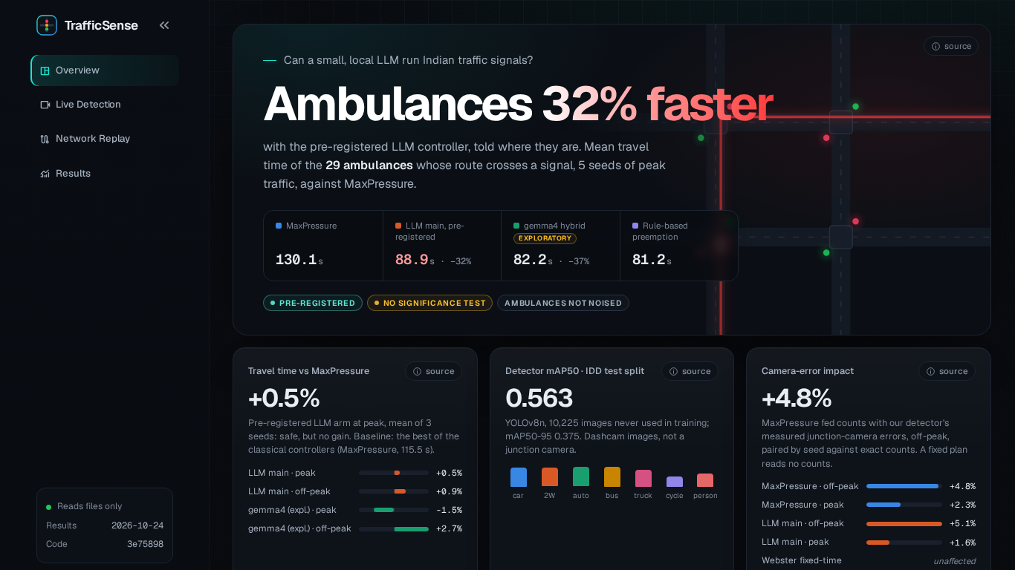
Figure 3.3: Dashboard, Overview page. The headline is the pre-registered arm’s ambulance result; exploratory numbers are labelled as such.
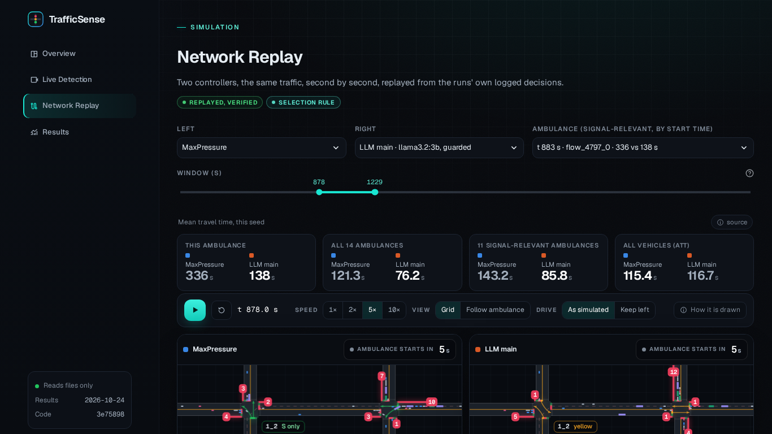
Figure 3.4: Dashboard, Network Replay page: MaxPressure (left) and the pre-registered LLM arm (right) on the same traffic, one ambulance’s trip. Replays re-drive the simulator with each run’s logged decisions and are kept only if they reproduce the run’s metrics exactly.

Chapter 4: Simulation and Scenario
A controller comparison is only as good as the simulator and the scenario behind it. This chapter first checks that our simulation pipeline gives the same answers as an independent implementation, then describes the Indian test network, where each of its parameters comes from, and how the classical baselines were tuned on it before the LLM controllers were tested.

4.1 CityFlow and what it can represent
CityFlow [13] is a microscopic traffic simulator designed for signal-control research: it moves every vehicle every second with a car-following model, is fast enough for hour-long runs on a laptop, and is the simulator of CoLLMLight and most RL work. It is lane-based: every vehicle drives in one lane and follows the vehicle in front. It cannot represent vehicles straddling lanes, two-wheelers filtering between cars or queuing several abreast, and it ignores vehicle width in its dynamics. Our Indian scenario therefore models the Indian vehicle mix (sizes, headways, accelerations) but not Indian driving behaviour. Its results describe “a lane-based simulation with an Indian vehicle mix”, and capacities measured in it are probably lower in vehicles per hour than on a real road with the same mix.
We run CityFlow with lane changing switched off. With lane changing on, CityFlow is not exactly repeatable: the same run, repeated with identical inputs, gives slightly different travel times. With it off, the same phase sequence always gives exactly the same run, which we verified by re-running every deterministic experiment from a fresh copy of the repository (Appendix C).

4.2 Validation against CoLLMLight’s code
Before trusting any comparison, we checked our environment wrapper, signal timing and metrics against an independent implementation: the CoLLMLight authors’ own code (commit ce204a9).
Method. Their FixedTime and MaxPressure baselines were run unmodified in a separate Python environment with their pinned library versions. Their configuration imports every agent class, including the neural and LLM ones, so those imports were replaced by inert stubs; FixedTime and MaxPressure never call them. Our own environment was then driven exactly as theirs: the same 4 phases, one decision every 30 s, a 5 s transition before every switch, no minimum or maximum green, lane changing on, and the same CityFlow seed their run drew. Their metric definitions differ from ours (they measure travel time per intersection approach rather than per trip, sum queues over the network, and sample at their decision times), so every matched run was scored twice: with our metrics and with a line-by-line reimplementation of theirs.
Result. Table 4.1 compares one run of each implementation under their metric definitions. Throughput, queue length and waiting time are identical floating-point numbers for both controllers on all three datasets. Average travel time under their definition is identical in all but one of the six runs; there, and in CityFlow’s own average travel time, the differences are in the sixth significant digit or beyond. These comparisons need lane changing on, and with it CityFlow is not exactly repeatable: repeating the same run, in their code or ours, moves the average travel time by similar or larger amounts, while throughput and their queue length never changed (Appendix C). The remaining differences are therefore within the simulator’s own noise. (An earlier draft attributed them to extra read-only queries; the fresh-clone check showed that test could not separate the two.) We therefore consider the pipeline validated.
Table 4.1: Our environment against CoLLMLight’s code, both driven the same way and scored with their metric definitions. “identical” means equal floating-point numbers; otherwise the relative difference is shown. “CityFlow ATT” is the engine’s own average travel time.
Dataset | Controller | ATT | Throughput | Queue | Waiting | CityFlow ATT
synthetic_4x4 | Fixedtime | identical | identical | identical | identical | 3.1e-07 rel.
synthetic_4x4 | MaxPressure | 3.7e-06 rel. | identical | identical | identical | 9.9e-07 rel.
Jinan 3x4 | Fixedtime | identical | identical | identical | identical | 1.8e-07 rel.
Jinan 3x4 | MaxPressure | identical | identical | identical | identical | 1.4e-06 rel.
hangzhou_4x4 | Fixedtime | identical | identical | identical | identical | identical
hangzhou_4x4 | MaxPressure | identical | identical | identical | identical | 4.6e-06 rel.
The validation also corrected one of our own earlier claims. We had written that CityFlow’s average travel time leaves out vehicles that never entered the network. It does not: it averages over every generated vehicle, timed from its scheduled start, including vehicles still waiting to enter. A unit test now reproduces the engine’s number from the flow file, and every metric description was corrected.

4.3 A bug in CoLLMLight’s FixedTime baseline
CoLLMLight’s fixed-time agent computes its next action as (cur_phase + 1) % 4, where cur_phase is CityFlow’s phase index (1–4). Actions, however, are numbered from 0 and the environment adds 1 again. Phase 1 therefore leads to phase 3 and phase 3 back to phase 1: the controller alternates between the two east–west phases, and north–south traffic never gets a green. Their own action log confirms it for every intersection over the whole hour. Table 4.2 shows what this does to the numbers: a correct 4-phase cycle on the same 30 s grid has a far lower travel time on the two real-world datasets. Any comparison with CoLLMLight’s published fixed-time numbers must take this into account; we use only our own, correct fixed-time controllers.
Table 4.2: CoLLMLight’s FixedTime (which serves east–west only) against a correct 4-phase cycle with the same 30 s decisions, and their MaxPressure for reference. One run per dataset, CoLLMLight’s settings.
Dataset | Controller | CityFlow ATT (s) | ATT, CoLLMLight’s definition (s) | Throughput, CoLLMLight’s definition
Synthetic 4x4 | CoLLMLight’s FixedTime (bug: E-W only) | 1612.0 | 1192.5 | 751
Synthetic 4x4 | CoLLMLight’s MaxPressure | 1263.3 | 683.1 | 2505
Synthetic 4x4 | Correct 4-phase FixedTime, same 30 s grid | 1420.6 | 875.6 | 1724
Jinan 3x4 | CoLLMLight’s FixedTime (bug: E-W only) | 1258.0 | 1239.3 | 1786
Jinan 3x4 | CoLLMLight’s MaxPressure | 317.8 | 273.2 | 4187
Jinan 3x4 | Correct 4-phase FixedTime, same 30 s grid | 479.6 | 441.2 | 4027
Hangzhou 4x4 | CoLLMLight’s FixedTime (bug: E-W only) | 1054.7 | 1002.8 | 1526
Hangzhou 4x4 | CoLLMLight’s MaxPressure | 365.7 | 325.3 | 2751
Hangzhou 4x4 | Correct 4-phase FixedTime, same 30 s grid | 667.9 | 616.0 | 2450
The validation also showed why the Synthetic 4x4 dataset is unusual. One of its entry roads carries 2660 vehicles per hour that all need a single straight lane, whose stop line discharges at most 1440 vehicles per hour even with a permanent green. No signal plan can clear it, so a large entry queue is a property of the dataset. For this reason the comparisons in this report use Jinan 3x4 (real flow) and our Indian network, and use Synthetic 4x4 only for validation.

4.4 The Indian 2x2 scenario

4.4.1 Network
The test network (Figure 4.1, Table 4.3) is a 2 × 2 grid generated with CityFlow’s own grid generator. India drives on the left and the generator builds right-hand traffic, but a square grid is mirror-symmetric: a right-hand network is the mirror image of a left-hand one, and the simulation is the same with the turn labels swapped. CityFlow’s right turn (kerb side, allowed in every phase) plays the role of India’s free left turn, and its left turn (across opposing traffic, protected phase) plays the role of India’s right turn.
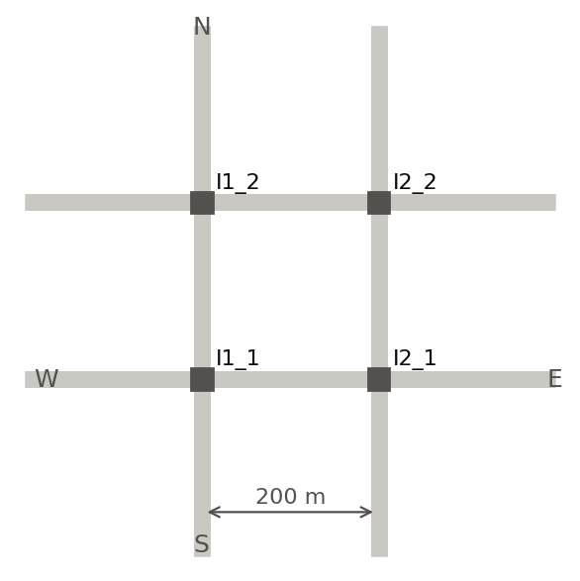
Figure 4.1: The Indian 2x2 network, drawn from its CityFlow road-network file. East–west is the major road.
Table 4.3: Network and signal parameters of the Indian 2x2 scenario (configs/scenarios/indian_2x2.yaml).
Parameter | Value | Source
Grid | 2 × 2 signalised intersections | project specification
Spacing between intersections | 200 m | project specification
Entry and exit roads | 200 m | assumption (same as spacing)
Lanes per direction | 3 (one per turn) | CityFlow generator layout
Lane width | 3.0 m | project specification
Speed limit | 12.5 m/s (45 km/h) | assumption within the 11–13 m/s range
Centre to stop line | 12 m | assumption (three lanes plus margin)
Phases | 0 = 5 s transition (free turns only); 1–8 green | CityFlow generator
Minimum / maximum green | 10 s / 60 s (MaxPressure and LLM arms: minimum 15 s) | configs/default.yaml

4.4.2 Vehicles
Each vehicle type has its own length, gap, headway, speed and acceleration (Table 4.4). The shares are the 2006 modal share of Chennai traffic [9], with bicycles removed (not modelled) and buses and trucks split equally (an assumption). Lengths and widths are the average Indian dimensions given by Umapathi and Khatawkar [29]. The car’s gap, headway and accelerations are CityFlow’s defaults; the other types’ values are assumptions chosen to be plausible (small vehicles follow closer and accelerate faster) and were not tuned to favour any controller.
Table 4.4: Vehicle types of the Indian scenario. Share = normalised share of all vehicles.
Type | Share | Length (m) | Width (m) | minGap (m) | headwayTime (s) | maxSpeed (m/s)
motorcycle | 45.1% | 1.67 | 0.7 | 1.0 | 1.0 | 12.5
auto_rickshaw | 17.6% | 3.2 | 1.4 | 1.5 | 1.5 | 11.1
car | 30.8% | 3.72 | 1.44 | 2.5 | 1.5 | 12.5
bus | 1.6% | 10.1 | 2.43 | 2.5 | 2.0 | 11.1
truck | 4.9% | 7.5 | 2.35 | 2.5 | 2.0 | 11.1

4.4.3 Demand
Vehicles arrive as a Poisson process on each of the 8 entry roads. East–west is the major road: each east or west entry has weight 1.0 and each north or south entry 0.6. At every intersection a vehicle goes straight with probability 0.60, takes the free (left) turn with 0.25 and the right turn with 0.15; these shares are assumptions. Each seed produces a different flow file, so seeds give genuinely different traffic.

4.4.4 Demand calibration
The demand levels were not chosen by eye. The goal was an off-peak level that is clearly below capacity and a peak level near capacity that still drains. A three-step procedure, fixed before it was run, set them:
- Measure capacity. Saturation flows were measured in the simulator with the vehicle mix by letting a queue discharge after a long red (Table 4.5).
- Sweep demand under MaxPressure. For total demands from 1000 to 14000 vehicles per hour and three seeds, MaxPressure ran for an hour and then until the network emptied (Figure 4.2).
- Apply the rule. The network “drains” if at most 2% of the vehicles are still waiting to enter at the end of the hour and it empties within 900 s after arrivals stop, on every seed. The lowest swept demand that does not drain is $R^{*}$ = 5500 veh/h. Peak is the largest swept demand at or below 0.9 × $R^{*}$ that drains, 4750 veh/h; off-peak is 0.5 × peak, 2375 veh/h.
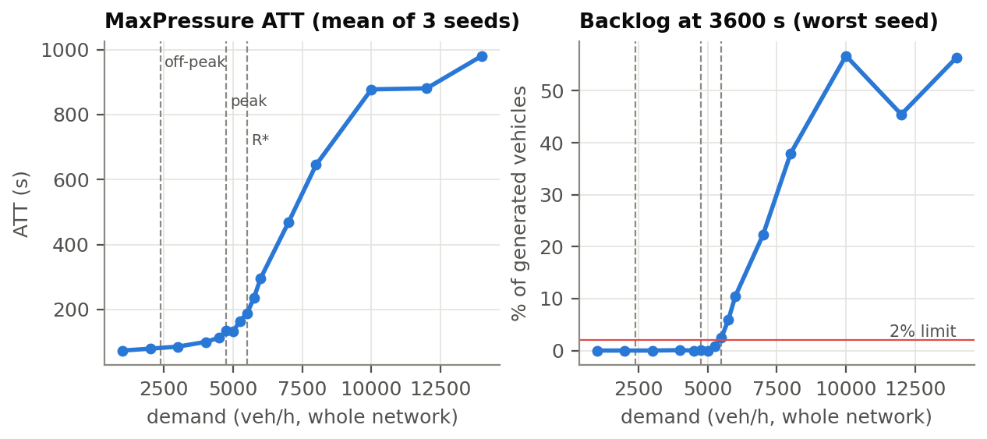
Figure 4.2: Demand calibration under MaxPressure: average travel time and the backlog left at the end of the hour, against total demand. The dashed lines mark the chosen off-peak and peak levels and $R^{*}$.
Table 4.5: Capacity of the Indian network with its vehicle mix, measured in the simulator.
Quantity (mixed traffic, measured) | Value
Saturation flow, straight lane | 2103 veh/h
Saturation flow, protected-turn lane (Indian right turn) | 2024 veh/h
Start-up lost time (mean of both lanes) | 1.88 s
Entry admission limit (CityFlow insertion) | 1341 veh/h
“Near capacity” here means near the capacity of MaxPressure as configured, not of the intersections. A controller-independent check with Webster’s critical flow ratio shows that the peak level uses only about 0.55 of Webster’s capacity limit. MaxPressure breaks down earlier because it switches often and every switch costs 5 s of transition: under the earlier 10 s minimum green, a third of each intersection’s time was transition (Section 4.6). This is why a well-timed fixed plan can keep up with MaxPressure at peak.

4.5 Emergency scenario
The emergency scenarios add ambulances to the normal flow files of the peak level without changing any other vehicle. Ambulances arrive at 6 per hour over the whole network (an assumption), with routes drawn like the normal traffic, from a random generator seeded separately so that the normal traffic does not depend on them. An ambulance is a 5 m van at the 12.5 m/s lane limit. Over seeds 0–4 there are 37 ambulances, of which 29 are signal-relevant: their route crosses at least one movement a signal controls (the others only make free turns, which no signal affects). CityFlow has no notion of yielding: other vehicles do not pull over and, with lane changing off, the ambulance cannot overtake. Only the signal can help it, which is exactly what the controllers are tested on.

4.6 Baselines and their tuning
An LLM controller should be compared with baselines that are as good as they can reasonably be, and those must be fixed before the comparison, not after. Three classical controllers were used.
- FixedTime: the 4 paired phases (each pair of opposing approaches together), 30 s of green each. This is the naive plan.
- Webster fixed time: the same 4 phases with a cycle and splits computed per intersection by Webster’s method. Saturation flows and start-up lost times are measured on the network with the run’s vehicle mix (mean of 30 random-order queues), and lane demand is read from the run’s own flow file, i.e. a perfect count of the simulated hour. This favours Webster: a real plan is built from older counts.
- MaxPressure: all 8 green phases, ties keep the current phase.
MaxPressure’s timing was tuned in two sweeps on four scenarios (Jinan, Hangzhou, Indian off-peak and peak; 3 seeds each), with selection rules committed before the runs: rank the settings by mean travel time in each scenario, choose the lowest mean rank, break ties by the lowest mean ratio to the best. The first sweep varied the decision interval and showed that what really changed was the shortest possible green. The second sweep therefore fixed the interval at 5 s and varied the minimum green (Table 4.6). A minimum green of 15 s was chosen, through the tie-break: the 10 s setting is best on three scenarios but last at Indian peak.
Table 4.6: Pre-registered selection of MaxPressure’s minimum green (decision interval 5 s): rank of each setting by mean travel time per scenario, mean rank, and the tie-break.
Min green | Jinan | Hangzhou | Off-peak | Peak | Mean rank | Mean ATT / best | Chosen
10 s | 1 | 1 | 1 | 4 | 1.75 | 1.058
15 s | 2 | 2 | 2 | 1 | 1.75 | 1.026 | chosen
20 s | 3 | 3 | 3 | 2 | 2.75 | 1.072
25 s | 4 | 4 | 4 | 3 | 3.75 | 1.139
The minimum green matters because of the transition. With a 10 s minimum green MaxPressure switches so often that 32.4% of each intersection’s time at peak is transition, against 24.7% with 15 s. In light traffic reacting quickly wins; near capacity the green lost to transitions costs more. No setting is best at both levels, and the pre-registered rule chose the compromise.
Table 4.7 gives all baselines on the Indian network. Off-peak, MaxPressure is clearly best. At peak, the tuned MaxPressure and the Webster plan are effectively tied (115.5 s and 116.3 s), and the 30 s FixedTime no longer drains: about 308 vehicles are still waiting to enter at the end of the hour. This tie matters for reading the LLM results: at peak, “as good as MaxPressure” is also “as good as a well-timed fixed plan”.
Table 4.7: All baselines on the Indian 2x2 network, mean ± std over seeds 0–2, 3600 s. The default MaxPressure is the tuned one (5 s interval, 15 s minimum green).
Level | Controller | ATT (s) | Queue / int. (veh) | Finished trips | Waiting to enter at end | Share of time in transition
off-peak | FixedTime, 4 paired phases, 30 s | 121.5 ± 0.2 | 10.58 ± 0.17 | 2316 ± 28 | 0.0 ± 0.0 | 0.142 ± 0.000
off-peak | FixedTime, all 8 phases, 30 s | 129.3 ± 1.3 | 11.88 ± 0.42 | 2298 ± 28 | 0.0 ± 0.0 | 0.142 ± 0.000
off-peak | FixedTime, 4 paired phases, Webster plan | 100.4 ± 4.1 | 6.82 ± 0.52 | 2320 ± 36 | 0.0 ± 0.0 | 0.326 ± 0.006
off-peak | MaxPressure (8 phases, 5 s, min 15 / max 60) | 88.1 ± 1.0 | 4.94 ± 0.23 | 2332 ± 36 | 0.0 ± 0.0 | 0.246 ± 0.001
off-peak | MaxPressure (8 phases, 15 s, min 10 / max 60) | 81.3 ± 0.3 | 3.80 ± 0.07 | 2332 ± 38 | 0.0 ± 0.0 | 0.314 ± 0.003
off-peak | MaxPressure (8 phases, 5 s, min 10 / max 60) | 82.0 ± 0.8 | 3.91 ± 0.17 | 2332 ± 37 | 0.0 ± 0.0 | 0.319 ± 0.003
peak | FixedTime, 4 paired phases, 30 s | 279.9 ± 9.9 | 44.44 ± 0.75 | 4166 ± 93 | 307.7 ± 20.5 | 0.142 ± 0.000
peak | FixedTime, all 8 phases, 30 s | 291.9 ± 7.3 | 47.67 ± 0.62 | 4113 ± 88 | 331.0 ± 18.3 | 0.142 ± 0.000
peak | FixedTime, 4 paired phases, Webster plan | 116.3 ± 4.6 | 18.27 ± 1.28 | 4577 ± 87 | 0.3 ± 0.6 | 0.227 ± 0.004
peak | MaxPressure (8 phases, 5 s, min 15 / max 60) | 115.5 ± 0.9 | 17.83 ± 0.32 | 4576 ± 68 | 0.3 ± 0.6 | 0.247 ± 0.001
peak | MaxPressure (8 phases, 15 s, min 10 / max 60) | 133.8 ± 15.9 | 23.24 ± 4.60 | 4540 ± 116 | 0.3 ± 0.6 | 0.321 ± 0.002
peak | MaxPressure (8 phases, 5 s, min 10 / max 60) | 142.4 ± 18.3 | 25.84 ± 5.22 | 4516 ± 131 | 0.3 ± 0.6 | 0.324 ± 0.001

Chapter 5: Perception
A deployed version of this system would not get exact vehicle counts from a simulator; it would count vehicles with a camera and a detector. The perception part of the project has a narrow, measurable purpose: train a detector on real Indian street images, measure the errors it makes in the terms a signal controller cares about (missed vehicles, invented vehicles, wrong classes), and turn those measurements into an error model for the simulation experiment of Section 7.5. The detector is not used to control signals directly.

5.1 Dataset
We use the detection part of the India Driving Dataset (IDD) [28], collected by IIIT Hyderabad and Intel from vehicles driving in Indian cities. It has bounding boxes for road users including auto-rickshaws, which most Western datasets lack. IDD is filmed from a moving vehicle, not from a pole at a junction; we return to this limitation below.
Classes. We keep 7 classes, mapped one-to-one from IDD: car, motorcycle, autorickshaw, bus, truck, bicycle and person. IDD’s rider boxes are dropped: a rider sits on a two-wheeler that has its own box, and counting riders would double-count road users, while labelling them person would make every two-wheeler look like a pedestrian. The catch-all vehicle fallback, the rare caravan, trailer and train classes, animals, traffic signs and traffic lights are dropped as well; regions that contain them become background. These rules were written down before any conversion code existed.
Splits. IDD’s official test labels are withheld, so the official test split cannot measure anything. Our test split is the official validation split; our validation split is 10% of the official training drives, chosen per camera group with a fixed seed. Splitting by drive rather than by frame matters: consecutive frames of one drive are near-duplicates, and a frame-level split would leak them into training and flatter the validation scores. The test split was evaluated once, after every choice (including the confidence threshold) had been frozen on the validation split. Table 5.1 gives the sizes.
Table 5.1: Our IDD splits after the class mapping. Drives = recorded sequences.
Our split | From | Used for | Images | Drives | Boxes
train | official train minus held-out drives | training | 28,384 | 393 | 247,051
val | held-out official-train drives | early stopping, threshold | 3,185 | 45 | 28,722
test | official val | final numbers, used once | 10,225 | 119 | 88,755
Image size. Training and evaluation use images of 640 pixels on the long side, which is what fits the GTX 1650. A full-HD frame is shrunk three times, so a distant motorcycle keeps only a third of its height in pixels. We therefore report errors by object size, so that this cost is visible rather than hidden in an average. The dataset itself stays outside the repository; a resized copy was made once to cut image-reading time.

5.2 Training
The detector is YOLOv8n [25] (about 3 million parameters), starting from weights pre-trained on COCO, whose classes already include cars, buses, trucks, motorcycles, bicycles and people. A short probe run decided the batch size: twice the batch needed more memory than the 4 GB card has and was slower, so training used batch 8. Mixed-precision training was switched off because GTX 16-series cards produce invalid (NaN) losses with it; no invalid loss occurred. Training ran for 50 epochs with early stopping after 10 epochs without improvement on our validation split.
The full run took 13.3 hours. Early stopping did not trigger: validation accuracy was still rising very slowly at the end (Figure 5.1), and the best epoch was 49. An earlier engineering problem is worth recording because it cost more time than the training itself: reading images from the external hard disk through WSL was limited to a few dozen images per second by a fixed cost per file, most of it Windows Defender’s on-access scan. Excluding the dataset folder from the scan removed the bottleneck, and the GPU, not the disk, became the limit.
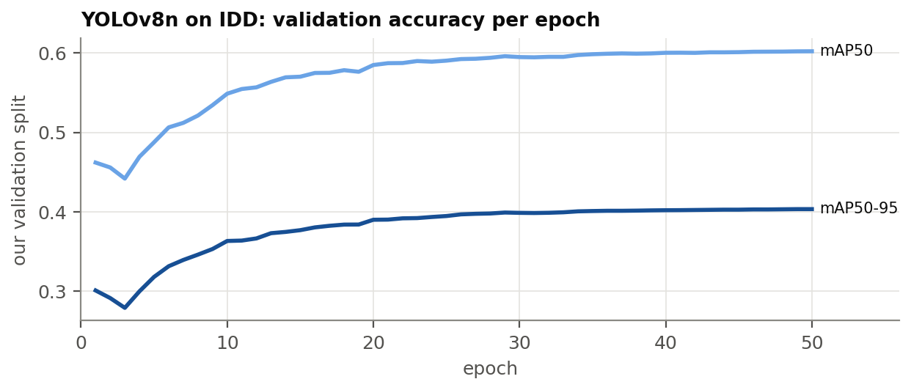
Figure 5.1: Accuracy on our validation split after each training epoch.

5.3 Evaluation
Operating point. A detector outputs boxes with confidence scores; a controller needs a yes/no decision per box. The confidence threshold was chosen on the validation split as the one that maximises the mean F1 score over the 7 classes: 0.3 (mean F1 0.620). The F1 curve is flat around this value, so the exact choice matters little.
Matching. On each test image, detections (sorted by confidence) are matched greedily to the unmatched ground-truth box with the highest IoU of at least 0.5, ignoring the class. A match with the same class is a true positive; a match with another class is a confusion; an unmatched detection is a false detection; an unmatched ground-truth box is a miss. Confidence intervals come from 1,000 bootstrap resamples of whole drives, not frames, so that correlated frames do not make them look tighter than they are.
Results. On the test split the detector reaches mAP50 0.563 and mAP50-95 0.375 (validation: 0.602 and 0.403). Table 5.2 gives the per-class numbers. Precision is high (few false detections) and recall is moderate: the detector undercounts.
Table 5.2: Detector on the test split (official IDD validation set), per class. mAP from Ultralytics; precision, recall, miss rate and false detections from our matching at confidence ≥ 0.3. Recall = 1 − miss rate − confusion rate.
Class | Boxes | mAP50 | mAP50-95 | Precision | Recall | Miss rate | False det. / image
car | 24,843 | 0.637 | 0.442 | 83.9% | 54.9% | 43.2% | 0.222
motorcycle | 25,489 | 0.630 | 0.373 | 81.9% | 56.2% | 43.4% | 0.271
autorickshaw | 7,782 | 0.652 | 0.461 | 82.0% | 56.0% | 40.2% | 0.070
bus | 4,915 | 0.664 | 0.502 | 82.3% | 56.9% | 36.8% | 0.039
truck | 7,077 | 0.576 | 0.412 | 72.9% | 48.3% | 46.3% | 0.079
bicycle | 569 | 0.339 | 0.193 | 61.0% | 24.8% | 55.4% | 0.006
person | 18,078 | 0.444 | 0.241 | 79.1% | 35.5% | 63.6% | 0.149
all | 88,753 | 0.563 | 0.375
Most misses are small, distant objects (Figure 5.2, Table 5.3). Small boxes are most of the ground truth, and the detector misses 59–76% of them, against 1–22% of large boxes. This is the cost of running at 640 pixels named above. One camera group dominates the test set: the highquality_16k camera supplies 3,633 images but 64,381 of the boxes, 74% of them small. The overall per-class rates therefore mostly describe crowded scenes with distant objects. Confusions are few and plausible: bicycles are labelled motorcycles, and buses, trucks and auto-rickshaws are confused with each other and with cars. person has the highest miss rate, partly because pedestrians are small and possibly because the model was taught not to fire on riders.
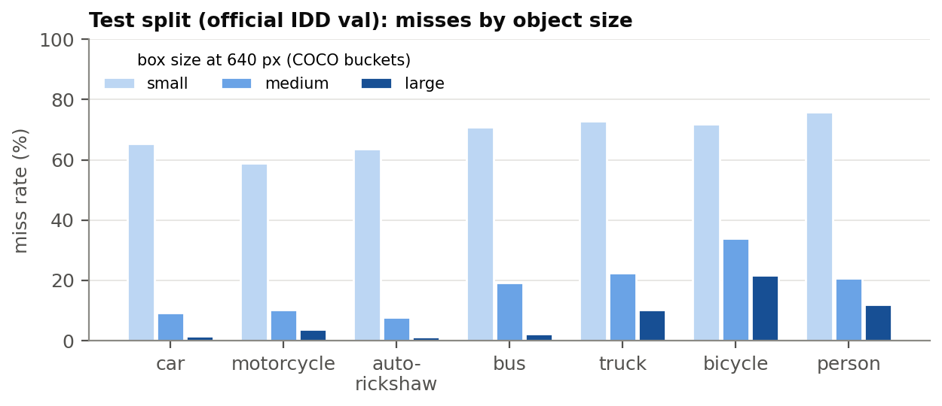
Figure 5.2: Miss rate by object size on the test split. Sizes are COCO’s buckets measured in the 640-pixel image.
Table 5.3: Miss rate by object size (number of ground-truth boxes in brackets), test split.
class | Small: miss rate (boxes) | Medium | Large
car | 65.4% (15,489) | 9.1% (6,065) | 1.3% (3,289)
motorcycle | 59.0% (17,565) | 10.1% (6,250) | 3.8% (1,674)
autorickshaw | 63.6% (4,646) | 7.8% (2,106) | 1.1% (1,030)
bus | 70.8% (2,199) | 19.2% (1,141) | 2.1% (1,575)
truck | 73.0% (3,712) | 22.4% (1,820) | 10.2% (1,545)
bicycle | 71.9% (334) | 33.8% (198) | 21.6% (37)
person | 75.7% (14,180) | 20.7% (3,288) | 12.0% (610)

5.4 Camera error model
The measurements are turned into the parameters of the observation-noise layer (Section 3.7), stored in outputs/perception/error_model.json and read from there by the simulation, never typed into code:
- Detection probability of each class, $p_{\text{detect}}=1−\text{miss rate}$.
- Label probabilities: the probability of each predicted class given the true class and that the object was detected (the normalised rows of the confusion matrix).
- False detections: a Poisson count per road and snapshot whose mean is the measured number of false detections per image of each class.
Two camera levels are defined (Table 5.4). The junction level uses detection rates measured on medium and large objects, because queued vehicles near a stop line are close to a camera on a pole. The crowded / far level uses the rates over all objects, dominated by distant ones. Both use the measured false-detection rates and label probabilities.
Table 5.4: Camera error parameters used in the simulation, per detector class.
detector class | junction p_detect | crowded p_detect | false det. per road and snapshot
car | 0.936 | 0.568 | 0.222
motorcycle | 0.913 | 0.567 | 0.271
autorickshaw | 0.944 | 0.598 | 0.070
bus | 0.907 | 0.632 | 0.039
truck | 0.832 | 0.537 | 0.079
bicycle (label only) | – | – | 0.006
Limitation. These are measured errors of our detector on dash-camera images. A camera on a pole at a junction sees from a different height and angle, with different occlusion. The error model is therefore a measured proxy for a junction camera, not its true error, and the two levels bracket a range rather than predict one value.

Chapter 6: Experimental Methodology
A comparison between a new controller and established ones is easy to bias without meaning to: by tuning the new method until it wins, by choosing the scenario or the metric after seeing the results, or by comparing against a weak baseline. This chapter describes the safeguards used and defines every metric.

6.1 Pre-registration
Pre-registration means writing down the design of an experiment and the rule that decides its outcome before running it, and committing that to version control so the order can be checked [30]. It separates confirmatory results, which test a fixed hypothesis, from exploratory ones, which suggest new hypotheses. Every major step of this project was pre-registered, and each study’s document records the commit at which its plan was fixed (Table 6.1).
Table 6.1: What was fixed in advance for each study. Commit hashes refer to the project’s git history.
Study | Fixed before any of its runs
Demand calibration | the “drains” criterion, the rule for $R^{*}$, peak and off-peak
MaxPressure tuning | the swept settings and the rank-based selection rule with its tie-break (commits 8414f9a, c7a6e34)
LLM benchmark | the setup and the model-selection rule; reused unchanged in every round
Final LLM design round | the three arms, and that its pick goes to the full experiments even if worse than MaxPressure
Full experiments | arms, scenarios, seeds, run length and analysis (commit 694dc0c)
Emergency experiment | ambulance rate, seeds, controllers and the primary metric
Detector | class mapping, splits, image size, training settings; threshold frozen on validation (876076d) before the single test evaluation
Camera-error experiment | noise model, levels, runs, analysis and checks (91aa214)
Model-size study | models, runs and tables, committed before its runs, but the study itself was added after the main results (exploratory)
The model-selection rule. Each LLM benchmark run is a 600 s run of the Indian peak scenario, seed 0. A model is eligible if fewer than 2% of its calls failed and its 95th-percentile latency is below 3 s; among eligible models the one with the lowest mean queue per intersection is chosen, ties broken by travel time. The decision interval is then the shortest multiple of the 5 s transition that is at least the chosen model’s 95th-percentile latency times the number of intersections, so that a full round of decisions fits in real time on one GPU.
Deviations and additions, stated openly. Four things were not part of the original plans and are labelled wherever they appear:
- Prompt v3 is a post-hoc fix. After the first rounds showed that the prompts never said which direction of pressure is better, two lines were changed (Section 7.1). The final design round, which used v3, was itself pre-registered and declared final.
- The gemma4:e4b hybrid arm is exploratory. It failed the selection rule only on latency and was added to the full experiments, at the user’s request, after their plan was fixed. It is labelled “exploratory, NOT selected by the rule” in every table.
- The model-size study was planned after the main results and is exploratory.
- The camera-error decomposition (one error source at a time) was added after the camera results had been read, to test an explanation offered for them; it is post-hoc.

6.2 Scenarios, seeds and run length
Every run simulates 3600 s. The Indian off-peak and peak scenarios and Jinan 3x4 use seeds 0, 1 and 2; the emergency scenario uses seeds 0–4 because ambulances are few. On the Indian network each seed is a different flow file, so seeds differ in traffic. Jinan has one fixed flow file, so the deterministic baselines give identical results on every seed; only the LLM runs vary there. LLM runs use the run seed as the sampling seed at temperature 0. Even so, Ollama on a GPU is not bit-for-bit deterministic: a repeated run gives slightly different answers in a few calls, after which the traffic diverges. Every decision is logged, so each LLM run can be replayed exactly from its log, and the dashboard’s replays are checked to reproduce their runs’ metrics.
The full experiments comprise 67 runs (Indian off-peak and peak: all baselines and both LLM arms; Jinan: baselines and the main arm; emergency: five controllers on five seeds). The camera-error experiment comprises 130 runs.

6.3 Metrics
All traffic metrics are measured from the simulator, never estimated.
- Average travel time (ATT): CityFlow’s get_average_travel_time() at the end of the run. It averages over every vehicle generated so far, from its scheduled start to its arrival or to the end of the run, including time spent waiting to enter the network. A controller that blocks an entry therefore cannot hide the delay it causes. ATT is the primary metric.
- Queue length: at each second, the number of waiting vehicles (speed below 0.1 m/s) on an intersection’s incoming lanes; averaged over seconds and intersections.
- Waiting time: per vehicle, the seconds spent with speed below 0.1 m/s, averaged over vehicles.
- Throughput: vehicles that finished their trip within the hour.
- Ambulance travel time: finish time minus scheduled start, per signal-relevant ambulance (the same convention as ATT), pooled over seeds; also its median and the time it spent stopped. Each controller is also compared with preemption ambulance by ambulance.
- LLM decision statistics: calls, failures by type, mean and 95th-percentile latency, how often the LLM’s answer differs from MaxPressure’s choice, how often the guard overrode it, and how often the applied phase differs from MaxPressure’s. These describe decisions; they are not traffic metrics.
- Detector metrics: mAP50 and mAP50-95 (Ultralytics), and precision, recall, miss rate and false detections per image from our own matching (Section 5.3).
Results are given as mean ± sample standard deviation over seeds. Because every controller sees the same flow file on the same seed, the most informative comparison is paired by seed: each arm’s ATT minus MaxPressure’s ATT on the same seed.

6.4 Fairness of the comparison
- Same timing. MaxPressure, preemption and all LLM arms decide on the same 5 s grid with the same 15 s minimum green and 60 s maximum green, so they differ only in how they choose a phase.
- Same traffic. All controllers see the same flow file on the same seed, and ambulances are appended to the normal flow without changing any other vehicle.
- Baselines tuned first. MaxPressure and Webster were tuned (Section 4.6) before any LLM run, and Webster’s plan uses a perfect count of the simulated demand.
- Clean runs. Batch runs refuse to start from a git tree with uncommitted changes, so every result can be traced to a commit. In the LLM benchmark, every loaded model was unloaded and the GPU had to be idle before each model was tested.
- Repeatability of baselines. Every baseline run of the full experiments that repeats an earlier run (same scenario, controller, settings, seed and flow file) was compared with it: 27 of 27 are identical in every metric.

6.5 Statistical treatment
With three seeds per scenario (five with ambulances) a significance test has little power, and none was pre-registered. Differences are therefore reported as measured, with their spread and, for paired comparisons, the result on each seed. A difference is called a result only when it has the same sign on every seed and is large compared with the seed-to-seed spread; smaller differences are described as “within seed noise”.

Chapter 7: Results
This chapter reports the results in the order the experiments were run: the LLM benchmark that selected the controller, the full experiments, the ambulance experiment, the exploratory model-size study, and the camera-error experiment. The baselines’ tuning and their results on the Indian network are in Section 4.6; the detector’s evaluation is in Section 5.3. Every table in this chapter is generated from the result files.

7.1 LLM benchmark and the design rounds
Each LLM arm was benchmarked on the same 600 s of Indian peak traffic (seed 0) with up to four local models (llama3.2:3b from the Llama 3 family [31], qwen2.5:3b [32], and Google’s gemma3:4b and gemma4:e4b), and the pre-registered rule (Section 6.1) was applied. Figure 7.1 and Table 7.1 summarise all rounds; Table 7.2 gives what the rule chose.
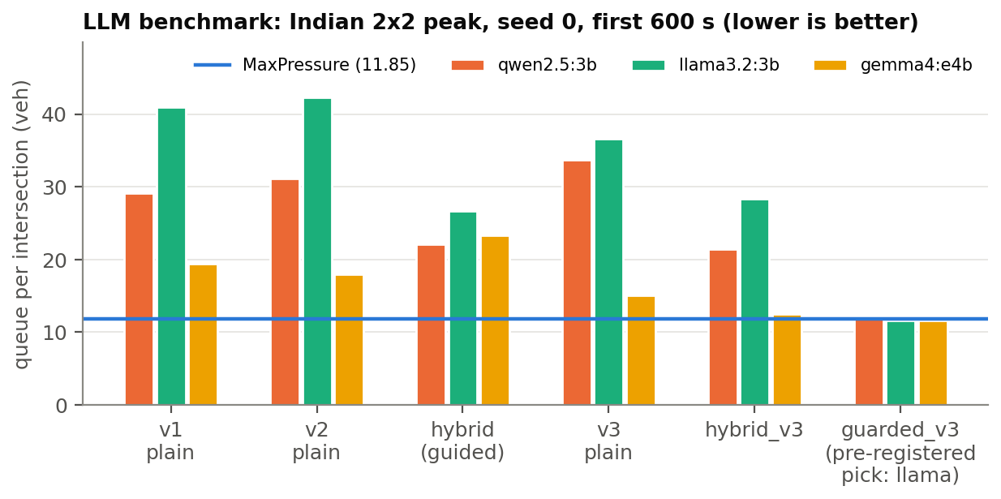
Figure 7.1: Mean queue per intersection over the first 600 s of Indian peak traffic for every arm and model, against MaxPressure (blue line). gemma3:4b, run only in v1, is in Table 7.1.
Round 1 (prompt v1). No model met the rule. qwen2.5:3b was just too slow (95th-percentile latency 3.34 s against the 3 s limit) and llama3.2:3b failed 6.2% of its calls with over-long reasons; both Gemma models were slower still. Every model controlled traffic much worse than MaxPressure: queues of 19–46 vehicles per intersection against 11.85. gemma3:4b did not fit in the 4 GB card and was dropped after this round. Latency was mostly the time to read the long prompt, so the next prompt was made much shorter.
Round 2 (prompt v2 and the hybrid). Prompt v2 gave each phase its pressure and queue directly, in about 285 tokens instead of about 654. The rule then chose llama3.2:3b, the only eligible model, which was also the worst controller of the round (queue 42.26). The decision logs showed why: given pressures, the small models preferred low pressure. In the hybrid arm, which offered only MaxPressure’s two best phases or keeping the current one, every model chose the lowest-pressure option in 77–86% of the calls where the options differed. Their reasons said so directly, for example “Low pressure, minimal queue impact”. The prompts defined pressure but never said which direction is better.
Final round (prompt v3, pre-registered as final). Two lines of the prompts were changed: the definition of pressure now ends “HIGHER pressure = the phase needs green MORE”, and the reason format no longer contains a placeholder that one model had copied into its answers. Three arms were tested with this prompt: plain v3, hybrid_v3, and guarded_v3, which adds the pressure guard (Section 3.5). The fix changed gemma4:e4b, which in hybrid_v3 chose the highest-pressure option in 78% of its calls. It did not change the two 3 B models, which still kept the current phase in most calls.
Table 7.1: LLM benchmark, all rounds: Indian 2x2 peak, seed 0, first 600 s. MaxPressure on the same traffic: queue 11.85 vehicles per intersection, ATT 92.5 s. Eligible = failure rate and latency within the pre-registered limits.
Arm | Model | Failures | Latency p95 (s) | Queue / int. (veh) | ATT at 600 s (s) | Eligible
v1 | gemma3:4b | 0.0% (none) | 5.43 | 46.35 | 197.4 | no
v1 | gemma4:e4b | 0.6% (reason_too_long 1) | 8.36 | 19.44 | 112.2 | no
v1 | llama3.2:3b | 6.2% (reason_too_long 18) | 3.35 | 40.94 | 181.1 | no
v1 | qwen2.5:3b | 0.0% (none) | 3.34 | 29.15 | 141.2 | no
v2 | gemma4:e4b | 0.0% (none) | 5.32 | 17.95 | 111.1 | no
v2 | llama3.2:3b | 0.3% (reason_too_long 1) | 1.52 | 42.26 | 181.5 | yes
v2 | qwen2.5:3b | 29.3% (reason_too_long 104) | 1.65 | 31.11 | 146.8 | no
hybrid | gemma4:e4b | 0.4% (reason_too_long 1) | 4.84 | 23.38 | 125.8 | no
hybrid | llama3.2:3b | 0.3% (reason_too_long 1) | 1.13 | 26.64 | 135.3 | yes
hybrid | qwen2.5:3b | 11.2% (reason_too_long 28) | 1.27 | 22.05 | 123.3 | no
v3 | gemma4:e4b | 0.0% (none) | 5.22 | 15.12 | 103.1 | no
v3 | llama3.2:3b | 0.0% (none) | 1.40 | 36.62 | 163.5 | yes
v3 | qwen2.5:3b | 1.4% (reason_too_long 5) | 1.53 | 33.67 | 156.1 | yes
hybrid_v3 | gemma4:e4b | 0.0% (none) | 4.80 | 12.46 | 93.6 | no
hybrid_v3 | llama3.2:3b | 0.0% (none) | 1.19 | 28.34 | 140.8 | yes
hybrid_v3 | qwen2.5:3b | 7.7% (reason_too_long 21) | 1.32 | 21.44 | 120.0 | no
guarded_v3 | gemma4:e4b | 0.0% (none) | 4.81 | 11.56 | 91.6 | no
guarded_v3 | llama3.2:3b | 0.0% (none) | 1.18 | 11.62 | 92.2 | yes
guarded_v3 | qwen2.5:3b | 10.2% (reason_too_long 13) | 1.23 | 11.85 | 92.5 | no

7.1.1 Selection
By the pre-registered rule the final round selected llm_guarded_mp with llama3.2:3b and a decision interval of 5 s (95th-percentile latency times four intersections: 4.7 s). Its queue in the benchmark, 11.62, was slightly below MaxPressure’s, but the guard had replaced most of the model’s answers: the applied phase differed from MaxPressure’s in only 15 of 121 decisions. As pre-registered, this controller went to the full experiments whatever its benchmark result, and design work on the LLM controller stopped. The best-performing LLM-led controller, gemma4:e4b, was not eligible because of its latency (95th percentile 4.80 s).
Table 7.2: What the pre-registered rule selected in each round and in the final decision.
Applied to | Eligible | Chosen | Decision interval
v1 | none | none | –
v2 | llama3.2:3b | llama3.2:3b | 10 s (p95 × intersections = 6.1 s)
hybrid | llama3.2:3b | llama3.2:3b | 5 s (p95 × intersections = 4.5 s)
v3 | llama3.2:3b, qwen2.5:3b | qwen2.5:3b | 10 s (p95 × intersections = 6.1 s)
hybrid_v3 | llama3.2:3b | llama3.2:3b | 5 s (p95 × intersections = 4.8 s)
guarded_v3 | llama3.2:3b | llama3.2:3b | 5 s (p95 × intersections = 4.7 s)
Phase 3b: all of v1, v2, hybrid | hybrid llama3.2:3b, v2 llama3.2:3b | hybrid llama3.2:3b | 5 s (p95 × intersections = 4.5 s)
Final decision (final-round arms) | guarded_v3 llama3.2:3b, hybrid_v3 llama3.2:3b, v3 llama3.2:3b, v3 qwen2.5:3b | guarded_v3 llama3.2:3b (llm_guarded_mp); queue 11.62 vs MaxPressure 11.85 | 5 s (p95 × intersections = 4.7 s)

7.2 Full experiments
Table 7.3, Table 7.4 and Table 7.5 give the results of the full experiments, and Figure 7.2 shows the travel times side by side.
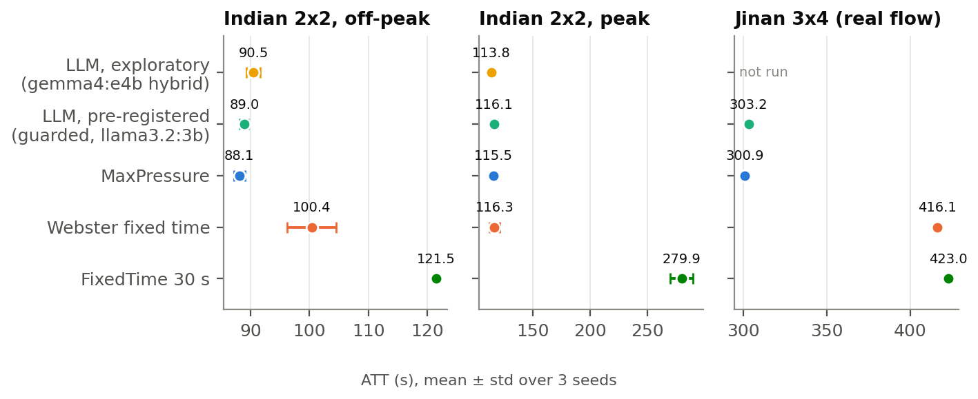
Figure 7.2: Average travel time of every controller in the three scenarios (mean ± std over three seeds). The two LLM arms are close to MaxPressure everywhere; FixedTime fails at peak.
Table 7.3: Indian 2x2, off-peak (2375 veh/h), 3600 s, mean ± std over seeds 0–2.
Controller | Seeds | ATT (s) | Queue / int. (veh) | Waiting / vehicle (s) | Finished trips | ATT vs MaxPressure
MaxPressure | 3 | 88.1 ± 1.0 | 4.94 ± 0.23 | 29.8 ± 0.9 | 2332 ± 36 | +0.0%
Webster fixed time | 3 | 100.4 ± 4.1 | 6.82 ± 0.52 | 41.1 ± 3.9 | 2320 ± 36 | +13.9%
FixedTime (4 phases, 30 s) | 3 | 121.5 ± 0.2 | 10.58 ± 0.17 | 63.7 ± 0.5 | 2316 ± 28 | +37.8%
LLM, pre-registered (guarded, llama3.2:3b) | 3 | 89.0 ± 0.8 | 5.08 ± 0.18 | 30.6 ± 0.6 | 2327 ± 41 | +0.9%
LLM, exploratory (hybrid_v3, gemma4:e4b) | 3 | 90.5 ± 1.2 | 5.37 ± 0.28 | 32.3 ± 1.1 | 2323 ± 34 | +2.7%

Table 7.4: Indian 2x2, peak (4750 veh/h), 3600 s, mean ± std over seeds 0–2.
Controller | Seeds | ATT (s) | Queue / int. (veh) | Waiting / vehicle (s) | Finished trips | ATT vs MaxPressure
MaxPressure | 3 | 115.5 ± 0.9 | 17.83 ± 0.32 | 54.1 ± 0.5 | 4576 ± 68 | +0.0%
Webster fixed time | 3 | 116.3 ± 4.6 | 18.27 ± 1.28 | 55.4 ± 4.0 | 4577 ± 87 | +0.7%
FixedTime (4 phases, 30 s) | 3 | 279.9 ± 9.9 | 44.44 ± 0.75 | 144.0 ± 1.6 | 4166 ± 93 | +142.3%
LLM, pre-registered (guarded, llama3.2:3b) | 3 | 116.1 ± 2.9 | 17.97 ± 0.85 | 54.5 ± 2.5 | 4582 ± 77 | +0.5%
LLM, exploratory (hybrid_v3, gemma4:e4b) | 3 | 113.7 ± 0.3 | 17.33 ± 0.44 | 52.6 ± 0.5 | 4577 ± 77 | -1.5%

Table 7.5: Jinan 3x4 (CoLLMLight’s real-world flow), 3600 s, seeds 0–2. The flow file is fixed, so the deterministic baselines are identical on every seed.
Controller | Seeds | ATT (s) | Queue / int. (veh) | Waiting / vehicle (s) | Finished trips | ATT vs MaxPressure
MaxPressure | 3 | 300.9 ± 0.0 | 5.62 ± 0.00 | 55.7 ± 0.0 | 4130 ± 0 | +0.0%
Webster fixed time | 3 | 416.1 ± 0.0 | 16.42 ± 0.00 | 162.6 ± 0.0 | 3965 ± 0 | +38.3%
FixedTime (4 phases, 30 s) | 3 | 423.0 ± 0.0 | 17.76 ± 0.00 | 176.2 ± 0.0 | 3968 ± 0 | +40.6%
LLM, pre-registered (guarded, llama3.2:3b) | 3 | 303.2 ± 1.1 | 5.81 ± 0.12 | 57.7 ± 1.2 | 4134 ± 5 | +0.8%
The pre-registered controller matches MaxPressure but does not beat it. Its ATT is +0.9% off-peak, +0.5% at peak and +0.8% on Jinan relative to MaxPressure. Paired by seed (Figure 7.3, Table 7.6), it is behind MaxPressure on all 3 off-peak seeds, all 3 Jinan seeds and 2 of the 3 peak seeds, by 0.2–3.5 s.
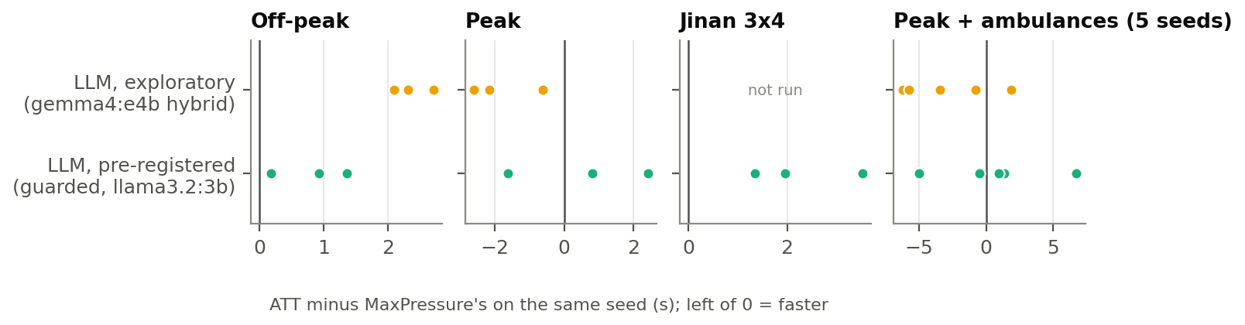
Figure 7.3: ATT minus MaxPressure’s ATT on the same seed, for the two LLM arms. Each dot is one seed; left of zero is faster than MaxPressure.
Table 7.6: Paired comparison: each LLM arm’s ATT minus MaxPressure’s on the same seed.
Scenario | Controller | ATT minus MaxPressure, per seed (s) | Seeds lower / higher than MaxPressure
Indian 2x2 off-peak | LLM, pre-registered (guarded, llama3.2:3b) | +0.92 / +1.36 / +0.18 | 0 lower, 3 higher of 3
Indian 2x2 off-peak | LLM, exploratory (hybrid_v3, gemma4:e4b) | +2.30 / +2.09 / +2.70 | 0 lower, 3 higher of 3
Indian 2x2 peak | LLM, pre-registered (guarded, llama3.2:3b) | +0.81 / +2.42 / -1.63 | 1 lower, 2 higher of 3
Indian 2x2 peak | LLM, exploratory (hybrid_v3, gemma4:e4b) | -2.61 / -2.15 / -0.61 | 3 lower, 0 higher of 3
Jinan 3x4 | LLM, pre-registered (guarded, llama3.2:3b) | +3.52 / +1.96 / +1.35 | 0 lower, 3 higher of 3
Peak + ambulances | Preemption (rule-based) | +1.33 / +0.01 / -1.71 / +3.18 / -1.28 | 2 lower, 3 higher of 5
Peak + ambulances | LLM, pre-registered (guarded, llama3.2:3b) | +6.72 / +1.31 / -0.50 / +0.92 / -5.03 | 2 lower, 3 higher of 5
Peak + ambulances | LLM, exploratory (hybrid_v3, gemma4:e4b) | +1.85 / -3.43 / -6.23 / -0.80 / -5.73 | 4 lower, 1 higher of 5
Why so close: the guard does most of the work (Table 7.7). The model’s own answer differs from MaxPressure’s choice in 87–93% of calls, but the guard replaces most of these answers (76–83% of calls), so the applied phase differs from MaxPressure’s in only 10–11% of calls. Every remaining difference is a decision the guard judged “close enough”, and on average those cost a little. The arm never failed a call off-peak or at peak and runs in real time: mean latency 1.02–1.10 s per call for a 5 s decision interval.
The exploratory gemma4:e4b arm is the only LLM arm that beats MaxPressure anywhere, and only under heavy traffic. At peak its ATT is lower on all 3 seeds (paired differences −0.6 to −2.6 s (−1.5% on the mean); off-peak it is worse on every seed (+2.7%). It departs from MaxPressure more off-peak (32.0% of calls) than at peak (20.9%), and off-peak those departures cost time. With three seeds and no significance test this is a lead, not a demonstrated improvement. The arm is also not real-time on this GPU: 4.54 s per call on average, so an hour of traffic took 3.2 hours over three seeds, against 0.6 hours for the main arm.
Table 7.7: LLM decision statistics, pooled over the seeds of each scenario. “Answer differs” is over successful calls; “applied phase differs” over all calls.
Scenario | Arm | Calls | Failures | Latency mean (s) | p95 per run (s) | Answer differs from MaxPressure | Guard replaced it | Applied phase differs
Indian 2x2 off-peak | LLM, pre-registered (guarded, llama3.2:3b) | 2177 | 0.0% (none) | 1.05 | 1.21–1.22 | 91.5% | 81.2% | 10.4%
Indian 2x2 off-peak | LLM, exploratory (hybrid_v3, gemma4:e4b) | 2802 | 0.1% (reason_too_long 4) | 4.61 | 4.92–5.02 | 32.1% | – (no guard) | 32.0%
Indian 2x2 peak | LLM, pre-registered (guarded, llama3.2:3b) | 2167 | 0.0% (none) | 1.02 | 1.19–1.19 | 92.8% | 82.8% | 10.0%
Indian 2x2 peak | LLM, exploratory (hybrid_v3, gemma4:e4b) | 2541 | 0.1% (reason_too_long 3) | 4.54 | 4.79–4.98 | 20.9% | – (no guard) | 20.9%
Jinan 3x4 | LLM, pre-registered (guarded, llama3.2:3b) | 6665 | 0.0% (reason_too_long 1) | 1.10 | 1.28–1.36 | 89.0% | 77.8% | 11.1%
Peak + ambulances | LLM, pre-registered (guarded, llama3.2:3b) | 3632 | 0.0% (none) | 1.06 | 1.24–1.24 | 86.9% | 76.3% | 10.6%
Peak + ambulances | LLM, exploratory (hybrid_v3, gemma4:e4b) | 4146 | 0.0% (reason_too_long 2) | 4.72 | 5.02–5.15 | 20.4% | – (no guard) | 20.4%

7.3 Ambulances
Table 7.8 and Table 7.9 give the emergency experiment: peak traffic plus ambulances, seeds 0–4, with the primary metric the mean travel time of the 29 signal-relevant ambulances.
Table 7.8: Emergency scenario, normal traffic: mean ± std over seeds 0–4.
Controller | ATT (s) | Queue / int. (veh) | Finished trips
MaxPressure | 115.7 ± 2.3 | 17.97 ± 0.86 | 4605 ± 66
Webster fixed time | 115.2 ± 2.7 | 18.01 ± 0.64 | 4606 ± 73
MaxPressure + preemption | 116.0 ± 0.7 | 18.08 ± 0.41 | 4606 ± 61
LLM, pre-registered (guarded, llama3.2:3b) | 116.4 ± 3.1 | 18.16 ± 0.72 | 4604 ± 64
LLM, exploratory (hybrid_v3, gemma4:e4b) | 112.9 ± 1.9 | 17.11 ± 0.30 | 4610 ± 70

Table 7.9: Signal-relevant ambulances, pooled over seeds 0–4. The last column compares each ambulance with the same ambulance under rule-based preemption.
Controller | Finished | Travel time (s) | Median (s) | Stopped (s) | Per ambulance vs preemption (s)
MaxPressure | 29 / 29 | 130.1 | 126.0 | 62.3 | 48.9 (1 faster, 28 slower of 29)
Webster fixed time | 29 / 29 | 123.5 | 123.0 | 55.0 | 42.3 (4 faster, 25 slower of 29)
MaxPressure + preemption | 29 / 29 | 81.2 | 80.0 | 14.1 | –
LLM, pre-registered (guarded, llama3.2:3b) | 29 / 29 | 88.9 | 87.0 | 21.2 | 7.7 (12 faster, 15 slower of 29)
LLM, exploratory (hybrid_v3, gemma4:e4b) | 29 / 29 | 82.2 | 78.0 | 15.3 | 1.1 (16 faster, 12 slower of 29)
Both LLM arms get most of the benefit of preemption (Figure 7.4). Mean ambulance travel time is 130.1 s under MaxPressure and 123.5 s under the Webster plan, which ignore ambulances; 88.9 s under the pre-registered LLM arm; and 81.2 s under rule-based preemption. The difference comes almost entirely from time spent stopped: 62.3 s under MaxPressure, 21.2 s under the main LLM arm. Ambulance by ambulance, the main arm is 7.7 s slower than preemption on average (12 faster, 15 slower); the exploratory gemma4:e4b arm is only 1.1 s slower. Part of the main arm’s benefit is by design: a phase serving a listed ambulance is exempt from the guard, so when the model picks it, it is applied.
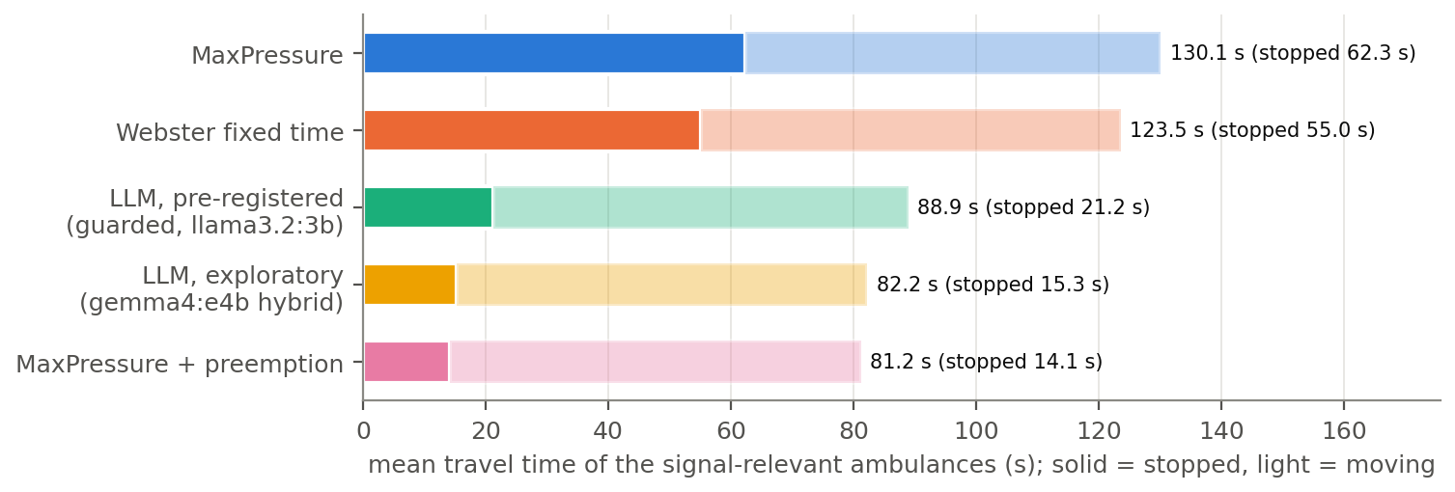
Figure 7.4: Mean travel time of the signal-relevant ambulances, split into time stopped (solid) and time moving (light).
Normal traffic does not pay for the priority. Network ATT under the main arm is 116.4 s against MaxPressure’s 115.7 s, a difference well inside the seed-to-seed spread (±2.3 s).

7.4 Model size (exploratory)
Exploratory, planned after the main results. With the controller fixed to the unguarded hybrid (hybrid_v3), only the model was changed, from 3 B local models to a hosted 550 B mixture-of-experts model (Nemotron 3 Ultra [33], 55 B parameters active per token). Table 7.10 and Figure 7.5 give the results.
Table 7.10: Exploratory model-size study, Indian 2x2 peak, 3 seeds. “Follows pressure” = share of answers that are the highest-pressure option. Failed calls apply MaxPressure’s choice.
Model | Total params (B) | ATT (s), mean ± std | ATT vs MaxPressure, mean (range over seeds) | Seeds worse than MaxPressure | Follows pressure | Answer differs from MaxPressure | Failed calls
qwen2.5:3b | 3.1 | 174.4 ± 2.8 | +51.0% (+47.6 to +53.5) | 3 of 3 | 17% | 83% | 308 of 5229 (5.9%): reason_too_long 308
llama3.2:3b | 3.2 | 209.6 ± 8.9 | +81.4% (+74.1 to +86.1) | 3 of 3 | 2% | 99% | 0 of 5393 (0.0%)
gemma4:e4b | 7.5 | 113.7 ± 0.3 | -1.5% (-2.2 to -0.5) | 0 of 3 | 80% | 21% | 3 of 2541 (0.1%): reason_too_long 3
llama3.1:8b | 8 | 117.1 ± 2.6 | +1.4% (-1.4 to +4.3) | 2 of 3 | 62% | 43% | 0 of 2207 (0.0%)
nemotron-3-ultra-550b | 550 | 114.8 ± 3.6 | -0.6% (-3.1 to +3.9) | 1 of 3 | 99% | 2% | 39 of 2205 (1.8%): retries_exhausted 37, timeout 2
MaxPressure (baseline) | – | 115.5 ± 0.9 | +0.0% | – | – | – | –
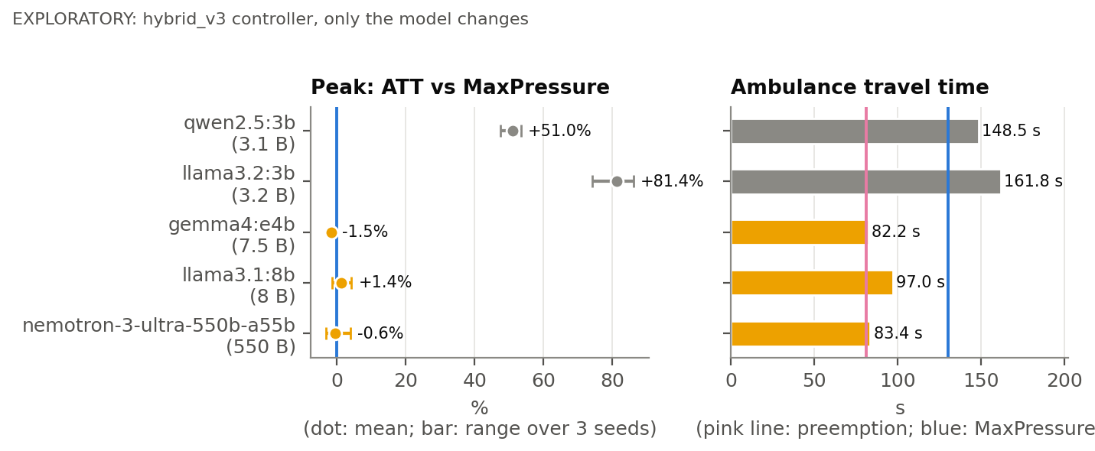
Figure 7.5: Exploratory: the same hybrid controller with five models. Left: ATT relative to MaxPressure at peak (dot: mean; bar: range over seeds). Right: mean travel time of the 29 signal-relevant ambulances. Grey: models worse than MaxPressure on every seed.
- Below some size the LLM makes the hybrid controller worse. With either 3 B model the hybrid is far behind MaxPressure on every seed (ATT +51.0% and +81.4% at peak). Without the guard, their preference for keeping the current phase is applied.
- From gemma4:e4b upwards, ATT is MaxPressure’s within seed noise. gemma4:e4b, llama3.1:8b and the 550 B model are within a few percent of MaxPressure; only gemma4 is better on every peak seed.
- Following pressure grows with size, but not strictly with parameter count. gemma4:e4b follows pressure in 80% of calls, llama3.1:8b in 62%, the hosted model in 99%: away from ambulances it nearly copies MaxPressure. Model family and training matter as much as size.
- Ambulances show the clearest effect of size (Table 7.11). gemma4:e4b and the hosted model bring the signal-relevant ambulances through about as fast as preemption, without preempting: when an ambulance is in view they leave MaxPressure’s choice and give it green.
Table 7.11: Exploratory: signal-relevant ambulances under each model (emergency scenario, 5 seeds), paired with MaxPressure and with preemption.
Controller / model | Signal-relevant ambulances finished | Travel time, mean (s) | Stopped time, mean (s) | vs MaxPressure, paired | vs MaxPressure + preemption, paired
qwen2.5:3b | 29 of 29 | 148.5 | 77.5 | +18.4 s (11 faster, 18 slower, of 29) | +67.3 s (3 faster, 26 slower, of 29)
llama3.2:3b | 29 of 29 | 161.8 | 86.4 | +31.7 s (13 faster, 16 slower, of 29) | +80.6 s (5 faster, 24 slower, of 29)
gemma4:e4b | 29 of 29 | 82.2 | 15.3 | -47.9 s (27 faster, 2 slower, of 29) | +1.1 s (16 faster, 12 slower, of 29)
llama3.1:8b | 29 of 29 | 97.0 | 29.7 | -33.1 s (23 faster, 6 slower, of 29) | +15.8 s (9 faster, 19 slower, of 29)
nemotron-3-ultra-550b | 29 of 29 | 83.4 | 16.5 | -46.7 s (28 faster, 1 slower, of 29) | +2.3 s (14 faster, 14 slower, of 29)
MaxPressure (baseline) | 29 of 29 | 130.1 | 62.3 | +0.0 s (0 faster, 0 slower, of 29) | +48.9 s (1 faster, 28 slower, of 29)
MaxPressure + preemption (baseline) | 29 of 29 | 81.2 | 14.1 | -48.9 s (28 faster, 1 slower, of 29) | +0.0 s (0 faster, 0 slower, of 29)
The hosted model’s runs depended on an API that throttled the account heavily during the full runs: many calls were retried several times, and calls that ran out of retries were counted as failures and fell back to MaxPressure’s choice (Appendix E). Its prompts also leave the machine, so it is not an on-device option.

7.5 Camera errors
The camera-error experiment repeated the main comparisons with the controllers’ counts degraded by the detector’s measured errors (Section 5.4), while the simulator stayed exact. Ambulance positions were not noised (GPS / V2X assumption). Table 7.12 and Table 7.13 give the main block and Figure 7.6 the paired changes.
Table 7.12: Camera errors, Indian 2x2 off-peak, 3 seeds. The paired change is against perfect counts on the same seed.
controller | level | ATT (s) | ATT vs perfect, paired (s; range; %) | queue / int. (veh) | waiting / veh (s) | finished trips
MaxPressure | perfect | 88.1 ± 1.0 | – | 4.94 ± 0.23 | 29.8 ± 0.9 | 2332 ± 36
 | junction | 92.4 ± 0.5 | +4.3 (+3.7 to +4.7); +4.8% | 5.64 ± 0.16 | 33.9 ± 0.4 | 2323 ± 35
 | crowded | 95.4 ± 1.7 | +7.3 (+6.4 to +8.8); +8.2% | 6.15 ± 0.34 | 37.0 ± 1.5 | 2320 ± 38
Webster fixed-time | perfect | 100.4 ± 4.1 | – | 6.82 ± 0.52 | 41.1 ± 3.9 | 2320 ± 36
 | junction | 100.4 ± 4.1 | +0.0 (+0.0 to +0.0); +0.0% | 6.82 ± 0.52 | 41.1 ± 3.9 | 2320 ± 36
 | crowded | 100.4 ± 4.1 | +0.0 (+0.0 to +0.0); +0.0% | 6.82 ± 0.52 | 41.1 ± 3.9 | 2320 ± 36
LLM arm (guarded llama3.2:3b) | perfect | 89.0 ± 0.8 | – | 5.08 ± 0.18 | 30.6 ± 0.6 | 2327 ± 41
 | junction | 93.5 ± 0.6 | +4.5 (+3.8 to +4.9); +5.1% | 5.82 ± 0.21 | 35.0 ± 0.7 | 2321 ± 35
 | crowded | 95.3 ± 0.3 | +6.4 (+5.5 to +7.5); +7.2% | 6.13 ± 0.09 | 36.9 ± 0.4 | 2318 ± 35

Table 7.13: Camera errors, Indian 2x2 peak, 3 seeds.
controller | level | ATT (s) | ATT vs perfect, paired (s; range; %) | queue / int. (veh) | waiting / veh (s) | finished trips
MaxPressure | perfect | 115.5 ± 0.9 | – | 17.83 ± 0.32 | 54.1 ± 0.5 | 4576 ± 68
 | junction | 118.2 ± 1.8 | +2.7 (+1.2 to +4.3); +2.3% | 18.62 ± 0.21 | 56.5 ± 1.6 | 4584 ± 80
 | crowded | 120.6 ± 1.4 | +5.1 (+3.5 to +7.7); +4.4% | 19.37 ± 0.67 | 58.8 ± 1.4 | 4582 ± 84
Webster fixed-time | perfect | 116.3 ± 4.6 | – | 18.27 ± 1.28 | 55.4 ± 4.0 | 4577 ± 87
 | junction | 116.3 ± 4.6 | +0.0 (+0.0 to +0.0); +0.0% | 18.27 ± 1.28 | 55.4 ± 4.0 | 4577 ± 87
 | crowded | 116.3 ± 4.6 | +0.0 (+0.0 to +0.0); +0.0% | 18.27 ± 1.28 | 55.4 ± 4.0 | 4577 ± 87
LLM arm (guarded llama3.2:3b) | perfect | 116.1 ± 2.9 | – | 17.97 ± 0.85 | 54.5 ± 2.5 | 4582 ± 77
 | junction | 117.9 ± 1.7 | +1.8 (-0.5 to +3.2); +1.6% | 18.52 ± 0.28 | 56.2 ± 1.4 | 4571 ± 77
 | crowded | 121.7 ± 1.2 | +5.6 (+3.6 to +9.6); +4.9% | 19.69 ± 0.74 | 59.7 ± 1.3 | 4577 ± 81
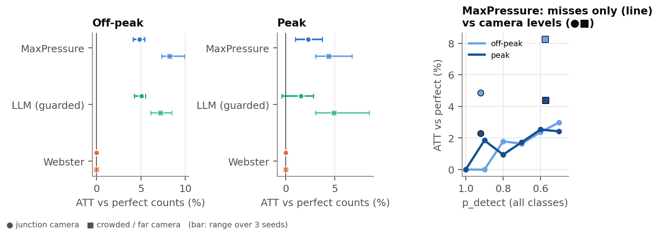
Figure 7.6: Left and centre: paired change in ATT against perfect counts for each controller and camera level (bar: range over seeds). Right: MaxPressure with only missed vehicles (uniform detection probability, line) and with the camera levels (markers) at their effective detection rates.
- Every count-based controller gets slower. With the junction camera MaxPressure’s ATT rises by 4.8% off-peak and 2.3% at peak, and with crowded / far detection by 8.2% and 4.4%; every seed is worse. The LLM arm degrades by about as much (junction +5.1% / +1.6%), which is expected: the guard’s pressures come from the same noisy counts.
- The Webster plan is unaffected: it never reads counts, and its runs are identical at every level.
- At peak the advantage of adaptive control disappears. With perfect counts MaxPressure and Webster were level at peak; with junction-camera counts MaxPressure’s mean ATT (118.2 s) falls behind Webster’s (116.3 s). Off-peak MaxPressure stays ahead, with a smaller margin.
Missed vehicles alone cost little (Table 7.14). With half of all vehicles missed and no false detections, MaxPressure loses only 3.0% off-peak and 2.4% at peak. When every vehicle is missed with the same probability, every phase’s expected pressure shrinks by the same factor, so the ranking is unchanged on average; only the added randomness costs. The junction camera is different: it detects 92% of vehicles, yet off-peak it costs +4.8%, whereas detecting 90% of vehicles with nothing else wrong costs 0.0%. What the camera adds are phantom vehicles: about 0.7 per road and snapshot, all counted as stopped.
Table 7.14: MaxPressure with every class detected with the same probability, no false detections and exact labels (mean ± std over 3 seeds, change against perfect counts in brackets).
p_detect (all classes, no false detections) | Off-peak: MaxPressure ATT (s) | Peak: MaxPressure ATT (s)
1.00 | 88.1 ± 1.0 | 115.5 ± 0.9
0.90 | 88.1 ± 0.8 (-0.0%) | 117.7 ± 1.5 (+1.8%)
0.80 | 89.7 ± 0.3 (+1.8%) | 116.6 ± 1.3 (+0.9%)
0.70 | 89.6 ± 0.7 (+1.6%) | 117.5 ± 1.2 (+1.7%)
0.60 | 90.2 ± 1.5 (+2.4%) | 118.5 ± 1.4 (+2.5%)
0.50 | 90.8 ± 0.8 (+3.0%) | 118.3 ± 0.7 (+2.4%)
Decomposition (post-hoc). To test that explanation, the junction level was re-run with one error component at a time (Table 7.15, Figure 7.7). Off-peak, false detections alone cost +3.8% of the +4.8%, misses +0.8% and class confusion nearly nothing, and the three add up to the whole effect. At peak no single component explains the +2.3%: the components sum to only +0.4%, so either they interact near capacity or part of the peak effect is chance; three seeds cannot tell which. Class confusion alone has no measurable effect because these controllers read class-free counts.
Table 7.15: Post-hoc decomposition of the junction-camera errors (MaxPressure, 3 seeds): one component switched on at a time. Each component draws its own random numbers, so they need not add up.
junction-camera errors | Off-peak: ATT vs perfect, paired (s; range; %) | Peak: ATT vs perfect, paired (s; range; %) | realised detection rate | phantoms per road and snapshot
(a) misses only | +0.7 (-0.6 to +1.7); +0.8% | +0.7 (+0.3 to +1.2); +0.6% | 0.920 | 0.000
(b) false detections only | +3.4 (+2.8 to +3.7); +3.8% | -0.3 (-1.8 to +1.0); -0.3% | 1.000 | 0.688
(c) class confusion only | +0.1 (-1.1 to +1.0); +0.2% | +0.1 (-1.6 to +1.4); +0.1% | 1.000 | 0.000
(d) all (main batch junction level) | +4.3 (+3.7 to +4.7); +4.8% | +2.7 (+1.2 to +4.3); +2.3% | 0.921 | 0.690
sum of (a) + (b) + (c) | +4.3; +4.8% | +0.4; +0.4%
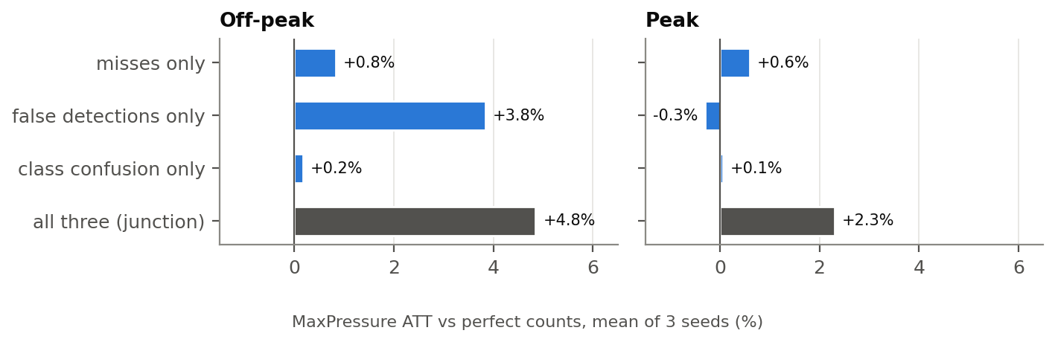
Figure 7.7: Post-hoc decomposition: MaxPressure’s ATT change with one junction-camera error component at a time.
Ambulances under camera errors (Table 7.16). Preemption keeps its advantage (81.2 s → 84.5 s) because it reads ambulance positions from the separate channel. The LLM arm’s ambulances are 11.0 s slower on average with junction-camera counts, but individual ambulances move by tens of seconds in either direction between paired runs, so this is not distinguishable from zero with 29 ambulances.
Table 7.16: Emergency scenario under junction-camera counts (5 seeds). Ambulance positions are not noised.
controller | level | ATT (s) | ATT vs perfect, paired (s; range; %) | ambulances finished | ambulance travel time (s) | ambulance vs perfect, paired (s)
MaxPressure | perfect | 115.7 ± 2.3 | – | 29 / 29 | 130.1 | –
 | junction | 117.6 ± 2.4 | +1.8 (-1.9 to +7.1); +1.6% | 29 / 29 | 135.9 | +5.8 (n 29; 14 slower, 13 faster)
Webster fixed-time | perfect | 115.2 ± 2.7 | – | 29 / 29 | 123.5 | –
 | junction | 115.2 ± 2.7 | +0.0 (+0.0 to +0.0); +0.0% | 29 / 29 | 123.5 | +0.0 (n 29; 0 slower, 0 faster)
MaxPressure + preemption | perfect | 116.0 ± 0.7 | – | 29 / 29 | 81.2 | –
 | junction | 117.2 ± 2.3 | +1.1 (-0.8 to +5.1); +1.0% | 29 / 29 | 84.5 | +3.3 (n 29; 16 slower, 12 faster)
LLM arm (guarded llama3.2:3b) | perfect | 116.4 ± 3.1 | – | 29 / 29 | 88.9 | –
 | junction | 120.2 ± 1.8 | +3.8 (-0.3 to +9.6); +3.3% | 29 / 29 | 99.9 | +11.0 (n 29; 17 slower, 11 faster)

7.6 Detector
The detector results are given in full in Section 5.3. In summary, YOLOv8n trained on IDD reaches mAP50 0.563 and mAP50-95 0.375 on held-out drives, with high precision and moderate recall; its errors are dominated by small, distant objects. The dashboard runs the same weights on video (Figure 7.8).
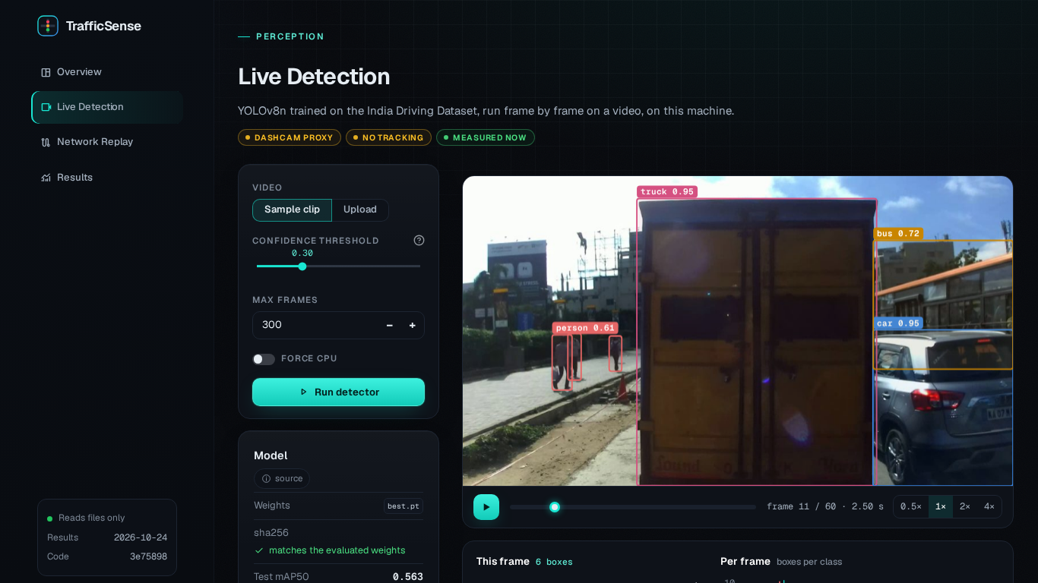
Figure 7.8: Dashboard, Live Detection page: the trained detector on a clip of IDD test frames, with boxes, per-class counts and the measured speed on the GTX 1650.

Chapter 8: Discussion

8.1 Why the LLM agents match MaxPressure but do not beat it
Three observations together explain the main result.
First, an LLM that reads pressure correctly becomes MaxPressure. In the hybrid controllers the LLM is shown each option’s pressure and queue, the same information MaxPressure uses. The largest model tested, the hosted Nemotron 3 Ultra, chose the highest-pressure option in 99% of its calls, and its ATT is within seed noise of MaxPressure’s (Section 7.4). This is the expected end point: for steady demand on a small grid, serving the largest pressure is close to the best a one-step rule can do, and the extra information in the prompt, the neighbours’ queues, rarely points to a better phase. To beat MaxPressure an agent must use information MaxPressure does not have, or plan over more than one decision. Neither was asked of the agents in the pre-registered design.
Second, small models misread the task. With prompts v2 and guided, the 3 B models treated low pressure as good and kept the current phase most of the time, and their reasons said so in words (Section 7.1). The v3 fix, which states which direction of pressure is better, changed gemma4:e4b but not the 3 B models. A model of this size follows the surface of the prompt (“keep”, “low queue”) more than its stated rule. Without a guard their choices are applied and the controller is far worse than MaxPressure (Table 7.10).
Third, the guard converts a poor model into MaxPressure with noise. The pre-registered controller’s answers differ from MaxPressure’s in about nine of ten calls, but the guard replaces most of them, and the applied phase differs in about one in ten. What remains are choices within 20% of the top pressure. Off-peak, when queues are short, such a choice gives green to a slightly smaller queue and costs a little; this is the small, consistent deficit seen on every off-peak seed. The guard therefore made the LLM safe to deploy, not useful.
The exploratory gemma4:e4b arm follows pressure in most calls and departs from MaxPressure in about one call in five at peak, where it was faster on every seed. We have not identified the mechanism. One hypothesis is that its departures more often keep a phase that is still discharging a long queue, avoiding a transition; this was not tested, and with three seeds the gain itself needs confirmation.

8.2 Why the LLM agents help ambulances
The ambulance experiment is the one case where the agent has information MaxPressure lacks: the prompt lists each approaching ambulance, its distance and the phases that serve it. A one-sentence instruction was enough for the pre-registered arm to cut ambulance travel time by 31.7% compared with MaxPressure, mostly by removing time stopped at a red. Two design choices helped: the phase that serves the ambulance is always among the options, and it is exempt from the guard. Normal traffic was not measurably slowed, because ambulances are rare and each priority decision affects one intersection for a short time.
A hand-written preemption rule did slightly better. This is the honest comparison for a deployment decision: for a single, well-defined rule like “give green to the ambulance”, a rule is simpler, faster and verifiable. The case for an LLM agent is flexibility, not performance. The same mechanism, a sentence in the system prompt and a line in the observation, can carry rules that are awkward to hard-code: a road closure, a school zone at certain hours, a police instruction, priority for a bus that is late. This project tested only the ambulance case.

8.3 What the camera study means
Adaptive control is only as good as its counts. With counts degraded by the errors of a real detector, every count-based controller lost a few percent of travel time, and at peak its advantage over a well-timed fixed plan, already small with exact counts, disappeared. Three lessons follow for a deployment.
- False detections hurt more than misses. Missing vehicles uniformly scales every pressure down and barely changes the ranking. A phantom vehicle adds pressure where there is none and changes the decision directly. For signal control a detector’s precision matters more than its recall, the opposite of the usual emphasis, and temporal smoothing or tracking that rejects one-frame detections should help (each snapshot here is independent, the worst case).
- Camera placement matters. The junction level, which assumes queued vehicles are close enough to be medium or large in the image, costs about half as much as the crowded / far level.
- A fixed plan is a robust fallback. Webster’s plan does not depend on counts at all. Where detection is unreliable, at night or in heavy rain, a controller should fall back to a good fixed plan rather than act on bad counts.
These conclusions rest on a proxy: the detector’s errors on dash-camera images. The same detector on a pole-mounted camera could be better (closer, less occlusion) or worse (unfamiliar viewpoint).

8.4 Threats to validity
Internal validity. Three seeds per scenario (five with ambulances) are few, and no significance test was pre-registered; differences of one or two percent are within seed noise and are reported as such. LLM runs are not bit-for-bit repeatable on the GPU, although every decision is logged and replayable. Prompt v3 was a post-hoc fix, the gemma4:e4b arm and the model-size study were added after the plans were fixed, and the camera decomposition was post-hoc; all are labelled. The hosted model’s runs were affected by heavy API throttling, which turned some decisions into MaxPressure fallbacks.
Construct validity. ATT counts time spent waiting to enter the network, which penalises controllers that block entries; this is intended but makes ATT differ from definitions used elsewhere, including CoLLMLight’s (Section 4.2). The ambulance metric assumes that nobody yields and that ambulances cannot overtake, so it measures only what the signal can do. The camera layer draws independent snapshots and does not model occlusion between lanes or ambulance detection.
External validity. CityFlow is lane-based and cannot represent lane-free Indian driving (Section 4.1). The Indian network is a 2 × 2 grid with synthetic, steady demand; its vehicle mix comes from one city in one year; and the turning shares are assumptions. Jinan provides one real-world flow. Latencies are specific to a GTX 1650. The results show what a small local model does on this network; they do not show how a deployed system would perform on a real junction.

8.5 Relation to the base paper
CoLLMLight reports that cooperative LLM agents outperform existing methods. Our results neither confirm nor contradict that claim, because the settings differ in ways that matter: CoLLMLight fine-tunes its model in several stages and uses an asynchronous reasoning architecture, while we used small models as released; we compared against MaxPressure and Webster tuned on the test networks; and we found that CoLLMLight’s own fixed-time baseline does not serve north–south traffic. Its metric definitions also differ from CityFlow’s, so numbers cannot be compared directly. What our results do show is that, without fine-tuning, a 3–4 B model is not enough to improve on a tuned MaxPressure, and that the clearest value of an LLM agent appears when it is given information a classical controller cannot use.

Chapter 9: Conclusion and Future Work

9.1 Conclusion
This project built and evaluated TrafficSense, a multi-agent traffic-signal controller in which each intersection is run by a local LLM agent that observes its own and its neighbours’ state, reasons and acts, adapted from CoLLMLight to a 4 GB laptop GPU. The objectives set in Section 1.3 were met as follows.
- A validated pipeline. Our CityFlow environment reproduces the CoLLMLight authors’ own baseline results when driven the same way (throughput and queue exactly, waiting and travel times to within the simulator’s run-to-run noise), and the validation exposed a bug in their fixed-time baseline.
- An Indian test network with documented parameters, calibrated against measured capacity, and baselines tuned before the comparison: MaxPressure with a 15 s minimum green, and a Webster plan computed from perfect counts.
- A pre-registered comparison. The selected LLM controller, llama3.2:3b guided and guarded by MaxPressure, performs within 0.5–0.9% of MaxPressure’s travel time and runs in real time, but does not improve on it. The reason is clear from its decision logs: small models misread pressure, and the guard, which makes them safe, also makes them MaxPressure.
- A clear benefit for emergency vehicles. Told about approaching ambulances, the agent cut their mean travel time from 130.1 s to 88.9 s, close to a hand-written preemption rule, without slowing other traffic.
- A measured camera-error study. A YOLOv8n detector trained on IDD reaches mAP50 0.563 on held-out drives. Its measured errors cost count-based controllers a few percent of travel time, mostly through false detections, and remove adaptive control’s small lead over a fixed plan at peak.
- A dashboard and a report generated from the data, with every number checked against the result files.
The overall answer to the question in Chapter 1 is therefore modest and, we believe, useful: a small local LLM does not yet beat a well-tuned classical controller on routine traffic, but as a guarded layer on top of one it is safe, and it adds value where the situation is described in words rather than in queue counts.

9.2 Future work
- Memory and tool-using agents. The agents here see one snapshot and answer once. An agent that remembers its recent decisions and their effects, and can call tools (MaxPressure’s ranking, a short look-ahead simulation, the queue history of an approach), could plan over several decisions, which is where an agent might beat a one-step rule.
- Fine-tuning small models. CoLLMLight’s training stages (reasoning refinement and policy refinement with simulation feedback) were not reproduced. Fine-tuning a 3 B model on decisions scored by the simulator may fix the pressure misreading that prompting could not.
- Real junction camera footage. Collecting and labelling video from a fixed camera at an Indian junction would replace the dash-camera proxy with the true error, and would allow tracking-based counting that rejects one-frame false detections.
- Larger networks and real demand. Hangzhou and New York networks are available in the same format; counts from a real Indian corridor would replace the synthetic demand. A simulator with sub-lane movement would represent two-wheeler filtering.
- Faster inference. A larger GPU or a smaller, faster model would make the stronger gemma4:e4b-class controller real-time and allow more seeds for a confirmatory test of its peak gain.
- Field testing. A first deployment would run the agent in shadow mode beside an existing controller, logging what it would have done, before it is allowed to switch a real signal. Ambulance positions would come from a GPS or V2X feed, as assumed here.

References
[1] F. V. Webster, ‘Traffic signal settings’, Road Research Laboratory, Her Majesty’s Stationery Office, London, Road Research Technical Paper 39, 1958.
[2] A. G. Sims and K. W. Dobinson, ‘The Sydney coordinated adaptive traffic (SCAT) system philosophy and benefits’, IEEE Transactions on Vehicular Technology, vol. 29, no. 2, pp. 130–137, 1980, doi: 10.1109/T-VT.1980.23833.
[3] P. B. Hunt, D. I. Robertson, R. D. Bretherton, and R. I. Winton, ‘SCOOT – a traffic responsive method of coordinating signals’, Transport; Road Research Laboratory, Crowthorne, TRRL Laboratory Report 1014, 1981.
[4] P. Varaiya, ‘Max pressure control of a network of signalized intersections’, Transportation Research Part C: Emerging Technologies, vol. 36, pp. 177–195, 2013, doi: 10.1016/j.trc.2013.08.014.
[5] H. Wei, G. Zheng, V. Gayah, and Z. Li, ‘Recent advances in reinforcement learning for traffic signal control: A survey of models and evaluation’, ACM SIGKDD Explorations Newsletter, vol. 22, no. 2, pp. 12–18, 2021, doi: 10.1145/3447556.3447565.
[6] S. Lai, Z. Xu, W. Zhang, H. Liu, and H. Xiong, ‘LLMLight: Large language models as traffic signal control agents’. arXiv preprint arXiv:2312.16044, 2023. Available: https://arxiv.org/abs/2312.16044
[7] M. Wang, A. Pang, Y. Kan, M.-O. Pun, C. S. Chen, and B. Huang, ‘LLM-assisted light: Leveraging large language model capabilities for human-mimetic traffic signal control in complex urban environments’. arXiv preprint arXiv:2403.08337, 2024. Available: https://arxiv.org/abs/2403.08337
[8] Z. Yuan, S. Lai, and H. Liu, ‘CoLLMLight: Cooperative large language model agents for network-wide traffic signal control’, in Proceedings of the international conference on learning representations (ICLR), 2026. Available: https://openreview.net/forum?id=KeJqoEVOeY
[9] Innovative Transport Solutions (iTrans) Pvt. Ltd., ‘Two- and three-wheelers in India’, Indian Institute of Technology Delhi, for the International Council on Clean Transportation (ICCT); the Institute for Transportation; Development Policy (ITDP), Final report, 2009.
[10] S. Chandra and U. Kumar, ‘Effect of lane width on capacity under mixed traffic conditions in India’, Journal of Transportation Engineering, vol. 129, no. 2, pp. 155–160, 2003, doi: 10.1061/(ASCE)0733-947X(2003)129:2(155).
[11] CSIR-Central Road Research Institute, Indian highway capacity manual (indo-HCM). New Delhi: CSIR-Central Road Research Institute, 2017.
[12] T. V. Mathew and P. Radhakrishnan, ‘Calibration of microsimulation models for nonlane-based heterogeneous traffic at signalized intersections’, Journal of Urban Planning and Development, vol. 136, no. 1, pp. 59–66, 2010, doi: 10.1061/(ASCE)0733-9488(2010)136:1(59).
[13] H. Zhang et al., ‘CityFlow: A multi-agent reinforcement learning environment for large scale city traffic scenario’, in The world wide web conference (WWW ’19), 2019, pp. 3620–3624. doi: 10.1145/3308558.3314139.
[14] P. Koonce et al., ‘Traffic signal timing manual’, Federal Highway Administration, U.S. Department of Transportation, FHWA-HOP-08-024, 2008.
[15] L. Tassiulas and A. Ephremides, ‘Stability properties of constrained queueing systems and scheduling policies for maximum throughput in multihop radio networks’, IEEE Transactions on Automatic Control, vol. 37, no. 12, pp. 1936–1948, 1992, doi: 10.1109/9.182479.
[16] B. Abdulhai, R. Pringle, and G. J. Karakoulas, ‘Reinforcement learning for true adaptive traffic signal control’, Journal of Transportation Engineering, vol. 129, no. 3, pp. 278–285, 2003, doi: 10.1061/(ASCE)0733-947X(2003)129:3(278).
[17] W. Genders and S. Razavi, ‘Using a deep reinforcement learning agent for traffic signal control’. arXiv preprint arXiv:1611.01142, 2016. Available: https://arxiv.org/abs/1611.01142
[18] H. Wei, G. Zheng, H. Yao, and Z. Li, ‘IntelliLight: A reinforcement learning approach for intelligent traffic light control’, in Proceedings of the 24th ACM SIGKDD international conference on knowledge discovery & data mining, 2018, pp. 2496–2505. doi: 10.1145/3219819.3220096.
[19] H. Wei et al., ‘PressLight: Learning max pressure control to coordinate traffic signals in arterial network’, in Proceedings of the 25th ACM SIGKDD international conference on knowledge discovery & data mining, 2019, pp. 1290–1298. doi: 10.1145/3292500.3330949.
[20] H. Wei et al., ‘CoLight: Learning network-level cooperation for traffic signal control’, in Proceedings of the 28th ACM international conference on information and knowledge management (CIKM), 2019, pp. 1913–1922. doi: 10.1145/3357384.3357902.
[21] C. Chen et al., ‘Toward a thousand lights: Decentralized deep reinforcement learning for large-scale traffic signal control’, in Proceedings of the AAAI conference on artificial intelligence, 2020, pp. 3414–3421. doi: 10.1609/aaai.v34i04.5744.
[22] Ollama, Ollama: Run large language models locally. (2026). Available: https://github.com/ollama/ollama
[23] N. Buch, S. A. Velastin, and J. Orwell, ‘A review of computer vision techniques for the analysis of urban traffic’, IEEE Transactions on Intelligent Transportation Systems, vol. 12, no. 3, pp. 920–939, 2011, doi: 10.1109/TITS.2011.2119372.
[24] J. Redmon, S. Divvala, R. Girshick, and A. Farhadi, ‘You only look once: Unified, real-time object detection’, in Proceedings of the IEEE conference on computer vision and pattern recognition (CVPR), 2016, pp. 779–788. doi: 10.1109/CVPR.2016.91.
[25] G. Jocher, A. Chaurasia, and J. Qiu, Ultralytics YOLOv8. (2023). Available: https://github.com/ultralytics/ultralytics
[26] T.-Y. Lin et al., ‘Microsoft COCO: Common objects in context’, in Computer vision – ECCV 2014, in Lecture notes in computer science, vol. 8693. Springer, 2014, pp. 740–755. doi: 10.1007/978-3-319-10602-1_48.
[27] K. Nellore and G. P. Hancke, ‘Traffic management for emergency vehicle priority based on visual sensing’, Sensors, vol. 16, no. 11, p. 1892, 2016, doi: 10.3390/s16111892.
[28] G. Varma, A. Subramanian, A. Namboodiri, M. Chandraker, and C. V. Jawahar, ‘IDD: A dataset for exploring problems of autonomous navigation in unconstrained environments’, in IEEE winter conference on applications of computer vision (WACV), 2019, pp. 1743–1751. doi: 10.1109/WACV.2019.00190.
[29] Umapathi and R. Khatawkar, ‘Effect of carriageway width on PCU and capacity of two lane roads: A case study of Shivamogga district’, Journal of Emerging Technologies and Innovative Research (JETIR), vol. 6, no. 6, pp. 89–93, 2019.
[30] B. A. Nosek, C. R. Ebersole, A. C. DeHaven, and D. T. Mellor, ‘The preregistration revolution’, Proceedings of the National Academy of Sciences, vol. 115, no. 11, pp. 2600–2606, 2018, doi: 10.1073/pnas.1708274114.
[31] A. Grattafiori et al., ‘The Llama 3 herd of models’. arXiv preprint arXiv:2407.21783, 2024. Available: https://arxiv.org/abs/2407.21783
[32] Qwen Team, ‘Qwen2.5 technical report’. arXiv preprint arXiv:2412.15115, 2024. Available: https://arxiv.org/abs/2412.15115
[33] NVIDIA, ‘Nemotron 3 Ultra (nvidia/nemotron-3-ultra-550b-a55b) model card’. NVIDIA API catalog, build.nvidia.com, 2026.

Appendix A: Configuration
Every setting used in the experiments is read from YAML files in configs/; no setting is typed into code. The listings below are copied from the files by the report’s build script, so they are the settings actually in force.

A.1 Main configuration
Excerpt of configs/default.yaml:
sim:
steps: 3600 # default run length (CLAUDE.md)
interval: 1.0 # seconds per simulator step
seed: 0
threads: 1
lane_change: false # CityFlow laneChange; CoLLMLight runs with true
signal:
min_green: 10 # s
max_green: 60 # s
emergency:
detection_range_m: 150 # ASSUMPTION: an ambulance on an incoming lane within this distance of
# the stop line is detected (lanes are 176-188 m long; at 12.5 m/s an
# ambulance covers 150 m in 12 s, enough for a 5 s decision step plus
# the 5 s transition)
controllers: # excerpt
fixedtime:
green_time: 30 # s per green phase
phases: paired # the 4 opposing-approach phases that serve every non-right movement once
fixedtime_webster: # 4 paired phases; cycle and splits by Webster's method (control/webster.py)
cycle_min: 60 # s
cycle_max: 180 # s
demand_window_s: 3600 # lane demand = vehicles in the flow file starting in [0, window)
measurement_reps: 30 # random-order queues averaged for saturation flow / start-up loss
measurement_seed: 0 # seed of those queue orders (not the run seed)
maxpressure:
decision_interval: 5 # s between re-evaluations
min_green: 15 # s, controller's own minimum green (>= signal.min_green).
# Chosen by scripts/tune_maxpressure_min_green.py (docs/baselines.md)
phases: all # all | paired (CoLLMLight's MaxPressure uses the 4 paired phases)
tie_break: keep_current # keep_current | lowest_index (CoLLMLight: np.argmax -> lowest)
preemption_mp: # MaxPressure + rule-based ambulance preemption (control/preemption.py)
decision_interval: 5 # same timing as the default MaxPressure and the LLM benchmark
min_green: 15
tie_break: keep_current
llm_guided_mp_v3:
mode: cooperative
prompt: guided_v3
options: 2
tie_break: keep_current
llm_guarded_mp: # llm_guided_mp_v3 + guard: the LLM's phase is applied only if its pressure
mode: cooperative # >= 0.8 x the top phase's (control/guided.py), else MaxPressure's choice
prompt: guided_v3
options: 2
tie_break: keep_current
guard_ratio: 0.8
llm:
provider: ollama
host: http://localhost:11434
endpoint: /api/chat # native endpoint, structured output via `format` (JSON schema)
model: null # chosen after scripts/benchmark_llm.py; must be set for LLM runs
timeout_s: 60 # per call; a timeout counts as a failed decision
temperature: 0
seed: 0 # LLM sampling seed, fixed (recorded in every summary.json)
num_ctx: 2048 # context window (tokens). Prompts are ~650; at 4096 llama3.2:3b no longer fits
# fully in the GTX 1650's VRAM. A prompt that could be truncated raises.
num_predict: 128 # cap on generated tokens; the JSON answer needs about 40
keep_alive: 30m # keep the model loaded between calls
decision_interval: null # s; decided after scripts/benchmark_llm.py
min_green: null # s; LLM controller's own min green (>= signal.min_green)
max_consecutive_failures: 20 # this many failed calls in a row stops the run with an error

A.2 Indian 2x2 scenario
Excerpt of configs/scenarios/indian_2x2.yaml; the vehicle-type parameters are given in Table 4.4.
roadnet:
file: data/scenarios/indian_2x2/roadnet.json
rows: 2
cols: 2
spacing_m: 200 # between intersections (Phase 2 spec)
boundary_road_m: 200 # entry/exit roads to the network edge (ASSUMPTION: same as spacing)
lane_width_m: 3.0 # Phase 2 spec (~3.0 m)
lanes: # per direction, one lane per turn (CityFlow generator layout)
left: 1
straight: 1
right: 1
lane_max_speed_mps: 12.5 # 45 km/h; Phase 2 spec range 11-13 m/s (ASSUMPTION within it)
intersection_width_m: 12 # distance from the centre to the stop line (ASSUMPTION, see doc)
# Phases come from the generator: phase 0 = 5 s transition (right turns only), phases 1-8 green.
turn_probabilities: # ASSUMPTION
go_straight: 0.60
turn_right: 0.25 # Indian free left
turn_left: 0.15 # Indian right turn
entry_weights: # ASSUMPTION
W: 1.0
E: 1.0
N: 0.6
S: 0.6
demand_levels:
offpeak:
veh_per_hour: 2375
peak:
veh_per_hour: 4750
emergency:
vehicle_type: ambulance
veh_per_hour: 6 # ASSUMPTION (Phase 3b spec "~6/hour", whole 2x2 network, both levels)
seed_offset: 1000 # ASSUMPTION: any fixed offset; ambulance RNG seed = flow seed + 1000

Appendix B: Prompts
The system prompts below are rendered by the controllers’ own code (src/trafficsense/llm/prompt.py) with the timing used in the experiments. The LLM must answer with JSON that matches a schema listing the allowed phase numbers; the reason is checked for length after parsing.

B.1 Prompt v1 (first round)
You control the traffic signal of one intersection in a city road network with mixed Indian traffic (two-wheelers, auto-rickshaws, cars, buses, trucks).
At each decision you choose which green phase to show next. Goal: keep vehicles moving and queues short across the whole network, so total travel time is low.
Rules of the signal:
- Choosing the current phase keeps it green. Choosing another phase first shows a 5 s transition in which only free turns move, so switching too often wastes green time.
- A green phase cannot be ended before 15 s and is ended automatically at 60 s.
Data you get for each movement: queue = stopped vehicles waiting at the stop line; moving = vehicles driving towards the stop line; downstream = stopped vehicles on the exit road (a full exit road blocks the movement).
Answer with JSON only: {"phase": <one of the allowed phase ids>, "reason": "<at most 25 words>"}.
The v1 user message listed, for every phase, each movement’s queue, moving and downstream counts, the vehicle types per approach, and the neighbours.

B.2 Prompt v2
You pick the next green phase for one traffic signal in an Indian city. Goal: short queues and low travel time network-wide.
Changing phase starts a 5 s transition in which only free turns move. A green lasts 15 to 60 s.
queue = stopped vehicles a phase serves; pressure = queue minus stopped vehicles on their exit roads.
Reply JSON: {"phase": <allowed id>, "reason": "<at most 15 words>"}

B.3 Prompt v3 (v2 with two lines changed)
You pick the next green phase for one traffic signal in an Indian city. Goal: short queues and low travel time network-wide.
Changing phase starts a 5 s transition in which only free turns move. A green lasts 15 to 60 s.
queue = stopped vehicles a phase serves; pressure = vehicles waiting to go minus vehicles already stopped on their exit roads. HIGHER pressure = the phase needs green MORE.
Reply JSON: {"phase": <allowed id>, "reason": "<short reason>"}. The reason must be 15 words or fewer.

B.4 Guided prompt (hybrid arm)
You help a MaxPressure controller run one traffic signal in an Indian city. Goal: short queues and low travel time network-wide.
MaxPressure ranks phases by pressure = stopped vehicles a phase serves minus stopped vehicles on their exit roads; queue = stopped vehicles a phase serves. Choose one of the offered phases; neighbour data may help.
Changing phase starts a 5 s transition in which only free turns move. A green lasts 15 to 60 s.
Reply JSON: {"phase": <offered id>, "reason": "<at most 15 words>"}

B.5 Guided prompt v3 (hybrid_v3 and the pre-registered guarded arm)
You help a MaxPressure controller run one traffic signal in an Indian city. Goal: short queues and low travel time network-wide.
MaxPressure ranks phases by pressure = vehicles waiting to go minus vehicles already stopped on their exit roads; HIGHER pressure = the phase needs green MORE; queue = stopped vehicles a phase serves. Choose one of the offered phases; neighbour data may help.
Changing phase starts a 5 s transition in which only free turns move. A green lasts 15 to 60 s.
Reply JSON: {"phase": <offered id>, "reason": "<short reason>"}. The reason must be 15 words or fewer.
In the emergency scenarios one sentence is added:
You help a MaxPressure controller run one traffic signal in an Indian city. Goal: short queues and low travel time network-wide.
MaxPressure ranks phases by pressure = vehicles waiting to go minus vehicles already stopped on their exit roads; HIGHER pressure = the phase needs green MORE; queue = stopped vehicles a phase serves. Choose one of the offered phases; neighbour data may help.
Changing phase starts a 5 s transition in which only free turns move. A green lasts 15 to 60 s.
Ambulances, if listed, must get through quickly: give green to a phase that serves them.
Reply JSON: {"phase": <offered id>, "reason": "<short reason>"}. The reason must be 15 words or fewer.

B.6 An example user message
The user message of the guided prompts at a real simulator state: Indian 2x2 peak with ambulances, seed 2, intersection_2_2 at t = 265 s, under MaxPressure control up to that moment. MaxPressure ranks phase 2 (S+N straight) first, but an ambulance 70 m from the stop line is served by phases 6, 1, so a phase that serves it is among the options.
Phase 1 (W+E straight) green for 15 s.
Options, best MaxPressure rank first (phase: pressure, queue):
2 S+N straight: 3, 4
3 W+E cross-turn: 3, 4
6 E only: -2, 3
1 W+E straight (keep current): -4, 0
Ambulances within 150 m:
E straight, 70 m from the stop line; served by phase 6, 1
Neighbours:
W: phase 1 (W+E straight); 9 stopped toward us, 7 on green; 4 stopped on our road to it
S: phase 5 (W only); 0 stopped toward us, 0 on green; 1 stopped on our road to it

B.7 A logged decision
One decision of the pre-registered arm, as logged in decisions.jsonl (selected keys): the first decision of its emergency run (seed 0) in which the LLM’s choice differed from MaxPressure’s and served an ambulance. The model’s reason still mentions “low pressure”, but its choice gives the ambulance green; because that phase serves a listed ambulance, the guard does not apply. The guard’s pressures are those shown in the prompt, which leave out the free turns.
{
"step": 1980,
"intersection": "intersection_1_2",
"current_phase": 5,
"time_in_phase": 15,
"allowed": [1, 2, 5, 8],
"mp_ranking": [1, 2, 8, 4, 6, 7, 5, 3],
"mp_choice": 1,
"ambulances": [{"vehicle": "flow_4668_0", "approach": "N", "distance_m": 44.2, "movement": "N cross-turn", "phases": [8, 4]}],
"latency_s": 1.42,
"prompt_tokens": 340,
"server_model": "llama3.2:3b",
"raw": "{\"phase\": 8, \"reason\": \"Low pressure, serving ambulances within 150m\"}",
"llm_phase": 8,
"guard_threshold": 2.4,
"guard_llm_pressure": 3,
"guard_override": false,
"guard_ambulance_exempt": true,
"phase": 8
}

Appendix C: Reproducibility

C.1 How the results are kept honest
- Provenance in every run. Each run writes a folder <time>_<scenario>_<controller>_s<seed>/ with summary.json (metrics plus controller, parameters, model as reported by the server, provider, seed, scenario, run length, git commit and whether the tree was clean, time, and for LLM runs the calls, failures by type and latency), metrics.csv (per-second metrics) and, for LLM runs, decisions.jsonl (every decision with the raw answer).
- Generated documents. Every table in the project’s documents is generated from the result files by a script, and each script has a --check mode that fails if the document and the data disagree.
- This report. Every table in this report is generated from the result files or copied from a checked document by scripts/make_report.py. Every other number taken from the data carries an invisible tag naming its source (a value in a result file, or a cell of a checked table), and make_report.py --check fails if any shown number differs from its source at the precision shown, or if the text contains an untagged number that is not a year, a reference, a small count or a product name. The figures are drawn from the result files, and the values each one plots are stored beside it and checked. scripts/build_report.py refuses to build the Word and PDF files unless that check passes, and then checks that the figure, table and section numbers in the PDF equal those in the Word file.

C.2 Steps
The project runs in WSL2 Ubuntu 22.04 with Python 3.10. The commands below are run from the repository root in its virtual environment; the batch scripts are resumable and skip finished runs.
# environment (exact versions: requirements-lock.txt)
python3.10 -m venv .venv && source .venv/bin/activate
git clone https://github.com/cityflow-project/CityFlow.git ../CityFlow
git -C ../CityFlow checkout 81ee0f4 && pip install ../CityFlow
pip install torch==2.14.1 torchvision==0.29.1 --index-url https://download.pytorch.org/whl/cu126
pip install -e ".[dev,dashboard,perception]" -c requirements-lock.txt
scripts/fetch_collmlight_data.sh # CoLLMLight roadnets and flows
curl -fsSL https://ollama.com/install.sh | sh # or Ollama for Windows (README)
ollama pull llama3.2:3b && ollama pull gemma4:e4b && ollama pull qwen2.5:3b
# Chapter 4: validation, scenario, baselines
python scripts/validation/run_collmlight_baseline.py --model Fixedtime --dataset synthetic_4x4 --seed 0
python scripts/validation/run_matched.py --scenario synthetic_4x4 --profile replica_fixedtime --engine-seed 47
python scripts/validation/make_tables.py
python scripts/generate_indian_roadnet.py
python scripts/calibrate_indian_demand.py --rates 1000 2000 3000 4000 4500 4750 5000 5250 5500 5750 6000 7000 8000 10000 12000 14000
python scripts/generate_indian_flow.py --level all --seed 0 1 2
python scripts/tune_maxpressure.py && python scripts/tune_maxpressure_min_green.py
python scripts/run_indian_experiments.py && python scripts/make_indian_tables.py
# Chapter 7: LLM benchmark, full experiments, ambulances
python scripts/benchmark_llm.py --arm v3 && python scripts/benchmark_llm.py --arm hybrid_v3
python scripts/benchmark_llm.py --arm guarded_v3
python scripts/generate_indian_flow.py --level all --seed 0 1 2 --emergency
python scripts/generate_indian_flow.py --level peak --seed 3 4 && python scripts/generate_indian_flow.py --level peak --seed 3 4 --emergency
python scripts/run_full_experiments.py && python scripts/make_results.py
# Chapter 5: detector (IDD downloaded separately, linked at data/external/idd_detection)
python scripts/prepare_idd.py && python scripts/resize_idd.py
python scripts/train_detector.py --full
python scripts/eval_detector.py --stage val && python scripts/eval_detector.py --stage test
python scripts/make_perception_results.py
# Chapter 7: camera errors and the exploratory model-size study
python scripts/run_camera_error.py && python scripts/run_camera_decomposition.py
python scripts/make_camera_error.py
python scripts/run_model_size.py --bench && python scripts/run_model_size.py --full
python scripts/make_model_size.py
# Dashboard replays, from the committed runs
python scripts/build_replays.py
# This report
python scripts/make_report.py && python scripts/build_report.py
# Checks
pytest -q
for s in validation/make_tables make_indian_tables make_baseline_tables make_results \
make_camera_error make_model_size make_perception_results make_reproducibility make_report; do
python scripts/$s.py --check
done
python scripts/benchmark_llm.py --check

C.3 A check from a fresh clone
To test these steps, the repository was cloned from GitHub into an empty folder and set up from the README alone, and every deterministic result was run again (docs/reproducibility.md, generated from outputs/reproducibility/fresh_clone.json). All 42 of the 42 runs of the fixed-time, Webster, MaxPressure and preemption controllers came out identical in every metric, as did the detector’s test-split evaluation (mAP50 0.563, mAP50-95 0.375, and the whole camera error model), the IDD label conversion and the dashboard’s replays. A 600 s run of the pre-registered LLM arm repeated the committed run exactly, in all 121 answers. The check found gaps in the setup instructions, not in the results: tests and checks that failed in a clean install, an evaluation script that read an absolute path, a PyTorch build the GPU driver could not use, and no pinned versions. Each was fixed, and the affected steps were run again in the same clone.
The one part that did not repeat exactly was CityFlow with lane changing on, which only the validation’s matched runs use: the same run, repeated, gives a slightly different average travel time, in CoLLMLight’s code as in ours, while throughput and their queue length never changed (Section 4.2).
LLM runs are not guaranteed to be bit-for-bit repeatable on a GPU (Section 6.2): a re-run can give slightly different numbers. The logged decisions reproduce each run exactly, and the dashboard’s replays are kept only when they do. The hosted model of the model-size study needs an API key in a git-ignored .env file and is subject to the provider’s rate limits.

C.4 Data not in the repository
IDD is downloaded from its authors after registration and is not redistributed; the detector weights, training runs, the dashboard’s replays and its sample clip are kept outside the repository and reached through git-ignored links set in configs/default.yaml. CoLLMLight’s roadnets and flows are downloaded by scripts/fetch_collmlight_data.sh.

Appendix D: Hardware and Software
All experiments ran on one laptop.
Component | Used
GPU | NVIDIA GeForce GTX 1650, 4 GB (local LLMs and detector training; never both at once)
CPU | AMD Ryzen 5 4600H
Memory | 16 GB RAM
Operating system | Windows with WSL2 Ubuntu 22.04
Python | Python 3.10 (CityFlow does not build on Python 3.13)
Simulator | CityFlow, built from source
LLM server | Ollama, native /api/chat endpoint with JSON-schema structured output
Local models | llama3.2:3b, qwen2.5:3b, gemma4:e4b, gemma3:4b (round 1 only), llama3.1:8b (exploratory), 4-bit quantised
Hosted model | nvidia/nemotron-3-ultra-550b-a55b through NVIDIA’s API (exploratory)
Detector | Ultralytics YOLOv8n, PyTorch with CUDA
Dashboard | Streamlit, Plotly, Playwright (screenshots and layout tests)
Report | pandoc, Tectonic (LaTeX), matplotlib
The GTX 1650 limits the work in two ways that shape the results: gemma3:4b does not fit in its memory and runs partly on the CPU, and the stronger gemma4:e4b needs several seconds per call, too slow for real-time control of four intersections.

Appendix E: Full Tables

E.1 Every baseline run on the Indian network
Table E.1: Every baseline run on the Indian 2x2 network (seeds 0–2), including the two MaxPressure settings not chosen by the tuning.
Level | Controller | Seed | ATT (s) | Queue / int. | Waiting (s) | Throughput | Waiting to enter
offpeak | FixedTime, 4 paired phases, 30 s | 0 | 121.6 | 10.44 | 64.1 | 2285 | 0
offpeak | FixedTime, 4 paired phases, 30 s | 1 | 121.2 | 10.53 | 63.1 | 2325 | 0
offpeak | FixedTime, 4 paired phases, 30 s | 2 | 121.6 | 10.77 | 63.9 | 2338 | 0
offpeak | FixedTime, all 8 phases, 30 s | 0 | 128.3 | 11.49 | 70.6 | 2267 | 0
offpeak | FixedTime, all 8 phases, 30 s | 1 | 128.8 | 11.82 | 70.9 | 2304 | 0
offpeak | FixedTime, all 8 phases, 30 s | 2 | 130.7 | 12.33 | 73.1 | 2322 | 0
offpeak | FixedTime, 4 paired phases, Webster plan | 0 | 104.4 | 7.33 | 45.0 | 2280 | 0
offpeak | FixedTime, 4 paired phases, Webster plan | 1 | 100.7 | 6.85 | 41.1 | 2329 | 0
offpeak | FixedTime, 4 paired phases, Webster plan | 2 | 96.1 | 6.28 | 37.2 | 2350 | 0
offpeak | MaxPressure (8 phases, 5 s, min 15 / max 60) | 0 | 87.2 | 4.72 | 29.0 | 2291 | 0
offpeak | MaxPressure (8 phases, 5 s, min 15 / max 60) | 1 | 88.2 | 4.94 | 29.6 | 2347 | 0
offpeak | MaxPressure (8 phases, 5 s, min 15 / max 60) | 2 | 89.1 | 5.17 | 30.7 | 2358 | 0
offpeak | MaxPressure (8 phases, 15 s, min 10 / max 60) | 0 | 81.0 | 3.73 | 22.9 | 2289 | 0
offpeak | MaxPressure (8 phases, 15 s, min 10 / max 60) | 1 | 81.6 | 3.82 | 22.9 | 2345 | 0
offpeak | MaxPressure (8 phases, 15 s, min 10 / max 60) | 2 | 81.3 | 3.86 | 22.9 | 2362 | 0
offpeak | MaxPressure (8 phases, 5 s, min 10 / max 60) | 0 | 81.2 | 3.72 | 22.9 | 2290 | 0
offpeak | MaxPressure (8 phases, 5 s, min 10 / max 60) | 1 | 82.2 | 3.92 | 23.5 | 2345 | 0
offpeak | MaxPressure (8 phases, 5 s, min 10 / max 60) | 2 | 82.7 | 4.07 | 24.1 | 2361 | 0
peak | FixedTime, 4 paired phases, 30 s | 0 | 291.2 | 43.64 | 144.8 | 4061 | 325
peak | FixedTime, 4 paired phases, 30 s | 1 | 275.8 | 44.54 | 142.3 | 4238 | 285
peak | FixedTime, 4 paired phases, 30 s | 2 | 272.7 | 45.14 | 145.1 | 4198 | 313
peak | FixedTime, all 8 phases, 30 s | 0 | 300.3 | 46.98 | 156.2 | 4016 | 335
peak | FixedTime, all 8 phases, 30 s | 1 | 288.7 | 47.83 | 153.6 | 4188 | 311
peak | FixedTime, all 8 phases, 30 s | 2 | 286.7 | 48.19 | 156.1 | 4135 | 347
peak | FixedTime, 4 paired phases, Webster plan | 0 | 118.3 | 18.47 | 57.0 | 4477 | 1
peak | FixedTime, 4 paired phases, Webster plan | 1 | 119.6 | 19.44 | 58.4 | 4637 | 0
peak | FixedTime, 4 paired phases, Webster plan | 2 | 111.1 | 16.91 | 50.8 | 4617 | 0
peak | MaxPressure (8 phases, 5 s, min 15 / max 60) | 0 | 116.0 | 17.53 | 54.1 | 4501 | 1
peak | MaxPressure (8 phases, 5 s, min 15 / max 60) | 1 | 116.1 | 18.16 | 54.6 | 4634 | 0
peak | MaxPressure (8 phases, 5 s, min 15 / max 60) | 2 | 114.5 | 17.80 | 53.5 | 4594 | 0
peak | MaxPressure (8 phases, 15 s, min 10 / max 60) | 0 | 152.0 | 28.47 | 87.9 | 4410 | 1
peak | MaxPressure (8 phases, 15 s, min 10 / max 60) | 1 | 122.2 | 19.78 | 59.4 | 4634 | 0
peak | MaxPressure (8 phases, 15 s, min 10 / max 60) | 2 | 127.4 | 21.48 | 64.6 | 4575 | 0
peak | MaxPressure (8 phases, 5 s, min 10 / max 60) | 0 | 162.9 | 31.69 | 97.8 | 4366 | 1
peak | MaxPressure (8 phases, 5 s, min 10 / max 60) | 1 | 136.3 | 24.18 | 72.6 | 4610 | 0
peak | MaxPressure (8 phases, 5 s, min 10 / max 60) | 2 | 127.9 | 21.65 | 65.1 | 4572 | 0

E.2 MaxPressure decision-interval sweep
Table E.2: First tuning sweep (decision interval, minimum green 10 s): rank of each interval per scenario. The 5 s and 15 s settings tie on mean rank; the tie-break chose 15 s, which the minimum-green sweep (Table 4.6) later replaced.
Interval | Rank: jinan_3x4 | Rank: hangzhou_4x4 | Rank: indian_2x2_offpeak | Rank: indian_2x2_peak | Mean rank | Mean ATT / best
5 s | 1 | 1 | 2 | 5 | 2.25 | 1.059
10 s | 3 | 3 | 3 | 2 | 2.75 | 1.028
15 s | 2 | 2 | 1 | 4 | 2.25 | 1.042
20 s | 4 | 4 | 4 | 1 | 3.25 | 1.045
30 s | 5 | 5 | 5 | 3 | 4.50 | 1.158

E.3 Validation against CoLLMLight
Table E.3: Validation runs scored with CoLLMLight’s metric definitions: their code against ours, same settings and CityFlow seed.
Dataset | Run | ATT (their def.) | Throughput (their def.) | Queue (their def.) | Waiting (their def.) | CityFlow ATT | Engine seed
Synthetic 4x4 | CoLLMLight code: FixedTime | 1192.5 | 751 | 467.3 | 1215.6 | 1612.0 | 47
Synthetic 4x4 | Ours, replaying their FixedTime (phases 1,3 on a 30 s grid) | 1192.5 | 751 | 467.3 | 1215.6 | 1612.0 | 47
Synthetic 4x4 | CoLLMLight code: MaxPressure | 683.1 | 2505 | 468.4 | 84.8 | 1263.3 | 47
Synthetic 4x4 | Ours, MaxPressure matched to theirs | 683.1 | 2505 | 468.4 | 84.8 | 1263.3 | 47
Jinan 3x4 | CoLLMLight code: FixedTime | 1239.3 | 1786 | 1338.6 | 920.3 | 1258.0 | 47
Jinan 3x4 | Ours, replaying their FixedTime (phases 1,3 on a 30 s grid) | 1239.3 | 1786 | 1338.6 | 920.3 | 1258.0 | 47
Jinan 3x4 | CoLLMLight code: MaxPressure | 273.2 | 4187 | 106.6 | 38.2 | 317.8 | 47
Jinan 3x4 | Ours, MaxPressure matched to theirs | 273.2 | 4187 | 106.6 | 38.2 | 317.8 | 47
Hangzhou 4x4 | CoLLMLight code: FixedTime | 1002.8 | 1526 | 694.5 | 827.5 | 1054.7 | 47
Hangzhou 4x4 | Ours, replaying their FixedTime (phases 1,3 on a 30 s grid) | 1002.8 | 1526 | 694.5 | 827.5 | 1054.7 | 47
Hangzhou 4x4 | CoLLMLight code: MaxPressure | 325.3 | 2751 | 69.0 | 49.6 | 365.7 | 47
Hangzhou 4x4 | Ours, MaxPressure matched to theirs | 325.3 | 2751 | 69.0 | 49.6 | 365.7 | 47

E.4 What the models chose in the benchmark
Table E.4: Benchmark decisions replayed from the logs: how often each model kept the current phase and chose the highest- or lowest-pressure option. Pressures are MaxPressure’s at the moment of each decision.
Arm (prompt) | Model | Successful calls | Kept current phase | Chose highest-pressure phase | Chose lowest-pressure phase | Kept current although another had higher pressure
v1 (v1) | gemma3:4b | 333 | 86% | 4% | 51% | 95%
v1 (v1) | gemma4:e4b | 159 | 35% | 9% | 29% | 34%
v1 (v1) | llama3.2:3b | 270 | 77% | 2% | 34% | 84%
v1 (v1) | qwen2.5:3b | 159 | 34% | 18% | 25% | 34%
v2 (v2) | gemma4:e4b | 120 | 0% | 40% | 9% | 0%
v2 (v2) | llama3.2:3b | 350 | 89% | 6% | 48% | 99%
v2 (v2) | qwen2.5:3b | 251 | 88% | 6% | 49% | 100%
hybrid (guided) | gemma4:e4b | 283 | 78% | 18% | 83% | 84%
hybrid (guided) | llama3.2:3b | 286 | 79% | 4% | 86% | 86%
hybrid (guided) | qwen2.5:3b | 221 | 78% | 25% | 77% | 80%
v3 (v3) | gemma4:e4b | 122 | 4% | 57% | 9% | 3%
v3 (v3) | llama3.2:3b | 350 | 88% | 9% | 50% | 99%
v3 (v3) | qwen2.5:3b | 355 | 89% | 5% | 48% | 100%
hybrid_v3 (guided_v3) | gemma4:e4b | 151 | 28% | 78% | 22% | 23%
hybrid_v3 (guided_v3) | llama3.2:3b | 299 | 81% | 5% | 90% | 90%
hybrid_v3 (guided_v3) | qwen2.5:3b | 252 | 82% | 20% | 81% | 86%
guarded_v3 (guided_v3) | gemma4:e4b | 127 | 17% | 88% | 9% | 9%
guarded_v3 (guided_v3) | llama3.2:3b | 121 | 66% | 13% | 71% | 70%
guarded_v3 (guided_v3) | qwen2.5:3b | 114 | 75% | 26% | 72% | 72%

E.5 LLM arm under camera errors
Table E.5: The pre-registered LLM arm’s decisions at each camera level.
scenario | level | LLM calls | failures | guard overrides | disagrees with MP | mean latency (s)
Off-peak | perfect | 2177 | 0 | 81.2% | 91.5% | 1.02
 | junction | 2195 | 0 | 85.2% | 93.1% | 1.00
 | crowded | 2189 | 0 | 82.5% | 92.9% | 1.00
Peak | perfect | 2167 | 0 | 82.8% | 92.8% | 0.99
 | junction | 2174 | 0 | 86.1% | 92.4% | 0.99
 | crowded | 2175 | 0 | 85.1% | 92.6% | 0.99
Emergency | perfect | 3632 | 0 | 76.3% | 86.9% | 1.03
 | junction | 3646 | 0 | 78.8% | 87.8% | 1.03

E.6 Hosted model runs (exploratory)
Table E.6: Every run of the hosted model: calls that needed retries after rate limiting, and calls that ran out of retries (MaxPressure’s choice applied).
Started (IST) | Run | Calls | Calls that needed retries | Failed calls → MaxPressure’s choice applied | Wall time (min)
2026-10-22 12:33 | indian_2x2_peak s0 | 128 | 0 (0%) | 0 (0.0%) | 5
2026-10-23 10:23 | indian_2x2_peak s0 | 736 | 286 (39%) | 11 (1.5%): retries_exhausted 10, timeout 1 | 121
2026-10-23 12:22 | indian_2x2_peak s1 | 734 | 351 (48%) | 12 (1.6%): retries_exhausted 11, timeout 1 | 135
2026-10-23 14:36 | indian_2x2_peak s2 | 735 | 417 (57%) | 16 (2.2%): retries_exhausted 16 | 150
2026-10-23 17:07 | indian_2x2_peak_amb s0 | 733 | 415 (57%) | 15 (2.0%): retries_exhausted 15 | 160
2026-10-23 19:46 | indian_2x2_peak_amb s1 | 749 | 425 (57%) | 20 (2.7%): retries_exhausted 17, timeout 3 | 170
2026-10-23 22:34 | indian_2x2_peak_amb s2 | 746 | 413 (55%) | 17 (2.3%): retries_exhausted 15, timeout 2 | 159
2026-10-24 01:13 | indian_2x2_peak_amb s3 | 731 | 405 (55%) | 24 (3.3%): retries_exhausted 21, timeout 3 | 150
2026-10-24 03:43 | indian_2x2_peak_amb s4 | 732 | 392 (54%) | 17 (2.3%): retries_exhausted 16, timeout 1 | 150

