TrafficSense: An AI-Based Smart Traffic Management System
Guarded Local-LLM Signal Control, Ambulance Priority and Camera Errors on an Indian Road Network

C Bhargav Kumar
Reg. No. 23BCE8195
School of Computer Science and Engineering, VIT-AP University
Amaravati, India
bhargav.23bce8195@vitapstudent.ac.in
Achalla Akul Lakhan
Reg. No. 23BCE8015
School of Computer Science and Engineering, VIT-AP University
Amaravati, India
akul.23bce8015@vitapstudent.ac.in
Darsi Amit
Reg. No. 23BCE8288
School of Computer Science and Engineering, VIT-AP University
Amaravati, India
amit.23bce8288@vitapstudent.ac.in
Mylapalli Abhishek Raj
Reg. No. 23BCE9470
School of Computer Science and Engineering, VIT-AP University
Amaravati, India
abhishek.23bce9470@vitapstudent.ac.in
Dr. Mohd Irfan (Guide)
School of Computer Science and Engineering, VIT-AP University
Amaravati, India
Abstract—Signalised junctions in Indian cities carry a mixed stream of two-wheelers, auto-rickshaws, cars, buses and trucks, and many still run fixed plans that give emergency vehicles no priority. Large language models (LLMs) have been proposed as signal agents that can use context such as an approaching ambulance. We ask whether such agents, running a small model on a 4 GB laptop GPU, can match the best classical controller, and how they cope with counts from a real camera detector. TrafficSense places one LLM agent at each intersection of a CityFlow network, adapted from CoLLMLight; our pipeline reproduces the CoLLMLight authors’ baseline results within the simulator’s run-to-run noise. On a calibrated 2x2 network with an Indian vehicle mix, with MaxPressure and a Webster plan tuned first and the evaluation pre-registered, the selected controller (llama3.2:3b, guided and guarded by MaxPressure) matched MaxPressure’s average travel time to within 0.5–0.9% but did not improve on it. With ambulances listed in its prompt, their mean travel time fell from 130.1 s to 88.9 s, close to rule-based preemption (81.2 s), at no measurable cost to other traffic. A YOLOv8n detector trained on the India Driving Dataset reached mAP50 0.563 on held-out drives; its measured errors, injected into the controllers’ counts, raised MaxPressure’s travel time by 2.3–4.8%, mainly through false detections, while the fixed plan was unaffected. A small LLM agent is therefore best used as a guarded layer that adds context MaxPressure cannot use, not as its replacement.
Keywords—traffic signal control, large language models, multi-agent systems, MaxPressure, emergency vehicle priority, YOLOv8, India Driving Dataset, CityFlow, pre-registration

Introduction
Indian urban traffic differs from the traffic most signal-control methods were built for. Two-wheelers and three-wheelers dominate the stream: in the Chennai modal share used for our scenario [1], motorised two-wheelers are 45.1% of vehicles. Lane discipline is weak, so per-lane loop detectors work poorly [2], and capacity depends on the vehicle mix [3], [4]. Many junctions still run fixed plans, and ambulances wait at red signals with no priority system.
Classical controllers range from fixed-time plans [5] to MaxPressure [6], which needs no training and has a stability proof. Since 2023, LLMs have been tried as signal agents [7], [8]. CoLLMLight [9], the base paper of this work, places one LLM agent at each intersection and lets neighbours cooperate through the prompt. The appeal is not optimisation power but context: an agent can be told in words that an ambulance is approaching. Published LLM controllers, however, are usually evaluated with large or fine-tuned models, against baselines not tuned for the test network, and on exact simulator counts.
We test a small local model, without fine-tuning, under a pre-registered plan. Our contributions are:
- a simulation pipeline validated against CoLLMLight’s own code, which also exposed a bug in its fixed-time baseline (Section V-A);
- a pre-registered comparison of guarded LLM controllers with a tuned MaxPressure and a Webster plan on an Indian-mix network: the selected controller matches MaxPressure but does not beat it, and its decision logs show why (Section VI-A);
- a clear benefit for ambulances: listing them in the prompt cuts their mean travel time by 31.7% against MaxPressure (Section VI-B);
- a camera-error study in which errors measured on Indian street images degrade the controllers’ counts, with a post-hoc decomposition by error type (Section VI-E);
- every number in this paper is generated from, or checked by a script against, the result files.

Related Work
Fixed-time and adaptive control. Webster’s method [5] gives the delay-minimising cycle of a fixed plan from flow ratios. Adaptive systems such as SCATS [10] and SCOOT [11] adjust plans from dense detector networks, which are rare on Indian roads.
MaxPressure. Back-pressure scheduling stabilises a queueing network whenever any policy can [12]; Varaiya carried it to traffic signals [6]. The pressure of a phase p is P(p)=(l,m)∈p​(xl−xm), with x the queued vehicles on incoming lane l and outgoing lane m; the phase with the highest pressure gets green.
Reinforcement learning (RL) learns a phase policy in simulation [13]: IntelliLight [14], PressLight [15], CoLight [16] and MPLight [17], mostly on CityFlow [18]. RL needs long training per network and does not explain its decisions.
LLM agents. LLMLight [7] prompts an LLM with one intersection’s state; LA-Light [8] gives it tools for rare events such as emergencies. CoLLMLight [9] adds cooperative reasoning over neighbours, an asynchronous decision architecture and cost-aware fine-tuning. We keep its multi-agent structure, its neighbour information and its datasets, but not its training.
Vision-based sensing. Cameras are the usual sensor for mixed traffic [19]; YOLO detectors [20], [21] run in real time on modest hardware, and visual sensing has been proposed for ambulance priority [22]. The India Driving Dataset (IDD) [23] covers Indian classes such as auto-rickshaws. Detection papers report mAP [24]; a controller is hurt instead by errors in its counts, which we measure.

Method

System overview
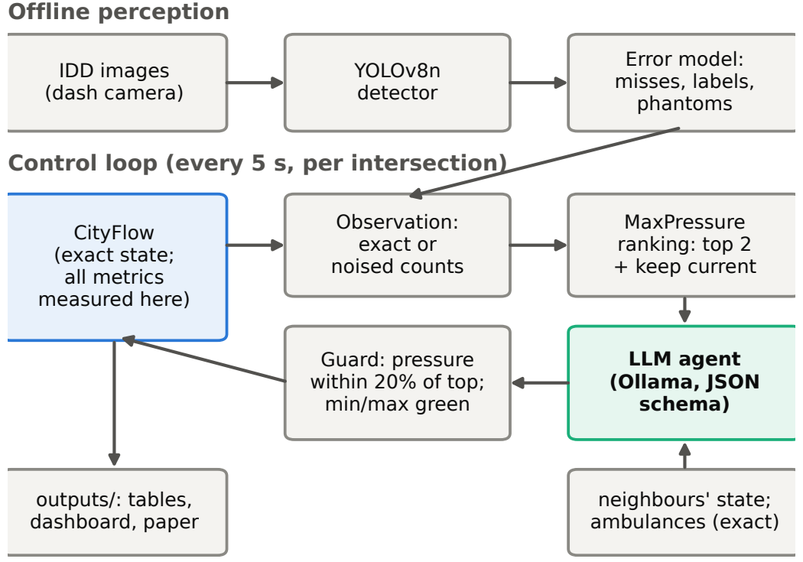
- System overview. Controllers see the simulator only through the observation layer; ambulance positions reach the agent through a separate, exact channel.
Fig. 1 shows the system. CityFlow holds the exact state and is the only place where metrics are measured. Controllers read lane counts through an observation layer that returns exact counts or, in the camera experiment, counts degraded by measured detector errors. Every run writes its provenance (controller, model as reported by the server, seed, scenario, git commit, LLM calls, failures and latency) to its result files.

Per-junction LLM agent loop
Every 5 s, each intersection whose green has lasted its minimum is asked for its next phase. (1) Observe: a short prompt gives, for each phase offered, its pressure and queue, so no arithmetic is needed, and for each neighbour its current phase and the stopped vehicles heading towards this junction. (2) Reason: the prompt goes to a local model through Ollama’s /api/chat [25] with a JSON schema that restricts the answer to the offered phases and a short reason, at temperature 0 with a fixed seed. (3) Act: the answer is validated (phase offered, reason of at most 15 words); a failure is counted by type and MaxPressure’s choice is applied for that decision. (4) Enforce: the wrapper inserts the 5 s transition and applies a 15 s minimum and 60 s maximum green. (5) Log: state, raw answer, latency and applied phase are written per decision. All agents share one GPU, so the decision interval must fit one call per intersection.

Controller arms
Plain arms let the LLM choose any green phase. Hybrid arms offer MaxPressure’s two best phases or keeping the current one. The guarded arm also applies the LLM’s choice only if its pressure is close to the best, $P≥P_{top}−(1−r) |P_{top}|$ with r=0.8, i.e. within 20% of the top pressure; otherwise MaxPressure’s choice is applied and the override counted. The guard was added after early rounds showed small models choosing low-pressure phases.

Ambulance handling
An ambulance within 150 m of the stop line is listed in the prompt with its movement, distance and serving phases, and the system prompt adds one sentence asking for green for it. A serving phase is added to the options if none is offered, and is exempt from the guard. The non-LLM competitor is MaxPressure with preemption: the serving phase with the highest pressure gets green, within the same green limits. Ambulance positions are assumed to come from GPS or V2X and are never noised.

Perception error model
We trained YOLOv8n [21] on IDD with 7 classes (car, motorcycle, auto-rickshaw, bus, truck, bicycle, person) at 640 px, splitting by drive so that near-duplicate frames cannot leak; IDD’s official validation split is our test split, used once after the confidence threshold (0.3, maximum mean F1 on validation) was frozen. Detections are matched to ground truth at IoU ≥ 0.5, class-free; the measured rates become the error model: a per-class detection probability, label probabilities from the confusion matrix, and a Poisson number of phantom stopped vehicles per road and snapshot. The junction level uses detection rates of medium and large objects (queued vehicles near a pole camera); the crowded / far level uses all objects. A fresh snapshot is drawn at every observation, while the simulator stays exact.

Implementation

Tools
Table I lists the software and hardware. The versions are those pinned in the repository’s lock file and recorded by the runs; the controllers, the observation layer and the experiment scripts are our own Python code.
- Implementation and tools.
Component | Tool and version
Simulator | CityFlow, built from source (commit 81ee0f4)
Controllers | FixedTime, Webster plan, MaxPressure, MP + preemption, LLM arms (own Python code)
LLM runtime | Ollama 0.40.3, /api/chat with a JSON schema
Models | llama3.2:3b (selected), qwen2.5:3b, gemma4:e4b; llama3.1:8b and a hosted 550 B model in the model-size study only
Detector | YOLOv8n; Ultralytics 8.4.183, PyTorch 2.14.1+cu126
Dataset | India Driving Dataset (IDD), 7 classes
Dashboard | Streamlit 1.65.0
Language | Python 3.10.12; NumPy 2.2.6, pandas 2.3.3, Matplotlib 3.10.9
Hardware | AMD Ryzen 5 4600H, 16 GB RAM; NVIDIA GTX 1650, 4 GB (WSL2, Ubuntu 22.04)

Software and dashboard
A Streamlit dashboard presents the results (Fig. 2). It reads only files in outputs/ (and the detector weights), and every chart and number carries a source chip naming the file it came from. It has four pages. Overview shows the headline result, with exploratory numbers labelled as such. Live Detection runs the trained detector on video. Network Replay replays two controllers side by side on the same traffic; replays re-drive the simulator with each run’s logged decisions and are kept only if they reproduce the run’s metrics exactly. Results gives the result tables. A test renders every page and fails if any number shown does not appear in the files the page read.

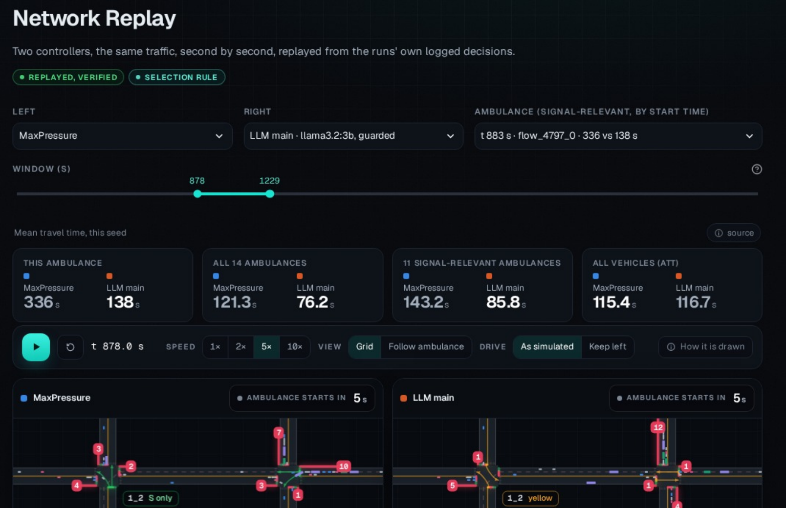
- Dashboard, Network Replay page (sidebar cropped): MaxPressure (left) and the pre-registered LLM arm (right) on the same traffic, following one ambulance’s trip.

Experimental Setup

Simulator validation
CoLLMLight’s FixedTime and MaxPressure were run unmodified, and our environment was driven the same way (4 phases, a decision every 30 s, the same CityFlow seed). Scored with their metric definitions, throughput, queue length and waiting time were identical floating-point numbers on all three of their datasets; average travel time differed at most in the sixth significant digit, within CityFlow’s own run-to-run noise with lane changing on. The check exposed a bug: their fixed-time agent computes (cur_phase+1)%4 on a 1-based phase, so it alternates between the two east–west phases and north–south traffic never gets green. We use only our own, correct fixed-time controllers.

Indian 2x2 scenario
A 2x2 grid with 200 m links and three lanes per approach carries five vehicle types (motorcycle, auto-rickshaw, car, bus, truck) with Indian dimensions [26] and the Chennai modal share [1], arriving as Poisson flows; each seed is a different flow file. CityFlow is lane-based, so the scenario models the Indian mix but not lane-free driving. Demand was calibrated by a rule fixed in advance: under MaxPressure, the lowest swept demand that does not drain is $R^{*}=5500$ veh/h; peak is the largest draining demand at or below $0.9R^{*}$, 4750 veh/h, and off-peak half of it, 2375 veh/h. We also use CoLLMLight’s Jinan 3x4 network with its real flow.

Baselines
FixedTime gives each of 4 paired phases 30 s. The Webster plan computes cycle and splits per intersection from saturation flows measured in the simulator and the run’s own flow file, a perfect count that favours it. MaxPressure’s minimum green was tuned before any LLM run with a pre-registered rank rule over four scenarios; it chose 15 s.

LLM selection and pre-registration
Each arm was benchmarked on the first 600 s of Indian peak traffic with llama3.2:3b [27], qwen2.5:3b [28] and Google’s gemma4:e4b (gemma3:4b in the first round only; it did not fit in 4 GB). The pre-registered rule makes a model eligible if fewer than 2% of its calls fail and its 95th-percentile latency is below 3 s, then picks the lowest mean queue. After the final, pre-registered round it selected the guarded arm with llama3.2:3b and a 5 s decision interval. The gemma4:e4b hybrid, which failed the rule only on latency (p95 4.80 s), was added to the full runs as an exploratory arm. Prompt v3, which states that higher pressure means a phase needs green more, was a post-hoc fix after earlier rounds; a model-size study and the camera decomposition are also exploratory or post-hoc. All four are labelled wherever they appear [29].

Runs and metrics
Every run is 3600 s; Indian off-peak, peak and Jinan use seeds 0–2 and the emergency scenario seeds 0–4. The full experiments comprise 67 runs and the camera experiment 130. The primary metric is the average travel time (ATT) from CityFlow, which includes time spent waiting to enter the network. We also measure queue length (vehicles below 0.1 m/s on incoming lanes) and, for ambulances, travel time per signal-relevant ambulance. Results are mean ± sample standard deviation over seeds; the most informative comparison is paired by seed. With 3 seeds (5 with ambulances) no significance test was pre-registered; a difference counts only if it has the same sign on every seed and is large against the seed spread. Repeated baseline runs were identical in 27 of 27 cases.

Results

Main comparison
Table II and Fig. 3 give the full experiments. The pre-registered controller’s ATT is +0.9% (off-peak), +0.5% (peak) and +0.8% (Jinan) relative to MaxPressure, and it is behind on 3 of 3 off-peak, 2 of 3 peak and 3 of 3 Jinan seeds. Its own answer differs from MaxPressure’s in 87–93% of calls, the guard replaces 76–83% of calls, and the applied phase differs in only 10–11%. It never failed a call off-peak or at peak and runs in real time (1.02–1.10 s per call). At peak, MaxPressure and the Webster plan are themselves level.
The exploratory gemma4:e4b arm is the only LLM arm faster than MaxPressure anywhere: at peak, on all 3 seeds (−1.5% on the mean), while off-peak it is slower on every seed (+2.7%). With three seeds this is a lead, not a demonstrated gain, and at 4.54 s per call it is not real time on this GPU.
- Average travel time (s), mean ± std over seeds 0–2, 3600 s runs.
Controller | Off-peak | Peak | Jinan 3x4
FixedTime, 30 s | 121.5 ± 0.2 | 279.9 ± 9.9 | 423.0 ± 0.0
Webster plan | 100.4 ± 4.1 | 116.3 ± 4.6 | 416.1 ± 0.0
MaxPressure (tuned) | 88.1 ± 1.0 | 115.5 ± 0.9 | 300.9 ± 0.0
LLM guardedª | 89.0 ± 0.8 | 116.1 ± 2.9 | 303.2 ± 1.1
LLM hybrid^{b} | 90.5 ± 1.2 | 113.7 ± 0.3 | –
ªPre-registered: guarded hybrid, llama3.2:3b. ^{b}Exploratory, not selected by the rule: hybrid, gemma4:e4b; not run on Jinan. Off-peak 2375, peak 4750 veh/h. Jinan’s flow file is fixed, so the deterministic baselines do not vary.
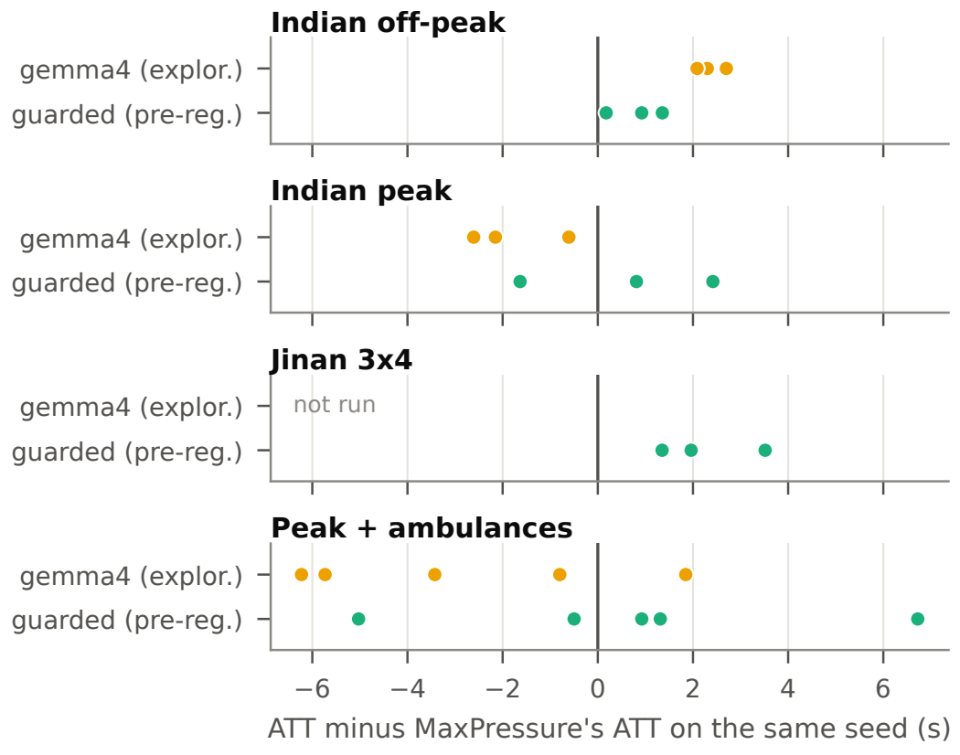
- ATT of each LLM arm minus MaxPressure’s ATT on the same seed; each dot is one seed, left of zero is faster than MaxPressure.

Ambulances
- Signal-relevant ambulances, pooled over seeds 0–4, and network ATT (mean ± std); all in seconds.
Controller | Amb. TT | Stopped | vs preempt. | Network ATT
MaxPressure | 130.1 | 62.3 | +48.9 (1/28) | 115.7 ± 2.3
Webster plan | 123.5 | 55.0 | +42.3 (4/25) | 115.2 ± 2.7
MP + preemption | 81.2 | 14.1 | – | 116.0 ± 0.7
LLM guardedª | 88.9 | 21.2 | +7.7 (12/15) | 116.4 ± 3.1
LLM hybrid^{b} | 82.2 | 15.3 | +1.1 (16/12) | 112.9 ± 1.9
Amb. TT: mean ambulance travel time; vs preempt.: mean paired difference to the same ambulance under preemption (faster/slower count). ^{a,b}As in Table II.
Ambulances arrive at 6 per hour on top of peak traffic; over 5 seeds, 29 of the 37 ambulances cross a signalised movement. Both LLM arms get most of the benefit of preemption (Table III, Fig. 4): mean travel time is 130.1 s under MaxPressure, 88.9 s under the pre-registered arm and 81.2 s with preemption. The gain is almost all time no longer spent stopped (62.3 s against 21.2 s). Paired by ambulance, the main arm is 7.7 s slower than preemption on average. Network ATT, 116.4 s against MaxPressure’s 115.7 s, is well inside the seed spread (±2.3 s).
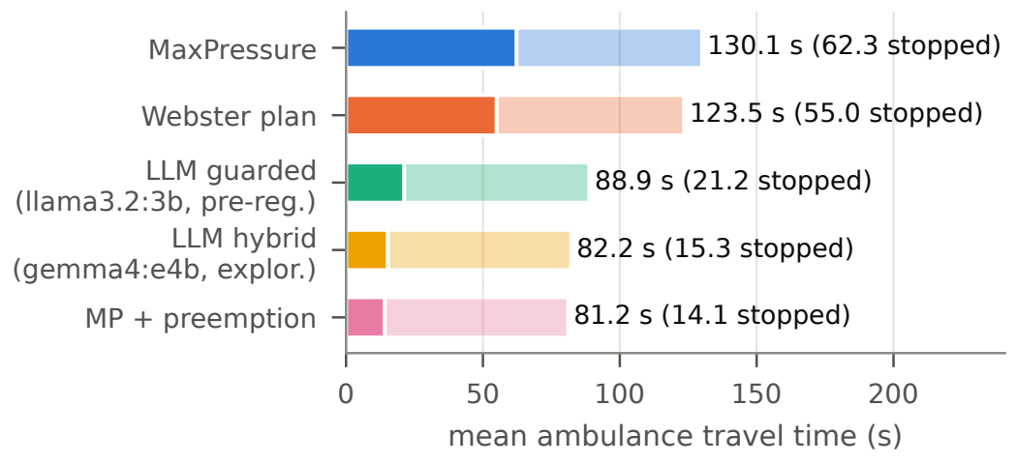
- Mean travel time of the signal-relevant ambulances; solid part = time stopped.

Model size (exploratory)
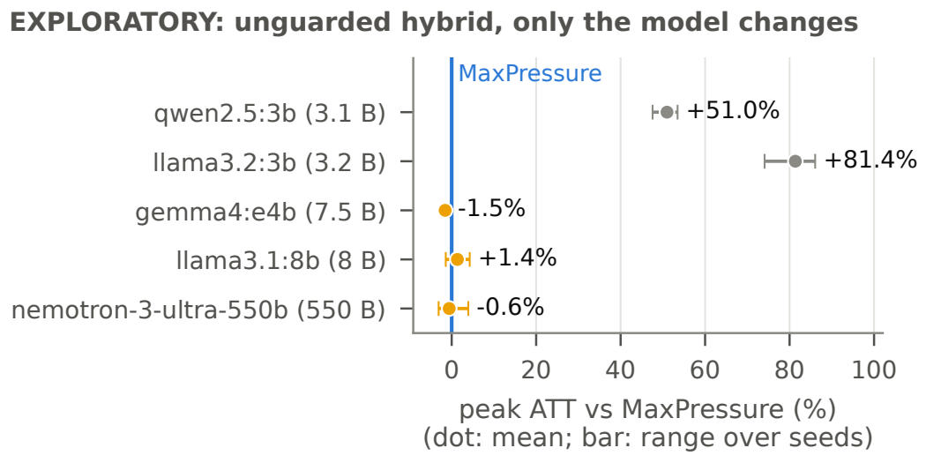
- Exploratory model-size study: peak ATT of the unguarded hybrid arm relative to MaxPressure on the same seeds, per model (total parameters in brackets).
Keeping the unguarded hybrid and changing only the model, both 3 B models made it far worse than MaxPressure on every seed (+51.0% and +81.4% at peak). gemma4:e4b, llama3.1:8b and a hosted 550 B mixture-of-experts model [30] were within seed noise of MaxPressure (the hosted API throttled heavily; 1.8% of its calls failed and fell back to MaxPressure’s choice); they chose the highest-pressure option in 80, 62 and 99% of calls (Fig. 5).

Detector
On the test split (IDD’s official validation set, 10225 images, used once) the detector reaches mAP50 0.563 and mAP50-95 0.375 (Table IV), with high precision and moderate recall; it misses 59–76% of small objects but only 1–22% of large ones. Bicycles and persons are the weakest classes. These are dash-camera images, not views from a junction camera, so the numbers describe the detector on Indian street scenes, not at a junction.
- YOLOv8n on the IDD test split, per class (Ultralytics AP).
Class | Boxes | AP50 | AP50-95
car | 24,843 | 0.637 | 0.442
motorcycle | 25,489 | 0.630 | 0.373
auto-rickshaw | 7,782 | 0.652 | 0.461
bus | 4,915 | 0.664 | 0.502
truck | 7,077 | 0.576 | 0.412
bicycle | 569 | 0.339 | 0.193
person | 18,078 | 0.444 | 0.241
all (mAP) | 88,753 | 0.563 | 0.375
Boxes: ground-truth boxes. Dash-camera images, not a junction camera; 640 px input.

Camera errors
- ATT change against perfect counts, paired by seed: mean % [seed range].
 | Off-peak |  | Peak
Controller | junction | crowded | junction | crowded
MaxPressure | +4.8 [4.1, 5.4] | +8.2 [7.3, 9.9] | +2.3 [1.0, 3.7] | +4.4 [3.0, 6.7]
LLMª | +5.1 [4.2, 5.5] | +7.2 [6.1, 8.5] | +1.6 [−0.4, 2.8] | +4.9 [3.0, 8.5]
Webster | +0.0 [0.0, 0.0] | +0.0 [0.0, 0.0] | +0.0 [0.0, 0.0] | +0.0 [0.0, 0.0]
Junction and crowded / far camera levels as in Section III-E. ªPre-registered guarded arm, llama3.2:3b.
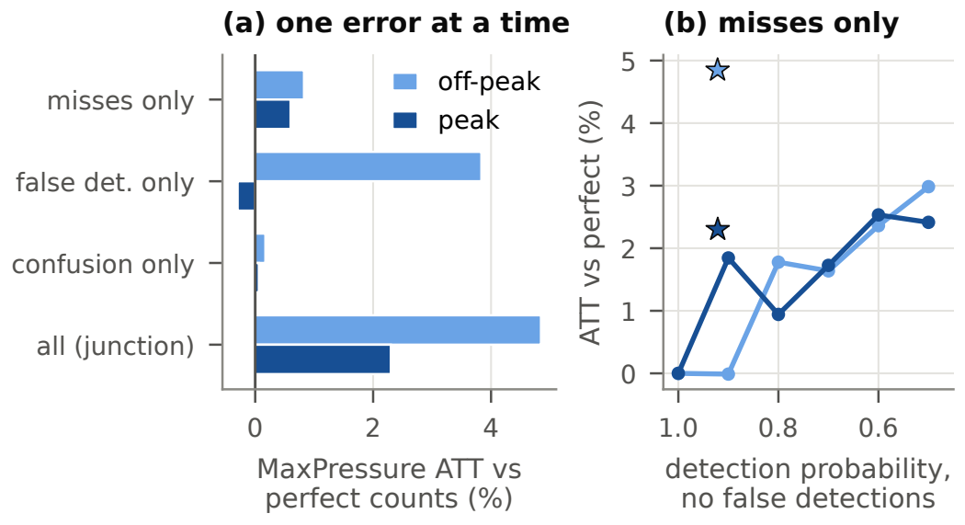
- MaxPressure under camera errors. (a) Post-hoc: one junction-camera error type at a time. (b) Only missed vehicles, uniform over classes (lines), against the junction camera at its effective detection rate (⋆).
With the detector’s errors in the counts (Table V), MaxPressure’s ATT rises by 4.8% off-peak and 2.3% at peak with the junction camera, worse on every seed; the LLM arm degrades about as much, since its guard reads the same counts; the Webster plan, which reads no counts, is unaffected. At peak, MaxPressure (118.2 s) falls behind Webster (116.3 s).
Misses alone cost little (Fig. 6b): with half of all vehicles missed and no phantoms, MaxPressure loses 3.0% off-peak, because uniform misses shrink every pressure by the same factor. The junction camera detects 92% of vehicles yet costs 4.8%, against 0.0% for 90% detection without phantoms; it adds about 0.7 phantom stopped vehicles per road and snapshot. A post-hoc decomposition (Fig. 6a) confirms it off-peak: false detections alone cost +3.8% of the +4.8%. At peak the components sum to only +0.4% of +2.3%; three seeds cannot tell interaction from chance. With junction-camera counts the LLM arm’s ambulances were 11.0 s slower on average, not distinguishable from zero with 29 ambulances; preemption, reading the exact channel, kept its advantage.

Discussion and Limitations
Why the LLMs match but do not beat MaxPressure. The hybrid prompt shows each option’s pressure, the information MaxPressure uses; a model that reads it correctly becomes MaxPressure, as the hosted model did. Small models misread it: with earlier prompts they treated low pressure as good and kept the current phase, and the prompt fix changed gemma4:e4b but not the 3 B models. The guard turns such a model into MaxPressure with noise: the remaining departures, within 20% of the top pressure, cost a little off-peak. To beat MaxPressure an agent needs information it lacks or planning over several decisions; neither was asked of these agents.
Why they help ambulances. Here the agent has information MaxPressure lacks, and one sentence in the prompt was enough. A hand-written preemption rule did slightly better and is simpler to verify; the case for an LLM is flexibility, since the same mechanism can carry rules that are awkward to hard-code (closures, school zones, a late bus). Only ambulances were tested.
Limitations. The camera errors are a proxy: measured on dash-camera images, not on a pole-mounted junction camera, and each snapshot is independent (no tracking). Three seeds per scenario (five with ambulances) are few and no significance test was run, so differences of one or two percent are within noise. LLM runs are not bit-for-bit repeatable on a GPU, although every decision is logged and replayable. CityFlow is lane-based and, with lane changing on, not exactly repeatable; we run with it off, where repeated runs are identical. Demand is synthetic and steady, the network small, latencies specific to a GTX 1650, and everything is simulation only: no real signal was controlled. Unlike CoLLMLight we did not fine-tune, so our results neither confirm nor contradict its claims.

Conclusion and Future Work
A small local LLM, guided and guarded by MaxPressure, controlled an Indian-mix network within 0.5–0.9% of a tuned MaxPressure in real time but did not improve on it; told about ambulances, it cut their travel time by 31.7%, close to a preemption rule, without slowing other traffic. Measured camera errors cost count-based control a few percent, mostly through false detections, so a detector’s precision matters more than its recall here, and a good fixed plan is a robust fallback. Future work: agents with memory and tools that plan over several decisions; fine-tuning small models on simulator feedback; footage from fixed junction cameras with tracking; larger networks and real demand; and shadow-mode field trials with GPS or V2X ambulance positions.

Acknowledgment
We thank our guide, Dr. Mohd Irfan, and the School of Computer Science and Engineering, VIT-AP University, for their guidance and support. We are grateful to the authors of CoLLMLight, whose open code made it possible to validate our simulator against theirs; to the CityFlow developers; and to IIIT Hyderabad and Intel for the India Driving Dataset.

References
- Innovative Transport Solutions (iTrans) Pvt. Ltd., “Two- and three-wheelers in India,” Indian Institute of Technology Delhi, for the International Council on Clean Transportation (ICCT); the Institute for Transportation; Development Policy (ITDP), Final report, 2009.
- T. V. Mathew and P. Radhakrishnan, “Calibration of microsimulation models for nonlane-based heterogeneous traffic at signalized intersections,” Journal of Urban Planning and Development, vol. 136, no. 1, pp. 59–66, 2010, doi: 10.1061/(ASCE)0733-9488(2010)136:1(59).
- S. Chandra and U. Kumar, “Effect of lane width on capacity under mixed traffic conditions in India,” Journal of Transportation Engineering, vol. 129, no. 2, pp. 155–160, 2003, doi: 10.1061/(ASCE)0733-947X(2003)129:2(155).
- CSIR-Central Road Research Institute, Indian highway capacity manual (indo-HCM). New Delhi: CSIR-Central Road Research Institute, 2017.
- F. V. Webster, “Traffic signal settings,” Road Research Laboratory, Her Majesty’s Stationery Office, London, Road Research Technical Paper 39, 1958.
- P. Varaiya, “Max pressure control of a network of signalized intersections,” Transportation Research Part C: Emerging Technologies, vol. 36, pp. 177–195, 2013, doi: 10.1016/j.trc.2013.08.014.
- S. Lai, Z. Xu, W. Zhang, H. Liu, and H. Xiong, “LLMLight: Large language models as traffic signal control agents.” arXiv preprint arXiv:2312.16044, 2023. Available: https://arxiv.org/abs/2312.16044
- M. Wang, A. Pang, Y. Kan, M.-O. Pun, C. S. Chen, and B. Huang, “LLM-assisted light: Leveraging large language model capabilities for human-mimetic traffic signal control in complex urban environments.” arXiv preprint arXiv:2403.08337, 2024. Available: https://arxiv.org/abs/2403.08337
- Z. Yuan, S. Lai, and H. Liu, “CoLLMLight: Cooperative large language model agents for network-wide traffic signal control,” in Proceedings of the international conference on learning representations (ICLR), 2026. Available: https://openreview.net/forum?id=KeJqoEVOeY
- A. G. Sims and K. W. Dobinson, “The Sydney coordinated adaptive traffic (SCAT) system philosophy and benefits,” IEEE Transactions on Vehicular Technology, vol. 29, no. 2, pp. 130–137, 1980, doi: 10.1109/T-VT.1980.23833.
- P. B. Hunt, D. I. Robertson, R. D. Bretherton, and R. I. Winton, “SCOOT – a traffic responsive method of coordinating signals,” Transport; Road Research Laboratory, Crowthorne, TRRL Laboratory Report 1014, 1981.
- L. Tassiulas and A. Ephremides, “Stability properties of constrained queueing systems and scheduling policies for maximum throughput in multihop radio networks,” IEEE Transactions on Automatic Control, vol. 37, no. 12, pp. 1936–1948, 1992, doi: 10.1109/9.182479.
- H. Wei, G. Zheng, V. Gayah, and Z. Li, “Recent advances in reinforcement learning for traffic signal control: A survey of models and evaluation,” ACM SIGKDD Explorations Newsletter, vol. 22, no. 2, pp. 12–18, 2021, doi: 10.1145/3447556.3447565.
- H. Wei, G. Zheng, H. Yao, and Z. Li, “IntelliLight: A reinforcement learning approach for intelligent traffic light control,” in Proceedings of the 24th ACM SIGKDD international conference on knowledge discovery & data mining, 2018, pp. 2496–2505. doi: 10.1145/3219819.3220096.
- H. Wei et al., “PressLight: Learning max pressure control to coordinate traffic signals in arterial network,” in Proceedings of the 25th ACM SIGKDD international conference on knowledge discovery & data mining, 2019, pp. 1290–1298. doi: 10.1145/3292500.3330949.
- H. Wei et al., “CoLight: Learning network-level cooperation for traffic signal control,” in Proceedings of the 28th ACM international conference on information and knowledge management (CIKM), 2019, pp. 1913–1922. doi: 10.1145/3357384.3357902.
- C. Chen et al., “Toward a thousand lights: Decentralized deep reinforcement learning for large-scale traffic signal control,” in Proceedings of the AAAI conference on artificial intelligence, 2020, pp. 3414–3421. doi: 10.1609/aaai.v34i04.5744.
- H. Zhang et al., “CityFlow: A multi-agent reinforcement learning environment for large scale city traffic scenario,” in The world wide web conference (WWW ’19), 2019, pp. 3620–3624. doi: 10.1145/3308558.3314139.
- N. Buch, S. A. Velastin, and J. Orwell, “A review of computer vision techniques for the analysis of urban traffic,” IEEE Transactions on Intelligent Transportation Systems, vol. 12, no. 3, pp. 920–939, 2011, doi: 10.1109/TITS.2011.2119372.
- J. Redmon, S. Divvala, R. Girshick, and A. Farhadi, “You only look once: Unified, real-time object detection,” in Proceedings of the IEEE conference on computer vision and pattern recognition (CVPR), 2016, pp. 779–788. doi: 10.1109/CVPR.2016.91.
- G. Jocher, A. Chaurasia, and J. Qiu, “Ultralytics YOLOv8.” 2023. Available: https://github.com/ultralytics/ultralytics
- K. Nellore and G. P. Hancke, “Traffic management for emergency vehicle priority based on visual sensing,” Sensors, vol. 16, no. 11, p. 1892, 2016, doi: 10.3390/s16111892.
- G. Varma, A. Subramanian, A. Namboodiri, M. Chandraker, and C. V. Jawahar, “IDD: A dataset for exploring problems of autonomous navigation in unconstrained environments,” in IEEE winter conference on applications of computer vision (WACV), 2019, pp. 1743–1751. doi: 10.1109/WACV.2019.00190.
- T.-Y. Lin et al., “Microsoft COCO: Common objects in context,” in Computer vision – ECCV 2014, in Lecture notes in computer science, vol. 8693. Springer, 2014, pp. 740–755. doi: 10.1007/978-3-319-10602-1_48.
- Ollama, “Ollama: Run large language models locally.” 2026. Available: https://github.com/ollama/ollama
- Umapathi and R. Khatawkar, “Effect of carriageway width on PCU and capacity of two lane roads: A case study of Shivamogga district,” Journal of Emerging Technologies and Innovative Research (JETIR), vol. 6, no. 6, pp. 89–93, 2019.
- A. Grattafiori et al., “The Llama 3 herd of models.” arXiv preprint arXiv:2407.21783, 2024. Available: https://arxiv.org/abs/2407.21783
- Qwen Team, “Qwen2.5 technical report.” arXiv preprint arXiv:2412.15115, 2024. Available: https://arxiv.org/abs/2412.15115
- B. A. Nosek, C. R. Ebersole, A. C. DeHaven, and D. T. Mellor, “The preregistration revolution,” Proceedings of the National Academy of Sciences, vol. 115, no. 11, pp. 2600–2606, 2018, doi: 10.1073/pnas.1708274114.
- NVIDIA, “Nemotron 3 Ultra (nvidia/nemotron-3-ultra-550b-a55b) model card.” NVIDIA API catalog, build.nvidia.com, 2026.

B.Tech CSE and Specializations, Capstone Project, Fall 2026-27, Capstone ID 3328F4C8. Registration numbers: C Bhargav Kumar 23BCE8195, Achalla Akul Lakhan 23BCE8015, Darsi Amit 23BCE8288, Mylapalli Abhishek Raj 23BCE9470.

