PROJECT REPORT OF CO-OP Project at Industry (Module2)
ON
Lintellect- Code Review Agent
submitted in partial fulfilment of the requirements for the award of degree of
BACHELOR OF ENGINEERING
In
COMPUTER SCIENCE AND ENGINEERING
Submitted by: Supervised By:
Sneha Sharma (2210992392) Dr. Monika Aggarwal
Mentor

Chitkara University Institute of Engineering and Technology

DEPARTMENT OF COMPUTER SCIENCE AND ENGINEERING
CHITKARA UNIVERSITY INSTITUTE OF ENGINEERING AND TECHNOLOGY
CHITKARA UNIVERSITY, PUNJAB, INDIA

CONTENTS
S.No. | Title | Page No.
1 | Declaration | ii
2 | Acknowledgement | iii
3 | Abstract | 1
4 | Introduction | 1
5 | Methodology | 2
6 | Tools and Technologies | 3
7 | Implementation | 3
8 | Major Findings / Outcomes / Output / Results | 5
9 | Conclusion and Future Scope | 5
10 | References | 6
11 | Appendices | 7

DECLARATION
I hereby certify that the work which is being presented in the project report entitled “Lintellect- Code Review Agent” in partial fulfilment of the requirement for the award of the degree of Bachelor of Engineering (Computer Science and Engineering), submitted in the Department of Computer Science and Engineering at Chitkara University Institute of Engineering and Technology, Chitkara University, Punjab, India, is an authentic record of our own work carried out under the supervision of Dr. Monika Aggarwal

Place: Rajpura
Date: May 18, 2026
Sneha Sharma (2210992392)
This is to certify that the above statement made by the candidate is correct to the best of my knowledge and belief.

Dr. Monika Aggarwal
Mentor
Department of Computer Science and Engineering
Chitkara University Institute of Engineering and Technology,
Chitkara University, Punjab, India
ACKNOWLEDGEMENT
I would like to express our sincere gratitude to my mentor, Dr. Monika Aggarwal, Department of Computer Science and Engineering, Chitkara University Institute of Engineering and Technology, for her invaluable guidance, constructive feedback, and continuous support throughout this research project. Her expert insights and encouragement were instrumental in shaping this work.
I am grateful to Chitkara University for providing me with the necessary academic resources, infrastructure, and a stimulating research environment that made this project possible.
Finally, I would like to thank our families and friends for their constant encouragement and moral support, which motivated me throughout this academic journey.

Abstract
Modern software development requires rapid iteration, secure deployments, and high-quality code standards. However, traditional manual code review processes are time-consuming, inconsistent, and heavily dependent on reviewer expertise. Existing static analysis tools primarily detect syntax-level issues but often fail to provide contextual reasoning, architectural insights, or intelligent improvement suggestions. These limitations reduce developer productivity and increase the likelihood of bugs and vulnerabilities reaching production systems.
Lintellect – Code Review Agent is an AI-powered intelligent code review platform designed to automate and enhance the software review process. The system analyses source code using contextual AI-driven techniques combined with rule-based validation methods to identify logical errors, security vulnerabilities, performance inefficiencies, and coding standard violations. The platform generates categorized feedback along with explanations and optimization recommendations.
The system architecture integrates a React-based frontend, a FastAPI backend, LangGraph orchestration, and Large Language Models through GROQ APIs. Lintellect supports scalable automated review workflows and can be integrated into CI/CD pipelines for real-time development support.
The proposed solution significantly reduces manual review effort, improves code reliability, accelerates deployment cycles, and enhances developer learning through immediate feedback. The project demonstrates how AI-assisted software engineering tools can improve consistency, efficiency, and maintainability in modern development environments.
Keywords: Artificial Intelligence · Code Review · Static Analysis · Software Engineering · FastAPI · LangGraph · Large Language Models · Developer Productivity

1. Introduction
Software quality assurance is one of the most critical aspects of modern software engineering. As software systems grow increasingly complex, developers face challenges in maintaining code quality, identifying vulnerabilities, and ensuring adherence to best practices. Manual code reviews remain essential but are often slow, inconsistent, and resource-intensive.
Traditional static analysis tools can detect syntax errors and predefined rule violations, but they lack contextual understanding and reasoning capabilities. Modern AI-based systems powered by Large Language Models (LLMs) have introduced new possibilities for intelligent software analysis by understanding code semantics, identifying logical issues, and generating human-like explanations.
Lintellect – Code Review Agent is designed to address these limitations by combining AI-driven contextual analysis with rule-based validation techniques. The platform provides instant code review feedback, detects bugs and vulnerabilities, identifies performance bottlenecks, and suggests improvements for maintainability and readability.
The project focuses on building a scalable and intelligent review workflow using FastAPI, LangGraph orchestration, and LLM-based analysis models integrated with an interactive React frontend. The system aims to improve developer productivity, reduce review delays, and standardize code quality practices across development teams.

2. Methodology
The development methodology for Lintellect follows a modular AI-assisted software engineering approach. The workflow begins with code submission through the frontend interface. The submitted source code is forwarded to the FastAPI backend, which coordinates the review pipeline.

The system uses LangGraph-based workflow orchestration to manage different review stages. The Analyzer Node performs contextual analysis of source code using Large Language Models. The Issue Finder Node identifies security risks, performance inefficiencies, and coding standard violations. Finally, the Report Generator Node compiles structured review reports and categorized recommendations.

The methodology combines:
• AI-driven contextual analysis
• Rule-based static validation
• Structured feedback generation
• Multi-stage review orchestration

The evaluation process focuses on review quality, issue detection capability, response generation consistency, and workflow scalability.

3. Tools and Technologies
The project was implemented using modern web development and AI technologies.
• Python 3.x – Core backend development
• FastAPI – REST API framework for handling requests and review processing

• LangGraph – Workflow orchestration for multi-stage AI processing
• GROQ API / LLM Models – AI-powered contextual code analysis
• GitHub – Version control and project management

• GitLab – Pipeline management

These technologies collectively enabled the development of a scalable, modular, and interactive AI-based code review platform.

4. Implementation
The implementation of Lintellect follows a layered architecture consisting of frontend, backend, orchestration, and AI analysis modules.
The frontend allows users to submit source code and visualize categorized review feedback. The FastAPI backend handles API communication, validation, and workflow coordination. LangGraph manages state-driven execution between multiple processing nodes. Large Language Models integrated through GROQ APIs perform intelligent code understanding and contextual review generation.

The review workflow includes:
• Source code submission
• Contextual AI analysis
• Issue identification
• Security and performance checks
• Report generation

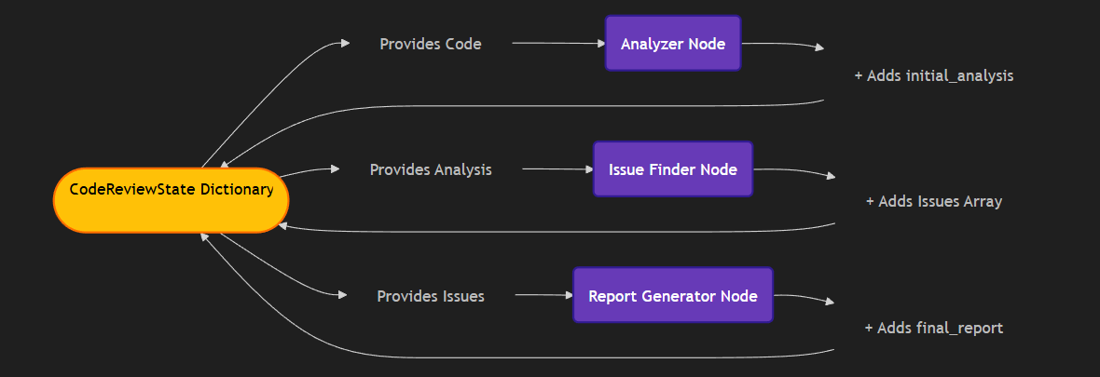
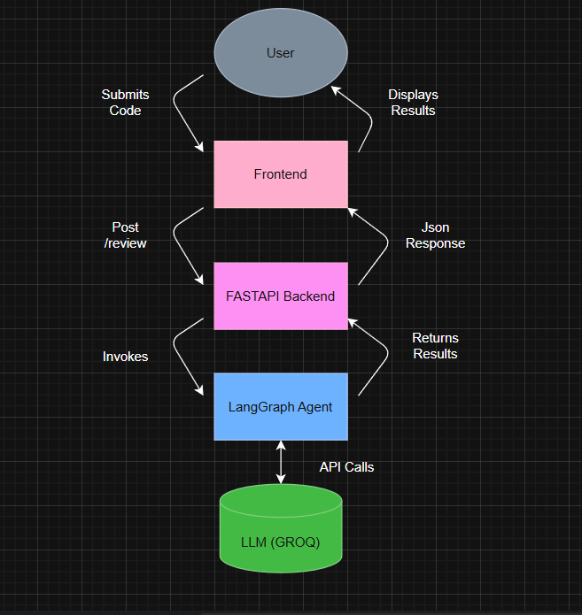

The system also supports structured JSON-based responses for future integration into CI/CD pipelines and collaborative development tools.

5. Major Findings / Outcomes / Results
The developed system successfully automated the code review workflow and generated contextual feedback for submitted source code.
Major outcomes include:
•Significant reduction in manual review effort
•Faster bug and vulnerability detection
•Improved consistency in coding standards
•Enhanced developer productivity through instant feedback
•Structured categorization of issues and recommendations
The system demonstrated effective performance in identifying logical errors, security vulnerabilities, and performance-related concerns while generating human-readable explanations and improvement suggestions.

6. Conclusion and Future Scope
Lintellect – Code Review Agent demonstrates how AI-powered systems can modernize software quality assurance processes by providing automated, scalable, and intelligent code reviews. The project combines Large Language Models with structured workflow orchestration to improve code reliability, reduce review delays, and enhance developer efficiency.
Future enhancements may include:
•Multi-language code review support
•Integration with GitHub pull requests
•Real-time collaborative review workflows
•Fine-tuned domain-specific AI review models
•Automated test case generation
• Advanced vulnerability scanning modules
The project establishes a strong foundation for intelligent AI-assisted development workflows in modern software engineering environments.

7. References
[1]FastAPI Documentation – https://fastapi.tiangolo.com/
[2]ReactJS Documentation – https://react.dev/
[3]LangGraph Documentation – https://langchain-ai.github.io/langgraph/
[4]OpenAI and LLM Research Papers
[5]Software Engineering Code Review Practices
[6] Static Analysis and Secure Coding Standards

Appendices

Appendix A: System Workflow and Review Evaluation
The Lintellect – Code Review Agent was evaluated using multiple code samples containing logical errors, security vulnerabilities, performance inefficiencies, and coding standard violations. The system successfully generated contextual review feedback and categorized issues into warnings, critical vulnerabilities, and optimization suggestions.

The evaluation demonstrated:
- Effective detection of common coding mistakes

- Identification of security risks such as unsafe inputs and insecure practices

- Performance optimization recommendations

- Consistent generation of human-readable review explanations

- Faster review turnaround compared to manual review processes

The system workflow included:

- Code submission through frontend interface

- Backend API processing using FastAPI

- LangGraph orchestration for multi-stage analysis

- AI-based contextual code review

- Structured report generation and visualization

Appendix B: Lintellect Review Framework
The proposed Lintellect framework consists of four major components:
- Code Parsing and Validation Module
- AI-Based Contextual Review Engine
- Issue Detection and Categorization Module
- Report Generation and Feedback Visualization System
These components interact to create an automated and intelligent code review pipeline capable of improving software quality, detecting vulnerabilities, and assisting developers with actionable recommendations.
The framework is designed to support scalable integration into modern software development workflows and CI/CD pipelines.

