Provenance-adaptive conformal ranking for honest dual-target drug repurposing from public bioactivity data
Application to the IDO1/TDO2 tryptophan-catabolising checkpoints
Xiyao Yu
School of Chemistry, Chemical Engineering and Biotechnology, Nanyang Technological University, Singapore

Abstract
Public bioactivity databases combine measurements from different papers, laboratories and assay contexts, while many repurposing models still validate those measurements as if they were independent samples from one stable distribution. We introduce Provenance-Adaptive Conformal Ranking (PACR), a source-document-aware uncertainty layer for dual-target repurposing from heterogeneous public bioactivity data, and apply it to IDO1/TDO2. We reparametrised 684 co-tested compounds into shared potency M and selectivity imbalance D, then evaluated random-forest regressors under random, scaffold, temporal and leave-document-out splits. Random and scaffold validation suggested useful skill; leave-document-out validation across 44 source documents reduced performance to approximately zero, marking source-document shift as the main deployment risk. Split-conformal lower-bound ranking rejected the apparent approved-drug hit list: among 2,387 approved drugs, no compound cleared a confident dual-active bound of pIC50 >= 6. PACR learns a conservative provenance-aware scale from proper-train leave-document-out residuals, applies conformal calibration on a separate calibration fold, and penalises compounds that lack support from the training documents' chemical domains. This stricter ranking preserved the negative verdict. The measured IDO1/TDO2 inhibitor overlap remains a separate empirical result: Pearson r = 0.43 (95% CI 0.36-0.49), showing that dual engagement is chemically accessible even when approved-drug repurposing is not confidently supported. Replication on COX-1/COX-2 supports the paired-target validation workflow outside the IDO1/TDO2 case. PACR provides a reusable template for dual-target screening when public scientific databases carry source-level distribution shift.
Keywords: drug repurposing, IDO1, TDO2, melanoma immunotherapy, QSAR, scaffold splitting, applicability domain, conformal prediction, leave-document-out validation, matched molecular pairs, dual-target inhibition

1. Introduction
Tumours use metabolic checkpoints to escape immune attack. IDO1 and TDO2 are haem-containing dioxygenases that convert L-tryptophan to N-formylkynurenine, the committed step of the kynurenine pathway [2]. Their iron-porphyrin cofactor is central to catalysis [6], so the structural analysis uses a haem-containing IDO1 structure to represent the active site. Local tryptophan depletion and kynurenine accumulation suppress effector T cells, promote regulatory T-cell differentiation and activate the aryl-hydrocarbon receptor, creating an immunosuppressive tumour microenvironment [3,4]. In melanoma, IDO1 expression is associated with poor prognosis, which made IDO1 inhibition an attractive immuno-oncology strategy [2,3].
Clinical results have been disappointing. Most IDO1 inhibitors show limited single-agent efficacy, and ECHO-301/KEYNOTE-252 found no outcome improvement for epacadostat plus pembrolizumab over pembrolizumab alone in advanced melanoma [1]. The failure shifted the practical question. IDO1 blockade may still need the right combination partner, and compensatory TDO2 activity may limit single-enzyme inhibition. That logic motivates dual IDO1/TDO2 inhibition [5].
Approved-drug repurposing offers a fast way to test this idea. Approved drugs already have human safety and pharmacokinetic information, and public bioactivity databases contain the chemical structures and activity measurements needed to build a screen. The main risk is evaluation optimism. A random train/test split rewards a model for recognising close analogues of training compounds, then overstates performance on structurally novel drugs. Scaffold splitting reduces this leakage. Public bioactivity data add another layer: compounds from the same source paper can share assay conditions, chemical series and laboratory context. A repurposing deck is out-of-document by construction, so source provenance has to enter validation.
We make PACR the methodological centre of the study. PACR is a conservative ranking layer for public bioactivity data under source-document shift, separate from the QSAR architecture. The framework first converts paired target measurements into shared potency and selectivity imbalance. It then tests whether apparent scaffold-level performance survives transfer to a new source publication. Finally, it ranks candidates by conformal lower bounds whose scale can use model uncertainty, chemical distance and document-domain distance. The IDO1/TDO2 screen serves as a stress test: a supported approved-drug dual hit should retain a high lower bound; an unsupported hit list should collapse into a calibrated negative result.

2. Methods

2.1 Targets and bioactivity data
Human IDO1 (ChEMBL target CHEMBL4685) and TDO2 (CHEMBL2140) bioactivities were retrieved from the live ChEMBL REST API (https://www.ebi.ac.uk/chembl/api/data/activity) in June 2026, with full pagination over the activity endpoint [7]. The query used the live database available on the retrieval date; reproducibility is handled through the committed raw cache and retrieval date. Endpoints IC50, Ki, Kd and EC50 were pulled (7,634 IDO1 and 1,684 TDO2 records; together the raw records span 2006-2025). The analysis retained inhibition/binding endpoints (IC50/Ki/Kd) with standard_relation = '=', standard_units = 'nM' and standard_value > 0, and removed rows with non-empty data_validity_comment fields. Potency was expressed as pActivity = -log10(value in M) and aggregated to one median value per molecule across retained measurements. Because most retained records are IC50 values and the activity thresholds are conventionally interpreted on an IC50-equivalent scale, figures and threshold statements use pIC50-equivalent shorthand where helpful.

2.2 Chemistry curation
SMILES were canonicalised with RDKit (release 2023.09) [13]. Salts and mixtures were reduced to the largest organic fragment with RDKit LargestFragmentChooser, then deduplicated on canonical SMILES. PAINS substructures were flagged with the RDKit FilterCatalog PAINS_A, PAINS_B and PAINS_C SMARTS sets [9]. Curation produced 3,585 IDO1 compounds (1,361 Bemis-Murcko scaffolds [8]; median pActivity 6.52) and 964 TDO2 compounds (356 scaffolds; median pActivity 6.01). Each compound received nine physicochemical descriptors (MW, cLogP, TPSA, H-bond donors/acceptors, rotatable bonds, aromatic rings, fraction sp3 C and QED) and a 2,048-bit radius-2 Morgan fingerprint [10].

2.3 Models and leakage-safe evaluation
Each target used a random-forest classifier (active = pActivity ≥ 6, equivalent to ≤ 1 µM on the pIC50-equivalent scale) and a random-forest regressor trained on Morgan fingerprints [11,12]. Both models used 500 trees and random_state = 0. The classifier used max_features = 'sqrt' and class_weight = 'balanced'; the regressor used max_features = 1.0. Other hyperparameters followed scikit-learn defaults. Performance was measured with pooled out-of-fold predictions under two 5-fold schemes: standard random KFold and GroupKFold grouped by Murcko scaffold.

2.4 Repurposing screen
The approved-drug deck started from 3,475 ChEMBL max_phase = 4 small molecules. Structure cleaning, removal of compounds already assayed against the target and deduplication left 2,387 drugs. Each drug received two scores: model output (predicted pActivity and active probability) and maximum Tanimoto similarity to potent reference actives (pActivity ≥ 7) using Morgan fingerprints. The applicability-domain flag required maximum Tanimoto similarity ≥ 0.30 to the relevant training set. The first-pass consensus ranking averaged the rank-normalised model and similarity scores.

2.5 Structure-based confirmation
The top IDO1 candidates, eight potent positive controls (pActivity ≥ 8) and six low-prediction decoys were docked into the haem-containing human IDO1 crystal structure PDB 6E40, IDO1 in complex with ferric haem and epacadostat, chain A, 2.31 Å [6], using smina [16,17]. The receptor retained chain-A protein atoms and ferric haem (HEM); water and co-crystallised epacadostat (ligand BBJ) were removed. Protein and ligands were converted to PDBQT with Open Babel, including Gasteiger charges and merged non-polar hydrogens. Ligand conformers were generated from SMILES with RDKit ETKDG embedding and MMFF94 optimisation. The search box (20 × 22 × 22 Å) was centred on the epacadostat centroid; docking used exhaustiveness = 8, num_modes = 5 and a fixed seed. Separation of positive-control and decoy scores was tested with a one-sided exact Mann-Whitney U test.

2.6 Cross-target selectivity analysis
The same 2,387-drug deck was scored against the IDO1 and TDO2 single-target models. A drug was labelled dual when both predicted pActivity values were ≥ 6 and both targets were in-domain. TDO2-selective candidates required TDO2 ≥ 6 and IDO1 < 5.5; IDO1-selective candidates used the converse rule. Section 3.7 shows why these labels are reported as a fragile baseline and then replaced by the paired M/D framework.

2.7 Provenance-aware conformal dual-target framework
For the 684 compounds measured against both enzymes, target-specific pActivity values were the median retained values from the curation step. For paired M/D modelling, each row was assigned one LODO grouping document (src_doc). When retained IDO1 and TDO2 records for the same compound shared a source document, that shared document was used (675/684 compounds, 98.7%). For the nine compounds without a retained shared source document, src_doc is the retained IDO1 source document and same_doc = False in data/paired_MD_dataset.csv. Thus the target-specific provenance counts in Fig. S1 (105 IDO1 and 53 TDO2 source documents) describe all retained source records contributing to the 684 co-tested set before paired-source assignment, whereas LODO uses the 44 assigned paired-source groups. Paired potencies were then reparametrised into shared potency M = (pActivity_IDO1 + pActivity_TDO2)/2 and selectivity imbalance D = pActivity_IDO1 - pActivity_TDO2. Separate random-forest regressors (300 trees, random_state = 0, other settings at scikit-learn defaults) were trained for M and D on 2,048-bit Morgan fingerprints. Single-target activities are recovered as pActivity_IDO1 = M + D/2 and pActivity_TDO2 = M - D/2.
Split-hardness ladder. M and D models were evaluated under five schemes with increasing deployment difficulty: random 5-fold; Murcko-scaffold GroupKFold; Butina cluster split; chemical-space cluster split; and temporal split. Butina clustering [14] used a Tanimoto distance cutoff of 0.4 (0.6 similarity), yielding 171 CV groups. The chemical-space split embedded fingerprints with UMAP [15] (n_neighbors = 15, min_dist = 0.1, metric = 'jaccard', random_state = 0) and partitioned the embedding into 10 KMeans groups (random_state = 0). The temporal split used train ≤ 2021 and test ≥ 2022, the earliest cutoff that kept a held-out set of at least 50 compounds (test n = 284) while retaining most data for training [21]. Metrics were computed once over pooled held-out predictions. A train ≤ 2020 / test ≥ 2021 split provided sensitivity analysis.
Leave-document-out (LODO) validation. LeaveOneGroupOut over the 44 source documents held out one publication at a time. Predictions from all held-out documents were pooled to compute one global R²/RMSE, and the per-document RMSE distribution was also reported.
Conformal prediction. Split-conformal intervals [18,19] used a scaffold-disjoint three-way partition of the 684 paired compounds: proper-train / calibration / test = 185 / 205 / 294. GroupShuffleSplit assigned Murcko scaffolds so no scaffold crossed partitions. The M and D regressors were fit on proper-train, and calibration residuals were computed on the calibration fold. M and D share the same two measured endpoints, so residual pairs (e_M, e_D) were kept together. Reconstructed IDO1/TDO2 predictive samples were formed as (M̂ + e_M) ± (D̂ + e_D)/2 over the calibration residual pairs, and 90% intervals were taken from empirical quantiles. Coverage was evaluated on the held-out test fold. Formal coverage claims refer to this held-out scaffold-disjoint validation setting. After validation, final deck ranking used M and D models refit on all 684 paired compounds with the validated calibration residual distribution carried forward as a pragmatic deployment procedure, not as an additional formal coverage guarantee.
Provenance-Adaptive Conformal Ranking (PACR). PACR makes interval width respond to the source-document shift exposed by LODO. It starts from an RF-normalized conformal scale and multiplies it by a conservative source-risk term. For target t in {M, D}, the baseline scale is
σ_base,t(x) = tree_std_t(x) + median_{x_i in C} tree_std_t(x_i), and σ_PACR,t(x) = σ_base,t(x) × exp(θ_0,t) × [1 + θ_chem,t d_chem(x) + θ_doc,t d_doc(x)].
Here d_chem(x) = 1 − max Tanimoto similarity to the proper-train compounds. The document-domain support score DSS(x) is the strongest per-document chemical support for x, calculated as the best per-document mean of the top-k Tanimoto similarities to compounds from that document; d_doc(x) = 1 − DSS(x). The implementation uses k=5; for documents with fewer than five proper-train compounds, DSS used all available compounds from that document. DSS was computed only from proper-train documents. Non-negative θ parameters were learned only from proper-train LODO residuals using an upper-quantile pinball loss (τ = 0.75). The fitted scale was then frozen while the calibration fold supplied the paired M/D residual distribution. PACR leaves the QSAR models unchanged and converts document provenance into a source-shift-aware ranking scale.
Algorithm 1. Provenance-Adaptive Conformal Ranking (PACR).
Input: paired bioactivity table with SMILES, pActivity_IDO1, pActivity_TDO2, Murcko scaffold and assigned paired-source document ID; candidate deck SMILES; activity threshold pActivity ≥ 6; conformal level 1 − α.
- Reparametrise paired measurements into shared potency M and selectivity imbalance D.
- Split paired compounds by scaffold into proper-train, calibration and test folds.
- Fit separate random-forest regressors for M and D on proper-train fingerprints.
- Inside proper-train, perform leave-document-out prediction to obtain source-shift residuals and fit the non-negative PACR scale parameters θ from chemical distance and document-domain distance.
- On the calibration fold, compute paired normalized residuals for M and D; keep residual pairs together.
- For each candidate, predict M̂ and D̂, compute the PACR scales for M and D, rescale the paired calibration residuals, and reconstruct IDO1/TDO2 samples as (M̂ + e_M) ± (D̂ + e_D)/2.
- Rank candidates by LCB_dual = min(lower 5% IDO1 bound, lower 5% TDO2 bound); report P(dual active), P(balanced dual), and the source-domain diagnostics.
Output: a conservative dual-target ranking whose lower bounds widen for compounds far from both the training chemistry and the training source-document domains.
PACR data use and validity. PACR scale parameters are learned inside the proper-training fold from leave-document-out residuals and then frozen. Calibration and test labels are never used to tune them. With the scale fixed, the final calibration step is a split-conformal procedure with a fixed nonconformity construction. Under exchangeability between calibration and test data, PACR retains marginal conformal validity. It does not claim conditional validity under arbitrary document shift. The split-seed and ablation analyses in §3.12 are robustness checks, not post-hoc tuning.
Lower-confidence-bound (LCB) re-ranking. Applied to the 2,387-drug deck, the conformal distributions yield P(dual active) = P(both pActivity ≥ 6), P(balanced dual) = P(both ≥ 6 and |D| ≤ 1), and a conservative score LCB_dual = min(lower 5% IDO1 bound, lower 5% TDO2 bound). Ranking by LCB_dual penalises uncertainty and was compared with the original point-estimate consensus.
Matched molecular pair (MMP) analysis. The 684 paired compounds were fragmented by single-cut MMP (RDKit rdMMPA) [20]. For every R-group transformation recurring in at least three matched pairs, mean delta M, delta D, delta pActivity_IDO1 and delta pActivity_TDO2 were computed to identify substituent changes that raise shared potency or shift IDO1/TDO2 balance.

3. Results

3.1 The IDO1 inhibitor landscape is diverse and drug-like
Curated IDO1 actives occupy distinct fingerprint-space families, with several regions enriched for high potency (Fig. 1A). Their physicochemistry was broadly drug-like: median molecular weight 376 Da, cLogP 3.3 and QED 0.54.

3.2 Scaffold splitting reveals true generalisation
The IDO1 model remained predictive after scaffold splitting. Classification AUROC was 0.936 ± 0.009 under random splitting and 0.907 ± 0.024 under scaffold splitting; regression R² was 0.697 under random splitting and 0.596 under scaffold splitting (Fig. 1B). Random splitting still overestimates performance. The scaffold-split results support first-pass IDO1 triage on unseen scaffolds.

3.3 The consensus ranking reflects structural similarity, with mixed target relevance
Among 2,387 approved drugs, 434 passed the applicability-domain and PAINS filters. The consensus score rewards structural resemblance to known IDO1 inhibitors, so the ranking captures inhibitor-like chemistry, not calibrated potency. The top list exposes the limitation. Tolvaptan (rank 2), lemborexant (rank 3), rimonabant (rank 4) and conivaptan (rank 7) have no clear immuno-oncology rationale and most likely enter through fingerprint similarity. The more interesting subset contains oncology kinase inhibitors, including cabozantinib (rank 1), ensartinib (ALK, rank 5), ripretinib (KIT/PDGFRalpha, rank 9), gefitinib (EGFR, rank 16) and trametinib (MEK, rank 18). Their flat, hydrophobic, heteroaromatic scaffolds overlap common IDO1 inhibitor chemistry. Nearest-neighbour Tanimoto values were modest (0.30-0.43), so no candidate is a near-duplicate of a training compound (Fig. 1C). This list sets up a triage baseline; it does not provide high-confidence target engagement.

3.4 Docking supports pocket plausibility, not target engagement
The docking setup passed a positive-control check: known potent inhibitors scored a mean -10.11 kcal/mol, and decoys scored -6.82 (one-sided exact Mann-Whitney p = 3.3 × 10^-4; Fig. 3A). Repurposing candidates overlapped the positive controls (mean -9.27 kcal/mol). Docking explains why the first-pass hit list looked plausible: several approved drugs fit geometrically into the haem-containing IDO1 pocket. It does not establish biochemical inhibition. The structural analysis is used as a cautionary check below the measured-data and conformal analyses.

3.5 The top candidates occupy the validated inhibitor pocket
Contact-residue analysis gives a pocket-occupancy check for the docked poses. Nine of the ten top candidates share 10-12 of epacadostat's 16 crystallographic contact residues (67-83%); conivaptan is the outlier with 4 shared contacts (29%) (Fig. 3). The recurring residues, Phe163, Phe226, Arg231, Tyr126, Ser263 and Leu234, map to the characterised IDO1 inhibitor pocket [6], spanning the A/S1 region and adjacent B/S2-side residues. Docking score and contact overlap capture different signals: ensartinib has the largest overlap yet a mid-ranked score, while tolvaptan and ripretinib combine stronger scores with high overlap. Figure 4 shows ensartinib and epacadostat in the same cleft.
These structural results have a narrow role. The receptor is the haem-containing IDO1 structure 6E40, so the catalytic iron-porphyrin environment is present. Smina scores remain coarse binding proxies, and rigid-receptor docking ignores induced fit. Contact fingerprints describe shape complementarity in the known pocket. They are not functional interaction maps or mutagenesis nominations. Full contact lists are provided as data/candidate_pocket_overlap_6e40.csv.

3.6 IDO1 and TDO2 inhibition are moderately correlated in measured data
The strongest reusable IDO1/TDO2 result is measured, not predicted. Among the 684 ChEMBL compounds assayed against both enzymes, measured IDO1 and TDO2 pIC50 values are moderately positively correlated (Pearson r = 0.43, 95% CI 0.36-0.49, p ≈ 4 × 10^-32; Spearman 0.43; Fig. 2A). The enzymes share overlapping inhibitor chemistry. At the ≤ 1 µM threshold (pIC50 ≥ 6), 60% of IDO1 inhibitors also inhibit TDO2 at ≤ 1 µM. At ≤ 100 nM (pIC50 ≥ 7), that fraction falls to 20%. Dual engagement is chemically accessible; balanced high-potency dual inhibition remains a design problem.
The provenance analysis supports the comparability of the paired measurements (Fig. S1). The 684 compounds span 105 IDO1 source documents, 53 TDO2 source documents, 209 IDO1 assays and 87 TDO2 assays over 2009-2025. No single document contributes more than 30% of the set, and 95-97% of measurements are IC50 values. For 99% of compounds, the IDO1 and TDO2 values come from the same source document, meaning both enzymes were assayed side by side under matched conditions. The correlation persists after removing the largest document (r = 0.34, n = 478) and is stronger within that document alone (r = 0.58, n = 206). The within-document value may reflect protocol homogeneity, a tighter chemical series or both; the full-set correlation is not created by pooling unrelated sources.
The measured correlation replaces the earlier model-based interpretation. The TDO2 model has lower scaffold-split performance than the IDO1 model: AUROC 0.873 versus 0.908 random, and regression R² 0.40 versus 0.61 (Fig. 2B). At this performance level, predicted cross-target correlations mostly measure model noise. All cross-target conclusions in this paper use the measured 684-compound paired set.

3.7 Model-based dual/selective classification is unreliable and is not a headline result
The two single-target models produce one nominal dual candidate (osilodrostat), 43 IDO1-selective drugs and 10 TDO2-selective drugs in the approved-drug deck. These labels are unstable. The measured enzyme correlation is r = 0.43, while the TDO2 regressor has scaffold R² = 0.40, so the model-derived selectivity axis carries substantial noise. Osilodrostat has no independent support as an IDO1/TDO2 binder. Niacin and niacinamide top the TDO2-selective list because their nicotinamide/tryptophan-pathway chemistry resembles substrate or product motifs in the training set. The paper reports these labels for completeness and uses the paired M/D framework for the main cross-target analysis.

3.8 Reparametrising paired data into shared potency and selectivity
M and D put the paired data on the design axes directly. The 684-compound set is centred at M ≈ 6.2 and has a mild IDO1 bias (mean D = 0.61). The balanced-dual region, |D| ≤ 1 or within 10-fold on both enzymes, contains 63% of compounds; 224 compounds are IDO1-biased and 32 are TDO2-biased (Fig. 5). This distribution matches the measured r = 0.43: shared chemistry is common, and strong single-target selectivity is less common.

3.9 Prediction skill collapses under realistic evaluation
The split-hardness ladder quantifies validation optimism (Fig. 6). For shared potency M, out-of-fold R² falls from 0.64 under random splitting to 0.50 under scaffold splitting and 0.48 under Butina clustering. It becomes negative under chemical-space clustering (-0.48) and temporal splitting (-0.93, test n = 284), meaning the model performs worse than the training mean when it must extrapolate to a new chemical region or future publication period. Leave-document-out validation gives pooled global R² = 0.03 for M and -0.05 for D, compared with 0.50 and 0.64 under scaffold splitting (Fig. 7). Scaffold splitting still allows within-document information to leak through shared assays, congeneric series and publication context. A repurposing deck is out-of-document by design, so point estimates need calibrated lower bounds.

3.10 Conformal intervals are calibrated, and a lower-bound ranking reports an honest negative
Split-conformal prediction with paired M/D residual sampling produced calibrated intervals. At the 90% level, empirical coverage was 0.86 for M, 0.95 for D, 0.86 for reconstructed IDO1 and 0.89 for reconstructed TDO2. The empirical-versus-nominal curves track the diagonal across levels (Fig. 8). Joint residual-pair resampling preserves the dependence between M and D residuals when reconstructing IDO1/TDO2 uncertainty.
Conformal LCB re-ranking overturns the approved-drug point-estimate list (Fig. 9). Cabozantinib falls from consensus rank 1 to LCB rank 2,225, tolvaptan from 2 to 2,351 and ensartinib from 5 to 1,758. The standard split-conformal interval has an almost fixed width, about 1.4 log units from calibration residuals, so the demotion mainly reflects moderate point predictions. Most approved drugs are distant from the 684 dual-tested compounds; only 142 of 2,387 reach the 0.30 applicability-domain similarity threshold. The in-domain drugs also fail the confident bound. Cabozantinib, for example, is in-domain at 0.33 but receives only moderate predicted potency. The maximum LCB_dual is 5.2, below the pIC50 6 dual-active threshold, and zero drugs clear it. The most probable exploratory candidates, delamanid and osilodrostat, reach only P_dual ≈ 0.6. The calibrated result is a negative screen, not a ranked repurposing claim.

3.11 Matched molecular pairs yield design rules for dual potency and balance
Single-cut MMP analysis of the 684 paired compounds found 272 shared cores and 376 R-group transformations observed in at least three matched pairs (1,780 at least two-pair transformations; Fig. 10). Transformations near the delta IDO1 = delta TDO2 diagonal tune shared potency with little change in balance. Several bulky-aliphatic to smaller-unsaturated changes raise M by about 1.5-1.8 log units on both enzymes. Off-diagonal transformations tune selectivity; a trifluoromethyl-thiophene swap shifts D by about 1.4 log units, roughly one order of magnitude in IDO1/TDO2 balance. These local rules are hypothesis-generating because per-transformation counts are modest. Their value is practical: they point from drug testing toward chemical modification for balanced dual inhibition.

3.12 PACR makes conformal ranking source-shift-aware
Standard split-conformal intervals achieve average 90% coverage. Their width is almost constant across chemical distance, so a far candidate receives nearly the same interval width as a near neighbour. RF-normalized conformal scaling adds random-forest tree-to-tree variance. PACR adds document provenance by learning a conservative source-document multiplier from proper-train LODO residuals (Fig. 11). This makes the diagnostic in §3.9 operational: document shift enters the uncertainty score.
The three conformal ranking variants widen intervals using different difficulty signals:
Table 2. Conformal ranking variants compared in the PACR analysis.
Method | Difficulty signals used | Main role
Standard conformal | None | Marginal calibration
RF-normalized | RF variance | Adaptive interval width
PACR | RF variance + chemical distance + document-domain distance | Source-shift-aware ranking
All three variants used the same scaffold-disjoint test fold. Standard split-conformal gave marginal IDO1/TDO2 coverage of 0.87/0.90; RF-normalized gave 0.89/0.89; PACR gave 0.92/0.92. PACR is intentionally conservative. Standard interval width stayed flat at 2.48 log units across applicability-domain (AD) quartiles and covered only 0.84 of the far quartile. RF-normalized width increased with AD distance (2.23 to 3.05 log units), and PACR increased more strongly (2.37 to 3.58). By source-document domain distance, PACR raised far-quartile IDO1 coverage to 0.97, compared with 0.84 for standard and 0.93 for RF-normalized. Width-error correlation moved from -0.06 (standard) to +0.19 (RF-normalized) and +0.22 (PACR). The learned PACR weights placed the strongest provenance penalty on the selectivity axis (D: theta_doc = 0.254, theta_chem = 0.034), matching the intuition that source-specific paired-assay effects most strongly affect balance.
Five scaffold-disjoint split seeds and PACR ablations gave the same pattern. At tau = 0.75, mean IDO1 coverage / far source-domain coverage were 0.887 / 0.778 for standard split-conformal, 0.883 / 0.843 for RF-normalized conformal and 0.909 / 0.918 for PACR with chemical plus document-domain distances. Chem-only and document-only PACR ablations were similar (0.910 / 0.918 and 0.909 / 0.912). The gain comes from a conservative source-risk scale, not a single brittle feature. Increasing tau from 0.65 to 0.80 acts as a conservatism knob: PACR chem+doc coverage rises from 0.890 / 0.866 to 0.925 / 0.926, and the maximum deck LCB_dual falls from 5.36 to 5.12.
The stricter score preserves the biological verdict. No approved drug clears the confident dual-active bound under any variant. The maximum LCB_dual is 5.52 for standard conformal, 5.44 for RF-normalized conformal and 5.29 for PACR, all below pIC50 6. PACR changes the methodological claim: the screen remains negative, and candidates outside the training documents' chemical domains receive explicit provenance penalties.

3.13 The document-level collapse is model-independent
The LODO collapse in §3.9 remains after changing molecular representation and learner. We repeated the shared-potency M evaluation across four representations, 2,048-bit Morgan fingerprints, 217 RDKit physicochemical descriptors, MACCS keys and pretrained ChemBERTa embeddings, paired with random forest, gradient boosting or ridge regression (Fig. 12). All combinations follow the same pattern: strong random-split performance (mean R² 0.59), weaker scaffold-split performance (0.44) and near-training-mean performance across source documents (mean R² -0.07, best case 0.11). ChemBERTa did not rescue LODO transfer (R² -0.35 with ridge, -0.03 with random forest). The failure mode is source-level distribution shift, not the specific Morgan/random-forest baseline.

3.14 The framework transfers to a second target pair (COX-1/COX-2)
COX-1/COX-2 tests the paired-target validation workflow on an independent selectivity pair. Applying the same curation recipe to ChEMBL targets CHEMBL221 and CHEMBL230 gave 1,666 COX-1 compounds, 4,400 COX-2 compounds and 1,379 co-tested compounds (Fig. 13). Measured COX-1 and COX-2 pActivity values are moderately correlated (Pearson r = 0.28, 95% CI 0.23-0.33, p ≈ 4 × 10^-26), and 44% of co-tested compounds are balanced (|D| ≤ 1). Predictive skill for M decays from random R² = 0.51 to scaffold R² = 0.28 and LODO R² = 0.16. Split-conformal coverage was close to nominal for M (0.88) but lower for D (0.81), indicating that selectivity imbalance remains the harder quantity to calibrate. The document-level decay also appears in this larger dataset, with a shallower collapse because COX has more paired data across more documents.

4. Discussion
The screen should be read conservatively. The first-pass consensus score identifies approved drugs with IDO1-inhibitor-like chemistry, not calibrated IDO1 potency. The top list mixes plausible oncology kinase inhibitors with off-target drugs such as a diuretic, a hypnotic and a withdrawn anti-obesity agent. The kinase inhibitors are the more useful subgroup because their flat heteroaromatic scaffolds have a structural rationale for IDO1 pocket overlap. They still remain bench hypotheses. Trametinib illustrates the limit: MEK inhibition is relevant to melanoma therapy; trametinib ranks only 18th, barely clears the point-estimate activity threshold and lacks a docking score in this dataset. It warrants a brief testable note, not a mechanistic story.
The central methodological result is the evaluation gap. A random-split AUROC near 0.94 makes IDO1 prediction look close to solved. Scaffold splitting gives a more realistic estimate that still remains optimistic. For TDO2, scaffold-split regression performance is only R² = 0.40, which makes single-target TDO2 predictions too noisy for strong selectivity claims. This is why model-based dual/selective classifications and model-derived cross-target correlations are treated as baselines, not conclusions.
The main empirical result is the model-free IDO1/TDO2 overlap estimate. The 684 co-tested compounds give r = 0.43 (95% CI 0.36-0.49), and provenance checks show that this signal is not produced by one source document. Most paired values come from the same document, the correlation remains after removing the largest document and the within-largest-document correlation is stronger. The threshold analysis gives the medicinal-chemistry message: most sub-µM IDO1 inhibitors also touch TDO2, while dual ≤ 100 nM potency is much less common. Dual inhibition is accessible and still requires co-optimisation.
PACR turns the source-shift diagnosis into a ranking rule. The split-hardness ladder and LODO validation show that scaffold-level performance can collapse across source documents. Conformal lower-bound ranking uses this diagnosis to suppress similarity artefacts from the point-estimate screen. PACR extends the same logic by learning a source-risk scale from proper-train LODO residuals and applying it during candidate ranking. The approved-drug deck then returns a calibrated negative: no compound reaches a confident dual-active lower bound. The negative result is useful because it prevents an unsupported shortlist from being presented as discovery. The M/D and MMP analyses redirect the output toward design: shared IDO1/TDO2 chemistry is common, and specific substituent changes can be tested for potency and balance.
Generalizability beyond IDO1/TDO2. The reusable unit is the paired-target design. Any target pair with overlapping public bioactivity data can be mapped onto shared activity and selectivity imbalance, evaluated with chemistry-, time- and provenance-disjoint splits, and ranked by conformal lower bounds. Kinase pairs, paralogous enzymes, resistance-bypass pairs and host-pathogen target combinations are natural settings when paired measurements and source-document metadata exist. COX-1/COX-2 provides a direct replication of the paired-target validation workflow: the independent pair shows a moderate measured cross-target correlation, random-to-scaffold-to-document skill decay, close-to-nominal M coverage and lower D coverage. The model-independence analysis shows the same document-level collapse across representations and learners. PACR converts that collapse into a source-shift-aware ranking rule in the IDO1/TDO2 case; broader target-pair PACR validation remains future work. The general claim is a transferable way to ask dual-target repurposing questions without letting leakage, source effects or uncalibrated uncertainty create false positives.

5. Limitations
- Retrospective and in silico only. The study contains no wet-lab validation. Predicted potencies and docking scores are computational hypotheses.
- Ligand-based bias. Morgan-fingerprint models reward similarity to training chemistry. The applicability-domain filter reduces this bias without removing it.
- TDO2 confidence is lower. The TDO2 dataset is smaller and more scaffold-clustered. Its scaffold-split R² is 0.40, so TDO2-selective predictions are low-confidence.
- Docking is a coarse binding proxy. Docking used haem-containing IDO1 structure 6E40, including the catalytic iron-porphyrin. Smina scoring only approximates binding, and rigid-receptor docking ignores induced fit. Contact-residue fingerprints describe shape complementarity in Figs 3 and 4; they do not define functional interaction maps or mutagenesis targets. Docking is subordinate to the ligand-based, measured-data and conformal analyses. An earlier draft used PDB 6IC2, a carbonic anhydrase II complex; all structural results were regenerated against IDO1.
- Consensus ranking is similarity-driven. The score rewards resemblance to known inhibitors. Off-target drugs with inhibitor-like scaffolds, including tolvaptan, lemborexant and rimonabant, can rank highly without evidence of IDO1 engagement. The ranking is a triage shortlist.
- Model-based selectivity is unreliable. With TDO2 scaffold R² = 0.40, model-derived dual/selective classes are dominated by noise. Cross-target conclusions use the measured 684-compound correlation.
- Assay heterogeneity. ChEMBL IC50 values aggregate diverse assay formats. Median aggregation reduces noise without eliminating it.
- Selectivity and safety are incomplete. A drug may bind a target only at concentrations irrelevant to approved dosing. Off-target and dose constraints were not modelled.
- The framework returns a negative screen. Conformal LCB ranking finds no confident approved-drug dual candidate. The contribution is methodological: calibrated, leakage-aware ranking under source shift.
- Conformal coverage is split-dependent. Intervals are calibrated under a scaffold-disjoint split with Morgan-fingerprint nonconformity. Standard split-conformal coverage is marginal. RF-normalized and PACR variants widen intervals for difficult or source-shifted compounds; PACR remains a conservative ranking layer and does not solve document-level extrapolation. All variants preserve the negative verdict.
- MMP rules have local support. Most transformations recur in only two or three matched pairs. The delta M / delta D estimates are indicative SAR trends and need confirmation on larger congeneric series.
- Generalisation is shown on one additional pair. COX-1/COX-2 extends the paired-target validation workflow beyond IDO1/TDO2, but this second-pair analysis does not include a full PACR comparison. The magnitude of document-level collapse will vary by dataset, and wider validation across target pairs remains future work.

6. Next steps
- Validate top IDO1 candidates in a cell-free kynurenine assay, and test TDO2 candidates in a matched TDO2 assay with reciprocal counter-screens.
- Run cellular kynurenine assays in IFN-gamma-induced, IDO1-expressing melanoma lines.
- Benchmark docking against additional haem-containing IDO1 structures. Use ensemble or induced-fit protocols when residue-level mechanisms are proposed.
- Test dual inhibition directly by assaying a panel of IDO1 inhibitors against TDO2, using the measured r = 0.43 overlap as the starting estimate.
- Track prospective predictions and record which compounds validate, so the real-world hit rate can be measured.
- Expand paired M/D modelling as more dual-tested compounds appear. Larger paired sets should tighten conformal intervals and make future dual-repurposing screens better powered.
- Test the MMP design rules on focused congeneric series to identify substituent changes that shift IDO1/TDO2 balance.

Figures and tables
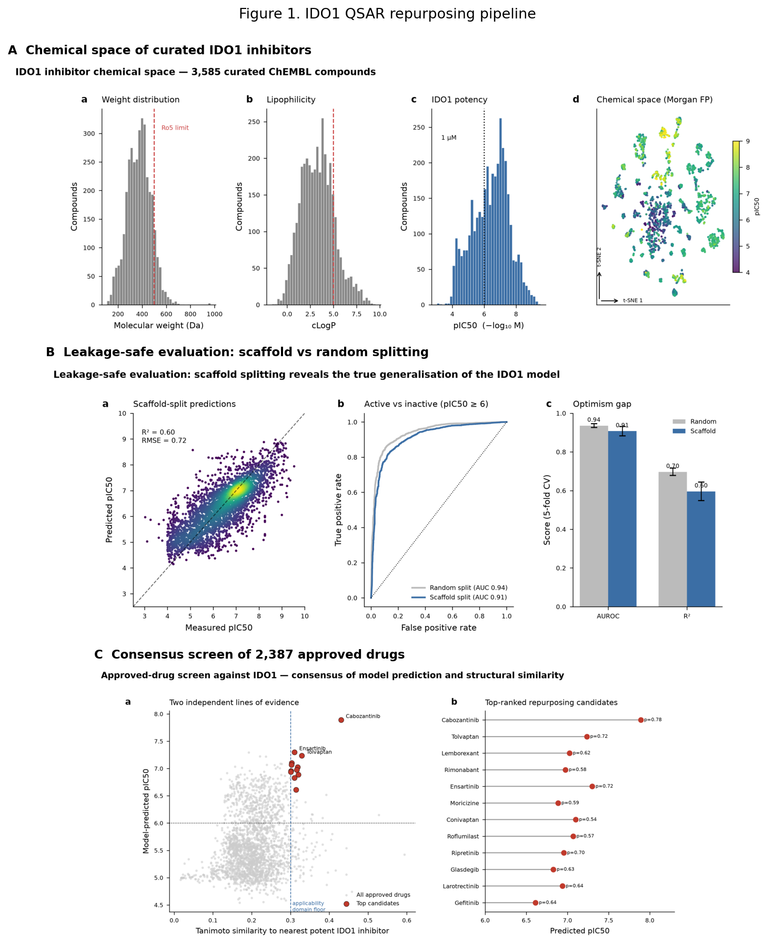
Figure 1. IDO1 QSAR repurposing pipeline. (A) Chemical space of 3,585 curated IDO1 inhibitors coloured by potency. (B) Leakage-safe evaluation: scaffold splitting exposes the optimism gap relative to random splitting. (C) Consensus screen of 2,387 approved drugs by model prediction and structural similarity. Structure-based confirmation is shown separately in Figure 3.
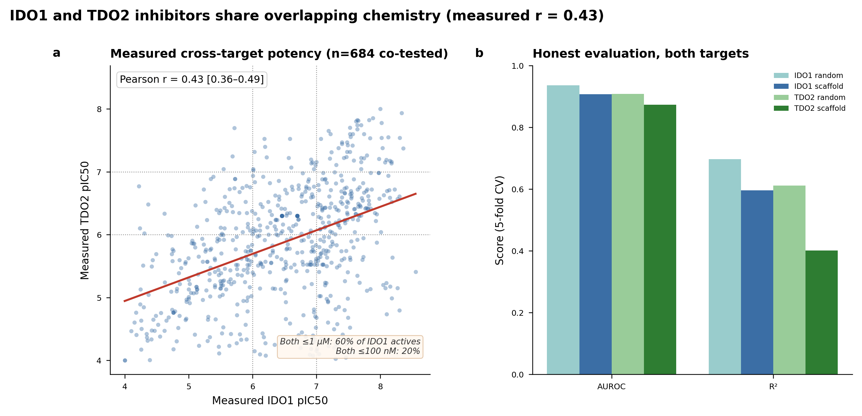
Figure 2. IDO1 versus TDO2 cross-target relationship. (A) The 684 compounds measured against both enzymes in ChEMBL, plotted by measured IDO1 versus measured TDO2 pIC50; the red line is the least-squares fit (Pearson r = 0.43, 95% CI 0.36-0.49, p ≈ 4 × 10^-32), a moderate positive correlation indicating overlapping inhibitor pharmacophores. Dotted guides mark the 1 µM (pIC50 6) and 100 nM (pIC50 7) thresholds; 60% of sub-µM IDO1 inhibitors also inhibit TDO2 at sub-µM, falling to 20% at ≤100 nM. (B) Honest scaffold-split and random-split model performance for both targets; the low TDO2 scaffold R² (0.40) is why the cross-target correlation is measured from data (panel A), not inferred from model predictions.
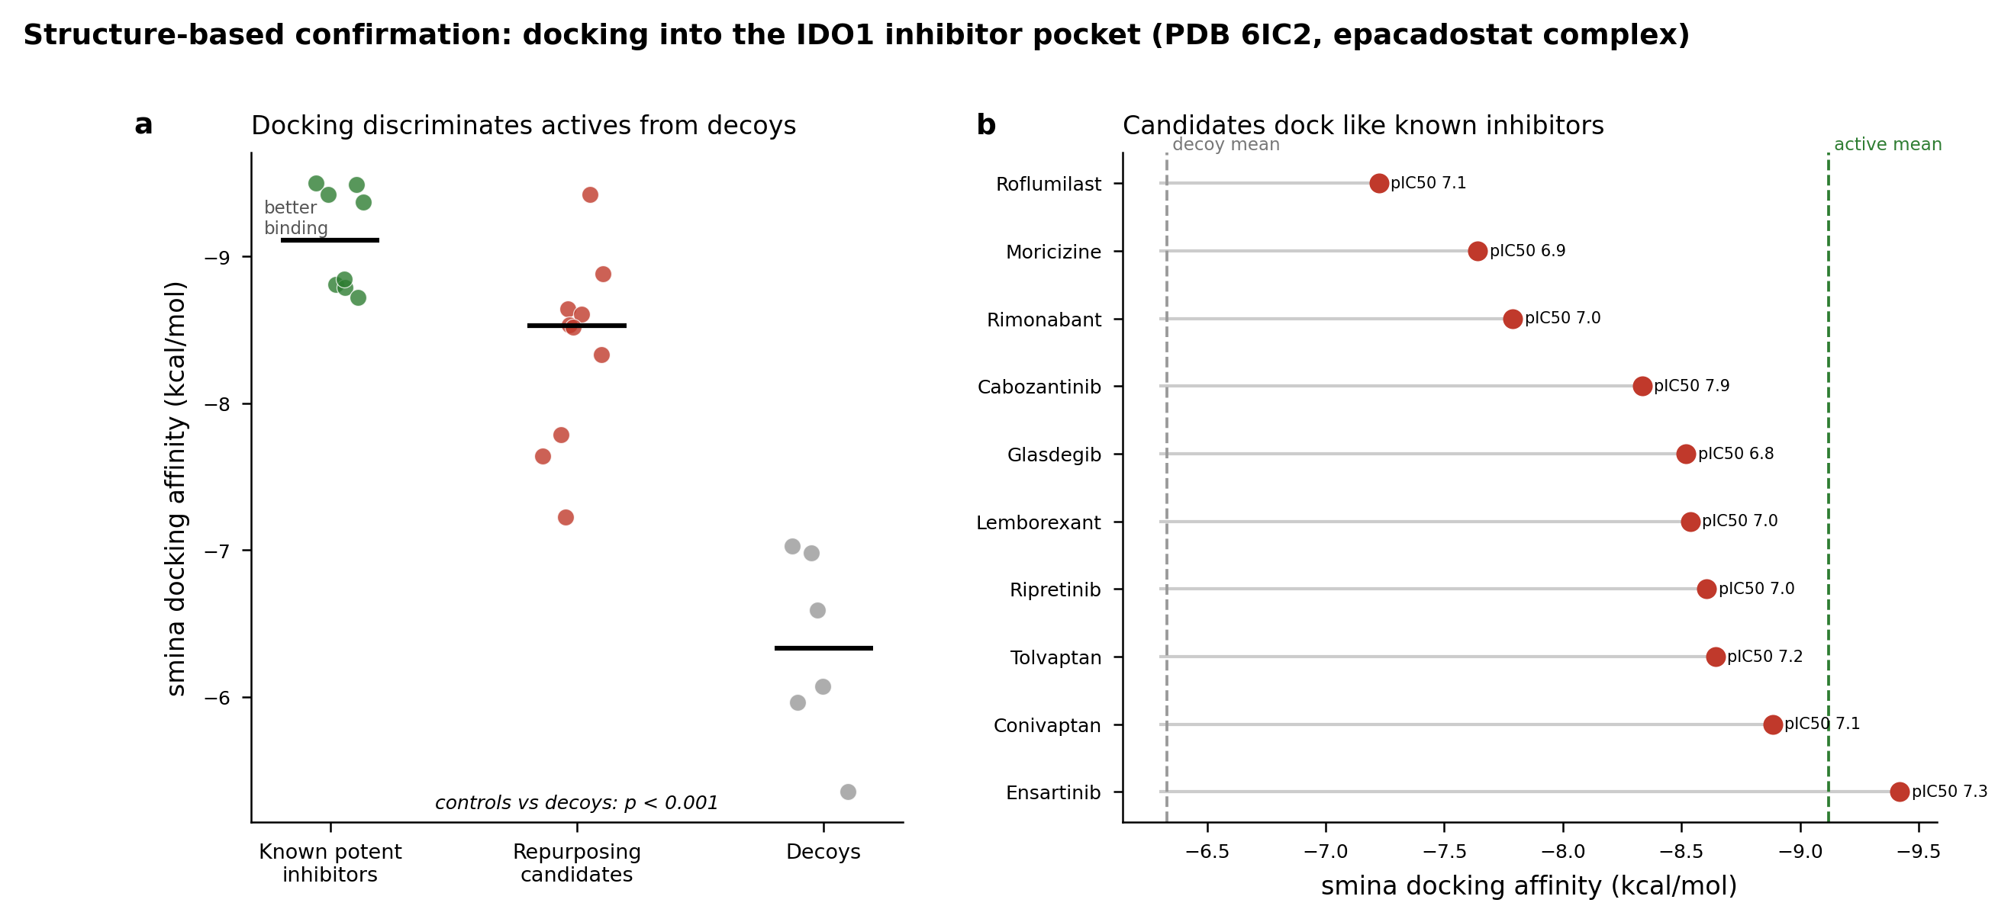
Figure 3. Structure-based confirmation in the haem-containing IDO1 pocket (PDB 6E40). (A) Docking affinity by role: known potent inhibitors (mean −10.11 kcal/mol) separate from decoys (−6.82; one-sided exact Mann–Whitney p = 3.3 × 10⁻⁴), with repurposing candidates (−9.27) overlapping the actives. (B) Contacts each candidate shares with the crystallographic epacadostat pose (16 total); nine of ten candidates share 10–12. (C) Percentage of epacadostat contacts recovered versus total IDO1 contacts per candidate; conivaptan illustrates that a strong docking score and canonical pocket engagement are distinct axes, as it scores well (−9.5 kcal/mol) yet recovers only 29% of epacadostat’s contacts, the lone outlier. The recurring consensus residues (Phe163, Phe226, Arg231, Tyr126, Ser263, Leu234) coincide with the crystallographically characterised IDO1 inhibitor pocket [6], spanning the A/S1 region and adjacent B/S2-side residues.
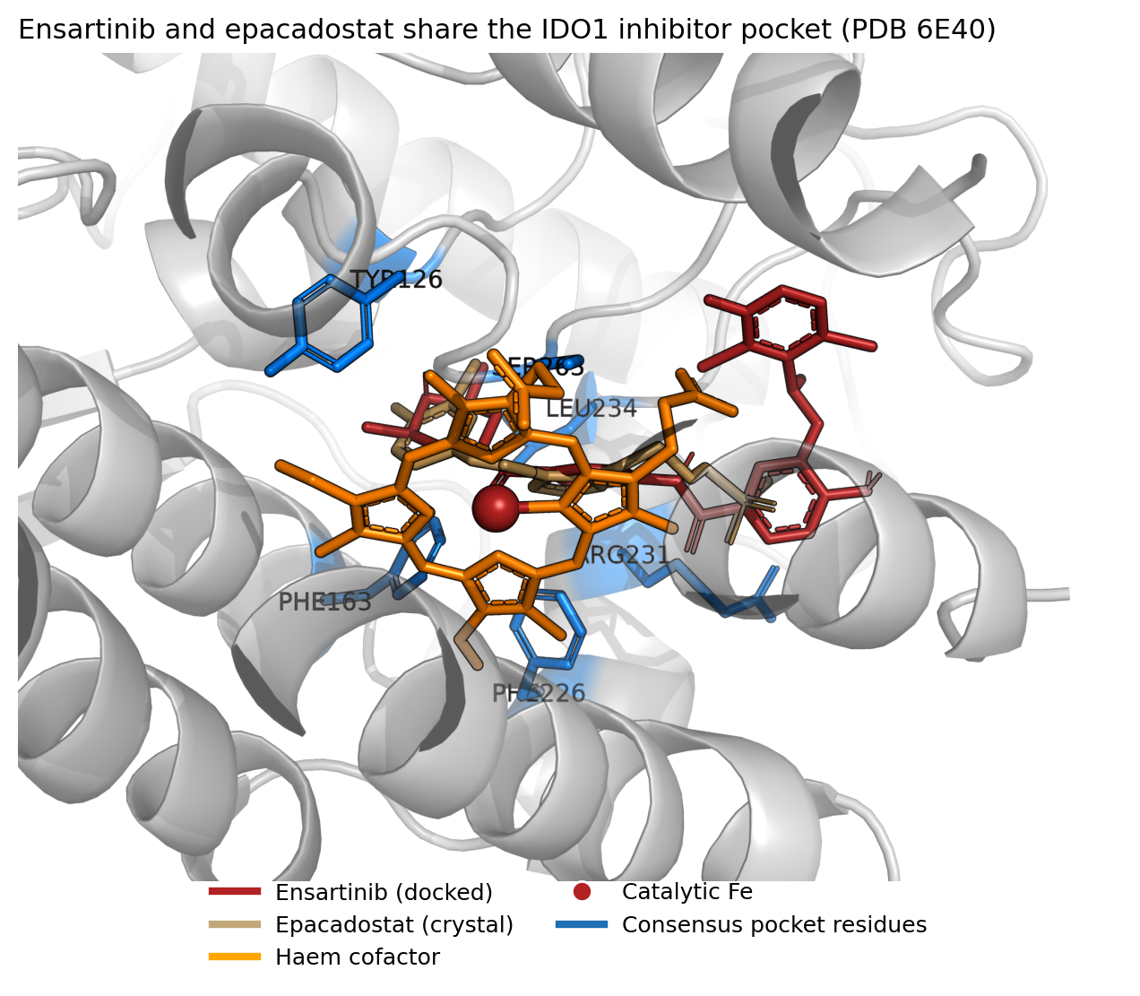
Figure 4. Ray-traced view of the haem-containing IDO1 inhibitor pocket (PDB 6E40). Ensartinib (firebrick sticks, docked) and epacadostat (tan sticks, crystal reference) occupy the same cleft of IDO1 (grey cartoon), adjacent to the ferric haem cofactor (orange) and its catalytic iron (red sphere); consensus contact residues (blue: Phe163, Phe226, Arg231, Tyr126, Ser263, Leu234) line the pocket. Rendered with PyMOL.
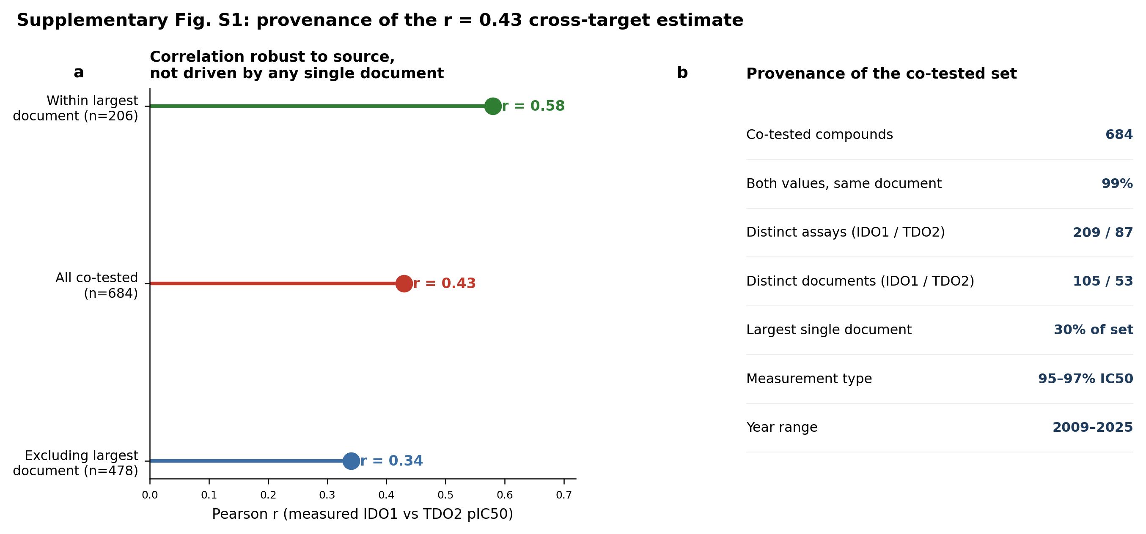
Figure S1. Measurement provenance of the 684 co-tested compounds, supporting the r = 0.43 estimate. (A) The cross-target correlation is robust to data source — it persists when the largest single document is excluded (r = 0.34) and is at least as strong within that document alone (r = 0.58), where measurements share one protocol. The elevated within-document value may reflect measurement homogeneity, a more congeneric series, or both; either way, pooling across sources does not manufacture the r = 0.43 signal. (B) Provenance summary: the set spans dozens of assays and documents over 2009–2025, is 95–97% IC50, and has both enzyme values from the same document for 99% of compounds.
Table 1. Top-ranked in-domain IDO1 repurposing candidates with predicted pIC50, active probability, nearest-neighbour Tanimoto to known actives, docking affinity, and approved indication / primary pharmacology. Ranks 11, 16 and 18 (larotrectinib, gefitinib, trametinib) were not in the docking set and are marked ND. Formatted table provided as table1_candidates.csv; full numeric data with first-approval years as top_candidates_integrated.csv.
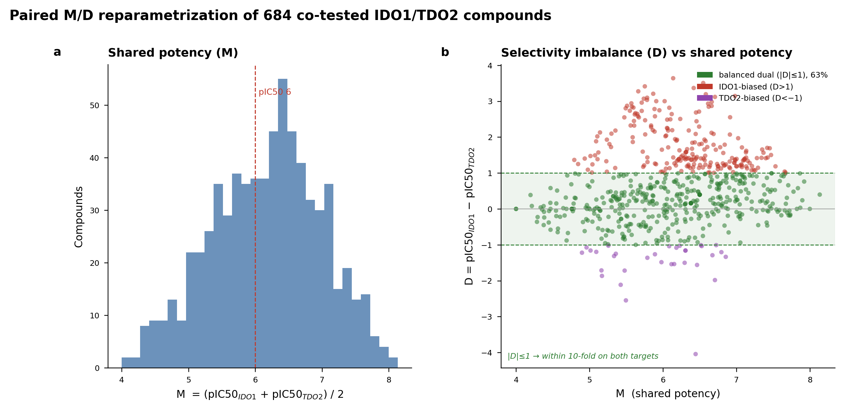
Figure 5. Paired M/D reparametrisation of the 684 co-tested compounds. (A) Distribution of shared potency M = (pActivity_IDO1 + pActivity_TDO2)/2. (B) Selectivity imbalance D = pActivity_IDO1 − pActivity_TDO2 versus M; the shaded band marks the balanced-dual region |D| ≤ 1 (within 10-fold on both enzymes), which contains 63% of compounds. Points coloured by balanced (green), IDO1-biased (red), TDO2-biased (purple).
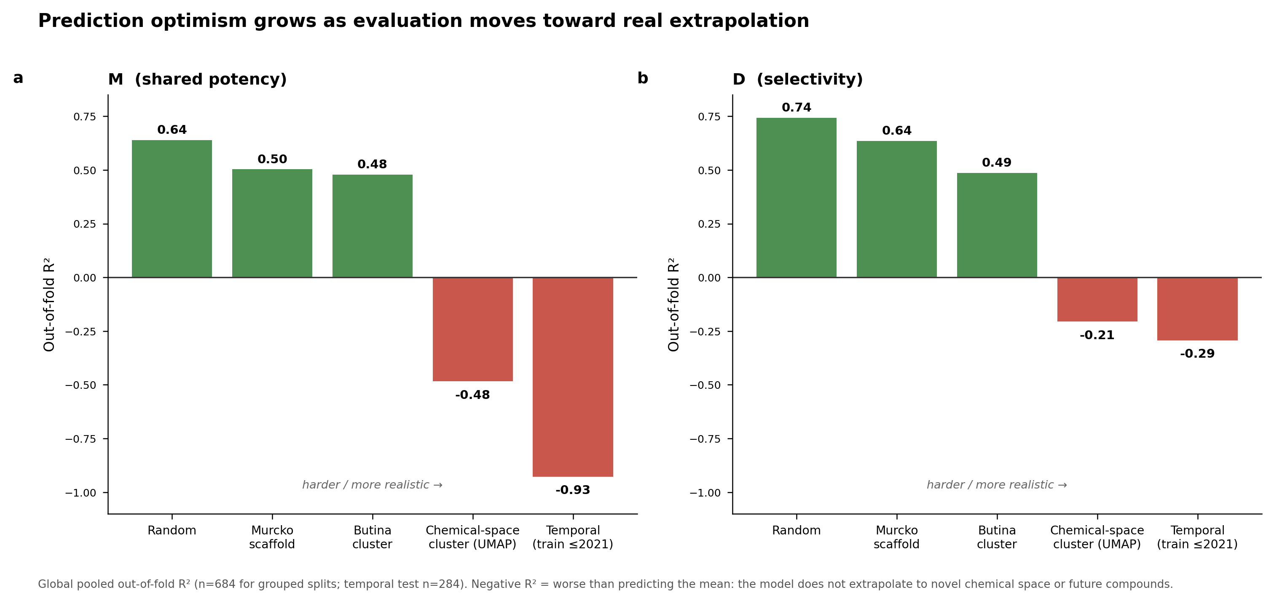
Figure 6. Split-hardness ladder. Global out-of-fold R² for the M (A) and D (B) models under five increasingly strict evaluation schemes — random, Murcko scaffold, Butina cluster, chemical-space (UMAP) cluster, and temporal. R² degrades from ~0.64 (random) to negative values under chemical-space and temporal extrapolation; negative R² indicates prediction worse than the training mean. Temporal test n = 284.
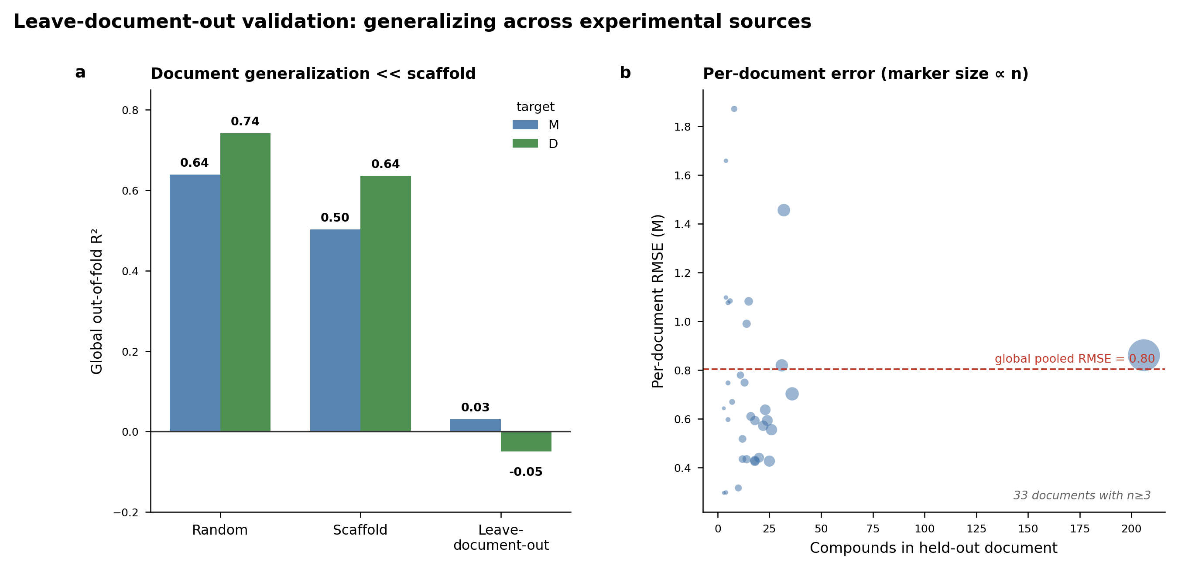
Figure 7. Leave-document-out validation. (A) Global pooled out-of-fold R² under random, scaffold, and leave-one-document-out splitting for M and D; document-level generalisation (0.03 / −0.05) is far worse than scaffold-level (0.50 / 0.64). (B) Per-document RMSE for M versus the number of compounds in each held-out document (marker size ∝ n), with the global pooled RMSE marked.
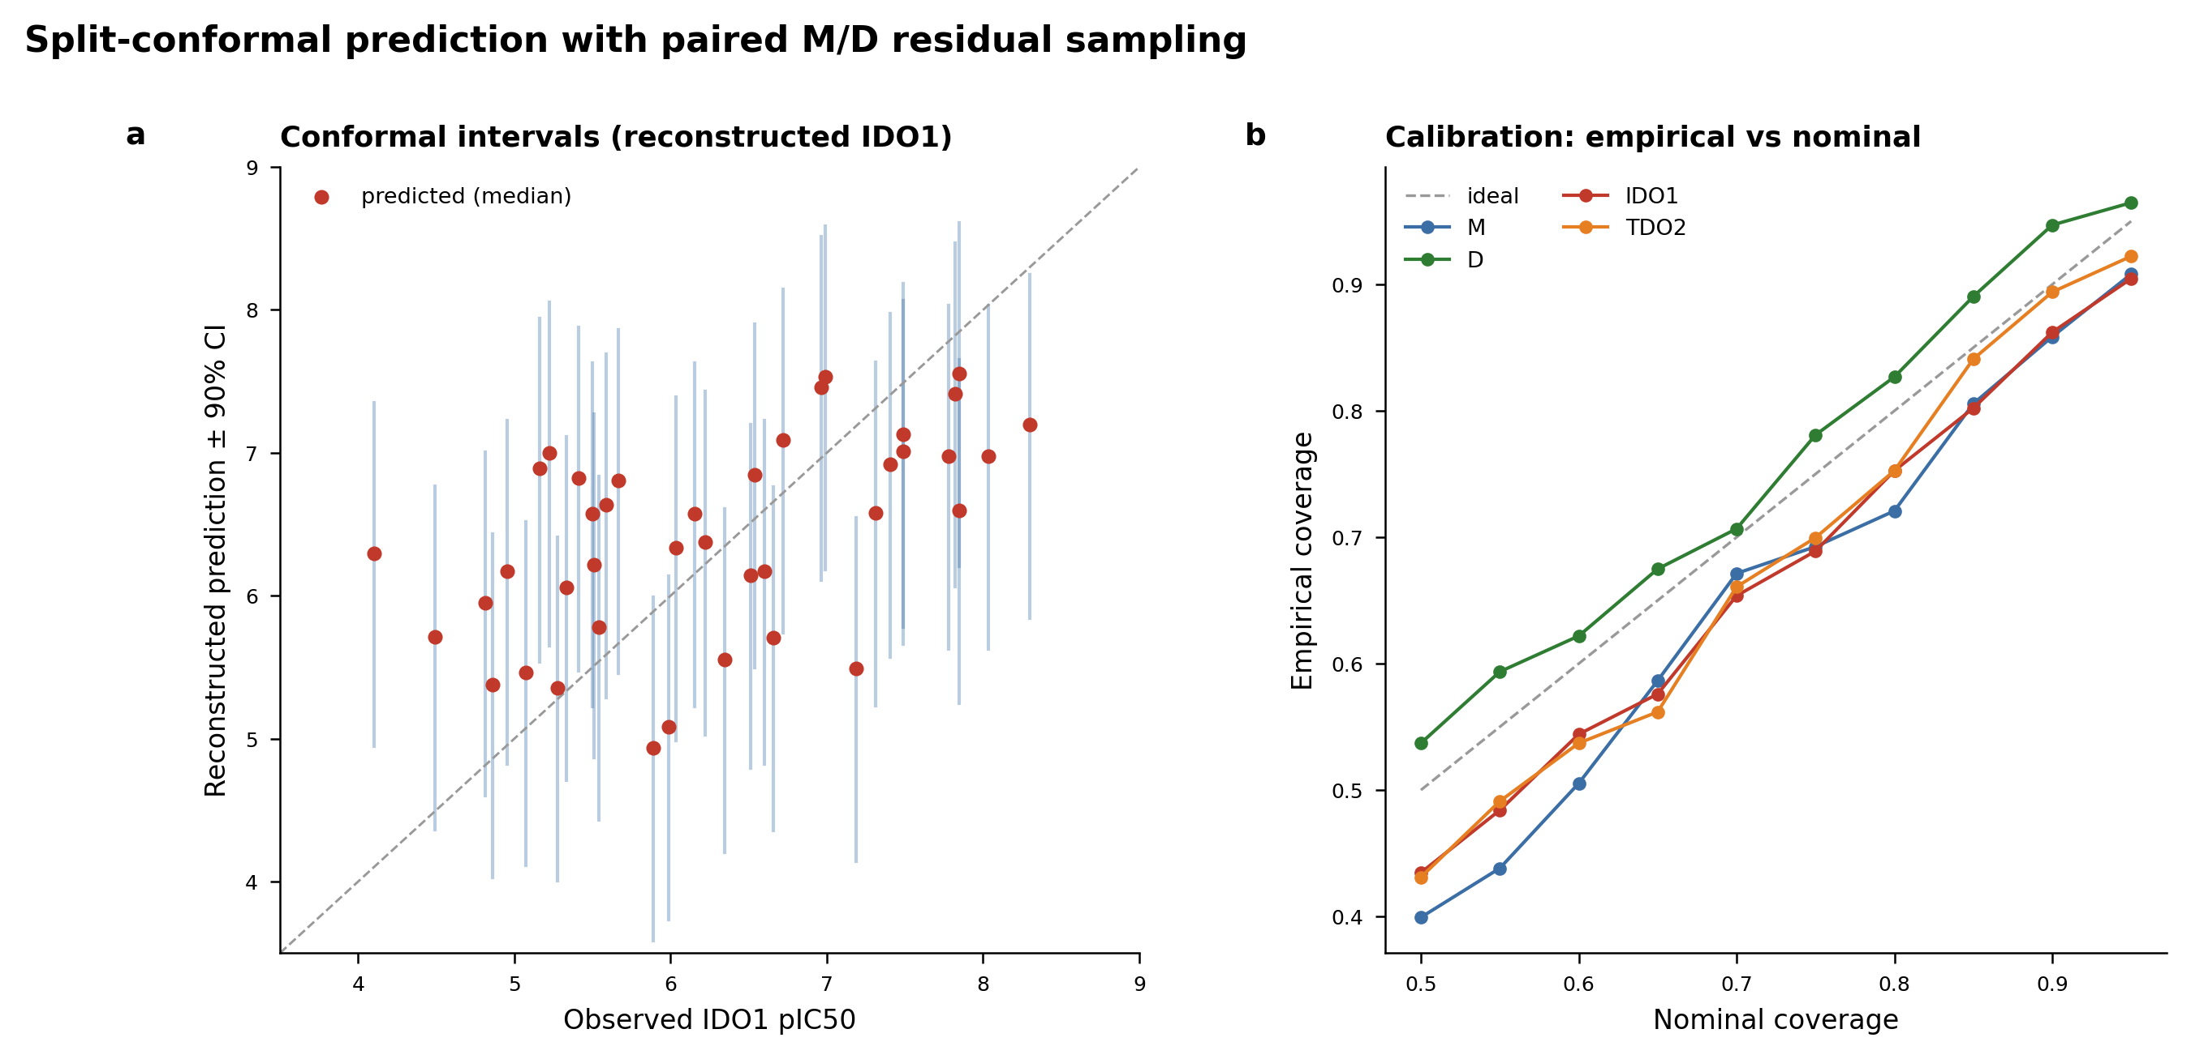
Figure 8. Split-conformal prediction with paired M/D residual sampling. (A) Reconstructed IDO1 predictions with 90% conformal intervals against observed pIC50 (test fold). (B) Empirical versus nominal coverage for M, D, and the reconstructed IDO1/TDO2 predictions; curves track the ideal diagonal, confirming calibration.
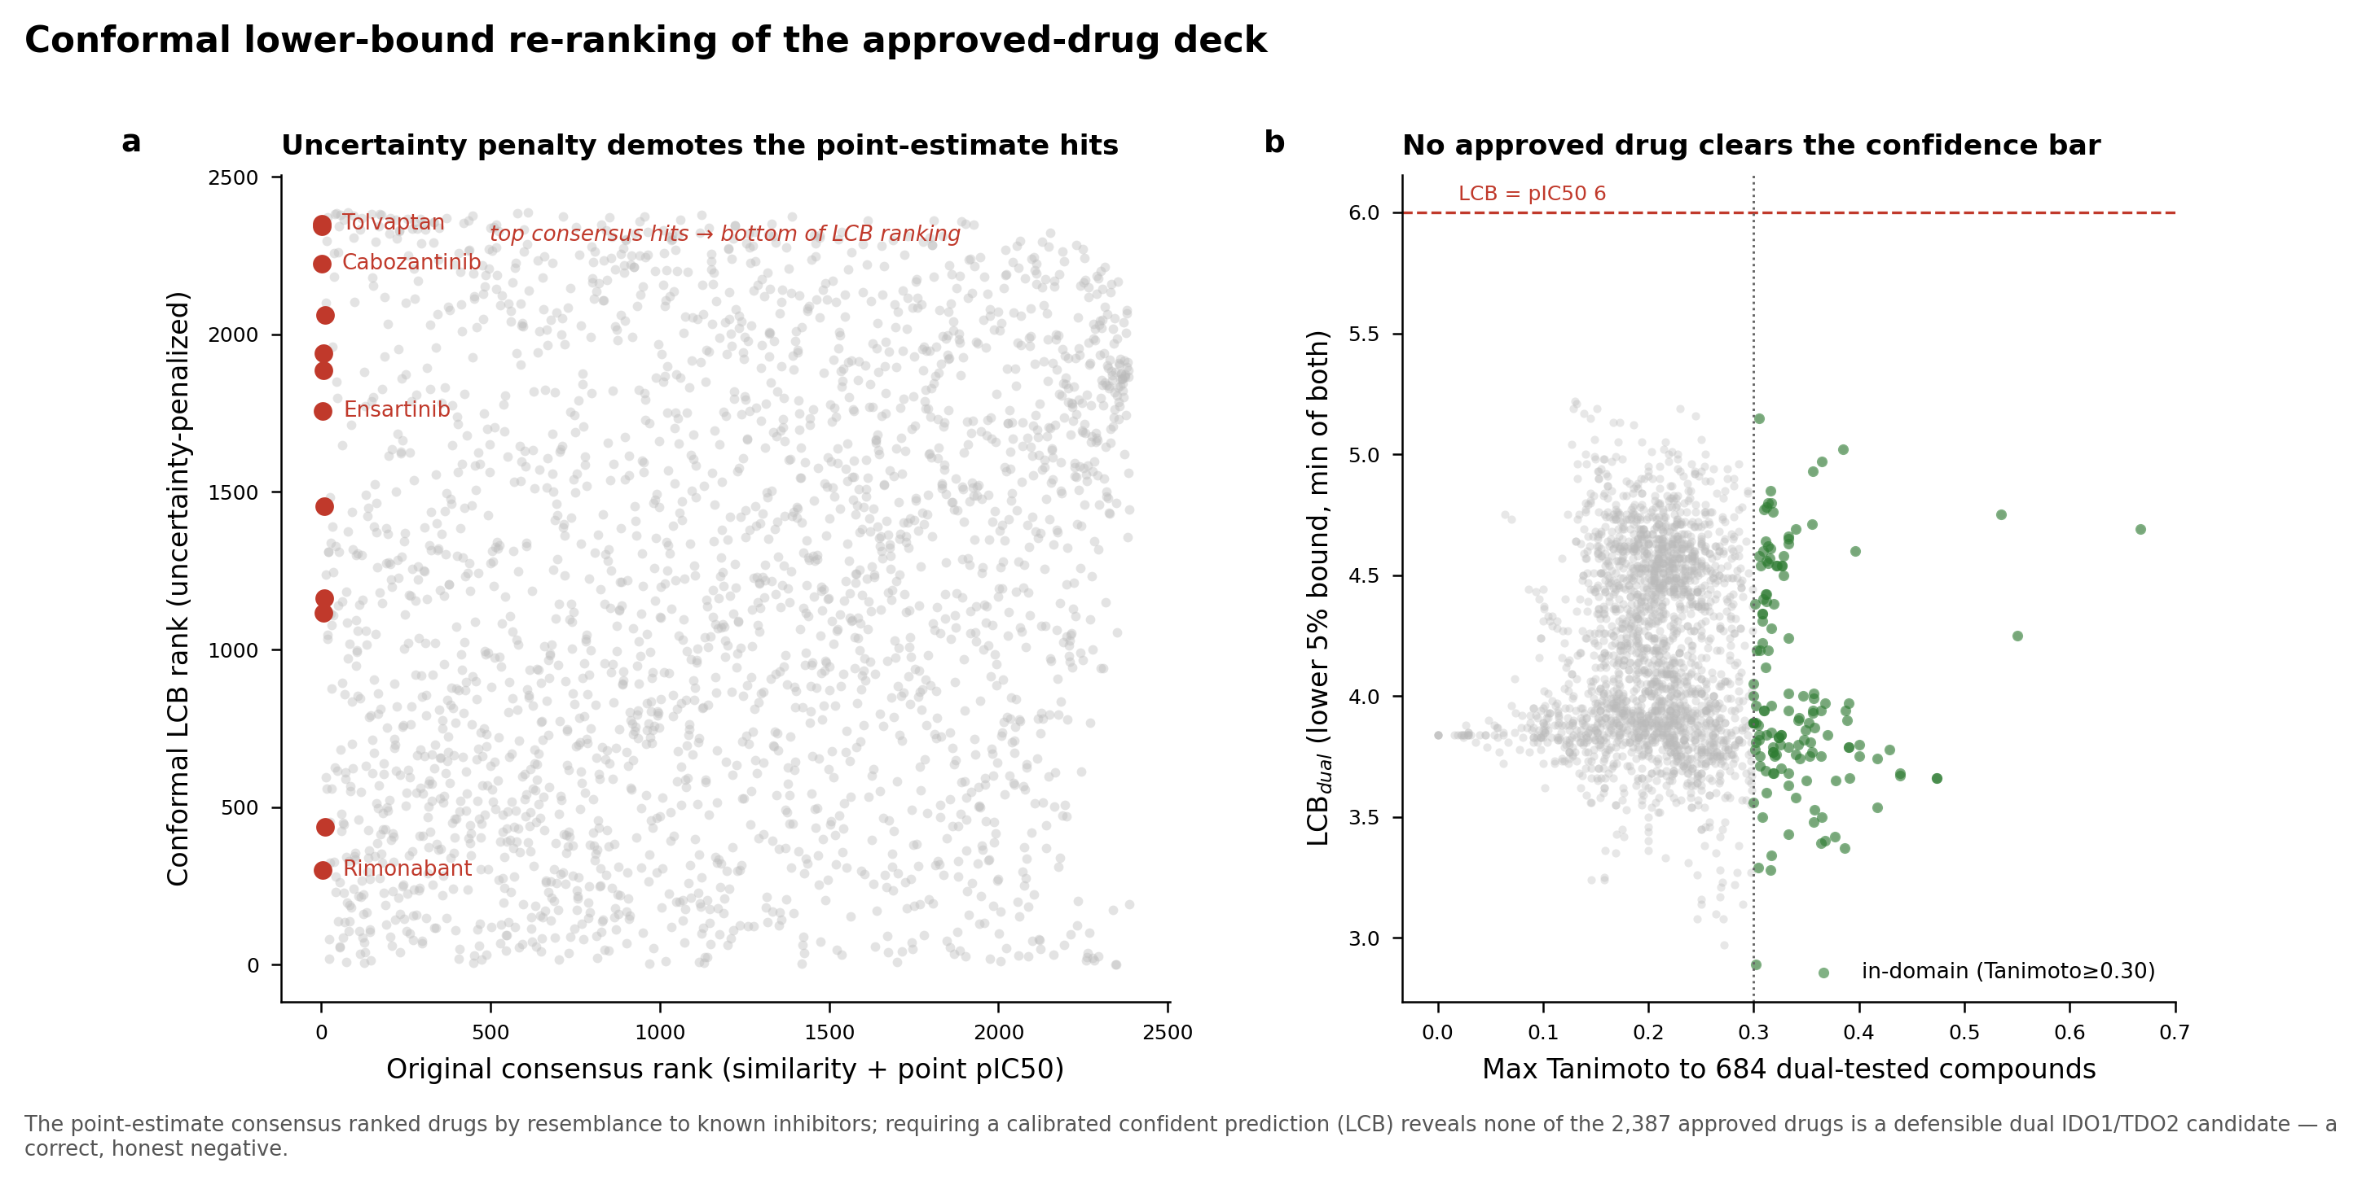
Figure 9. Conformal lower-bound re-ranking of the approved-drug deck. (A) Original consensus rank versus conformal LCB rank; the top point-estimate hits (red) are demoted to the bottom of the LCB ranking. (B) LCB_dual versus applicability-domain similarity to the 684 dual-tested compounds; no approved drug clears the pIC50 6 confident-dual bound (dashed line), an honest negative. The conformal offset is near-constant, so the low bounds reflect deflated point predictions for out-of-domain chemistry, not widened intervals.
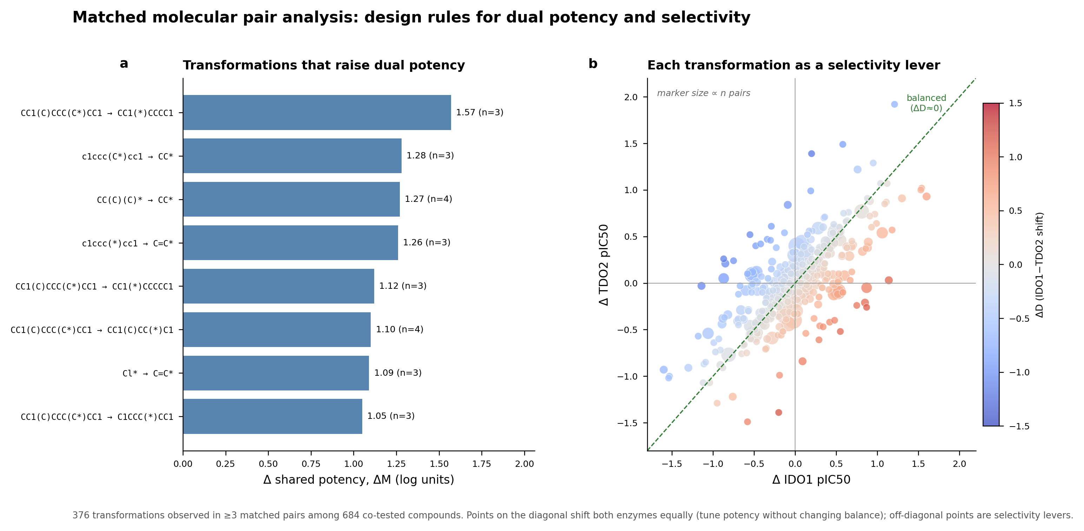
Figure 10. Matched molecular pair design rules. (A) R-group transformations (observed in ≥ 3 matched pairs) that most raise shared potency ΔM. (B) Each transformation as a point in (ΔIDO1, ΔTDO2) space, coloured by ΔD and sized by pair count; points on the diagonal tune potency without changing balance, off-diagonal points are selectivity levers.
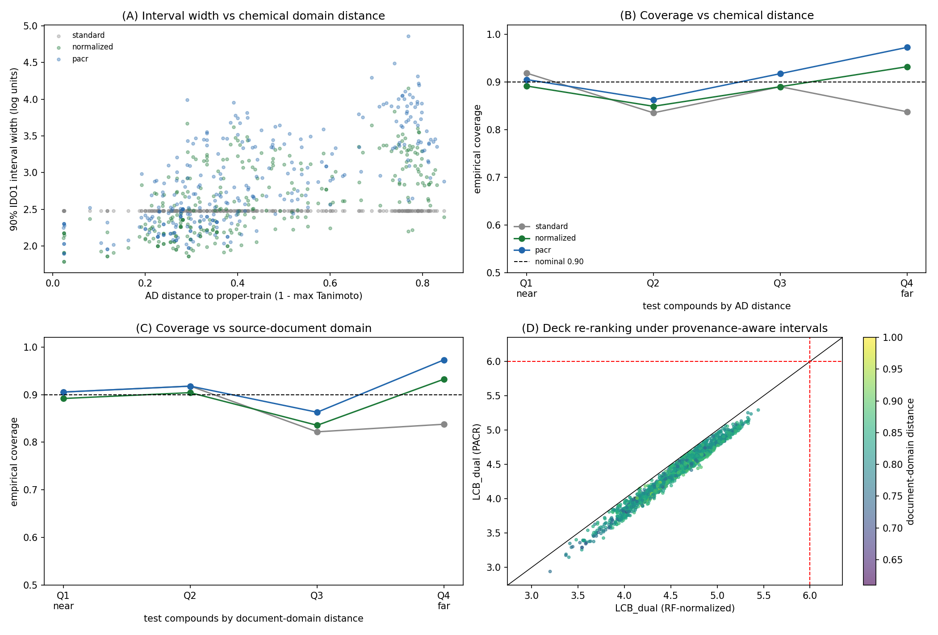
Figure 11. Provenance-Adaptive Conformal Ranking (PACR). (A) 90% IDO1 interval width versus applicability-domain distance for standard split-conformal (grey), RF-normalized conformal (green), and PACR (blue); PACR adds a learned source-document multiplier and widens most strongly for distant compounds. (B) Empirical coverage by AD-distance quartile. (C) Empirical coverage by source-document domain-distance quartile; PACR is conservative on the far document-domain quartile. (D) Deck LCB_dual under RF-normalized conformal versus PACR, coloured by document-domain distance; no drug crosses the confident-dual bound (red), and the honest negative is preserved.
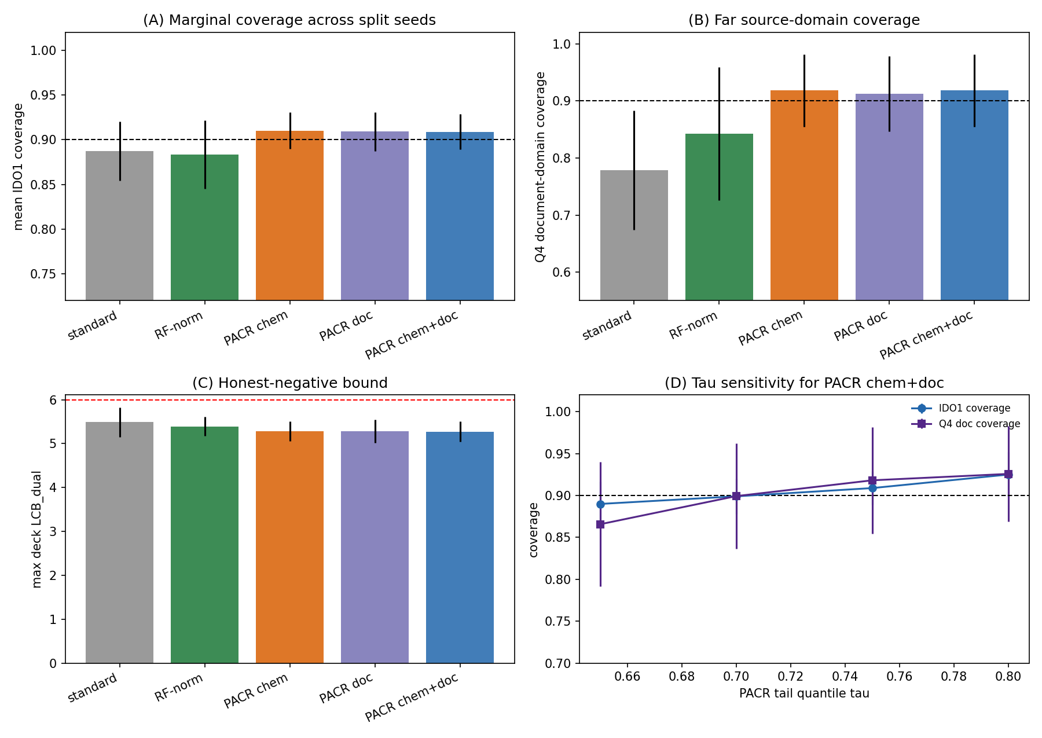
Figure S2. PACR sensitivity and ablation. Across five scaffold-disjoint split seeds, PACR variants are compared against standard split-conformal and RF-normalized conformal baselines. (A) Mean IDO1 marginal coverage. (B) Far source-document-domain quartile coverage, where standard split-conformal under-covers most strongly. (C) Maximum approved-drug LCB_dual; all methods remain below the pIC50 6 confident-dual threshold. (D) Tail-quantile sensitivity for PACR chem+doc: increasing τ from 0.65 to 0.80 acts as a monotonic conservatism knob, increasing coverage while lowering the maximum deck lower bound.
Table S1. PACR sensitivity summary across split seeds, tail quantiles and feature ablations. The full table is provided as extensions/ext1_pacr_sensitivity_summary.csv, with row-level results in extensions/ext1_pacr_sensitivity.csv. Across every split seed, τ setting and PACR ablation, zero approved drugs clear the pIC50 6 confident dual-active bound.
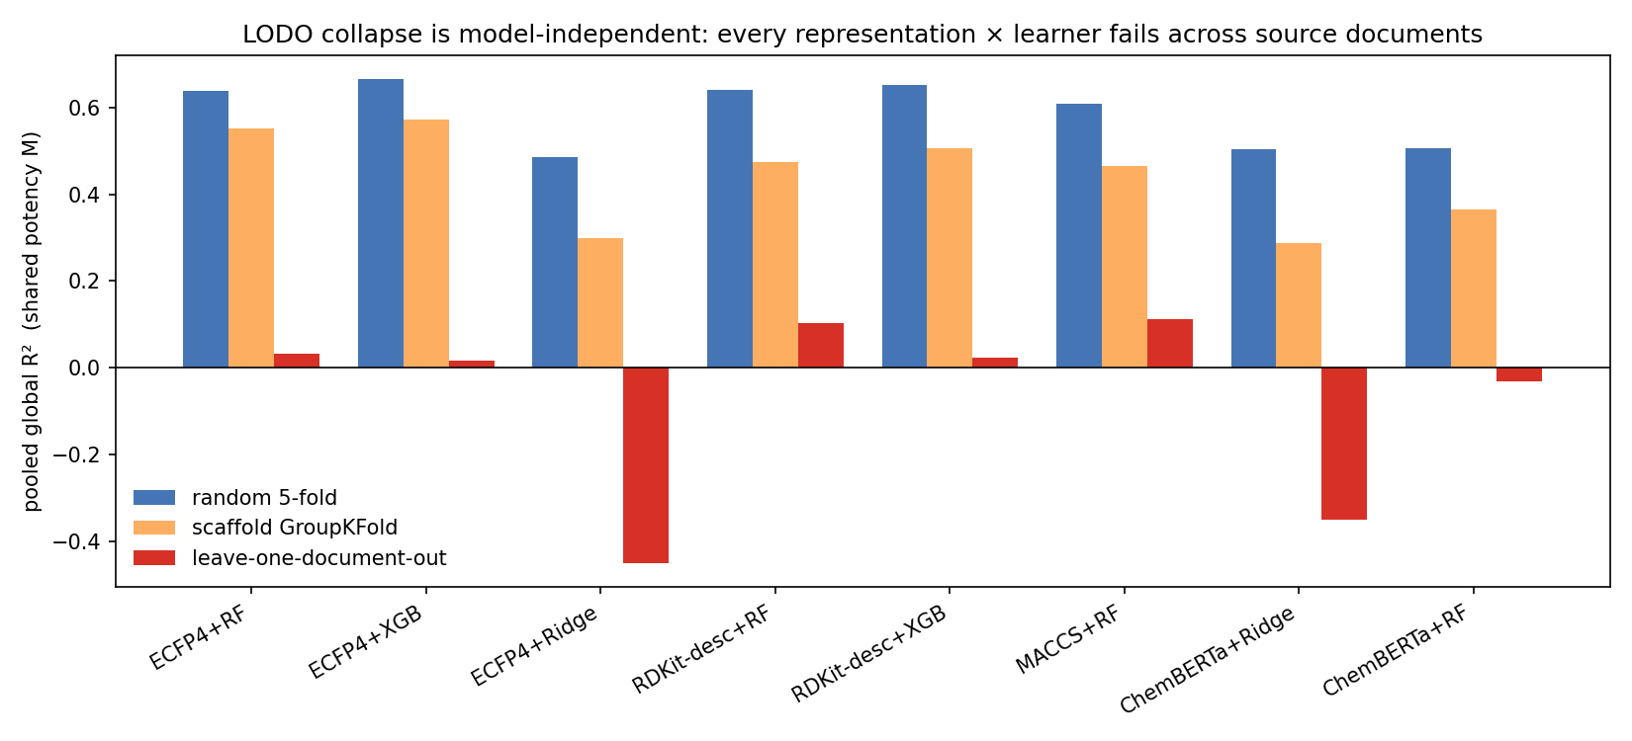
Figure 12. Model-independence of the leave-one-document-out collapse. Pooled global R² for shared potency M under random 5-fold, scaffold GroupKFold, and leave-one-document-out splitting, for eight representation × learner combinations (Morgan/RDKit-descriptor/MACCS/ChemBERTa × random-forest/gradient-boosting/ridge). Every method succeeds under random and scaffold splitting and collapses under LODO (maximum LODO R² 0.11); the pretrained ChemBERTa embedding does not rescue generalisation.
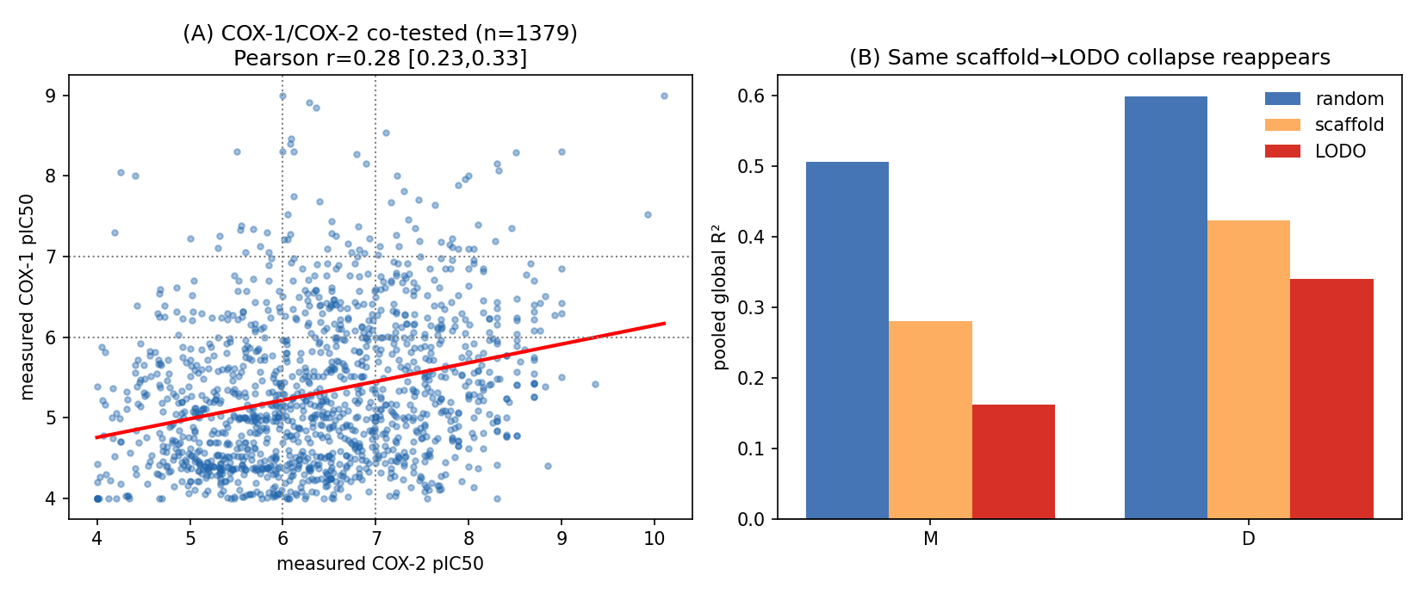
Figure 13. Second target-pair validation on COX-1/COX-2. (A) The 1,379 compounds measured against both enzymes in ChEMBL, plotted by measured COX-1 versus COX-2 pActivity; the red line is the least-squares fit (Pearson r = 0.28, 95% CI 0.23-0.33). (B) Split-hardness ladder for M and D (random, scaffold, leave-one-document-out): the same monotonic scaffold-to-document-level decay seen for IDO1/TDO2 reappears on the independent pair.

Data and code availability
All analysis used public ChEMBL bioactivity data and open-source tools (RDKit, scikit-learn, smina). Curated datasets, ranked candidate lists, trained models, docking outputs and figures are provided as supplementary artifacts. Framework outputs include the paired M/D dataset (data/paired_MD_dataset.csv), split-hardness and leave-document-out results (data/split_hardness.csv, data/lodo_results.csv), conformal calibration (data/conformal_calibration.csv), the conformal deck ranking (data/dual_conformal_ranked.csv), matched-pair transformations (data/mmp_transformations.csv) and the conformal M/D models with calibration residuals (models/md_conformal_models.joblib).
The src/ directory provides a self-validating reconstruction of the pipeline, with stages s1_curate through s6_mmp orchestrated by src/run_all.sh. It rebuilds curation, features, models, the repurposing screen, split-hardness/LODO/conformal analyses and MMP transformations from cached raw ChEMBL bioactivity. Each stage checks its output against committed artifacts: curation reproduces exactly; model AUROC is within 0.001; screen applicability-domain values reproduce within rounding; Butina clusters and LODO R² reproduce. The extension analyses for §3.12-§3.14 are in extensions/, with scripts, figures and results summaries. A pinned requirements.txt and a top-level README.md document the environment and artifact map.

References
- Long GV, Dummer R, Hamid O, et al. Epacadostat plus pembrolizumab versus placebo plus pembrolizumab in patients with unresectable or metastatic melanoma (ECHO-301/KEYNOTE-252): a phase 3, randomised, double-blind study. Lancet Oncol. 2019;20(8):1083–1097. doi:10.1016/S1470-2045(19)30274-8.
- Platten M, Nollen EAA, Röhrig UF, Fallarino F, Opitz CA. Tryptophan metabolism as a common therapeutic target in cancer, neurodegeneration and beyond. Nat. Rev. Drug Discov. 2019;18(5):379–401. doi:10.1038/s41573-019-0016-5.
- Munn DH, Mellor AL. Indoleamine 2,3-dioxygenase and tumor-induced tolerance. J. Clin. Invest. 2007;117(5):1147–1154. doi:10.1172/JCI31178.
- Opitz CA, Litzenburger UM, Sahm F, et al. An endogenous tumour-promoting ligand of the human aryl hydrocarbon receptor. Nature 2011;478(7368):197–203. doi:10.1038/nature10491.
- Pilotte L, Larrieu P, Stroobant V, et al. Reversal of tumoral immune resistance by inhibition of tryptophan 2,3-dioxygenase. Proc. Natl. Acad. Sci. USA 2012;109(7):2497–2502. doi:10.1073/pnas.1113873109.
- Lewis-Ballester A, Pham KN, Batabyal D, et al. Structural insights into substrate and inhibitor binding sites in human indoleamine 2,3-dioxygenase 1. Nat. Commun. 2017;8:1693. doi:10.1038/s41467-017-01725-8.
- Mendez D, Gaulton A, Bento AP, et al. ChEMBL: towards direct deposition of bioassay data. Nucleic Acids Res. 2019;47(D1):D930–D940. doi:10.1093/nar/gky1075.
- Bemis GW, Murcko MA. The properties of known drugs. 1. Molecular frameworks. J. Med. Chem. 1996;39(15):2887–2893. doi:10.1021/jm9602928.
- Baell JB, Holloway GA. New substructure filters for removal of pan assay interference compounds (PAINS) from screening libraries and for their exclusion in bioassays. J. Med. Chem. 2010;53(7):2719–2740. doi:10.1021/jm901137j.
- Rogers D, Hahn M. Extended-connectivity fingerprints. J. Chem. Inf. Model. 2010;50(5):742–754. doi:10.1021/ci100050t.
- Breiman L. Random forests. Mach. Learn. 2001;45(1):5–32. doi:10.1023/A:1010933404324.
- Pedregosa F, Varoquaux G, Gramfort A, et al. Scikit-learn: machine learning in Python. J. Mach. Learn. Res. 2011;12:2825–2830.
- Landrum G. RDKit: Open-source cheminformatics. https://www.rdkit.org.
- Butina D. Unsupervised data base clustering based on daylight’s fingerprint and Tanimoto similarity: a fast and automated way to cluster small and large data sets. J. Chem. Inf. Comput. Sci. 1999;39(4):747–750. doi:10.1021/ci9803381.
- McInnes L, Healy J, Melville J. UMAP: Uniform Manifold Approximation and Projection for dimension reduction. arXiv 2018;1802.03426. doi:10.48550/arXiv.1802.03426.
- Trott O, Olson AJ. AutoDock Vina: improving the speed and accuracy of docking with a new scoring function, efficient optimization, and multithreading. J. Comput. Chem. 2010;31(2):455–461. doi:10.1002/jcc.21334.
- Koes DR, Baumgartner MP, Camacho CJ. Lessons learned in empirical scoring with smina from the CSAR 2011 benchmarking exercise. J. Chem. Inf. Model. 2013;53(8):1893–1904. doi:10.1021/ci300604z.
- Vovk V, Gammerman A, Shafer G. Algorithmic Learning in a Random World. Springer; 2005. doi:10.1007/b106715.
- Papadopoulos H, Proedrou K, Vovk V, Gammerman A. Inductive confidence machines for regression. In: Machine Learning: ECML 2002. Springer; 2002:345–356. doi:10.1007/3-540-36755-1_29.
- Hussain J, Rea C. Computationally efficient algorithm to identify matched molecular pairs (MMPs) in large data sets. J. Chem. Inf. Model. 2010;50(3):339–348. doi:10.1021/ci900450m.
- Sheridan RP. Time-split cross-validation as a method for estimating the goodness of prospective prediction. J. Chem. Inf. Model. 2013;53(4):783–790. doi:10.1021/ci400084k.

Acknowledgements
This work was carried out by the author, who designed the study, performed the computational analysis, and interpreted the results.

