(Interpreted) requirements of the program:
The program involves in creating, plotting, and comparing graphs.
The requirement of the program requires allow the user to type in the name of file, afterwards take what the user have typed in and search for the file. The program will process the file and extract the values from it. The file will contain x-y values and 3 names for other files. Using the x-y value, create empty x-y graphs. Afterwards, it will search and process the other 3 files, extracting their values and plot them onto the empty graphs separately which can be displayed on the terminal. The program should also be able to compare the graphs, calculate and give a summary of the graphs.
On the user-end, upon start-up the user should see a main menu and prompting him/her to enter their choice from 1-8. On selecting 1, the program should prompt them to enter the config filename. The program will then process it. Afterwards, it should take the user back to the main menu where the user can select another option. Selecting 2, 3, 4, 5 and 6 will display a map according to the option. Selecting 7, it should show the weather forecast summary report. On after selecting option 1-7, the program should always take the user back to the main menu. Selecting option 8 should quit the program.

Summary of each implementation of each module:
readAndProcess: This function will prompt user to input the filename, storing it into a String variable. It will add “.txt” to the end of the string if the user did not add it. Afterwards it will search, open the file, reading the file line by line, and store each line into a variable. It will pass variables accordingly to creatMap, readCityLocation, readPerimeter, readCloudPressure to create the required maps.

createMap: This function is to create the base empty map with the x-y grid. It will function will take in an empty 2d array allocate memory and put values into the 2d array. First it will insert “ ” into each “gird” of the array, next it will insert the x and y range values, lastly it will insert “#” accordingly.

readCityLocation: This function is to create the map for displaying the cities locations. It takes in an empty 2d array with its x-y established. It will first search, open the file and read line by line. While each line read, it will insert the value accordingly into the 2d array.

readPerimeter: This function is to mark the area around the cities. It takes in the 2d array with the cities and gird already inserted. It will then check and mark the area around the cities.

readCloudPressure: This function is to insert the value of cloudiness and pressure into their respective maps. It will take in an empty 2d array with its x-y established. It will then open the respective file and read line by line, inserting the value to it’s respectively locations. If the map is for LHM symbols, it will substitute the value according before inserting into the map.

displayCloudPressureMap: This function is to display the 2d array with it’s corresponding index value. It will take in the array, change the value, display it and change it back to the original value.

forecastSummaryReport: This function will display the forecast summary report. It will take in 3 maps, map with perimeter of the cities, map with cloudiness and the map with the pressure inserted. It will then compare the perimeter of cities map and map with cloudiness and map with pressure. Afterwards it will compute and display the results.

deleteMapMemory: This function will delete the map from the memory to free space. It will take in the map, run it through a nested loop and delete the array one by one and delete the pointer-to-pointer variable.

Reflections on program development (e.g. assumptions made, difficulties faced, what could have done better, possible enhancements in future, what have u learnt):
Starting out, I knew the code for the assignment is going to be long with the assignment pdf being 25 pages. I assumed that the tricky part was only going to be retrieving the values from the text files. I had initially thought creating the map was going to be manageable. But alas, I was wrong. I had a hard time creating the base map (x-y graph) as the required display was inverted from the 2d array. E.g. x-1, y-1 on the required display is not equal to column-1, row-1 on the 2d array. Creating the perimeter around the cities was also a challenge as I had to think of a way to mark the area around the cities. For possible enhancements in the future, I think the code’s length can be cut by ¼ or ½ by using only one map and leaving the main config file open till the user exit the program. Throughout this assignment, I have learnt how to create, use, allocate a 2d array dynamically and visualize how it work in the background. I have also learnt how to read a file and various small function, e.g. converting from string to int by using stoi().

Design diagram overview:
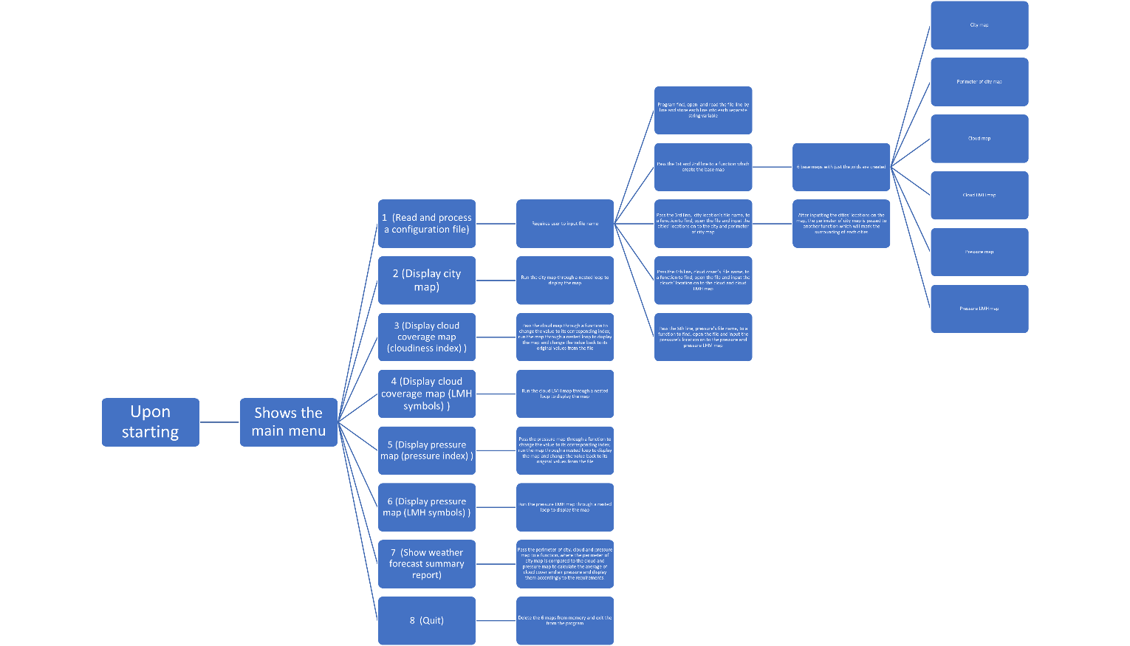

Upon choosing option 1:
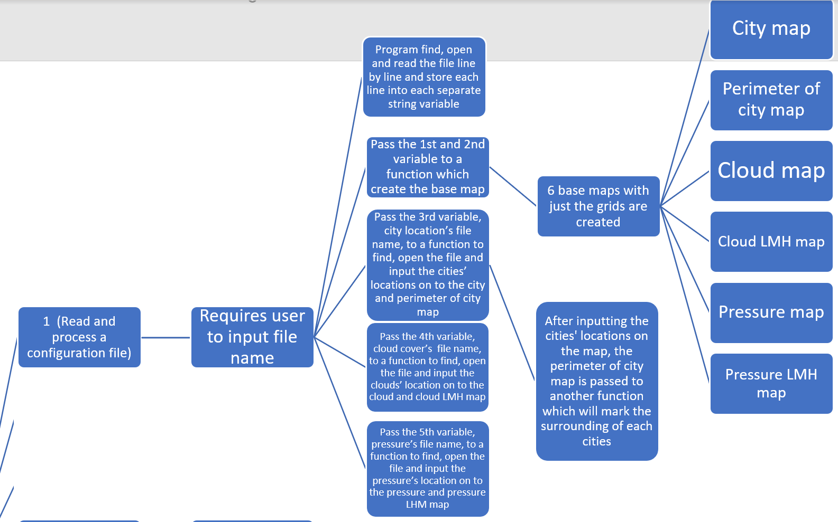
Upon choosing option 2:
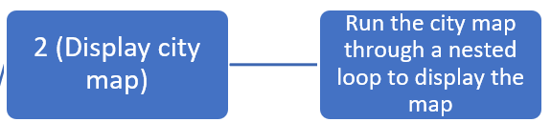
Upon choosing option 3:
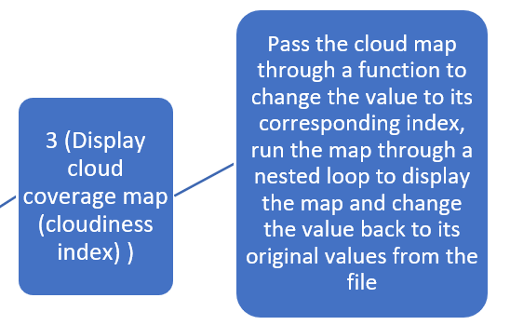
Upon choosing option 4:
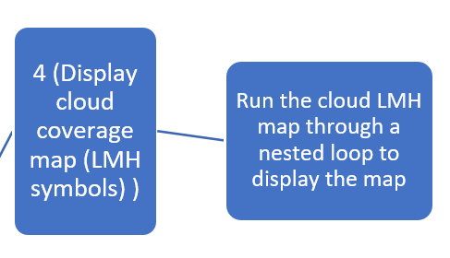
Upon choosing option 5:
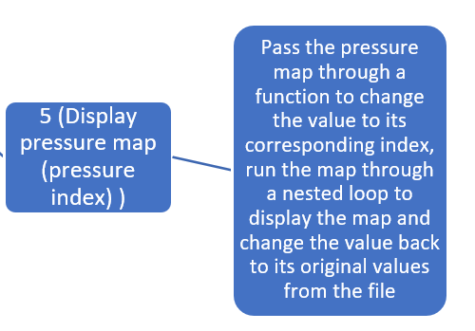
Upon choosing option 6:
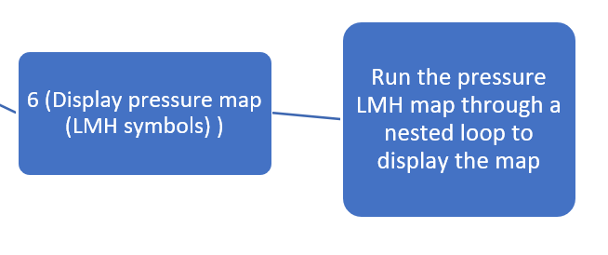
Upon choosing option 7:
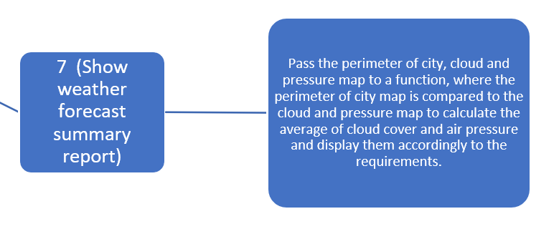
Upon choosing option 8:
