CSCI251 Assignment 1 Test Cases

Name : Chua Tian Sheng
Student No. : 7432434

General Instructions

- Prepare the following :

- Setup the exact same version of your program that you submitted to Moodle (before deadline), inside Ubuntu OS

- Open up Excel document ‘CSCI251_A1_Checklist.xls‘

- Perform test cases SEQUENTIALLY on your program, do not skip steps / sequence!

- FOR EACH test case :

  - Perform the test case on your program

  - If your program ‘pass’ the test case

- Do screen capture, and paste the image in this document, (CSCI251_A1_Test_Cases.doc), where indicated

- Update CSCI251_A1_Checklist.xls (select ‘yes’) at the row corresponding to your test case

Else // i.e. program ‘fails’ the test case

- No need for screen capture (leave the section blank)

- Update CSCI251_A1_Checklist.xls (select ‘no’) at the row corresponding to your test case

- Note : Please RESIZE your screen capture, Adjust the Spacing such that each
test case begins on a new page !!

Before you proceed ...

1) Please delete all previous input ( *.txt ) files that may be present in your program’s folder (e.g. those resource files like config.txt, cloudcover.txt, etc previously downloaded from Google Groups)

2) Download the following input files to the same folder as your Assn1 program (that you submitted 1 day earlier) :

- TestCases_Config.txt
- TestCases_CityLocation.txt
- TestCases_CloudCover.txt
- TestCases_Pressure.txt

*** V. V. V. IMPT NOTE #1 ***
When you download the above files, DO NOT open them in your host O.S.! If you open them in a host OS like Windows, the text editor may save them into a windows-compatible format and your Ubuntu C++ program will have problems reading the files! You should open / access these files ONLY in Ubuntu O.S.

3) Start your program in Ubuntu, and select option 1 :

"1) Read in and process a configuration file"

4) Key in the following data (shown in red) :

Please enter config filename : TestCases_Config.txt

*** V. V. V. IMPT NOTE #2 ***
If for some reason, your program cannot still read the above input filename, last resort is to use Ubuntu text editor 'gedit', copy and paste the contents of the above input filename into a separate filename (e.g. myInput.txt), and save it inside Ubuntu! This is guaranteed to ensure the contents of the files are saved in Ubuntu O.S. compatible format!

Test Cases #1a – #1d

Assuming your program has started, and the correct config filename has been entered (see instructions in pg 2) ...

    - From your program main menu, select option : 2 - Display city map

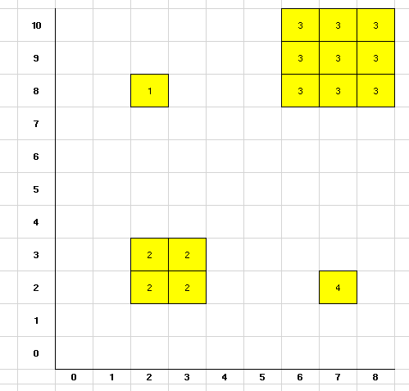

    - Update Excel file ‘CSCI251_A1_Checklist.xls’, select ‘Yes’ in column ‘C’, (for the row corresponding to Test Case #1a), if your program’s results shows the correct grid area location(s) [2, 8] for city id = 1, (Tokyo)

    - Update Excel file ‘CSCI251_A1_Checklist.xls’, select ‘Yes’ in column ‘C’, (for the row corresponding to Test Case #1b), if your program’s results shows the correct grid area location(s) [2, 2], [2, 3], [3, 2], [3, 3], for city id = 2, (Beijing)

    - Update Excel file ‘CSCI251_A1_Checklist.xls’, select ‘Yes’ in column ‘C’, (for the row corresponding to Test Case #1c), if your program’s results shows the correct grid area location(s) [6, 8], [6, 9], [6, 10], [7, 8], [7, 9], [7, 10], [8, 8], [8, 9], [8, 10], for city id = 3, (Oslo)

    - Update Excel file ‘CSCI251_A1_Checklist.xls’, select ‘Yes’ in column ‘C’, (for the row corresponding to Test Case #1d), if your program’s results shows the correct grid area location(s) [7, 2] for city id = 4, (Paris)

    - Confirm that your program's display of all the city's id is at the EXACT same grid area locations as those indicated in the Figure above.

    - If all the data are displayed correctly, paste screen capture(s) of your Ubuntu screen's output under heading : < Paste Screen Capture(s) below > at the end of this test case.

    - Do as many screen captures as necessary, of your program’s output

< Paste Screen Capture(s) below >

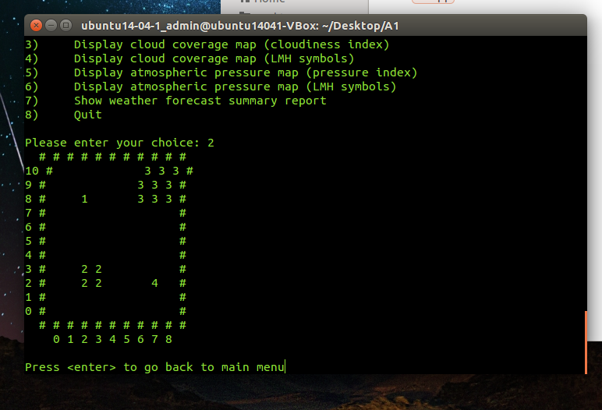

Test Cases #2a – #2b

Assuming your program has started, and the correct config filename has been entered (see instructions in pg 2) ...

- From your program main menu, select option : 3 - Display cloud coverage map (cloudiness index)

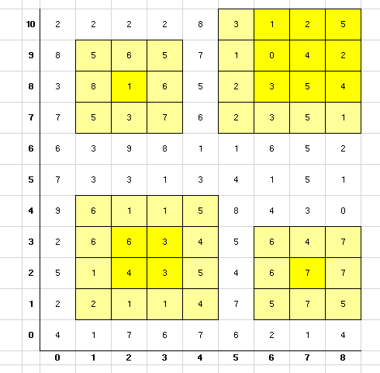

- Update Excel file ‘CSCI251_A1_Checklist.xls’, select ‘Yes’ in column ‘C’, (for the row corresponding to Test Case #2a), if your program’s results shows the correct cloudiness index values for ALL City Occupied Grid Areas (i.e. the cells shaded in dark yellow as shown in figure above)

- Update Excel file ‘CSCI251_A1_Checklist.xls’, select ‘Yes’ in column ‘C’, (for the row corresponding to Test Case #2b), if your program’s results shows the correct cloudiness index values for ALL Non-City Occupied Grid Areas (i.e. the cells which are NOT shaded in dark yellow as shown in figure above)

- Confirm that your program's display of all the cloudiness index values are EXACTLY the same as those indicated in the Figure above.

- If all the data are displayed correctly, paste screen capture(s) of your Ubuntu screen's output under heading : < Paste Screen Capture(s) below > at the end of this test case.

- Do as many screen captures as necessary, of your program’s output

< Paste Screen Capture(s) below >

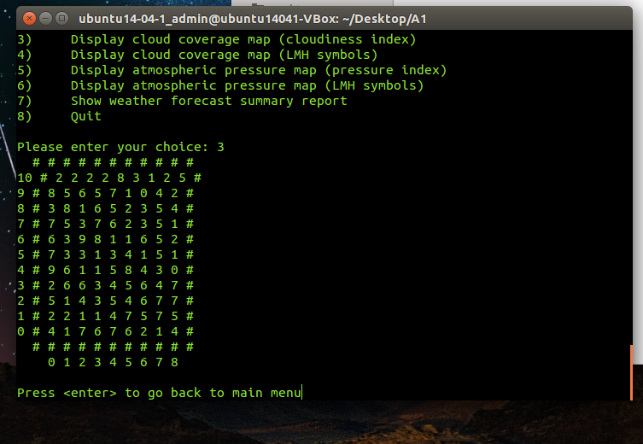

Test Cases #3a – #3b

Assuming your program has started, and the correct config filename has been entered (see instructions in pg 2) ...

- From your program main menu, select option : 4 - Display cloud coverage map (LMH symbols)

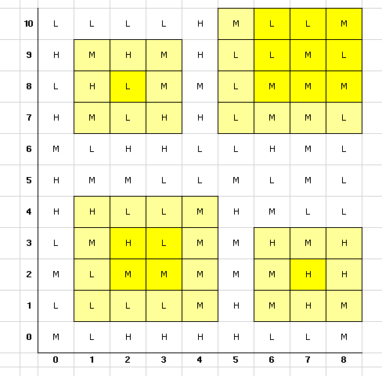

- Update Excel file ‘CSCI251_A1_Checklist.xls’, select ‘Yes’ in column ‘C’, (for the row corresponding to Test Case #3a), if your program’s results shows the correct LMH symbol values for ALL City Occupied Grid Areas (i.e. the cells shaded in dark yellow as shown in figure above)

- Update Excel file ‘CSCI251_A1_Checklist.xls’, select ‘Yes’ in column ‘C’, (for the row corresponding to Test Case #3b), if your program’s results shows the correct LMH symbol values for ALL Non-City Occupied Grid Areas (i.e. the cells which are NOT shaded in dark yellow as shown in figure above)

- Confirm that your program's display of all the LMH symbol values are EXACTLY the same as those indicated in the Figure above.

- If all the data are displayed correctly, paste screen capture(s) of your Ubuntu screen's output under heading : < Paste Screen Capture(s) below > at the end of this test case.

- Do as many screen captures as necessary, of your program’s output

< Paste Screen Capture(s) below >

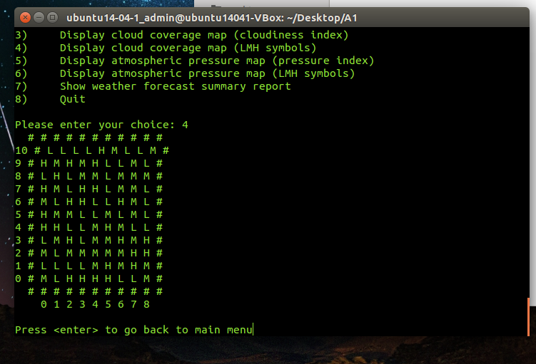

Test Cases #4a – #4b

Assuming your program has started, and the correct config filename has been entered (see instructions in pg 2) ...

- From your program main menu, select option : 5 - Display atmospheric pressure map (pressure index)

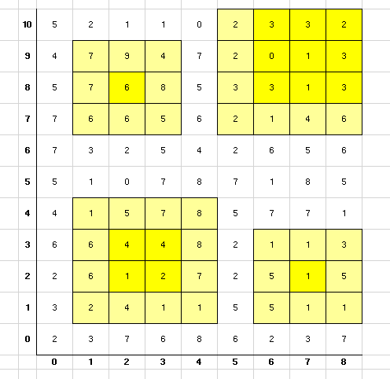

- Update Excel file ‘CSCI251_A1_Checklist.xls’, select ‘Yes’ in column ‘C’, (for the row corresponding to Test Case #4a), if your program’s results shows the correct atmospheric pressure index values for ALL City Occupied Grid Areas (i.e. the cells shaded in dark yellow as shown in figure above)

- Update Excel file ‘CSCI251_A1_Checklist.xls’, select ‘Yes’ in column ‘C’, (for the row corresponding to Test Case #4b), if your program’s results shows the correct atmospheric pressure index values for ALL Non-City Occupied Grid Areas (i.e. the cells which are NOT shaded in dark yellow as shown in figure above)

- Confirm that your program's display of all the atmospheric pressure index values are EXACTLY the same as those indicated in the Figure above.

- If all the data are displayed correctly, paste screen capture(s) of your Ubuntu screen's output under heading : < Paste Screen Capture(s) below > at the end of this test case.

- Do as many screen captures as necessary, of your program’s output

< Paste Screen Capture(s) below >

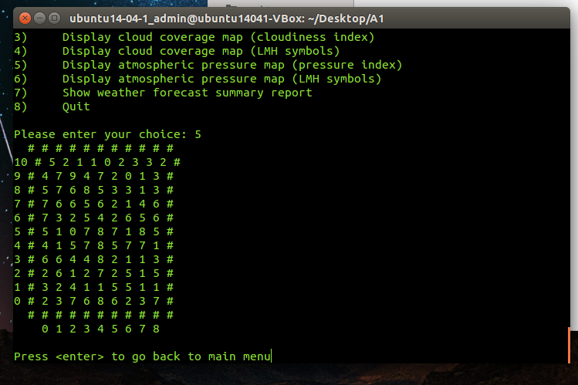

Test Cases #5a – #5b

Assuming your program has started, and the correct config filename has been entered (see instructions in pg 2) ...

- From your program main menu, select option : 6 - Display atmospheric pressure map (LMH symbols)

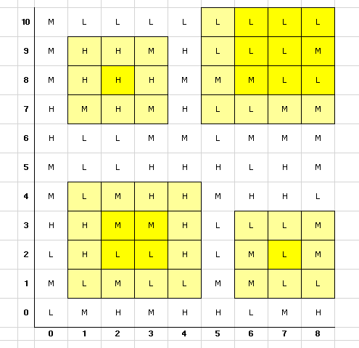

- Update Excel file ‘CSCI251_A1_Checklist.xls’, select ‘Yes’ in column ‘C’, (for the row corresponding to Test Case #5a), if your program’s results shows the correct LMH symbol values for ALL City Occupied Grid Areas (i.e. the cells shaded in dark yellow as shown in figure above)

- Update Excel file ‘CSCI251_A1_Checklist.xls’, select ‘Yes’ in column ‘C’, (for the row corresponding to Test Case #5b), if your program’s results shows the correct LMH symbol values for ALL Non-City Occupied Grid Areas (i.e. the cells which are NOT shaded in dark yellow as shown in figure above)

- Confirm that your program's display of all the LMH symbol values are EXACTLY the same as those indicated in the Figure above.

- If all the data are displayed correctly, paste screen capture(s) of your Ubuntu screen's output under heading : < Paste Screen Capture(s) below > at the end of this test case.

- Do as many screen captures as necessary, of your program’s output

< Paste Screen Capture(s) below >

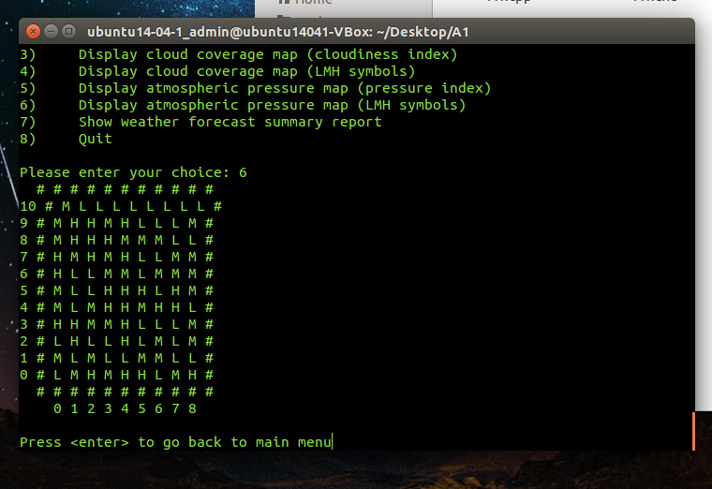

Test Cases #6a – #6d

Assuming your program has started, and the correct config filename has been entered (see instructions in pg 2) ...

- From your program main menu, select option : 7 - Show weather forecast summary report

Weather Forecast Summary Report
-------------------------------
City Name : Tokyo
City ID : 1
Ave. Cloud Cover (ACC) : 54.22 (M)
Ave. Pressure (AP) : 69.78 (H)
Probability of Rain (%) : 20.00

~~
~~~

// ... other details ...

- Update Excel file ‘CSCI251_A1_Checklist.xls’, select ‘Yes’ in column ‘C’, (for the row corresponding to Test Case #6a), if your program’s results shows the correct Ave. Cloud Cover (ACC) value 54.22 and correct LMH symbol value (M) for city id = 1, Tokyo (see figure above)

- Update Excel file ‘CSCI251_A1_Checklist.xls’, select ‘Yes’ in column ‘C’, (for the row corresponding to Test Case #6b), if your program’s results shows the correct Ave. Pressure (AP) value 69.78 and correct LMH symbol value (H) for city id = 1, Tokyo (see figure above)

- Update Excel file ‘CSCI251_A1_Checklist.xls’, select ‘Yes’ in column ‘C’, (for the row corresponding to Test Case #6c), if your program’s results shows the correct Probabiity of Rain (%) value 20 for city id = 1, Tokyo (see figure above)

- Update Excel file ‘CSCI251_A1_Checklist.xls’, select ‘Yes’ in column ‘C’, (for the row corresponding to Test Case #6d), if your program’s results shows the correct Probabiity of Rain ASCII graphic chars for city id = 1, Tokyo (see figure above)

- If all the data are displayed correctly, paste screen capture(s) of your Ubuntu screen's output under heading : < Paste Screen Capture(s) below > at the end of this test case.

- Do as many screen captures as necessary, of your program’s output

< Paste Screen Capture(s) below >

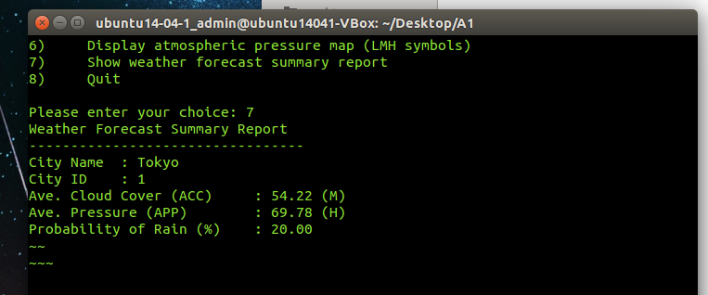

Test Cases #7a – #7d

Assuming your program has started, and the correct config filename has been entered (see instructions in pg 2) ...

- From your program main menu, select option : 7 - Show weather forecast summary report

Weather Forecast Summary Report
-------------------------------

// ... other details ...

City Name : Beijing
City ID : 2
Ave. Cloud Cover (ACC) : 38.19 (M)
Ave. Pressure (AP) : 46.13 (M)
Probability of Rain (%) : 50.00

~~~~
~~~~~
\

// ... other details ...

- Update Excel file ‘CSCI251_A1_Checklist.xls’, select ‘Yes’ in column ‘C’, (for the row corresponding to Test Case #7a), if your program’s results shows the correct Ave. Cloud Cover (ACC) value 38.19 and correct LMH symbol value (M) for city id = 2, Beijing (see figure above)

- Update Excel file ‘CSCI251_A1_Checklist.xls’, select ‘Yes’ in column ‘C’, (for the row corresponding to Test Case #7b), if your program’s results shows the correct Ave. Pressure (AP) value 46.13 and correct LMH symbol value (M) for city id = 2, Beijing (see figure above)

- Update Excel file ‘CSCI251_A1_Checklist.xls’, select ‘Yes’ in column ‘C’, (for the row corresponding to Test Case #7c), if your program’s results shows the correct Probabiity of Rain (%) value 50 for city id = 2, Beijing (see figure above)

- Update Excel file ‘CSCI251_A1_Checklist.xls’, select ‘Yes’ in column ‘C’, (for the row corresponding to Test Case #7d), if your program’s results shows the correct Probabiity of Rain ASCII graphic chars for city id = 2, Beijing (see figure above)

- If all the data are displayed correctly, paste screen capture(s) of your Ubuntu screen's output under heading : < Paste Screen Capture(s) below > at the end of this test case.

- Do as many screen captures as necessary, of your program’s output

< Paste Screen Capture(s) below >

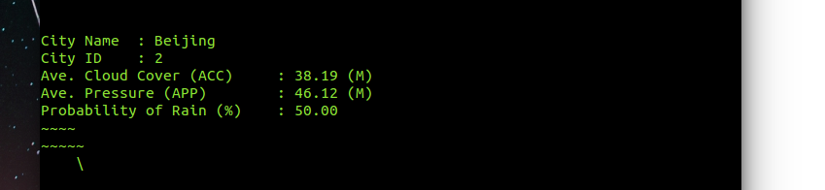

Test Cases #8a – #8d

Assuming your program has started, and the correct config filename has been entered (see instructions in pg 2) ...

- From your program main menu, select option : 7 - Show weather forecast summary report

Weather Forecast Summary Report
-------------------------------

// ... other details ...

City Name : Oslo
City ID : 3
Ave. Cloud Cover (ACC) : 33.19 (L)
Ave. Pressure (AP) : 29.00 (L)
Probability of Rain (%) : 70.00

~~~~
~~~~~
\\\

// ... other details ...

- Update Excel file ‘CSCI251_A1_Checklist.xls’, select ‘Yes’ in column ‘C’, (for the row corresponding to Test Case #8a), if your program’s results shows the correct Ave. Cloud Cover (ACC) value 33.19 and correct LMH symbol value (L) for city id = 3, Oslo (see figure above)

- Update Excel file ‘CSCI251_A1_Checklist.xls’, select ‘Yes’ in column ‘C’, (for the row corresponding to Test Case #8b), if your program’s results shows the correct Ave. Pressure (AP) value 29.00 and correct LMH symbol value (L) for city id = 3, Oslo (see figure above)

- Update Excel file ‘CSCI251_A1_Checklist.xls’, select ‘Yes’ in column ‘C’, (for the row corresponding to Test Case #8c), if your program’s results shows the correct Probabiity of Rain (%) value 70 for city id = 3, Oslo (see figure above)

- Update Excel file ‘CSCI251_A1_Checklist.xls’, select ‘Yes’ in column ‘C’, (for the row corresponding to Test Case #8d), if your program’s results shows the correct Probabiity of Rain ASCII graphic chars for city id = 3, Oslo (see figure above)

- If all the data are displayed correctly, paste screen capture(s) of your Ubuntu screen's output under heading : < Paste Screen Capture(s) below > at the end of this test case.

- Do as many screen captures as necessary, of your program’s output

< Paste Screen Capture(s) below >

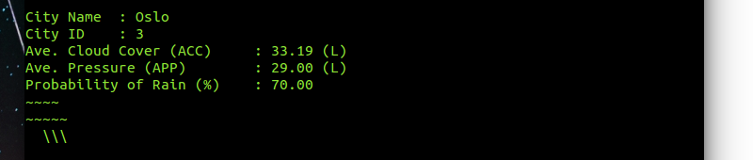

Test Cases #9a – #9d

Assuming your program has started, and the correct config filename has been entered (see instructions in pg 2) ...

- From your program main menu, select option : 7 - Show weather forecast summary report

Weather Forecast Summary Report
-------------------------------

City Name : Paris
City ID : 4
Ave. Cloud Cover (ACC) : 66.33 (H)
Ave. Pressure (AP) : 29.11 (L)
Probability of Rain (%) : 90.00

~~~~
~~~~~
\\\\\

// ... other details ...

- Update Excel file ‘CSCI251_A1_Checklist.xls’, select ‘Yes’ in column ‘C’, (for the row corresponding to Test Case #9a), if your program’s results shows the correct Ave. Cloud Cover (ACC) value 66.33 and correct LMH symbol value (H) for city id = 4, Paris (see figure above)

- Update Excel file ‘CSCI251_A1_Checklist.xls’, select ‘Yes’ in column ‘C’, (for the row corresponding to Test Case #9b), if your program’s results shows the correct Ave. Pressure (AP) value 29.11 and correct LMH symbol value (L) for city id = 4, Paris (see figure above)

- Update Excel file ‘CSCI251_A1_Checklist.xls’, select ‘Yes’ in column ‘C’, (for the row corresponding to Test Case #9c), if your program’s results shows the correct Probabiity of Rain (%) value 90 for city id = 4, Paris (see figure above)

- Update Excel file ‘CSCI251_A1_Checklist.xls’, select ‘Yes’ in column ‘C’, (for the row corresponding to Test Case #9d), if your program’s results shows the correct Probabiity of Rain ASCII graphic chars for city id = 4, Paris (see figure above)

- If all the data are displayed correctly, paste screen capture(s) of your Ubuntu screen's output under heading : < Paste Screen Capture(s) below > at the end of this test case.

- Do as many screen captures as necessary, of your program’s output

< Paste Screen Capture(s) below >

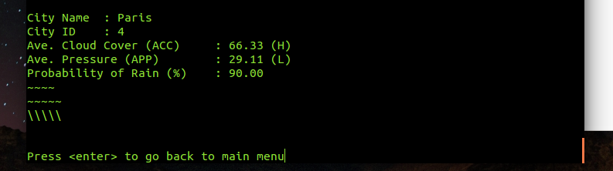

(Optional) Extra Feature / Functionality / Value Add

Description
(In the space below, type a short summary to describe the extra feature(s) implemented)

< Paste Screen Capture(s) below >

(In the space below, use as many screen captures, MS Word arrows, textboxes, as necessary, to show that your extra feature(s) works!)

