50.021 – AI

Kwan Hui

Week 3 Coding - Constraint Satisfaction Problems

[The following notes are compiled from various sources such as textbooks, lecture ma- terials, Web resources and are shared for academic purposes only, intended for use by students registered for a specific course. In the interest of brevity, every source is not cited. The compiler of these notes gratefully acknowledges all such sources. ]

Due: 10th June, 11:59pm Submission: via eDimension

**1 Coding: Semi-Magic Square**

Consider a 3 3 array, where the value of each entry can be either 1, 2 or 3. We want to find an assignment to each of the entries so that the entries in each row, in each column and in one of the diagonals are different. This will also ensure that these row, column and diagonals add up to 6 (i.e., 1 + 2 + 3). Note that the “adding to 6” constraint is not a “binary constraint” as it involves more than two variables. However, the constraint that each pair of values in the row, column or diagonal be different is a “binary constraint”.

*×*

You can find a description of the Semi-Magic Square problem in the figure below.

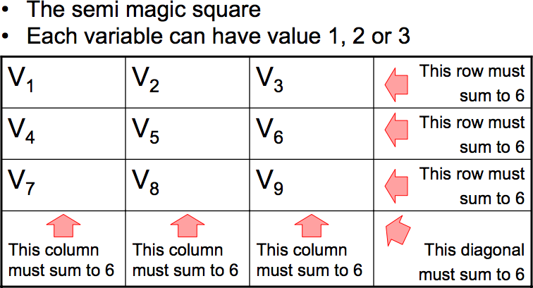

Your tasks are as follows:

1. Implement a CSP that captures this problem. Use the file semi-magic.py in the code distribution, which also imports csp.py. You should use the variable names in the image above in your CSP formulation.
2. Attempt to solve this problem with the various solution methods, ranging from pure backtracking and its various enhancements/heuristics such as variable and value orderings, forward checking, etc.
3. Look at the number of assignments attempted by each algorithm, that should give you some idea of the effectiveness of the methods on this problem. Elaborate on your findings from these results, i.e., what you understand.