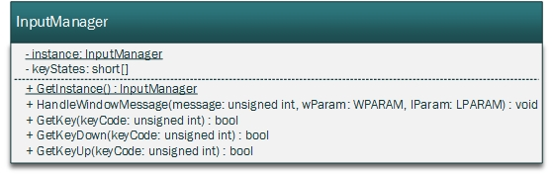

HandleWindowMessage will be called by the WndProc function.

WndProc calls it on WM_KEYUP and WM_KEYDOWN and passes the message code as well as the wParam and lParam to HandleWindowMessage, which then changes the keyStates array to hold the information about which keys are pressed or not.

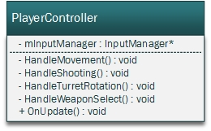

OnUpdate will be called each tick and calls the Handle* methods. It will also check if the escape key is pressed and exit the game.

HandleMovement will check for the WASD keys to move the player around, it does so by asking the InputManager for the keyState.  
HandleShooting will ask for the state of the spacebar and shoots the weapon accordingly.  
HandleTurretRotation will use the arrow keys to move the turret around.  
HandleWeaponSelect will change the selected weapon through the according keys (1-9).