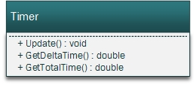

Timer will be used for the respawn timer and the game timer.

Update will be called every game tick.  
GetDeltaTime returns the time between updates.  
GetTotalTime returns the time since the creation of the timer.