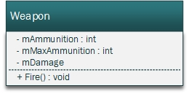

The weapon class will be used for the currently selected and the weapons available by the player.

If mMaxAmmunition is 0 it’s treated as if mAmmunition is infinite.  
The basic weapon which is available from the start for every player has mMaxAmmunition equals 0 and therefore infinite ammunition, but it also has a small damage value in mDamage.

The method Fire will spawn the projectiles, play the weapon sound and spawn particles. It also reduces the mAmmunition by 1.