Working Title

-Proposal Documentation-

Table of Contents

0 Abstract 3

1 Game Design 3

1.0 Overview 3

1.1 Mechanics 3

1.2 Story 3

1.3 Look & Feel 3

2 Project Management 3

2.0 Team 3

2.1 Task Breakdown Structure 3

2.2 Scheduling 3

2.3 Measurement 3

2.4 Task Allocation 3

3 Software 3

4 File Structure 4

5 Assets 4

6 Risks 4

7 Reference List 4

8 Appendix 4

# Abstract

Description of the document’s content.

# Game Design

Covers the overall design of the game. Includes reasoning for target audience, art style, platform, etc.

## Overview

The 3d game is designed to run on android devices as specified by the client and supports API levels from 9 to 22. The goal of the game is to find the exit of a maze. The player is represented by one or more marbles which need to be directed through the level and deal with certain task to unblock closed paths. The score is created by the needed time for finishing the level and the collection of special items.  
The Camera records the scene from above and follows the marble through the level. If played with multiple marbles, the camera tries to capture all marbles by zooming in out. The marbles emit light, so the player can only see the maze in a certain area around the marbles.

## Mechanics

Goes into detail about the game’s core mechanic. This section also mentions possible puzzle elements. A diagram could visualize a basic scene.

A level consists of a board which represents the Maze. The marbles are moved through the level by rotating the board around the z- and x-axis. This is done by rotating the device around the desired axis. The player has to mind that when one of the marbles falls of the game board the level needs to be restarted to finish it.  
In levels with more than one marble the player sometimes needs to unblock several paths by rolling a marble into a specified area. When the marble leaves this area the path gets locked again.   
The player can also unlock blockades by collecting specific items which are spread over the level.

## Story

Describes the story if there is any, can possibly be left out.

## Look & Feel

Describes the look & feel of the game.

# Project Management

Contains all information about the management of our group during the project.

## Team

Rough overview of the people involved in the team and their skills.

## Task Breakdown Structure

Breaks down the work into several modules, which are then broken down into different tasks (Explained by diagram). Also talks about task dependencies.

## Scheduling

How long does each task need and when does each task have to be finished? Critical Path analysis and corresponding diagram.

* Prototype: W/C 17th Oct
* Vertical Slice: W/C 7th Nov
* Alpha: W/C 21st Nov
* Beta: W/C 5th Dec

## Measurement

How will the project process be measured? When is a task done? How will the requirements be tested? Describes the testing concepts used and how they will most likely be applied.

## Task Allocation

Who performs which task(s) and why? (Table would suffice)

# Software

Describes which software is being used for which tasks and why this is the best solution. Includes Frameworks etc.

# File Structure

We kinda already did this but this chapter addresses why this structure has been chosen. This does not have to go into detail.

The folder is primarily divided into a document and a unity folder to separate the unity project files from the other assessments files. All game files are organized under the assets folder among their data type. This should make it easier to find a specific asset and helps to avoid duplicated files within the project. An exception are the UI assets. They are organized in a separate folder, because they would not share assets with other game components and work on their own.

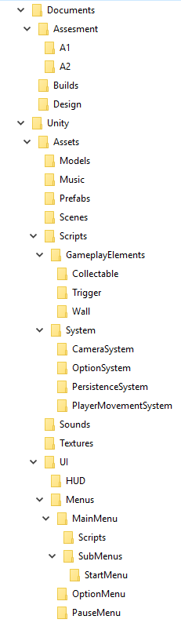

# Assets

Lists the required assets.

# Risks

Of course there is the critical path, but what else are possible risks? What are possible backup plans?

# Reference List

Put all your references in here.

# Appendix

Contains all material which would not fit onto a single page, or is not needed in context (i.e. research material, etc.).