Marble Maze

Alexander Kocourek, Michael Aniol, Rene Pinkere, Konstantin Schaper
CGP605, AE1
Southampton Solent University
Table of Contents
Table of Contents 2
1 Abstract 4
2 Game Design 4
2.1 Overview 4
2.2 Gameplay Elements 4
2.2.1 Triggers 4
2.2.2 Doors 4
2.2.3 Razorblades 5
2.2.4 Passages 5
2.2.5 Destroyable walls 5
2.2.6 Rubber walls 5
2.2.7 Moving Platforms 5
2.2.8 Teleporters 5
2.2.9 Pushers 5
2.2.10 Trap Doors 5
2.2.11 Speed/Slow-Tiles 5
2.3 Story 5
2.4 Look & Feel 6
2.4.1 HUD 6
3 Project Management 6
3.1 Team 6
3.2 Task Breakdown Structure 6
Scheduling 6
3.3 6
3.3.1 Deadlines 7
3.4 Measurement 7
3.5 Task Allocation 7
4 Software 7
5 File Structure 8
6 Assets 9
7 Risks 12
8 Reference List 12
9 Appendix 12

Abstract
This document fulfils the role of a pre-production documentation and outlines both, the game design and the project management for the video game “Marble Maze” (TBD), which is a group project for the ‘Mobile Applications’ unit at Southampton Solent University.

Game Design
The following sub-sections cover the overall design of the game.

Overview
The 3D skill and puzzle mobile game “Marble Maze” is about the player virtually holding a board with a maze on it. The player is represented by one or more marbles which need to be directed through the maze by tilting the device in the z-and x-axis. Additionally, there are puzzles the user has to solve using the given marbles. When one of the marbles falls off the board the active playing session is lost and the level is being reloaded for the next try. The player’s score after each level is related to the time needed for finishing the level and the collection of special objects.
The game is designed to run on android devices as specified by the client and supports API levels from 9 to 22. The Camera records the scene from above and follows the marble through the level. If played with multiple marbles, the camera tries to capture all marbles by zooming in out. The marbles emit light, so the player can only see the maze in a certain area around the marbles.
The target audience are primarily male teenagers from 12 years upwards, which is due to the mix of intense fast paced gameplay and challenging puzzles. Female players of the same age are the game’s secondary target audience, as they might not enjoy the technical mind set as much. (This paragraph needs references)

Gameplay Elements
The following sub-sections list possible puzzle elements that could be used in levels:

Triggers
The marble must be placed on a switch (trigger) to open locked doors or to disable barriers, so that the player can pass them with another marble. In some cases, the doors are locked again when the marble leaves the switch.
Triggers can either be trial-and-error or they are color-coded.

Doors
Some doors open automatically and close again after a short time. The player must pass the door at the right moment.

Razorblades
Rotating sharp objects like a blade which can destroy the marble. Those objects may patrol around a certain area.

Passages
Passages in which the walls move slowly towards each other. The player has to rush through the passage before the marble gets crushed.

Destroyable walls
The player has to slam against a destroyable wall with high speed to smash it and open the path. The walls may reconstruct themselves after a short period of time.

Rubber walls
These walls have a bounce effect, so that the marble will be pushed away after hitting the wall.

Moving Platforms
Moving platforms which can bring the marble over an abyss but the player must be careful that the marble does not fall off.

Teleporters
Always two teleporters correspond with each other. When a marble enters a tile with a teleporter on it, it will be transported to the corresponding one.

Pushers
Vertical platforms which extend from a wall in specified intervals. Could also be connected to triggers.

Trap Doors
Trap doors start opening when a marble passes them. If the marble is too slow, it will fall through the board and the player has lost. Some of those traps can be deactivated by corresponding triggers.

Speed/Slow-Tiles
Certain tiles on the ground might increase/decrease the marbles speed, when rolled over. The tile could also have a direction, in which the force is added, so coming from different angles brings different results.

Story
The game is designed for mobile use, exclusively based around mechanics and has short playtime each session. Therefore, it does not require a dedicated story to get the desired experience across. Some enhancing story elements might be designed and added at a later stage of development though.

Look & Feel
The game has a simple futuristic design with square shapes and a predominant use of white and black colors, but it also uses neon colors for highlighting obstacles such as a laser barrier. It is intended to convey the impression of a modern version of the classic board game it is inspired by, with additional elements.

HUD
Mobile applications need their user interface as clean as possible as most of the screen space will be obtained by the game board. Because of this, the Head-up Display only shows the elapsed time, the current score and a menu icon at top of the display (see Appendix C).

Project Management
The following sub-sections goes into detail about the management of the group of involved persons during the project.

Team
(Rough overview of the people involved in the team and their skills. Could be left out)

Task Breakdown Structure
As shown in Appendix A, the work is broken down into several sections which are further divided into specific groups of work. This gives an overview of the workload, which the concrete tasks can then be derivated from.

Scheduling
The scheduling is done with Microsoft Project and can be seen in the ‘Project_Management.mpp’ file or in appendix K. The schedule has four milestones which represents the required deadlines by Thomas Publishing. The duration of each task were chosen from experience of the group members from similar task done in the future. These times were extended to prevent delays by unforeseen problems. Due to the fact that almost every task has slack and many of them are done in parallel, there is only a small critical path. Microsoft Project shows the path from the music task to the final beta milestone which does not include any other tasks. The critical path analysis can be seen in appendix L. To prevent to not be able to deliver the software on time several backup plans were found. The project is not required to have assets, so the correspondent task can all or just a few be omitted. Due to the fact that not all gameplay elements are required to create a working version of the game, some of them can be omitted as well if time needs to be saved.

Deadlines
There are several deadlines defined by the assessment specification, each critical to the project’s success:
- Prototype: W/C 17th Oct
- Vertical Slice: W/C 7th Nov
- Alpha: W/C 21st Nov
- Assessment Hand-in: W/C 9th Dec
- Beta: W/C 12th Dec

Measurement
Each task is tracked and measured in a percentage of work done in the main Project Management File.
Due to the small timeframe and scope of this project, there will be exclusively functionally Black-Box tested. Testing a feature and guaranteeing that it functions as intended lies in the responsibility of the developer who implements it. Unit tests are going to be used where appropriate.

Task Allocation
The aim was to allocate the task fairly among the group members in terms of complexity and scope. The strengths of the individuals were taken into account. Since Konstatin Schaper already had experience with remote databases, he was assigned to the belonging tasks. To keep a balance, he was not assigned to any of the gameplay elements. Michael Aniol was assigned to build the menus and implementing advertisement in the game, because he had already worked on those task on different projects. The development of the marble- and the camera movement was allocated to Alexander Kocourek. The reason for this is that he created a small prototype during the game design. Everything else was distributed equally, so that everybody has to create one level and the same amount of gameplay elements. Rene Pinkere got a lesser workload, because he is going to be absent for two weeks due to personal reasons. The allocation might be edited later on, if it turns out it was not fair.

Software
The project’s client application will be set up in Unity3D, because of its built in support for mobile development and our teams overall experience with this game engine. The main programming language will be C#, again due to previous experience and built in support for various kinds of server connections.
A simple PHP REST Web API featuring the slim framework will be used as backend for persisting user data. Webservers are cost-efficient in relation to other application server solutions and the RESTful endpoint can later be used for any other services that might be desired, such as a website. This is mainly due to the use of the generally accepted JSON data format and the universal HTTP transfer protocol. Slim matches the given requirements perfectly and is still lightweight and fast to learn. The design for the described persistence unit is documented in the appendices H, I and J.
Industry standard version control framework git is going to be used to keep track of all project files. This prevents the risk of loss of data, enables branching and rolling back previous changes. GitHub is the team’s preferred implementation. Even though there are minor differences between the different Git platforms, the team is most comfortable with GitHub and its excellent metrics tools.
The Project Management is going to be done through various Word Documents and a shared Microsoft Project file. The latter Software allows easy maintenance and creation of tasks. Including dependency management, task allocation and built-in critical path analysis.

File Structure
The folder is primarily divided into a document and a unity folder to separate the unity project files from the other assessments files. All game files are organized under the assets folder among their data type. This should make it easier to find a specific asset and helps to avoid duplicated files within the project. An exception are the UI assets. They are organized in a separate folder, because they would not share assets with other game components and work on their own. A visualization of this structure can be inspected in Appendix B.

Assets
ID | Name |  | Type | Description | Use
A001 | mMenu |  | Music | Background Music of menu | Menus
A002 | sClick |  | Sound | Appears when menu button is clicked | Menus
A003 | tStdWall |  | Texture | Wall Texture | Standard Walls
A004 | tTrigger |  | Texture | Trigger Texture | Triggers
A005 | tDoor |  | Texture | Door Texture | Doors
A006 | tPassage |  | Texture | Texture of walls and floor in passages | Passages
A007 | tDWall |  | Texture | Texture of Wall | Destroyable Walls
A008 | tRWall |  | Texture | Texture of Wall | Rubber Walls
A009 | tPlatform |  | Texture | Texture of Floor | Moving Platforms
A010 | tRazor |  | Texture | Texture of moving obstacles | Razorblades
A011 | tBackground |  | Texture | Background of menu | Menus
A012 | tButtons |  | Texture | Texture of Buttons | Menus
A013 | sTrigger |  | Sound | Plays when trigger is activated | Triggers
A014 | sDoor |  | Sound | Plays when Door is opened ore closed | Doors
A015 | sRazorFly |  | Sound | Plays when razors are flying around | Razorblades
A016 | sRazorHit |  | Sound | Plays when marble gets hit by a razor | Razorblades
A017 | sPlattform |  | Sound | Plays when platforms are moving around | Platforms
A018 | sDWall |  | Sound | Plays when wall gets destroyed | Destroyable Walls
A019 | sRWall |  | Sound | Plays when marble hits the wall | Rubber Walls
A020 | tTeleporter |  | Texture | Texture of the teleporter object | Teleporter
A021 | sTeleporter |  | Sound | Sounds plays when marble gets teleported | Teleporter
A023 | tTrapDoor |  | Texture | Texture of trap doors | Trapdoor
A024 | sTrapdoor |  | Sound | Sound when trap is triggerd | Trapdoor
A025 | tPusher |  | Texture | Texture of pusher | Pusher
A026 | sPusher |  | Sound | Sound when pusher moves | Pusher
A027 | mGame |  | Music | Background Music during a level | Ingame

Risks
(Of course there is the critical path, but what else are possible risks? What are possible backup plans?)

Reference List
ANON., 2016. Slim framework [viewed 8 December 2016]. Available from: https://www.slimframework.com/

PILOPA, 2016. Pilopa/Mobile_Applications_Project [viewed 8 December 2016]. Available from: https://github.com/Pilopa/Mobile_Applications_Project

TECHNOLOGIES, U., 2016. Unity - mobile development [viewed 8 December 2016]. Available from: https://unity3d.com/learn/tutorials/topics/mobile-touch/mobile-development

Appendix
- Work Breakdown Structure
- Project File Structure
- Head-up Display
- MainMenu Concept
- OptionsMenu Concept
- StartMenu Concept
- PauseMenu Concept
- Database ERD
- WebAPI Routes
- Unity Manager WebAPI Interface
- Schedule
- Critical Path
- Work Breakdown Structure
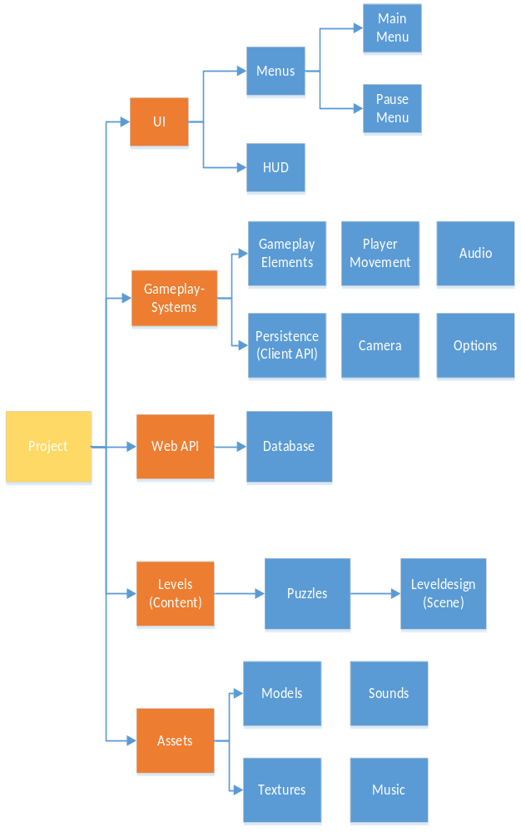
- Project File Structure
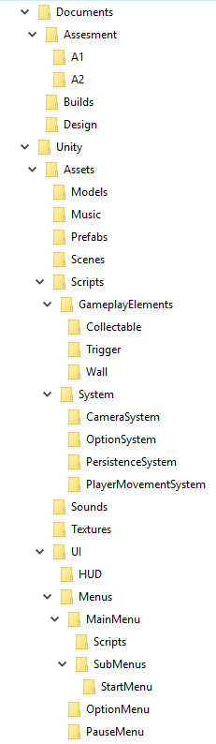
- Head-up Display
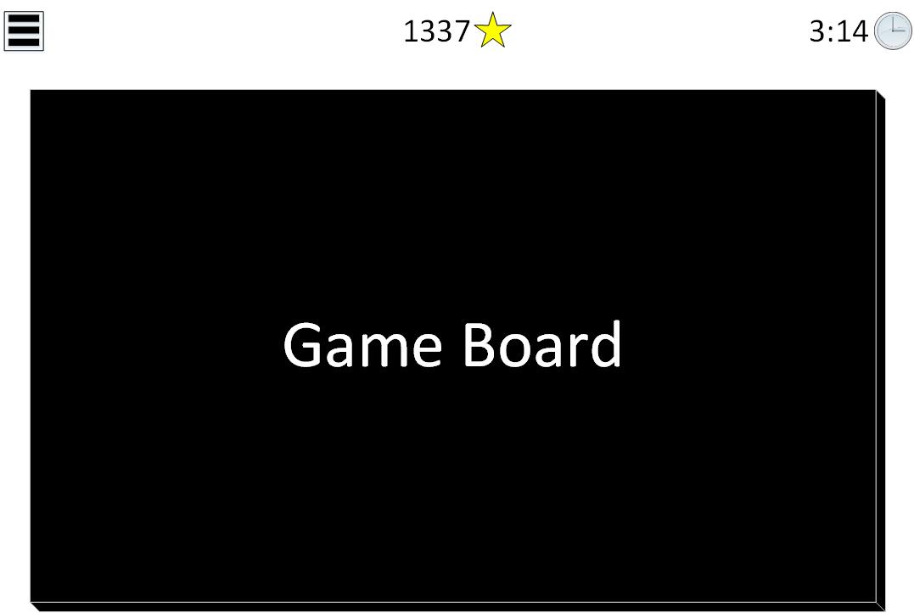

- MainMenu Concept
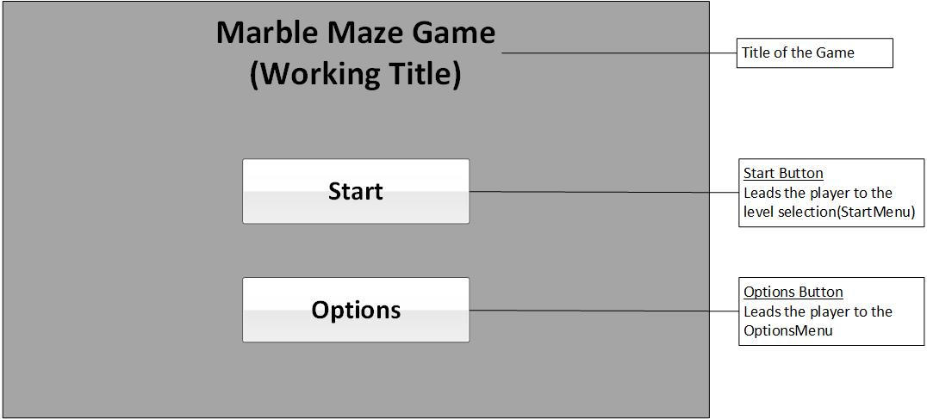
- OptionsMenu Concept
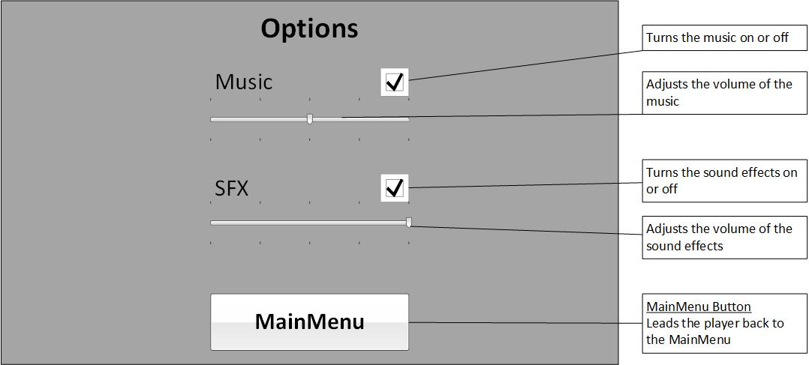
- StartMenu Concept
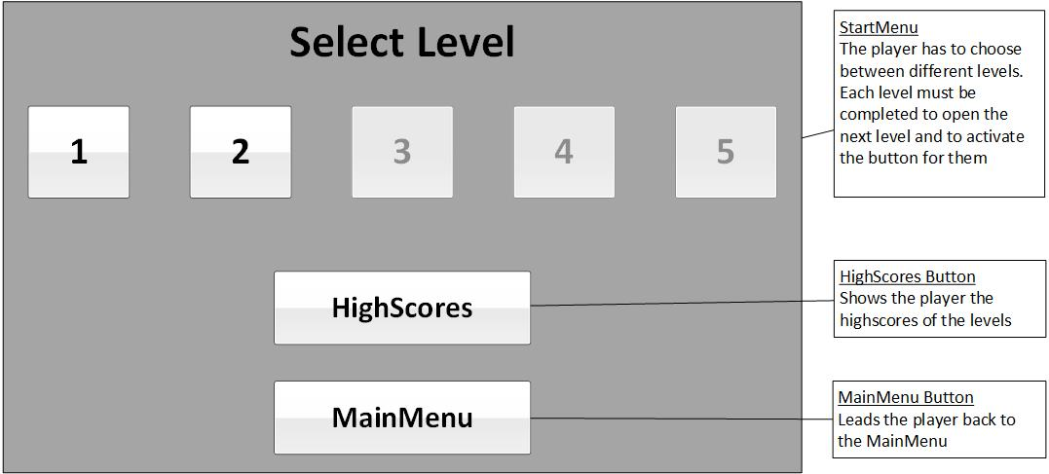
- PauseMenu Concept
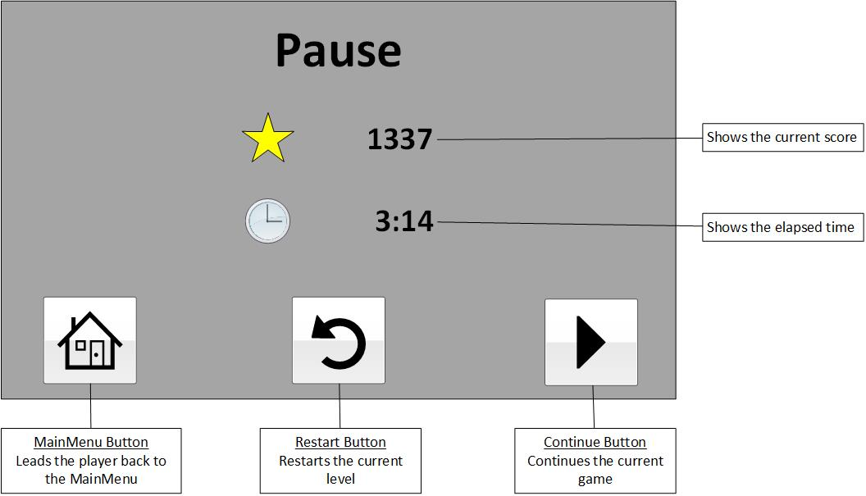
- Database ERD
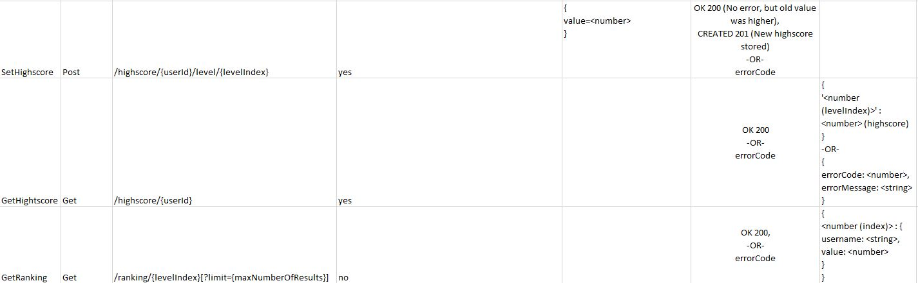
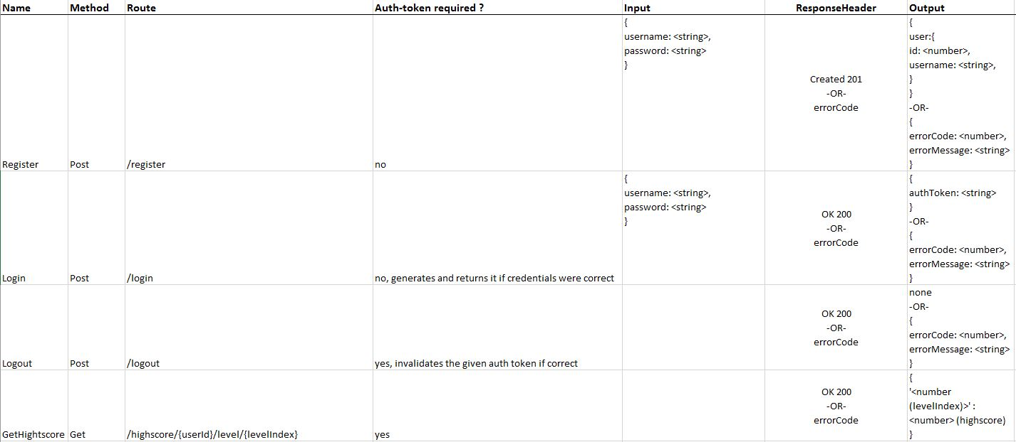
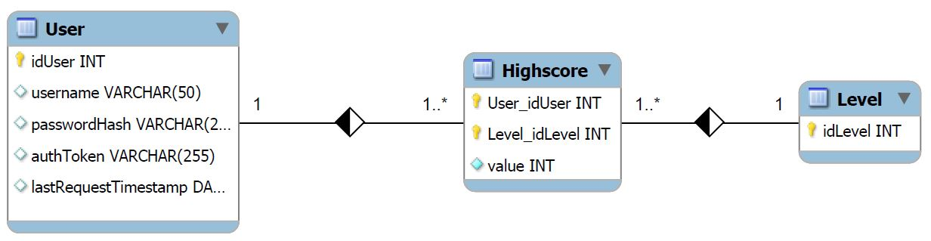
- WebAPI Routes
- Unity Manager WebAPI Interface
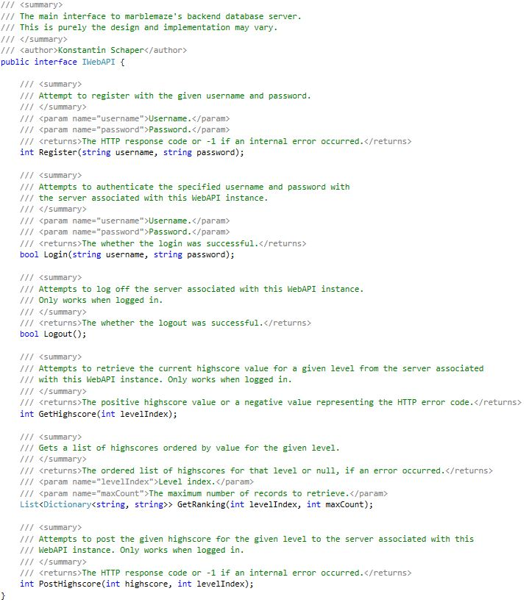
- Schedule

