**3.4 Sequence Diagram**

**SD01 Passenger can register to the system (URS-01)**

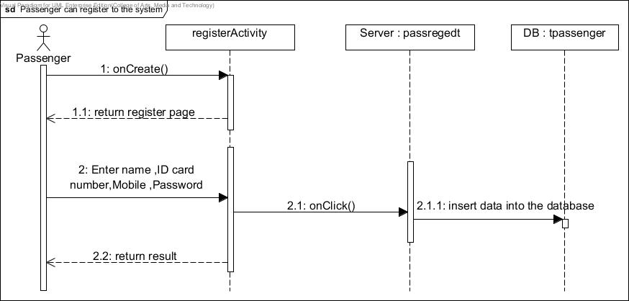

*Figure10-1: SD01 Passenger can register to the system.*

**SD02 Passenger can login to the system (URS-02)**

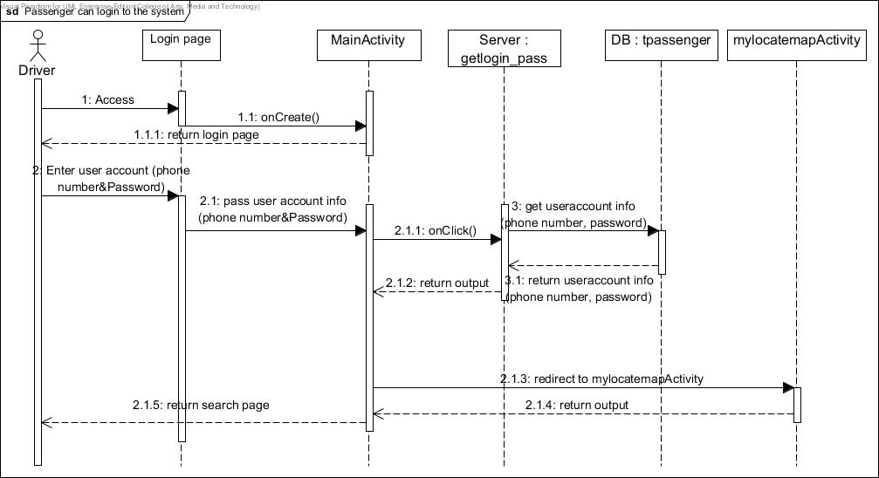

*Figure10-2: SD02 Passenger can login to the system (URS-02)*

**SD03 Passenger can logout of the system (URS-03)**

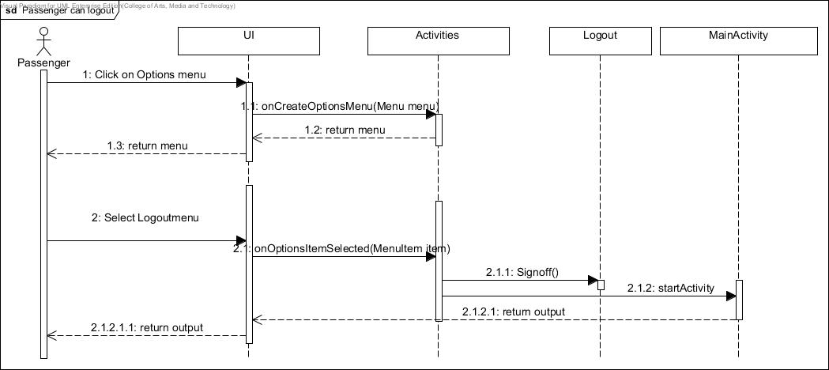

*Figure10-3: SD03 Passenger can logout of the system (URS-03)*

**SD04 Passenger can search for taxi (URS-04)**

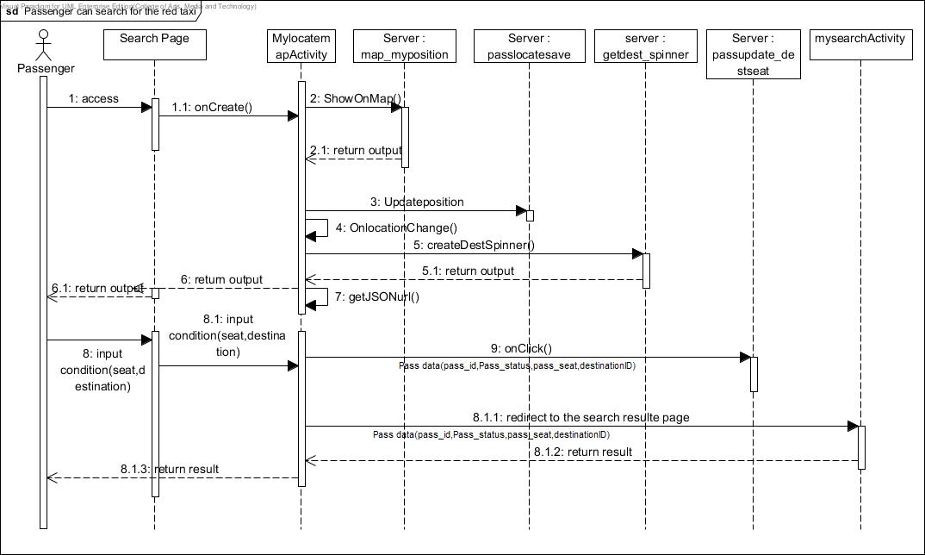

*Figure10-4: SD04 Passenger can search for taxi (URS-04)*

**SD05 Passenger can send request for taxi (URS-05)**

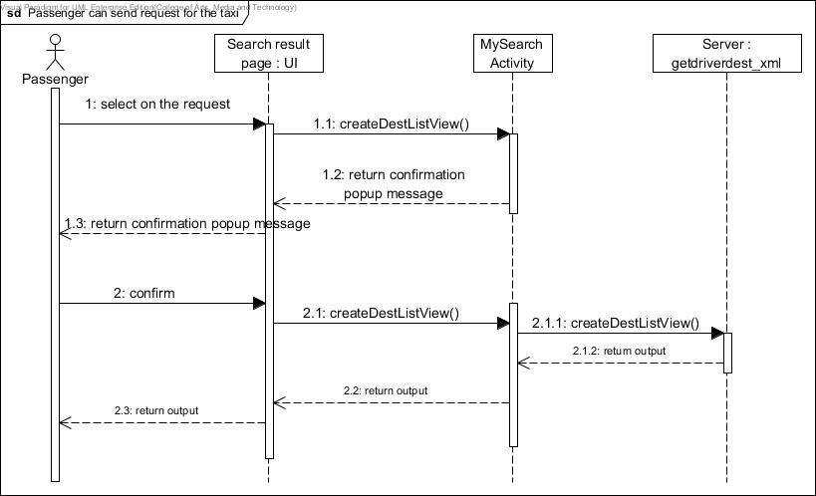

*Figure10-5: SD05 Passenger can send request for taxi (URS-05)*

**SD06 Passenger can chat with driver (URS-06)**

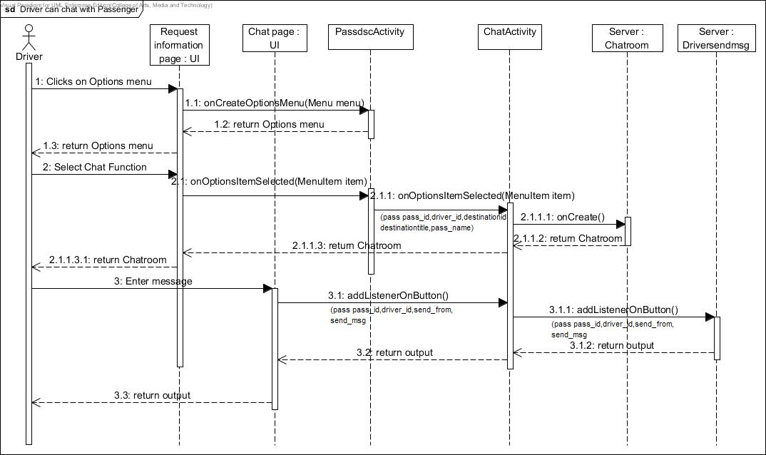

*Figure10-6: SD06 Passenger can chat with driver (URS-06)*

**SD07 Driver can register into the system (URS-07)**

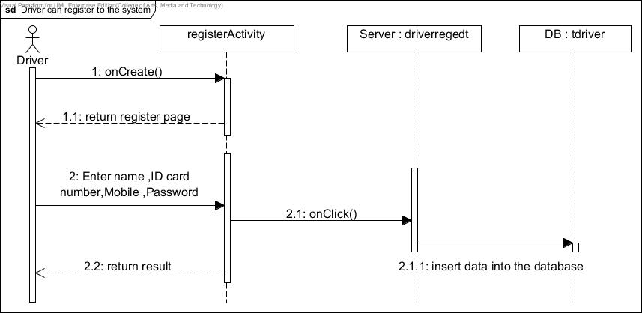

*Figure10-7: SD06 Driver can register into the system (URS-07)*

**SD08 Driver can log in to the system (URS-08)**

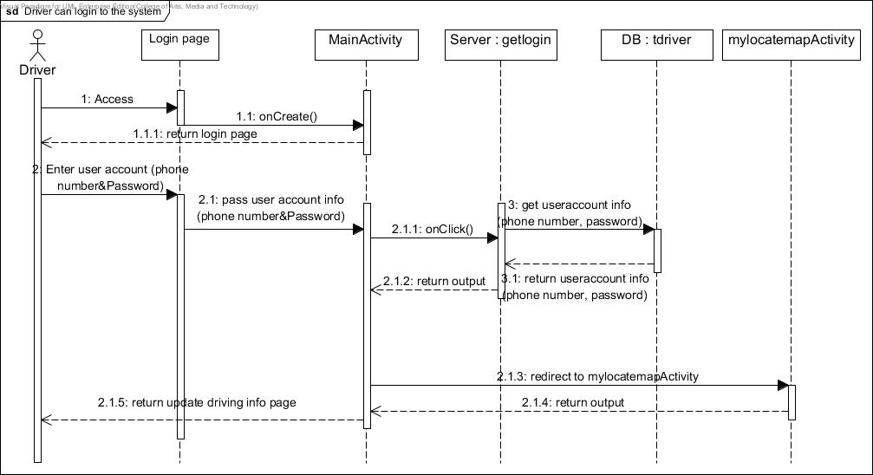

*Figure10-8: SD08 Driver can log in to the system (URS-08)*

**SD09 Driver can logout from the system (URS-09)**

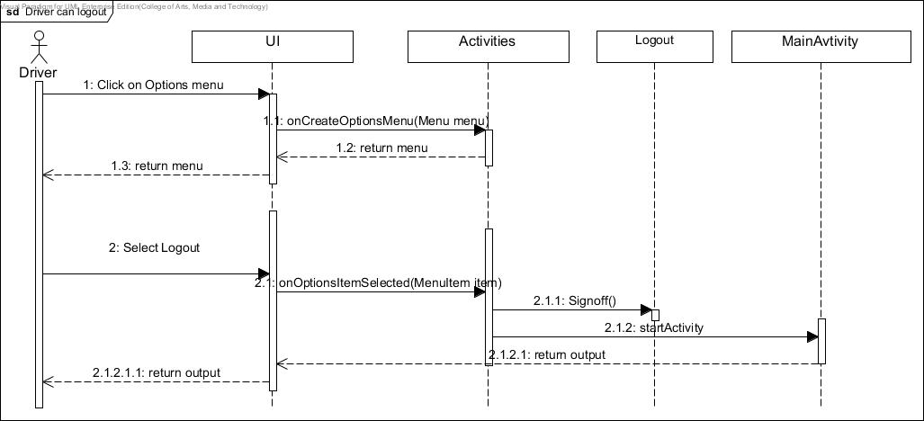

*Figure10-9: SD09 Driver can logout from the system (URS-09)*

**SD10 Driver can update driving information (URS-10)**

**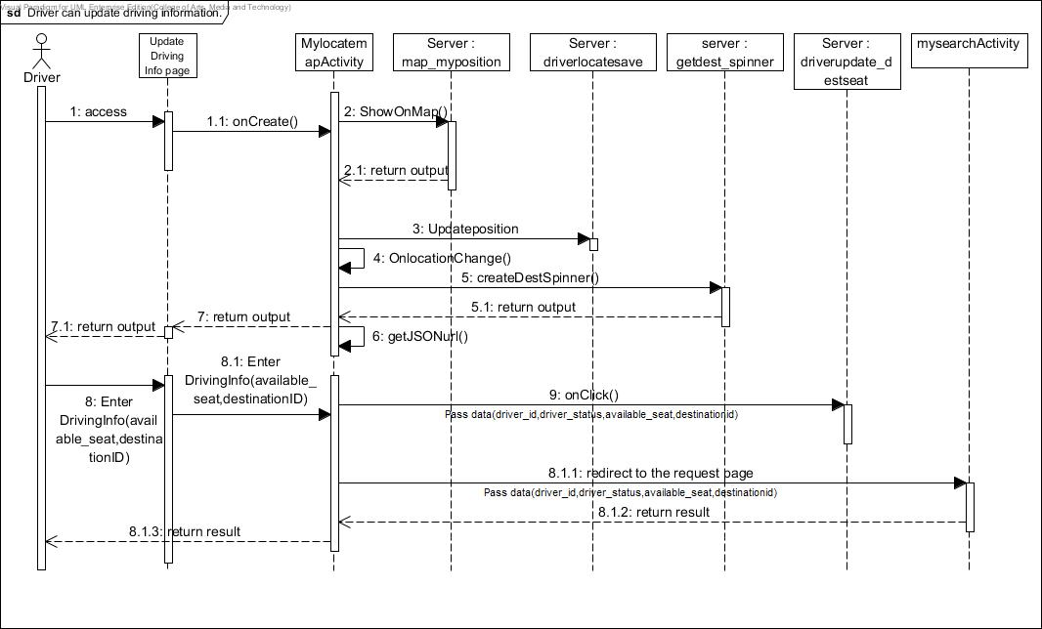***Figure10-10: SD09 Driver can update driving information (URS-10)*

**SD11 Driver can respond to passenger’s request (URS-11)**

*Figure10-11: SD11 Driver can respond to passenger’s request (URS-11)*

**SD12 Driver can chat with passenger (URS-012)**



*Figure10-12: SD12 Driver can chat with passenger (URS-012)*

**SD13 Administrator can login to the Administration system (URS-013)**

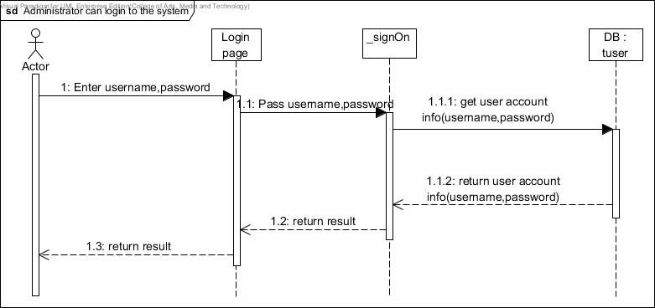

*Figure10-13: SD13* Administrator can login to the Administration system (URS-013)

**SD14 Administrator can logout (URS-14)**

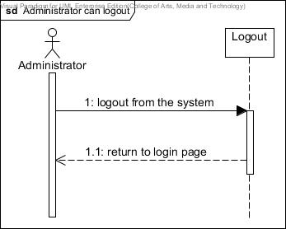

*Figure10-14: SD14* Administrator can logout (URS-14)

**SD15 Administrator can add destinations (URS-15)**

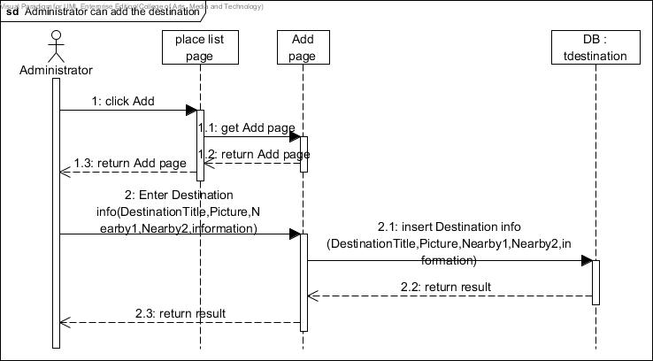

*Figure10-15: SD15 Administrator can add destinations (URS-15)*

**SD16 Administrator can browse the destination (URS-16)**

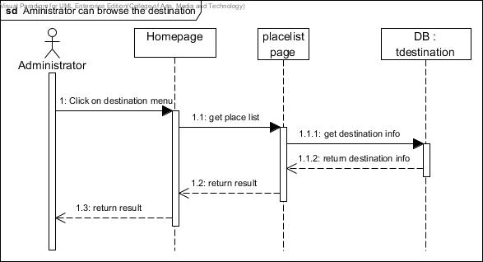

*Figure10-16: SD16 Administrator can browse destinations (URS-16)*

**SD17 Administrator can edit destinations (URS-17)**

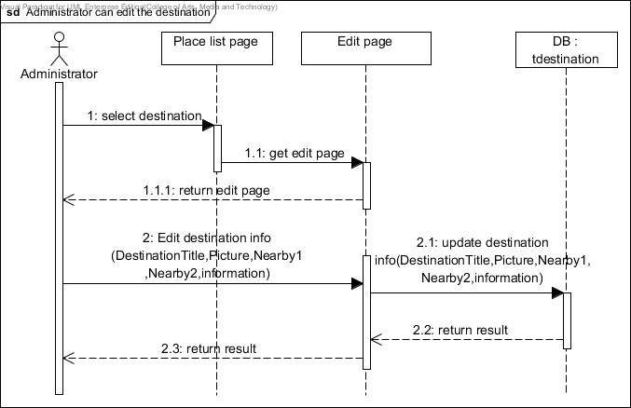

*Figure10-17: SD17 Administrator can edit destinations (URS-17)*

**SD18 Administrator can delete destinations (URS-18)**

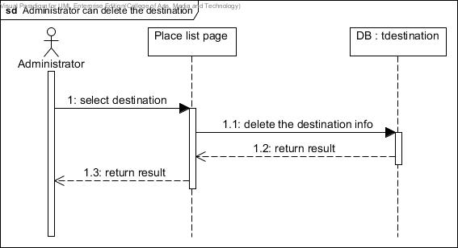

*Figure10-18: SD18 Administrator can edit destinations (URS-18)*

**SD19 Administrator can search destinations (URS-19)**

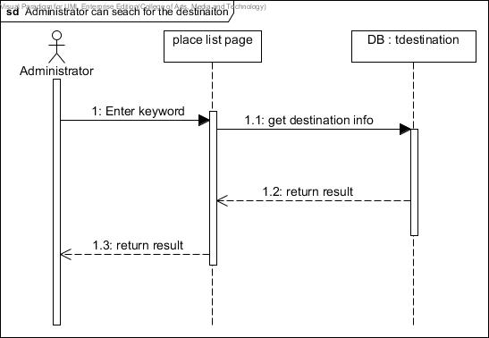

*Figure10-19: SD19 Administrator can edit destinations (URS-19)*

**SD20 Administrator can clear data (URS-20)**

**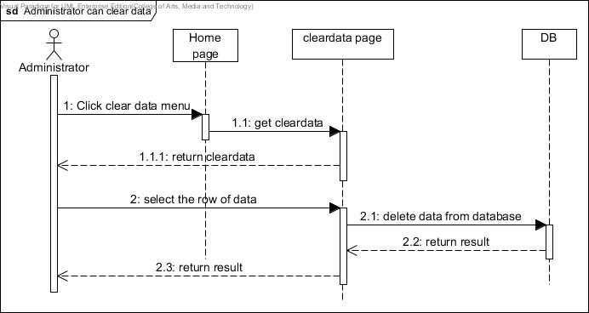***Figure10-20: SD20 Administrator can clear data (URS-20*

**SD21 Driver can change his/her status from online to offline and vice versa. (URS-21)**

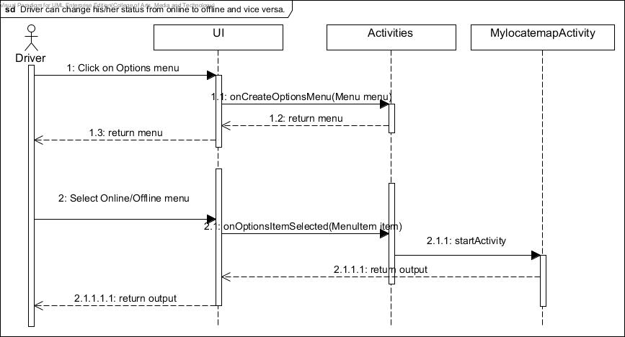

*Figure10-21: SD21 Driver can change his/her status from online to offline and vice versa. (URS-21)*

**SD22 Passenger can cancel the request (URS-22)**

**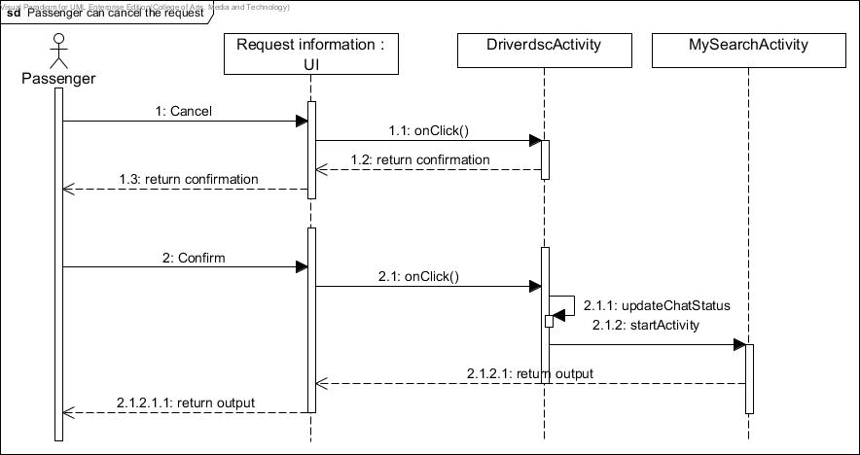***Figure10-22: Passenger can cancel the request (URS-22)*

**SD23 Passenger can view the request information that has been sent to Driver(URS-23)**

**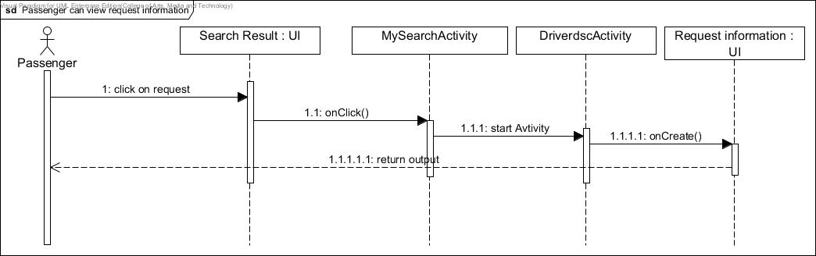***Figure10-23: SD23 Passenger can view the request information that has been sent to Driver(URS-23)*