**3.2 Class Diagram Design**

**3.2.1 Driver’s ClassDiagram Design**

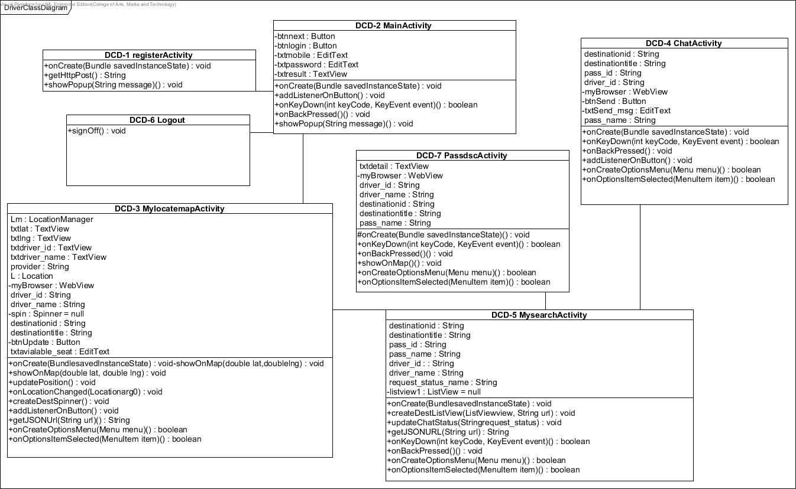

*Figure8: Driver’s ClassDiagram Design.*

**3.2.2 Passenger’s Class Diagram Design**

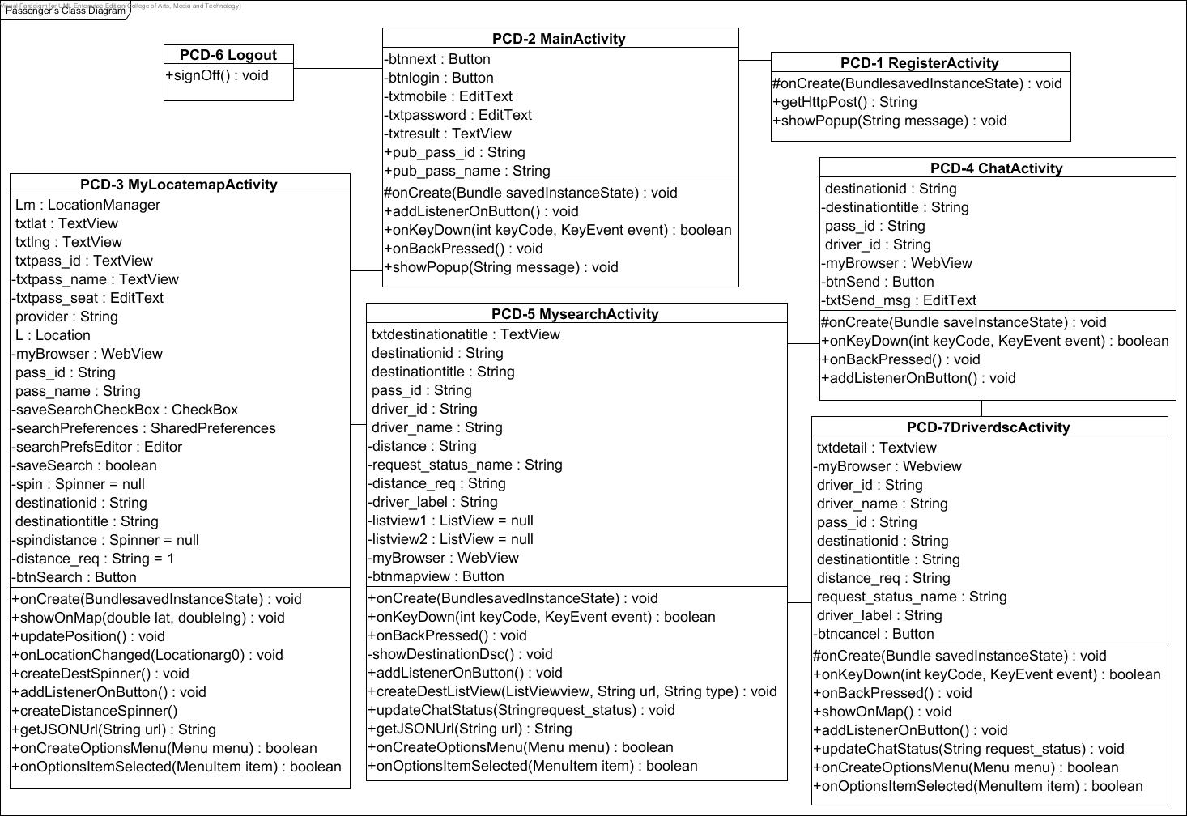

*Figure9: Passenger’s ClassDiagram Design.*

**3.3 Class Diagram Description**

**3.3.1 Driver’s Class Diagram**

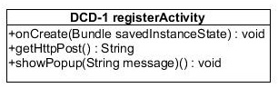

*Figure8-1: DCD-1 registerActivity.*

**Attributes**

|  |  |  |  |
| --- | --- | --- | --- |
| **ID** | **Name** | **Description** | **Data Type** |
| - | - | - | - |

**Methods**

|  |  |  |  |  |
| --- | --- | --- | --- | --- |
| **ID** | **Name** | **Description** | **Parameters** | **Return** |
| 1 | #onCreate | Open action on android | Bundle savedInstanceState | void |
| 2 | +getHttpPost | Connect with server | String url,  List<NameValuePair>params | String |
| 3. | showPopup |  | String message | void |

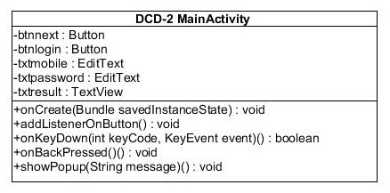

*Figure8-2: DCD-2 MainActivity.*

**Attributes**

|  |  |  |  |
| --- | --- | --- | --- |
| **ID** | **Name** | **Description** | **Data Type** |
| 1 | btnnext | Button which contains next actions after login | Button |
| 2 | btnlogin | Button which contains login action | Button |
| 3 | txtmobile | Text field to put mobile number | EditText |
| 4 | txtpassword | Text field to put password | EditText |
| 5 | txtresult | Field that display login result | TextView |

**Methods**

|  |  |  |  |  |
| --- | --- | --- | --- | --- |
| **ID** | **Name** | **Description** | **Parameters** | **Return** |
| 1 | #onCreate | Open action on android | Bundle savedInstanceState | void |
| 2 | addListenerOnButton | Run an action in andriod | - | void |
| 3. | onKeyDown |  | int keyCode, KeyEvent event | boolean |
| 4. | onBackPressed |  | - | void |
| 5 | showPopup |  | String message | void |

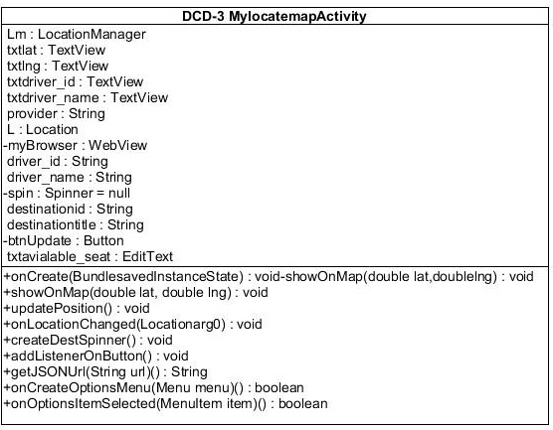

*Figure8-3: DCD-3 MylocatemapActivity.*

**Attributes**

|  |  |  |  |
| --- | --- | --- | --- |
| **ID** | **Name** | **Description** | **Data Type** |
| 1 | Lm | Set the location and connect to google map | LocationManager |
| 2 | txtlat | Set latitude | TextView |
| 3 | txtlng | Set longutude | TextView |
| 4 | txtdriver_id | Textfield to put driver’s id | TextView |
| 5 | txtdriver_name | Textfield to put driver’s name | TextView |
| 6 | provider | Set and get map | String |
| 7 | L | Location | Location |
| 8 | myBrowser | Find map | Webview |
| 9 | driver_id | Driver’s id | String |
| 10 | driver_name | Driver’s name | String |
| 11 | Spin | Special attribute for spinner method | Spinner |
| 12 | destinationid | Set destination id | String |
| 13 | destinationtitle | Set destination target | String |
| 14 | btnUpdate | Button action update destination | Button |
| 15 | txtavialable_seat | Textfield set available seat | EditText |

**Methods**

|  |  |  |  |  |
| --- | --- | --- | --- | --- |
| **ID** | **Name** | **Description** | **Parameters** | **Return** |
| 1 | #onCreate | Open action on android | Bundle savedInstanceState | void |
| 2 | showOnMap | Show point on map | double lat,  double lng | void |
| 3 | updatePosition | Map update | - | void |
| 4 | onLocationChanged | Map point location update | Location arg0 | void |
| 5 | createDestSpinner | Method with show map destination on android | - | void |
| 6 | addListenerOnButton | Run an action in andriod | - | void |
| 7 | getJSONUrl |  | String url | String |
| 8 | onCreateOptionsMenu |  | Menu menu | boolean |
| 9 | onOptionsItemSelected |  | MenuItem item | boolean |

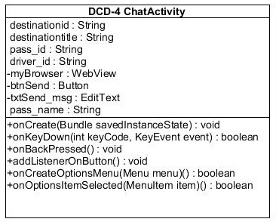

*Figure8-4: DCD-4 ChatActivity.*

**Attributes**

|  |  |  |  |
| --- | --- | --- | --- |
| **ID** | **Name** | **Description** | **Data Type** |
| 1 | destinationid |  | String |
| 2 | destinationtitle |  | String |
| 3 | Pass_id |  | String |
| 4 | Driver_id |  | String |
| 5 | myBrowser |  | Webview |
| 6 | btnSend |  | Button |
| 7 | txtSend_msg |  | Edit Text |
| 8 | Pass_name |  | String |

**Methods**

|  |  |  |  |  |
| --- | --- | --- | --- | --- |
| **ID** | **Name** | **Description** | **Parameters** | **Return** |
| 1 | #onCreate | Open action on android | Bundle savedInstanceState | void |
| 2 | onKeyDown |  | int keyCode, KeyEvent event | boolean |
| 3 | onBackPressed |  | - | void |
| 4 | addListenerOnButton() |  | - | void |
| 5 | onCreateOptionsMenu |  | Menu menu | boolean |
| 6 | onOptionsItemSelected |  | MenuItem item | boolean |

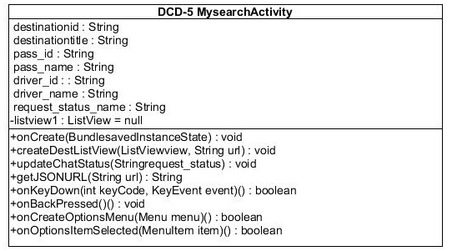

*Figure8-5: DCD-5 MysearchActivity.*

**Attributes**

|  |  |  |  |
| --- | --- | --- | --- |
| **ID** | **Name** | **Description** | **Data Type** |
| 1 | destinationid |  | String |
| 2 | destinationtitle |  | String |
| 3 | pass_id |  | String |
| 4 | pass_name |  | String |
| 5 | driver_id |  | String |
| 6 | driver_name |  | String |
| 7 | request_status_name |  | String |
| 8 | listview1 |  | ListView |

**Methods**

|  |  |  |  |  |
| --- | --- | --- | --- | --- |
| **ID** | **Name** | **Description** | **Parameters** | **Return** |
| 1 | #onCreate |  | Bundle savedInstanceState | void |
| 2 | onKeyDown |  | intkeyCode, KeyEvent event | boolean |
| 3 | onBackPressed |  | - | void |
| 4 | createDestListView |  | ListView view,String url | void |
| 5 | updateChatStatus |  | String request_status | void |
| 6 | getJSONUrl |  | String url | String |
| 7 | onCreateOptionsMenu |  | Menu menu | boolean |
| 8 | onOptionsItemSelected |  | MenuItem item | boolean |

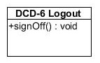

*Figure8-6: DCD-6 Logout.*

**Attributes**

|  |  |  |  |
| --- | --- | --- | --- |
| **ID** | **Name** | **Description** | **Data Type** |
| - | - | - | - |

**Methods**

|  |  |  |  |  |
| --- | --- | --- | --- | --- |
| **ID** | **Name** | **Description** | **Parameters** | **Return** |
| 1 | +signOff | Sign off from the system and display the login page. | - | void |

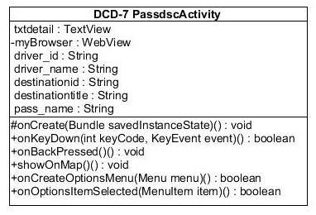

*Figure8-7: DCD-7 PassdscActivity*

**Attributes**

|  |  |  |  |
| --- | --- | --- | --- |
| **ID** | **Name** | **Description** | **Data Type** |
| 1 | txtdetail | - | TextView |
| 2 | myBroeser:Webview |  | WebView |
| 3 | driver_id |  | String |
| 4 | driver_name |  | String |
| 5 | destinaition_id |  | String |
| 6 | Destinaition_title |  | String |
| 7 | Pass_name |  | String |

**Methods**

|  |  |  |  |  |
| --- | --- | --- | --- | --- |
| **ID** | **Name** | **Description** | **Parameters** | **Return** |
| 1 | onCreate |  | Bundle savedInstanceState | void |
| 2 | onKeyDown |  | intkeyCode, KeyEvent event | boolean |
| 3 | onBackPressed |  |  | void |
| 4 | showOnMap |  |  | void |
| 5 | onCreateOptionsMenu |  | Menu menu | boolean |
| 6 | onOptionsItemSelected |  | MenuItem item | boolean |

**3.3.2 Passenger’s Class Diagram**

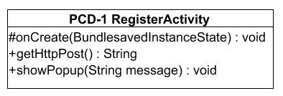

*Figure9-1: PCD-1 RegisterActivity.*

**Attributes**

|  |  |  |  |
| --- | --- | --- | --- |
| **ID** | **Name** | **Description** | **Data Type** |
| - | - | - | - |

**Methods**

|  |  |  |  |  |
| --- | --- | --- | --- | --- |
| **ID** | **Name** | **Description** |  | **Return** |
| 1 | #onCreate | Open action on android | Bundle savedInstanceState | void |
| 2 | +getHttpPost | Connect with server | String url,  List<NameValuePair>params | String |
| 3 | showPopup |  | (String message) | void |

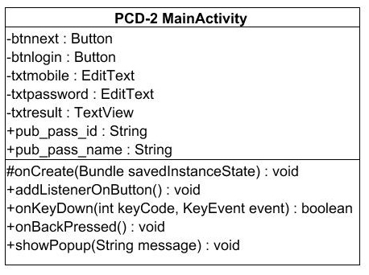

*Figure9-2: PCD-2 MainActivity.*

**Attributes**

|  |  |  |  |
| --- | --- | --- | --- |
| **ID** | **Name** | **Description** | **Data Type** |
| 1 | btnnext | Button which contains next actions after login | Button |
| 2 | btnlogin | Button which contains login action | Button |
| 3 | txtmobile | text field to put mobile number | EditText |
| 4 | txtpassword | text field to put password | EditText |
| 5 | txtresult | field that display login result | TextView |
| 6 | pub_pass_id |  | String |
| 7 | pub_pass_name |  | String |

**Methods**

|  |  |  |  |  |
| --- | --- | --- | --- | --- |
| **ID** | **Name** | **Description** | **Parameters** | **Return** |
| 1 | onCreate | Open action on android | Bundle savedInstanceState | void |
| 2 | addListenerOnButton | Run an action in andriod | - | void |
| 3 | onKeyDown |  | Int keyCode, KeyEvent event | boolean |
| 4 | onBackPressed |  |  | void |
| 5 | showPopup |  | (String message) | void |

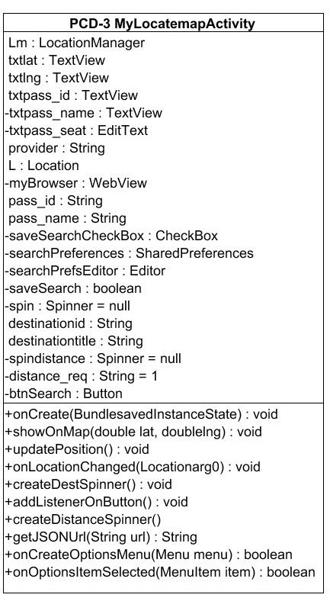

*Figure9-3: PCD-3 MylocatemapActivity.*

**Attributes**

|  |  |  |  |
| --- | --- | --- | --- |
| **ID** | **Name** | **Description** | **Data Type** |
| 1 | Lm | Set the location and connect to google map | LocationManager |
| 2 | txtlat | Set latitude | TextView |
| 3 | txtlng | Set longutude | TextView |
| 4 | txtpass_id | Textfield to put driver’s id | TextView |
| 5 | txtpass_name | Textfield to put driver’s name | TextView |
| 6 | Txtpass_seat |  | EditText |
| 7 | provider | Set and get map | String |
| 8 | L | Location | Location |
| 9 | myBrowser | Find map | WebView |
| 10 | pass_id | Driver’s id | String |
| 11 | pass_name | Driver’s name | String |
| 12 | saveSearchCheckBox |  | CheckBox |
| 13 | searchPreferences |  | SharedPreferences |
| 14 | searchPrefsEditor |  | SharedPreferences.Editor |
| 15 | saveSearch |  | boolean |
| 16 | Spin |  | Spinner |
| 17 | destinationid |  | String |
| 18 | destinationtitle |  | String |
| 19 | spindistance |  | Spinner |
| 20 | btnSearch |  | Button |
| 21 | distance_req |  | String |

**Methods**

|  |  |  |  |  |
| --- | --- | --- | --- | --- |
| **ID** | **Name** | **Description** | **Parameters** | **Return** |
| 1 | #onCreate | Open action on android | Bundle savedInstanceState | void |
| 2 | showOnMap | Show point on map | double lat,  double lng | void |
| 3 | updatePosition | Map update | - | void |
| 4 | onLocationChanged | Map point location update | Location arg0 | void |
| 5 | createDestSpinner | Show map destination on android | - | void |
| 6 | addListenerOnButton | Run an action in andriod | - | void |
|  | createDistanceSpinner |  | - | void |
|  | getJSONUrl |  | String url | String |
|  | onCreateOptionsMenu |  | Menu menu | boolean |
|  | onOptionsItemSelected |  | MenuItem item | boolean |

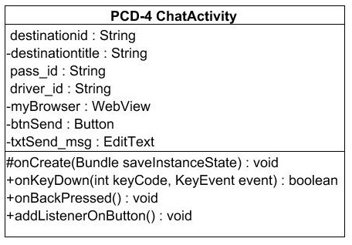

*Figure9-4: PCD-4 ChatActivity.*

**Attributes**

|  |  |  |  |
| --- | --- | --- | --- |
| **ID** | **Name** | **Description** | **Data Type** |
| 1 | destinationid | Set destination id | String |
| 2 | destinationtitle | Set destination title | String |
| 3 | Pass_id | Set passenger id | String |
| 4 | driver_id | Set driver id | String |
| 5 | myBrowser | Find map | WebView |
| 6 | btnSend | Button with send action | Button |
| 7 | txtSend_msg | Textfield message | EditText |

**Methods**

|  |  |  |  |  |
| --- | --- | --- | --- | --- |
| **ID** | **Name** | **Description** | **Parameters** | **Return** |
| 1 | onCreate | Open action on android | Bundle savedInstanceState | Void |
| 2 | onKeyDown | Action that put chat event | intkeyCode,  KeyEvent event | Boolean |
| 3 | onBackPressed | Action that send button |  | Void |
| 4 | addListenerOnButton | Run an action in android |  | Void |

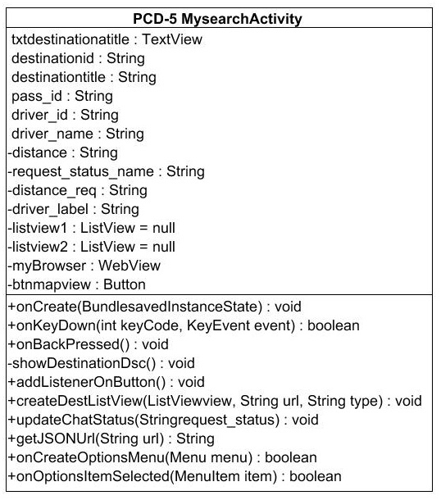

*Figure9-5: PCD-5 MySearchActivity.*

**Attributes**

|  |  |  |  |
| --- | --- | --- | --- |
| **ID** | **Name** | **Description** | **Data Type** |
| 1 | txtdestinationtitle | Set destination id | TextView |
| 2 | destinationid | Set destination title | String |
| 3 | destinationtitle | Set passenger id | String |
| 4 | Pass_id | Set driver id | String |
| 5 | driver_id | Find map | String |
| 6 | driver_name | Button with send action | String |
| 7 | distance | Textfield message | String |
| 8 | request_status_name | Set name on the list | String |
| 9 | distance_req |  | String |
| 10 | driver_label |  | String |
| 11 | listview1 | Set in list1 | ListView |
| 12 | listview2 | Set in list2 | ListView |
| 13 | myBrowser | Find map | WebView |
| 14 | Btnmapview | Button show map view | Button |

**Methods**

|  |  |  |  |  |
| --- | --- | --- | --- | --- |
| 2 | onKeyDown | Action that put chat event | intkeyCode,  KeyEvent event | Boolean |
| 3 | onBackPressed | Action that send button |  | Void |

|  |  |  |  |  |
| --- | --- | --- | --- | --- |
| **ID** | **Name** | **Description** | **Parameters** | **Return** |
| 1 | onCreate | Open action on android | Bundle savedInstanceState | Void |
| 2 | onKeyDown |  | intkeyCode,  KeyEvent event | boolean |
| 3 | onBackPressed |  | - | Void |
| 4 | showDestinationDsc | Show destination | - | Void |
| 5 | addListenerOnButton | Run an action in andriod | - | Void |
| 6 | createDestListView | Set destination on list | ListView view,  String url,  String type | Void |
| 7 | updateChatStatus | Update chat status | String request_status | Void |
| 8 | getJSONUrl | Connect with JSON | String url | Void |
| 9 | onCreateOptionsMenu |  | Menu menu | boolean |
| 10 | onCreateItemSelected |  | (MenuItem Item) | Boolean |

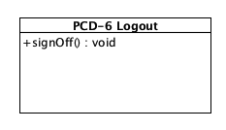

*Figure9-6: PCD-6 Logout.*

**Attributes**

|  |  |  |  |
| --- | --- | --- | --- |
| **ID** | **Name** | **Description** | **Data Type** |
| - | - | - | - |

**Methods**

|  |  |  |  |  |
| --- | --- | --- | --- | --- |
| **ID** | **Name** | **Description** | **Parameters** | **Return** |
| 1 | +signOff | Sign off from the system and display the login page. | - | Void |

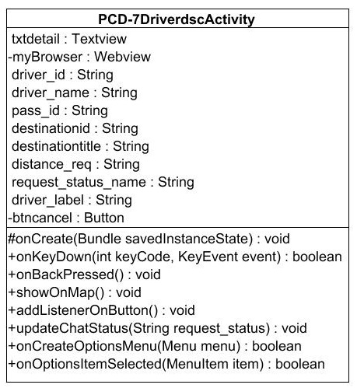

**Attributes**

|  |  |  |  |
| --- | --- | --- | --- |
| **ID** | **Name** | **Description** | **Data Type** |
| 1 | txtdetail | - | TextView |
| 2 | myBroeser:Webview |  | WebView |
| 3 | driver_id |  | String |
| 4 | driver_name |  | String |
|  | Pass_id |  | String |
| 5 | destinaition_id |  | String |
| 6 | Destinaition_title |  | String |
|  | Distance_req |  | String |
| 7 | request_status_name |  | String |
|  | driver_label |  | String |
|  | btncancel |  | String |

**Methods**

|  |  |  |  |  |
| --- | --- | --- | --- | --- |
| **ID** | **Name** | **Description** | **Parameters** | **Return** |
| 1 | onCreate |  | Bundle savedInstanceState | void |
| 2 | onKeyDown |  | intkeyCode, KeyEvent event | boolean |
| 3 | onBackPressed |  |  | void |
| 4 | showOnMap |  |  | void |
| 5 | addListenerOnButton |  |  | void |
| 6 | onCreateOptionsMenu |  | Menu menu | boolean |
| 7 | onOptionsItemSelected |  | MenuItem item | boolean |