**Title:** Marine Megafauna in Deep Time OR Extinct Marine Megafauna over geological time

**Authors:** Catalina Pimiento, Gregor H. Mathes, Kristína Kocáková, Clade experts, Students, Volunteers

**Abstract:**

Background: The marine megafauna is important and charismatic

Gap/Problem: Never been assessed as a whole, nor it has been defined over deep-time scales

Aim: To review the literature, identify patterns and propose a definition of megafauna over deep time

Finds:

**Introduction**

Today, the global marine megafauna includes all animals of over 45 kg that inhabit oceanic and coastal habitats (Estes *et al.* 2016). They encompass different clades, such as invertebrates, bony and cartilaginous fish, reptiles, mammals and birds (Estes *et al.* 2016). Collectively, these animals can play important roles in marine systems, including nutrient transportation and storage, top-down population control, biochemical cycling of major elements, connection of oceanic ecosystems, and shaping and alteration of habitats, among others (Estes *et al.* 2016). At least 40% of the modern marine megafaunal species are threatened to extinction today due to multiple human impacts (Pimiento *et al.* 2020). This endangered fauna, however, largely represent the survivors of a global extinction event that took place around 3 million years ago, which resulted in the loss of one third of their genera and over 15% of their functional diversity (Pimiento *et al.* 2017).

The study of the extinct marine megafauna can be difficult because of the inherent incompleteness of their fossil record, which makes taxonomic identifications and estimates of body size troublesome. This problem is exacerbated by the polyphyletic nature of this fauna, which imposes constraints depending on the different body plans. For example, body size estimates are markedly different between groups, making comparisons difficult given the heterogeneity of the size measures (total length, diameter, etc.). Indeed, applying the 45kg cut-off to the fossil record is problematic, as the mass of many fossil taxa are unknown. As a result, a definition of what constitutes the marine megafauna in deep time has never been proposed.

Defining the marine megafauna of the past is the first step to reach a better understanding of the ecological roles that it played in the past and their extinction mechanisms. Here, we review the scientific literature in order to list the extinct marine megafaunal species that live in the geological past. To do so, we searched for all the records of extinct animals equal or over 1 m of body size. We used this cut-off based on the fact that modern marine megafauna is, in addition of >45 kg, also ≥1 m when body length is considered. For example, the smallest megafauna species today include the sea otter (*Enhydra lutris*), the emperor pinguin (*Aptenodytes forsteri*) and the common ling (*Molva molva*), all of which can reach >1 m of length (Estes *et al.* 2016; Pimiento *et al.* 2020). Although this definition is arbitrary and might not be universally applicable, it allows us to focus on a set of species as a first step towards reaching a better understanding of the marine megafauna that lived in the geological past. Based on this information, we explore their trends in terms of taxonomic identity, body size, ecological traits over time and per clade, as well as potential extinction mechanisms.

**Literature Review and analysis**

The data was gathered via a joint effort of experts on the taxonomic groups covered in this study, and the students enrolled in the Marine Megafauna through Deep Time course at the University of Zurich in autumn semester of 2022. A list of extinct taxa considered to be exceptionally large in body size in their respective taxonomic group (Data S1) was compiled by the experts [CK, TA, JAC, TS, AVT, and DF] based on their experience and knowledge, with >1 m given as cut-off value for body length. These lists were given to the student groups, each working on one of the following groups: invertebrates, (bony) fish, chondrichthyes, reptiles, birds, and mammals. The students were tasked with the collection of relevant information for each taxon in the list, and with the expansion of the list by searching for additional taxa. Additional taxa were searched using Google Scholar or specific journal websites using a variety of key words, such as “*giant*”, “*large*”, “*fossil*”, “*extinct*”, “*marine*” in addition to key words relevant to each clade.

Four categories of information were collected – taxonomy, age range, size, and ecology. Any taxa identified to a rank above genus were excluded. With regards to age range, the oldest and youngest record of each taxon was specified to the best available resolution. These ages were obtained from literature and from Paleobiology Database (herein, PBDB). All age entries were cross-checked to ensure the validity. Whenever we found a record in literature expanding the minimum and maximum age reported in the PBDB, we updated this information in the dataset. The size data includes the maximum measure of body size available for each taxon and the type of measurement. Any taxa for which it body size was unknown was excluded. The ecological information collected follows previous works (Pimiento *et al.* 2017; Pimiento *et al.* 2019; Pimiento *et al.* 2020; Paillard *et al.* 2021) and includes guild (i.e., most common feeding mechanism, including macropredator [active predator], micropredator [e.g., filter feeder] and herbivore), vertical position (i.e., position in the water column where they feed, including benthic [bottom on the ocean] or pelagic [along the water column] and habitat (i.e., lateral position where they live, including coastal [in the continental shelf or above 200 m of depth], or oceanic [open ocean below 200 m depth offshore]). After the compilation of the data by the students, a set of different authors [add initials of volunteers] double checked the size and age entries of each taxon. Finally, the dataset was reviewed by experts to ensure validity of the data entries. We were able to collect ecological data for most extinct megafaunal taxa. However, around 6% of the taxa are missing guild data; 19% are missing data on vertical position, and 22% on the habitat. Fish and reptiles are the groups with the most missing data.

We analysed the data collected in R version 4.2.3 using the Tidyverse consortium of R packages (reference). In addition to this exploratory analysis of the collected data, we modelled trends in extinction risk of megafauna taxa within a Bayesian framework using the brms package (reference). We first downloaded occurrence data on species level from the PBDB for each megafauna species on the 25th April 2023. Simultaneously, we gathered a baseline dataset by downloading all occurrences belonging to the same genus as the megafauna taxon (but excluding the focal megafauna taxon). Each genus in this baseline dataset was assumed to have a body length < 1m. We then calculated the average extinction risk for the baseline group as well as for the megafauna group. For this, we first identified the first and last appearance datums (FAD and LAD, respectively) for each taxon. We then temporally binned FADs and LADs into geological stages (reference). Taxa confined to a single stage (singletons) were excluded for all datasets as they tend to produce undesirable distortions of the fossil record (reference). We then modelled the risk to go extinct using a hierarchical Bayesian generalized model with a binomial family link, whereby the LAD of each taxon was coded as “extinction” and occurrences in geologic stages between the FAD and the LAD as “survival”. We emphasise that this approach assumes that the observed first and last occurrences are equivalent to the true times of origination and extinction of genera at the resolution of geologic stages. We regressed this binomial extinction/ survival response against the group id (i.e., megafauna versus baseline) allowing for a mixed effect trend, thereby estimating the average extinction risk for the focal group in each time interval. We additionally allowed this average extinction risk to vary between taxonomic groups by setting a random effect. We used flat priors on each parameter as the amount of data was high (3.055 extinction/ survival responses), allowing the likelihood to dominate the posterior samples.

**State of knowledge**

Our exhaustive literature review reveals at least 541 extinct marine taxa (defined here has ≥1 m of body length; Data S1). These belong to the following main clades: invertebrates (phyla: Mollusca, Echinodermata, Arthropoda, and Annelida); bony fish (classes: †Acanthodii, Actinopterygii, Placodermi, Sarcopterygii, and the infraphylum Agnatha), chondrichthyans(superorders: Selachimorpha, Batoidea and Holecephanli); reptiles (orders: †Ichthyosauria, †Nothosauroidea, †Placodontia, †Plesiosauria, Squamata and Testudines; family: †Tanystropheidae [Archosaumorpha]), sea birds (order: Spenisciformes) and mammals (orders: Carnivora, Cetacea, Desmostylia, Sirenia and Pilosa [Xenarthra]; Data S1).

The majority of taxa’s body size was found to be estimated based on total length, which in general terms refers to the size from the tip of the head to the end of the body. Invertebrates were the only taxa that were not measured as such, with their body size estimations including body length, column length, diameter, and maximum shell size (Fig. S1; Table S1). Many of the size values were reported in the literature as estimated using extrapolations based on the size of body parts (e.g., length of the humerus in birds, or tooth size in sharks (Jadwiszczak, 2001, Perez et al. 2021). In some cases, a measure different from the total body size was considered, including fossilised remains representing the majority of the animal body, such as shell lengths in cephalopods, carapace lengths in turtles and column lengths in crinoids (REFS?).

Most of the taxa gathered were identified to species level (78%). The majority of megafaunal taxa are fish (34%), followed by mammals (23%). Megafaunal taxa were found on all geological Eras and Periods. Similar taxonomic richness is found in Mesozoic and Cenozoic, with the Palaeozoic having ~30% less taxa than the other Eras. Invertebrates, fishes, and chondrichthyans have marine megafaunal representation in all three Eras, whereas the reptilian megafauna is only present in the Palaeozoic and Mesozoic, and megafaunal birds and mammals only in the Cenozoic (Fig 1).

Around two-thirds of the megafaunal taxa (474; 79%) are represented in the Paleobiology Database (herein, PBDB). Those identified to the genus level have a 63% representation, whereas those identified to the species level 68%. Around 26% of the extinct megafaunal species have only one occurrence in the PBDB (Fig. S2). Fishes are the least represented group in the PBDB, with only 31% of their species having an occurrence (Fig. S2). Megafaunal chondrichthyans display the lowest number of singletons, and the highest number total of occurrences in PBDB, with *Otodus megalodon* having the highest number of occurrences compared with the rest of the extinct megafauna (n = 288; Fig. S2).

**The extinct marine megafauna**

The largest extinct marine megafaunal taxa was 21 m, a size reached by two Ichthyosaur species (*Shonisaurus sikanniensis* and *S. popularis* [REF]) in the Triassic (Figs. 1A, 1C-D. The second largest size was found to be 20 m, reached by *O. megalodon* [the largest macropredatory shark to ever lived (Perez *et al.* 2021)] in the Neogene and by *Basilosaurus,* a prehistoric archaeocete whale from the Paleogene [(Perez *et al.* 2021)REF] (Figs. 1A, 1C-D). The largest fish was found to be *Leedsichthys problematicus* (16.5 m; 4th largest size) and the largest invertebrate was *Seirocrinus subangularis,* a 15 m crinoid (5th largest size), both from the Jurassic [REFS]. Birds occupy the lowest spectrum of body size ranges, with the largest maximum size being that of *Anthropornis,* a 2 m penguin from the Paleogene [REF] (Figs. 1A, 1C-D).

The body size distribution of global extinct marine megafauna is right skewed (median = 2.5 m; mean = 3.55 m; max = 21 m; Fig. 1A). This is also the case in each Era (Fig. S3) and taxonomic group (Fig. 1C). While the Mesozoic and Cenozoic Eras display the full range of extinct megafaunal sizes (1 – 21 m in the Mesozoic, 1 – 20 m in the Cenozoic), the Palaeozoic only displays half of the range, with the maximum size being 9 m (*Endoceras giganteum*, a cephalopod from the Ordovician) (Figs. S3).

Fig. 1.

***Megafaunal clades***

*Invertebrates:* Marine megafaunal invertebrates were more common in the geological past than in the present (53 species in the past *vs*. 5 species today; Data S1, (Estes *et al.* 2016)). The highest number of invertebrate megafaunal taxa takes place in the Palaeozoic (Fig. 1B).It is in this time-period when the earliest forms of marine megafauna appear, the Cambrian Radiodonts *Anomalocaris canadensis* and *Amplectobelua symbrachiata* (Fig. 1E). Within invertebrates, the extinct marine megafaunal clades include mostly molluscs and arthropods (Fig. 1D, S4). Most invertebrate megafauna taxa have sizes between 1 and 3 m, with the largest size reached being 15 m by an echinoderm in the Mesozoic (*Seirocrinus subangularis*; Fig. 1C, S4). While arthropod megafauna is only present in the Palaeozoic, molluscs are the only invertebrate phylum present in all three eras(Fig. S4).

*Fish:* Extinct fish marine megafauna include 191 species, which is comparable with the number of megafaunal species today (133 species (Estes *et al.* 2016)). Both in the past and today, fish represent the most specious group of marine megafauna (Fig. 1). The extinct marine megafaunal fishes are mostly represented by Actinopterygii and Placodermi (Fig. 1D). The earliest megafaunal fish species appeared in the Silurian (*Megamastax amblyodus,* Sarcopterygii (Fig. 1E). Interestingly, today, the sarcopterygian *Latimeria chalumnae*, a Coelacanth, is part of today’s marine megafauna (Estes *et al.* 2016), despite being absent from the Cenozoic assemblage (Fig. S5). The highest number of fish megafaunal fish taxa take place in the Paleozoic (Fig. 1B).Most of the fish megafauna were between 1 and 2 m, with the maximum size being 16.5 m, reached by an Actinopterygian in the Mesozoic (*Leedsichthys problematicus;* Fig. 1C, 1D, S5). The Palaeozoic is the only era when all the main fish clades have megafaunal representatives, with the Cenozoic only having actinopterygian megafaunal representatives (Fig. S5). Indeed, today all but one species of megafaunal fish species are Actinopterygians (Estes *et al.* 2016).

*Chondrichthyans:* Extinct chondrichthyan marine megafauna include 73 species, the vast majority being sharks (Selachii; Fig 1D). This diversity is comparable with that of today, when 69 species are part of modern marine megafauna (Estes *et al.* 2016). In the past, most chondrichthyan marine megafauna occur in the Mesozoic and Cenozoic (Fig. 1A), with sharks being the only clade occurring in all three Eras, batoids being absent from the Paleozoic, and chimeras absent from the Cenozoic (Fig. S6). Within extinct megafaunal sharks, body size appears to increase over time (Fig. S6). The earliest chondrichthyan megafaunal taxa appear in the Upper Devonian (*Cladoselache clarki, Ctenacanthus, Phoebodus, Stethacanthus altonensis* and *Stethacanthus productus*; Fig. 1E). Most extinct chondrichthyan megafauna are between 1 and 5 m, with the largest species being *O. megalodon* from the Cenozoic (Figs. 1A, 1D, S6).

*Reptiles*: There are 90 extinct marine megafaunal species that are reptiles, most of them occurring in the Mesozoic and none in the Palaeozoic (Fig. 1). This diversity is much higher than today, when only six reptilian species are part of the global marine megafauna (Estes *et al.* 2016). Indeed, most reptilian megafaunal clades are entirely extinct today. In the Cenozoic, the only reptilian extinct marine megafauna are Squamates (Fig. S7). This order holds the highest number of megafaunal taxa (Fig. 1C). The earliest reptilian megafaunal species appears in the Lower Triassic (*Utatsusaurus hataii;* Fig. 1E). Most extinct reptilian megafauna are between 1 and 5 m, with the largest taxa belonging to the genus *Shonisaurus* from the Triassic, which can reach up to 21 m (Figs. 1A, 1D, S6).

*Birds:* The least diverse group of extinct marine megafauna are birds, with only 17 species reaching ≥1 m. This group is represented by a single order, Sphenisciformes (Pinguins), which are only present in the Cenozoic Era (Figs. 1B, 1D). Nevertheless, this diversity largely surpasses that of today, when only one sea bird is part of the global marine megafauna (*A. forsteri*) (Estes *et al.* 2016). The earliest megafaunal birds appeared in the Palaeocene (*Crossvallia unienwillia, Kumimanu biceae,* and *Waimanu manneringi*, Fig. 1E). All the extinct megafaunal sea birds reach sizes between 1 and 2 m (Figs. 1D, 1F).

*Mammals:* There are 124 mammals that are part of the extinct marine megafauna, a diversity comparable with today’s (119 species; (Estes *et al.* 2016; Pimiento *et al.* 2020)). As such, this is the second most specious megafaunal group, which only occurs in the Cenozoic Era (Fig. 1A). Within mammals, cetaceans and carnivorans display the highest numbers of extinct megafaunal taxa (Fig. 1D). Most marine mammals that are part of the megafauna range between 1 and 3 m (Figs. 1C, 1F), with the largest taxa being the genus *Basilosaurus*, a Cetacean that reached 20 m in the Eocene, which is the earliest age when extinct marine megafaunal mammals appeared (Fig. 1E).

***Megafaunal Eras***

*Palaeozoic:* During the Cambrian, only two taxa were found to be categorised as megafauna

as defined here (*Anomalocaris canadensis* and *Amplectobelua symbrachiata,* both reaching 1 m; Fig. 2E, S8). During the Ordovician, the maximum body size for the entire Palaeozoic is reached (Fig. 2E, S8) with the 9 m Nautiloid, *Endoceras giganteum* [REF]. Both the Cambrian and the Ordovician have only invertebrate megafauna (Fig. 2E). Fish megafauna first appear in the Silurian with the 1 m lobe-finned fish *Megamastax amblyodus* [REF]. Although the Devonian is dominated by fish megafauna, this is the period when the first three chondrichthyan megafauna appear, the largest being the 5 m *Ctenacanthus* [REF]. While invertebrates, fish and chondrichthyans all have megafaunal representatives in the Devonian and Carboniferous, invertebrates do not have megafaunal representatives in the Permian (Fig. 2E).

*Mesozoic:* Reptilian megafauna first appear in the Mesozoic. During this Era, specifically during the Triassic, two species of ichthyosaurs display the largest body size of the entire geological time (*Shonisaurus*; see above; Figs. 1E, S8). While reptiles dominate the megafauna of the Triassic and Cretaceous, fish are the most prominent group of the Jurassic (Fig. 1E). The Cretaceous is the period with the highest number of megafaunal taxa (n = 137). Invertebrates, fish, chondrichthyans and reptiles all have megafaunal representatives in the three periods of the Mesozoic (Fig. 1E).

*Cenozoic:* During this Era, megafaunal mammals and birds first appear. Although mammals seem to dominate during this time, especially in the Paleogene and Neogene (Fig. 1E),

all megafaunal groups converge in the Cenozoic. Chondrichthyans display the largest size of this Era, specifically during the Neogene (see above; Fig. 1E, S4B) and are the only megafaunal group with representatives in the Quaternary (*Hemipristis serra*, 6m; Fig. 1E) [REF]. As such, this time period is the most taxa-poor of the entire geological time. Given the high diversity of megafaunal species today (Estes *et al.* 2016), this lack of diversity is likely a sampling and/or preservation artifact (REFs).

***Ecological Patterns***

The vast majority of extinct marine megafauna (78%) are macropredators, with all six taxonomic groups having macropredatory representatives. Notably, macropredators include the largest taxa. Herbivores are least common guild (4%), and it is only occupied by mammals no larger than 10 m. As such, this guild is absent from the Palaeozoic and Mesozoic (Fig. 2A-B). Similarly, herbivore megafauna are >10 m of body size. Filter-feeders include the remaining diversity (18%), and it is represented by all groups, except birds and reptiles (Fig. 2A-B). While filter-feeding is not common amongst the largest sizes, there are some large representatives including the fish *L. problematicus* (16.5 m; Jurassic), the crinoid *S. subangularis* (15 m; Jurassic) and the cetacean *Paleocetus* (12 m; Neogene; Fig. 2B). Nevertheless, unlike the present time when the largest sizes are reached by filter-feeders (e.g., baleen whales; 30 m), in the geological past, when largest sizes were reached by active predators (20-21 m; *S. sikanniensis*, *S. popularis* and *O. megalodon*).

About half of the extinct marine megafauna are exclusively pelagic (52%) and occur in all three eras and size classes. Exclusively benthic taxa comprise the 22% of the diversity. No extinct chondrichthyan and no taxa of over 15 m of length was found to be exclusively benthic. Benthopelagic taxa are only the 7% of the total diversity and it is mostly represented by chondrichthyans and mammals, with reptiles and fish having one benthoplegic taxa each (Fig. 2B-C). Therefore, it can be said that the extinct marine megafauna was mostly pelagic, living and feeding in along the water column.

Half of the extinct marine megafauna lived in coastal environments, with all taxonomic groups having coastal representatives. Exclusively oceanic megafauna includes 20% of the total diversity, with all groups except birds. Only the 10% of the extinct marine megafauna lived in both coastal and oceanic habitats and include fish, chondrichthyans, reptiles and mammals. The largest sizes are both coastal al oceanic (Fig. 2C-D).

**Figure 2**

**Potential extinction mechanisms**

We found the extinction risk of species belonging to megafauna to be similar to species not belonging to megafauna (Fig. 3). The baseline group of species not belonging to megafauna showed an average extinction risk of 34.9% (95% Credible Interval [25%, 49%]) across all geologic stages, while megafauna species had an average extinction risk of 34.3% (95% CI [17%, 50%]). This result is robust across all studied taxonomic groups, whereas Chondrichthyes showed slightly higher extinction risk values for baseline taxa with an i 27%, and Reptiles the strongest increase with 53%. We additionally found this signal of higher risk for megafauna taxa to be robust across the whole Phanerozoic (Fig. 4) but increasing through time, showing a higher extinction selectivity for megafauna taxa towards the recent. These results are

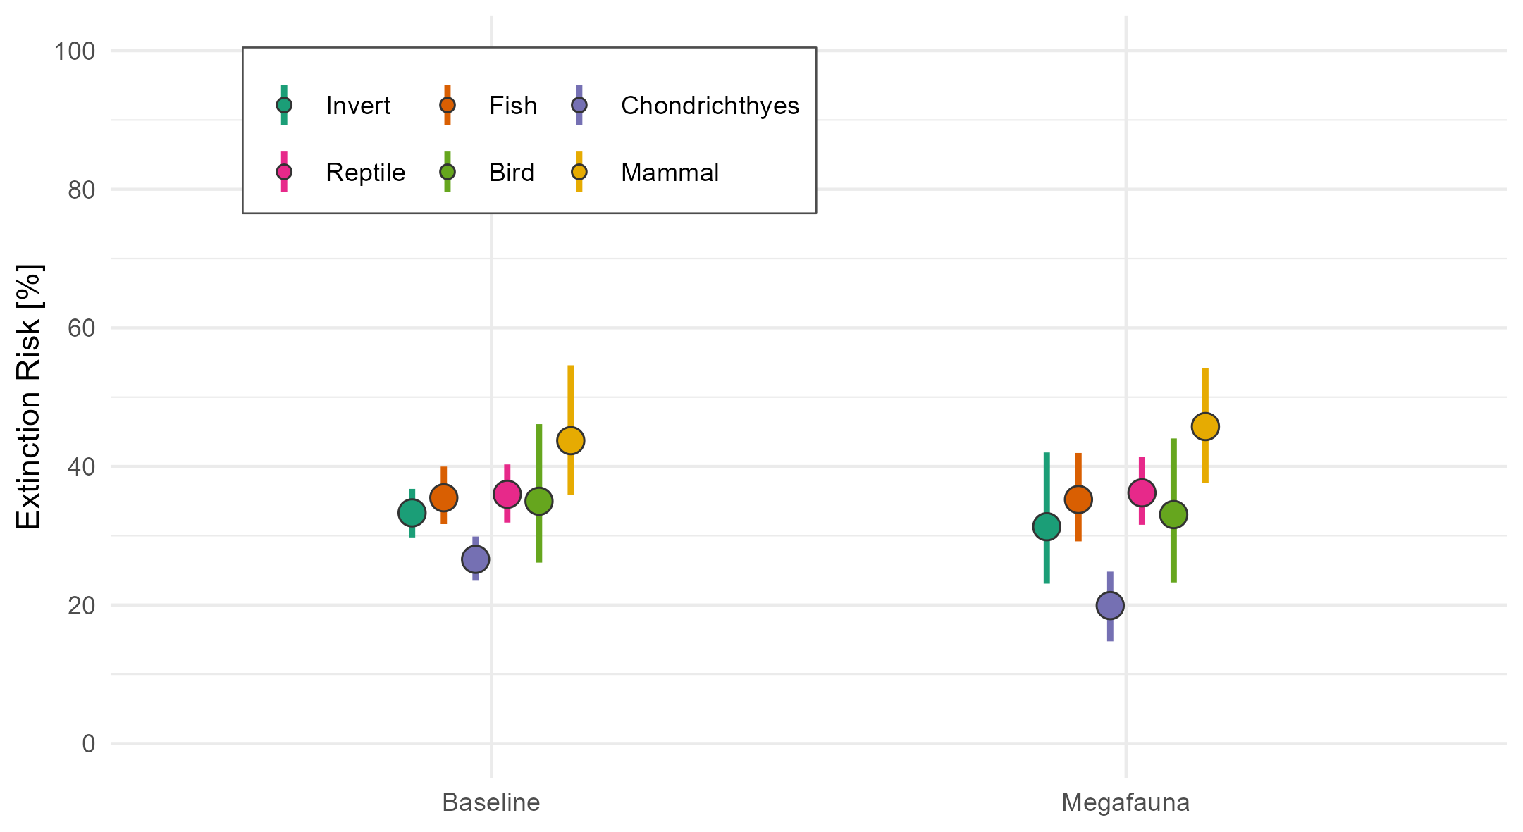

*Figure 3: The extinction risk for fossil taxa as estimated by a Bayesian generalized linear mixed effect model based on occurrences from the PBDB. Points show the average extinction risk for each taxonomic group, and lines the 95% Credible Interval. The baseline estimates are for species that belong to the same genus as the focal megafauna species.*

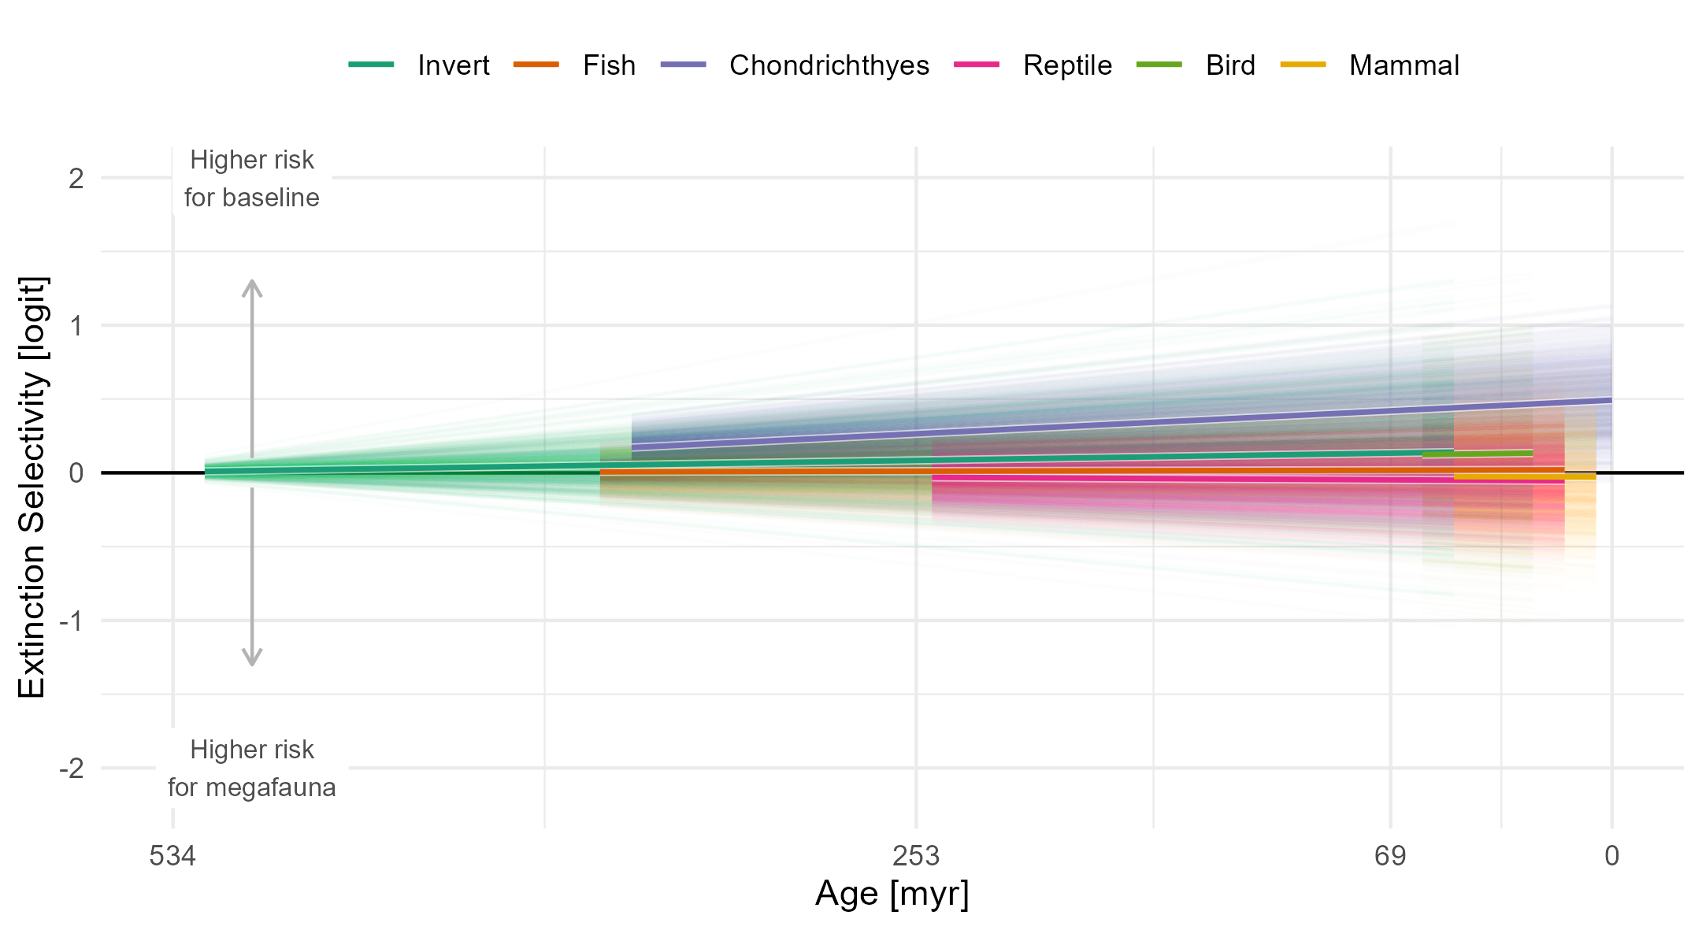

*Figure 4: The extinction selectivity for all studied taxonomic groups across the Phanerozoic. Each line depicts a sample from the posterior distribution of the Bayesian generalized linear mixed effect model. Positive values indicate a higher extinction risk for the baseline group (species that belong to the same genus as the focal megafauna species) and negative values a higher extinction risk for megafauna taxa.*

**References**

1.

Estes, J.A., Heithaus, M., McCauley, D.J., Rasher, D.B. & Worm, B. (2016). Megafaunal Impacts on Structure and Function of Ocean Ecosystems. *Annual Review of Environment and Resources*, 41, 83-116.

2.

Paillard, A., Shimada, K. & Pimiento, C. (2021). The fossil record of extant elasmobranchs. *Journal of Fish Biology*, 98, 445-455.

3.

Perez, V.J., Leder, R.M. & Badaut, T. (2021). Body length estimation of Neogene macrophagous lamniform sharks (Carcharodon and Otodus) derived from associated fossil dentitions.

4.

Pimiento, C., Cantalapiedra, J.L., Shimada, K., Field, D.J. & Smaers, J.B. (2019). Evolutionary pathways toward gigantism in sharks and rays. *Evolution*, 73, 588-599.

5.

Pimiento, C., Griffin, J.N., Clements, C.F., Silvestro, D., Varela, S., Uhen, M.D. *et al.* (2017). The Pliocene marine megafauna extinction and its impact on functional diversity. *Nature Ecology & Evolution*, 1, 1100.

6.

Pimiento, C., Leprieur, F., Silvestro, D., Lefcheck, J.S., Albouy, C., Rasher, D.B. *et al.* (2020). Functional diversity of marine megafauna in the Anthropocene. *Science Advances*, 6, eaay7650.