Pim Trouerbach

Advanced Cyber Security

Cyber Security Notes

Base16:

0x0CD = 205 (0\*256+16\*12+13\*1)

0x1AF = 431 (1\*256+10\*16+15\*1)

* Each position in the number is increasing range from 16^0, 16^1, 16^2, 16^3 and so on….
* 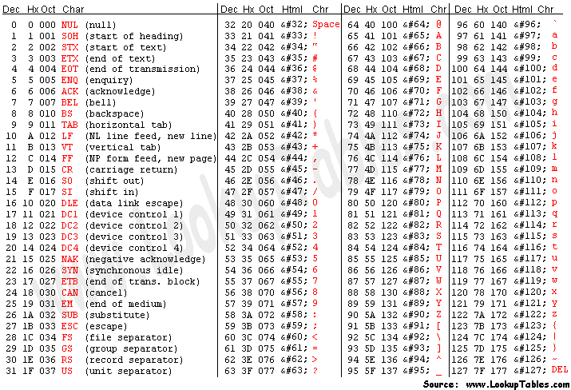

SQL Injection:

* instead of storing data inside files, databases are quicker to read and they are more accessible to users.