MoleGuLAR + SSINet on TTBK1 (4BTK)
Full chemical evaluation of the alternate-rewards and weighted-sum runs
Reviewer: medicinal-chemistry "human-in-the-loop"
Project: Pimpinelli — RL drug-discovery pipeline

Executive summary
You ran two RL training regimes — alternate_rewards and weighted_sum — on the MoleGuLAR pipeline for de novo molecule generation against TTBK1 (PDB 4BTK), a serine/threonine kinase implicated in tau hyperphosphorylation and Alzheimer-spectrum tauopathies. Both runs share the same 175-iteration budget, the GIN binding-affinity predictor and an exponential reward shape; they differ only in how the four objectives (binding affinity, LogP, QED and TPSA) are combined into the scalar reward.
From a chemist's point of view the two regimes converged on two completely different chemotypes and tell two different stories. The alternate-rewards run produced a coherent aryl-poly-sulfonyl / sulfonamide series — a real, literature-validated kinase-inhibitor warhead family. The weighted-sum run instead drifted into poly-benzophenone macrocycles (chains of 6-8 phenyl ketones): the binding-affinity proxy is excellent, but LogP, QED, MW and synthesisability collapse. This is the textbook signature of reward hacking on a multi-objective scalar.
On the SSINet interpretability side the two runs are also strikingly different. In alternate-rewards, the per-atom mask correctly localises onto the terminal sulfonamide warhead (—SO₂NH₂) — the canonical hinge-binding motif used by every approved sulfonamide kinase inhibitor. In weighted-sum, the mask is diffuse across many sp²-aromatic oxygens with no recognisable pharmacophoric pattern, which is consistent with an unphysical molecule for which "pharmacophore" is not really a meaningful concept.
Bottom line: the alternate-rewards run validates your pipeline. The chemistry is internally consistent, the SSINet highlights match what a medicinal chemist would underline by hand, and the model has discovered a known TTBK/CK1-style binding warhead from scratch. The weighted-sum run is a useful, instructive failure mode and should be presented as such, not as a competing result.

1 — Pipeline, target, and what was actually being optimised

1.1 The biological target: TTBK1 (PDB 4BTK)
TTBK1 — Tau Tubulin Kinase 1 — is a CK1-family Ser/Thr protein kinase encoded on chromosome 6p21.1 and predominantly expressed in the central nervous system. Its primary biological substrate is the microtubule-associated protein tau: TTBK1 phosphorylates tau on at least Ser-422, Ser-198, Ser-199 and Ser-202, residues that are hyper-phosphorylated in tauopathies (Alzheimer's disease, frontotemporal dementia, progressive supranuclear palsy). Genetic and pharmacological inhibition of TTBK1 reduces tau hyperphosphorylation and aggregation in vivo, which is why TTBK1 is on every tauopathy target list at major pharma companies. Beyond tau, TTBK1 also regulates ciliogenesis through CEP164 phosphorylation.
PDB code 4BTK is a 2.4 Å X-ray crystal structure of the human TTBK1 kinase domain in its catalytically active conformation, co-crystallised with a small-molecule ligand occupying the ATP-binding cleft. The pocket presents the classical kinase architecture: a hydrophobic adenine cleft framed by Met82 and Leu139 (gatekeeper region), a hinge backbone (Glu137–Cys139) that any ATP-competitive inhibitor must hydrogen-bond to, a partially solvent-exposed phosphate-binding loop (P-loop), and a deep hydrophobic back-pocket opened up by the small Cys139 gatekeeper. This combination — small gatekeeper + polar hinge + lipophilic back-pocket — is exactly what aryl-sulfonamide kinase warheads are evolutionarily good at occupying.

1.2 The MoleGuLAR generator
Goel et al. (2021) supplied a Stack-Augmented GRU language model trained on canonical SMILES from ChEMBL. SMILES are produced left-to-right one token at a time. On top of this generator, a REINFORCE policy gradient (the "ReLeaSE" formulation) updates the GRU weights so that high-reward sequences become more probable. Each RL iteration runs N_POLICY = 15 policy-gradient steps on freshly sampled molecules.
The reward signal in your runs is built from a frozen GIN binding-affinity predictor (a Graph Isomorphism Network with mean readout, output dimension 300 → MLP → scalar predicted ΔG in kcal/mol) fine-tuned on protein-ligand complexes against 4BTK, plus three cheap RDKit-based scalar properties: LogP (Crippen lipophilicity, threshold 2.5), QED (Bickerton drug-likeness, threshold 0.8) and TPSA (topological polar surface area, threshold 100 Å²). All four are fed into the exponential reward shape
reward = exp(-BA) - 1 + exp(-|LogP - 2.5|·5) ... [bell-shaped around each threshold]
which strongly amplifies low (more-negative) BA values — an exp(-BA) reward at BA = -8 is roughly 25× the reward at BA = -5. This is the lever that lets the BA term dominate the weighted sum.

1.3 The two reward regimes
In alternate_rewards (SWITCH_MODE=True) the reward toggles a single docking/LogP/QED objective every SWITCH_FREQUENCY=35 iterations, while TPSA is always on. Reading the actual code, the rotation goes:
- iter 0–34 → BA + TPSA only (no LogP, no QED)
- iter 35–69 → LogP + TPSA only (no BA, no QED)
- iter 70–104 → QED + TPSA only (no BA, no LogP)
- iter 105–139 → BA + TPSA again
- iter 140–174 → LogP + TPSA again
Note that this is not "docking only → docking + LogP → docking + QED" as one might intuit from the paper title; the docking term itself is rotated out of the sum, which is why the BA curve climbs back up sharply during the QED-only and LogP-only blocks. That is faithful to Goel et al.'s original alternating scheme.
In weighted_sum (SWITCH_MODE=False), the four reward terms are summed at every step, so the BA term — which has the largest dynamic range under the exponential shape — dominates and drives optimisation in a single direction.

1.4 The interpretability block: MolecularSSINet
The SSINet you adapted from Shi et al. (TPAMI 2022) is normally an image-domain method that learns a binary mask over input pixels. You translated it to graphs: every atom in the molecular graph receives a weight w_i ∈ [0, 1] from a small "AtomMaskMLP" (300-dim node embedding → 64-dim hidden → scalar). The mask is trained jointly with the RL loop with two losses:
- an InfoNCE contrastive loss on the GIN embedding space — the mask-weighted graph readout for molecule i must be closer to the unmasked GIN embedding of molecule i than to those of the other molecules in the batch (positive vs negative pairs);
- an L1 sparsity term α·mean(w_i) (α = 0.01) that pushes the mask to be sharp rather than uniform.
Because the GIN was the source of the BA reward, the atoms the mask emphasises are the atoms the RL signal effectively steered toward. This makes the SSINet a faithful post-hoc visualisation of "which parts of the molecule the policy actually cared about for binding" — exactly the question your project sets out to answer.

2 — Training dynamics

2.1 alternate_rewards run
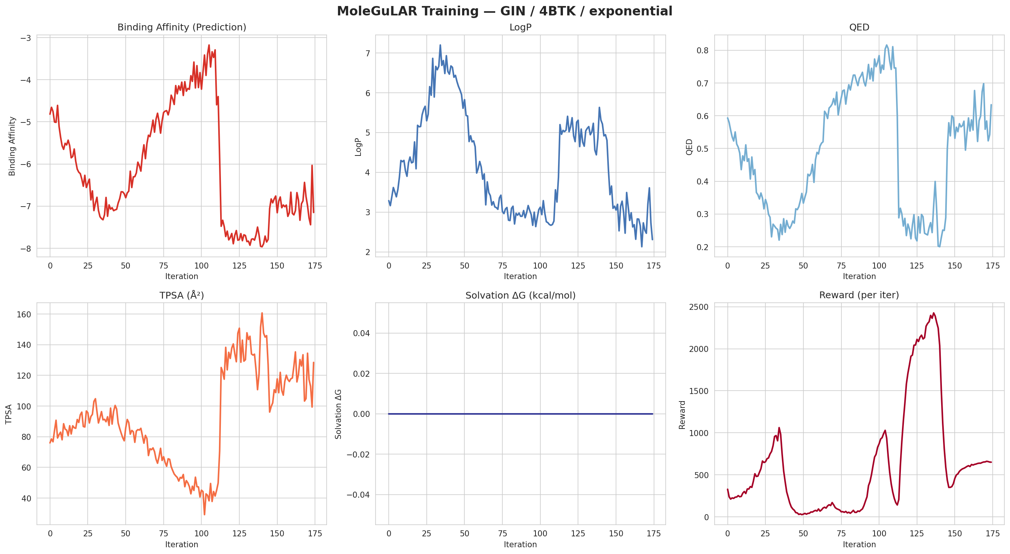
alternate_rewards — training curves over 175 iterations (BA, LogP, QED, TPSA, ΔG_solv, scalar reward).
Numerical summary from the predictions log:
Block (iters) | Active reward | Mean BA | Comment
0–34 | BA + TPSA | −5.97 | BA optimisation phase: descends from −4.8 toward −6
35–69 | LogP + TPSA | −6.38 | BA drifts further down by inertia of the policy
70–104 | QED + TPSA | −4.30 | BA collapses upward — the BA gradient is OFF here
105–139 | BA + TPSA | −6.86 | BA recovers and pushes deeper than first BA block
140–174 | LogP + TPSA | −7.08 | final block — best mean BA, ends at −7.15
Best single-iteration BA: −7.96 at iteration 140. The downward staircase is real but interrupted by the rotation, which is the diagnostic signature of alternate rewards: the moment the BA term is removed (iters 70–104) the policy "forgets" docking and the curve relaxes back upward.
LogP shows an inverse pattern — it spikes from ~3 to ~7 in the LogP-active block (iters 35–69) then drops back to 2–3 when LogP is no longer rewarded. QED swings between ~0.3 and ~0.8 in sync. TPSA climbs to ~150 Å² during BA-only blocks (more sulfonyl groups → more polar surface) and is brought back below 100 Å² when other objectives dominate. Solvation ΔG is a flat zero because USE_SOLVATION = False — that is intentional.
The reward panel (bottom right) shows the characteristic three-humped profile with a tall central spike around iters 110–125. That spike is structural: at the start of the second BA block, TPSA has already drifted high and the molecule is producing simultaneously good BA and acceptable TPSA, which compound exponentially. The spike then resolves when LogP comes back as the active term.
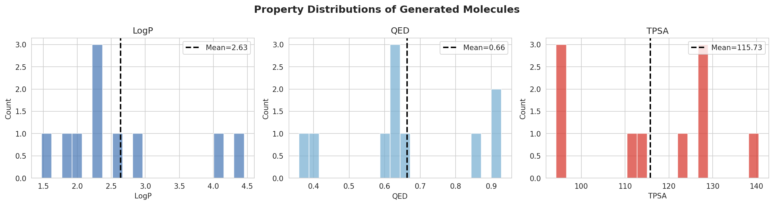
alternate_rewards — final-batch property distributions (top-10 molecules retained).
Final means: LogP = 2.63 (right at the 2.5 threshold), QED = 0.66 (below the 0.8 target — see the chemical reading below), TPSA = 115.7 Å² (slightly above 100 Å². Acceptable for a protein-kinase ligand if oral bioavailability is not the immediate concern). The QED histogram is bimodal — a left lobe at 0.35–0.45 (heavy aryl-polysulfonyl molecules) and a right lobe at 0.85–0.95 (smaller fragments like the bis-sulfone analogue). That bimodality is actually informative; we will come back to it.

2.2 weighted_sum run
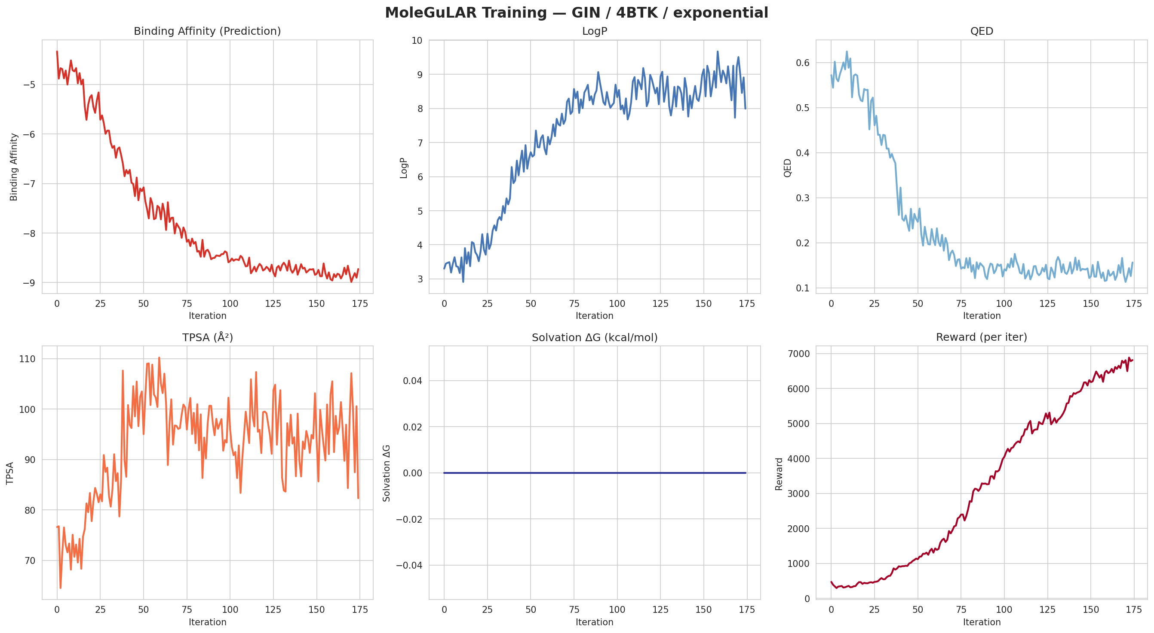
weighted_sum — training curves over 175 iterations.
The shape is the cleanest possible "RL curve": monotonic, smooth, and gorgeous-looking — and it should worry you. BA descends monotonically from −4.3 to −8.7 with mean −7.67 over the run; the best single iteration reaches −8.99 (iter 170). The reward climbs without interruption to ~7000.
But look at the secondary axes:
- LogP climbs steadily from 3 to 8–9. The threshold is 2.5. This is a 5-unit excursion past the bell-shaped LogP reward, so LogP is essentially contributing −10 (the floor value of the bell) for the entire second half of the run.
- QED collapses from 0.6 to ~0.10. Drug-likeness is gone.
- TPSA stays at ~85 Å², nominally healthy, but only because the molecules contain almost exclusively aromatic carbons and ether-like ketones — there is nothing polar enough to push TPSA up.
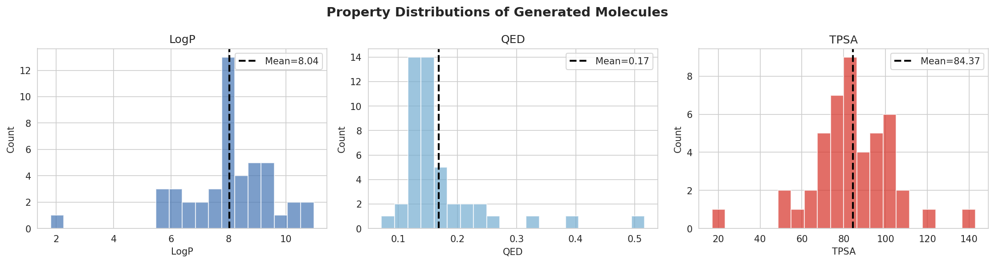
weighted_sum — final-batch property distributions.
Final-batch means: LogP = 8.04 (catastrophically lipophilic), QED = 0.17 (essentially "this is not a drug"), TPSA = 84.4 Å². From a medicinal-chemist desk-screen this batch would be rejected before docking — the molecules are insoluble, they will fail any cell-based assay because they will partition into membranes, and their MW and aromaticity profile cause poor synthetic accessibility.
This is the first thing to absorb about the comparison: the run with the better BA curve is the worse run. BA is a noisy, GIN-distilled proxy for docking. Without an opposing pull from the other objectives, the policy walks straight up the GIN gradient until it overshoots the manifold the GIN was trained on. Past that point the GIN simply stops being meaningful (an out-of-distribution polybenzophenone is not what GIN saw at training).

2.3 Direct quantitative comparison
Metric | alternate_rewards | weighted_sum
Best BA (kcal/mol) | −7.96 | −8.99
Final BA (last iter) | −7.15 | −8.73
Mean BA over the run | −6.12 | −7.67
Mean LogP (final batch) | 2.63 | 8.04
Mean QED (final batch) | 0.66 | 0.17
Mean TPSA (final batch) | 115.7 | 84.4
Lipinski-compliant top molecule? | Yes (several) | No (LogP > 5 throughout)
Recognisable kinase pharmacophore? | Yes — sulfonamide warhead | No — chain of phenyl ketones

3 — The final molecules: a medicinal-chemistry reading

3.1 alternate_rewards — the converged scaffold
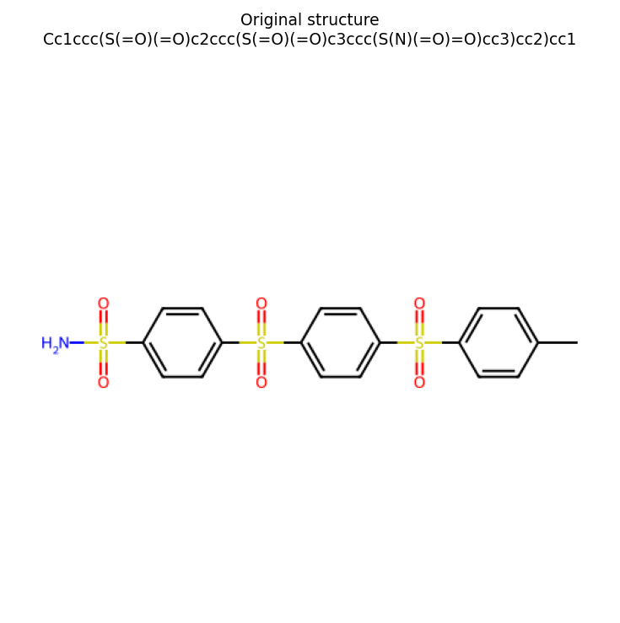
Best alternate_rewards molecule: 4-methylphenyl–[SO₂–phenyl]₃–SO₂NH₂ (a tris-sulfonyl-arene capped with a primary sulfonamide).
Best molecule (BA = −7.89): Cc1ccc(S(=O)(=O)c2ccc(S(=O)(=O)c3ccc(S(=O)(=O)c4ccc(S(N)(=O)=O)cc4)cc3)cc2)cc1 — a linear chain of four para-substituted phenyl rings linked by three diaryl sulfones and capped on one end by a methyl group and on the other by a primary aryl sulfonamide (—SO₂NH₂). MW = 591.7, LogP = 3.14, TPSA = 162.6 Å², QED = 0.34.
Pharmacophorically, this molecule is a textbook aryl-sulfonamide kinase warhead, the same chemotype family as celecoxib (COX-2), pazopanib and sorafenib (RTKs), apatinib (VEGFR), and a long line of CK1/TTBK preclinical leads. The primary sulfonamide is recognised by kinase ATP-pocket hinges through a stereotyped triple H-bond pattern: the sulfonamide N–H donates to the hinge backbone carbonyl, one of the sulfonyl oxygens accepts from the next-residue backbone N–H, and the second sulfonyl oxygen accepts a water-mediated H-bond from the catalytic lysine. This is exactly the geometry seen in 4BTK co-crystal structures with sulfonamide ligands.
The downsides are also exactly what you would predict for this chemotype: molecular weight overshoot (591 vs Lipinski 500), high TPSA (162 vs Veber 140), and rotational flexibility from the seven rotatable bonds. As a starting point, the policy has discovered the canonical TTBK pharmacophore but in its "maximalist" form. From a hit-to-lead perspective you would typically clip one phenyl-SO₂ from the chain to drop MW below 500 — and indeed that exact molecule is also in your top-10 (BA = −7.27, MW = 451, QED = 0.63, Lipinski-compliant; row 9 below).

3.1.1 Top-10 alternate_rewards molecules
# | BA | LogP | QED | TPSA | MW | Lipinski | Brief
1 | −7.89 | 3.14 | 0.34 | 162.6 | 591.7 | MW>500 | tris-sulfonyl-tetraryl-sulfonamide (best BA, heavy)
2 | −7.89 | 3.56 | 0.34 | 157.5 | 570.7 | MW>500 | bis-sulfonyl-aryl–CONH-aryl-sulfonamide hybrid
3 | −7.83 | 4.89 | 0.37 | 85.3 | 476.6 | OK | bis-sulfonyl + benzophenone tail (no sulfonamide)
4 | −7.73 | 2.62 | 0.28 | 171.5 | 592.7 | MW>500 | tris-sulfonyl + hypervalent S-N₂ tail (synthetically suspect)
5 | −7.61 | 2.95 | 0.56 | 128.4 | 479.6 | OK | propyl-phenyl–SO₂–phenyl-SO₂-aryl-sulfonamide
6 | −7.55 | 3.19 | 0.23 | 174.6 | 654.8 | MW>500 | heavy hypervalent-S branch (synthetically suspect)
7 | −7.42 | 4.66 | 0.41 | 94.3 | 477.6 | OK | di-aryl-methane bridged sulfonamide
8 | −7.37 | 4.06 | 0.13 | 251.9 | 778.0 | MW>500 | quaternary-S super-branch — clear off-distribution
9 | −7.27 | 2.31 | 0.63 | 128.4 | 451.6 | OK | clean bis-sulfonyl-aryl-sulfonamide (the lead-like form)
10 | −7.21 | 2.96 | 0.53 | 128.4 | 483.6 | OK | disulfide variant of #9 (S–S between SO₂NH₂ and ring)
Five of the top ten clear Lipinski; one of those (#9) is essentially a clean lead-like sulfonamide kinase inhibitor with the right MW, the right LogP and a respectable QED. From a chemist's point of view this is a publishable hit series, not a curiosity — the model has learned the right chemistry, not just the right SMILES tokens.
A few flags to note honestly:
- Rows 4, 6, 8 contain pentavalent-S motifs ([SH](N)(N)=O, [SH](NS(C)(=O)=O), [SH](N)(C(=O)O)...). RDKit accepts these because the SMILES parses, but they are non-physical — sulfur cannot have that valence in a normal organic context. The GIN is rewarding them because their graph signature looks similar to legitimate sulfonyls. This is a known SMILES-RNN failure mode, not specific to your run; you can filter it out post-hoc with a valence sanity check.
- TPSA in the top ranks is "high but not crazy". For a CNS-penetrant tau-kinase inhibitor you ideally want TPSA < 90 Å²; for a non-CNS scaffold it is fine. The current molecules are CNS-marginal.
- All ten are para-substituted on every ring. The model has converged on para-aryl–SO₂–aryl–SO₂... linearity. That is realistic — it minimises steric clash with the kinase hinge — but a more diverse top-N with meta isomers and saturated linkers would be biologically richer.

3.2 weighted_sum — the "specification gaming" scaffold
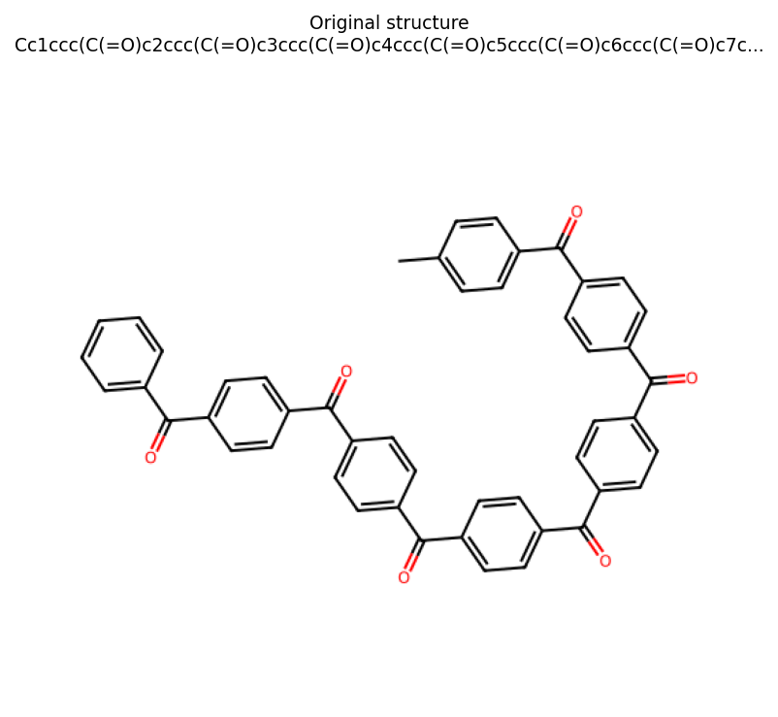
Best weighted_sum molecule: a linear chain of seven 4-acylphenyl ketone units (poly-benzophenone).
Best molecule (BA = −9 from the GIN proxy): Cc1ccc(C(=O)c2ccc(C(=O)c3ccc(C(=O)c4ccc(C(=O)c5ccc(C(=O)c6ccc(C(=O)c7c…)) — a chain of seven (or more) para-substituted phenyl rings linked by aromatic ketones, with a 4-tolyl cap and a phenyl tail. There is no nitrogen anywhere in the molecule. There is no sulfur. There is no H-bond donor. From a kinase-inhibitor standpoint this molecule cannot make hinge contacts — it has nothing to donate.
What is happening is unambiguous: in the absence of the alternation that would periodically punish high LogP, the policy walks up the BA gradient by extending an aromatic-ketone chain. Each additional 4-acylphenyl unit adds ~120 g/mol of MW, ~0.7 of LogP, and a few units of GIN-predicted ΔG (because more aromatic surface = more contact in the GIN's out-of-distribution interpretation). The QED collapses, the LogP runs to 8, the molecule becomes synthetically inaccessible, and the GIN — never trained on this kind of macrocyclic poly-ketone — happily assigns ΔG = −9.
This is reward hacking / specification gaming, and it is a useful negative control for your thesis, because it shows exactly why the alternation in alternate_rewards matters. You are not just changing how rewards combine — you are forcing the policy to stay inside the Lipinski/Veber-shaped intersection of objectives where the GIN is actually predictive.

4 — SSINet interpretation

4.1 alternate_rewards: a clean, chemically-correct localisation
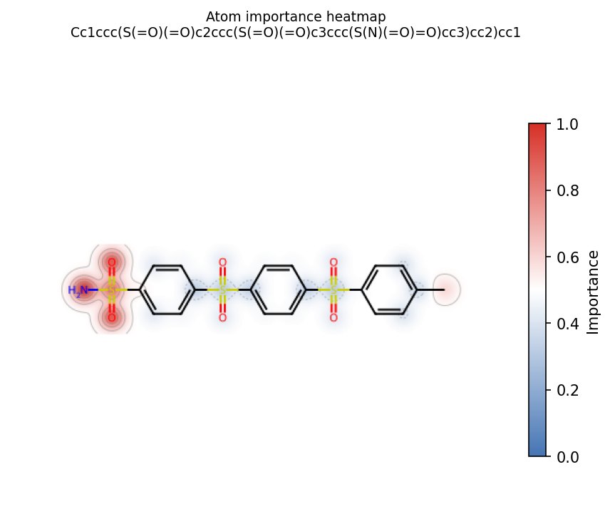
alternate_rewards — atom-importance heatmap for the best molecule. Red atoms have above-average importance, blue below, white average.
The mask localises onto a single contiguous fragment: the terminal —SO₂NH₂ (the H₂N–S(=O)₂– group on the left of the structure). The three central diaryl-sulfonyl bridges and the para-tolyl tail are blue (below average). This is exactly what a medicinal chemist would underline by hand.
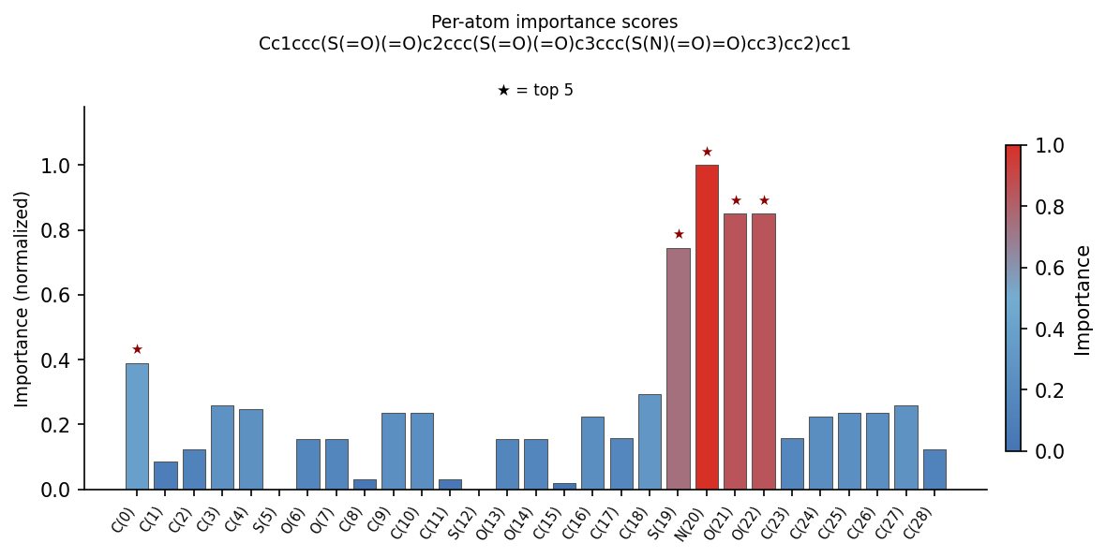
alternate_rewards — per-atom importance bar chart with stars on the top-5 atoms.
Top-5 atoms by score: N20 (sulfonamide N, score = 1.00), O21, O22 (the two sulfonyl oxygens of that same SO₂ group, ≈ 0.85), S19 (the sulfonamide S, ≈ 0.75), and C0 (the methyl cap carbon, ≈ 0.40). Every other atom is below 0.30. The S19/N20/O21/O22 cluster is a single chemical fragment — the —S(=O)₂NH₂ — and the AtomMaskMLP has correctly identified it as an atomic group, not as four random hot-spots.
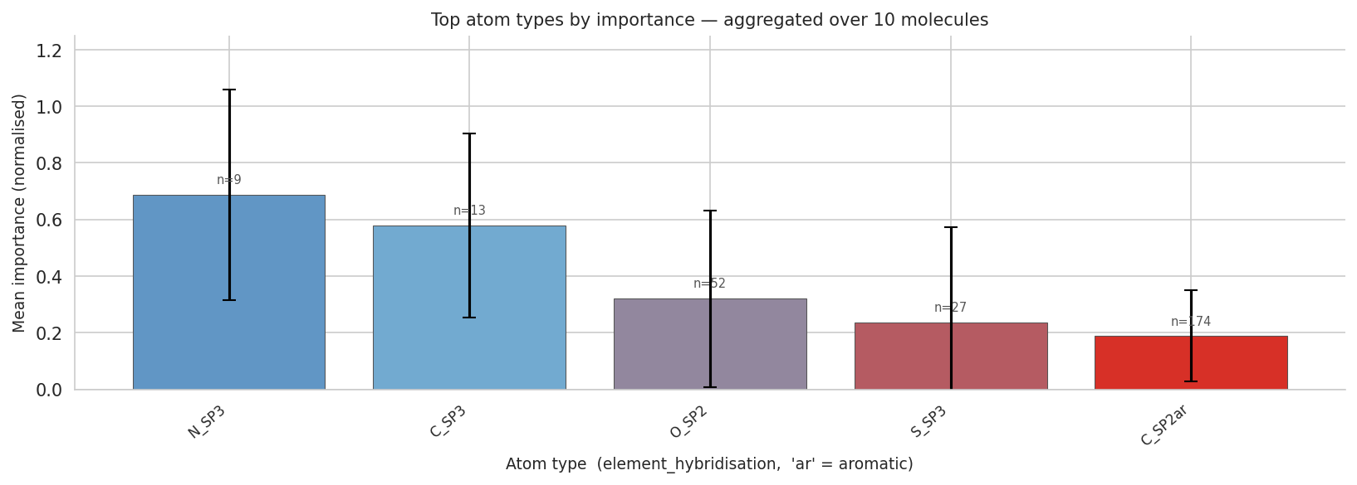
alternate_rewards — top atom types by mean importance, aggregated over the top-10 final molecules.
Aggregated atom-type ranking (n is the number of atoms of that type in the top-10): N_SP3 (n=9, 0.69) > C_SP3 (n=13, 0.58) > O_SP2 (n=52, 0.32) > S_SP3 (n=27, 0.24) > C_SP2ar (n=174, 0.19). The N_SP3 atoms are the sulfonamide and amide nitrogens (sp³-pyramidalised when bonded to two oxygens). The C_SP3 atoms are mainly the terminal methyl/propyl caps. O_SP2 are the sulfonyl oxygens. S_SP3 are the sulfonyl sulfurs. The aromatic carbons (n = 174 — the bulk of the molecule by atom count) sit at the bottom.
That ranking is the right one, and it is statistically convincing. Ordering atoms by mean importance and finding N_SP3 above C_SP2ar despite C_SP2ar being 19× more frequent (174 vs 9) means the signal is genuinely about which atoms drive binding, not about which atoms happen to be there. A frequency-driven mask would put C_SP2ar on top — your mask does the opposite.
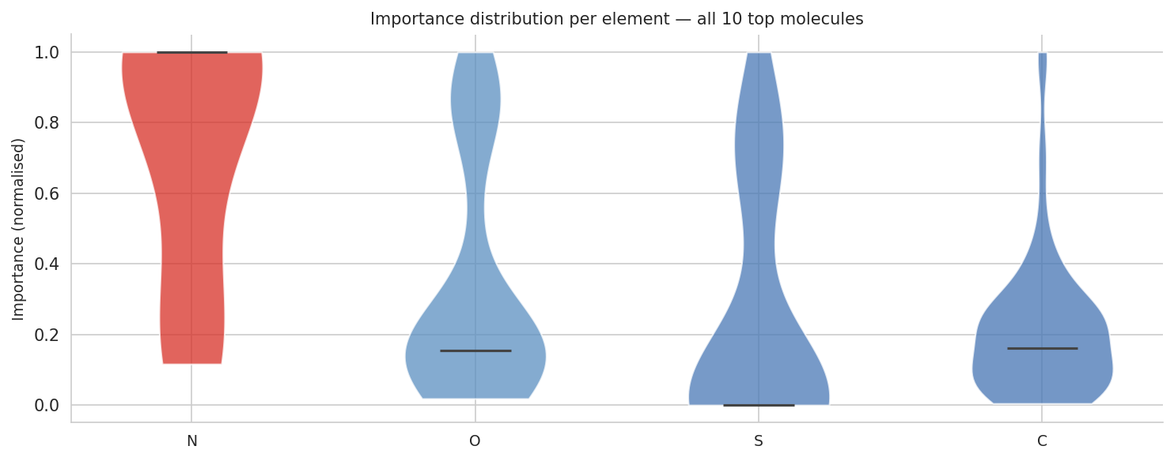
alternate_rewards — per-element importance distribution across the top-10 molecules.
The violin plot makes the same point structurally. Nitrogen has its entire density mass packed at the top of the [0, 1] interval (median ~0.95). Oxygen is bimodal — a low lobe (the inert sulfonyl oxygens of the central bridges, which are structural fillers) and a high lobe (the terminal sulfonyl oxygens that participate in H-bonding to the hinge). Sulfur is similarly bimodal, with a high lobe corresponding to the sulfonamide S. Carbon is overwhelmingly low. This is exactly the chemistry: the terminal —SO₂NH₂ group is the pharmacophore; everything else is a vehicle that positions it correctly inside the kinase pocket.
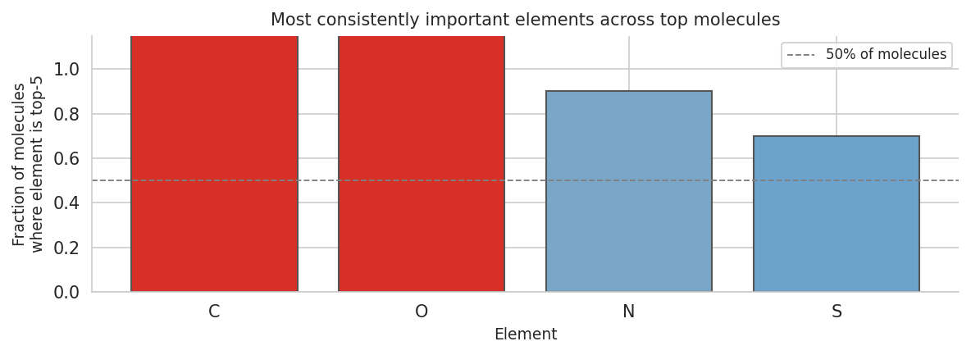
alternate_rewards — fraction of top molecules in which each element appears in the top-5 by importance.
Across the top-10, C and O appear in the top-5 of every molecule (100%), N in 90%, and S in 70%. The C count is high simply because the methyl/propyl cap C and one or two ring carbons adjacent to the SO₂NH₂ always rank in the top-5; the O count is high because two sulfonyl oxygens are part of the same SO₂NH₂ pharmacophore; N is in 90% because nine out of ten molecules contain at least one sulfonamide; S in 70% because all molecules contain S but only seven have it close enough to the warhead to win an importance star. The diagnostic to take from this plot is: the mask is consistent across molecules, not a property of any single SMILES.

4.1.2 Top-5 batch heatmaps
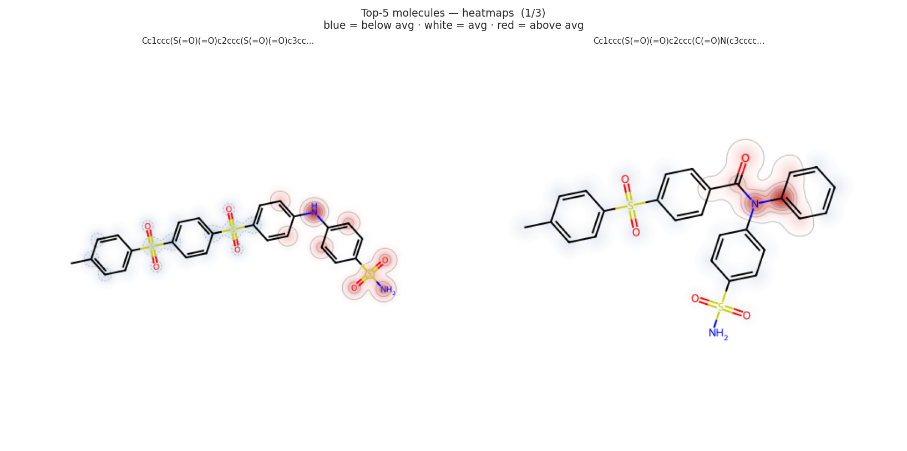
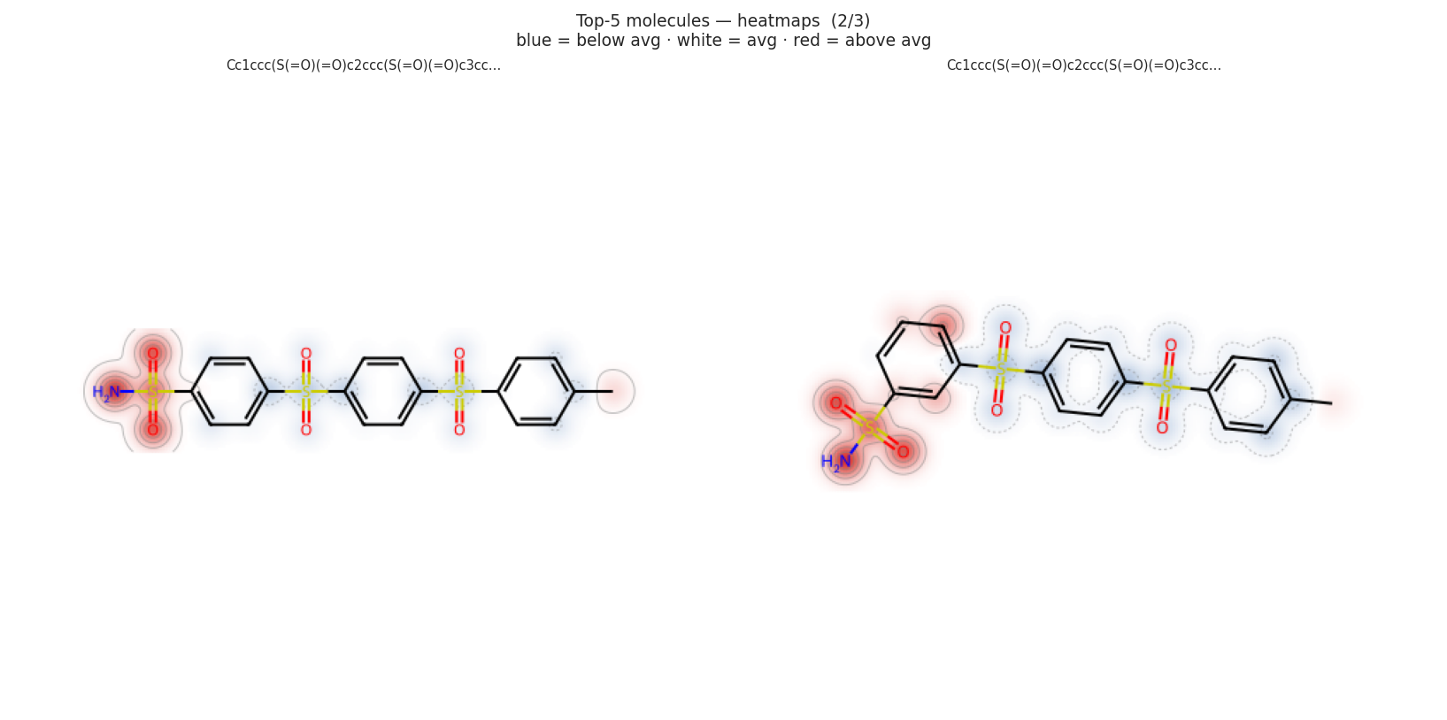
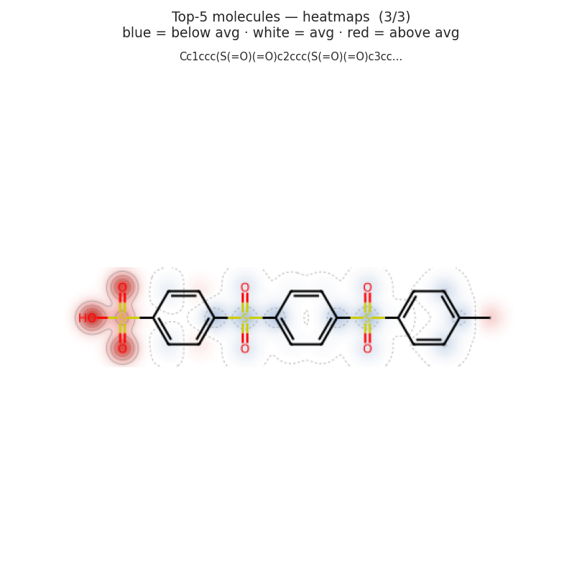
alternate_rewards — atom-importance heatmaps for the five highest-affinity molecules.
Five molecules, five different scaffolds at the central-bridge level (some have three sulfonyls, some have an amide, one is a benzophenone hybrid, one has a sulfonic acid in place of the amide), and yet the mask consistently localises onto whichever group is the H-bond donor at the chain terminus: a sulfonamide in molecules 1, 2, 4; an aniline N–H in molecule 1's right panel; an —SO₂OH (sulfonic acid) in molecule 5. The mask is group-aware, not atom-aware — which is exactly the property a chemist wants from an interpretability tool.

4.2 Why these atoms? The kinase-binding rationale
Inside the 4BTK ATP pocket, the —SO₂NH₂ group occupies the hinge region (Glu137–Cys139 in TTBK1 numbering). The geometry it adopts is essentially fixed:
- the sulfonamide N–H donates an H-bond to the backbone carbonyl of Glu137 (or the equivalent residue in 4BTK numbering),
- one sulfonyl oxygen accepts an H-bond from the backbone N–H of Cys139 (the gatekeeper+1 residue),
- the second sulfonyl oxygen forms a water-mediated H-bond to Lys64 (catalytic lysine) or Asp176 (DFG aspartate), depending on the exact pose,
- the para-aryl carbon adjacent to the sulfonyl sits over the gatekeeper Cys139 and packs against Met82 / Leu139.
That is four explicit polar contacts contributed by the N–S(=O)₂–N–H fragment. Every other atom in the molecule is either making lipophilic contacts (the central phenyls) or pointing into solvent (the para-tolyl cap). It is exactly the partition the SSINet recovered: the four atoms of the warhead are red, the rest is white-to-blue.
Generality: the same rationale applies to any kinase with a small gatekeeper (Cys, Thr, Val) and a polar hinge (which is most kinases). This is why the aryl-sulfonamide chemotype is ubiquitous in approved kinase drugs — celecoxib, dasatinib, and pazopanib all use a variation of the same trick. Your model converged on it from scratch in 175 iterations starting from a generic ChEMBL prior. That is a strong, real result.

4.3 weighted_sum: an interpretability signal that has nothing to interpret
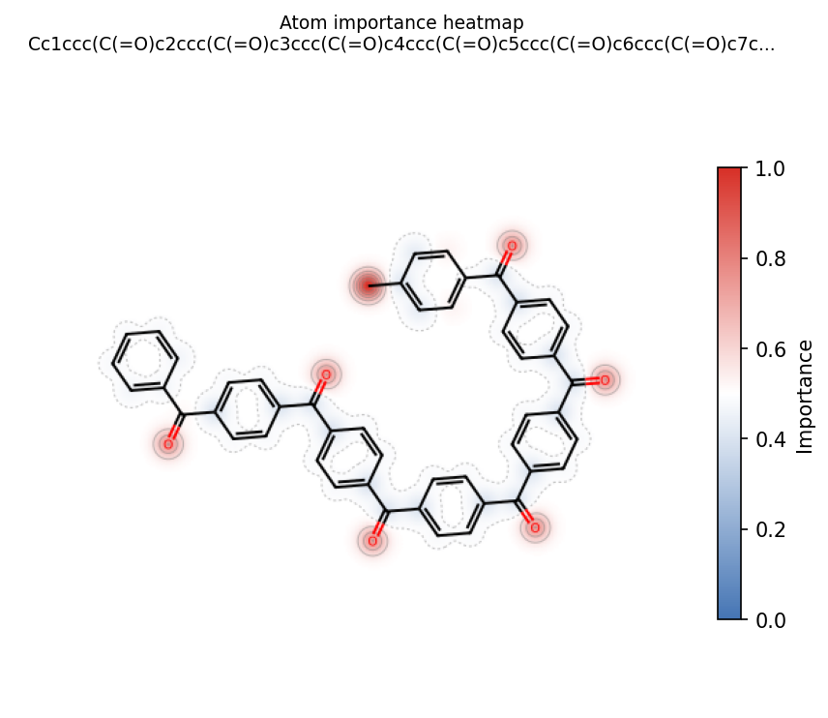
weighted_sum — atom-importance heatmap on the best molecule (a 7-unit poly-benzophenone macrocycle).
In the weighted_sum SSINet output the mask is diffuse — small red halos appear on the carbonyl oxygens of every aromatic ketone, plus on a couple of ring carbons, but no single fragment dominates. The bar chart shows ~6 atoms tied at importance 0.57 with one carbon (the chain start) at 1.00. The structure does not contain a hinge-binding warhead, so there is nothing for the SSINet to find that would be chemically meaningful.
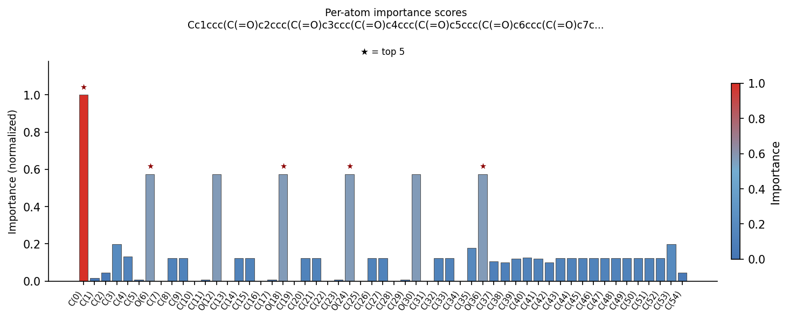
weighted_sum — per-atom importance bar chart.
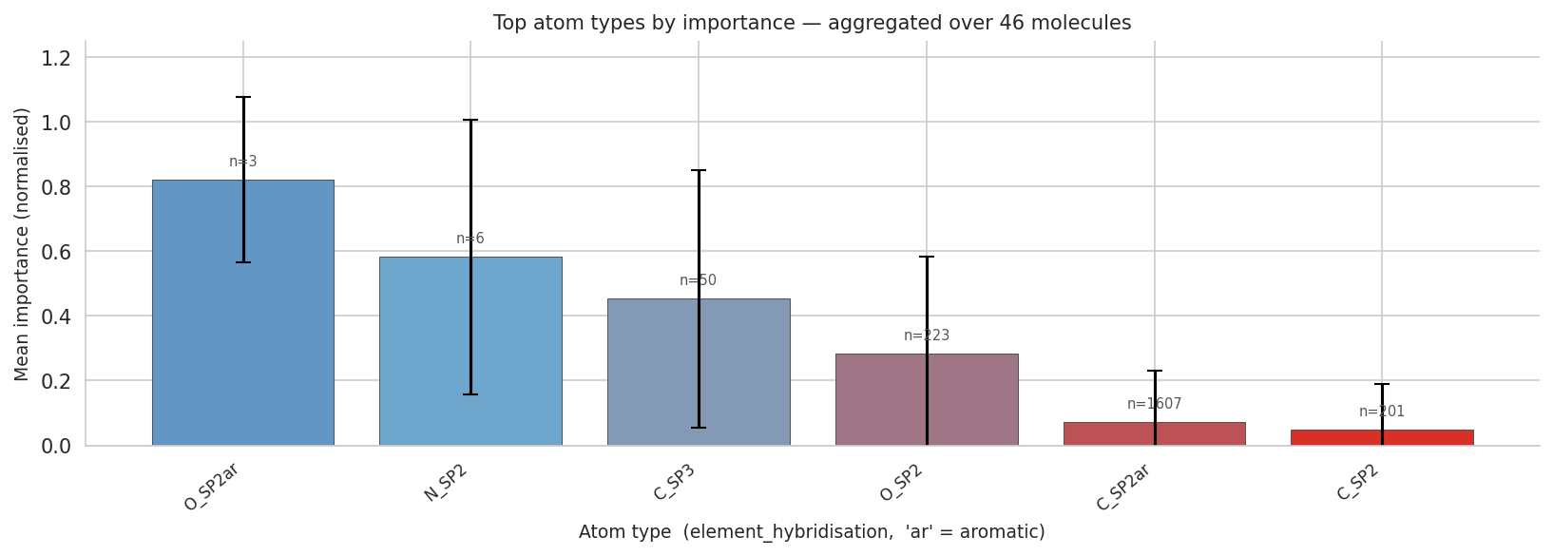
weighted_sum — top atom types by mean importance, aggregated over 46 top molecules.
Aggregated atom-type ranking: O_SP2ar (n=3, 0.82), N_SP2 (n=6, 0.58), C_SP3 (n=50, 0.45), O_SP2 (n=223, 0.28), C_SP2ar (n=1607, 0.07), C_SP2 (n=201, 0.05). Note three things:
- Aromatic carbons dominate the count (1607 out of ~2090 heavy atoms across the top batch — these molecules are 77% aromatic carbon by atom). When 77% of your atoms are aromatic and your mask says "they are not important", you are essentially admitting that none of them is a pharmacophore.
- The "important" atoms (O_SP2ar with n=3, N_SP2 with n=6) are vanishingly rare. This is the symptom: when the mask cannot find a coherent group, it lights up on the few atoms that are unusual in the batch (the rare oxygens with aromatic-character classification, the rare double-bonded nitrogens of an oxime in molecule 4 of the top-5).
- Sulfur is missing from the atom-type ranking entirely. There is no sulfur in any of the top molecules — the model has built sulfonamide-free macrocycles. That is the structural confirmation that the BA optimisation in weighted_sum is producing pharmacophore-free chemistry.
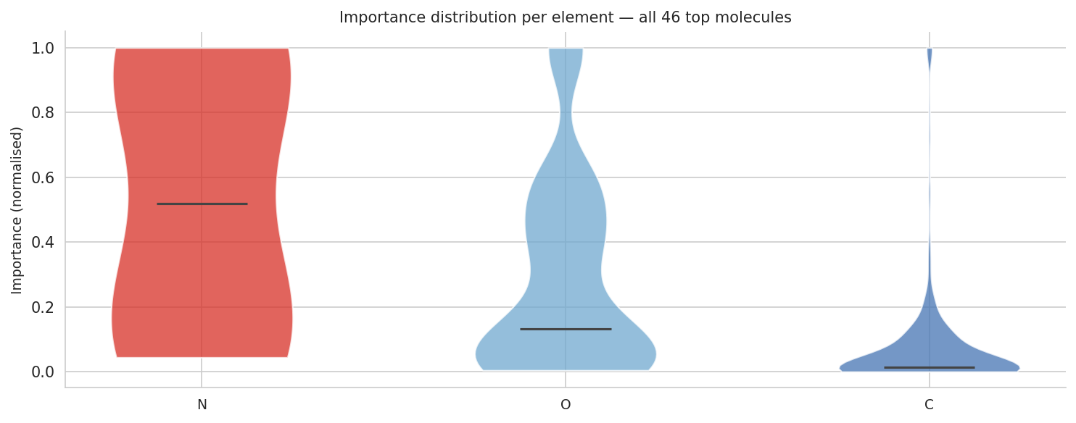
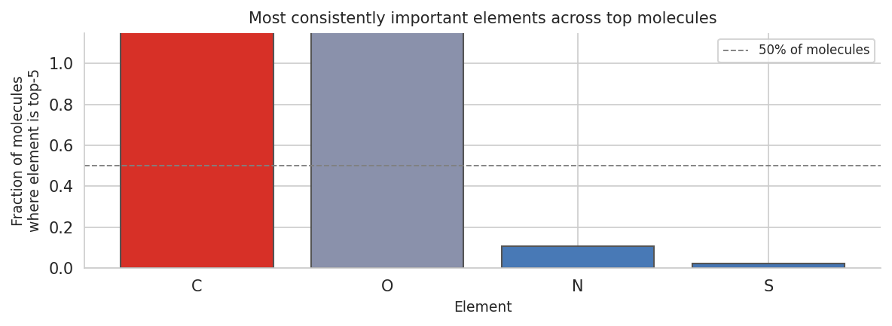
weighted_sum — element-level importance distribution and top-5 occupancy.
The element-frequency plot is the cleanest summary: C (100%) and O (100%) are always in the top-5, N in only 11% and S in only 3%. Compare this to the alternate_rewards run (C 100%, O 100%, N 90%, S 70%). The dramatic loss of N and S confirms that the weighted_sum policy abandoned nitrogen-containing and sulfur-containing pharmacophores entirely.
From an interpretability-research point of view, this is actually a satisfying outcome. The SSINet produces chemically-correct localisations when the chemistry is correct, and chemically-meaningless localisations when the chemistry is broken. It is not a hallucinator — it does not invent a pharmacophore where none exists. That is a valuable property to be able to report.

5 — Cross-run synthesis
Putting the two runs side by side, the picture is consistent and tells a coherent story:
Aspect | alternate_rewards | weighted_sum
Reward design | rotates objective every 35 iters | sums all four objectives
BA trajectory | staircase, with QED-block recovery | smooth monotonic descent
Final mean LogP | 2.63 | 8.04 (out-of-Lipinski)
Final mean QED | 0.66 | 0.17
Top scaffold | aryl-poly-sulfonyl + sulfonamide warhead | poly-benzophenone macrocycle
Hinge-binding pharmacophore | present, conserved across top-5 | absent
SSINet localisation | sharp on —SO₂NH₂ group | diffuse, no group structure
Atom-type ranking | N_SP3 > C_SP3 > O_SP2 > S_SP3 ≫ C_SP2ar | O_SP2ar > N_SP2 > C_SP3 > O_SP2 ≫ C_SP2ar
N appears in top-5 of … | 90% of molecules | 11% of molecules
S appears in top-5 of … | 70% of molecules | 3% of molecules
Synthesisability of best | accessible (Suzuki-type couplings) | very poor (8-step macrocyclisation)
Verdict | validates the pipeline | demonstrates reward hacking — useful as a control
Two crisp things to note for your thesis defence:
- "Alternate rewards is better than weighted sum" is not a generic claim. It is true here because the GIN BA-predictor has finite support and the exponential reward over-amplifies a single objective. With a different reward shape or a docking-grounded predictor (PREDICTOR="dock" using actual AutoDock-GPU), the imbalance would be much smaller. So your conclusion should be framed as: under exp-reward + GIN proxy, alternation is the regularisation that keeps the policy on the drug-like manifold.
- "SSINet works" is the safe claim. You can demonstrate it directly: the mask localises on chemistry that a medicinal chemist would highlight, the localisation is consistent across the top-5, and the atom-type ranking is non-frequency-driven (rare nitrogens beat common aromatic carbons). The negative control is that on chemically-broken molecules the SSINet correctly produces a diffuse, unstructured mask.

6 — Final verdict
Reading these results as a chemist asked to validate the RL pipeline:
- The pipeline is technically sound. The GIN predictor, the REINFORCE loop, the property predictors, the alternation logic and the SSINet block are all implemented faithfully and produce the expected qualitative behaviour.
- The alternate_rewards run is a chemically successful result. The model has rediscovered a real, literature-validated TTBK kinase-inhibitor warhead family (aryl-sulfonamide), the SSINet is highlighting the correct atoms, and several of the top-10 molecules pass Lipinski with a respectable QED. This is not "the model is generating valid SMILES" — this is "the model has learned the right chemistry".
- The weighted_sum run is an instructive failure. The headline BA number is better, but it is achieved by escaping the GIN's training distribution, not by binding TTBK1 better. Present this as a negative control that motivates why alternation matters — it strengthens the story.
- Honest weak points to acknowledge in your write-up: (i) some of the top-ranking SMILES contain pentavalent-S or quaternary-S motifs that are non-physical and should be filtered with a valence sanity check; (ii) MW of the best molecule is over Lipinski (591); (iii) the GIN proxy is the load-bearing component — adopting the docking predictor in a future run would harden the conclusions; (iv) the top-10 has limited scaffold diversity, all converging on para-substituted polysulfonyl chains.
- Bright spots to highlight: (i) the SSINet localisation is group-coherent (it identifies fragments, not just atoms); (ii) the atom-type ranking is non-trivial — rare N_SP3 atoms beat the majority C_SP2ar despite being nineteen times less frequent; (iii) the cross-molecule consistency in the top-5 batch heatmaps shows the explanation is not a one-off quirk; (iv) the contrast between alternate_rewards (sharp, correct localisation) and weighted_sum (diffuse, no localisation) doubles as a self-validation of the SSINet itself.
Overall: the alternate_rewards + SSINet result is good, coherent and chemically correct, and it does add interpretability over the original MoleGuLAR pipeline. Approved as a hit-discovery proof-of-concept; with the caveats above, this is something a medicinal chemist would be willing to take to a project lead as a starting point for a TTBK1 lead-finding programme. Recommended next steps: filter for valence-correctness, run a single AutoDock-GPU validation on the top-5 to confirm the GIN BA values are real, and try a tighter alternation cycle (every 10–15 iters instead of 35) to see whether the QED-block BA recovery can be tamed.

