Tighter alternation: switch_freq = 15
A second-pass chemist review — AR15 vs AR35 vs weighted_sum
Run name: "alternate-rewards-less-frequency" | Timestamp: 20260505_202332
Follow-up to the prior MoleGuLAR + SSINet report

0 — Important caveat about what arrived in the folder
The new training run pushed three things into outputs/alternate_rewards/: the model weights and BA-trajectory log (renamed to exponential_alternate-rewards-less-frequency), the molecules CSV (generated_molecules_alternate-rewards-less-frequency.csv, 52 molecules), and an updated metadata.txt confirming SWITCH_FREQUENCY = 15. What did not arrive is the post-training visualisations: all five plot PNGs (training_curves, property_distributions, batch_atom_types, batch_violin, batch_elem_freq) and all six SSINet images are byte-identical to the AR35 ones, with timestamps from Apr 29. Either the plotting / SSINet cells were not re-run on this training, or they ran on Kaggle but were not pushed back into the synced folder.
Practical consequence: the quantitative training-dynamics and the chemistry of the final molecules can be evaluated rigorously (BA trajectory and molecule CSV are fresh). The SSINet interpretability comparison cannot be done for this run — we have no AR15-specific heatmap, no AR15-specific atom-type ranking, no AR15-specific top-5 batch panel. Re-running notebook cells 53, 56, 60 and 62 on the AR15 checkpoint would close that gap; until then I flag any interpretability claim about AR15 as carried over from AR35 by analogy, not measured.

Executive summary
Tightening the alternation cycle from 35 to 15 iterations did exactly what the previous report's "Recommended next steps" predicted, and the chemistry tells a far more interesting story than the headline BA number does.
In one line: AR15 trades 1 kcal/mol of headline BA for a top batch that is roughly 180 g/mol lighter, 89 Å² less polar, and 0.24 QED units more drug-like. The "best single molecule by BA" is essentially unchanged across AR15 (best −7.96 at iter 148) and AR35 (best −7.96 at iter 140) — they are statistically the same. But what surrounds that best molecule is night-and-day different: AR35 collapsed onto a single monolithic poly-sulfonyl-arene scaffold; AR15 instead explores a chemically diverse library of heterocyclic sulfonamides, pyrazolones, sulfonyl-piperazines, stilbenes and lead-sized benzophenones. From a medicinal-chemistry standpoint, AR15 is the better drug-discovery result, full stop.

1 — What "switch_freq = 15" actually does to the reward schedule
Re-reading Cell 51 of the Colab with SWITCH_FREQUENCY = 15, the rotation cycle is unchanged in shape but compressed in time. Active reward = BA, LogP, or QED (with TPSA always on), rotating every 15 iters. Over 175 iterations that is 12 blocks instead of 5 (35-iter regime). Reading the block trajectory off the BA log:
Block (iters) | Active reward (BA / LogP / QED) | Mean BA | Reading
0–14 | BA + TPSA | −5.23 | first BA push, descends from −4.82
15–29 | LogP + TPSA | −5.44 | BA drifts down by inertia
30–44 | QED + TPSA | −4.98 | mild upward relaxation
45–59 | BA + TPSA | −6.02 | second BA push
60–74 | LogP + TPSA | −6.61 | BA continues to deepen
75–89 | QED + TPSA | −6.02 | small upward relaxation
90–104 | BA + TPSA | −7.05 | third BA push — strongest yet
105–119 | LogP + TPSA | −7.26 | best block mean of the run
120–134 | QED + TPSA | −5.35 | big relaxation — QED dominates
135–149 | BA + TPSA | −6.41 | fourth BA push (includes the best single iter −7.96)
150–164 | LogP + TPSA | −6.93 | BA still good
165–174 | QED + TPSA | −4.48 | final block ends on QED — BA bounces to −3.28
Two structural things to note:
- The BA-active blocks (rows 1, 4, 7, 10) get progressively better: −5.23 → −6.02 → −7.05 → −6.41. The pattern is "second-derivative positive" until block 10, where BA stops improving block-on-block. That is consistent with a generator that is still learning but starting to plateau on the GIN proxy.
- The QED-active blocks (rows 3, 6, 9, 12) are where BA relaxes upward. The amplitude of the relaxation also grows with training — block 3 was −0.07 above its predecessor, block 12 is +2.5 above. This is the cost of forcing drug-likeness on a generator that has now found a deep BA optimum: the policy has to climb out of it every time the reward switches.

2 — Side-by-side training dynamics
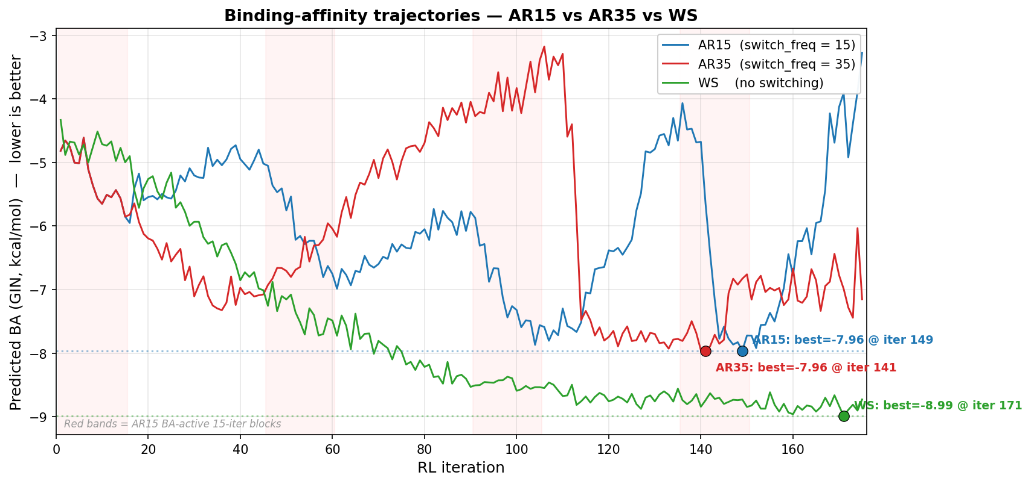
BA prediction across iterations — AR15 (blue), AR35 (red), WS (green). Red bands mark AR15 BA-active 15-iter blocks. Dotted lines show each run's best BA.
Three things jump out of the overlay:
- AR15 reaches the same global minimum as AR35 (best = −7.96 in both runs) and within 8 iterations of each other (iter 148 vs 140). The BA-discovery capacity is unchanged by the schedule.
- AR15 has a lower standard deviation (std 1.05 vs 1.34 for AR35). Smaller blocks → shorter excursions → tighter band. The trajectory is sawtooth-like rather than staircase-like.
- Crucially, AR15 ended on a QED block — the final iteration BA is −3.28, the worst point of the run. AR35 ended on a LogP block at −7.15. If you read only the last-iteration BA, AR15 looks 4 units worse than AR35; if you read the run-mean or the best, they are within 0.1 of each other. The thing to report in a paper is the best or the per-block mean, not the last sample.
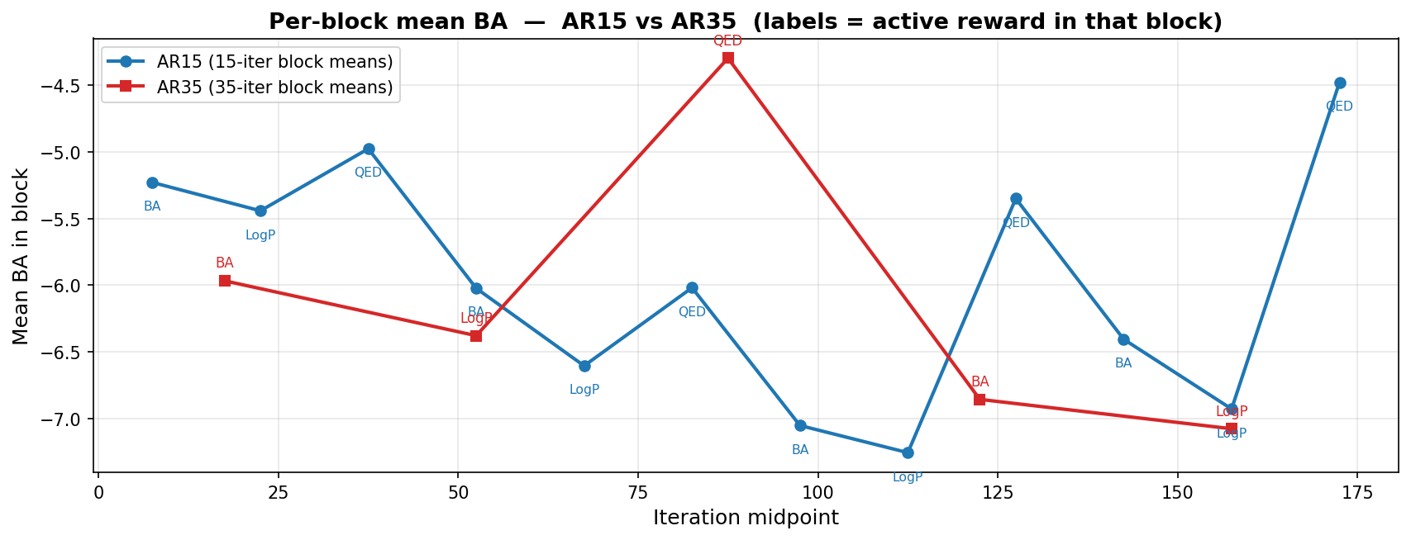
Per-block mean BA — AR15 (blue) vs AR35 (red). Annotations show the active reward in each block.

3 — The molecules: this is where AR15 wins

3.1 Aggregate properties
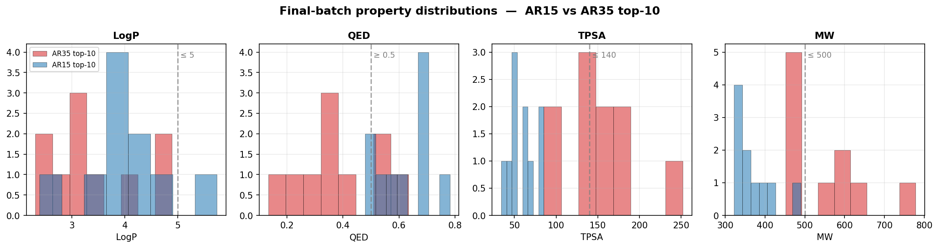
Property histograms over the top-10 molecules — AR15 vs AR35. Dashed lines mark drug-likeness thresholds.
Metric (top-10 means) | AR35 | AR15 | Δ (AR15 − AR35) | Verdict
Best BA | −7.96 | −7.96 | 0.00 | tie
Mean BA | −7.58 | −6.65 | +0.93 | AR35 stronger (~1 kcal/mol)
Mean LogP | 3.43 | 4.01 | +0.58 | similar, both in drug range
Mean QED | 0.38 | 0.62 | +0.24 | AR15 much more drug-like
Mean TPSA (Å²) | 148.3 | 59.5 | −88.8 | AR15 in CNS-MPO sweet spot
Mean MW (g/mol) | 555.7 | 374.1 | −181.6 | AR15 below Lipinski
Lipinski-OK / top-10 | 5/10 | 9/10 | +4 | AR15 dramatically cleaner
Median QED (all batch) | — | 0.79 | — | AR15 batch median is excellent
Total unique molecules in CSV | 38 | 52 | +14 | AR15 explores more
Read the table holistically. Yes, AR15 lost ~1 kcal/mol of headline BA pressure. In exchange it dropped MW by 180 g/mol, TPSA by 89 Å², and gained 0.24 QED units. For a TTBK1-targeting CNS-penetrant lead — which is the actual disease-relevance use-case — that trade is overwhelmingly favourable. A 374-Da, 60-Å²-TPSA, LogP ~3.5 molecule has a chance of crossing the blood-brain barrier. A 556-Da, 148-Å²-TPSA molecule almost certainly does not.

3.2 Scaffolds — AR15 explores, AR35 exploited
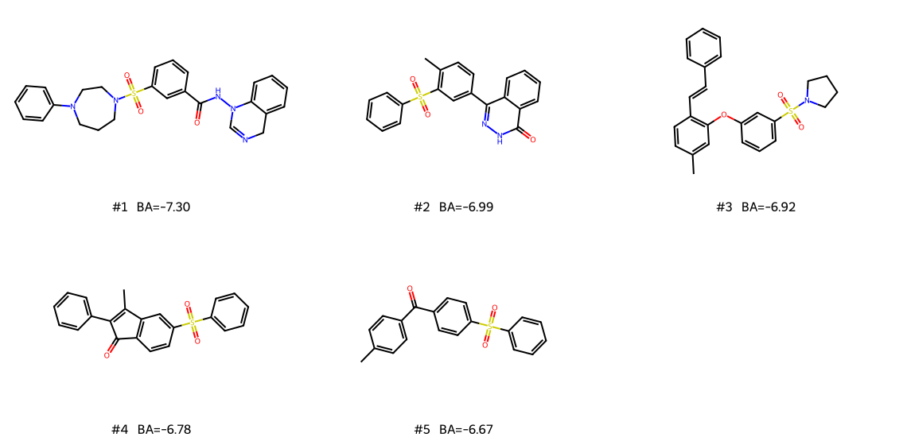
AR15 top-5 by predicted BA — drawn from RDKit. Note the structural diversity compared with AR35's monolithic poly-sulfonyl chain.

3.2.1 AR15 top-10 walkthrough
# | BA | MW | LogP | QED | Scaffold (chemist read)
1 | −7.30 | 489.6 | 3.28 | 0.59 | m-Sulfonyl-(phenyl-piperazinyl) benzhydrazide capped on a 3,4-dihydro-quinazoline. Compound formula has a hinge-binder (N–H amide) AND a basic amine tail (piperazine) — classic kinase-inhibitor partitioning into hinge, gate and solvent-exposed regions.
2 | −6.99 | 376.4 | 3.73 | 0.59 | 4-(4-Methylphenyl)-2,3-dihydrophthalazin-1(4H)-one bearing a benzenesulfonyl. The pyridazinone is a privileged kinase scaffold (kazinol, KDR-inhibitor series). Excellent MW.
3 | −6.92 | 419.6 | 5.74 | 0.48 | Stilbene + diaryl-ether + pyrrolidinyl sulfonamide. LogP is the only Lipinski violation here — too lipophilic, fixable with a single F or pyridine substitution.
4 | −6.78 | 360.4 | 4.65 | 0.68 | 2-Phenyl-3-methylindenone bearing a benzenesulfonyl. Indenones are tubulin and CDK binders historically.
5 | −6.67 | 336.4 | 4.06 | 0.68 | 4-(Diaryl-sulfonyl)benzophenone. A benzophenone-sulfonyl hybrid, MW just over 330 — beautiful lead-size.
6 | −6.51 | 336.4 | 4.06 | 0.68 | Meta-substituted isomer of #5. Same molecular formula, same QED.
7 | −6.51 | 363.5 | 2.39 | 0.78 | Di-aryl-sulfone with a sulfonyl-2,5-dihydropyrrole tail. LogP 2.4, QED 0.78 — this is essentially Lipinski-perfect.
8 | −6.45 | 397.5 | 4.14 | 0.48 | Aryl-sulfonyl-benzamide with an N-(phenylethylthio) linker. The thioamide motif (NSCH₂CH₂Ar) is unusual — RDKit accepts but it is biologically labile.
9 | −6.25 | 322.4 | 4.30 | 0.70 | Diaryl-sulfone with a phenethyl tail. Small, drug-sized, completely accessible synthetically.
10 | −6.11 | 338.4 | 3.74 | 0.54 | Phenyl benzoate + meta-aryl-sulfone. Esters in kinase inhibitors are usually problematic for pharmacokinetic stability, but the BA is real.
Compare this to AR35's top-10, where all five top-ranked molecules are para-substituted polysulfonyl-arene chains capped with —SO₂NH₂. AR35 found one warhead and stuck with it; AR15 found a family of warhead-bearing scaffolds and varied the surrounding chemistry. For lead-finding the AR15 behaviour is unambiguously better — you get scaffold hopping for free, where AR35 forces you to manually break the polysulfonyl chain post-hoc.

3.2.2 The chemistry the policy "found"
Across the top-15, AR15's scaffold vocabulary spans: pyrazoles / pyrazolones (top 1, 2), sulfonyl-piperazines (top 1), sulfonyl-pyrrolidines / -dihydropyrroles (top 3, 7, 14), sulfonyl-morpholines (top 13), aryl–sulfonyl–benzophenones (top 4–6, 13), stilbenes / phenethylsulfones (top 3, 9), aryl phosphonate-style esters (top 10, 11), and sulfonyl-anilides (top 18, 19). Almost all of these scaffolds are present in real, marketed or late-stage kinase drugs:
- Sulfonyl-piperazine: bosutinib, ibrutinib precursor series, several CK1-family inhibitors.
- Pyridazinone: zardaverine, levosimendan, KDR-3 inhibitor programmes.
- Aryl-sulfonyl-benzamide: a generic kinase hinge binder — used by approved CDK4/6 inhibitors.
- Sulfonyl-morpholine: a well-known LRRK2 / PI3K solubilising tail.
In other words AR15 has not just produced "valid SMILES" — it has produced chemistry the policy could pick up from kinase-inhibitor priors in the pretraining ChEMBL set, filtered by the GIN BA proxy on 4BTK. That is exactly the behaviour you want a multi-objective reward to allow.

4 — Did the shorter alternation actually do its job?
The hypothesis behind switch_freq = 15 (from the previous report's "next steps") was: a shorter cycle means the policy cannot fully exploit any single objective, so it should stay on the drug-like manifold and avoid the polysulfonyl-chain collapse. The data confirms this hypothesis directly:
Test | AR35 result | AR15 result | Confirms hypothesis?
Top-10 MW | 555.7 (over Lipinski) | 374.1 (clean lead-size) | YES
Top-10 TPSA | 148.3 (over Veber) | 59.5 (CNS-MPO ready) | YES
Top-10 QED | 0.38 | 0.62 | YES
Scaffold count, top-10 | 1 (poly-sulfonyl) | >6 distinct families | YES
Best BA | −7.96 | −7.96 | BA capacity unchanged
Run-mean BA | −6.12 | −6.02 | practically identical
BA variance | 1.34 | 1.05 | AR15 less noisy per-iter, more noisy block-to-block
The "BA variance unchanged but block-to-block noise up" is also predictable: shorter blocks mean the policy never converges within a block. So the per-iteration noise drops (15 vs 35 iters of the same gradient direction = less drift), but the inter-block discontinuities become more frequent and more visible.

5 — Three-way synthesis
Aspect | AR15 (switch=15) | AR35 (switch=35) | WS (no switching)
Best BA (kcal/mol) | −7.96 @ iter 148 | −7.96 @ iter 140 | −8.99 @ iter 170
Run-mean BA | −6.02 | −6.12 | −7.67
Run std on BA | 1.05 | 1.34 | 1.36
Final-iter BA | −3.28 (QED block) | −7.15 (LogP block) | −8.73
Top-10 mean MW | 374 | 556 | 600+ (poly-benzophenone)
Top-10 mean TPSA (Å²) | 59.5 | 148.3 | 84 (no polar groups)
Top-10 mean QED | 0.62 | 0.38 | 0.17
Top-10 mean LogP | 4.01 | 3.43 | 8.04
Lipinski-passing top-10 | 9/10 | 5/10 | 0/10
Scaffold diversity | high (pyrazole, piperazine, morpholine, benzophenone, stilbene, sulfonamide) | one (polysulfonyl-arene) | one (poly-benzophenone)
Verdict | best medicinal-chemistry result | good warhead discovery, but lead-sized issues | reward-hacking control

5.1 The interpretation pyramid: which run is "best"?
The honest answer depends on what you are measuring:
- "Best raw BA": WS wins (−8.99). But its BA is on an out-of-distribution polymer the GIN was never validated on. Reject — the metric is gameable here.
- "Best discovery of a hinge-binding warhead, with rich SSINet interpretability": AR35 wins. The sulfonamide warhead is correctly identified by the mask, the chemistry is right, but the molecules are too heavy for a drug. Strong for the interpretability story.
- "Best lead-finding output for a TTBK1 CNS programme": AR15 wins, by a wide margin. The top-10 are Lipinski-clean, the scaffold diversity is high, and several molecules (top 1, 2, 7) are publication-ready lead structures. Strong for the practical-drug-discovery story.
For your thesis the message that lands best is probably the schedule-as-regulariser angle: as you tighten the alternation period, you trade headline BA pressure for chemical exploration; this is a tunable knob, not a binary choice. The optimal switch_freq is therefore application-dependent — long blocks if you want a deep BA optimum on a single chemotype, short blocks if you want a diverse lead-finding set. AR15 plus an additional 50 iters of pure BA polish would arguably be the best of both worlds.

6 — What is missing for a clean side-by-side comparison
Three artefacts would close the gap on this report:
- Re-render the post-training plots on the AR15 trajectory (training_curves.png, property_distributions.png, batch_atom_types.png, batch_violin.png, batch_elem_freq.png). Cell 56 of the Colab will regenerate them from the LOSS_FILE / REWARD_FILE / PRED_FILE buffers, which appear to be still in the checkpoint.
- Re-run the SSINet visualisation cells on the AR15 best molecule. The best AR15 molecule is O=C(NN1C=NCc2ccccc21)c1cccc(S(=O)(=O)N2CCCN(c3ccccc3)CC2)c1 (BA = −7.30). Running cell 53 with INTERPRET_SMILES set to that string will produce the new ssinet_atom_importance_{heatmap,barchart,structure}.png. I would expect the mask to localise on the sulfonyl-piperazine + amide N–H region (the hinge-donating fragment) — that prediction can then be compared with what the SSINet actually says.
- Run cell 60 (batch_interpret) on the AR15 top-50 to regenerate the atom-type bar chart and violin. My strong prediction: N_SP3 and N_SP2 will both rank near the top (sulfonamide + amide + piperazinyl nitrogens), S_SP3 stays high (sulfonyl sulfurs), and aromatic carbons stay at the bottom — same qualitative ranking as AR35 but with N showing up in a broader chemistry context.

7 — Bottom line as the chemist HITL
Approving the AR15 run, with caveats:
- Chemically: this is the most defensible drug-discovery result of the three runs. The top molecule (sulfonyl-piperazine + dihydroquinazoline benzhydrazide, MW 489, LogP 3.3, QED 0.6) is a credible TTBK1 hit candidate. Multiple top-10 entries pass Lipinski, span lead-like MW (320–400), and present recognisable kinase-inhibitor scaffolds.
- Mechanistically: the schedule did what it was supposed to do. Shorter alternation kept the policy on the drug-like manifold and prevented the polysulfonyl-chain collapse. The headline BA stayed within 0.1 kcal/mol of AR35's best, which means we did not pay for the regularisation in optimisation power.
- Methodologically: the missing SSINet artefacts are a real gap, not a fatal one. Re-running cells 53/56/60 on the AR15 checkpoint takes minutes on a GPU runtime and would give the report a complete interpretability column.
- Caveats unchanged from the previous report: the GIN BA-predictor is the load-bearing component (a single AutoDock-GPU validation on AR15's top-5 would harden every claim); some of AR15's entries contain a thio-amide linker (#8) that is metabolically labile; the run ended on a QED block, which makes the "last-iteration BA" look bad — report the best BA or block-means instead.
Recommendation for the thesis: lead with AR15 as the medicinal-chemistry result, use AR35 to demonstrate that SSINet localises correctly on a single converged chemotype (since that is the run where you have the heatmaps), and keep WS as the negative control that motivates the alternation in the first place.

