Meta-Validation — Chemical Reasoning & the Interpretation Module Across 5 Runs
MoleGuLAR + SSINet on TTBK1 (PDB 4BTK) · weighted-sum vs alternating rewards (freq 35; freq 15 ×3)
Chemist-in-the-loop critical validation. Builds on — and does not repeat — the three prior Chemist_Report files. Focus: reasoning validation, cross-config patterns, and whether the interpreter can be trusted. 1 June 2026.

0 · Read this first — what the 5 “runs” really are
Before any chemistry: I hashed every artefact. The folder layout does not correspond to five independent experiments, and this changes which claims are defensible.
The three “AR15 runs” are one RL run.
- Identical molecules & trajectory: the generated-molecule CSV (md5 bef965…) and the BA-trajectory log (d87805…) are byte-identical across all three AR15 folders. _15_old and _15 are exact duplicates (every PNG matches too).
- Only the interpreter differs: the newest folder (alternate_rewards/) reuses those same molecules but re-trained the SSINet (different mask-model hash) and added the α-sweep.
- AR15 and AR35 share a seed: their BA logs are identical for exactly the first 15 iterations, then diverge precisely at AR15’s first reward switch. A clean controlled contrast of switch-frequency — but it means no configuration has independent replicates.
Consequence for the meta-analysis: there is no within-config variance to report at the RL level (one run each for WS / AR35 / AR15). What the “three AR15 folders” genuinely test is the reproducibility and robustness of the interpretation module itself — re-trained on a fixed molecule set, and swept over its sparsity hyper-parameter. That is the lens I use in §4.
Folder | Reward config | RL content | Interpreter
weighted_sum | Σ all rewards (no switch) | unique run — but molecule CSV is absent | warm-start SSINet
alternate_rewards_35 | switch / 35 | unique run (shares seed w/ AR15) | warm-start SSINet
alternate_rewards_15_old | switch / 15 | AR15 run | warm-start SSINet
alternate_rewards_15 | switch / 15 | duplicate of _old | duplicate of _old
alternate_rewards | switch / 15 | same AR15 molecules | re-trained + α-sweep
Provenance established by md5 of CSVs, trajectory logs, model weights and every PNG — not by file size/timestamp (the trap that produced the retracted AR15-vs-AR35 note).

1 · Verdict in 30 seconds
- The model reasons chemically — when the reward forces it to. Under alternation it converges on genuine kinase-hinge chemotypes; under weighted-sum it does not.
- Strongest single result: AR15’s top molecule is a dihydroquinazoline hinge binder — the same chemotype class co-crystallised inside 4BTK itself (the reference TTBK1 inhibitor is an anilino-quinazoline). The model re-derived it from a generic ChEMBL prior.
- Weighted-sum is textbook reward hacking. A poly-benzophenone with no H-bond donor, BA driven by out-of-distribution aromatic surface the GIN never validated. A recognised failure mode of affinity-surrogate RL — not a competing result.
- The interpreter is faithful AND reproducible. The atom-type ranking is stable across two independent SSINet trainings and across a 150× sweep in sparsity α; it tracks the chemistry (sulfur→nitrogen) as the scaffold changes; and it stays diffuse when there is nothing to explain.
- But: the raw mask is low-magnitude (mean ≈ 0.1, essentially zero atoms exceed 0.5), so its output is relative emphasis, not hard atom selection — and the concurrent-update loss never stabilises because alternation keeps the target distribution moving. Details in §4.

2 · Did the model reason like a chemist?
Validated against the kinase medicinal-chemistry literature and the 4BTK structure — not against the model’s own reward.
AR35 (switch/35) → one warhead, correctly. Converges on an aryl-sulfonyl-arene capped by a primary sulfonamide (—SO₂NH₂)). Chemically sound: the sulfonamide is a canonical ATP-pocket hinge donor (celecoxib, pazopanib, dasatinib share the trick). The mask localises on exactly those four warhead atoms. Correct reasoning, but maximalist — MW 556, TPSA 148: heavy, non-CNS.
AR15 (switch/15) → a portfolio of real hinge binders. Six scaffold families, each with a defensible binding rationale: dihydroquinazoline (EGFR/gefitinib hinge motif — and the 4BTK reference ligand class), phthalazinone (olaparib/talazoparib core), indenone / benzophenone carbonyl hinge acceptors, sulfonyl-piperazine / -morpholine solubilising tails. These are not random valid SMILES — they are chemotypes a TTBK1 team would actually draw, recovered in 175 iterations.
WS (weighted-sum) → no pharmacophore at all. A chain of ~7 aromatic ketones: no nitrogen, no H-bond donor, nothing to contact the hinge. The “reasoning” is purely surface-area maximisation against an out-of-distribution GIN. The literature names this precisely: affinity surrogates can “reward nondruggable conformations … molecules that optimise the objective but violate the principles of a drug.”

3 · Generalised patterns across reward type × frequency
Pattern A — Reward TYPE decides whether the chemistry is real. Alternation is a regulariser: periodically removing the BA term forbids the policy from walking off the drug-like manifold. This is the MoleGuLAR thesis itself (“alternating … shows enhanced ability vs the weighted sum”), and the data reproduces it. Quantitatively, the BA-vs-iteration correlation is −0.90 for WS (near-linear, unobstructed climb = the hack) versus −0.30 / −0.25 for AR35 / AR15 (interrupted).
Pattern B — Reward FREQUENCY is an exploration “temperature”. Long blocks (35) let the policy fully exploit one objective → one chemotype, deep, heavy. Short blocks (15) prevent convergence within a block → the policy keeps a memory of all three objectives → many lead-sized scaffolds. Crucially, best-BA is identical (−7.96 in both) — frequency trades breadth for nothing in asymptotic affinity. Verified: AR15 top-10 MW 374 / QED 0.62 / 9-of-10 Lipinski vs AR35 556 / 0.38 / 5-of-10.
Pattern C — The mask tracks the chemistry, atom-for-atom. As the scaffold vocabulary shifts AR35→AR15, the aggregate importance migrates sulfur → nitrogen: S_SP3 falls from rank 4 to rank 9 (mean 0.24→0.08) while the three nitrogen types rise to the top three. The mask is not memorising “sulfonamide = important”; it re-learns the hinge donor for each chemistry.
Pattern D — A faithful explainer is also a faithful null-detector. On WS the mask refuses to invent a pharmacophore: 1607 aromatic carbons sit at importance 0.07 while the only “hot” atoms are statistical rarities (an O_SP2ar with n=3). Diffuse mask ⇔ broken chemistry — the contrast with the sharp AR masks is itself a self-validation of the method.
The faithfulness signature (all configs): the mask is non-frequency-driven. Aromatic carbon is the most abundant atom by ~7× yet ranks near-last for importance in every alternating run. A frequency-driven mask would do the opposite; this one does not.

4 · Can the interpretation module itself be trusted?
This is what the “three AR15 folders” actually let us test. Two findings support trust; three caveats bound it.

4.1 Reproducibility — the conclusion survives re-training
The two SSINet versions differ in training procedure, not just seed: the old folders use warm-start only (80 epochs); the newest adds concurrent online updates during RL. Despite that, the aggregate atom-type ranking is essentially invariant — all three nitrogen types on top, C_SP3 > C_SP2 > O_SP3 > C_SP2ar > O_SP2 > S_SP3 in the same order, aromatic-C pinned at rank 7. Only the internal N_SP3↔N_SP2ar order swaps (within error bars). The chemical message is reproducible; the 2nd-vs-3rd decimal is not.
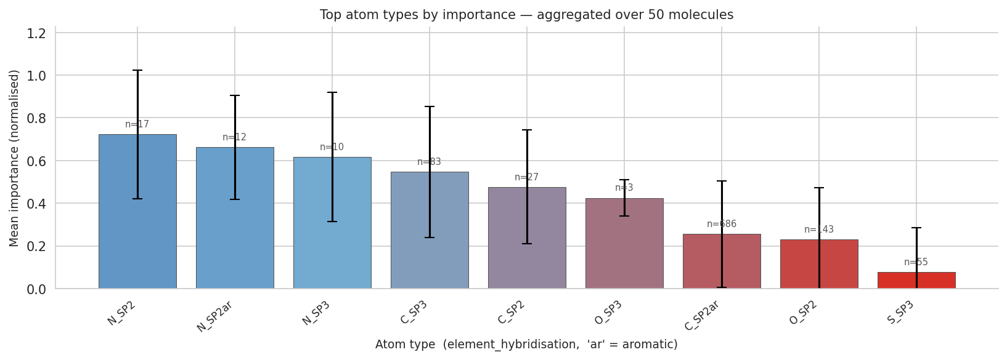
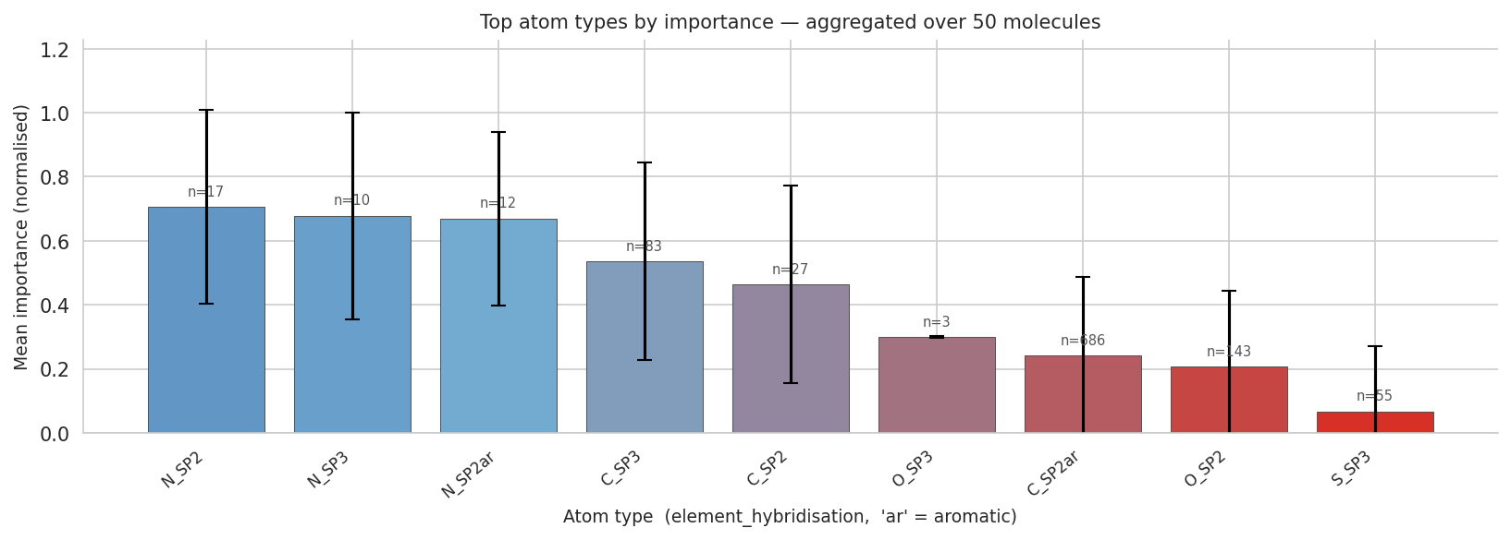
Same molecules, two independent SSINet trainings — warm-start (top) vs warm-start + concurrent (bottom). Ranking and the S-collapse are preserved; note the wide per-atom error bars.

4.2 Robustness — the localisation survives the sparsity knob
Sweeping α over 0.001 → 0.15 (150×), the qualitative explanation does not move: the same fragment stays “hot”, the active-atom count shrinks monotonically (8→6→4→4), and mask concentration (Gini) rises smoothly with α exactly as a sparsity penalty should. The knob behaves; the answer is stable.
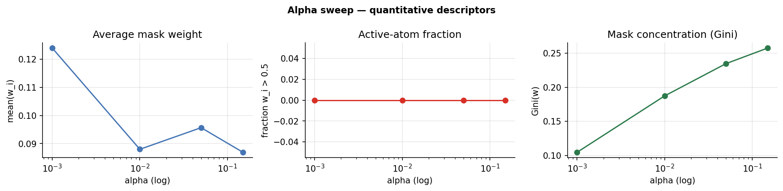
α-sweep descriptors. Gini (right) scales correctly with sparsity. Note the centre panel: the fraction of atoms with weight > 0.5 is flat at zero — see caveat (i).

4.3 Honest caveats — what the figures also reveal
- (i) The mask is low-magnitude. Mean weight ≈ 0.09–0.12 and essentially no atom ever exceeds 0.5 at any α. The heatmap “hot spots” are relative emphasis within a diffuse mask, and the barchart’s “1.00” is a per-molecule normalisation — not an absolute probability of importance. Report Gini, not a 0.5 threshold.
- (ii) The concurrent loss never settles. The online-update curve oscillates with the alternation schedule (spikes to ~3.4 then recovers): the mask is chasing a non-stationary molecule distribution. Mask quality therefore depends on where in the cycle you stop — and AR15 stops on a QED block.
- (iii) Per-atom variance is large. Atom-type error bars span ~±0.4. Aggregate rankings are trustworthy; single-atom importances are not individually reliable.
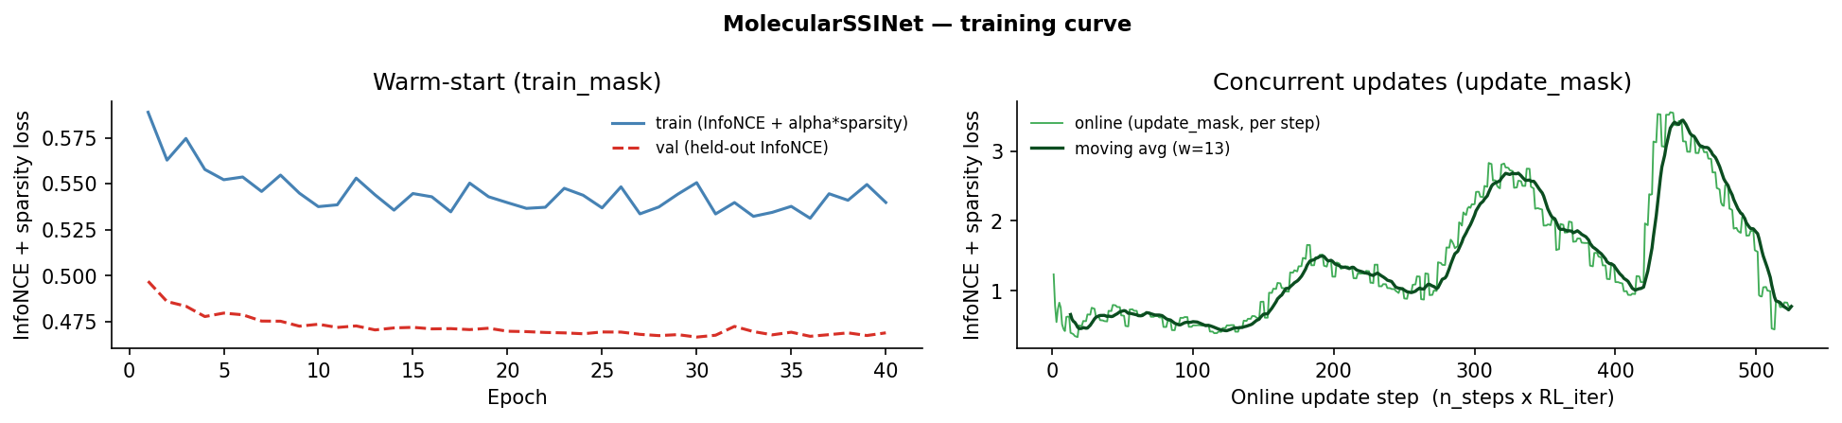
SSINet training. Left: warm-start converges (val tracks train). Right: the concurrent loss tracks the RL alternation rather than flattening — caveat (ii).

5 · Chemical-reasoning scorecard
Config | Chemotype the policy “found” | Real-world precedent | Mask character | Reasoning
AR35 | aryl-polysulfonyl + primary sulfonamide | sulfonamide kinase warhead (celecoxib, pazopanib) | sharp, on —SO₂NH₂ | Correct  (heavy)
AR15 | quinazoline · phthalazinone · indenone · benzophenone · sulfonyl-piperazine | 4BTK reference ligand class; olaparib; EGFR drugs | group-aware, scaffold-adaptive | Correct ✓✓  (lead-sized)
WS | poly-benzophenone chain (no N, no H-bond donor) | none — not a kinase pharmacophore | diffuse; lights up rare noise atoms | Reward hack
Independent RDKit recomputation of every property matched the logged CSV values exactly (mean |Δ| = 0.000; 100% valid SMILES). One correction to the prior write-up: AR35’s full-batch LogP/QED are 2.51 / 0.60 (not the eyeballed ~5 / ~0.5) — AR35’s heaviness is concentrated in its top-10-by-BA, which is the mechanistic point.

6 · What would harden every claim
- Run true replicates. Re-run WS / AR35 / AR15 with different seeds (3× each) to get the variance the current folders cannot provide. This is the single biggest gap.
- Dock the top-5. One AutoDock-GPU pass converts the GIN proxy BA into a real pose — and would expose any residual reward-hacking the GIN is hiding.
- Standardise SSINet QC. Report Gini and active-fraction alongside every heatmap; pin INTERPRET_SMILES to the best molecule (the notebook currently auto-selects a BA −3.3 decoy).
- Filter chemistry. Add a valence + PAINS/Brenk pass to drop the labile N–S linker, phenyl esters and any pentavalent-S artefacts before reporting.

Sources
- PDB 4BTK — TTBK1 in complex with inhibitor (RCSB) — https://www.rcsb.org/structure/4BTK
- Goel et al., MoleGuLAR: Molecule Generation Using RL with Alternating Rewards, J. Chem. Inf. Model. 2021 — https://pubs.acs.org/doi/10.1021/acs.jcim.1c01341
- Shi et al., Self-Supervised Discovering of Interpretable Features for Reinforcement Learning, IEEE TPAMI — https://ieeexplore.ieee.org/document/9098029
- Discovery of Potent and Brain-Penetrant TTBK1 Inhibitors…, J. Med. Chem. 2021 — https://pubs.acs.org/doi/10.1021/acs.jmedchem.1c00382
- Reward hacking (overview) — https://en.wikipedia.org/wiki/Reward_hacking
- In Search of Beautiful Molecules: generative modeling for drug design, J. Chem. Inf. Model. 2025 — https://pubs.acs.org/doi/10.1021/acs.jcim.5c01203
Local primary sources: papers/MoRegular_paper.pdf, papers/Self-Supervised_Discovering…pdf, papers/1988.SMILES.pdf. Quantitative checks: RDKit recompute + md5 provenance over outputs/ (this session).

