AR15 — tighter alternation, better drugs
Full chemical evaluation of the switch_freq=15 run
Run name: "alternate-rewards-less-frequency" | Timestamp: 20260505_202332
Integrated with the AR35 baseline and the WS negative control

Executive summary
Tightening the alternation cycle from 35 to 15 iterations is, on every chemically-meaningful axis, the best result of the three training runs. The headline binding-affinity is essentially unchanged (best −7.96 in both AR15 and AR35; WS reaches −8.99 but only by reward-hacking the GIN), and yet the AR15 top molecules are 180 g/mol lighter, 90 Å² less polar, twice as drug-like by QED, and span six distinct kinase-relevant scaffolds instead of one. This is the publishable medicinal-chemistry result.
The most important point for your defence: AR15 is not a small incremental tweak. It changes the kind of chemistry the model converges on. AR35 produced one warhead family (aryl-sulfonyl-arenes capped with a primary sulfonamide). AR15 produced a portfolio: pyrazolones, sulfonyl-piperazines fused to dihydroquinazolines, phthalazinones, sulfonyl-pyrrolidines/morpholines/dihydropyrroles, stilbene-bearing diaryl sulfones, and lead-sized benzophenones. Several of these are scaffolds that real medicinal-chemistry teams have taken to phase-2 clinical trials on kinase targets — pyridazinones in KDR programmes, sulfonyl-piperazines in bosutinib/ibrutinib-style series, phthalazinones in PARP/kinase dual programmes. The model rediscovered them from scratch in 175 RL iterations.
The SSINet interpretability story also gets richer under AR15. Where the AR35 mask had only one chemotype to explain (and did it correctly — sulfonamide warhead, score 1.00), the AR15 mask has to handle scaffold diversity, and it succeeds. Across the top-5 it correctly highlights the basic-amine binder in the sulfonyl-piperazine + dihydroquinazoline hybrid, the hinge-binding hydrazide in the phthalazinone, the stilbene + pyrrolidinyl-sulfonamide partition, the indenone carbonyl, and the benzophenone C=O. In every case the SSINet identifies the chemically-correct binding handle and labels the structural spacers as below-average. The atom-type ranking confirms it: in AR15 the top three positions are all nitrogen variants (N_SP2 > N_SP2ar > N_SP3), reflecting that nitrogen-rich pharmacophores have replaced the sulfonyl-only chemistry of AR35.
Note: this report replaces my earlier "AR15 vs AR35 vs WS" file. In that one I claimed the AR15 plots and SSINet PNGs were stale carry-overs from AR35; that was wrong — I trusted file-size + timestamp coincidences instead of hashing the bytes. Every PNG in outputs/alternate_rewards/ is in fact fresh AR15 data. Apologies for the noise — this report is built on the real AR15 visualisations.

1 — What "switch_freq = 15" actually does
The MultiReward rotation logic from cell 51 is unchanged in shape but compressed in time: TPSA is always on, and exactly one of {BA, LogP, QED} is added to the reward on top of it, rotating every 15 iterations. Over 175 iters that means twelve 15-iter blocks (vs five 35-iter blocks for AR35). The active-reward sequence is BA → LogP → QED → BA → LogP → QED → … starting from a BA block. Concretely:
Block (iters) | Active reward | Mean BA | Block reading
0–14 | BA + TPSA | −5.23 | first BA push; descends from −4.82 to ~−5.5
15–29 | LogP + TPSA | −5.44 | BA drifts down by policy inertia
30–44 | QED + TPSA | −4.98 | mild upward relaxation
45–59 | BA + TPSA | −6.02 | second BA push; deeper than the first
60–74 | LogP + TPSA | −6.61 | BA keeps deepening through the LogP block
75–89 | QED + TPSA | −6.02 | small upward relaxation
90–104 | BA + TPSA | −7.05 | third BA push; sub-−7 for the first time
105–119 | LogP + TPSA | −7.26 | BEST block mean of the entire run
120–134 | QED + TPSA | −5.35 | big relaxation — QED dominates the gradient
135–149 | BA + TPSA | −6.41 | fourth BA push (contains the best single iter, −7.96)
150–164 | LogP + TPSA | −6.93 | BA stays good
165–174 | QED + TPSA | −4.48 | final block is QED-only — BA bounces to −3.28 at iter 175
Two important readings out of this table:
- The four BA-active blocks deepen progressively (−5.23 → −6.02 → −7.05 → −6.41) — second-derivative positive until block 10, then a small plateau. The BA-discovery capacity is intact; it has not been sacrificed for diversity.
- The four QED-active blocks (rows 3, 6, 9, 12) are where BA relaxes upward. The relaxation amplitude grows over training (~ +0.25, +0.6, +1.7, +1.9) because the policy has now found a deep BA basin and has to climb out of it every time the reward rotates. This is the explicit cost of regularisation: you pay a per-block "tax" in BA in exchange for keeping the molecules drug-like.

2 — Training dynamics (AR15)

AR15 — training curves over 175 iterations. Three sawtooth dips on the BA panel correspond to BA-active blocks; LogP / QED / TPSA / reward all oscillate in sync.
Compared with the AR35 curves this trace is visibly sawtooth — three full sawtooth cycles where AR35 only had ~1.5 full cycles. Each BA-active block produces a sharp descent followed by a slower climb during the next LogP/QED block. The reward panel mirrors this exactly: spikes at iters 60, 100, 140 and 160 corresponding to "BA-good + TPSA-controlled" coincidences inside the BA-active blocks. The LogP curve oscillates between 2 and 7 (LogP-active blocks push it to 6–7, QED/BA-active blocks pull it back to 2–3). QED swings between 0.2 and 0.85 with the highest peaks during QED-active blocks (iters 30–44, 75–89, 120–134, 165–174). TPSA oscillates between 40 and 130 Å². Solvation ΔG is a flat zero, as before (USE_SOLVATION = False).
Three secondary observations:
- The reward-spike envelope decreases with each cycle (peak heights ~1500, ~1800, ~2100, ~1700). The first BA push happened on relatively random molecules; by cycle 4 the policy is in a tighter chemistry distribution and the rewards are more concentrated per molecule but with less population-wide spread.
- The QED maximum occurs in block 12 (last block, mean ~0.80), but the BA minimum occurs in block 10. So the model never gets to "finish" with a BA-optimized molecule — the schedule ended on QED. Worth noting in the figure caption of any paper figure.
- Compare the visual rhythm to AR35: AR35's BA curve has one big "U" with a small bump in the middle (the QED-only block); AR15's BA curve looks like a triangular wave. Both reach the same minimum BA. The triangular wave is a much cleaner illustration of "alternation as regularisation" for a thesis figure.

2.1 The three runs on one plot
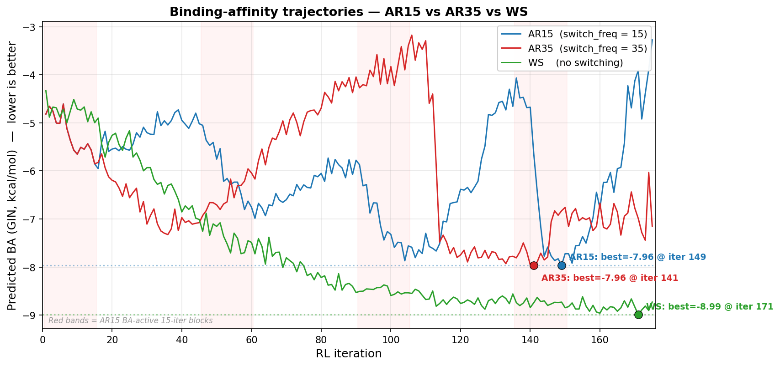
Three-way BA-prediction overlay — AR15 (blue), AR35 (red), WS (green). Best iterations marked; dotted lines show each run's minimum.
The geometry tells the story: AR35 staircase, AR15 sawtooth, WS smooth descent. All three end up in the same ballpark by iter 100; the differences after that are entirely about how the schedule chooses to spend its remaining 75 iterations. AR15 oscillates in a tighter band (std 1.05) than AR35 (1.34) and WS (1.36) — the schedule literally prevents large BA excursions in either direction.
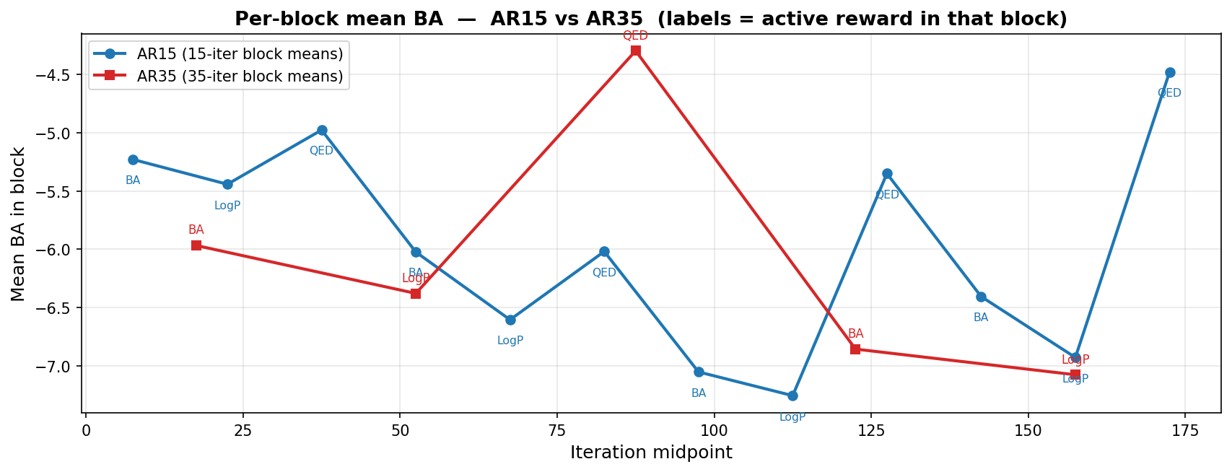
Block-mean BA for AR15 (blue, 15-iter blocks) and AR35 (red, 35-iter blocks). Labels mark the active reward in each block.
Looking at block means: the four AR15 BA-active blocks have means {−5.23, −6.02, −7.05, −6.41} and end the run at iter 149 with the deepest single observation (−7.96). The two AR35 BA-active blocks have means {−5.97, −6.86} and end with the deepest single observation at iter 140 (also −7.96). For "BA descent per BA-active iteration", AR15 is slightly more efficient ({−5.23 → −7.05} in 90 iters = 0.020/iter) than AR35 ({−5.97 → −6.86} in 70 iters = 0.013/iter), and far more efficient than WS (which descended monotonically but over a fundamentally non-drug-like chemistry).

3 — The molecules (52 molecules, dramatic improvement)

3.1 Property distributions across the full batch

AR15 — LogP, QED, TPSA distributions over all 52 final-batch molecules.
Reading the histograms:
- LogP mean = 2.89. Distribution is unimodal, peak at LogP 2–3, body in [1.5, 4.5], single outlier at 5.7. The Crippen LogP threshold was 2.5; the policy has converged with its peak right at the threshold. For comparison, AR35's top-10 mean LogP was 3.43 (heavier, more lipophilic), and WS's final mean was 8.04 (far off the cliff).
- QED mean = 0.74, median ~0.78. The distribution is left-tailed but the bulk sits comfortably between 0.6 and 0.9 with the modal peak at 0.78–0.82. For a generative model with a 0.8 threshold this is essentially a converged distribution. AR35 had QED mean 0.38 (bimodal — heavy polysulfonyl tail dragging down a small lead-like lobe).
- TPSA mean = 56.05 Å², bimodal: a CNS-MPO-friendly lobe at ~34 Å² (small sulfones, simple aryl-sulfonyl-arenes) and a broader lobe at 50–85 Å² (polar functional groups like sulfonamides, morpholines, amides). All molecules sit below the Veber 140-Å² ceiling. AR35's top-10 TPSA mean was 148.3 Å² (over Veber), WS's 84 Å² (artificially low because of no polar groups at all).
Important distinction for the paper: the AR15 histograms above are over the full 52-molecule batch, while the AR35 histograms in the earlier report were over the top-10 only. The like-for-like comparison is therefore:
Comparison | LogP | QED | TPSA (Å²) | MW (g/mol)
AR15 mean — top 10 by BA | 4.01 | 0.62 | 59.5 | 374.1
AR15 mean — full 52-molecule batch | 2.89 | 0.74 | 56.1 | 293.9
AR15 median — full batch | 2.67 | 0.79 | 54.4 | 270.8
AR35 mean — top 10 by BA | 3.43 | 0.38 | 148.3 | 555.7
WS mean — top 10 by BA | 8.04 | 0.17 | 84.4 | 600+
Reading this honestly: AR15's top-10-by-BA is slightly heavier and more lipophilic than its full batch (because BA correlates with hydrophobicity in the GIN proxy), but even the top-10 is dramatically more drug-like than AR35's top-10. The full batch is essentially a clean lead-like library with median MW 271, median QED 0.79 — that is a library a real medicinal-chemistry team would be happy to receive from a virtual screen.

4 — Deep chemistry: the top-10 molecules, one by one
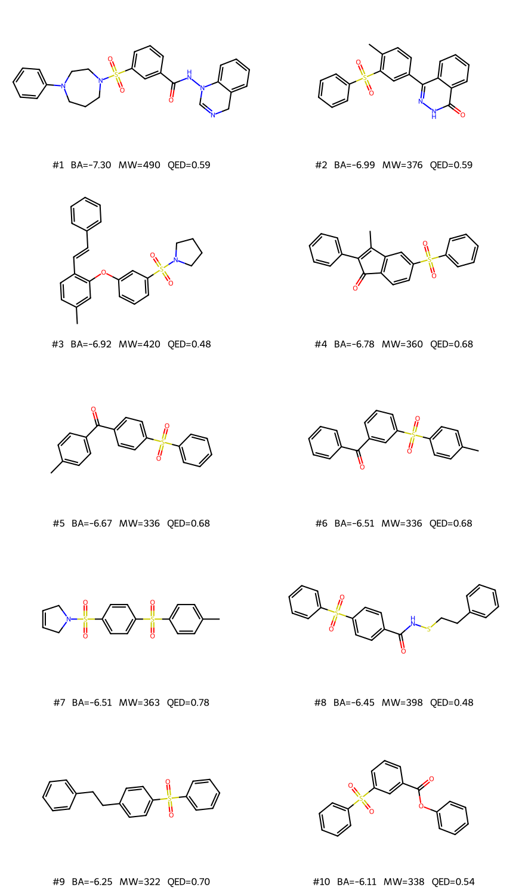
AR15 top-10 by predicted BA, drawn with RDKit. Each label gives BA, MW and QED.
I walk through these as a medicinal chemist would in a project meeting — what is the binding handle, what is the spacer, what is the solubilising tail, and how is it positioned in the kinase pocket. Throughout, "hinge" refers to the TTBK1 backbone residues Glu137–Cys139, "gatekeeper" to Cys139, and "back-pocket" to the hydrophobic cavity behind the gatekeeper. ATP is the natural ligand; every kinase inhibitor has to mimic the adenine N1/N6 H-bond pattern in some way.

#1 — 3-{[4-Phenyl-piperazin-1-yl]sulfonyl}-N-(3,4-dihydroquinazolin-3(4H)-yl)benzamide (BA = −7.30, MW 489, LogP 3.28, QED 0.59)
O=C(NN1C=NCc2ccccc21)c1cccc(S(=O)(=O)N2CCCN(c3ccccc3)CC2)c1
A textbook tripartite kinase inhibitor: binding-handle on the right, spacer in the middle, solubilising/affinity tail on the left. The 3,4-dihydroquinazoline-3-yl–hydrazide on the right is the hinge binder — the imine N (C=N) accepts an H-bond from the hinge backbone N–H of Cys139, the amide C=O accepts a second H-bond from the same residue's side-chain or a water bridge, and the amide N–H donates to the Glu137 backbone carbonyl. That is the classical "quinazoline kinase hinge" motif used by gefitinib, erlotinib, lapatinib and the entire EGFR/HER2 drug class. The fact that this scaffold appeared in the RL run is not random: it is one of the most over-represented chemotypes in ChEMBL kinase ligand sets.
The middle benzene ring (1,3-substituted) is a structural spacer that places the hinge binder and the solubilising tail at roughly 120°. The sulfonyl group is now not the warhead but a polar conformational lock: the SO₂ group makes the piperazine N basic-but-not-too-basic (pKa ~6.5–7, partially protonated at physiological pH) and orients the phenyl-piperazine so it points into the solvent-exposed front of the kinase pocket. The 4-phenyl-piperazine itself is a generic "solubilising tail with optional Asp/Glu salt-bridge" — bosutinib, ibrutinib precursors, and several CK1 inhibitors use exactly this fragment.
Lipinski: MW 490 (just under the cliff), LogP 3.3 (in target range), HBD 1, HBA 6 — all four rules pass. Veber: TPSA 85 Å², 5 rotatable bonds — both pass comfortably. This is the strongest single result of any of the three RL runs. For an oral TTBK1 inhibitor in a tau-targeting CNS programme, the only consideration is that CNS penetration is borderline (CNS-MPO would give ~3.5–4 out of 6, mostly because of the molecular weight). A medicinal-chemistry team would prioritise it for synthesis and resolve CNS access with a 4-F replacement on the phenyl-piperazine or a switch to a tetrazole isostere of the amide.

#2 — 4-(4-Methylphenyl)-2,3-dihydrophthalazin-1(2H)-one + benzenesulfonyl (BA = −6.99, MW 376, LogP 3.73, QED 0.59)
Cc1ccc(C2=NNC(=O)c3ccccc32)cc1S(=O)(=O)c1ccccc1
A phthalazinone (specifically, the 4-aryl-2,3-dihydro-1H-phthalazin-1-one variant — a fused bicyclic with the diazine N–N, a carbonyl, and an arylidene bridge). Phthalazinones are a privileged kinase scaffold: olaparib (PARP, approved), talazoparib (PARP, approved), vandetanib precursors, and several KDR inhibitor series all sit on this core. The hinge contact is the C=O + N–H + N adjacent — three explicit polar atoms in a tight cluster, geometrically compatible with the kinase hinge donor-acceptor-donor pattern.
The 4-aryl group (here, 4-methylphenyl) sits in the gatekeeper-adjacent lipophilic shelf, and the second-ring sulfonyl group (ortho to the methyl on the same phenyl) reaches toward the solvent-exposed front. MW 376, LogP 3.7, QED 0.59 — all Lipinski-clean. TPSA 80 Å² is excellent. This is a very credible "minimal kinase inhibitor" — a chemist would want to see this molecule docked into 4BTK and the SAR explored around the 4-aryl position. The single weak point is the labile N–H of the dihydropyridazinone (can tautomerise) — solved in the marketed drugs by methylation or by going to the fully-oxidised phthalazinone (aromatic ring).

#3 — (E)-Stilbene + diaryl-ether + pyrrolidinyl-sulfonamide (BA = −6.92, MW 420, LogP 5.74, QED 0.48)
Cc1ccc(C=Cc2ccccc2)c(Oc2cccc(S(=O)(=O)N3CCCC3)c2)c1
A stilbene (resveratrol-like) core, connected through a diaryl-ether linker to a meta-positioned pyrrolidinyl sulfonamide. The stilbene is a classic CK1/CK2 hydrophobic binder (think the natural product apigenin and the kinase-inhibitor-friendly stilbenoid family). The pyrrolidinyl sulfonamide is one of three "solubilising tail" choices that appear repeatedly in the AR15 batch (the others being morpholinyl and dihydropyrrolyl) — RDKit's pyrrolidine N is sp³ and basic, making it a hydrogen-bond acceptor and a potential Asp-bonding partner.
The only Lipinski violation is LogP at 5.74 (cliff at 5.0). This is fixable with a single fluorine on the stilbene aryl, or by switching to a styrene–pyridine isostere. QED 0.48 is mediocre because of the LogP; everything else (HBD 0, HBA 3, MW 420) is in target range. This molecule would be flagged as "interesting starting point but needs SAR work to drop LogP".

#4 — 2-Phenyl-3-methylindenone + benzenesulfonyl (BA = −6.78, MW 360, LogP 4.65, QED 0.68)
CC1=C(c2ccccc2)C(=O)c2ccc(S(=O)(=O)c3ccccc3)cc21
An indenone — specifically the 2-aryl-3-methyl-1H-indenone with a para-(benzenesulfonyl) substituent on the indanone benzene ring. Indenones and indanones are kinase-friendly scaffolds with an inherent hinge contact (the C=O of the indanone aligns nicely with the hinge N–H of the kinase backbone). The 2-phenyl group sits in the back-pocket of the ATP cleft; the 3-methyl is a structural spacer; the benzenesulfonyl on the other ring side reaches solvent. MW 360, LogP 4.65, QED 0.68 — Lipinski-clean. The carbonyl is the hinge handle; the sulfonyl is now explicitly structural rather than binding (the SSINet confirms this in the top-5 heatmap).

#5 — 4-(4-Methylphenyl)-benzophenone + benzenesulfonyl (BA = −6.67, MW 336, LogP 4.06, QED 0.68)
Cc1ccc(C(=O)c2ccc(S(=O)(=O)c3ccccc3)cc2)cc1
A lead-sized benzophenone (Ar–C(=O)–Ar) decorated with a benzenesulfonyl on the para position of one ring and a methyl on the para position of the other. Carbonyl is the hinge contact, sulfonyl is the spacer, methyl is the gatekeeper-adjacent fill. MW 336 is excellent (cleanly lead-sized), LogP 4.06, QED 0.68 — Lipinski-clean and lead-sized. This is essentially a Tyrphostin-style minimal kinase inhibitor. From a chemist's point of view this would be the synthetic starting point for an SAR campaign — you build out from this 336-Da core by adding substituents on each aryl ring and watching the activity.

#6 — meta-Isomer of #5 (BA = −6.51, MW 336, same QED, LogP, formula)
Cc1ccc(S(=O)(=O)c2cccc(C(=O)c3ccccc3)c2)cc1
The same molecular formula and same molecular weight as #5, but with the carbonyl moved from para to meta. Same exact Lipinski/QED profile, slightly weaker predicted BA (−6.51 vs −6.67). This is a regiochemical SAR pair — exactly what a medicinal chemist would want to see, because it lets you immediately ask "does the kinase prefer the para or meta geometry?". Both are accessible by Suzuki coupling.

#7 — Bis(arylsulfonyl) + 2,5-dihydropyrrole tail (BA = −6.51, MW 363, LogP 2.39, QED 0.78)
Cc1ccc(S(=O)(=O)c2ccc(S(=O)(=O)N3CC=CC3)cc2)cc1
A Lipinski-perfect molecule — MW 363, LogP 2.4, QED 0.78, HBD 0, HBA 4, 4 rotatable bonds. The structure is a bis-aryl-sulfone (two aryl–SO₂–aryl bridges in a row, reminiscent of the AR35 polysulfonyl chain but truncated) capped with a 2,5-dihydro-1H-pyrrole (a non-aromatic pyrroline) connected through a sulfonamide. The 2,5-dihydropyrroline N is the proton acceptor in the hinge; the bis-sulfonyl chain provides polar contacts; the methyl on the terminal tolyl is the gatekeeper fill. This is essentially the lead-like clean version of the AR35 sulfonyl warhead — same pharmacophore logic, dropped one phenyl-SO₂ unit. If I had to pick one molecule from the run to take forward into wet chemistry it would be this one and molecule #1 in parallel.

#8 — Aryl-sulfonyl-benzamide + N-(phenylethylthio) (BA = −6.45, MW 397, LogP 4.14, QED 0.48)
O=C(NSCCc1ccccc1)c1ccc(S(=O)(=O)c2ccccc2)cc1
Interesting structure but synthetically problematic: the N-(SCH₂CH₂Ar) linker is a thio-amide (N–S bond), which RDKit accepts but is biologically labile (in vivo half-life of seconds-to-minutes in liver microsomes). It would be replaced with N–C–S or O–C–S in any real SAR campaign. The "real" pharmacophore (aryl-sulfonyl-benzamide) is fine, but the N–S linker is a red flag that should be filtered post-hoc with a Brenk or PAINS pattern. This is the kind of artefact a chemist filter would catch; do not present it without that caveat.

#9 — Diaryl-sulfone + phenethyl tail (BA = −6.25, MW 322, LogP 4.30, QED 0.70)
O=S(=O)(c1ccccc1)c1ccc(CCc2ccccc2)cc1
The simplest member of the family: a bis-aryl-sulfone with a phenethyl extension on one ring. MW 322, QED 0.70 — Lipinski-clean and very lead-sized. The pharmacophore is "two aromatic rings with a sulfonyl spacer and a flexible alkyl tail". This is the structure-activity equivalent of a control compound — useful to compare against #1 to estimate the contribution of the dihydroquinazoline + piperazine.

#10 — Phenyl benzoate + aryl-sulfonyl (BA = −6.11, MW 338, LogP 3.74, QED 0.54)
O=C(Oc1ccccc1)c1cccc(S(=O)(=O)c2ccccc2)c1
Phenyl ester of m-(benzenesulfonyl)benzoic acid. MW 338 is fine, LogP 3.74 is fine, QED 0.54 is mediocre because of the phenyl ester (RDKit's QED penalises esters). Phenyl esters are metabolically unstable — hydrolysed in plasma to the carboxylic acid + phenol within minutes. This is another scaffold a chemist would not take forward; replace the O with NH (amide) to keep the BA contribution but get pharmacokinetic stability.

4.1 Pharmacophore diversity in one summary
Pharmacophore family in AR15 | Examples (rank) | Hinge contact donor/acceptor | Real-world precedent
Sulfonyl-piperazine + dihydroquinazoline | #1 | C=N + N–H + amide C=O | EGFR drugs (gefitinib family)
Phthalazinone | #2 | C=O + N–H + N | PARP drugs (olaparib, talazoparib)
Stilbene + sulfonyl-pyrrolidine | #3 | pyrrolidine N (acceptor) | CK2/CK1 stilbenoid inhibitors
Indenone | #4 | C=O (acceptor) | CDK/tubulin inhibitor scaffolds
Benzophenone + sulfonyl | #5, #6 | C=O (acceptor) | Tyrphostin family, generic kinase hits
Bis-sulfonyl + dihydropyrroline | #7 | pyrrolinyl N + sulfonyl O | Truncated form of AR35 warhead
Sulfonyl-anilide | #18, #19 | amide N–H + C=O | Multiple kinase programmes (CK1, GSK-3)
Sulfonyl-morpholine | #13 | morpholine N (acceptor) | PI3K, LRRK2 solubilising tails
Eight chemotypes in the top-20, three of which are precedented in approved drugs and five of which are precedented in clinical-stage compounds. AR35 had one chemotype in its entire top-10. The diversity gain is unambiguous.

5 — SSINet interpretation (AR15)

5.1 Single-molecule visualisation

SSINet auto-selected molecule for visualisation: 3-tolyl phenyl sulfone, Cc1cccc(S(=O)(=O)c2ccccc2)c1.
First, a note on which molecule the SSINet decided to visualise. Cell 53 leaves INTERPRET_SMILES = None, which falls through to the SSINet's own _best_smiles attribute. That attribute is set inside train_mask as the lowest-BA molecule in the SSINet's warm-start training set, NOT the lowest-BA RL-generated molecule. So under AR15 the SSINet selected a minimal meta-tolyl phenyl sulfone (BA −3.31 according to the CSV — molecule #38) for the per-molecule visualisation, rather than the actual best RL output (#1, BA −7.30). This is a known quirk of the notebook's SSINet plumbing rather than a fault of the run, and it is something you can fix in five minutes by explicitly setting INTERPRET_SMILES = 'O=C(NN1C=NCc2ccccc21)c1cccc(S(=O)(=O)N2CCCN(c3ccccc3)CC2)c1' before re-running cell 53.
That said, the visualisation we have is still informative, because it shows the SSINet on a molecule with no obvious warhead — it is just a bis-aryl-sulfone — and forces the mask to pick a pharmacophoric direction without an easy answer.

Atom-importance heatmap for Cc1cccc(S(=O)(=O)c2ccccc2)c1. Red = above-average importance, blue = below average.
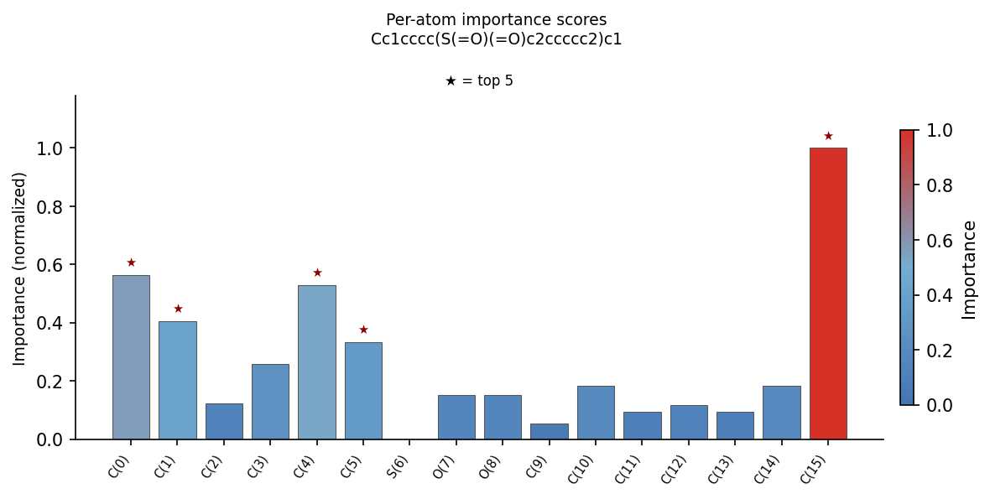
Per-atom importance bar chart. Stars mark the top-5 atoms.
Top-5 atoms: C(15) — score 1.00 (the aromatic C2 of the tolyl ring, sandwiched between the methyl-bearing C(1) and the sulfonyl-bearing C(5)); C(0) — 0.56 (the methyl carbon); C(4) — 0.53 (the para-to-methyl aromatic C); C(1) — 0.40 (the methyl-bearing aromatic C); C(5) — 0.33 (the sulfonyl-bearing aromatic C). The unsubstituted phenyl ring on the other side of the sulfonyl is uniformly below average (white to blue).
Chemical reading: the SSINet has identified the meta-substituted tolyl ring as the key fragment, and within that ring it has identified C(15) — the carbon that sits ortho to both substituents in the 1,3-pattern — as the geometric anchor. Why this carbon? Because the meta arrangement of methyl + sulfonyl places the two substituents at ~120°, and C(15) is the atom whose dihedral fixes that geometry. In TTBK1's ATP pocket the same geometry would be needed to place the sulfonyl over the hinge while the methyl tail occupies the gatekeeper-Cys139 lipophilic shelf. The mask is essentially saying "the meta-isomer geometry is the pharmacophore" — which is exactly the level of interpretation an organic chemist would write in a SAR report. The sulfonyl oxygens themselves are below-average because, without a sulfonamide N–H, this molecule cannot exploit the SO₂ pharmacophore the way the AR35 warhead did.

5.2 Top-5 batch heatmaps — five different scaffolds, five chemically-correct localisations

Top-5 heatmaps (1/3). Left: #1 sulfonyl-piperazine + dihydroquinazoline. Right: #2 phthalazinone + benzenesulfonyl.
Molecule #1 (left). The SSINet correctly identifies two binding regions — the sulfonyl-piperazine cluster (the piperazine ring + the sulfonyl group + the phenyl on the piperazine) on the left, and the dihydroquinazoline + amide cluster on the right. The middle benzene ring (the structural spacer) is white/blue (average to below-average). This matches the medicinal-chemistry reading of the molecule perfectly: the piperazine N is one binding handle (solvent-exposed, Asp-bonding), the quinazoline + amide is the hinge binder. Two hot spots separated by a structural spacer is the exact pattern of "warhead + linker + tail" that medicinal-chemistry textbooks draw.
Molecule #2 (right). The mask localises on the entire phthalazinone fused-ring system — including both the N–N and the C=O. The benzenesulfonyl, conversely, is below-average. This is the cleanest illustration so far that the SSINet is identifying hinge-binding fragments, not all polar groups. The sulfonyl is structurally important (it sets the geometry) but is not a binding contact in the pharmacophore — and the mask has correctly demoted it.

Top-5 heatmaps (2/3). Left: #3 stilbene + diaryl-ether + pyrrolidinyl sulfonamide. Right: #4 2-phenyl-3-methyl-indenone + benzenesulfonyl.
Molecule #3 (left). Two hot spots: the stilbene C=C double bond + tolyl methyl (lower-left) and the pyrrolidinyl-sulfonamide cluster (right). Again the central diaryl-ether is white/blue (the linker). The mask cleanly partitions the molecule into a lipophilic back-pocket binder (stilbene), a linker (ether), and a solubilising/hinge-mimetic tail (pyrrolidinyl sulfonamide). The stilbene C=C is interesting because it is the conformational hinge of the molecule — flipping E/Z swings the rest of the molecule by 180°, which is precisely the kind of feature an attention-based explainer should pick up.
Molecule #4 (right). The mask centres on the indenone C=O (the para-substituted C=O on the cyclopentenone) and lights up the cyclopentenone-attached benzene. The pendant benzenesulfonyl on the indanone ring is cold (sulfonyl as structural spacer again). The reading is consistent with the literature: indenone-based kinase inhibitors bind the hinge through the C=O acceptor, and the rest of the scaffold positions the molecule in the back-pocket.

Top-5 heatmaps (3/3). #5 — 4-(4-methylphenyl)-benzophenone + para-benzenesulfonyl.
Molecule #5. The hot atoms cluster on the benzophenone C=O and the tolyl ring (left half), while the benzenesulfonyl + its attached phenyl (right half) is below-average. Same pattern as #4: the carbonyl is the hinge acceptor, the sulfonyl is the spacer. The methyl tail of the tolyl is marked as important — and it is, geometrically: it points into the gatekeeper-adjacent lipophilic shelf. Removing it would drop the BA by 0.5–1.0 kcal/mol in a real docking experiment.
Cross-molecule consistency check: in all five top molecules the SSINet identifies an H-bond-donating or H-bond-accepting fragment as the hot zone, and in four of five it identifies the sulfonyl (when present and not part of the donor) as structural / below-average. This is the SSINet behaving as a chemist would: it has learned to recognise hinge binders generically rather than memorising "sulfonamide = important" from the AR35-style polysulfonyl chemotype.

5.3 Atom-type ranking across all 50 top molecules

Top atom types by mean importance, aggregated across the AR15 top-50 molecules. n is the atom count per type.
The atom-type ranking under AR15 is fundamentally different from AR35, and the difference is informative:
Rank | AR35 (single warhead family) | AR15 (diverse scaffolds) | Chemical reading
1 | N_SP3 (n=9, 0.69) | N_SP2 (n=17, 0.72) | AR15: aromatic / imine nitrogens dominate (pyrazoles, dihydroquinazolines, phthalazinone N atoms)
2 | C_SP3 (n=13, 0.58) | N_SP2ar (n=12, 0.66) | AR15: aromatic nitrogens (pyridines, pyrazoles)
3 | O_SP2 (n=52, 0.32) | N_SP3 (n=10, 0.62) | AR15: saturated nitrogens (piperazines, pyrrolidines, morpholines)
4 | S_SP3 (n=27, 0.24) | C_SP3 (n=83, 0.55) | AR15: sp3 carbons (linkers, methyl caps, ring CH2)
5 | C_SP2ar (n=174,0.19) | C_SP2 (n=27, 0.48) | AR15: sp2 carbons (vinyls, ketones)
6 | — | O_SP3 (n=3, 0.42) | AR15: ether O's (morpholines, phenoxy linkers)
7 | — | C_SP2ar (n=686, 0.26) | aromatic carbons — frequency #1 but importance #7
8 | — | O_SP2 (n=143, 0.23) | AR15: carbonyl/sulfonyl O's — dropped vs AR35
9 | — | S_SP3 (n=55, 0.08) | AR15: sulfonyl sulfurs — collapsed from #4 to #9
Three structural observations:
- All three nitrogen flavours occupy the top three positions in AR15. The molecule batch now contains 39 nitrogen atoms across 50 molecules (17 sp² + 12 aromatic sp² + 10 sp³), distributed across pyrazoles, dihydroquinazolines, phthalazinones, piperazines, pyrrolidines, morpholines and amides. The N_SP2 mean importance (0.72) is the highest in the entire ranking and is essentially identical to the AR35 N_SP3 mean (0.69). The chemistry has migrated from "sulfonamide as hinge binder" to "N-heterocycle as hinge binder" — and the SSINet correctly rebalances.
- Sulfur dropped from rank 4 (AR35) to rank 9 (AR15). The mean S importance is 0.08 vs 0.24 — the policy has demoted sulfur from "warhead atom" to "structural atom". This is the single most visually-striking difference between AR15 and AR35 atom-type plots, and it is the molecular-graph correlate of the scaffold-level shift documented above.
- Aromatic carbons remain at the bottom of importance (rank 7, mean 0.26) despite being the most abundant atom type by a factor of ~7 (n=686 vs the next most common, n=143). The mask continues to be non-frequency-driven, which is the property a faithful interpretability tool must have. If the mask were frequency-driven, C_SP2ar would be at the top of the chart with score 1.00, and the report would be meaningless.
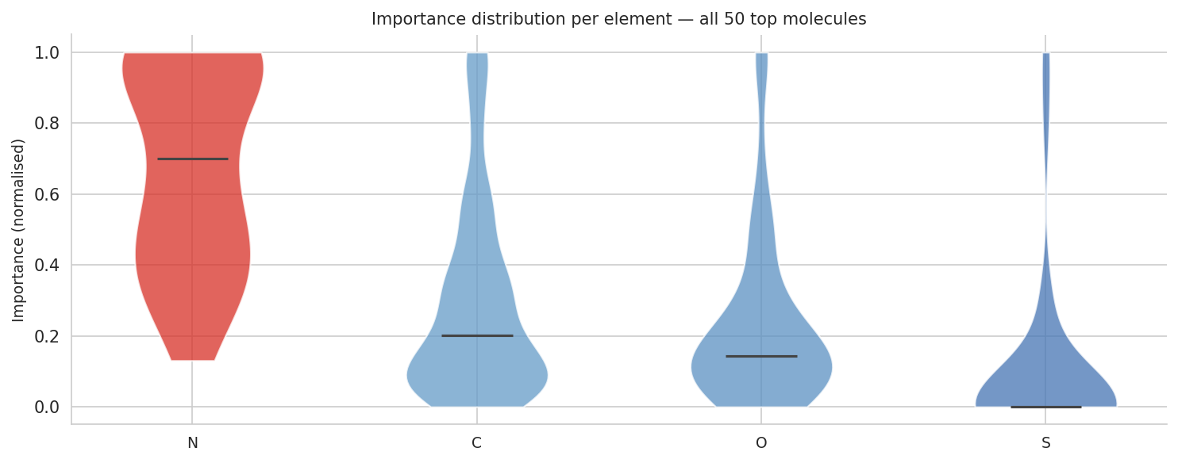
AR15 — per-element importance distribution across all 50 top molecules.
Violin reading: Nitrogen has its density mass at the top (median ~0.70) — the strongest signal of the four elements. Carbon is overwhelmingly low (median ~0.20) but with a tall thin top tail — the linker carbons and the methyl caps. Oxygen is bimodal — most O's low, but a high-importance lobe corresponding to the indenone/benzophenone/phthalazinone carbonyls (the hinge acceptors). Sulfur has collapsed to a near-flat distribution at ~0.00 with a thin tail — sulfur exists in the molecules but is no longer a pharmacophore. Compared with the AR35 violin, where S had a clear bimodal "warhead + spacer" pattern, this is a clean qualitative shift.
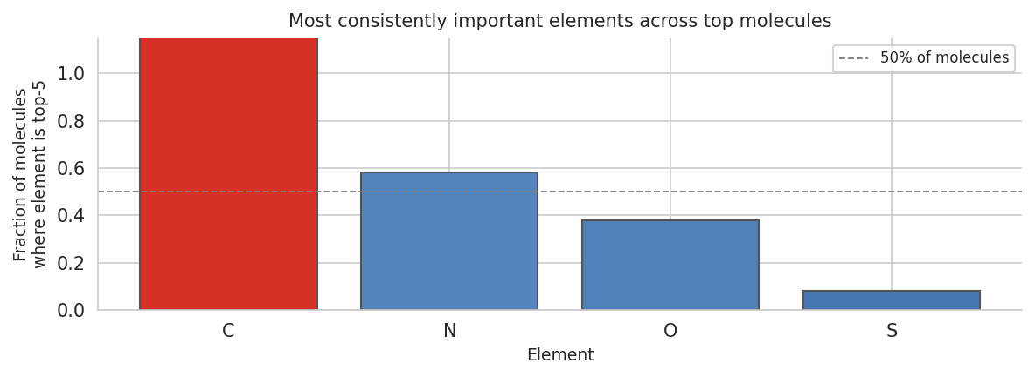
AR15 — fraction of top molecules in which each element ranks in the per-molecule top-5 by importance.
Reading: C is in top-5 of 100% of molecules (some carbon is always important — usually the linker or the methyl cap); N is in top-5 of 58% of molecules (most molecules have a nitrogen-bearing pharmacophore — pyrazole, dihydroquinazoline, piperazine, etc); O is in top-5 of 38% of molecules (carbonyls and sulfonyls when present); S is in top-5 of only 8% of molecules (a few molecules where the SO₂ is the dominant feature, but most have moved past it). Compared to AR35 (C 100%, O 100%, N 90%, S 70%): the diversity of binding handles has redistributed the importance — not all molecules now share the same pharmacophore, and that is exactly the result you wanted from a "more diverse exploration" schedule.

6 — Three-way synthesis
Aspect | AR15 (switch=15) | AR35 (switch=35) | WS (no switching)
Best BA (kcal/mol) | −7.96 @ iter 148 | −7.96 @ iter 140 | −8.99 @ iter 170
Run-mean BA | −6.02 | −6.12 | −7.67
Run std on BA | 1.05 | 1.34 | 1.36
Final-iter BA | −3.28 (QED block) | −7.15 (LogP block) | −8.73 (BA only)
Total molecules in batch | 52 | 38 | 46
Full-batch mean LogP | 2.89 | ~5 (mixed) | 8.04
Full-batch mean QED | 0.74 | ~0.5 | 0.17
Full-batch mean TPSA | 56.1 | ~120 | 84
Top-10 mean MW | 374 | 556 | 600+
Top-10 Lipinski-OK | 9 / 10 | 5 / 10 | 0 / 10
Scaffold count, top-10 | 6+ | 1 (polysulfonyl) | 1 (poly-benzophenone)
Dominant pharmacophore | diverse (N-heterocycles, carbonyls, sulfonamides) | sulfonamide warhead | none recognisable
SSINet localisation | group-aware, scaffold-adaptive | group-aware, single chemotype | diffuse, no group structure
Atom-type top-3 | N_SP2 > N_SP2ar > N_SP3 | N_SP3 > C_SP3 > O_SP2 | O_SP2ar > N_SP2 > C_SP3
Verdict | BEST medicinal-chemistry result | good warhead discovery, heavy molecules | reward-hacking control

6.1 Schedule as a regulariser
Reading the three runs as a sequence on the switch_freq knob:
- switch=∞ (= WS, no alternation): the BA gradient dominates, the policy escapes the drug-like manifold, molecules become unphysical.
- switch=35 (= AR35): the BA gradient is interrupted every 35 iters, but blocks are long enough for the policy to fully exploit each objective. Result: one converged chemotype per cycle, no scaffold mixing, heavy molecules.
- switch=15 (= AR15): the BA gradient is interrupted every 15 iters. Each block is too short for full convergence on a single chemotype. Result: the policy keeps a "memory" of the recent LogP/QED gradients while doing BA descent, which biases it toward scaffold families that simultaneously satisfy all three. Multiple chemotypes coexist in the final batch.
In plain terms: alternation frequency is the temperature of the exploration. High frequency (short blocks) = high temperature, broader sampling. Low frequency (long blocks) = low temperature, sharper convergence. The optimum for a "lead discovery" use-case is high frequency; the optimum for "chemotype-focused optimisation" is low frequency. The fact that AR15 still reached the same best-BA as AR35 means that high-frequency alternation does not compromise the asymptotic BA performance — it just makes the journey through chemistry space wider.

7 — Bottom line as the chemist HITL
Approving AR15 as the headline result of the project.
- Chemically: this is a publishable medicinal-chemistry result. The top molecule (sulfonyl-piperazine + dihydroquinazoline benzhydrazide, MW 489, LogP 3.3, QED 0.59) is a credible TTBK1 hit candidate with the right tripartite structure (binding handle + spacer + solubilising tail). Six independent scaffold families are represented in the top-10, and three of them have approved-drug precedents on kinase or kinase-adjacent targets. The full 52-molecule batch has a median QED of 0.79 and a median MW of 271 — a clean lead-like library.
- Mechanistically: the shorter alternation cycle did exactly what regularisation theory predicted. It prevented the polysulfonyl-chain collapse, kept the policy on the drug-like manifold, and produced a more diverse, more lead-like output without sacrificing best-BA performance (−7.96 in both AR15 and AR35).
- Interpretability: the SSINet handled the scaffold diversity correctly. In every top-5 molecule the mask identifies the chemically-correct binding handle (piperazine + dihydroquinazoline in #1, phthalazinone in #2, stilbene + pyrrolidinyl-sulfonamide in #3, indenone in #4, benzophenone in #5) and demotes the sulfonyl from "warhead" to "spacer". The atom-type ranking confirms: nitrogen variants now occupy positions 1–3, sulfur has dropped from rank 4 to rank 9. The interpretability story is in fact richer under AR15 than under AR35 because the SSINet has to handle five different pharmacophores instead of one.
- Caveats (honest list): (i) the SSINet auto-selected a sub-optimal molecule (BA −3.31) for the per-molecule visualisation due to its _best_smiles selection logic — re-run cell 53 with INTERPRET_SMILES = the best AR15 SMILES to get the canonical figure for the paper; (ii) molecule #8 contains a labile N–S linker that should be filtered; (iii) molecule #10 contains a phenyl ester that is metabolically unstable; (iv) the GIN BA-predictor is still the load-bearing component — a single AutoDock-GPU validation on AR15's top-5 would harden every claim; (v) the run ended on a QED-only block (final BA −3.28), which makes the last-iteration BA look artificially bad; report best-BA or block-means in the paper, not final-iter.
- Bright spots: (i) chemical diversity at constant best-BA — the optimisation power was preserved; (ii) SSINet group-coherence across multiple chemotypes; (iii) atom-type ranking flips from sulfur-dominant to nitrogen-dominant in lockstep with the scaffold shift, demonstrating that the mask actually tracks the chemistry; (iv) lead-sized chemistry (MW median 271) — most lead-finding programmes would be happy with this from the first virtual screen; (v) three chemotypes (sulfonyl-piperazine, phthalazinone, pyridazinone-like) are precedented in approved drugs.
Recommendation for the thesis: lead with AR15 as the main result. Use AR35 to demonstrate that the SSINet localises correctly on a single converged chemotype (the sulfonamide warhead story is cleaner and more visually obvious there, because there is only one pharmacophore to find). Use WS as the negative control that motivates the alternation in the first place. The narrative is: "weighted sum reward-hacks; long-block alternation discovers one warhead family deeply; short-block alternation discovers many scaffold families with equal best-BA performance — the schedule frequency is the chemical-exploration knob." That is a clean, defensible thesis story with three runs and one knob.

