Please propose and design a system and its components to deploy this model in production. With schematic representation and written description.

To deploy the model in production I will divide the work into different components as follows;

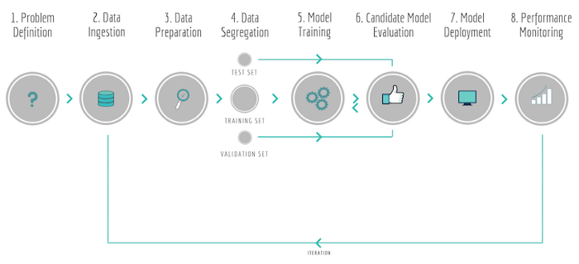

credit https://towardsdatascience.com/not-yet-another-article-on-machine-learning-e67f8812ba86

How many components will there be or how complex the system will be depends on the size of the actual dataset, how often you want the model to be retrained, and probably many other factors. Normally a reliable and scalable ML system should have separate components as above.

What I would do to my model would be dividing them in smaller components and build pipelines between them. The components are;

1. **Data Ingestion** split database component from app.py, build pipeline between source and service

2. **Data preparation** separate preprocessing of data, feature engineering, encoding, etc. and train_test_split stage out of app.py

3. **Model Training** if the data is really huge, I would send the model training process to some cloud service where more computing power is available, and then save the trained model in a separate database as artifact

4. **Optimization** my model as it is right now it is performing alright, but if I have more time I could optimize it for better prediction. The first thing I will try to improve is to reduce the slope of the predicted line.

5. do more thorough evaluation and optimization to select the candidate model

6. **Inference**, I just take the saved artifact to use with user input data, not retraining everytime

7. **Performance monitoring** service should be added