AeroSense User Manual
Revision: 2026-10-20 R8. This manual covers connection, acquisition, data export and the expanded cell-free sodium-fluorescein workflow. Use a reader that passed developer checks. Cell experiments remain a separate procedure with the existing GCaMP6f-expressing HEK293 cells and Gibco DMEM.
The procedures use ASD-STE100 Issue 9 writing principles. They use short sentences, stable terms, and one instruction per step. Full vocabulary and rule compliance has not been audited. This document does not claim formal ASD-STE100 compliance. Writing reference.
Use the Developer Manual for assembly and programming. The sample guide gives detailed preparation and supporting sources. The USD BOM and feedback form are separate.

1 Prepare the reader
Preparation: Obtain a checked reader, its Wi-Fi password, and its API key. Obtain the verified duty, working fill, filter configuration, and measured LED directions.
Term | Meaning
Working fill | 100 µL per well; confirm closure without leakage
Block | One two-second acquisition
Illuminated blank | Nonfluorescent, cell-free sample with LEDs on
Phase reference | Stable fluorescence standard used to establish signal phase
F0 | Unstimulated living-cell baseline after optical correction
Condition ID | Common assembly and acquisition configuration
Sample label | The recorded content, such as water blank, 1 µM sodium fluorescein or a mixed-layout fill ID

The four liquids share one gas space and one PD. Displayed channels correspond to LED frequencies. They are not automatically separated into independent well signals. The reader has no validated odor classifier. It does not control temperature, CO2, humidity, or gas flow.
Steps:
1. Inspect the reader for moisture.
2. Check tubes for pinching.
3. Check visible wires for looseness.
4. Confirm that the working fill passed closure and leakage tests.
5. Confirm the installed filter configuration.
Check: Start filter trials with one LEE 101 layer. Use 100 µL per well. The team reports a full-well capacity of approximately 120 µL. Confirm closure without leakage. Keep the fill equal across wells and controls. The airflow model uses the 100 µL working fill.
Failure action: If the reader leaks or has loose wiring, do not power it. Return it to the developer. If BOARD_VALIDATED is locked, perform dark tests only.

2 Connect the phone
Preparation: Keep the assembled reader dry. Locate J2 USB-C and physical SW1. Use a USB wall charger labelled 5 V output. Direct phone control does not require internet access.
Power connection: wall outlet → 5 V USB charger → USB cable → J2.
J2 supplies PCB power. A USB–TTL adapter at J3 supplies programming signals only; its VCC remains disconnected. You do not need that adapter for normal phone use.
Before first use, the developer must complete both firmware and LittleFS uploads. Restart the ESP32 after both succeed. The ESP32 creates its own Wi-Fi hotspot, named AeroSense by default.
Use the value of AP_PASSWORD for AeroSense. WIFI_PASSWORD lets the reader join an existing router; it can remain empty in direct mode. Use API_KEY after opening the control page. If AP_PASSWORD changes, the developer must rebuild and upload the firmware.
Steps:
1. Set SW1 to OFF.
2. Connect J2 by USB cable to a charger labelled 5 V output in a wall outlet.
3. Set SW1 to ON.
4. On the phone, select Settings > Wi-Fi > AeroSense.
5. Enter the value of AP_PASSWORD supplied by the developer.
6. If the phone reports no internet, keep the connection.
7. Open http://192.168.4.1/ in the browser.
8. Enter the supplied API key.
9. Press Connect.
10. Confirm DEVICE at the top.
11. Locate Pause test and End schedule in Advanced settings.
12. Keep the page open and the phone awake for automatic calibration capture.
13. The device executes ordinary interval schedules. Phone disconnection does not cancel them. Restart or power loss does.
With a suitable charged battery at J1 and SW1 ON, J2 is optional. The schematic supports J2 power without a battery. Physical operation on this board still requires confirmation.
Check: The Wi-Fi password and API key have different purposes. DEMO DATA means synthetic practice data. Installing a real sample does not change DEMO into a measurement.
If network control fails, the phone cannot confirm a stop. Turn SW1 off. If U2 is hot, also unplug J2 and USB-to-TTL and disconnect the J1 battery.
For practice, ask the developer to start Demo. Open http://127.0.0.1:8765/ on that computer. README.md is the document index. It is not the control interface.

3 Use the interface and check the PD
These screenshots illustrate the interface controls. Labels or layout can differ with the installed software revision. Red numbers match the instructions below. DEMO is for practice; confirm DEVICE before acquiring experimental data.

3 1 Connect the device
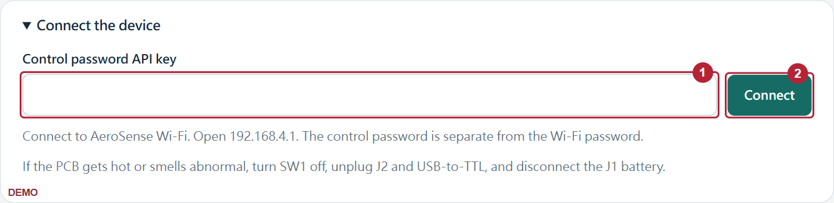
1 | Control password Enter API_KEY. It is not the Wi-Fi AP_PASSWORD.
2 | Connect Press Connect. Require DEVICE at the top. DEMO is for practice only.

3 2 Use the main controls
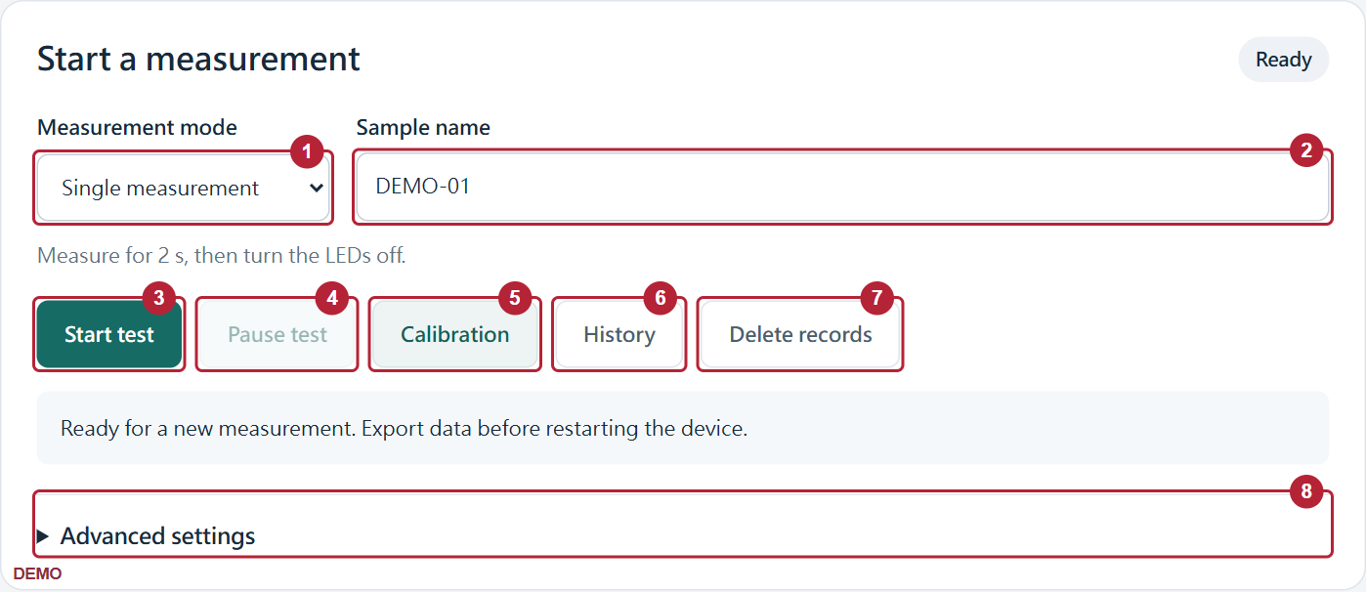
1 | Measurement mode Select a single measurement or an interval schedule.
2 | Sample name Enter a name before starting, such as DARK_A1 or sample-01.
3 | Start test Start one measurement or a finite schedule.
4 | Pause test Turn the LEDs off and retain the remaining count. Press Resume test to continue.
5 | Calibration Open the calibration tools. Prepare physical blanks and reference samples first.
6 | History Open the received measurement summaries.
7 | Delete records Export first. End the schedule before deletion. Saved calibration references remain.
8 | Advanced settings Open LED selection, on-time, notes and End schedule.

3 3 Set an interval schedule
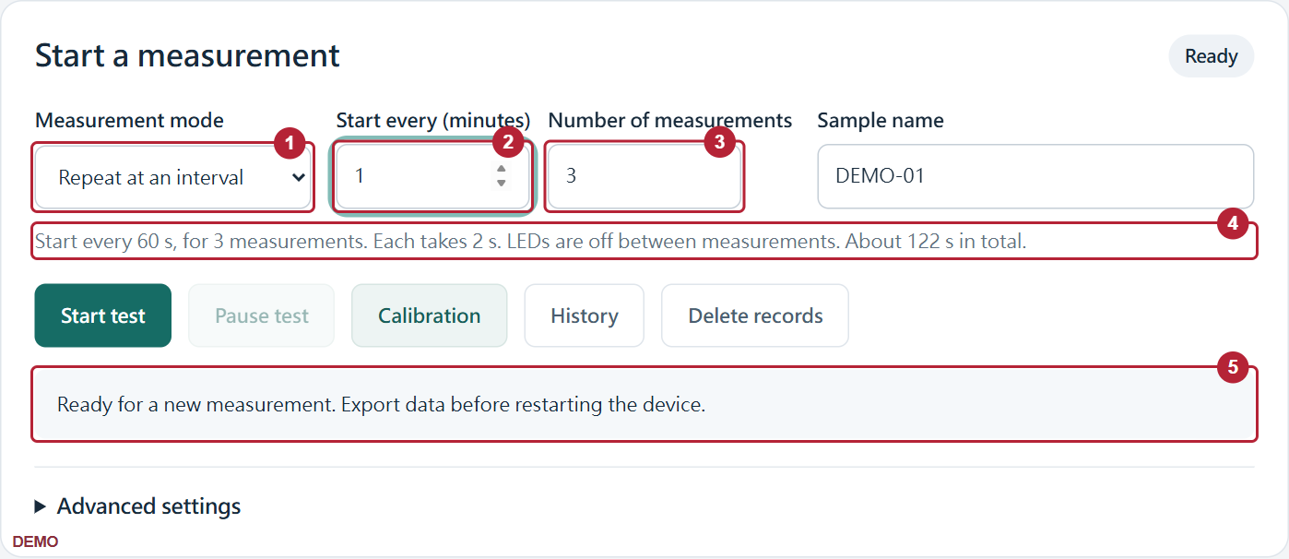
1 | Measurement mode Select Repeat at an interval.
2 | Start every Enter 1 for a 60 s start-to-start period. It is not a 60 s delay after completion.
3 | Number of measurements Enter 3 for three measurements. The schedule stops automatically.
4 | Schedule description For 1 minute and 3 measurements, target starts are at 0, 60 and 120 s. Each measurement lasts 2 s.
5 | Progress Read the completed count and countdown. Resume waits 3 s and repeats an unfinished measurement.
The ESP32 uses its uptime clock. No added RTC is needed. This is not a wall-clock schedule. Data transfer or processing can delay a start. The reader does not issue rapid catch-up measurements. A sampling fault stops the schedule.

3 4 Use advanced settings
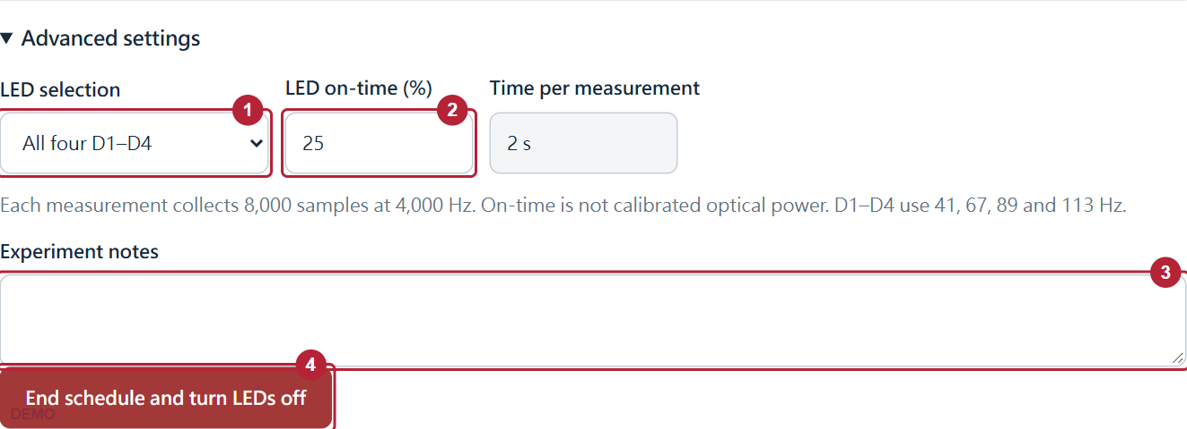
1 | LED selection All four LEDs is the routine default. Select All off for the covered-PD check. Select one LED for its initial check.
2 | LED on-time Default: 25%. Use 5% for the approved first single-LED check. This is not calibrated optical power.
3 | Experiment notes Enter filter, fill, sample and stimulus information.
4 | End schedule Cancel the remaining schedule and turn LEDs off. Use before sample exchange or history deletion.

3 5 Read the chart and analysis
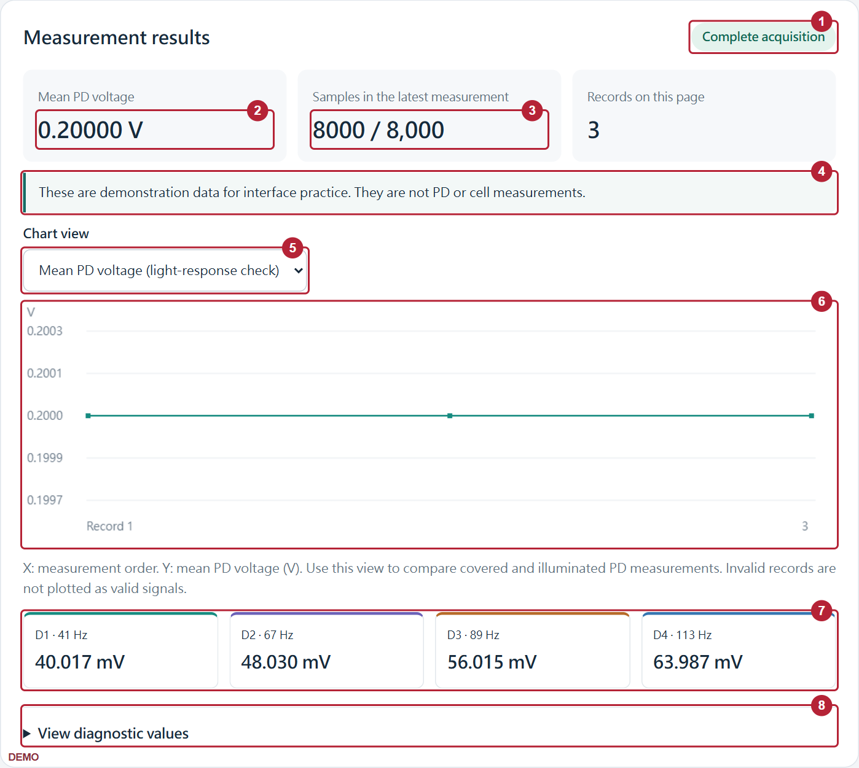
1 | Acquisition status Complete acquisition means that implemented sample-count, timing and clipping checks passed.
2 | Mean PD voltage Calculated from ADC codes and the nominal 2.5 V reference. Use it for light-response comparisons, not concentration.
3 | Sample count A normal block has 8000 samples. One sample is insufficient. Invalid numerical results are shown as dashes.
4 | Analysis Read the supported interpretation and next step. DEMO data are clearly identified.
5 | Chart view Use mean voltage for PD checks. Use LED-frequency signals for fluorescence comparisons.
6 | Chart The horizontal axis is measurement order, not continuous time. Invalid records are not plotted as valid values.
7 | Four channels D1–D4 use 41, 67, 89 and 113 Hz. They are not four independently resolved well concentrations.
8 | Diagnostics Read ADC range, timing and errors. JSON contains the full fields.

3 6 Read measurement history
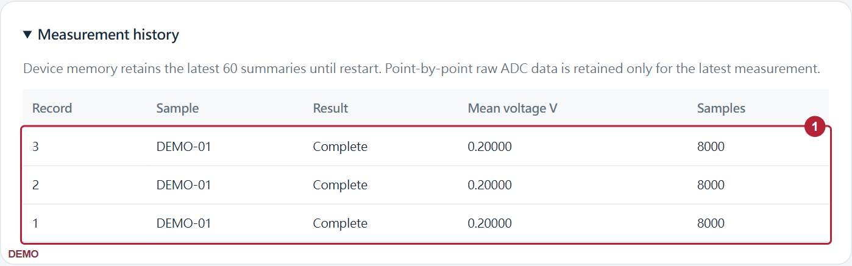
1 | History table Records are newest first. Read the sample name, status, voltage and sample count. JSON retains invalid records.
To retain three raw waveforms, download each before the next acquisition. A download at the end contains only the final block. Export before Delete records. Deletion does not remove files already saved on your computer.

3 7 Save CSV and JSON
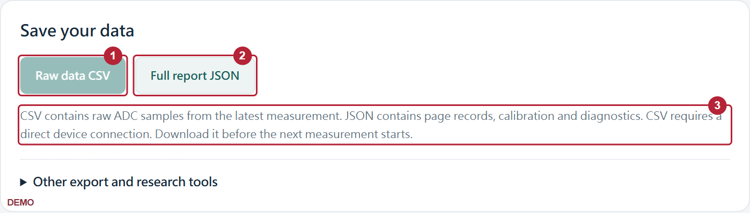
1 | Raw data CSV On a direct ESP32 connection, save the latest ADC block. Columns contain record ID, sample index, time in µs, ADC code and voltage in V. DEMO does not supply fake raw data.
2 | Full report JSON Save page records, calibration, schedule status, I/Q, amplitudes and full error information.
3 | Storage limits Download raw CSV before the next measurement. A new acquisition overwrites the previous raw block. Channel summary CSV under Other export is not raw ADC data.

3 8 Calibrate with blank and standard
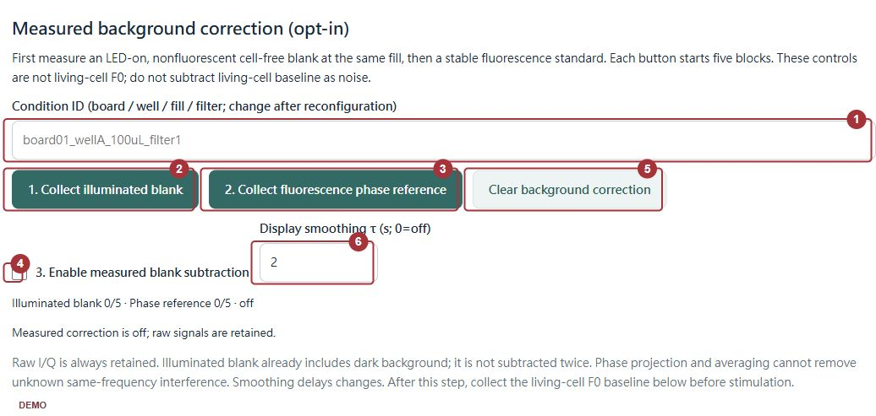
1 | Condition ID Identify the board, wells, fill and filter configuration. Recalibrate after changes.
2 | Collect illuminated blank Load the matched cell-free solvent or medium. Close the shield. Press to collect five measurements.
3 | Collect phase reference Load a stable fluorescence standard. Press to collect five measurements. Do not use living cells as the blank.
4 | Enable blank subtraction Enable after valid blank and phase-reference collection.
5 | Clear background correction Reset the current correction. Raw history remains available.
6 | Display smoothing Zero disables smoothing. Smoothing delays changes and cannot repair timing faults.

3 9 Use living-cell baseline tools
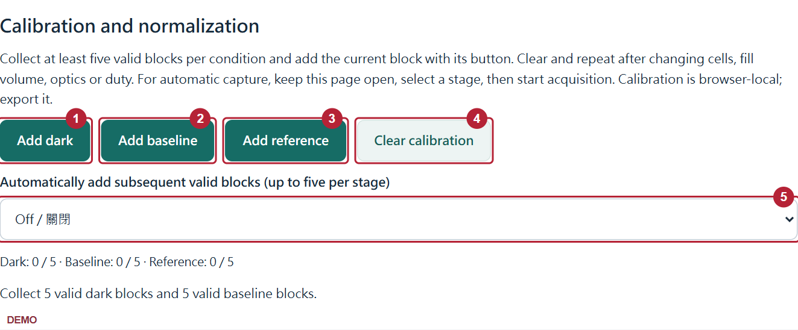
1 | Add dark Add the current valid all-LEDs-off record to the dark set.
2 | Add baseline Add a valid unstimulated living-cell record as F0.
3 | Add reference Add a valid established stimulus record. This does not train an odor classifier.
4 | Clear calibration Reset current calibration and automatic capture.
5 | Automatic capture Select the stage, then start five scheduled measurements. Keep the page open. Do not add a record twice.

3 10 Check the PD light response
Before a powered PD check, confirm that the electronics lead has cleared the power circuit and battery. If U2 heating or a sampling fault occurs, stop and resolve it first. A running fan alone does not establish electrical safety.
The covered and illuminated tests check light response. The blank and fluorescence-standard tests check whether fluorescence can be distinguished.
1. Remove liquids. Keep the reader dry. Adjust the shield only with power disconnected. Make the PD window accessible to a nonconductive opaque card. Do not touch joints or the PD surface.
2. Connect. Select Single measurement. Open Advanced settings. Select All off. Select Mean PD voltage in Chart view. Biological calibration is not required for this check.
3. Cover the receiver window with a nonconductive opaque card. Keep its position fixed. Enter DARK_A1 as the sample name. Press Start test.
4. Wait until the measurement stops. Require Complete acquisition and 8000 / 8,000. Open View diagnostic values. Require valid=true, railSamples=0 and an empty error field.
5. Record the mean voltage. Save Raw data CSV. If only one sample is present, or a timing error occurs, export JSON and stop this procedure. Do not interpret that result as PD response.
6. Remove the card. Illuminate the receiver window with a weak, fixed white-light source. Do not use a laser or place a bright light against the PD. Enter LIGHT_1. Measure once and save CSV.
7. Cover the same window again. Enter DARK_B1. Measure once and save CSV. Keep other settings, source position and fan state unchanged.
8. Repeat the same sequence twice. Use DARK_A2, LIGHT_2 and DARK_B2, then the corresponding names for cycle 3. Export JSON after the last measurement.
Interpretation: illumination must cause a repeatable mean-voltage change. Covering the window again must return the value near the initial dark value. The analog circuit determines the direction. The value does not have to increase.
The change must exceed the variation between repeated measurements of the same condition. Reduce illumination if ADC values approach a limit. A fixed code, such as 32767 in every condition, does not establish normal PD operation.
Use mean voltage and raw ADC data for this test. Do not use D1–D4 amplitudes to judge constant external light. Those channels measure signals at specific frequencies.
After this check passes, use the cell-free workflow in Sections 4 and 7. Keep the installed filter, alignment, 100 µL fill and LED settings fixed. Acquire double-distilled water first, then the sodium-fluorescein standards. Save each raw CSV before the next acquisition and retain the full JSON.
Compare all four frequency channels with the matched blank and standards. Use the uniform series to establish the concentration response under the fixed optical settings.

4 Prepare the fluorescence standards
Preparation: Use documented sodium fluorescein, CAS 518-47-8, and one batch of double-distilled water. Prepare separate labelled solutions at 1, 2.5, 5, 10 and 20 µM, plus water blank. Fill every well with 100 µL. The current series reads each fresh sample three consecutive times.
Use the same double-distilled water for the stock, working dilutions, blank and final rinse. Record the stock concentration and solvent. If the available stock has a different matrix, obtain a matching blank or remake the series; do not silently substitute PBS. Keep these dye solutions separate from living cells.
Use a documented stock and accurately pipettable volumes. The table specifies target concentrations; retain the actual preparation route.
Solution | Final concentration | Fill per well
Sodium fluorescein 1 µM | 0.001 mM | 100 µL
Sodium fluorescein 2.5 µM | 0.0025 mM | 100 µL
Sodium fluorescein 5 µM | 0.005 mM | 100 µL
Sodium fluorescein 10 µM | 0.01 mM | 100 µL
Sodium fluorescein 20 µM | 0.02 mM | 100 µL
Water blank | 0 µM; same solvent | 100 µL

Calculate Cstock × Vstock = Cfinal × Vfinal in separate labelled tubes. Use a documented intermediate if needed for accurate pipetting. For powder, record identity, formula mass and assay. Do not weigh the amount for a single well.
Steps:
1. Label each preparation with the full concentration, solvent, preparation ID and fill ID.
2. Prepare each target solution separately from the documented stock or intermediate.
3. Mix each solution before dispensing.
4. Reserve enough solution for all four 100 µL wells and handling loss.
5. Protect all standards from unnecessary light.
6. Reserve dye-free double-distilled water for the blank and final rinse.
7. Record preparation time, stock identity and available pH and temperature measurements.
8. Dispense 100 µL per well. Check bubbles, the outside of the carrier and lid clearance before installation.
Check: The sodium-fluorescein levels are 1, 2.5, 5, 10 and 20 µM. The water blank contains no added dye. The old shorthand C means 0.1 µM; use full concentrations in reports.
Failure action: Resolve uncertain stock identity or concentration before using the standards. Check the double-distilled water rinse for carryover before starting a new fill.

5 Select the filter configuration
Preparation: Ask the developer to install and verify the filter. Start with one LEE 101 layer. Keep the same duty and working fill during each comparison.
Configuration | Use
No filter | Engineering leakage comparison; stop for ADC clipping
One LEE 101 layer | Preferred first practical test
Two LEE 101 layers | Test whether extra rejection improves measured SNR
One 500 nm 12.5 mm Ultra-Thin OD4 Longpass | Candidate after mechanical fit is resolved

LEE 101 belongs over the PD receiver. LED excitation paths stay open. Layers reduce blue leakage and green fluorescence. A lower blank alone does not establish a better measurement.
The OD4 candidate is an Everix flexible polymer/dye filter, Edmund Optics #29-190. Thickness is 0.30 mm. Diameter is 12.45 ± 0.15 mm. It does not fit the existing 5.2 × 4.2 mm seat. Supplier-approved mounting or cutting and edge sealing remain unresolved. Do not force the disc into the reader. Angular transmission also needs confirmation.
Check: Select a configuration with adequate signal, acceptable noise, and no clipping. Recalibrate after every filter change. The filter report provides numerical comparisons and model limits.
Failure action: If the blank clips, stop acquisition. Ask the developer to correct leakage or settings. Blank subtraction cannot remove photon noise, clipping, or changing leakage.

6 Calibrate the routine interface
Press Calibration on the main screen. Then use the tools in the following steps.
Preparation: Fix the carrier, 100 µL fill, filter, duty, LEDs and medium. For the double-distilled water dye series, use double-distilled water in all four wells and collect it before the standards. The tools below provide optional display correction; retain the raw data independently.

Collect the illuminated blank
1. Enter a Condition ID, such as board01_wellA_100uL_LEE101x1.
2. Load the matching cell-free blank into all four wells.
3. Close the light shield.
4. Set Sample name to B_CAL.
5. Press 1. Collect illuminated blank.
6. Wait for five distinct valid blocks.
7. Check that calibration status is complete.
8. Download the latest raw ADC block before another acquisition.
Use 100uL in the identifier for the current working fill. Retain the IDs of the blank records actually used. A previous saved calibration is not automatically the current double-distilled water blank.

Collect the phase reference
1. Stop the schedule before solution exchange.
2. Confirm that LEDs are off.
3. Stop external gas flow.
4. Put the same stable fluorescence standard in all four wells.
5. Close the light shield.
6. Set Sample name to PHASE_REF.
7. Press 2. Collect fluorescence phase reference.
8. Wait for five valid blocks.
9. Check each channel's reference status.
10. Enable 3. Enable measured blank subtraction.
11. Set Display smoothing τ to 0.

Check the independent blank
1. Stop acquisition before solution exchange.
2. Replace the standard with matched blank.
3. Close the light shield.
4. Set Sample name to B_CHECK.
5. Select Repeat at an interval. Set the count to 5 and select the required start period.
6. Press Start test.
7. Inspect all five new blocks.
Check: Keep the new B_CHECK measurements separate from the calibration fit. Record the blank IDs and whether a fluorescence phase reference was collected.
Failure action: If a check fails, retain the records. Correct the cause before a new complete calibration. Do not use smoothing to hide the failure.
Use a fresh water-reference mean for each optical configuration. Keep earlier saved blank IDs in the archive. Do not apply a previous session's blank automatically. Bracket future series with water checks after rinsing.

7 Run and record the double-distilled water dye series
Preparation: Use one carrier with 100 µL per well and fixed filter, duty and frequencies. Read each uniform or single-well fill three times. Switch LEDs off between readings and keep the loading-to-read interval consistent.
Group | Preparation and reads | Contents of D1-D4
Uniform series | One fresh fill per level; three technical reads | All wells: 0, 1, 2.5, 5, 10 or 20 µM
D1 only | One fresh fill; three technical reads | 10 µM / water / water / water
D2 only | One fresh fill; three technical reads | Water / 10 µM / water / water
D3 only | One fresh fill; three technical reads | Water / water / 10 µM / water
D4 only | One fresh fill; three technical reads | Water / water / water / 10 µM
Acquisition | All four LEDs active | D1-D4: 41 / 67 / 89 / 113 Hz; 25% duty

Steps:
1. Record the software revision, carrier, filter, fill, duty, frequencies and physical well-to-channel mapping.
2. Fill all four wells with double-distilled water, close the light shield and collect the blank before any dye standard.
3. For the uniform series, put one freshly prepared target solution in all four wells and read the same fill three times without reloading.
4. Save the raw CSV after every reading and before the next acquisition. Retain the corresponding record ID and timestamp.
5. Record water blank and 1, 2.5, 5, 10 and 20 µM with separate preparation and fill IDs. Preserve actual acquisition order.
6. Before cleaning or reloading, stop the schedule, turn the LEDs off and stop external gas flow.
7. Clean the same carrier, complete a double-distilled water rinse and check for residual dye. Reload fresh samples without changing the optical alignment.
8. For each single-well group, put 10 µM in the selected well and water in the other three. Measure D1-only, D2-only, D3-only and D4-only fills with all LEDs active.
9. Give each fresh reload a new fill ID. Repeated readings without reloading are technical repeats of that fill.
10. Export the full session JSON, all raw CSVs and the preparation and layout record. Use timestamps, not filename order, to recover acquisition order.
The expanded series has six uniform groups and four single-well groups. Each is one fresh preparation/fill with three technical readings: 30 acquisitions. These technical readings quantify repeatability; they are not three independent preparations. Keep the earlier mixed layouts A and B as a separate dataset.
Failure action: Retain clipping, timing errors, unstable blanks and carryover observations. After a reboot, filter change or changed alignment, establish a new acquisition context and blank. A reload of the same carrier is not an independent device replicate.
Analysis: subtract the matching water I/Q mean once and use each isolated 10 µM source to set its channel phase. Fit the same exponential function family for D1-D4 with separate coefficients. The present curves apply to the tested all-wells-equal fill. Keep both 2.5 µM acquisitions as QC records; primary fitting uses water, 1, 5, 10 and 20 µM. Validate whole held-out concentration groups. Matrix-first unmixing and extra residual offsets did not improve the current multiwell check, so they are not applied to this conversion. Use the sample guide for coefficients, recovery checks and the next mixed-fill calibration steps.

8 Prepare complete Gibco DMEM
Preparation: Use your existing GCaMP6f-expressing HEK293. Use the existing Gibco DMEM and FBS used successfully for these cells. No new reporter-expression procedure is required.
Steps for 50 mL complete medium:
1. Read the DMEM bottle label.
2. Check whether the medium is basal or already complete.
3. Check whether L-glutamine or GlutaMAX is present.
4. If the medium is already complete, use it without adding FBS again.
5. If it is basal DMEM, transfer 45.00 mL to a sterile container.
6. Add 5.00 mL of the existing suitable FBS.
7. Mix gently.
8. Label the final 50.00 mL as DMEM with 10% FBS.
Check: If L-glutamine or GlutaMAX is present, do not add more automatically. If absent, use the established supplement recipe and product instructions. Include added supplements within the final 50 mL. Reduce basal DMEM by their combined volume.
For an established recipe requiring 2 mM added glutamine, use 0.50 mL of 200 mM stock. Combine 44.50 mL basal DMEM, 5.00 mL FBS, and that supplement. This conditional example does not prescribe extra glutamine for every Gibco product.
Keep established reporter selection conditions. Do not add new antibiotics, pyruvate, or other supplements without a reason in the existing procedure. Do not heat-inactivate FBS unless that procedure requires it.
Environment steps:
1. Set the incubator to 37°C.
2. Use the established CO2 setting for these cells and this DMEM.
3. If the established setting is 5%, retain humidified 5% CO2.
4. Check medium pH after equilibration.
Failure action: If the bottle formulation changed, check its instructions before changing CO2 or supplements. Gibco DMEM formulations differ. Some specify 5–10% CO2. Keep the successful culture recipe for the first device comparison. EMEM is not a required purchase. See the complete medium guide.

9 Seed the wells and check readiness
Preparation: Use a healthy expanding culture. Prepare the removable wells away from electronics. Use a qualified aseptic process compatible with the resin. Keep a matched standard-cultureware control.
The nominal well floor is 0.112 cm². Start with 3,000 viable cells per well. At 100 µL, this requires 3.0 × 10^4 viable cells/mL. This is a starting estimate, not a measured optimum.
Four wells require 400 µL. Prepare at least 500 µL for handling losses. If the counted stock contains 1.00 × 10^6 viable cells/mL, use 15 µL stock plus 485 µL complete DMEM. This gives 500 µL at the target concentration. Count viable cells, not total particles.
If the verified fill changes, use 3,000 × 1,000 / fill_in_µL viable cells/mL. Match control cultureware by cells/cm².
Steps:
1. Prepare a suspension with the laboratory's established dissociation procedure.
2. Count viable cells.
3. Dilute the suspension to the calculated concentration in complete DMEM.
4. Put the removable wells level in a sterile secondary culture dish.
5. Mix the cell suspension gently before dispensing.
6. Dispense 100 µL slowly along each well wall.
7. Inspect for bubbles.
8. Cover the secondary dish with a suitable gas-exchange cover.
9. Incubate under the conditions in Section 8.
10. Inspect attachment at 4–6 hours.
11. Inspect morphology and coverage at 18–24 hours.
12. Check health and reporter response at 24–48 hours.
Confirm that the 100 µL fill permits closure without leakage. Do not incubate the PCB or battery in a humid incubator. If starting from a frozen vial, recover it in standard cultureware first.
Check: Cells are attached and healthy. There is no visible contamination or marked detachment. A provisional coverage target is 60–80%. The known positive control responds on the reference instrument. Elapsed time alone is insufficient.
Aqua Clear Plus has no demonstrated culture-compatibility process in this project. Compare resin wells with standard cultureware. The sample guide proposes viability of at least 80% of the matched control. It also specifies background and attachment checks.
Failure action: If plastic passes but resin fails, resolve the material or surface process first. Do not assume another fixed incubation period will correct poor attachment. Do not assume UV, alcohol, or a coating proves compatibility.
Check evaporation with a matched cell-free well. More than 10% volume loss is a proposed rework threshold. At 100 µL, that is 10 µL. Do not top up blindly and treat the result as unchanged.

10 Calibrate and measure the reporter cells
Preparation: Use the established assay medium when possible. Existing DMEM is the first route when its required environment can be maintained. Keep its CO2 condition and verify 37°C at the sample. The reader does not supply these controls.
double-distilled water used for the dye series is not a cell-culture medium. Keep the qualified cellular assay medium for cell measurements. HEPES does not control temperature. The sample guide describes an optional imaging-buffer branch.
Optical preparation:
1. Prepare a cell-free blank with the actual assay medium.
2. Use the final filter, duty, working fill, and optical arrangement.
3. Collect the illuminated blank with Section 6.
4. Collect the matched phase reference with Section 6.
5. Check an independent blank.
6. Install the cell sample with the established calibration-transfer procedure.
Check: A different well insert can change resin background and alignment. Verify repeated insert exchange in the cell-free pilot. Do not conceal a changed assembly with an unchanged Condition ID. A restart needs a valid calibration-transfer procedure and new F0.
Cell measurement steps:
1. Confirm sample temperature and medium pH.
2. Inspect cell attachment before measurement.
3. Set a sample label for the unstimulated cells.
4. Select Automatic capture Baseline.
5. Start the unstimulated acquisition.
6. Collect at least five distinct valid baseline blocks.
7. Keep a stable 2–5 minute baseline record when the assay permits.
8. Record the stimulus start time.
9. Apply the laboratory's established stimulus procedure.
10. Collect the response with unchanged settings.
11. Export raw and unsmoothed corrected data.
12. Inspect attachment after measurement.
Check: The cells already express GCaMP6f. A known positive control still checks whether the reporter response is functional. Include matched vehicle and reference-instrument controls. Use existing non-reporter controls when available.
Use a first 10–15 minute measurement as a feasibility trial. This is a planning duration, not a proven safe exposure. Keep the gas pump off for the initial optical/cell comparison. Do not add fluorescein to the cells.
Failure action: If temperature, pH, attachment, or QC fails, stop interpretation. If F0 is near zero or below noise, do not force a ratio. If environmental control is unavailable, continue cell-free work first.
Subtract the independent assay-medium blank once, then use the living-cell baseline for ΔF/F0. Do not save living cells as the optical blank. A double-distilled water dye blank cannot replace the actual cell-medium blank.
Each block averages two seconds, followed by at least three seconds idle. Rapid GCaMP6f peaks can be missed. Compare an established sustained response over a prespecified time window. Align traces to recorded stimulus time. Do not shift curves to improve agreement.
Four shared-gas wells are not four independent exposure replicates. Gas arrival above liquid does not prove cell exposure. A general calcium-positive response does not establish odor specificity.

11 Export data and finish
Preparation: Keep the browser open until export finishes. JSON preserves the fullest session record. CSV is convenient for inspection.
Steps:
1. Enter sample and condition information in the notes.
2. Press Full report JSON.
3. On a direct connection, press Raw data CSV for the latest block. Open Other export for a channel summary.
4. Check that both files were saved.
5. If a raw waveform is required, download the latest raw ADC before another block.
6. Press End schedule and turn LEDs off.
7. Confirm that the LEDs are off.
8. Stop external gas flow.
9. Equalize pressure through the open outlet.
10. Switch off power before disassembly or cleaning.
Check: Preserve calibration records, raw values, failed blocks, and exclusion reasons. Useful filenames include date, device, sample, condition, and replicate. Screenshots alone are insufficient.
The device retains the latest 60 summaries and one raw ADC block until restart. Its cloud upload queue has eight slots. The page retains at most 1000 records. Reconnection can recover retained summaries, but not overwritten raw waveforms. Browser notes and automatic calibration capture still need the page open.
Failure action: If export is incomplete, keep the page open. Resolve the download before clearing records. Do not label recovered partial data as a complete series.

12 Correct problems
Symptom | Action
No AeroSense Wi-Fi | Check J2 power and SW1 ON; then ask the developer to check firmware
Webpage 404 | Ask the developer to check LittleFS upload
401 | Check the current device API key
board_not_validated | Keep Dark; request developer checks
ADC_rail, timing, or jitter | Stop; preserve raw ADC for diagnosis
Large blank or clipping | Check shielding, filter bypass, and duty before recalibration
Weak phase reference | Check standard, alignment, and blank
baseline_below_noise | Check F0 and reporter response; do not force ratios
Network failure prevents stopping | Remove power with SW1
Leakage or abnormal heating | Disconnect power and stop gas flow
Cell detachment or pH change | Stop the cell test and restore the established culture environment

Use the separate feedback form for actual observations. Leave unperformed tasks blank. Keep device checks, dye results, and cell results separate.

