AeroSense Bio

Business Plan

A Bio-Integrated Biomimetic Olfactory Sensing Platform — Giving Machines Biological-Grade Smell

iGEM 2026

Table of Contents
1. Executive Summary and Positioning | 5
2. Key Achievements and Validation | 5
3. Problem and Market Pain Points | 6
4. Customer Insights and Untested Hypotheses | 8
5. Solution and Core Technology | 10
6. Scientific Evidence and Technical Provenance | 12
7. Benchmark Cases and Competitive Positioning | 13
8. Market Opportunity and Focus Strategy | 16
9. Business Model and Economic Logic | 18
10. Application Pipeline and Roadmap | 20
11. Technical Proof of Concept and Beachhead Use Case | 21
12. Team | 22
13. Financial Plan | 22
14. Risks and Mitigation | 24
15. Regulatory and IP Strategy | 25
16. Vision and Impact | 27
Appendix A: Mentor Feedback and Revision Comparison Table | 28
Appendix B: Planned Field Interviews and Interview Outline | 30

1. Executive Summary and Positioning
MISSION  Give machines biological-grade smell — turning odor into a measurable data dimension | FOCUS (Phase 1)  Early VOC detection of pests and disease in controlled-environment agriculture — validating the business model in a single beachhead market first | STAGE  Cell-level proof of concept complete; edge hardware PCB under validation; beachhead field pilot in preparation

Starting Point of This Revision: Per our mentor's advice, this document no longer opens with what technology we have, but instead first answers where the industry's real pain lies and why current solutions fall short, before explaining whether — and to what extent — AeroSense's technical advantages actually address that pain. The narrative order from Chapter 3 onward has been rearranged accordingly: pain points and quantitative evidence first, then customer insights and untested hypotheses, and only then the solution and technology.
Smell is the most underrated data source in the world. Crop disease, food spoilage, environmental pollution, and even lung cancer all release specific volatile organic compounds (VOCs) before symptoms become visible. Yet today's electronic noses remain constrained by three core bottlenecks — insufficient sensitivity, poor selectivity, and long-term baseline drift — which can be further broken down into six specific pain points shared across industries (see Chapter 3).
AeroSense Bio engineers Drosophila (fruit fly) olfactory receptors for expression in human cells, reads odor binding in real time via calcium fluorescence, and identifies odors using a neuromorphic algorithm modeled on the fly brain — all packaged into a field-deployable edge device. Our sensing element is alive — the cells continuously renew their receptors and never age or drift, and the receptors can be "programmed" to target any odor of interest, turning the platform into an infinitely extensible odor-detection operating system. Commercially, we build recurring revenue on a "device + replaceable live-cell cartridge" model, entering through the lowest-regulatory-burden category — agricultural disease — and, once the beachhead market validates a repeatable business model, gradually expanding into environmental monitoring and food safety, with early medical screening evaluated as a long-term direction (see Chapter 8, Focus Strategy).
The Most Critical, and Still Incomplete, Piece Right Now Is First-Hand Demand-Side Validation: what the team has completed so far is a preliminary consumer survey (n=168, directional data) and solid technical/scientific evidence. However, the on-site observations at farmers' associations, interviews with laboratory physicians, and exchanges with Shih-Chuang Biotech that our mentor specifically flagged are "planned but not yet executed" in this revision — see the concrete action plan in Chapter 4 and Appendix B. This BP is written to honestly disclose our current validation progress, explaining the strength of evidence we already have and how the team plans to close the remaining gaps in the near term.

2. Key Achievements and Validation
Biological olfaction is already an international frontier race; AeroSense shows clear validation signals in technical originality and research foundation:
Achievement / Validation | Description | Validation Status
Original Technology Integration | First platform to integrate Drosophila olfactory receptors + neuromorphic AI into a self-renewing cell + edge-device sensing system | Concept complete
Leading Research Foundation | Core computation layer builds on mushroom-body olfactory coding research from the Institute of Systems Neuroscience (published in Science Advances, 2025; the team has direct research lineage) | Published, independently verifiable
Cell-Level Proof of Concept | Cell-level proof of concept complete: receptor activation produces a measurable fluorescence transient (ΔF/F) | Complete
Edge Hardware (DLIA) | In-house digital lock-in amplifier (DLIA) readout architecture; PCB sent for fabrication; staged validation protocol (Stage A–E) finalized | PCB under validation; quantitative data expected Q3–Q4 2026
Ecosystem Validation | Originated from the international synthetic biology competition (iGEM); incubated on campus; tested through multiple startup competitions | Complete

*Note: Quantitative metrics for the edge hardware layer — such as the "with DLIA vs. without DLIA" comparison, crosstalk suppression, and dynamic reserve — have acceptance criteria defined in the team's internal "DLIA Hardware Validation Protocol" (e.g., linearity R² > 0.99, crosstalk suppression > 40 dB). These will be executed per Stage A→E once the PCB returns from fabrication, with measured data backfilled; they are not production-scale measured values already available in this version of the BP.*

3. Problem and Market Pain Points

3.1 Argument Logic: Starting from Pain Points
Our mentor advised us to "first identify the market's pain, then check whether we actually have an advantage in solving it." This chapter is therefore structured in two layers: the first layer covers six technical pain points common across industries (3.2), and the second layer covers the specific symptoms and quantitative data for each of four application scenarios (3.3). Chapter 5's solution responds to each of these six shared pain points in turn, so that technical specifications and market pain points don't talk past each other.

3.2 Six Cross-Industry Pain Points
Traditional odor/VOC sensing approaches — whether metal-oxide electronic noses, gas chromatography–mass spectrometry (GC-MS), or manual sensory inspection/spot checks — repeatedly exhibit six types of problems. This is also where our mentor specifically asked us to show, point by point, how our solution performs:
Pain Point | Specific Symptom | Industry Impact
Blind (Insufficient Sensitivity) | Signal-to-noise ratio is inadequate for low-concentration VOCs; most metal-oxide sensors need ppm-level concentrations for reliable detection, while signals released in the early stages of disease/spoilage are typically at the ppb level — effectively "unable to smell it." | The early-warning window is missed; by the time symptoms are visible to the eye, the golden window for intervention has already passed.
Biased (Poor Selectivity / Prone to Misclassification) | Weak discrimination between cross-reactive odors, since the same sensor responds to overlapping sets of VOCs; published literature shows electronic-nose sensitivity/specificity for lung-cancer breath screening swinging widely between 71%–100% depending on the study method. | High misclassification rates make it difficult to establish a reading standard trusted in clinical or production settings.
Fragile (Baseline Drift / Short Lifespan) | Chemical sensing membranes oxidize, get poisoned, and age with use, requiring frequent recalibration; precision instruments like GC-MS are also sensitive to environmental vibration and temperature. | Accuracy degrades quickly after field deployment, requiring frequent maintenance or return to the manufacturer for recalibration.
Fixed Scope (Targets Cannot Be Expanded) | Once a sensor is manufactured, its target odor is fixed; adding a new detection target often requires redesigning the sensing membrane or retraining the entire system. | Unable to quickly iterate for new diseases, new regulations, or new customer needs; scaling up is costly.
High Power Consumption | GC-MS requires continuous heating for sample preparation and a vacuum pump; most precision instruments are not viable on battery power. | Difficult to deploy in greenhouses, outdoor controlled-environment agriculture, or sites without stable power.
Failures Are Hard to Detect | Most sensing systems lack built-in self-diagnostics; membrane poisoning or drift is often only discovered once results become obviously abnormal — for example, readings keep showing "normal" while a crop has already suffered widespread disease. | False negatives accumulate over time unnoticed, eroding user trust.

AeroSense's technical proposition (see Chapter 5) is to address all six issues above through the combination of "live-cell receptors + programmability + neuromorphic edge computing + digital lock-in," rather than gaining an advantage on only a single dimension (such as sensitivity). Chapter 7's competitive matrix has likewise been re-presented along these same six dimensions, so it doesn't drift apart from the market pain points (responding to Mentor Comment 9).

3.3 Specific Pain Points and Quantitative Data Across Four Application Scenarios

Early Detection of Agricultural Pests and Disease
According to the UN Food and Agriculture Organization (FAO), pests and disease cause crop yield losses of up to 40% globally each year, with economic losses exceeding US$220 billion. Taiwan's controlled-environment agriculture faces the same challenge: diseases often release specific volatile organic compounds days before visible lesions appear, yet field practice still relies mainly on manual visual inspection and experience, lacking a quantitative, continuous, early-detection tool. The team has not yet obtained disease-specific local loss figures or field-inspection frequency data for Taiwan — this is the gap the farmers' association interviews planned in Appendix B are meant to fill. This version of the BP relies on international data to establish that the problem exists, to avoid inflating the argument with unverified local figures.

Food Freshness and Safety
Based on the team's 2026 "Food Preservation and Mold Risk — Public Habits and Needs Survey" (n=168, mainly general consumers and students, non-random sampling, directional reference only), we observed quantitative patterns directly related to a "knowledge–behavior gap":
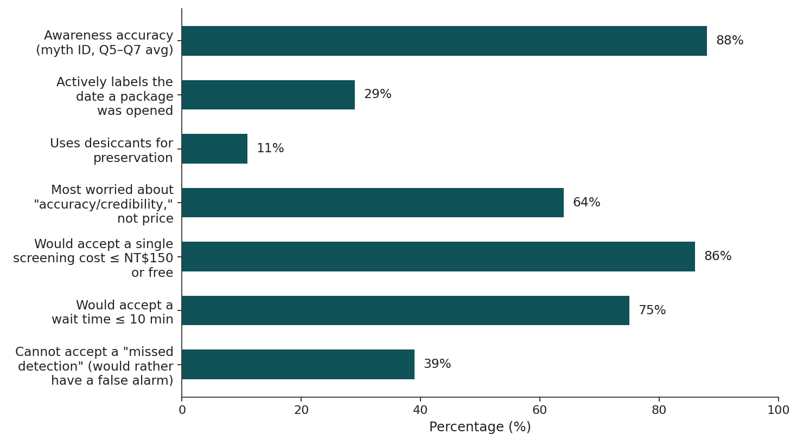
Figure 1 Key Findings from the Consumer Survey (Source: AeroSense team survey, 2026, n=168)
- 88% of respondents correctly identified common myths — such as "just cut off the mold and it's fine to eat" or "heating fully removes the toxin" — as false, showing that basic public awareness isn't the problem. The problem isn't a lack of understanding — it's the lack of a tool for continuous judgment — only 29% actively label the date a package was opened, and only 11% use desiccants or other active preservation behaviors.
- 64% of respondents are most concerned about "accuracy/credibility" rather than price itself, and 86% expect a single screening to cost under NT$150 or be free — indicating a low willingness-to-pay ceiling among consumers, which supports positioning toward B2B (incoming goods/warehousing/retail) rather than direct-to-home sales (echoing the focus-strategy adjustment in Chapter 8).
- 39% of respondents said they "cannot accept a missed detection" (they would rather have a false alarm than miss a real risk), which supports designing the product's output as a risk-tiered scale rather than a binary "safe/unsafe" classification.

Environmental Odor / Industrial Safety Gas Monitoring
Industrial fugitive emissions, odor pollution, and low-concentration hazardous gases in indoor air all require precise identification against high background noise — exactly where traditional electronic noses' two weaknesses, poor selectivity and susceptibility to environmental interference, are most exposed. This application is still at the concept stage (see Chapter 10, Application Pipeline) and awaits more complete field and regulatory research.

Non-Invasive Early Medical Screening
Published literature shows that the accuracy of breath VOC analysis for early lung cancer detection varies widely depending on the technique and study design: GC-MS sensitivity ranges from 85%–97%, while electronic-nose approaches swing between 71%–100% (Machado et al. 2005; Gasparri et al. 2016; Di Natale et al. 2003; among others). Current low-dose CT (LDCT) screening also commonly suffers from a high false-positive rate requiring invasive biopsy confirmation. This application faces the highest regulatory bar (medical device classification, see Chapter 3) and is currently classified as a long-term direction, not a priority for resource investment in the next one to two years.

4. Customer Insights and Untested Hypotheses
Mentor Comments 3 and 4 explicitly state that market pain points and needs must be validated through field interviews and observation, not assumed unilaterally by the team; they also require us to confirm whether existing solutions already satisfy the need, to avoid investing resources in a problem for which no strong switching motivation actually exists. This chapter honestly distinguishes between validation work that is "completed" and "planned but not yet completed," and explains the impact on our business judgment.

4.1 Validation Completed to Date
Validation Item | Method / Sample | Key Findings | Judgment Supported
General Consumer Survey | Online survey, n=168, mainly general consumers and students | High baseline awareness but passive preservation behavior; low willingness-to-pay ceiling; values accuracy over price; prefers conservative readings (see Section 3.3) | Supports a B2B-first, risk-tiered-output product design direction; insufficient to demonstrate purchase intent among farmers' associations or food businesses
Technical Literature and Scientific Foundation Review | Peer-reviewed literature trace-back (see Chapter 6) | The core algorithm and receptor engineering have clear, independently verifiable scientific sources | Supports the technical credibility argument, but is not market validation
Electronic Nose Industry and Competitor Review | Public data and market research reports | The global electronic-nose market is approximately US$164M in 2026, growing to approximately US$293M by 2031, a CAGR of 12.26%; food and beverage is the largest application (see Chapter 8) | Confirms the market exists and is growing, but does not prove product-market fit for this team

4.2 Planned but Not Yet Completed Critical Validation (Gaps Identified by Our Mentor)
Below is the validation work that Mentor Comments 3 and 4 directly flagged as having the greatest impact on business judgment, but which the team has not yet carried out. We list it honestly because these gaps currently represent the single largest source of uncertainty in this venture's business case, and are not something that desk research can substitute for.
Untested Hypothesis | Validation Method | Key Questions | Expected Timeline
Whether farmers' associations / controlled-environment farms are willing to purchase an electronic nose to replace manual field inspection | On-site visits to at least 2–3 farmers' associations / controlled-environment farms, observing the inspection process and interviewing on-site | What is the current disease-assessment process and frequency? What is their experience of misses/misjudgments from manual visual inspection? Does their willingness to pay fall within the device + cartridge pricing range the team has planned (see Chapter 9)? Is there a genuinely unmet motivation to switch, or is the current approach actually good enough? | Before the beachhead field pilot launches, Q3–Q4 2026
How dissatisfied laboratory physicians are with current testing workflows, and the conditions under which they would switch to an electronic nose | Interviews with at least 3–5 laboratory/pulmonology physicians or medical laboratory technologists | What is the current testing process and its accuracy? What dissatisfies them about existing methods? Are they already evaluating new screening technologies? What sensitivity/specificity would they require? What certifications would be needed (TFDA classification, ISO 13485, clinical trial scale)? Can the medical sector afford current electronic-nose pricing? | Before medical early screening becomes a formally resourced project (Chapter 8 lists it as a long-term direction, not a priority for the next one to two years)
Whether existing solutions (manual field inspection, spot checks, GC-MS) are already "good enough," such that no real motivation to switch has yet emerged | In the interviews above, explicitly ask "why haven't you switched yet?" rather than only asking "would you like to?" | Is there a case of "knowing the problem exists but lacking motivation to switch"? What are the threshold conditions for switching (price / accuracy / regulation / insurance reimbursement)? | Conducted in parallel with the two interviews above

Appendix B provides a concrete action plan and draft interview outline for the interviews above, ready for the team to execute in the near term. Until the farmers' association and physician interviews are completed, this BP's market argument for the agriculture and medical application areas should be treated as a hypothesis supported by international literature and technical grounds, but with local demand-side evidence still to be filled in — not as a validated conclusion — this is also why Chapter 8 designates "early detection of agricultural pests and disease" as the sole beachhead market for Phase 1 resource investment: completing a fast build–measure–learn cycle in one scenario first, rather than building an equally deep market case for all four application areas at once.

5. Solution and Core Technology
Rather than building a better chemical sensor, we "domesticate" an olfactory system already validated by evolution, and digitize it with AI. The platform consists of three interlocking subsystem layers: the live sensing layer, the neuromorphic computation layer, and the edge hardware layer.
- Live Sensing Layer: Human HEK293T cells co-express Drosophila olfactory receptors (OR/Orco) and the GCaMP6 calcium fluorescence indicator. Odor binding immediately triggers calcium influx, producing a real-time fluorescence transient (ΔF/F). The cells continuously renew their receptors, making them fundamentally immune to aging drift.
- Neuromorphic Computation Layer: An engineered version of the Drosophila olfactory circuit (AL→MB) — lateral inhibition improves the signal-to-noise ratio, and locality-sensitive hashing (LSH) sparse coding separates overlapping odors; low power, edge-deployable.
- Edge Hardware Layer: An in-house optical readout system — photodiode array + optical frequency-division multiplexing (FDM) + digital lock-in amplification (DLIA) — extracting a clean signal even under strong light and noise.

5.1 How the Solution Addresses the Six Cross-Industry Pain Points
Responding to Mentor Comment 5: the following explains, point by point, exactly how our technology addresses each of the six shared pain points and what level of evidence currently supports it, avoiding vague claims of being "better."
Industry Pain Point | AeroSense's Technical Response | Evidence Level
Blind (Insufficient Sensitivity) | The live-cell receptor binding signal is amplified via GCaMP6 calcium fluorescence, and DLIA digital lock-in extracts weak signals from noise; in principle this compresses the effective detection bandwidth into a narrow-band filter, greatly improving the signal-to-noise ratio | Cell-level ΔF/F validated; DLIA electronic/optical lock-in validation (Stage B) in progress
Biased (Poor Selectivity) | A single receptor has evolutionarily derived high specificity for its target ligand, and lateral inhibition combined with LSH sparse coding can separate overlapping odor patterns across a multi-receptor array | Cell-level validation complete; cross-selectivity of the multi-receptor array awaits systematic testing once the receptor library is expanded
Fragile (Baseline Drift) | The sensing element consists of continuously dividing, self-renewing live cells, which in principle do not suffer the oxidative poisoning and physical aging problems of chemical sensing membranes | Stable receptor expression has been validated at the cell-culture level; long-term (month-scale) field stability awaits validation in the field pilot
Fixed Scope (Targets Cannot Be Expanded) | Receptors can be "reprogrammed" via molecular biology methods, and structure-prediction tools such as AlphaFold can accelerate the screening and affinity optimization of new receptors | The technical principle has a clear literature basis (see Chapter 6); the actual turnaround time for bringing a new receptor online awaits validation on the first non-original target odor
High Power Consumption | The neuromorphic computation layer replaces dense matrix operations with sparse coding (LSH), and digital lock-in can be implemented on an ESP32-class MCU; in principle, power consumption is far lower than approaches like GC-MS that require continuous heating and vacuum pumping | Architectural design target; measured power data to be backfilled from hardware Stage D environmental robustness testing
Failures Are Hard to Detect | DLIA outputs a noise floor and dynamic reserve value with every measurement, which can serve as a self-monitoring indicator of system health; the receptor layer additionally incorporates redundant candidate sequences and AI-based pre-screening of abnormal receptors (see Chapter 14, Risks and Mitigation) | Design has been incorporated into the architecture; no failure-detection cases yet exist from long-term field operation

6. Scientific Evidence and Technical Provenance
Our mentor advised that we "should supplement the scientific evidence currently available." This chapter formally incorporates the "Technical Source Supporting Documentation," originally a separate attachment, into the body of the BP, tracing each module back to peer-reviewed literature to demonstrate that the platform is not conceptual speculation.

6.1 Core Technical Source: Flagship Peer-Reviewed Paper
Cheng, L.-S., Charng, C.-C., Chen, R.-H., Feng, K.-L., Chiang, A.-S., Lo, C.-C., & Lee, T.-K. (2025). Hybrid neural networks in the mushroom body drive olfactory preference in Drosophila. Science Advances, 11(22), eadq9893. DOI: 10.1126/sciadv.adq9893.
Author affiliations: Institute of Systems Neuroscience and Department of Life Science, Brain Research Center, and Department of Physics at National Tsing Hua University (as well as UC San Diego and Academia Sinica's Institute of Physics, among others). This paper is open access (CC BY 4.0); the analysis code is publicly available on Dryad, and the data is stored on Zenodo, so it can be independently verified. The study found that the projection-neuron (PN) to Kenyon-cell (KC) connections in the Drosophila mushroom body (MB) are not entirely random, but instead form a spatially organized "hybrid network" — a structure that achieves a computational advantage between "food-odor detection" and "odor discrimination." This is precisely the first-hand, experimentally validated scientific foundation for the core algorithm of AeroSense's neuromorphic computation layer (the AL→MB→MBON circuit).

6.2 Direct Lineage Between the Team and the Research
- Co-author Ching-Che Charng : advisor to our team, providing a direct research continuity from this paper to AeroSense's computation layer.
- Co-author and faculty advisor Chung-Chuan Lo : Associate Dean of the College of Life Science and Director of the Institute of Systems Neuroscience at National Tsing Hua University, whose main research areas are computational neuroscience and NeuroAI.
Therefore, AeroSense's "fruit-fly brain algorithm" is an engineering extension of the team's own published, verifiable research — not an application of secondhand literature. This is the single most defensible piece of evidence in this venture's deep-tech due diligence.

6.3 Technology Module × Scientific Source Mapping
Technology Module | Corresponding Subproject | Peer-Reviewed Scientific Source
Neuromorphic Computation Layer (AL→MB, PN–KC–MBON, LSH Sparse Coding) | Subproject 2: Biomimetic Computing / SNN | Cheng, Charng et al. 2025, Science Advances (flagship, team's own); Dasgupta et al. 2017, Science (Drosophila olfactory LSH algorithm)
Live Sensing Layer (Drosophila OR/Orco + GCaMP6 in HEK293T; OBP; Plasmid Construction) | Subproject 1: Odor Cell Detection Array | Zboray et al. 2023, Sci. Rep.; Butterwick et al. 2018, Nature (Orco cryo-EM structure); Pacalon et al. 2023, Nat. Commun. (OR co-receptor structure)
Programmable Receptor Design (AI Structure Prediction + Site-Directed Mutagenesis for Affinity) | Subproject 1, Objective 1 | Jumper et al. 2021, Nature (AlphaFold structure prediction)
Edge Hardware Layer (Optical Readout / FDM / DLIA) | Subproject 3: Integrated Hardware | Standard signal-processing techniques (lock-in detection principles, Stanford SRS App Note #3; Zurich Instruments technical documentation) + the team's own independent engineering development

Verifiability statement: the flagship paper is open access under CC BY 4.0 (full text available via DOI 10.1126/sciadv.adq9893); the connectome analysis code is public on Dryad, and related data is stored on Zenodo, so the computational results are reproducible. All literature cited in this chapter is peer-reviewed and independently verifiable.

7. Benchmark Cases and Competitive Positioning
Biological olfaction already has benchmark companies across the consumer, industrial, and biomedical directions, validating both market demand and technical feasibility:
- Consumer: Aryballe (France; peptide + silicon photonics + ML; investors include Hyundai, Samsung, and IFF), Osmo (USA; AI-driven scent design; closed a $70M Series B in 2026).
- Industrial / Security: Koniku (living-neuron detection, partnered with Airbus), and traditional electronic noses (Alpha MOS and others).
- Biomedical: Owlstone Medical (UK; breath analysis for early disease screening), Aromyx (human olfactory-receptor cell-based biosensing).

7.1 Benchmarking Against Shih-Chuang Biotech (Responding to Mentor Comment 2)
Our mentor recommended that the team actually visit Shih-Chuang Biotech to understand its nearly decade-long development since its founding in 2017 (ROC year 106), draw lessons from its experience, and assess the scope for collaboration or integration between the two teams in the electronic-nose market — particularly since our respective faculty advisors have collaborated before. Below is the desk research the team completed ahead of a formal visit, to serve as background preparation for the interview; the actual conclusions on the interview and on any integration potential still await an in-person meeting between the two teams, which is listed as the highest-priority item in the field plan in Appendix B.
Item | Publicly Available Information We Have Gathered
Founding and Origins | Formally founded in 2017 (ROC year 106), spun out of a National Tsing Hua University electronic-nose research team that had already accumulated over a decade of R&D capability before founding; founded by young NTHU students, and backed by NTHU incubation support and angel investment
Core Technology | Electronic nose (digital olfaction platform) integrating artificial intelligence, machine learning algorithms, nanomaterials science, and system-on-chip technology
Validated Application Results | Rapid breath screening achieved over 90% recognition accuracy for pneumonia and four of its bacterial strains (17th National Innovation Award judges' comments, 2020)
Application Portfolio | Medical (rapid breath screening, lung cancer diagnosis, monitoring and treatment-effect assessment for diseases such as NTM), industrial (toxic gas detection in specialized settings), and agriculture (agricultural process monitoring, tea-processing quality control)
Observations on Its Development Over the Past Decade | From a campus research team to an incorporated company, raising an angel round and winning a national-level innovation award, it followed the path of "first achieve high recognition accuracy in a single scenario (rapid respiratory-infection screening), then expand horizontally into industrial and agricultural applications." This stands in contrast to how this venture currently presents "multiple scenarios side by side, not yet focused" — and this path is itself a real-world example supporting Mentor Comment 7's advice to "focus."

Specific Questions the Team Plans to Ask Shih-Chuang (Draft Interview Outline, See Appendix B)
1. Over the nearly ten years from research team to incorporated company, what pitfalls did you encounter that you "expected to succeed but didn't" (technical path, regulation, distribution channels, fundraising)?
2. In the process of commercializing the electronic nose, which application scenario first achieved a working business model? What were the key conditions for making it work?
3. In expanding from a single technology platform into the three areas of medical, industrial, and agricultural, how did you decide the order of resource allocation?
4. What limitations have you encountered with a nanomaterial/chip-based sensing approach in terms of long-term stability and expanding to new targets? Is this complementary to AeroSense's live-cell receptor approach?
5. In the past collaboration between our two faculty advisors, is there already a technical or market-side foundation that could be carried forward? Is there a direct competitive relationship, or is there clear complementarity and room for integration (for example, Shih-Chuang's strength in chips and signal processing versus AeroSense's strength in biological receptors and neuromorphic algorithms)?

7.2 Specification Comparison (Remapped to the Six Cross-Industry Pain Points, Responding to Mentor Comment 9)
Criterion (Corresponding Pain Point) | Traditional Electronic Nose | Aromyx | Koniku | Aryballe | AeroSense
Sensitivity (Not Blind) | Medium | High | High | Medium-High | High*
Selectivity (Not Biased) | Low | High | Medium-High | Medium | High*
Long-Term Stability / Not Fragile (No Drift) | Poor | Single-use | Monthly replacement | Good | Good (self-renewing)*
Ability to Add New Targets (Not Fixed Scope) | Difficult | Slower | Slower | Fixed | Programmable*
Power Consumption | Medium-High (precision instruments need heating/pumps) | Medium-High (lab equipment) | Medium-High | Medium | Low (design target)*
Self-Diagnosable Failures | None | None | None | None | In design: DLIA dynamic-reserve self-monitoring*
Field / Real-Time Deployment | Yes | Lab-oriented | Yes | Yes | Yes (edge)
Reusability | Yes | Single-use | Needs replacement | Yes | Cartridge refill
Unit / Operating Cost | Low | High | High | Medium | Medium (amortized)

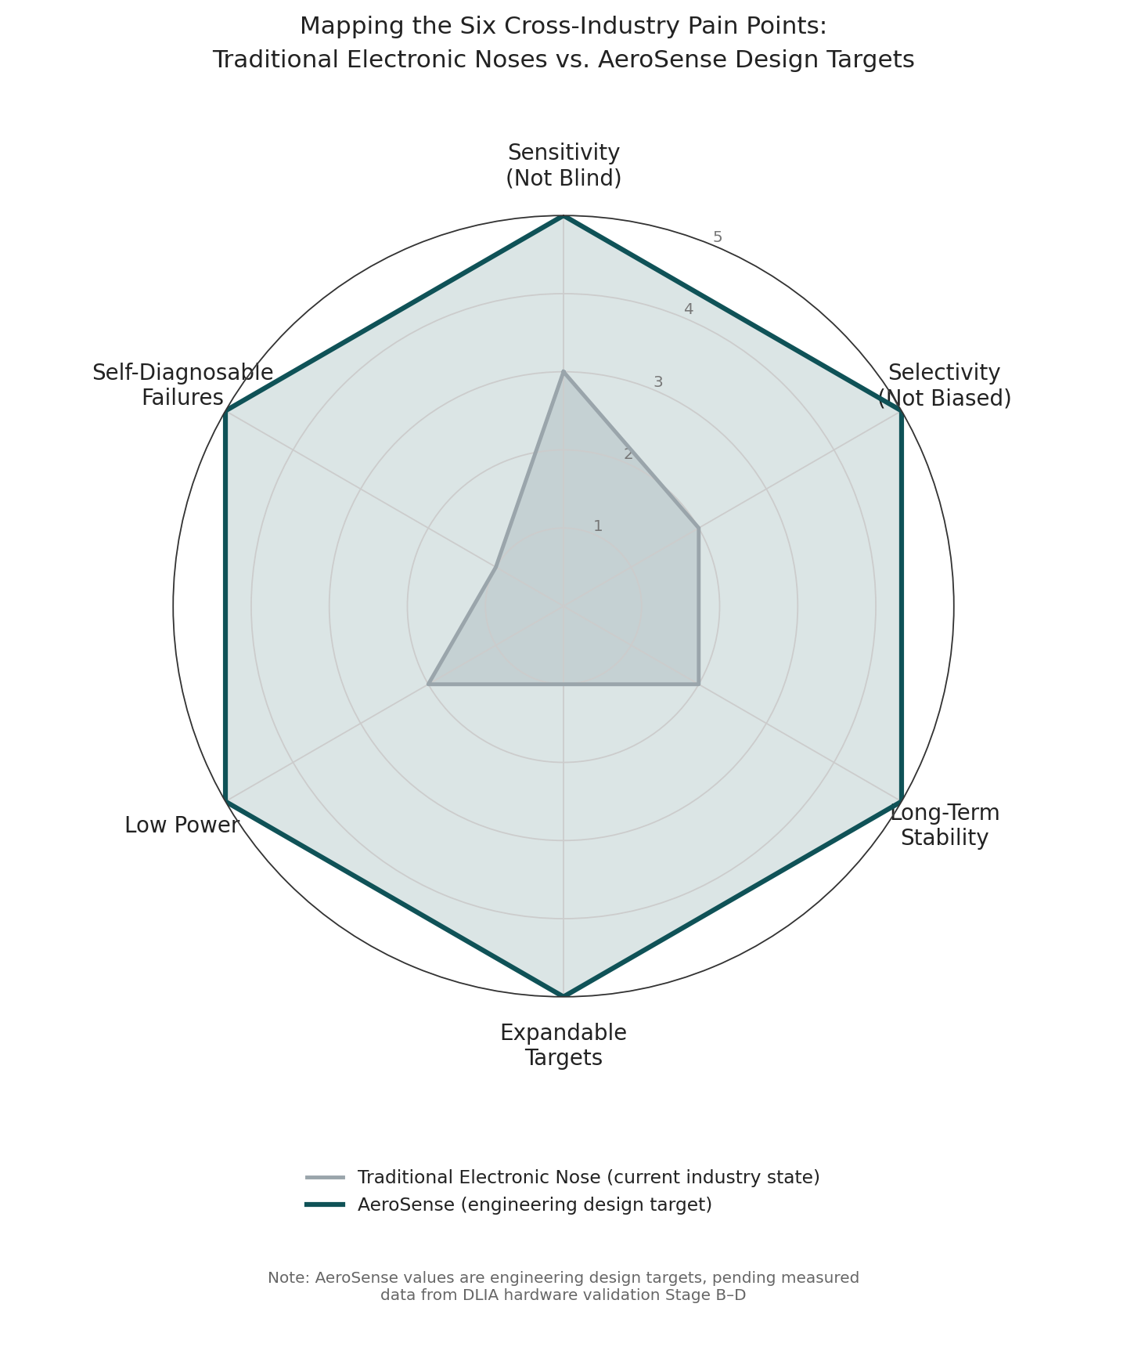
Figure 2 Mapping the Six Cross-Industry Pain Points: Traditional Electronic Noses vs. AeroSense Design Targets

AeroSense's combination of fly receptors + self-renewing cells + neuromorphic edge computing + a programmable receptor library addresses competitors' weaknesses — aging, needing replacement, hard to expand, high cost, and lab-bound — claiming the leading quadrant of "field-deployable, real-time, scalable, and evolvable." Shih-Chuang Biotech, by contrast, has achieved commercially validated high recognition rates in respiratory-infection rapid screening via a chip + nanomaterial approach. How complementary the two teams' technical paths are is worth clarifying further through the interview described in Section 7.1.

8. Market Opportunity and Focus Strategy

8.1 Market Size
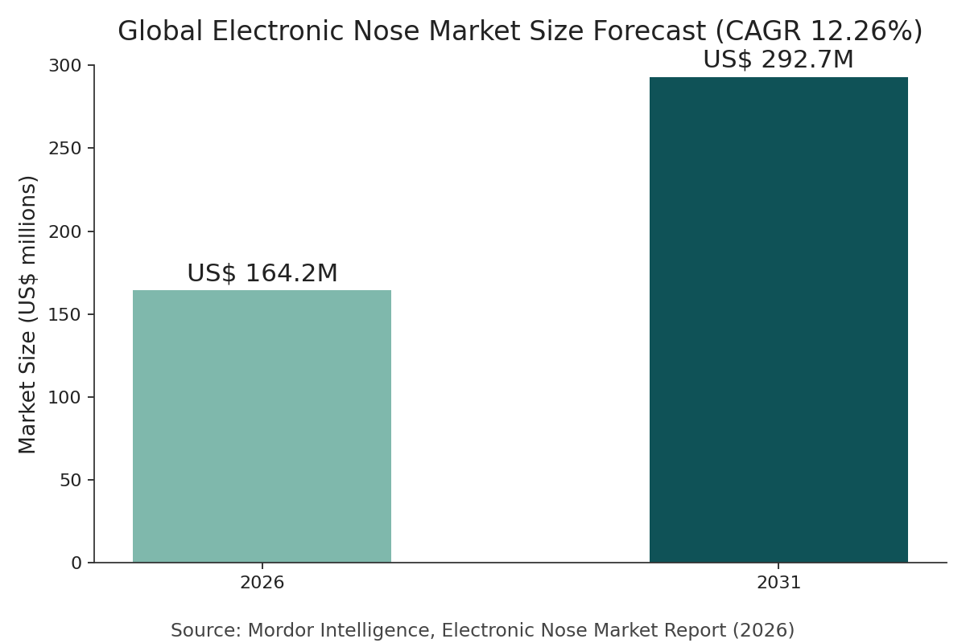
Figure 3 Global Electronic Nose Market Size Forecast (Source: Mordor Intelligence, Electronic Nose Market Report, 2026)
According to Mordor Intelligence, the global electronic-nose market was approximately US$164 million in 2026 and is projected to grow to approximately US$293 million by 2031, a CAGR of 12.26%, with food and beverage applications representing the largest share (about 34.9%) and Asia-Pacific as the fastest-growing region (CAGR 13.72%). Other market research firms (such as IMARC) define the product category differently and arrive at substantially different estimates, so this BP presents figures as ranges cross-referenced across multiple sources, to avoid distortion from relying on any single number (responding to Mentor Comment 6).
Tier | Scope | Description
TAM | Global Gas Sensing / Electronic Nose Market | Spanning agriculture, food safety, environment, industrial safety, and medical; approximately US$160–200M in 2026 and continuing to grow
SAM | Asia-Pacific Early VOC Detection (Agricultural Disease + Food Freshness) | Real-time, on-site, scalable monitoring needs across controlled-environment agriculture, agribusiness, food processing, and cold chain
SOM | Taiwan and Nearby Region Controlled-Environment Agriculture and Food-Site Pilots | Early installation and cartridge subscription revenue entered via academic societies and incubation channels

8.2 Value Chain Positioning
Position | Content
Upstream | Receptor genes and cell engineering, GCaMP fluorescent indicators, electronic components, AI structure-prediction tools
Midstream (This Team) | Receptor engineering and live-cell sensing cartridges, neuromorphic recognition models, edge device integration
Downstream | Agricultural/controlled-environment horticulture integrators, food processing and cold chain, environmental monitoring services, and (long-term) medical and health-screening channels

8.3 Focus Strategy (New Section, Responding to Mentor Comment 7)
Why Focus — and Where to Focus
Our mentor explicitly pointed out that this venture's potential scope of applicability is large (agriculture, food safety, environment, medical), but development should be focused early on, so resources are not spread too thin. The team has adopted this advice: in Phase 1 (the next 12–18 months), personnel and funding will be formally committed only to the single beachhead market of "early VOC detection of agricultural pests and disease", for the following reasons:
(1) Lowest regulatory barrier — classified as a general environmental sensing instrument, not a medical device, allowing the fastest path to a field pilot and revenue (see the regulatory phase table in Chapter 15).
(2) Our existing technical evidence (cell-level validation from Subprojects 1 and 2) is closest to the target odors in this scenario, so a pilot can launch without developing new receptors.
(3) The three-year P&L and cash-burn models in the financial plan (Chapter 13) are already built on the installation and cartridge cadence of this single scenario as their base assumption, keeping resource allocation consistent with the narrative.
The three applications of food safety, environmental monitoring, and early medical screening (see Chapter 10, Application Pipeline) will, at this stage, retain technical extensibility but not be allocated dedicated resources, until the beachhead market validates a repeatable build–measure–learn business model, after which we will expand in sequence per the Chapter 10 timeline — avoiding the "resources spread too thin" our mentor warned against.

9. Business Model and Economic Logic
Mentor Comment 11 pointed out that, so far, the technical stability and application mechanism only describe a direction and industry, without defining the "actual service/product offered" or an estimable business model. This chapter makes the product and pricing concrete, based on the assumptions in the team's financial worksheet.

9.1 Product Definition (Physical Specifications)
The Phase 1 physical product is a gas-tight, desktop detection device, with the internal structure as follows (per the team's product diagram):
- Gas-Tight Lid: features gas in/out ports for introducing the sample gas into the sensing chamber.
- Four-Well Optical Sensing Module: integrates an LED excitation light source and an optical readout window, enabling simultaneous four-channel detection (FDM optical frequency-division multiplexing).
- Custom PCB: an ESP32-based control circuit handling LED driving and digital lock-in computation.
- Raspberry Pi–Class Single-Board Computer: handles data aggregation, display/network output, and cloud data upload.
- Replaceable Live-Cell Cartridge (consumable): contains engineered cells expressing Drosophila olfactory receptors; the core of recurring revenue, replaced periodically according to cartridge lifespan.

9.2 Three-Tier Business Model and Pricing
The business model builds recurring revenue on three tiers — "device sales + replaceable live-cell cartridge subscription + software/data services" — and leads with B2B. Based on the team's financial worksheet assumptions, specific pricing is as follows (assumed scenario, to be calibrated against actual pilot quotes):
Revenue Tier | Pricing Assumption | Business Logic
Hardware Sales (the Razor) | Unit price of NT$120,000 per device, falling to approximately NT$110,000 per device once in mass production | One-time revenue that quickly expands the installed base, building the customer base for cartridge subscriptions
Cartridge Subscription (the Blade) | NT$4,000 per unit per month, rising to approximately NT$4,500 per unit per month once at scale | Periodically replaced live-cell cartridges, contributing predictable recurring revenue (MRR)
Software / Data Services | Recognition-model and dashboard subscriptions, plus custom receptor development services (NRE) | Contributing from Year 2 onward, estimated at approximately NT$1.2M by Year 3

Under these assumptions, the team's financial worksheet projects the following three-year revenue structure: Year 1, 3 units sold, 3 cumulative installs; Year 2, 12 units sold, 15 cumulative installs; Year 3, 35 units sold, 50 cumulative installs; gross margin rises from 45% to 60% as scale and receptor-library reuse increase (see Chapter 13, Financial Plan). We chose to lead with B2B because enterprise buyers have clear pain points, clear budget and willingness to pay, and a single customer can deploy across multiple sites to scale usage; field data flowing back accelerates model optimization and strengthens our moat, while avoiding the education cost and long adoption cycle of the consumer market.

9.3 Data Flywheel
Hardware sales drive growth in the installed base → cartridges and subscriptions contribute recurring revenue (LTV) → field data continuously flows back → the model and receptor library get more accurate the more they're used, forming a competitive moat that becomes harder to catch up with over time. This flywheel logic reinforces the pricing structure in Section 9.2: the device is priced low (the "razor") to win installed base, while the cartridge and software subscriptions (the "blade") are the primary long-term source of gross margin and moat.

10. Application Pipeline and Roadmap
The platform is agnostic to the target odor and can expand horizontally into multiple vertical applications. However, per the focus strategy in Chapter 8, only "early agricultural disease detection" is a formally resourced project at this stage; the other applications retain technical extensibility but are not currently allocated dedicated personnel or funding:
Application Area | Concept | POC | Pilot | Scale-Up | Resourcing Status
Early Agricultural Disease Detection |  |  | ● |  | The only formally resourced item in Phase 1
Food Freshness and Safety |  |  | ● |  | Technically extensible, not currently allocated dedicated resources
Environmental Odor / Industrial Safety Gas |  | ● |  |  | Technically extensible, not currently allocated dedicated resources
Security / Trace Substance Detection | ● |  |  |  | Under observation, not a near-term investment
Non-Invasive Early Medical Screening | ● |  |  |  | Long-term direction, to be invested in once the regulatory and clinical pathway becomes clearer

Technical and business milestones: Q2–Q3 2026 — complete cell-level proof of concept and the first version of the AL+MB model; Q3–Q4 2026 — complete AI receptor optimization and the hardware POC/MVP (including DLIA Stage A–D validation); H1 2027 — target 85% accuracy for the multi-receptor array and complete a paid pilot; from H2 2027 onward, based on beachhead-market validation results, plan for production-scale design and expand installations and move into the environmental market.

11. Technical Proof of Concept and Beachhead Use Case
- Proof of Principle: co-expressing Drosophila receptors and Orco in cells alongside GCaMP6, we used the Orco agonist VUAA1 to induce a measurable calcium fluorescence transient (ΔF/F), validating the sensing principle of "odor binding → fluorescence signal."
- Beachhead Scenario (Agriculture): deploying the device in a greenhouse to continuously monitor crop volatiles; when a specific disease VOC fingerprint appears, an early warning is issued so farmers can intervene before visible symptoms appear, validating the commercial model of cartridge subscriptions and installed-base growth.
The commercial validation logic for this beachhead scenario needs to be cross-checked against the results of the farmers' association field interviews listed in Chapter 4: the technical path of "issuing a warning when a disease VOC fingerprint appears" is currently supported by cell-level and literature-based evidence, but the business hypothesis that "farmers are willing to pay for this, and that it is better than current field-inspection practice" can only be considered confirmed after the Appendix B interviews validate it.

12. Team
AeroSense is a deep-tech team spanning biology, AI, and hardware. At this drafting stage it consists mainly of lab students, covering the following functions:
Member | Role | Responsibilities
Pin-Che Huang | CEO, Hardware | Overall operations, business strategy, and external fundraising; optoelectronic readout hardware, electromechanical integration, and device design
Yi-Chia Fang | COO, Systems Integration | Operations management, business development, and cross-disciplinary coordination; fluidics control, signal processing, and device assembly
Chun-Ting Chou | CTO, Dry lab /  Machine Learning | Neuromorphic models and odor-recognition algorithms
I-Jung Chen | CTO, Wet Lab /  Parts Collection | Drosophila receptor engineering, cell transfection, and fluorescence functional validation
Kuan-Hua Lin | CFO&CMO, Financial / Design | Financial planning and fundraising, budget management, and brand/product design

Faculty Advisor: Prof. Chung-Chuan Lo (Associate Dean, College of Life Science, and Director, Institute of Systems Neuroscience, National Tsing Hua University). The team has a complete research chain from neuroscience principles to engineering implementation, and its core computational technology has direct lineage to the Drosophila mushroom-body research published in Science Advances (2025).

13. Financial Plan
As an early-stage deep-tech team, we prioritize technical milestones and field validation at this stage, with revenue ramping up gradually after the beachhead-market pilot. The charts below are based on the assumptions in our financial workbook (assumed scenario, to be calibrated against actual pilot quotes).
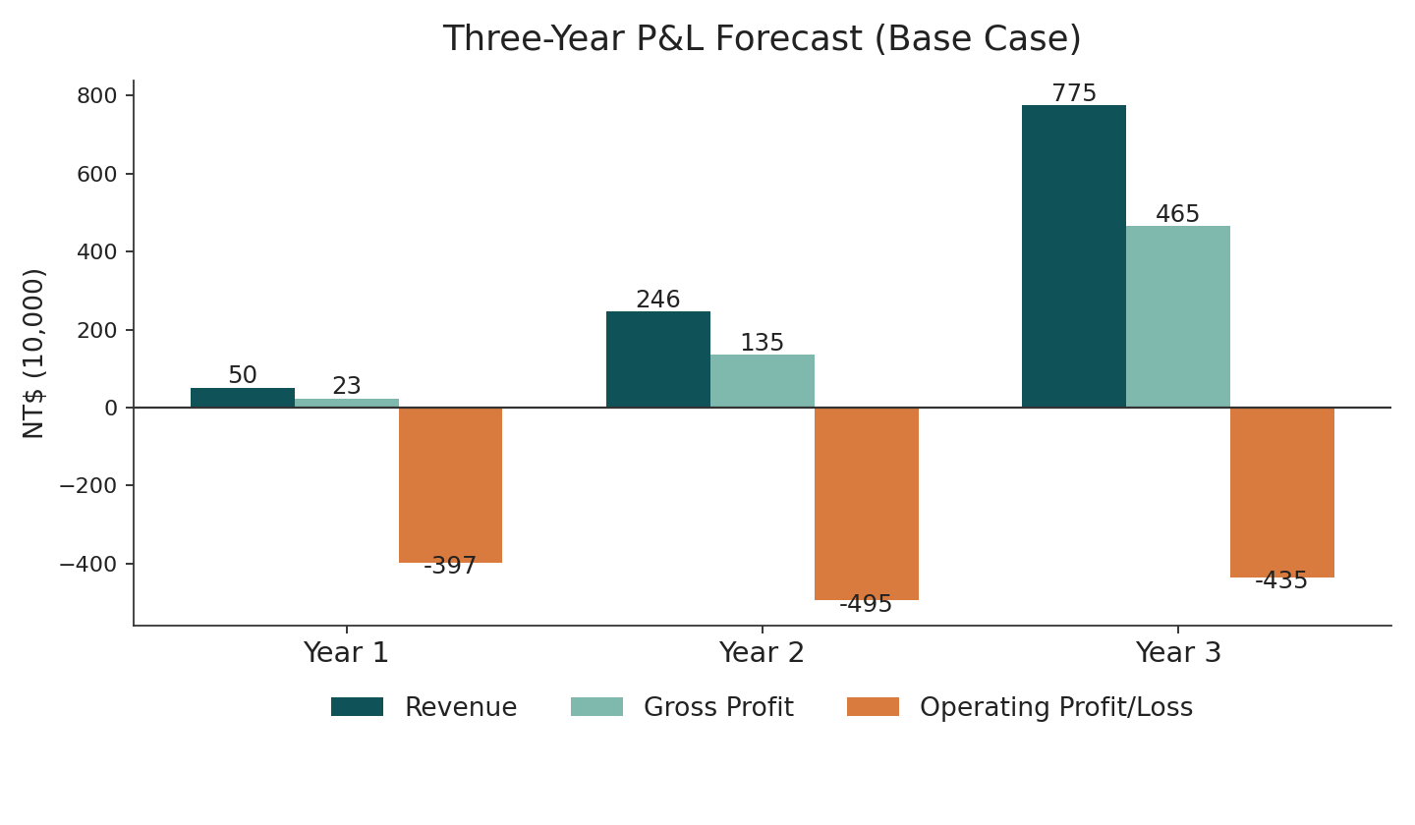
Figure 4 Three-Year P&L Forecast: Strong Revenue Growth, Still a Net Operating Loss After Three Years Given the Deep-Tech Nature of the Business — Underscoring the Need for Fundraising
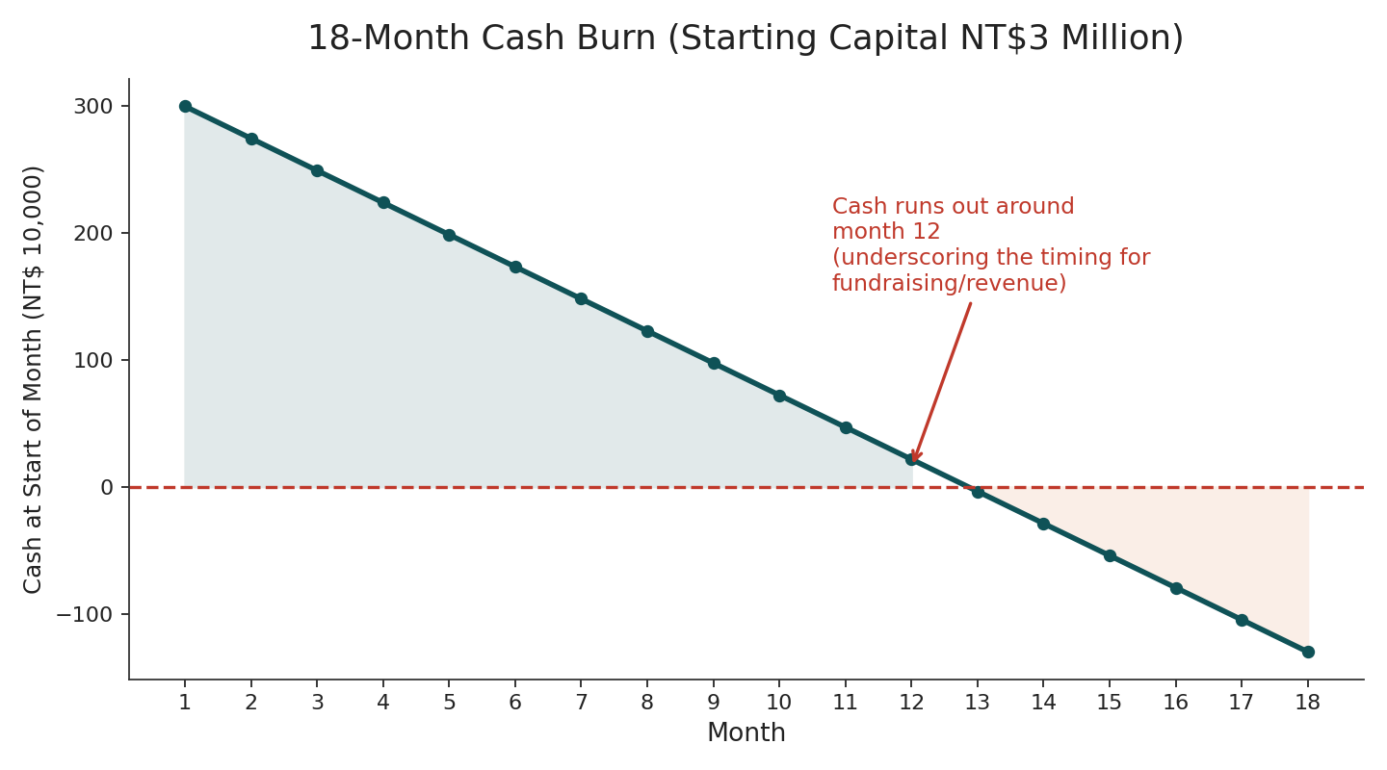
Figure 5 18-Month Cash Burn: With NT$3 Million in Starting Capital, Cash Runs Out Around Month 12 — the Next Funding Round or Revenue Must Be Secured Before Then
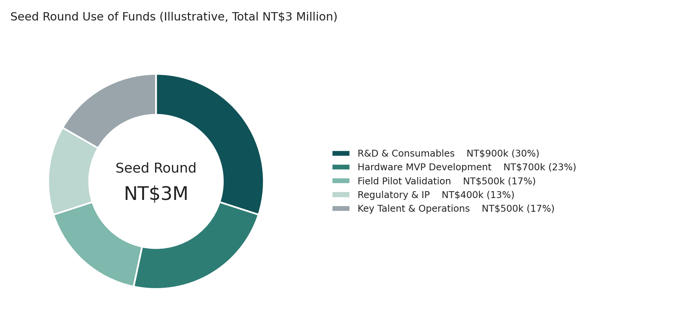
Figure 6 Seed Round Use of Funds (Illustrative, Total NT$3 Million)
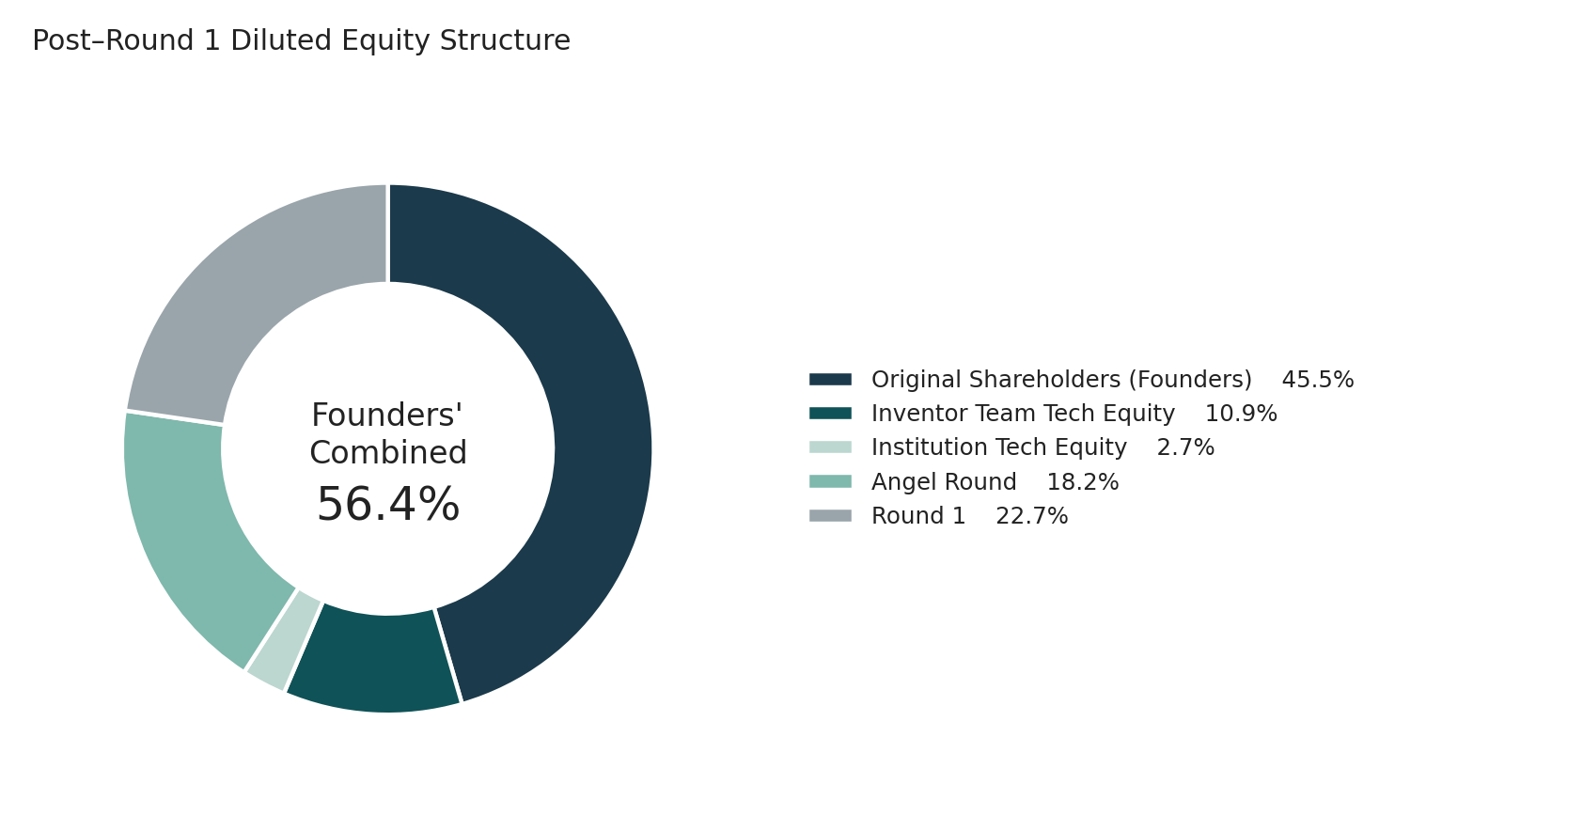
Figure 7 Post–Round 1 Diluted Equity Structure: Founders Retain a Combined 56.4% Stake, Maintaining Control
- Fundraising: planning an angel/seed round (in parallel with competitions and government grants), to fund the critical stage from POC to a commercializable pilot.
- Key Metrics: target runway of 12–18 months; tracking gross margin, LTV/CAC, and the breakeven number of installed units.
Share counts, percentage ownership, valuation, and cash proceeds for the four rounds (founding team capital contribution → technology equity → angel round → Round 1) are detailed in the separately attached financial workbook. The institutional share of technology equity involves university IP ownership and must be finalized with the technology transfer office (see Chapter 15).

14. Risks and Mitigation
Risk | Mitigation Strategy
Insufficient Receptor/Cell Signal-to-Noise Ratio | Adopt higher-signal GCaMP variants, redundant multi-receptor design, and enhanced imaging algorithms
Loss of Function in Mutated Receptors | Design multiple candidate sequences per target, pre-screen localization with fluorescent tags, and pre-screen with AI
Hardware Mass Production and Cost | Modular design, spreading hardware cost across cartridge consumables, and progressive process optimization
Lengthy Medical Market Regulation | Monetize first through agriculture/food safety/environment, treating medical as a long-term, high-value option with early groundwork
GCaMP Licensing and Risk of Being Copied | Address GCaMP commercial licensing early, or design around it; build multiple moats through a receptor database, integration know-how, data network effects, and patents
Funding and Operational Runway | Starting capital runs out in about 12 months; the next funding round and milestone-based disbursements must be planned ahead, with burn rate kept under control
Market Demand Not Yet First-Hand Validated | Farmers'-association and laboratory-physician interviews are not yet complete (see Chapter 4); until then, market demand in the agriculture and medical scenarios should be treated as an untested hypothesis. We have concentrated beachhead-market resources in a single scenario to limit this risk's scope of impact
Existing Solutions May Already Be "Good Enough," Switching Motivation Unclear | Explicitly probe the threshold conditions for switching during interviews (see Appendix B), to avoid investing resources in solving a problem the customer isn't actually in a hurry to solve

15. Regulatory and IP Strategy
Two Key Risks That Must Be Addressed Early
(1) Calcium fluorescence indicator licensing: the GCaMP family is patented by HHMI Janelia; the publicly distributed material is for non-profit research use only, and commercial use requires obtaining a license or designing around it with an alternative indicator.
(2) University IP ownership: the core receptor technology originates from the Institute of Systems Neuroscience and is classified as a work-for-hire invention; before commercialization, a license/assignment agreement must be signed with NTHU's Office of Technology Transfer, and the technology-equity ratio clarified.

15.1 Regulatory Milestones by Phase
Phase | Regulatory Focus
Phase 1: Agriculture / Food Safety | The device is classified as a general sensing instrument, not a medical device — the lightest regulatory bar; compliant with electrical safety/EMC (BSMI, CE)
Biosafety | Uses genetically modified (GMO) cells and must comply with biosafety level (BSL) requirements; deployed devices require assessment of GMO-related regulations and waste disposal
Phase 3: Medical | Use for diagnosis classifies it as a medical device; in Taiwan it is classified by TFDA under the Medical Device Act, requiring ISO 13485 and clinical validation; in the US it would go through FDA 510(k)/De Novo/PMA

15.2 Current IP Position and Future Plans (New Section, Responding to Mentor Comment 10)

Currently in Place
- The scientific basis for the core algorithm derives from a published paper the team participated in (Science Advances, 2025), with a clear research timeline and personnel lineage that can serve as the technical disclosure foundation for future patent applications.
- The plasmid construction and cell lines for receptor engineering have completed proof of concept, providing the most basic prototype of feasibility data needed for a patent application.

Planned Applications (in Priority Order)
1. Edge Hardware Readout Architecture: the integrated readout method combining photodiode array + optical FDM + digital lock-in amplification is the team's own independent engineering development, not an adaptation of an existing solution, making it a near-term priority for evaluating an invention patent application.
2. Programmable Receptor Engineering and Screening Method: a workflow combining AlphaFold structure prediction with site-directed mutagenesis to improve binding affinity; if sufficiently novel, could be evaluated for a method patent.
3. Cartridge Mechanism Design and Replacement Mechanism: as the physical vehicle for long-term recurring revenue, we recommend applying for a utility model/design patent to protect the physical interface of the business model.
4. Edge Implementation of the Neuromorphic Decoding Algorithm: pending clarification of the novelty boundary relative to existing literature (Dasgupta et al. 2017, the LSH algorithm), we will assess the patentable scope, to avoid overlapping with existing public algorithms in a way that would preclude patentability.

Freedom-to-Operate and Licensing Gaps
- Commercial licensing of GCaMP6 (see the risk box above) must have negotiations completed, or an alternative solution evaluated, before the beachhead market pilot scales up. This is one of the critical-path items for cash flow and production timing, not simply a legal matter.
- University IP ownership and technology-transfer terms (the institutional share of technology equity) need to be confirmed early with NTHU's Office of Technology Transfer, to avoid affecting equity and IP due diligence during future fundraising.

16. Vision and Impact
AeroSense's ultimate goal is to make "smell" a data dimension anyone can use and measure anywhere. In the short term, we help farmers intervene before disease outbreaks, reducing pesticide use and crop loss, and help the food industry protect freshness and safety. In the medium term, we make environmental odors and hazardous gases impossible to hide. In the long term, a single breath will be able to sound an early warning for disease. Once machines have biological-grade smell, many problems that today are discovered "too late" will be seen ahead of time.
What this revision aims to emphasize is that the path to realizing this vision will, per our mentor's advice, begin by validating the real pain point and a repeatable business model in a single beachhead market — rather than declaring equal-weight commitments across all four application areas at once.

