AeroSense Developer Manual
Revision: 2026-10-19 R6. Use this manual to assemble, program, and start the reader. This revision incorporates assembly-trial feedback. Assembly observations do not establish optical or biological performance.
The procedures use ASD-STE100 Issue 9 writing principles. They use short sentences, stable terms, and one action per step. Full vocabulary and rule compliance has not been audited. This document does not claim formal ASD-STE100 compliance. Writing reference.
Use the User Manual for routine controls. Use the USD BOM for purchasing. Use the existing eight parts in 01_print.
R6 changes: M2.5 PCB screws and nuts; M3 × 36 mm outer-enclosure screws; fan spacers and a blade-clearance check; and an explicit check of the middle hood, photodiode and well alignment. The original CAD dimensions remain nominal. Confirm the fit of the actual printed parts before applying power.

1 Prepare the parts
Preparation: Use a dry tray, tweezers, scissors, and drivers that fit the supplied screw heads. Complete resin washing and post-curing before assembly. Follow the resin supplier's instructions.
Part | Quantity | Specification
01 base; 02 light shield; 03 gas lid; 08 compression plate | One each | PC/GF-like Black
04 NE; 05 NW; 06 SW; 07 SE wells | One each | Aqua Clear Plus
PCB screws and nuts | 4 screws + 4 nuts | M2.5. Select screw length for the actual PCB/post/washer stack; do not let the screw bottom out.
PCB flat washers | 4 | Fit M2.5 screws and the available bearing area. Keep metal clear of tracks and components.
Fan fasteners | 2 screws + 2 nuts + 2 washers | M3; the nominal design used 16 mm screws. Recheck length after adding spacers. Washers: 3.2 mm ID × 7 mm OD × 0.5 mm.
Outer-enclosure fasteners | 2 screws + 2 nuts | M3 × 36 mm screws with matching M3 nuts.
Fan spacers | One matched set | Support the fan frame evenly. Select height by the blade-clearance check; no fixed height is confirmed.
Fan | 1 | Nominal 40 × 40 × 10 mm; 32 mm mounting pitch. Verify the supplied fan.
Seal sheet | As required | 0.8 mm opaque silicone
Receiver filter | 1 layer initially | LEE 101 Yellow

Screw lengths exclude the head. Use the supplied pan- or socket-head fasteners, not countersunk screws. Check thread engagement and clearance with the actual stack. The PCB screw length and fan spacer height have not been specified. Do not substitute the old M3 PCB screws. The gas shelf is part of lid 03.
Steps:
1. Set SW1 to OFF.
2. Disconnect external power.
3. Remove the battery.
4. Arrange the eight printed parts by their numbers.
5. Separate the PCB, fan and enclosure fasteners into labelled groups.
6. Remove loose support remains and debris.
Keep the parts dry. Do not use a cracked well or damaged wire.
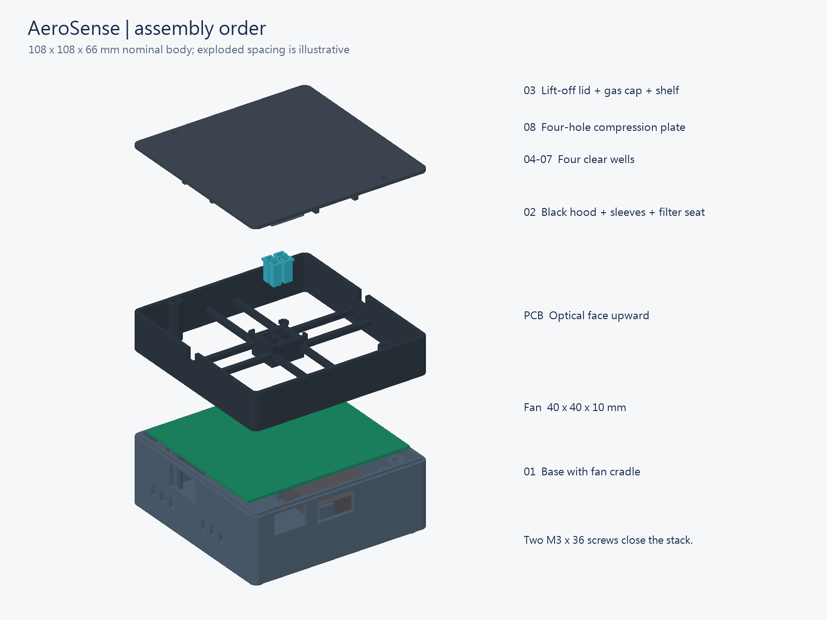
Assembly positions. This drawing retains the nominal CAD geometry; the fan spacer and M2.5 nut retention must be checked on the actual build.

2 Identify the orientation
Put the PCB optical face upward. The USB-C opening is the front. SW1 is on the right when viewed in this orientation. Before lowering the PCB, identify the ESP32 Wi-Fi antenna: it is the printed conductor area at the end of the ESP32 module, beside its silver metal shield. It is not the USB connector. Match the actual ports to the enclosure openings.
The well positions are NE, NW, SW, and SE. These names identify fixed assembly positions. Do not exchange them when rotating the reader.
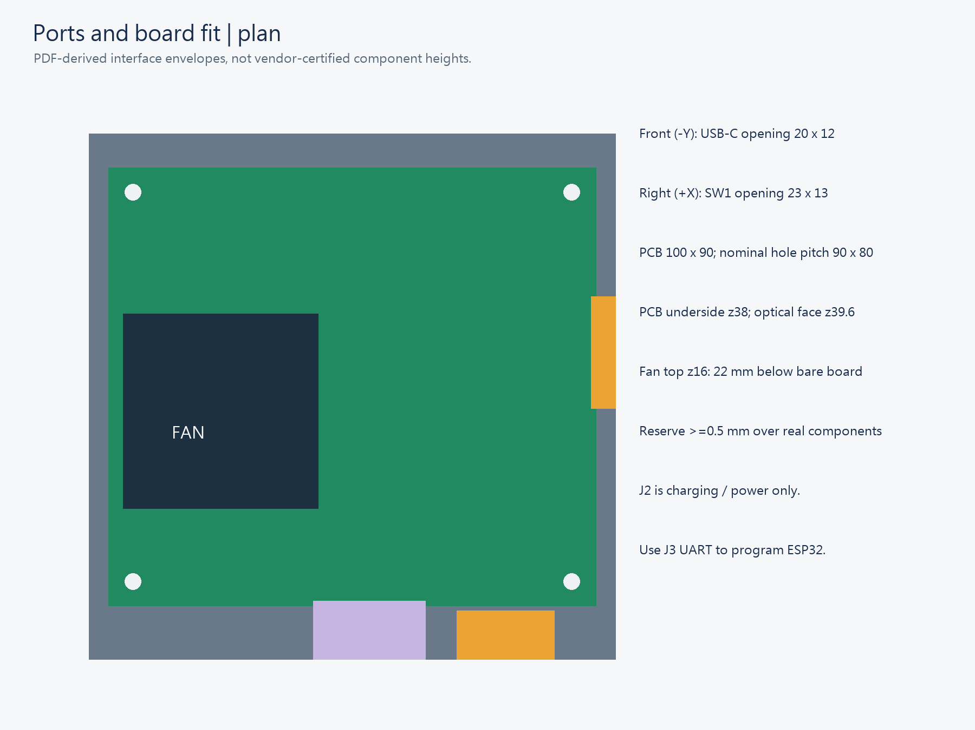
Interfaces and orientation
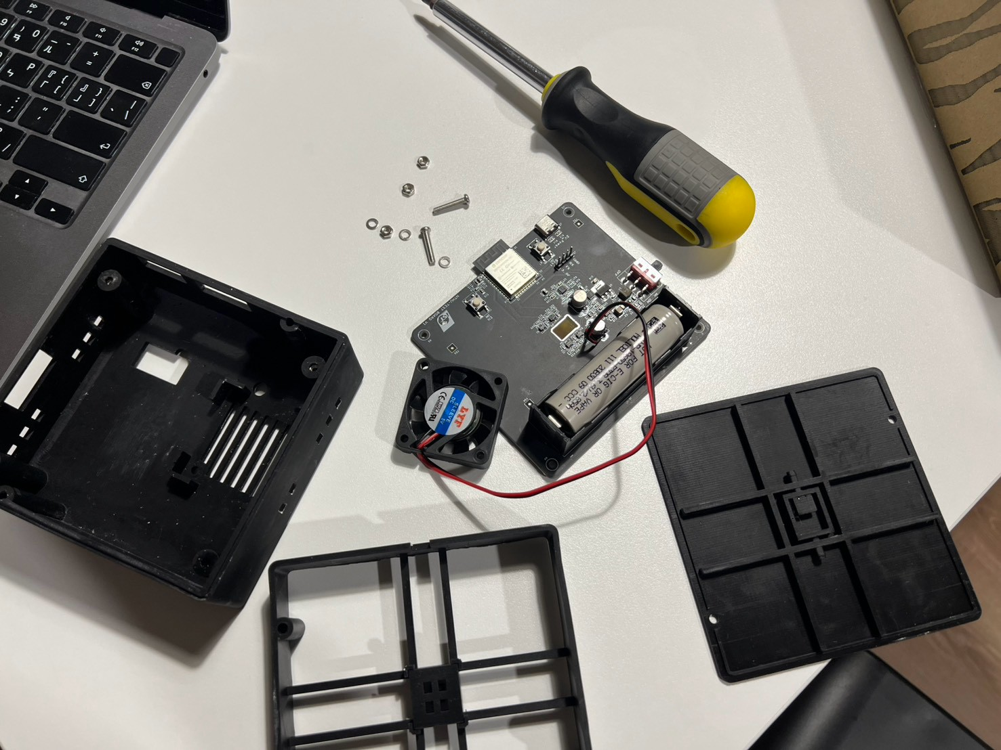
Assembly-trial photograph. The ESP32 module is near the upper-left edge of the PCB in this view; its dark antenna extension sits beside the silver shield. Identify it before turning the optical face upward. Disconnect external power and remove the battery before assembly.

3 Install the fan and PCB
Preparation: Keep power disconnected. Use the four M2.5 PCB screws, four M2.5 nuts and four PCB washers separately from the fan hardware. Use two fan screws, two matching M3 nuts and two fan washers, plus a matched spacer set. Reserve the two enclosure nuts for Section 6.
Steps:
1. Put the two fan nuts in the diagonal recesses underneath the base.
2. Place the spacers between the fan frame and its base supports. Keep the intake open.
3. Set the fan on the spacers. Point its airflow arrow toward the PCB.
4. Put one fan washer under each screw head. Insert the two diagonal fan screws and engage the nuts.
5. Tighten the fan screws alternately. Do not twist the fan frame.
6. With power off, turn the blades gently by hand through a full rotation. They must not touch the base, spacers or wires. Adjust the spacer height if contact remains, then repeat this check.
7. Route the fan wires along the enclosure edge. Keep the fan disconnected.
8. Fit one M2.5 nut at each of the four PCB supports, below the PCB bearing surface and aligned with the screw hole. Hold each nut while starting its screw; do not leave a loose nut on the PCB.
9. Check nut retention before lowering the board. If an old M3-sized side pocket cannot retain the M2.5 nut, correct the holder before assembly. Do not omit the nut or move it to an unverified position beneath the base.
10. Match the PCB USB-C, SW1 and antenna orientation to Section 2.
11. Lower the PCB onto its four supports. Check that all four supports contact the board without rocking.
12. Put one correctly sized washer under each M2.5 screw head. Keep the washer clear of conductors.
13. Start all four M2.5 screws loosely. Temporarily place middle hood 02 and lid 03 without tightening the enclosure screws. Check the optical alignment described in Section 5 and check the ports.
14. Remove the lid and hood. Tighten the four PCB screws gradually in a diagonal sequence while the board remains flat. The lid is not used to force the PCB into place.
15. Recheck the fan blade clearance, nut retention and wire route. Keep the fan unpowered until the electrical checks below.
Check: The fan blades turn freely after tightening. The PCB lies flat. All four PCB screws engage retained M2.5 nuts. No loose metal remains in the base. USB-C, SW1, J3, SW2, and SW3 remain accessible.
If a part catches, lift it and align it again. Do not force the PCB down with screws. Follow the fan connector's polarity. Never power the fan from an ESP32 GPIO. The fan cools the PCB; it does not supply sample gas.
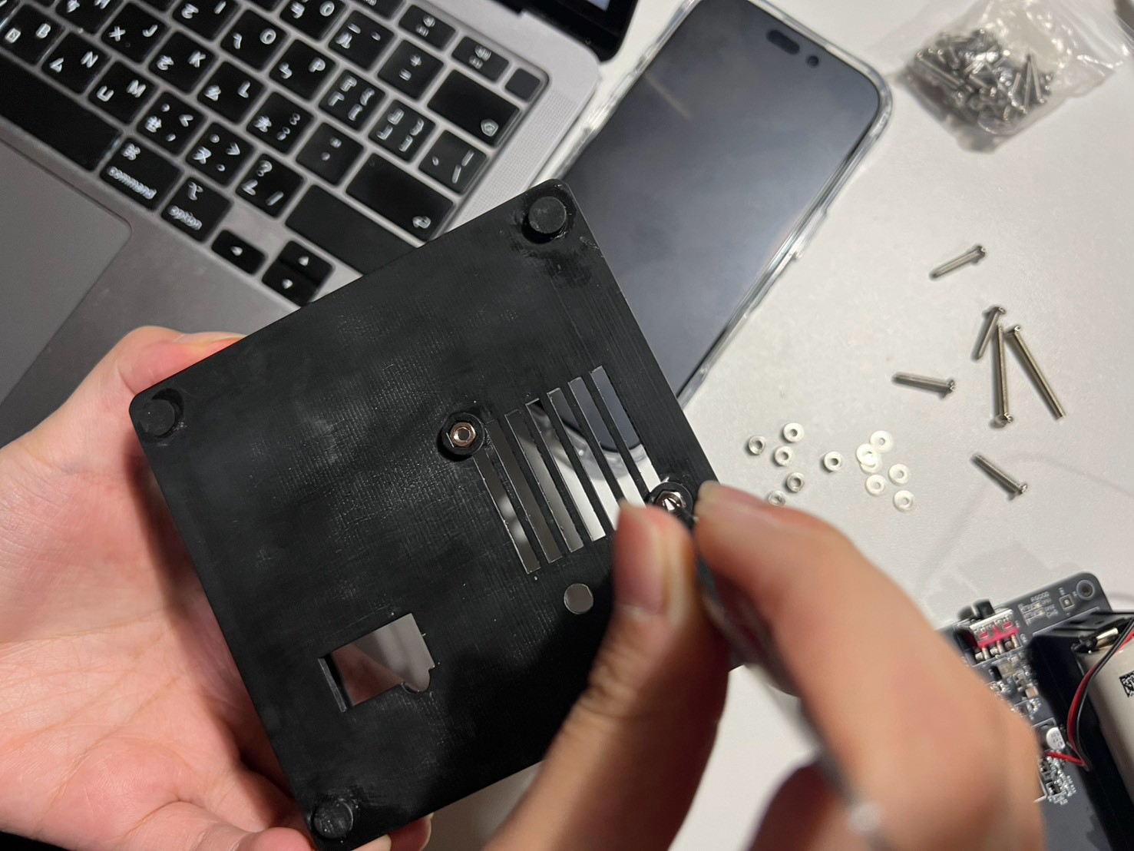 | 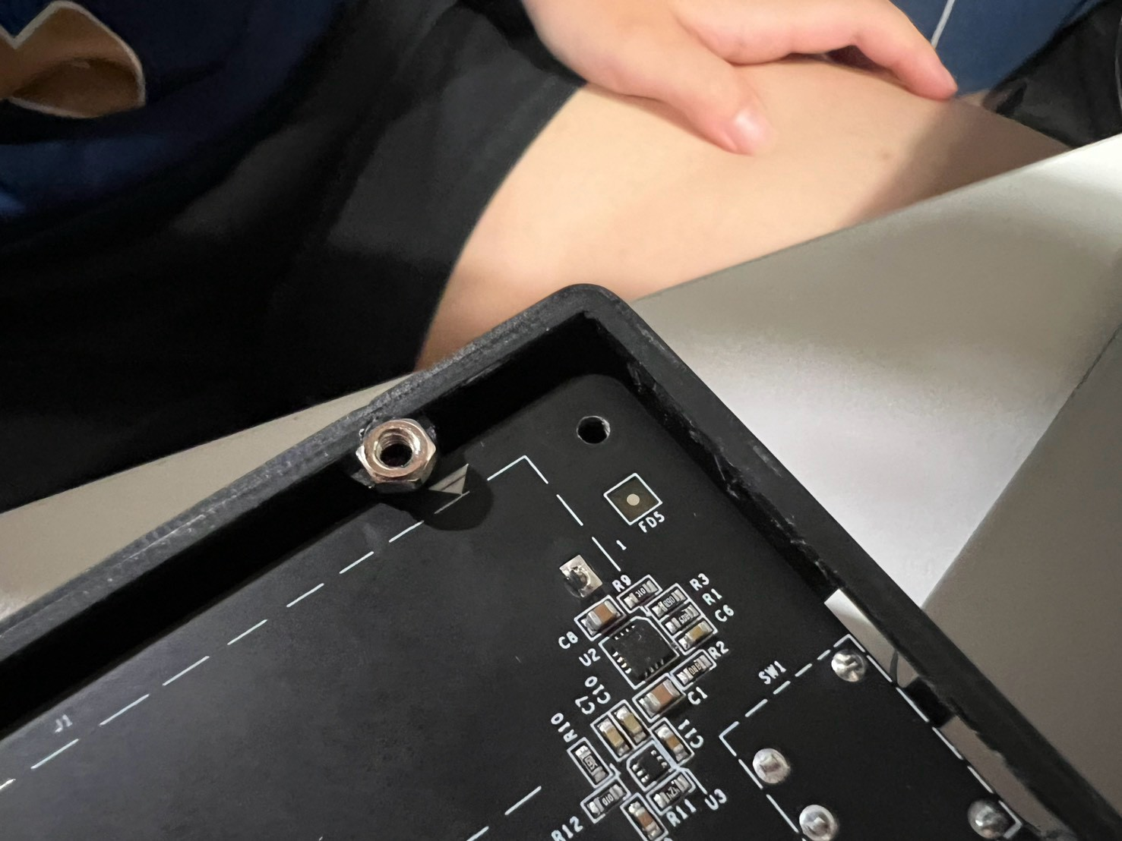
Fan fastening during the trial. The two diagonal nuts are reached from below the base. The photo does not set the spacer height; use the free-rotation check. | The trial exposed difficulty retaining a nut beside the PCB. This is an observed fit issue, not an approved loose-nut arrangement. Check the corrected M2.5 holder before assembly.
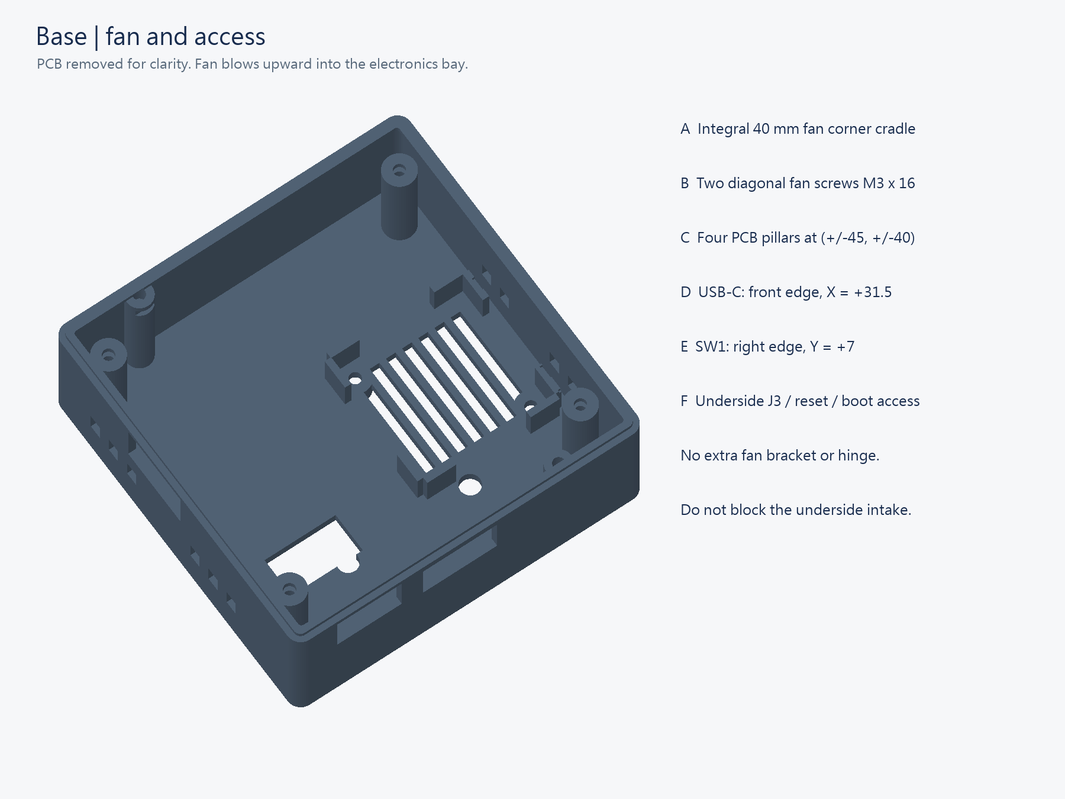
Nominal fan support and openings. The diagram predates the spacer correction. Verify the actual raised fan, screw and component clearances; the illustrated unraised fan height is not an assembly measurement.

Fan power
The present fan is labelled DC 5 V, 0.2 A. It has red and black wires with a plug. Nominal input power is about 1 W.
Mounting: the nominal design accepts a 40 × 40 × 10 mm fan with 32 mm hole spacing and two diagonal M3 fasteners. The assembly trial showed that the fan must be raised to prevent blade contact with the base. Add stable, equal-height spacers at its mounting supports, then select screws that still engage the underside nuts without contacting the PCB. The earlier 16 mm length must be checked against the added spacer height. Do not mount the fan through unprovided PCB holes.
Power: the schematic has no dedicated fan connector. Use a matching, correctly polarized 5 V USB adapter lead with an external 5 V supply. Allow more than 0.2 A supply capacity and margin for starting current.
Do not connect the fan to J1, J3 or GPIO. J1 connects the battery. J3 carries 3.3 V logic signals. Matching two-pin housings do not establish correct polarity.
Red usually indicates positive and black negative. Confirm this with the fan label and wiring data. Connect fan positive to +5 V and negative to GND. A correct adapter lead avoids soldering.
For PCB power, the developer must identify suitable physical 5 V and GND pads. Check supply and starting-current margin first. Do not guess IC or capacitor pins. 5V_USB and boosted 5V are different nets with different switch behavior.
Secure wires with power disconnected. Keep them away from blades, optical windows, tubing and solder joints. Leave the underside intake open. The fan cools electronics; it does not supply sample gas.
Abnormal U2 heating was reported. A fan must not conceal a short circuit, charge-setting fault or supply fault. Do not repeatedly power the affected PCB to test cooling before the fault is resolved.

4 Install the receiver filter
Preparation: Start with one LEE 101 Yellow layer. Keep the PCB unpowered. The receiver seat is nominally 5.2 × 4.2 mm.
Steps:
1. Cut the LEE sheet to fit the receiver seat.
2. Invert light shield 02 on the dry tray.
3. Put the filter flat in the receiver seat.
4. Cover the PD collection aperture completely.
5. Keep the four LED excitation paths open.
6. Block light paths around the filter edges.
7. Keep adhesive outside the collection aperture.
Check: The filter lies flat. Its edges do not leave an open light path. Do not press or crease the filter.
The experiment compares no filter, one LEE layer, two LEE layers, and one 500 nm OD4 longpass filter. Follow the validation plan for that comparison.
The OD4 candidate is Edmund Optics #29-190. Its 12.45 mm disc does not fit this rectangular seat. Use it only after a suitable mounting method is available. Do not force or arbitrarily cut the disc. Product specification.
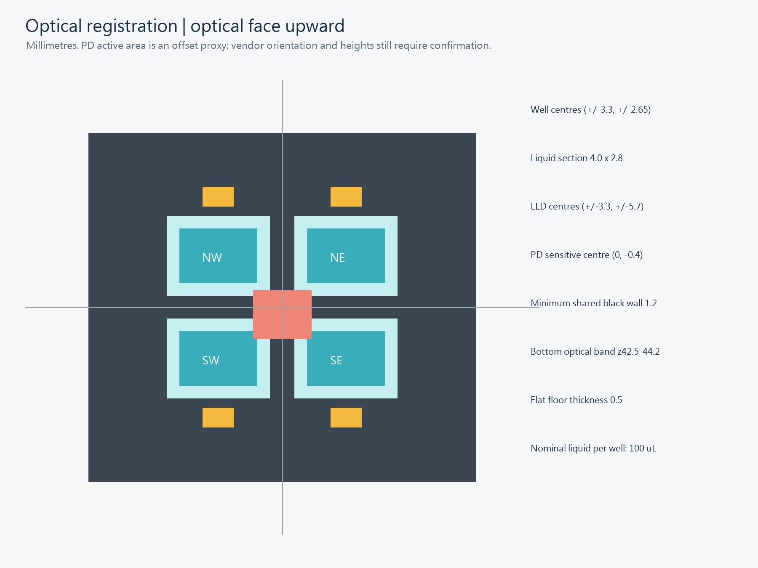
Receiver filter and well alignment; use a working fill of 100 µL per well.

5 Install the seals and wells
Preparation: Open the seal template. Print at actual size, or 100%. Disable fit-to-page scaling. Cut the three seals from the 0.8 mm silicone sheet.
Seal | Shape
PD seal | Small frame around the PD window
Lower seal | Four openings aligned with the four wells
Upper seal | One rectangular opening above plate 08

Steps:
1. Put the small PD seal around the PD window.
2. Keep the active window open.
3. Orient middle hood 02 above the PCB without pressing it down. Align its receiver opening with the centre of the photodiode (PD), then lower it gently.
4. Insert wells 04–07 in their marked positions. Check the well centres and the shared collection opening against the optical-registration drawing. The black walls must not cover the PD active window.
5. Point each well flange outward.
6. Keep each well floor downward.
7. Put the four-hole seal over the well openings.
8. Align its four holes with the wells.
9. Put plate 08 in its guides.
10. Put the upper ring seal above plate 08.
11. Remove visible debris and wrinkles from the seals.
The hood is directional. Before fitting seals, inspect from above and from the side: the PD must be centred under its collection opening and the wells must align with their sleeves. If the hood seats but the optical openings do not align, lift it and correct its orientation. Do not choose orientation from the outer square shape alone. The wells rest on their flanges; their floors must not press on PCB components. Keep plate 08 in the stack to distribute the lid force.
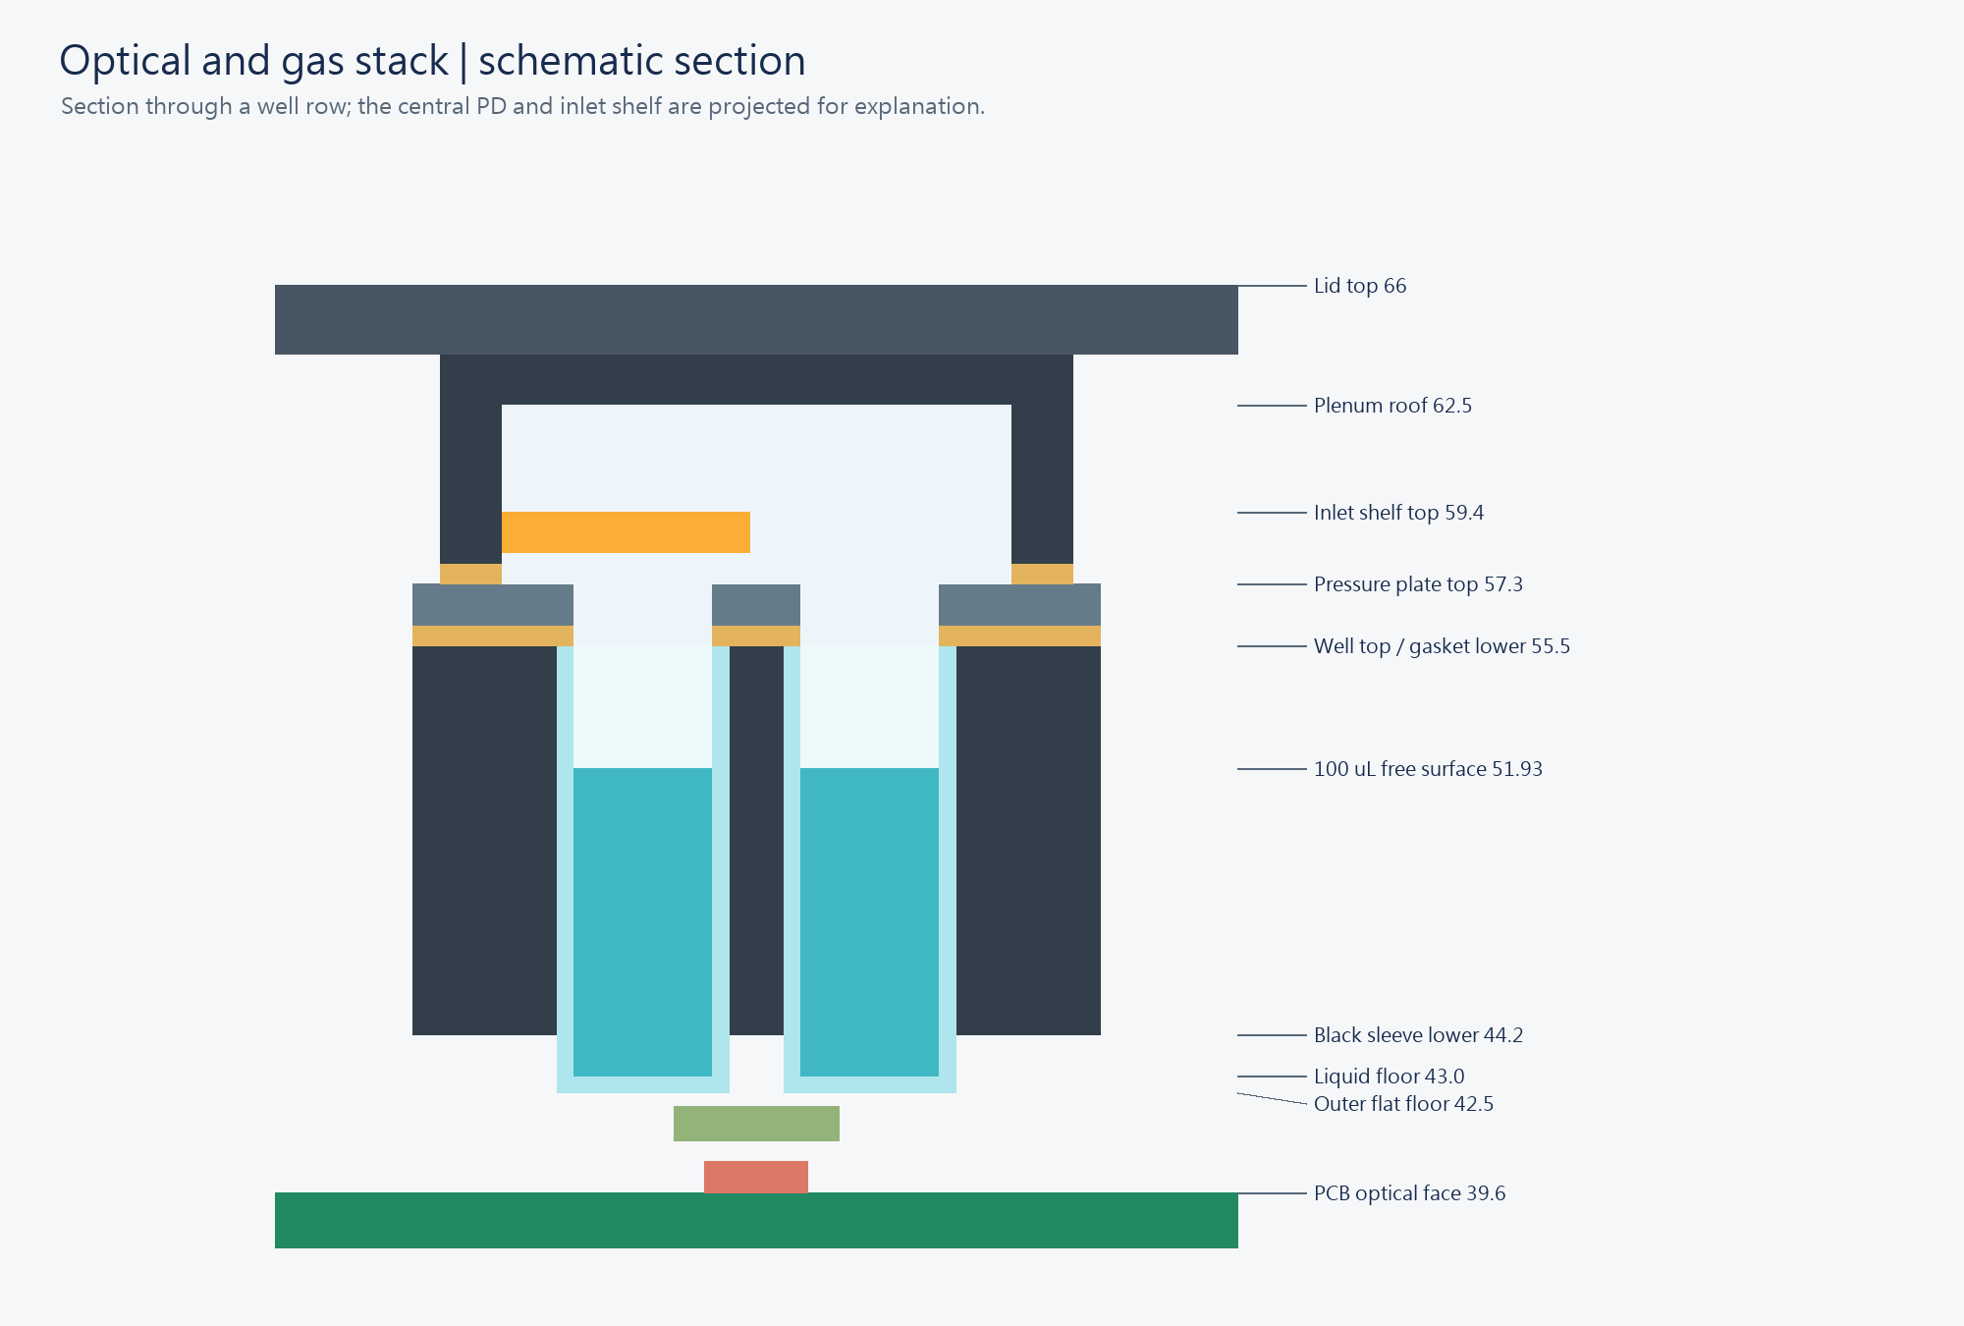
Wells and seal order; use a working fill of 100 µL per well.
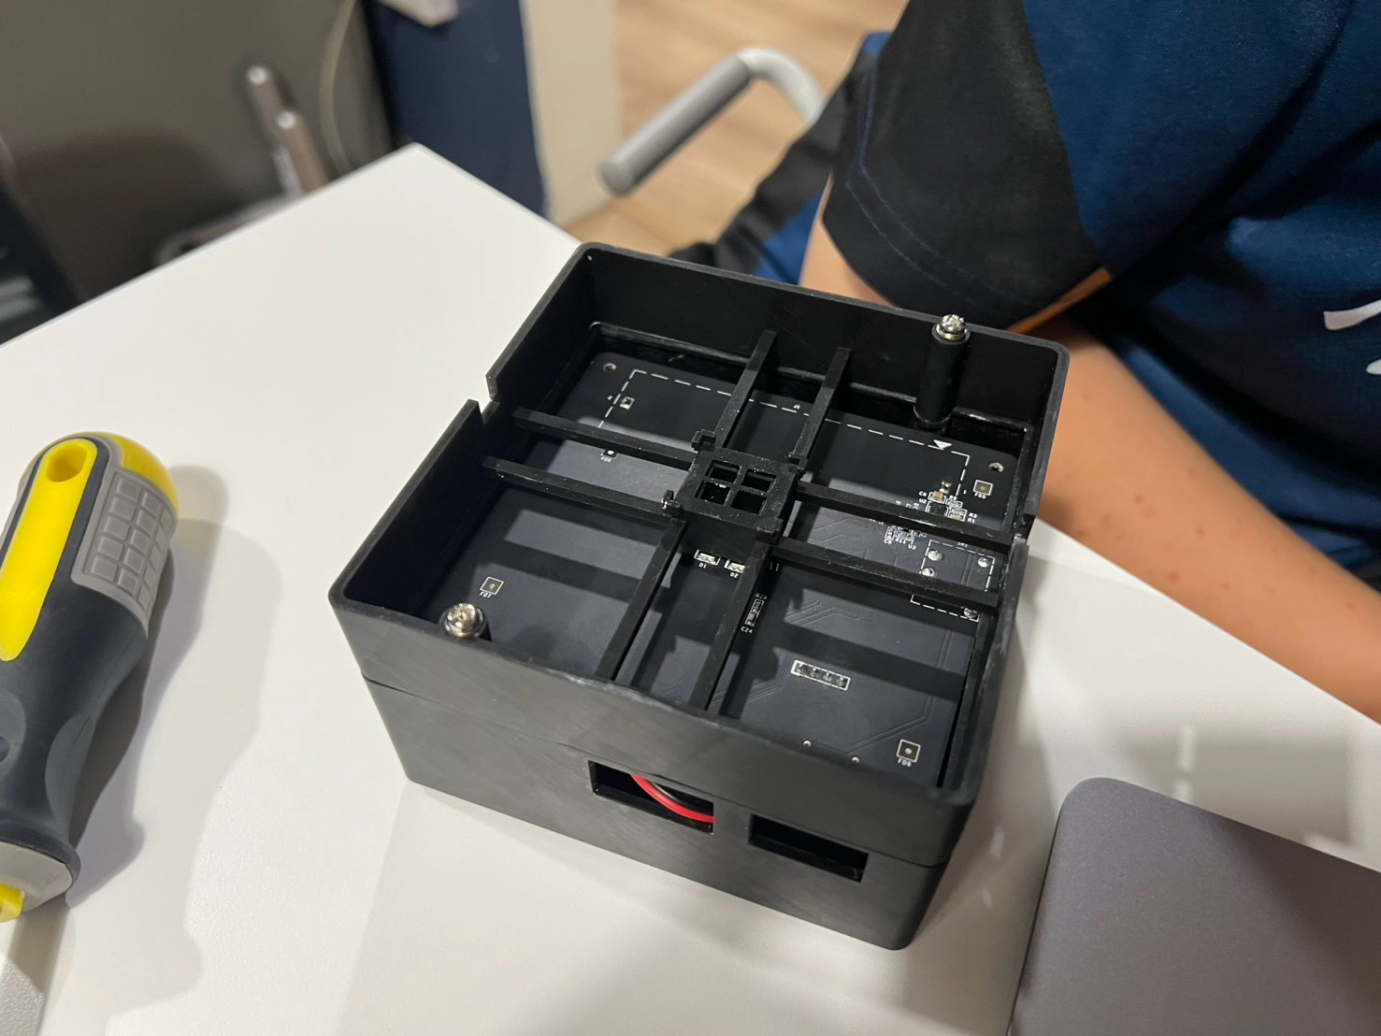
Middle-hood fit check during the assembly trial. Use this view to identify the cross-shaped supports and central well holder. The photograph shows the assembly task; confirm PD and well alignment on the actual board before closing.

6 Connect the tubes and close the lid
Preparation: Use flexible couplers, gas tubing, two suitable gas filters, two M3 × 36 mm outer-enclosure screws and two matching M3 nuts. Leave external gas flow off. Complete the PCB tightening and optical-alignment checks first.
Steps:
1. Find IN and OUT on the gas-lid drawing.
2. Mark these names on the lid.
3. Support the root of the IN tube tail.
4. Push its flexible coupler on gently.
5. Fit the OUT coupler in the same way.
6. Route both tubes through the enclosure openings.
7. Connect the inlet filter and sample tube to IN.
8. Connect OUT through its filter to the downstream suction unit.
9. Keep the outlet open to gas flow.
10. Seat the two enclosure nuts in their lid-post holders. Confirm that both are retained and aligned with the screw paths. Lower lid 03 over the seal stack.
11. Start both M3 × 36 mm screws by hand while the lid remains loose. Each screw must engage its nut without force.
12. Tighten the screws alternately until the lid seats evenly. Stop if a nut turns, escapes or cannot seat. Correct the holder; do not close the reader with a missing nut.
13. Keep the tubes free from pinching.
Gas path: sample → inlet filter → IN → chamber → OUT → outlet filter → controlled suction → approved exhaust.
IN is on the CAD −X side. OUT is on +X. The apparent left and right sides change when the lid rotates. Do not force rigid tubing onto printed tails. Do not clamp both ports while closing the lid.
Keep liquids away from the PCB during assembly. Use 100 µL per well. The team reports that a well is full at approximately 120 µL. This is an approximate capacity, not the working fill. Before the first wet experiment, check closure and leakage.
The reader does not control gas flow, temperature, CO2, or humidity. Use the airflow model guide for gas-operation context.
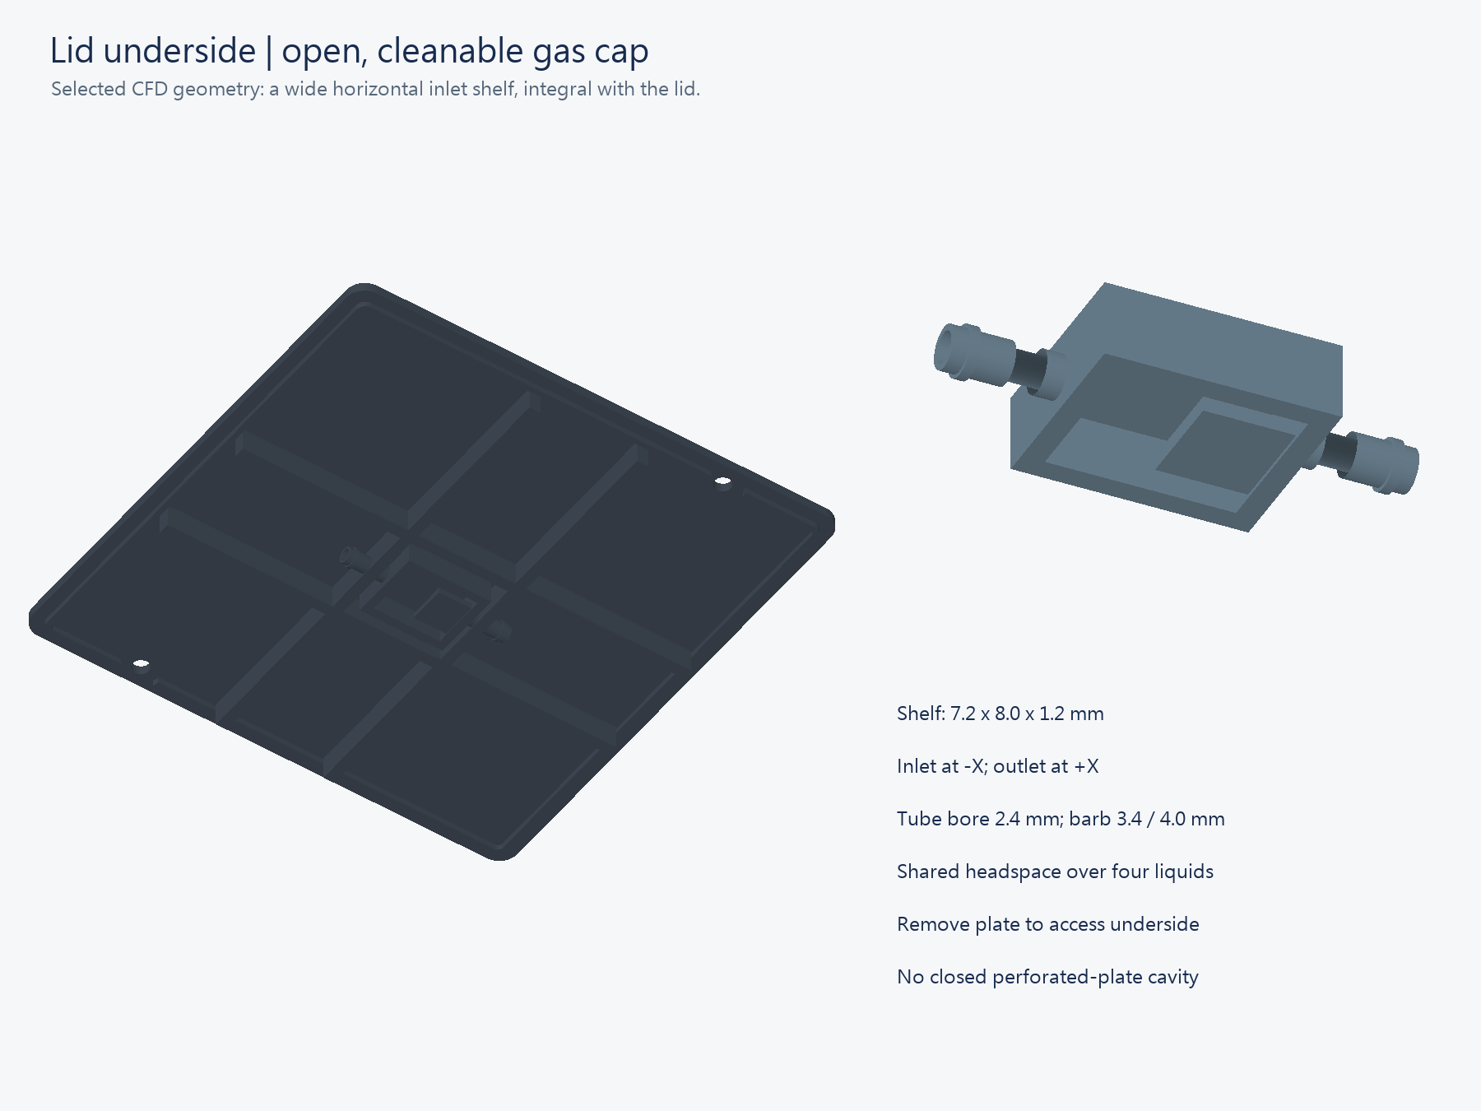
Gas shelf and tube connections

7 Connect the programming adapter and PCB power
Preparation: Use a USB–TTL adapter (USB–UART) with 3.3 V TX logic. Use a separate USB wall charger labelled 5 V output for J2.
The standard programming route uses two USB connections:
Connection | Purpose
Computer USB → USB–TTL adapter → J3 | Programming signals: TX, RX, and GND
Wall outlet → 5 V USB charger → USB cable → J2 USB-C | PCB power

The adapter does not power the PCB through these three signal wires. Keep its VCC disconnected. J2 is the power input, not the programming COM interface.
J3 pin | Signal | Adapter connection
1 | 3V3_DIG | Leave disconnected
2 | TXD0, GPIO1 | RX
3 | RXD0, GPIO3 | TX
4 | GND | GND

Steps:
1. Set SW1 to OFF.
2. Disconnect J2 power.
3. Disconnect the adapter USB cable.
4. Identify J3 pin 1 from the board marking.
5. Set the adapter TX logic to 3.3 V.
6. Connect J3 pin 2 to adapter RX.
7. Connect J3 pin 3 to adapter TX.
8. Connect J3 pin 4 to adapter GND.
9. Leave J3 pin 1 and adapter VCC disconnected.
10. Check for swapped wires, loose metal, and bridged pins.
11. Connect the adapter USB cable to the computer.
12. Connect J2 by USB cable to a charger labelled 5 V output in a wall outlet.
13. Set SW1 to ON.
Check: TX and RX cross. Grounds connect. The PCB has power, and SW1 is ON. A COM port only confirms the adapter connection. With SW1 OFF, the COM port can remain visible while the ESP32 gives no response.
The schematic supports J2 power without a battery. This is a circuit-design conclusion, not a completed physical-board test. With a suitable charged battery at J1 and SW1 ON, J2 is optional.
A VCC jumper does not always change TX voltage. RS-232 and 5 V TX are unsuitable. If the pin order or adapter logic is unknown, keep power off until identified. See the J3 schematic detail.

8 Configure and build
Preparation: Install the official PlatformIO IDE extension in VS Code. SW1 is power. SW2 is EN / Reset. SW3 is BOOT.
Steps:
1. Open 03_software/firmware in PlatformIO.
2. If private configuration is absent, copy src/config.example.h to src/aerosense_config.h.
3. Set AP_PASSWORD to at least eight ASCII characters.
4. Set API_KEY to a separate private random value.
5. Keep WIFI_SSID empty for initial direct control.
6. Keep CLOUD_URL empty.
7. Keep BOARD_VALIDATED=false.
8. Save the configuration.
9. Open the PlatformIO terminal.
10. Run the firmware build command.
pio run -e esp32dev
11. After SUCCESS, run the filesystem build command.
pio run -e esp32dev -t buildfs
Check: Both builds show SUCCESS. Firmware and LittleFS are separate outputs. AP_PASSWORD controls Wi-Fi access. API_KEY authorizes webpage commands. Preserve existing private settings.
If WinError 183 names .pio/build/esp32dev, wait for other Build or Upload operations to finish. Then repeat Build once. The cause is not confirmed. A mirror warning can recover if the package later reports installation. Read the final SUCCESS or FAILED result. Do not move the project for this error.
If the build still fails, retain its first error for diagnosis. Do not upload a failed build. Do not publish src/aerosense_config.h or private keys.

9 Upload firmware and the webpage
Preparation: Complete Section 7. Keep J2 power connected and SW1 ON throughout both uploads. Find the adapter COM port in Device Manager. COM7 below is an example. Close the serial monitor before upload.
Order: connect wires with power off → supply PCB power → SW1 ON → BOOT/Reset → upload → BOOT/Reset → uploadfs.
Firmware steps:
1. Type this command without pressing Enter.
pio run -e esp32dev -t upload --upload-port COM7
2. Hold SW3.
3. Press and release SW2.
4. Keep SW3 held.
5. Press Enter in the terminal.
6. After ESP32 detection or Writing starts, release SW3.
7. Wait for SUCCESS.
Filesystem steps:
Keep PCB power on. Repeat the BOOT/Reset sequence for this second upload.
1. Type this command without pressing Enter.
pio run -e esp32dev -t uploadfs --upload-port COM7
2. Hold SW3.
3. Press and release SW2.
4. Keep SW3 held.
5. Press Enter in the terminal.
6. After ESP32 detection or Writing starts, release SW3.
7. Wait for SUCCESS.
8. Check that SW3 is released.
9. Press and release SW2.
Check: Both uploads succeed. Firmware upload alone does not install the webpage. Use this command when boot output is required:
pio device monitor --port COM7 --baud 115200
The fixed boot reminder says “upload filesystem before opening UI.” This message can appear after successful upload. It does not prove a filesystem fault. Press Ctrl+C before the next upload.
If Connecting persists or No serial data received appears, first check J2 power and SW1 ON. Then check COM, crossed TX/RX, common GND, and the BOOT/Reset sequence. A visible COM port does not prove PCB power. If the webpage shows 404, check buildfs and uploadfs.

10 Start and check the controls
First resolve U2 overheating. Keep the device dry. BOARD_VALIDATED is a manual setting, not evidence of successful validation.
1. Upload firmware and the web files with uploadfs. Restart the ESP32.
2. Connect the phone to AeroSense Wi-Fi with AP_PASSWORD. Open http://192.168.4.1/.
3. Enter API_KEY. Press Connect. Confirm DEVICE.
4. Select Single measurement. Select All off in Advanced settings. Press Start test.
5. Require 8000 samples, valid=true, railSamples=0 and an empty error field.
6. If only one sample or a sampling error is reported, export JSON and the latest raw CSV. Stop optical interpretation.
7. After this passes, follow User Manual Section 3, Step 10 for covered, weak-light and covered-again measurements.
8. Enable LEDs only after power and ADC checks pass. For the first LED test, select one LED, 5% on-time and one 2 s measurement.
9. Identify the other LEDs in the same way. A fault turns LEDs off immediately. A light that was not visibly observed can still have been commanded briefly.
Interval schedule: 1 minute and 3 measurements targets starts at 0, 60 and 120 s. Each block lasts 2 s. LEDs are off between blocks. The ESP32 schedules them independently of the phone.
Pause discards an incomplete active block and retains the remaining count. Resume waits at least 3 s and retries it. End schedule cancels the remainder. A fault stops the schedule. Restart does not resume it.
Main controls: single or interval measurement, sample name, calibration, start, pause, deletion and history. LED selection, on-time, the fixed 2 s duration and End schedule are in Advanced settings.
Storage: RAM retains the latest 60 summaries until restart. Raw ADC holds only the latest block. Download each CSV before the next acquisition if every waveform is needed.
Compilation and DEMO tests do not prove repaired board timing. The reported one-sample record had a 273 µs read window and adc_read_too_long. This revision retains the existing validity limits.

11 Continue with experiments
Assembly and a working interface do not establish optical or cell performance. Use the existing guides below for the scientific procedures.
Task | Guide
Blank, phase reference, dye sequence, filter comparison, and analysis | Validation plan
Fluorescein preparation, first wet check, DMEM, seeding, and cell controls | Sample guide
Routine controls, acquisition, and data export | User Manual
Historical 11 October planning record; its dates are not official competition deadlines | Completion plan
Short independent user trial | Feedback form

Calibration remains necessary. Use the linked experiment procedures before interpreting sample signals. They specify when a changed filter, setting, or assembly needs new calibration.
For handover, provide the Wi-Fi password, API key, firmware version, filter configuration, and actual LED directions. State which experiments have been completed. Cell use requires the sample guide's material and biological checks.

12 Open the reader and correct faults
Before opening:
1. Save the session data.
2. Press End schedule and turn LEDs off.
3. Stop external gas flow.
4. Keep the outlet open to equalize pressure.
5. Switch off power.
6. Disconnect external power.
7. Remove the lid screws.
8. Lift the lid, upper seal, plate, and lower seal in that order.
9. Lift each well by its flange.
Keep liquid away from the PCB. Reassemble with Sections 5 and 6.
For interface practice, run this command from 03_software:
python server/server.py --demo
Open http://127.0.0.1:8765/ on that computer. Confirm DEMO DATA. Use Ctrl+C to stop the server. DEMO values are synthetic.
For an optional private LAN server, use the software setup guide.
Symptom | Action
No programming COM from J2 | Use J3 with the USB–UART adapter
Connecting or No serial data received | Check J2 power and SW1 ON first; then COM, TX/RX, GND, and BOOT/Reset
Webpage 404 | Build and upload LittleFS
401 | Enter the current API key
board_not_validated | Keep Dark until the first electrical checks pass
ADC_rail or timing error | Stop and correct the fault before calibration
Leakage or abnormal heating | Disconnect power and stop gas flow
Network failure prevents stopping | Switch SW1 off
upload_queue_full | Restore the server connection before more acquisition
no_trained_model_installed | Use acquisition and export; no trained classifier is supplied

Word is the editable source. PDF is the reading edition. This English R6 incorporates the assembly-trial notes and the team’s confirmed fastener corrections. The annotated earlier manual remains a historical trial record. Export a new PDF after editing Word.

