V-Slot Bearing Gantry System Project

Pina Cammisano, 6235654


Learning today Leading tomorrow

Department of Computer Engineering Technology
Workshop Measurements

Table of Contents

Introduction 3
Objectives 3
Material Used 3
Procedure 3
Results and Discussion 3
Conclusion 3
References 3
Index 4

Introduction
The V-Slot Bearing Gantry System is a linear motion system designed to move a gantry plate back and forth along an aluminum extrusion track using a belt-driven mechanism. Powered by a NEMA 17 stepper motor, the system is controlled by an Arduino micro- controller interfaced with a TB6600 stepper motor driver. The gantry’s motion is guided by a V-slot bearing system, ensuring smooth and precise movement. Two limit switches, mounted on 3D-printed components, detect the gantry’s position at the track ends, triggering the motor to reverse direction for continuous motion. The system is powered by a dedicated power supply connected to a wall outlet. This project integrates mechanical design, 3D printing, and embedded systems to create a functional linear actuator suitable for applications such as CNC machines or automated systems.

Objectives
- Design and assemble a belt-driven gantry system using V-slot bearings and aluminum extrusion
- Implement precise control of a Nema 17 stepper motor using an Arduino and TB6600
- Integrate limit switches to enable automatic direction reversal for continuous gantry motion
- Create 3D-printed components (motor holder and extrusion holder) for secure and aligned assembly
- Develop and test Arduino code to manage motor pulses and switch inputs for reliable operation

Material Used
- Nema 17 stepper motor
- 3D-printed moor holder
- 3D-printed aluminum extrusion holder
- Aluminum extrusion (V-Slot)
- Gantry plate
- TB6600 Stepper motor driver 4A
- Miniature hinge roller lever micro switch
- 12V SA 60W AC/DC Power Supply
- GT2 pulley (16 teeth)
- GT2 Idler timing puller
- Belt
- Arduino uno
- Wall outlet for power supply
- Wires
- Logbook

Procedure
- The first thing done for this project was creating all our materials on inventor
- Once all the materials were created, I then placed everything on a wooden board (on inventor) to figure out what was the most logical placement
- Bought all the parts needed
- 3-D printed the holders
- Began screwing all the parts on wooden platform
- Began to wire everything together
- Tested my wiring with a basic code given by the teacher
- Began working on the final code
- Tested everything

Results and Discussion
The V-slot bearing gantry system successfully achieved continuous back-and-forth motion
along the aluminum extrusion track. The key results and observations are:
• Mechanical Performance: The V-slot bearings provided smooth and stable motion, with the belt maintaining consistent tension. the 3D-printed motor holder caused slight belt slippage.
• Electrical Functionality: The TB6600 driver reliably controlled the NEMA 17 motor, with the Arduino’s 500-microsecond pulse interval ensuring smooth operation. The active-high limit switches (pins 5 and 6) accurately detected the gantry’s endpoints, triggering direction changes.
• Control Logic: The Arduino code (shown below) effectively managed motor direction and pulses. The 50ms debounce delay prevented false triggers from switch noise.

Listing 1: Arduino Code for V-Slot Gantry System

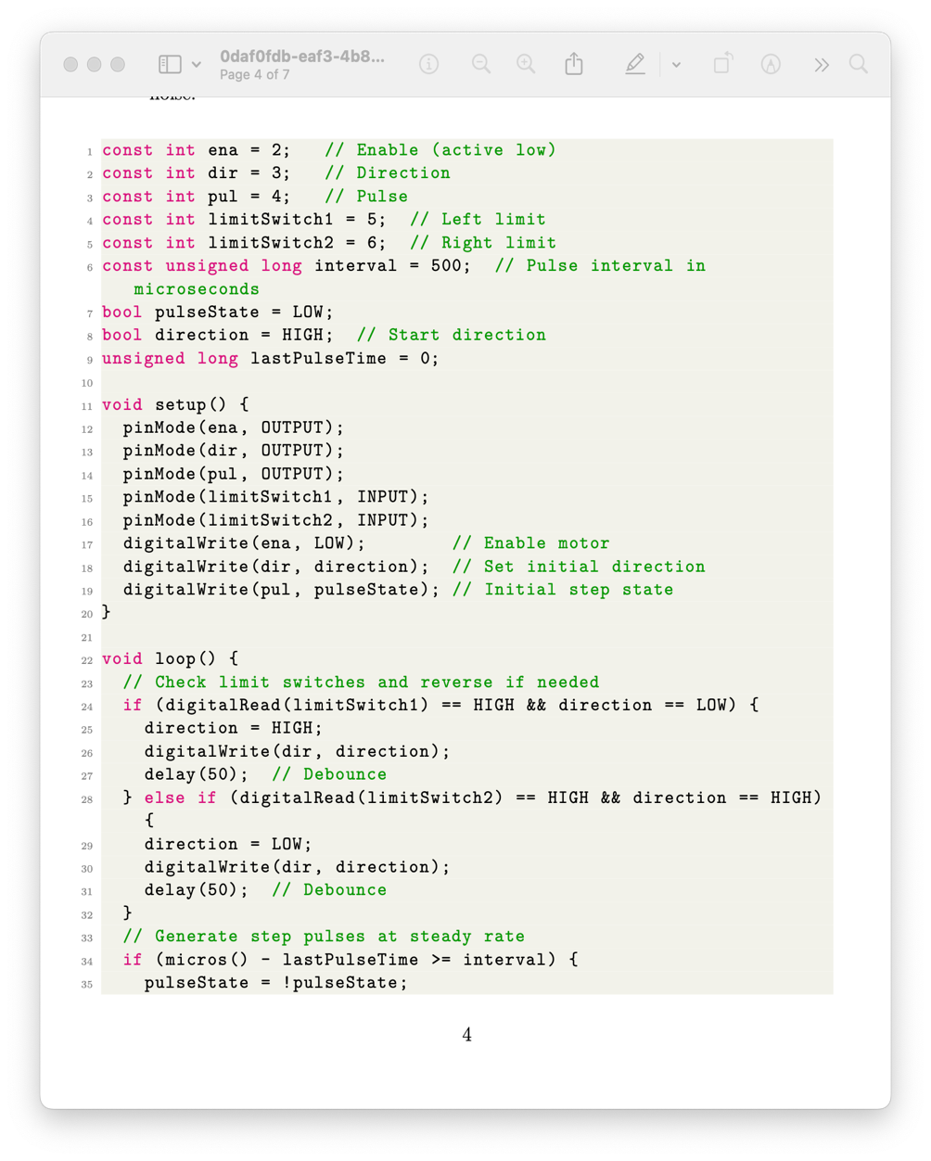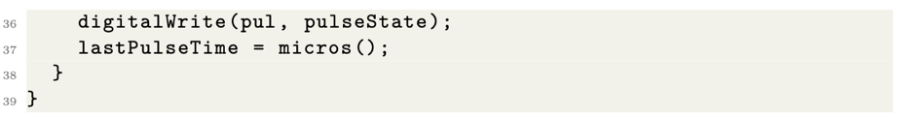

Flowchart: The control logic flowchart, created in Microsoft Visio, includes:
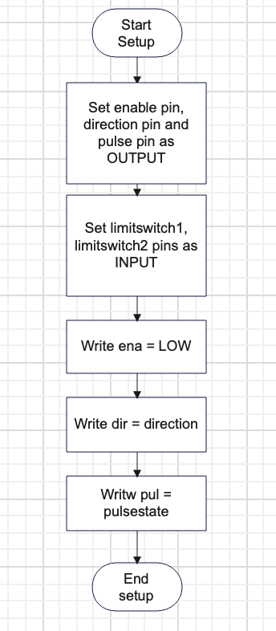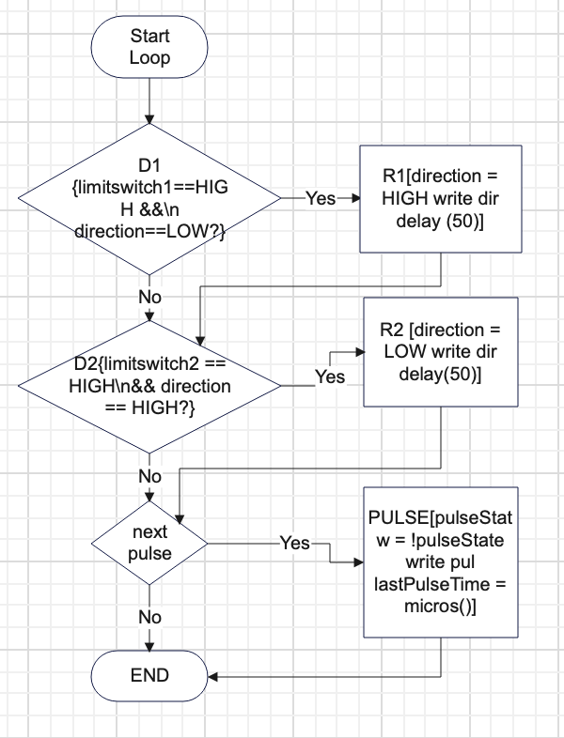

Schematic Diagram:
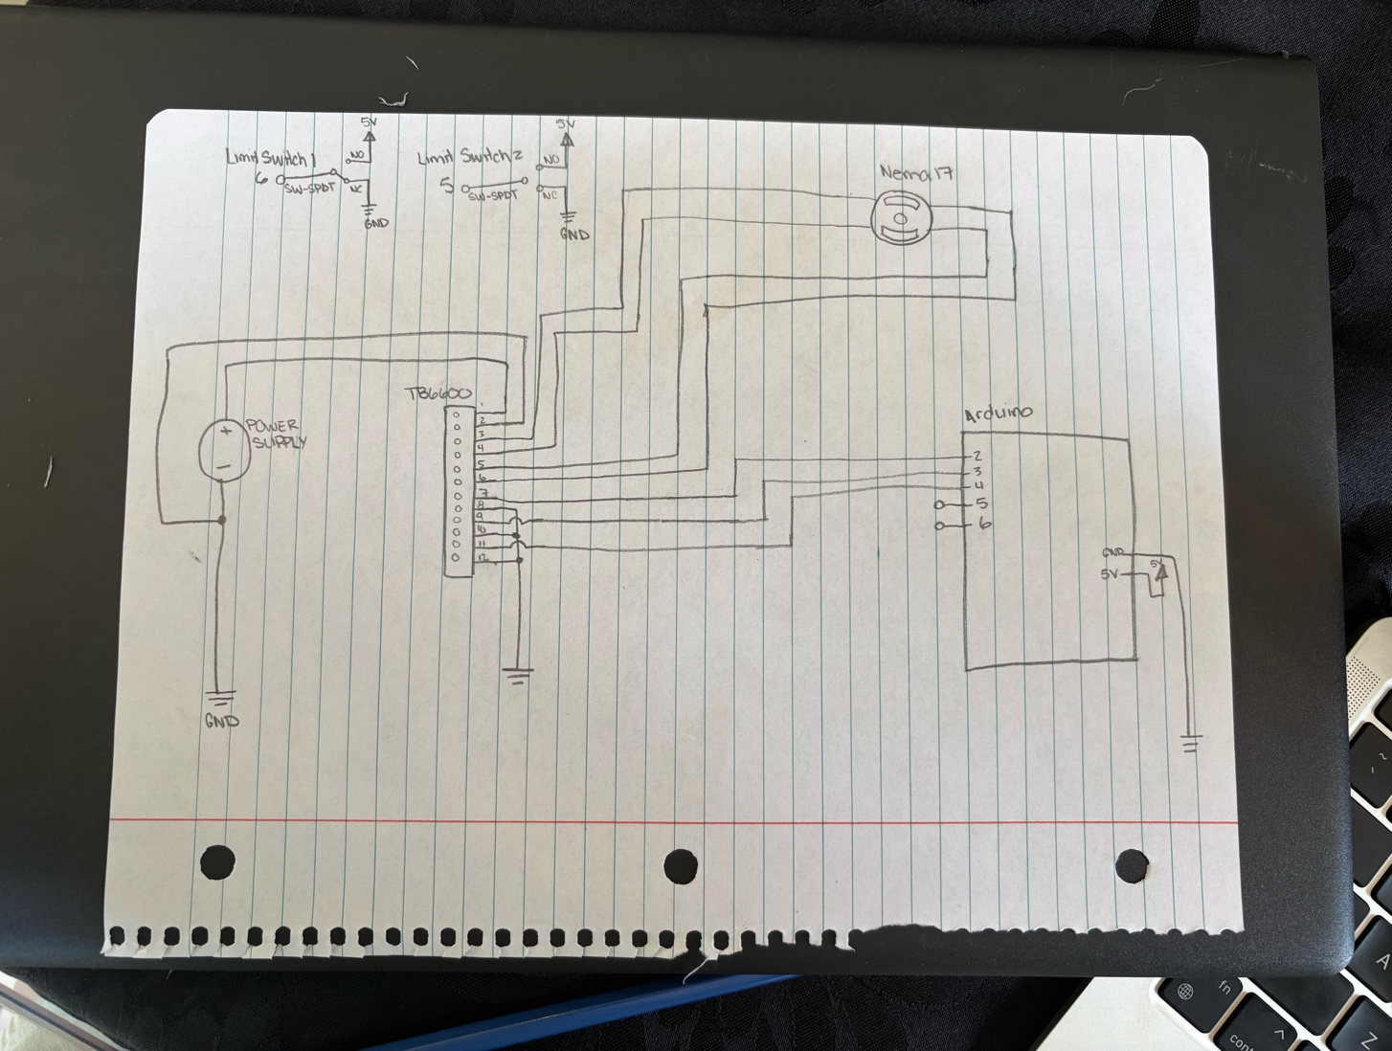
Figure 3: 3D Model of V-Slot Gantry System:
- Attached to submission
Figure 4: Part Placement of Gantry System
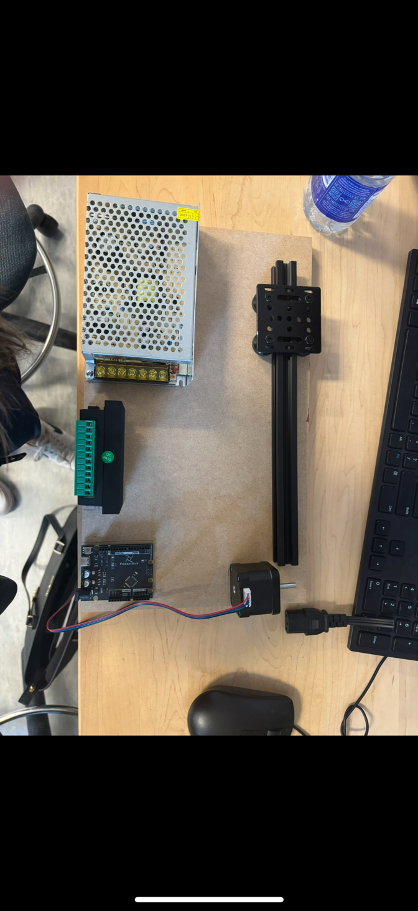
Figure 5: Final V-Slot Gantry System
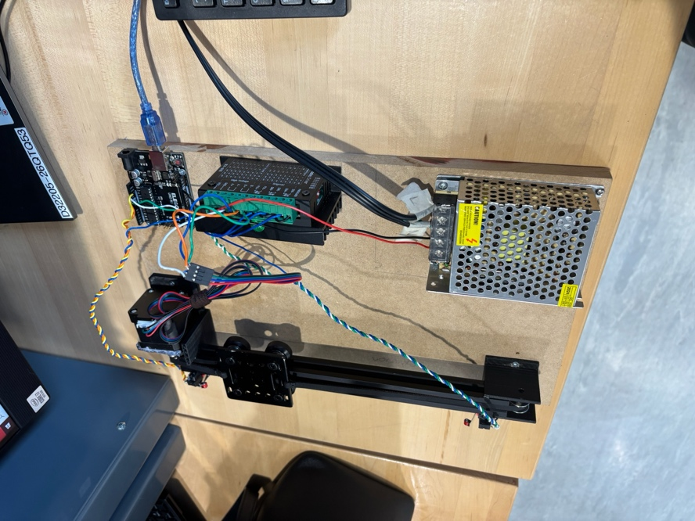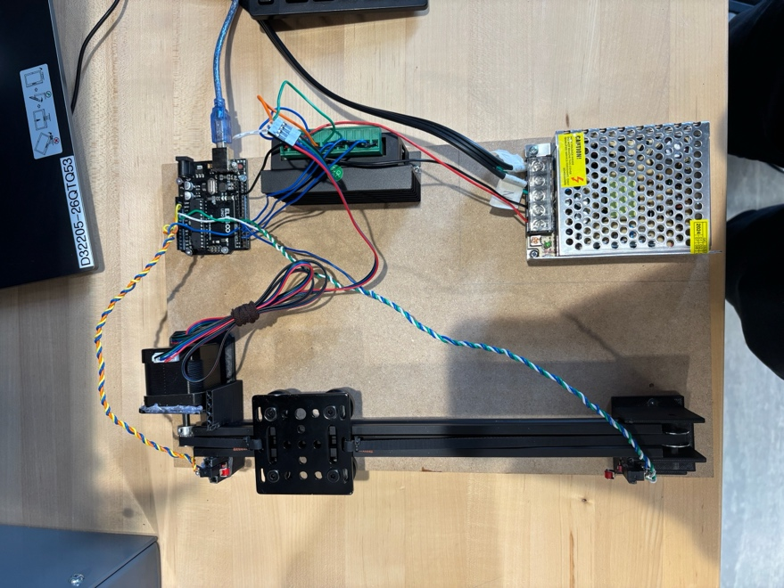
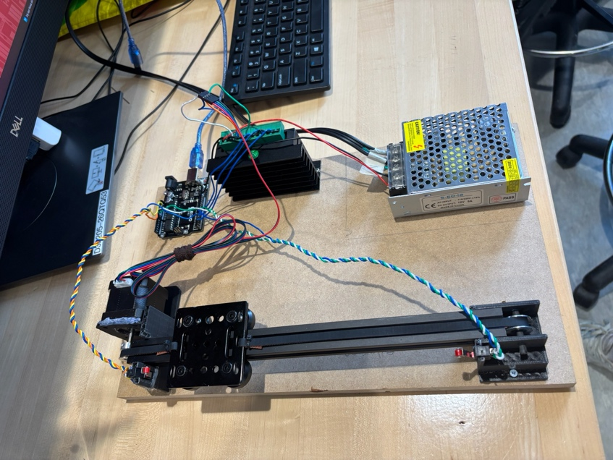

Conclusion
The V-slot bearing gantry system successfully achieved continuous linear motion, with the NEMA 17 stepper motor driving the gantry plate along the aluminum extrusion via a belt. The limit switches, configured as normally open (NO) and active-high, reliably triggered direction reversal. In the NO configuration, each switch’s circuit is open when not pressed, outputting LOW (0V) to Arduino pins 5 and 6. When the gantry presses a switch, the circuit closes, pulling the pin to HIGH (5V) via an external pull-up resistor or the TB6600’s 5V supply, as detected by ‘digitalRead(limitSwitch1) == HIGH‘ and ‘digitalRead(limitSwitch2) == HIGH‘. The TB6600’s ENA pin is active-low, enabled setting pin 2 to LOW. This setup simplified the code but required careful wiring to avoid noise.
Switch Schematic:
• NO Configuration: One switch terminal connects to Arduino pin 5 or 6, the other
to ground. When pressed, the switch closes, connecting the pin to 5V (active-high)
via a pull-up resistor.

• Alternative (NC): A normally closed switch would connect the pin to ground when not
pressed and open when pressed.
Lessons Learned:
• Switch Logic: Using active-high NO switches taught me to align hardware and
software for reliable signal detection, with debouncing (50ms delay) critical to avoid
false triggers.

• Mechanical Design: 3D printing required precise tolerances for the motor holder
and belt alignment to prevent slippage.

• Electronics: Proper grounding and pull-up resistor configuration were essential for
stable switch operation.

• Programming: Using ‘micros()‘ for pulse timing ensured smooth motor control
without blocking the loop.
What I Would Do Differently:
• Switch Configuration: I would test normally closed (NC) switches to reduce noise
susceptibility, adjusting the code to use ‘INPUTP U LLU P ‘and check for LOW signals.
• Early Prototype: I would print my parts earlier to address alignment issues sooner.
• Wiring Organization: I would us the proper coloured wires to make my life simpler when debugging.

