*
Introduction to Circuit Design and Prototyping
Final Project

Pina Cammisano, 6235654


Learning today Leading tomorrow

Department of Computer Engineering Technology
Course Name
Teachers’ name
Table of Contents

Introduction 4
Material Used 4
Cost 4
Drawing 5
Proteus Simulation 6
Implimentation 6
Conclusion 7

Introduction
- This final project was to evaluate the knowledge we had from our theory and lab classes to see if we can put everything together in order to make a remote control that goes left, right, front and back. In the remote control, there was a buzzer and 4 different LED’s that way when the car goes forward the two front LEDs (yellow) would go on, when the car backs up the two back LED’s (red) will go on as well as the buzzer and when it turns the side the LED on that side will also turn on. If it is turning as, it is going front the LED in the front will go on, if it is turning backwards the LED in the back of the car will turn on as well as the buzzer.

Material Used
- 2 DC motors
- 1 potentiometer
- 2 DPDT switches
- A box for remote controller
- 4 AA batteries
- Resistors
- Cables and connectors
- Robot chassis
- Wheels and axles
- Motor mounts
- Screws and fasteners
- Breadboard
- Soldering iron + solder
- Wire strippers and cutters
- Multimeters and voltmeter
- Screwdriver

Cost
- The total cost of this project came out to 50 dollars, most of the stuff needed I already had at home, or the school supplied me with them, I only had to by the kit given by the teacher which came to around 50 dollars.

Drawing
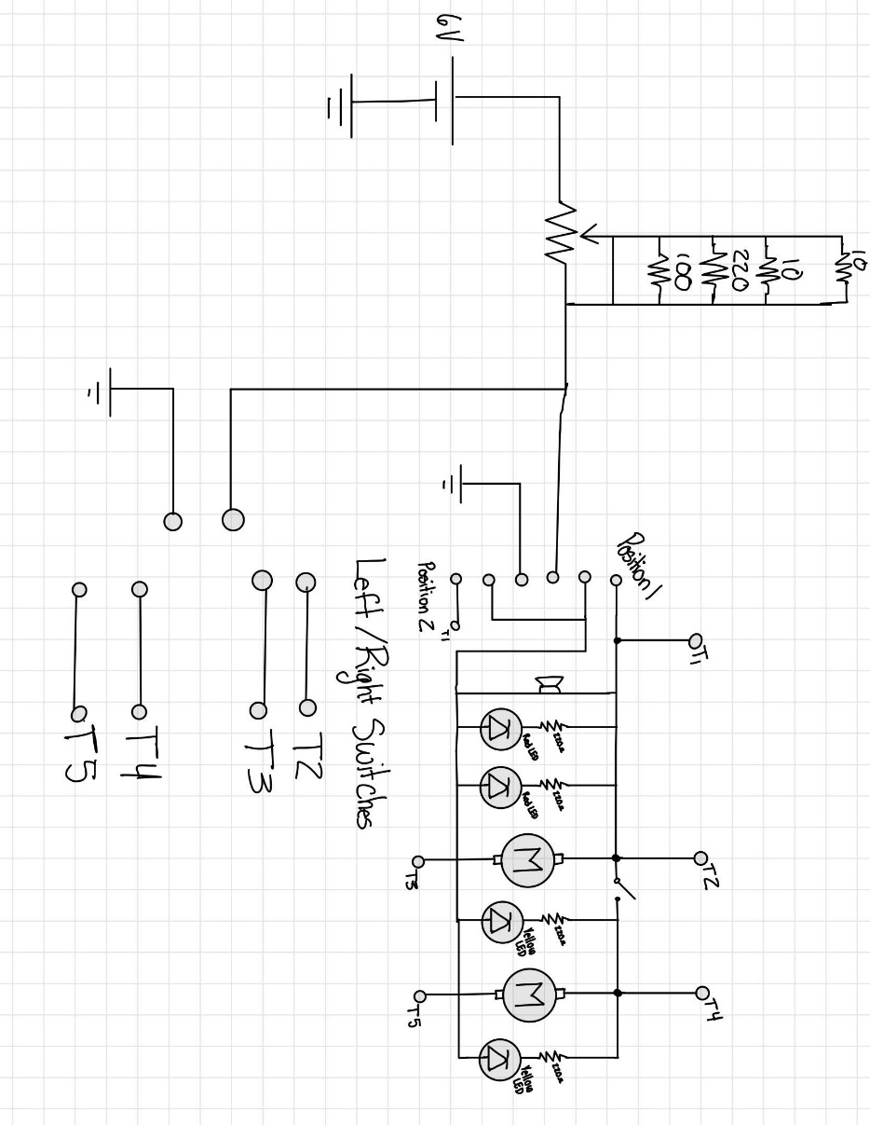

Proteus Simulation
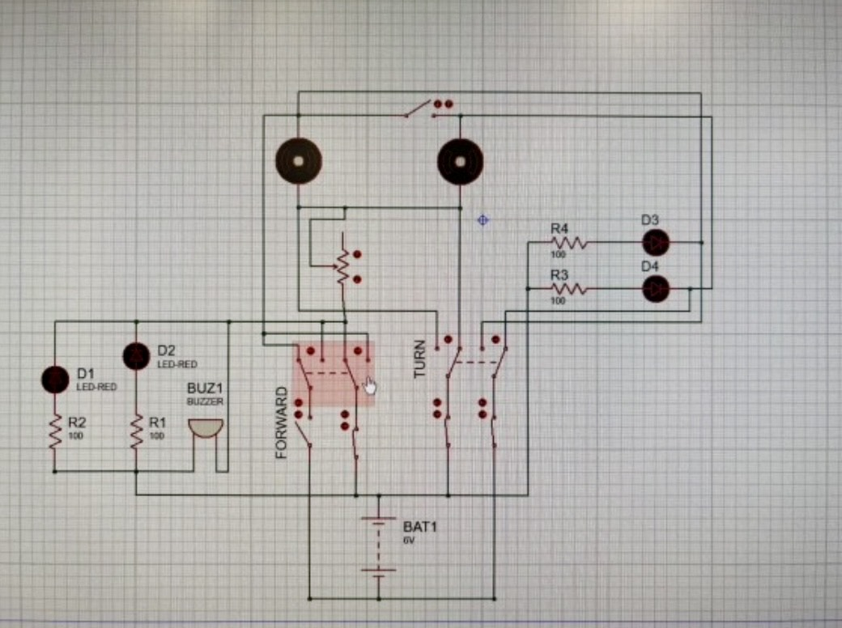

Implimentation
- When starting to work on the car, I feel like my main issue was underestimating how much time I had and how much time I needed to work on the project. The main issue I had that confused me a lot when making my circuit on the breadboard was the polarity of my two DC motors, for the first motor I soldered a red wire on the top to show it was my power and a black one at the bottom to show its my ground but when doing the second motor I reversed those polarities and accidentally put ground on top and power at the bottom which confused me a lot at the beginning when trying to make my circuit. My second issue that I had was trying to make the car go front and back and I spent a while working on it until I decided to try and wire my DPDT switches another way allowing me to fix that problem. I decided to wire them the same way as I wired my left and right switch because I used that switch to test my motor and realized that my car went front and back instead. My next issue was trying to figure out how to properly place my wires onto my breadboard in order to make my car go left and right because I kept making it go front and back, after a short time of working on this I was able to get it to turn and then placed my LED’s on to my car and I decided to solder my resistors directly on the LEDs so I would have more space on my breadboard. After all this was done, I started working on my circuit and putting everything together. After the fist circuit I chose to do, I realized I didn’t have enough space on the breadboard to fit one of the front LED’s so I just decided to wire wrap the two front LED’s together but realized after I did this that when I turn my car both the LEDs will turn on so I removed the connection and decided to make a new circuit. With the new circuit my switches weren’t working the way they were supposed one switch was doing everything and the other one would have no function even though it was connected to the breadboard, so I took the new circuit apart and started another circuit which ended up being my last circuit. I finally got everything to work but the car would only turn on the right side and not the left so I brought it home to work on it until my battery pack malfunctioned so I decided to connect my car to my Arduino so that I continue working on it but I still did not have enough time to finish the circuit and two of my LED’s burnt but I also did not have enough time change them since my resistors were also attached to them. As for the potentiometer I decided to leave it as the last thing to work on due to the fact that many kids were having issues with it, and I wanted to focus mostly and the major things since I saw the potentiometer wasn’t worth much. In the end I didn’t have enough time to do it.

Conclusion
In conclusion, this project taught me a lot and as much as I got annoyed when things didn’t go as planned, I was proud of myself for continuing to work on it and was proud of how far I got given all the problems I had. Not only did this project show me how there is always a solution for everything it also showed me how it is important to be organized and how if I would’ve made my schematic properly from the start and really understood my schematic, I wouldn’t have had these problems of guessing on where to connect what. I also learnt that there are so many different ways to do things and how the DPDT switches can work with motors, LED’s and a buzzer. Once I understood the schematic needed for the circuit, I realized how this project wasn’t as hard as I thought it to be.

