Ultrasonic Ranging Sensor
Final Project

Pina Cammisano, 6235654

Abstract: This study describes how I measured how long it takes for a sound wave to reach and return to an object using an ultrasonic sensor. The speed of sound was then utilized to determine the object's distance from that time. I used simple math to create an analog voltage between 0.00 and 5.00 volts using that distance measurement. Using an Arduino, the final voltage value was shown in real time on a 4-digit, 7-segment display. The idea was to utilize code to simulate the behavior of an analog system using a digital sensor.

Project Presented On: 14/05/2025
Report Submitted On: 16/05/2025


Learning today Leading tomorrow

Department of Computer Engineering Technology
Introduction to circuit design and prototyping
Manijeh Khataie

Table of Contents

Overview 3
Materials 3
Theory and Calculations 3
Procedure 4
Logarithmic vs Linear 4
Code explanation 4
Proteus 6
Circuit Pictures 7
Challenges and Resolution 8
Conclusion 8

Overview
- The objective of this project is to translate digital sensor distance readings into a numerical representation that approximates a voltage range of 0.00 to 5.00 volts. A 4-digit, 7-segment display with dynamically updating digits shows the outcome. The goal is to use digital components and simple computations to convert real-world data into a format that resembles an analog signal.

Materials
- Arduino Uno
- 4-digit 7-segment display
- HC-SR04 ultrasonic sensor
- 1kΩ resistors (4)
- Breadboard
- Jumper wires
- Wire cutters
- Logbook

Theory and Calculations
The project does not display the raw distance from the sensor but instead uses the measurement to generate a simulated voltage between 0.00 and 5.00 volts, shown on a 7-segment display. This involves converting a digital reading into an analog-like value through mathematical scaling.
The HC-SR04 sensor measures the time (in microseconds) for a sound wave to travel to an object and return, known as the round-trip time. This duration, when the echoPin is HIGH, is used for calculations. Distance is calculated by multiplying the time by the speed of sound (converted to meters per microsecond) and dividing by 2 to account for the round trip. The formula is:
Distance = (Time (μs) × 0.000343 (m/μs)) / 2
The distance is then scaled to a voltage by dividing it by the sensor’s maximum range (set to 400 cm) to obtain a ratio between 0 and 1, which is multiplied by 5 to fit the 0–5 volt range. The constrain() function ensures the voltage stays within bounds. The formula is:
Voltage = (Distance (m) / Max Distance (m)) × 5.0
To prepare the voltage for display, it is multiplied by 100 and rounded to an integer (e.g., 3.46 becomes 346, with 0.5 added to avoid rounding errors). The formula is:
Display Value = int(Voltage × 100 + 0.5)
This integer is split into three digits stored in an array for the 7-segment display, formatted as X.XX. The fourth digit is set to -1 in the array, signaling the program to leave it blank. A decimal point is activated after the first digit.
Multiplexing is used to display digits, cycling through each digit every 4 milliseconds to create the illusion of simultaneous illumination. A binary lookup table dictates which segments light up for each digit. As the display is common anode, logic is inverted: LOW activates a segment, and HIGH deactivates it. The decimal point is independently controlled for the appropriate digit.

Procedure
The HC-SR04 sensor was connected to the Arduino with VCC to 5V, GND to ground, Trig to pin 15, and Echo to pin 16. These pins manage the ultrasonic pulse and its return time. The 4-digit 7-segment display (common anode) had segments a–g wired to pins 6, 7, 8, 9, 10, 12, and 11, with the decimal point on pin 13. Digit anodes were connected to pins 2, 3, 4, and 5. Each segment pin included a 1kΩ resistor to limit current and protect the LEDs.
The components were organized on a breadboard, with the sensor at one end, the display centrally placed, and wires arranged for clarity. A shared ground rail ensured proper grounding. After wiring, the Arduino was programmed to read sensor timing, compute distance, scale it to voltage, and display the digits via multiplexing.

Logarithmic vs Linear
Since the time it takes for the sound wave to return rises in direct proportion to distance, the HC-SR04 sensor functions linearly. The voltage is obtained by dividing the distance by the maximum range and then multiplying by five. The distance is computed using the Emdash and the speed of sound. As a result, there is no logarithmic compression—where changes would decrease at higher values—and a linear relationship between distance and voltage. Both voltage and distance scale consistently.

Code explanation
- setup()

  - Configures the ultrasonic sensor pins:

    - pinMode(trigPin, OUTPUT) so we can send the trigger pulse

    - pinMode(echoPin, INPUT) to read the echo response

  - Marks every segment pin (a–g) and the decimal‐point pin as OUTPUT in a simple for loop so we can control each LED segment.

  - Marks each of the four digit‐select pins as OUTPUT in another for loop so we can enable one digit at a time.

- clearSegments()

  - Writes HIGH to all segment pins and the decimal‐point pin.

  - On a common‐anode display, HIGH means “off,” ensuring no LEDs are lit before drawing a new digit.

- clearDigits()

  - Writes LOW to all four digit‐select pins.

  - This makes sure no digit is accidentally powered when we switch segments on or off.

- showDigit(digitIndex, number, showDot)

- Calls clearDigits() and clearSegments() to start from a blank slate.

- Checks number (0–9) and sets exactly the right segment pins to LOW to form that numeral.

- If showDot is true, pulls the decimal‐point pin LOW.

- Powers the chosen digit by writing its select pin HIGH.

- Delays ~4 ms so you actually see that digit before the next one is drawn.

- loop()

- Send the ultrasonic pulse:

  - Pull trigPin low briefly, then high for 10 µs, then low again.

- Measure echo time:

  - Use pulseIn(echoPin, HIGH) to get how long the echo pin stayed high.

- Convert to distance:

  - distance = duration * 0.034 / 2 (sound travels at ~0.034 cm/µs, divide by 2 for round-trip).

- Map to voltage:

  - voltage = (distance / MAX_DIST) * 5.0

  - Clamp so 0.00 ≤ voltage ≤ 5.00.

- Prepare for display:

  - Multiply by 100 and round (vInt = voltage * 100 + 0.5) so 3.46 V becomes 346.

  - Extract three digits:

    - digit1 = vInt / 100

    - digit2 = (vInt / 10) % 10

    - digit3 = vInt % 10

- Show “X.XX” on the display:

  - showDigit(0, digit1, true) → first digit + decimal point

  - showDigit(1, digit2, false) → second digit

  - showDigit(2, digit3, false) → third digit

  - showDigit(3, –1, false) → fourth digit blank (nothing to draw)

- Repeat endlessly so the display updates in real time..

Proteus
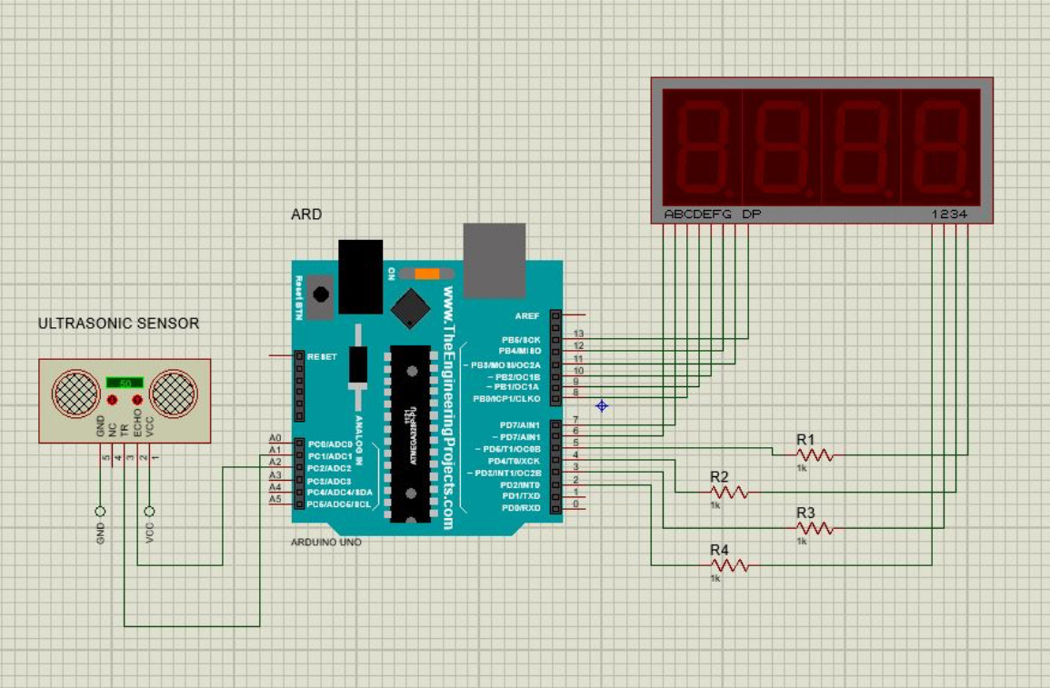

Circuit Pictures
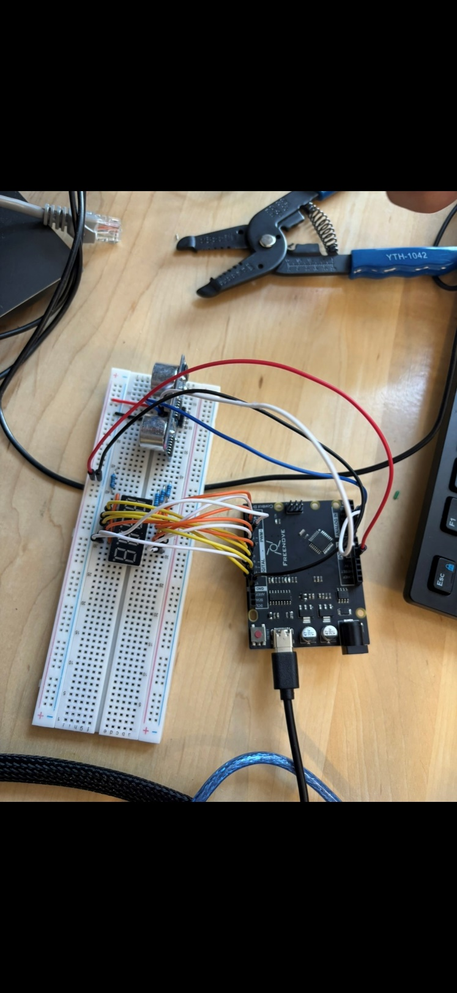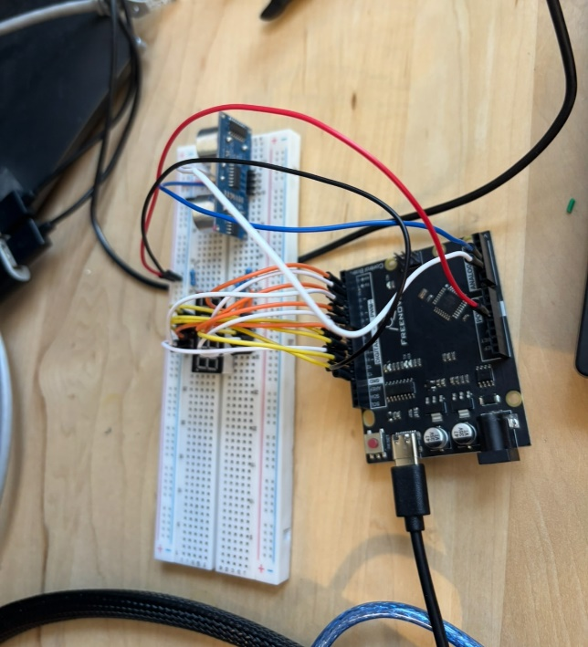
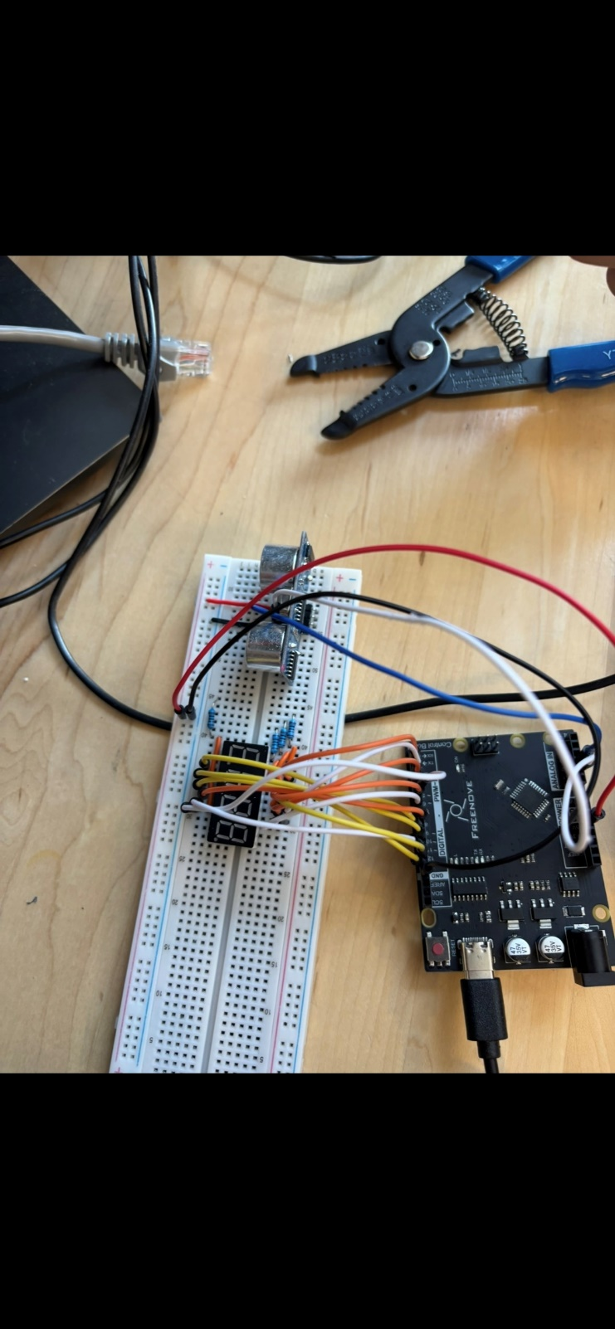

Challenges and Resolution
A number of problems surfaced during development. The multiplexing delay was adjusted to provide enough display time for each digit in order to fix the 7-segment display's constant flickering or failure to illuminate specific digits. Using the constrain() function to cap voltage values between 0.00 and 5.00 and making sure the path was clear helped to reduce the occasional irregular or excessive readings from the ultrasonic sensor. Initially, several segments failed due to improper wiring; this was resolved by double-checking connections and adding resistors to each segment for stability and protection. Reliable operation was ensured by these modifications.

Conclusion

A system that transforms ultrasonic distance data into a simulated voltage that appears as X.XX on a 4-digit, 7-segment display was successfully developed by this project. Distance, which is scaled to a 0.00–5.00 volt range and divided into digits for real-time display, is calculated using the sensor's round-trip time. The setup shows how digital components and computations may simulate a constant analog voltage. It was put into practice on an Arduino and verified in Proteus.

