PROJECT NAME: SIMPLYBLOGGING SITE

Tools and Technology Used:

- HTML
- CSS
- Javascript
- Bootstrap
- Visual Studio Code
- GitHub/Git

HTML files:

1.index.html

2.about.html

3.login.html

4.post.html

Internal Javascript has been used for the functionality of adding new blog posts:

screenshots:

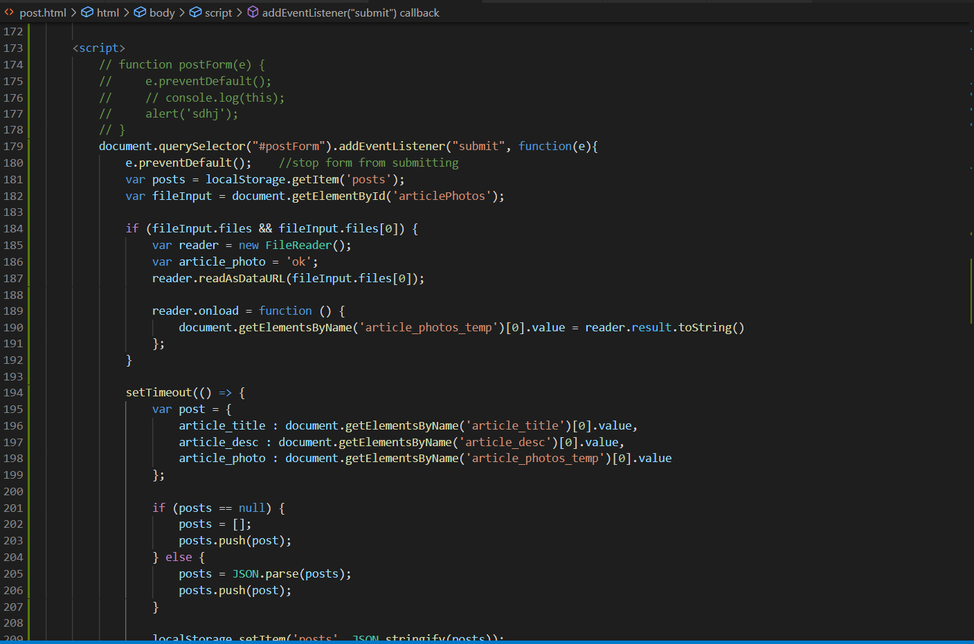

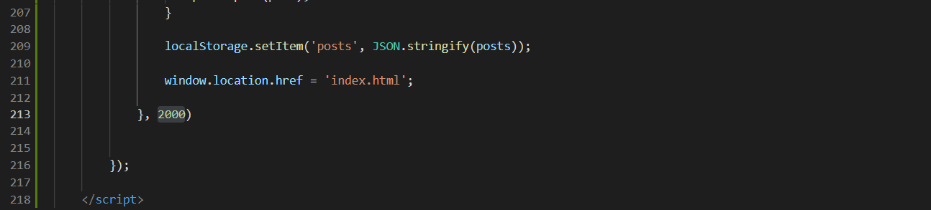
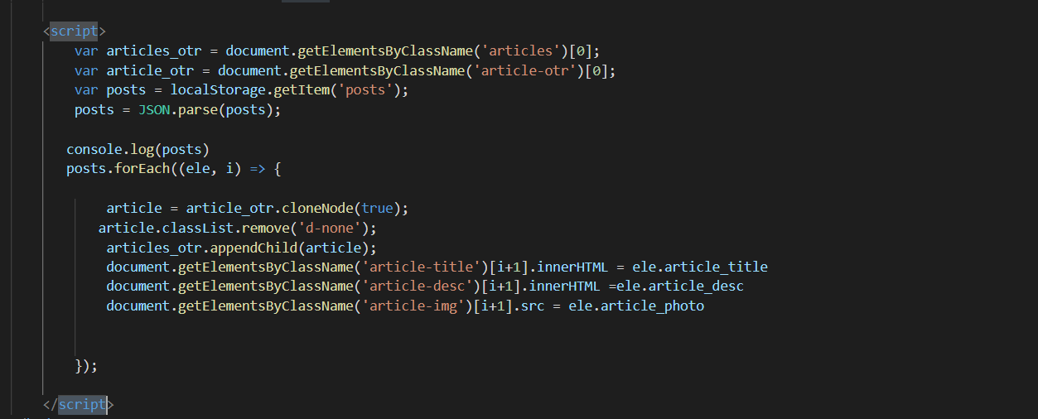

External JS used for login functionality:
File Name: login.js

Process:

1.Login page has been created using the HTML file : login.html
HTML <form> element is used to create an HTML form for the login page.
Screenshot:
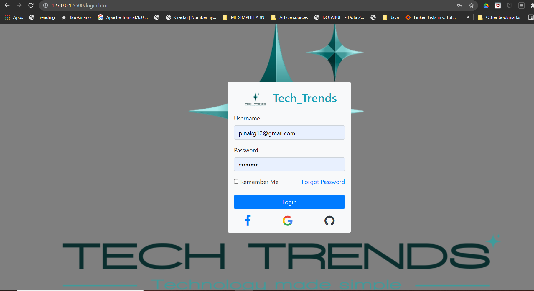
When the user clicks on the login button , the form is sumbitted using addEventListener() method which is fired when the user clicks the login button .
There are validations for every form element which has been handled in login.js .
When the username is left blank , error will be displayed as “Please enter username! ”
When the Password is left blank , error will be displayed as “Please enter password! ”
When both the fields are left blank , error will be displayed as “Please enter username and paswoord! ”
The Password should contain atleast 1 uppercase, 1 lowercase, 1 digit and 1 special character!
Otherwise error will be displayed as “Please make sure that your password contain atleast 1 uppercase, 1 lowercase, 1 digit and 1 special character! ”
When all the form fields are validated user will be redirected to the Home page (index.html) using window.location.href.
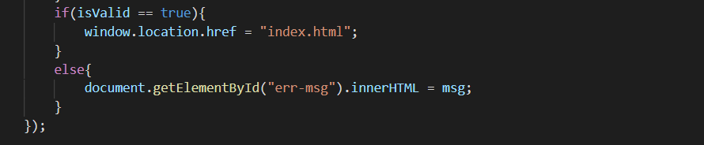

ERROR SCREENSHOTS:
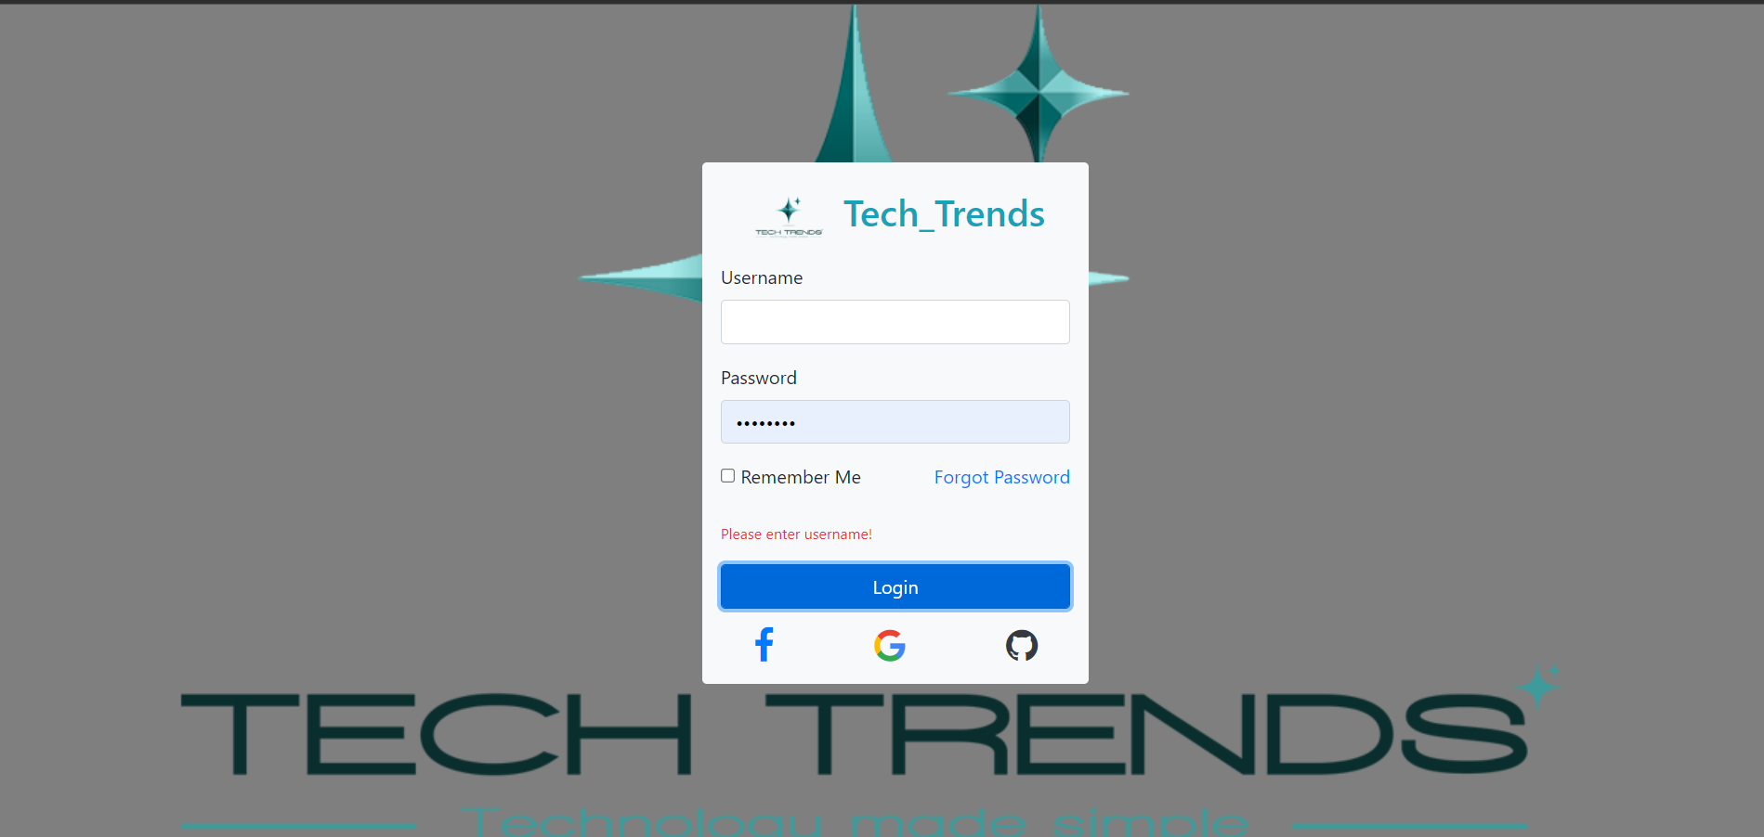
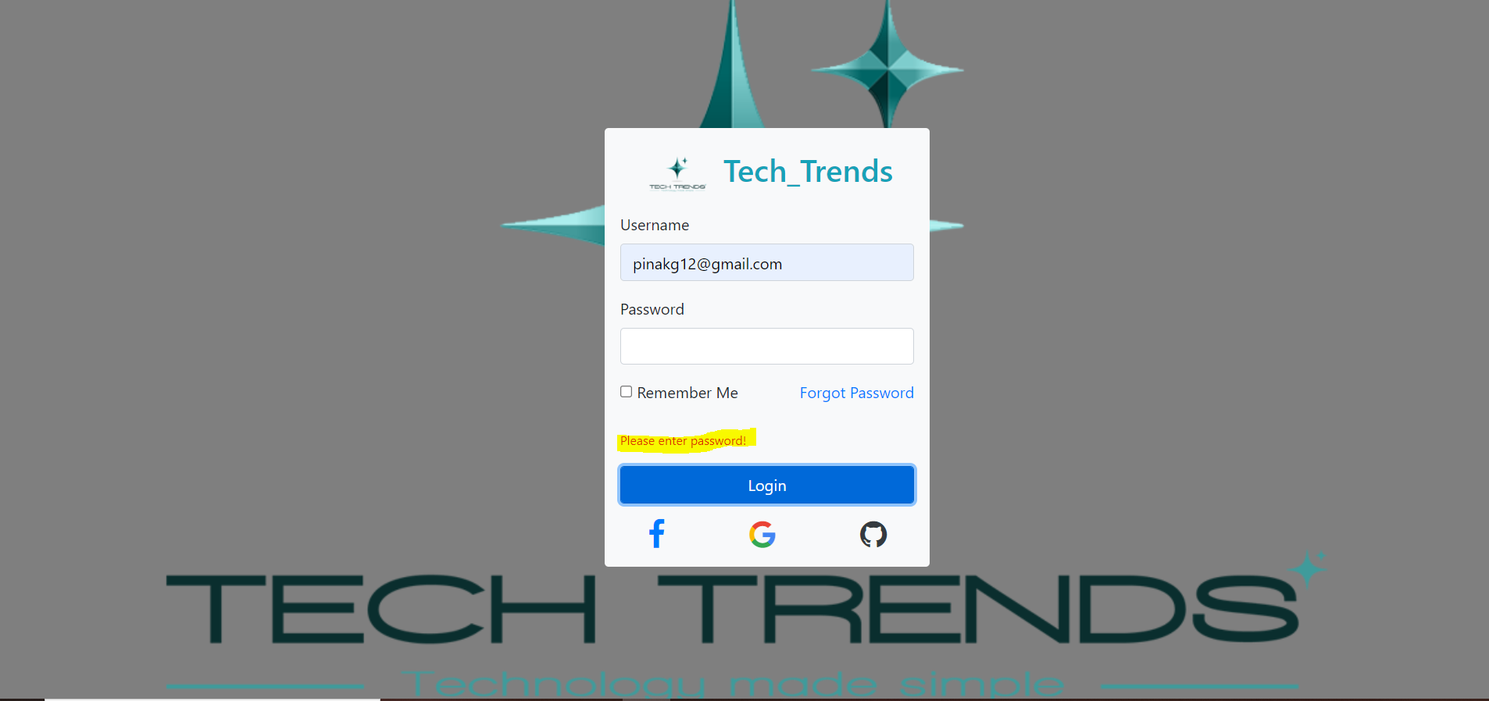
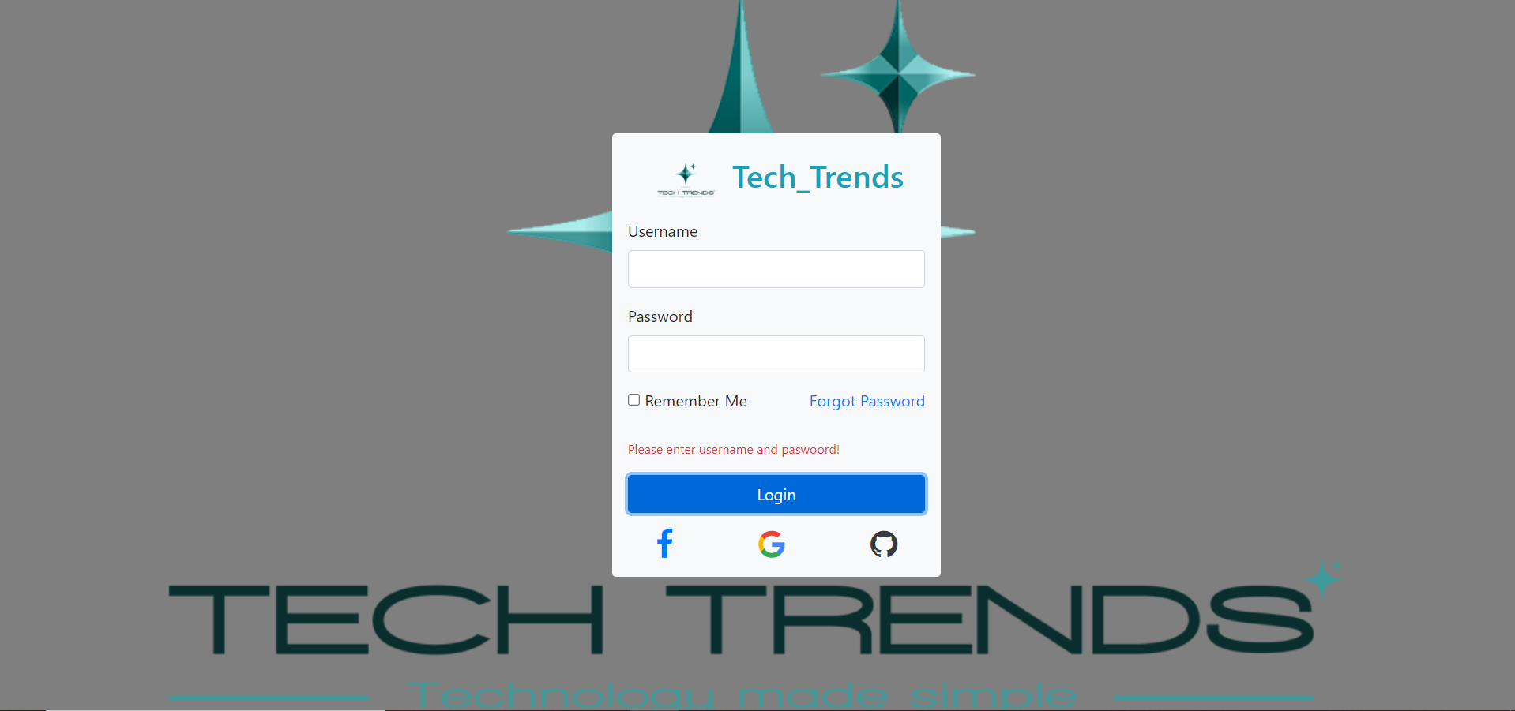
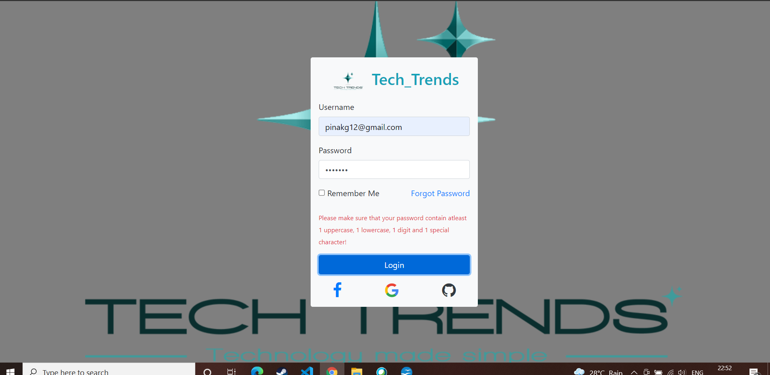

2.index.html is created for the Home page containing all the blogs.

SCREENSHOT:
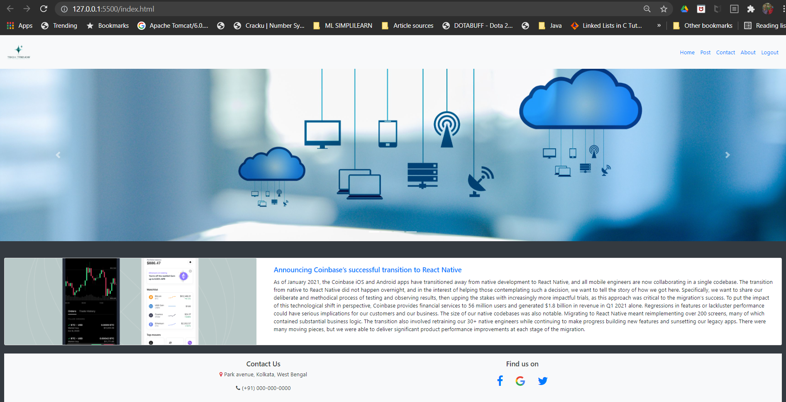

Navbar:
A grey horizontal navbar that becomes vertical on small screens
<nav class="navbar navbar-expand-sm bg-light">
Link has been created inside unordered lists for Home,Post,Contact,About,Logout using the <a> tag (anchor tag).
Bootstrap carousel plugin has been used to slide through a series of images on the Home Page(index.html)
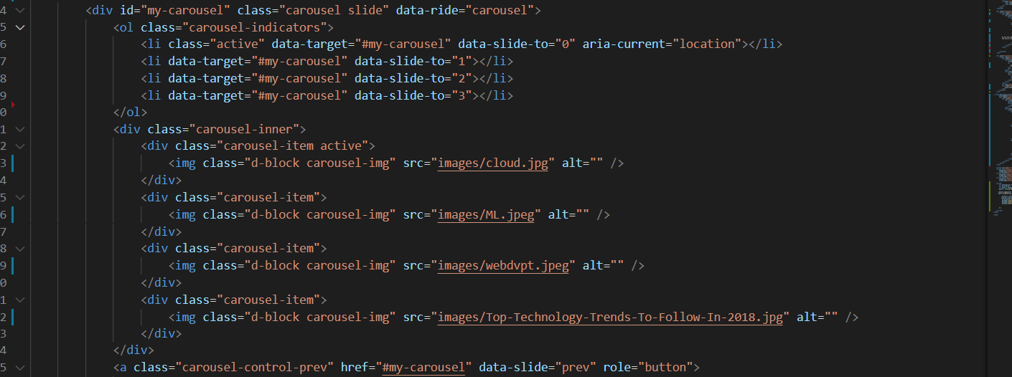

Bootstrap container-fluid element has been used in the div class for the blog posts to resize accordingly as you make even the smallest changes to your browser width. This makes the page reactive to any browser window size.
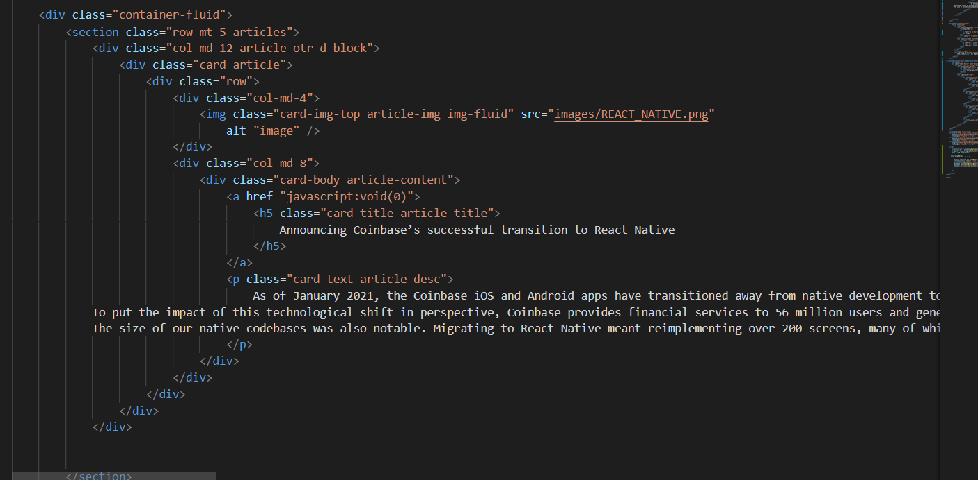

Modal has been used for the Contact Form when user clicks on Contact.
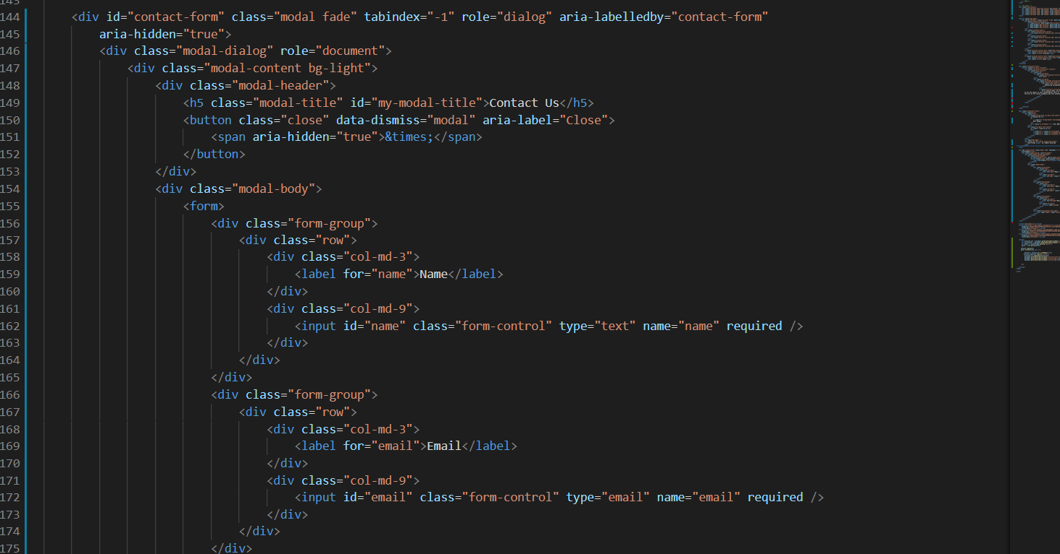

Contact Form :
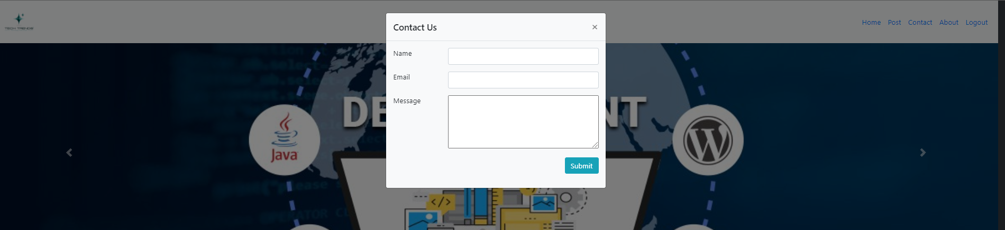

3.About Page has been created using HTML file about.html, onclick About from Home user is redirected to the About page containing information about the Organization.

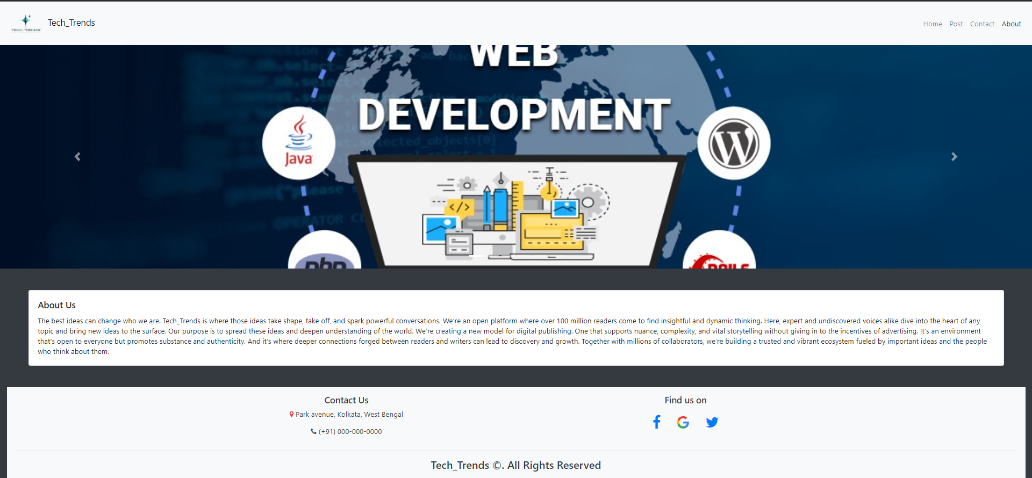
4.Adding Blogs by the User.

Logic Description:
AddEventListener() method has been used to add an event handler to the submit element.

FileReader.readAsDataURL() method has been used to read the contents of the File which contains the Image which is to be uploaded for the Blog Post.
When the read operation is finished, the readyState becomes DONE, and the loadend is triggered. At that time, the result attribute contains the data as a data: URL representing the file's data as a base64 encoded string.
The localStorage object stores data for the new Blog Post which is to be added . The data will not be deleted when the browser is closed.
After storing the new blog data in localStorage , it is redirected to index.html .

When the user clicks on Post in Navbar user is redirected to post.html which contains the form containing input fields :
- Title
- Description
- Add Images
Title: User needs to add the title of the blog
Description: User need to add the description of the blog
Add Images: User need to add image for the blog post.

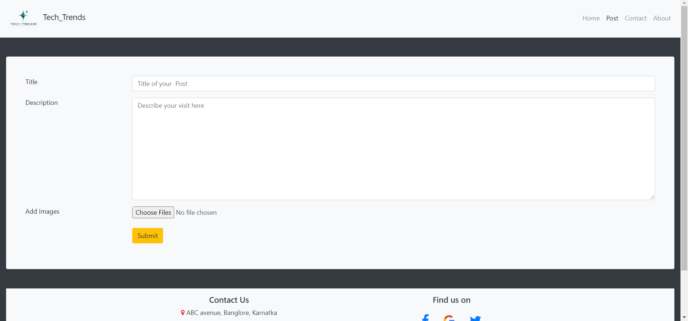
After the user adds the input in the fields mentioned and clicks on submit, user is redirected to the Home page and the user blog gets added in the blogs.

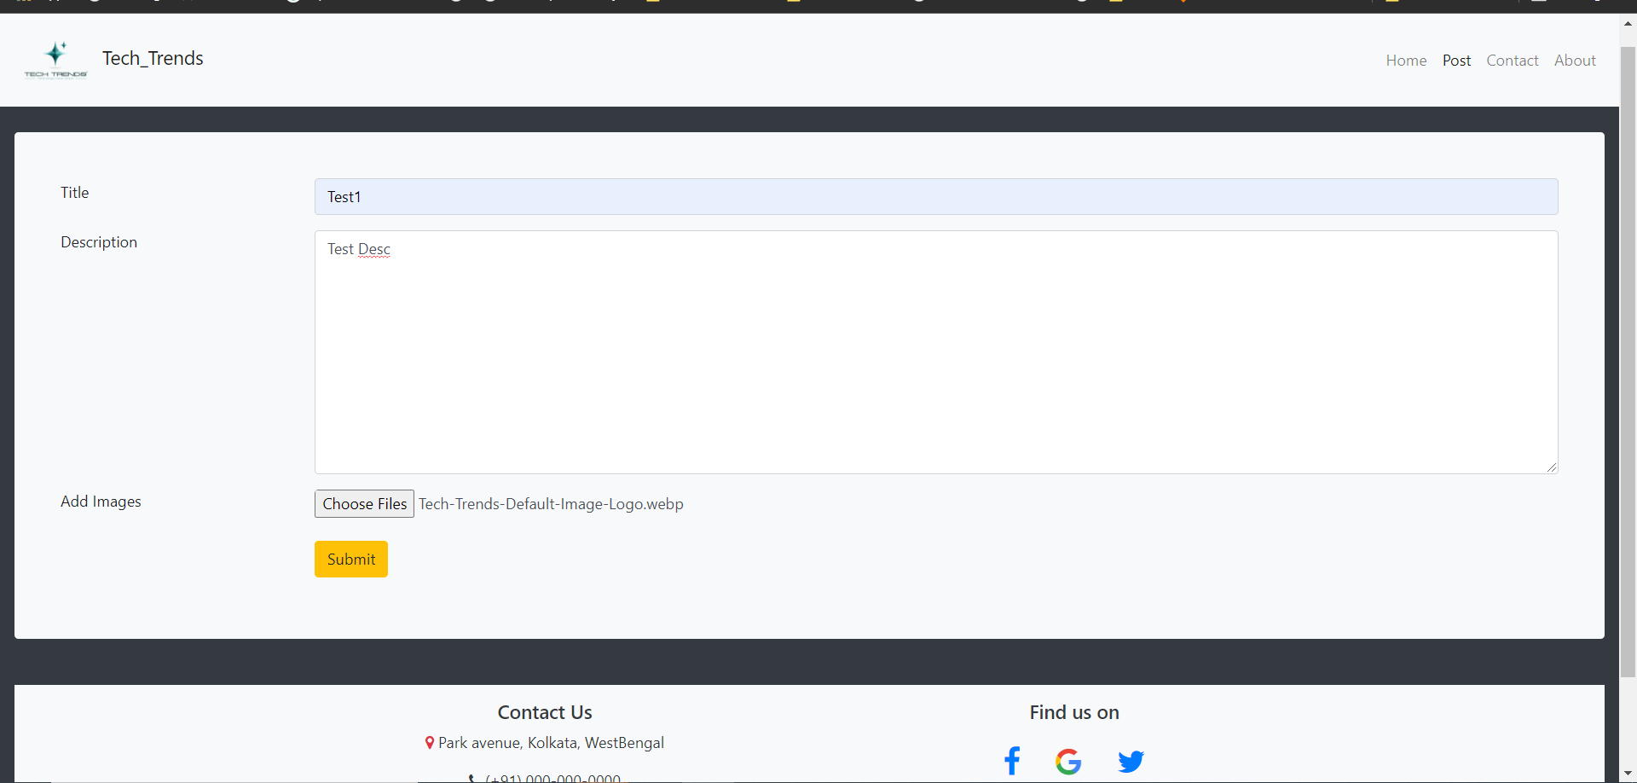

Blog Post has now been added to the Home page.


