E6156 - Topics in SW Engineering:  
Cloud Computing  
(F22)  
  
HW/Sprint 0

# Introduction and Overview

Lecture 1, slide “Assignment 1/Project Step 1” provides an overview of HW 0. Each student completes the assignment individually. We start working in teams for HW 1/Sprint 1. There are three main sections to the HW:

1. Local environment setup and executing the samples.
2. GitHub setup
3. Deploying and executing the application on AWS.

You complete the sections by including screenshots of various environments, programs, etc.

# Local Environment Test

The instructions are to clone and test starter applications:

* UI: <https://github.com/donald-f-ferguson/F22-Simple-Web-UI.git>
* Microservice: <https://github.com/donald-f-ferguson/F22-Starter-Microservice.git>
* DB: <https://github.com/donald-f-ferguson/F22-Starter-DB.git>

## Web UI

Show a screen capture of the web UI project in WebStorm. Make sure your screenshot shows “ng serve” succeeding. My example is below.

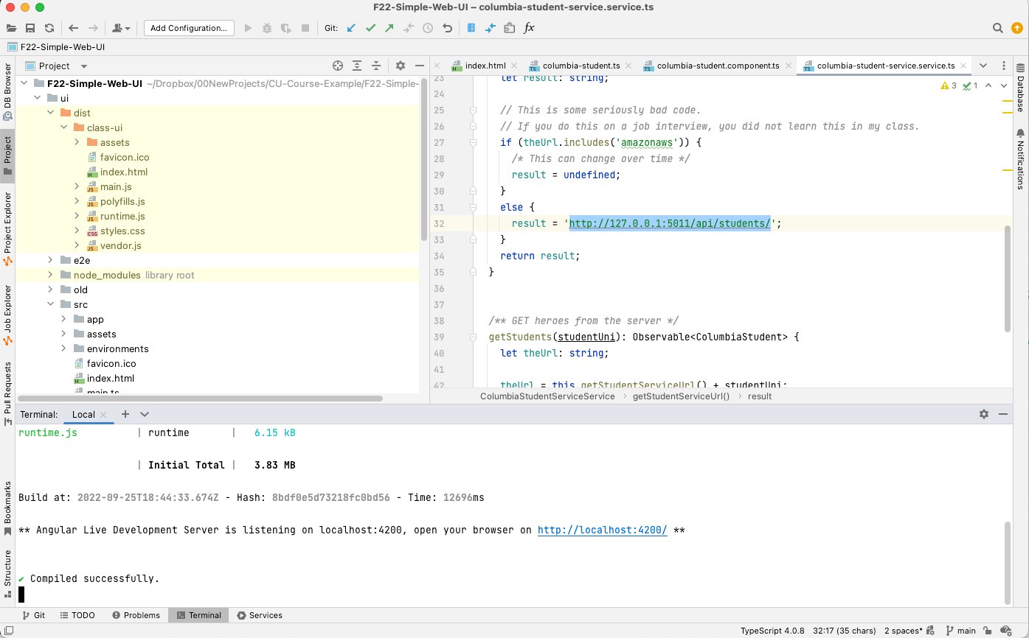

## Database Project

Show a screen capture of your project in DataGrip. My example is below.

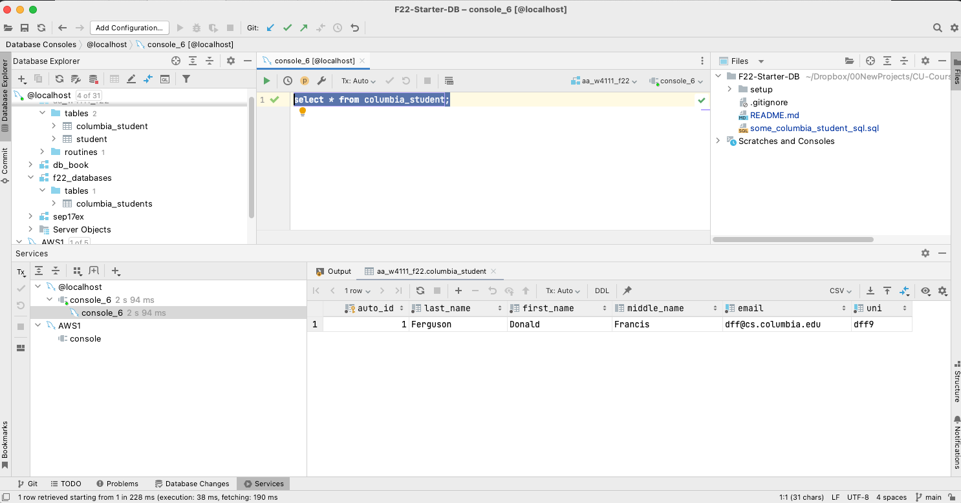

## PyCharm Project

Show a screen capture of your project in PyCharm. My example is below. Make sure that you show the application running.

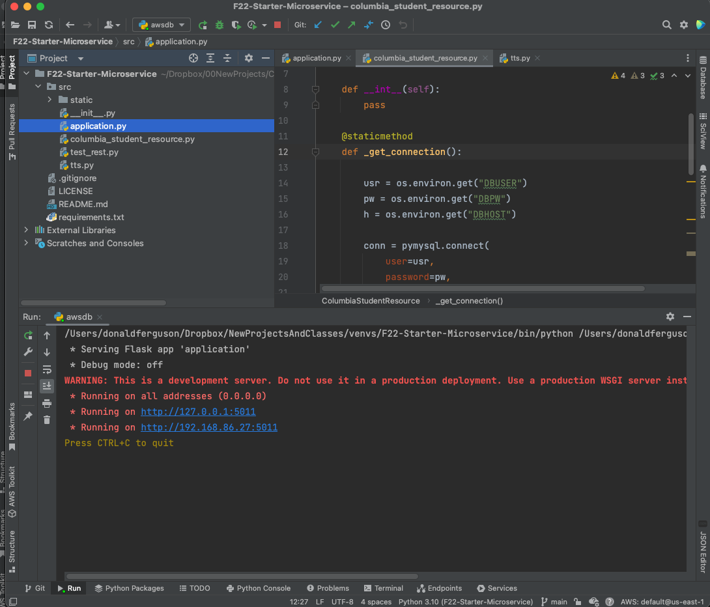

## End-to-End Test

Show the browser window and PyCharm window for an end-to-end test. My example is below.

**Note: Your test must have your uni, name, etc. in the data displayed.**

Use the same approach to screen captures as above.

### PyCharm Screenshot

Make sure the terminal window screen capture shows execution.

### Browser Window

Include a screen capture showing the result of executing the loop up in the browser application.

# GitHub Repositories

Show a screen capture of each of your GitHub repositories below.

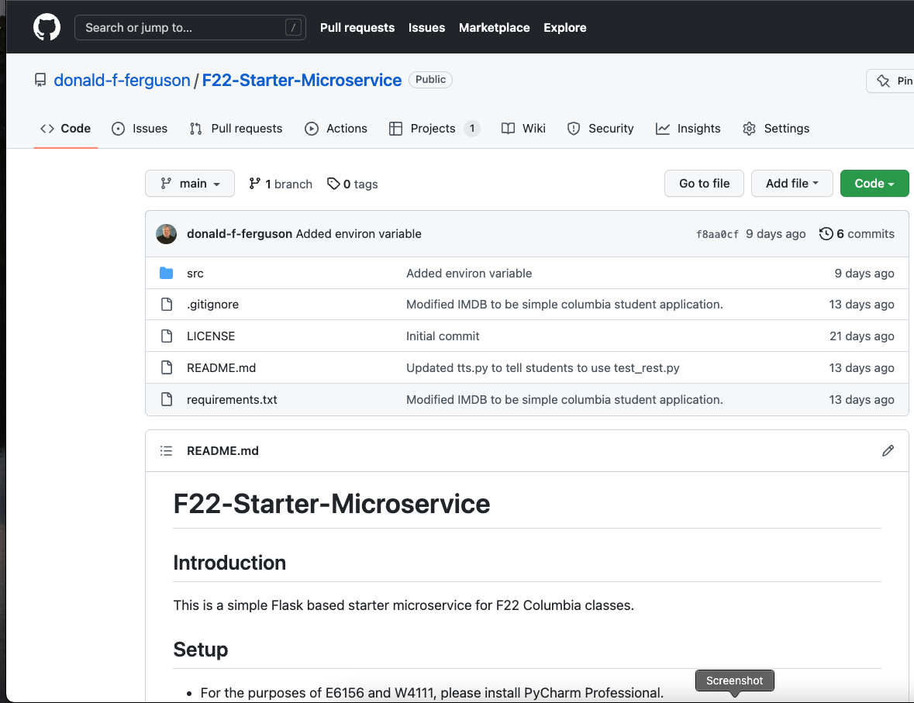

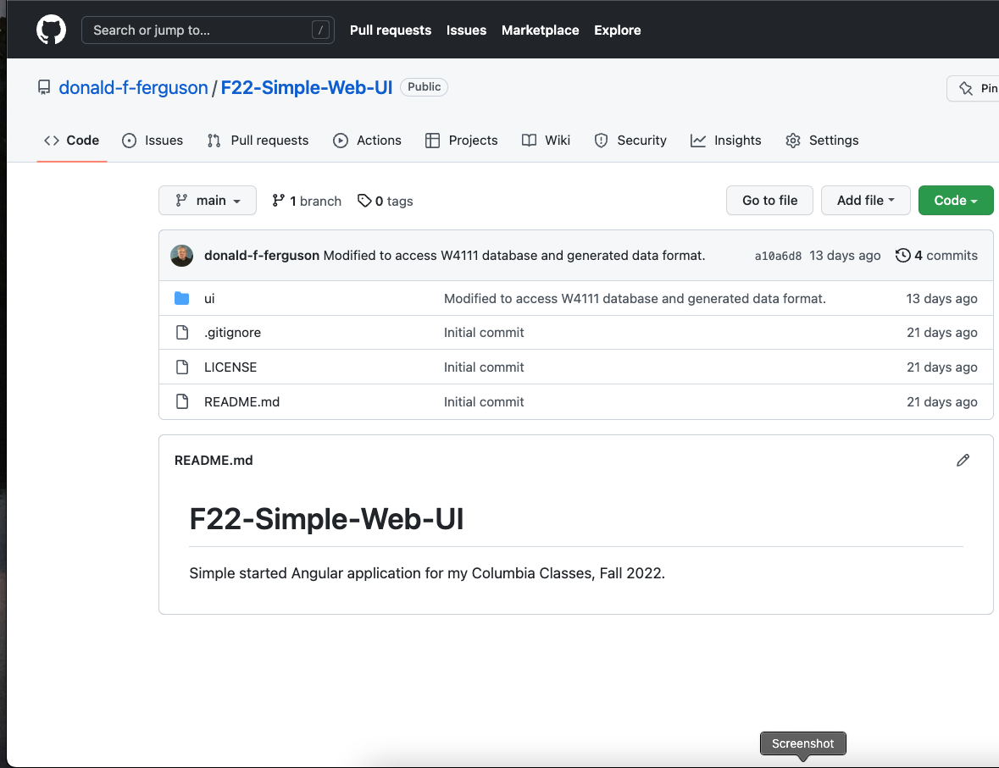

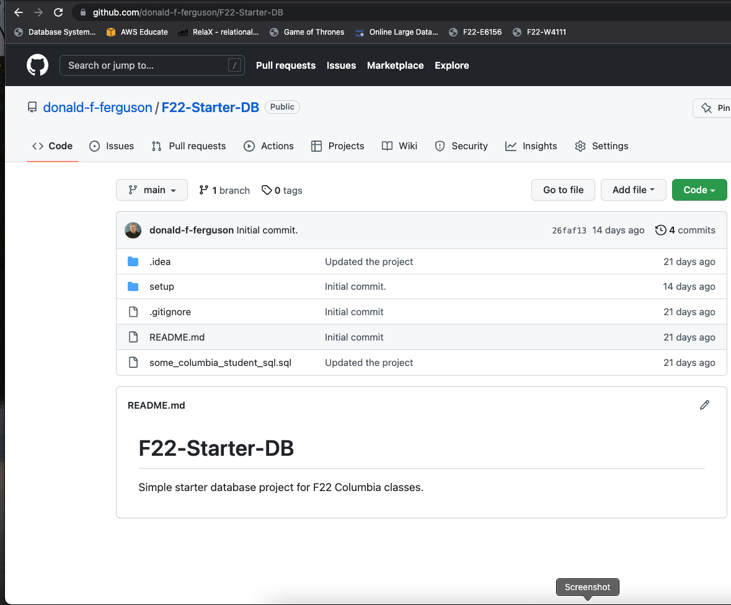

# AWS

## EC2

Show a screen capture of your EC2 instance.

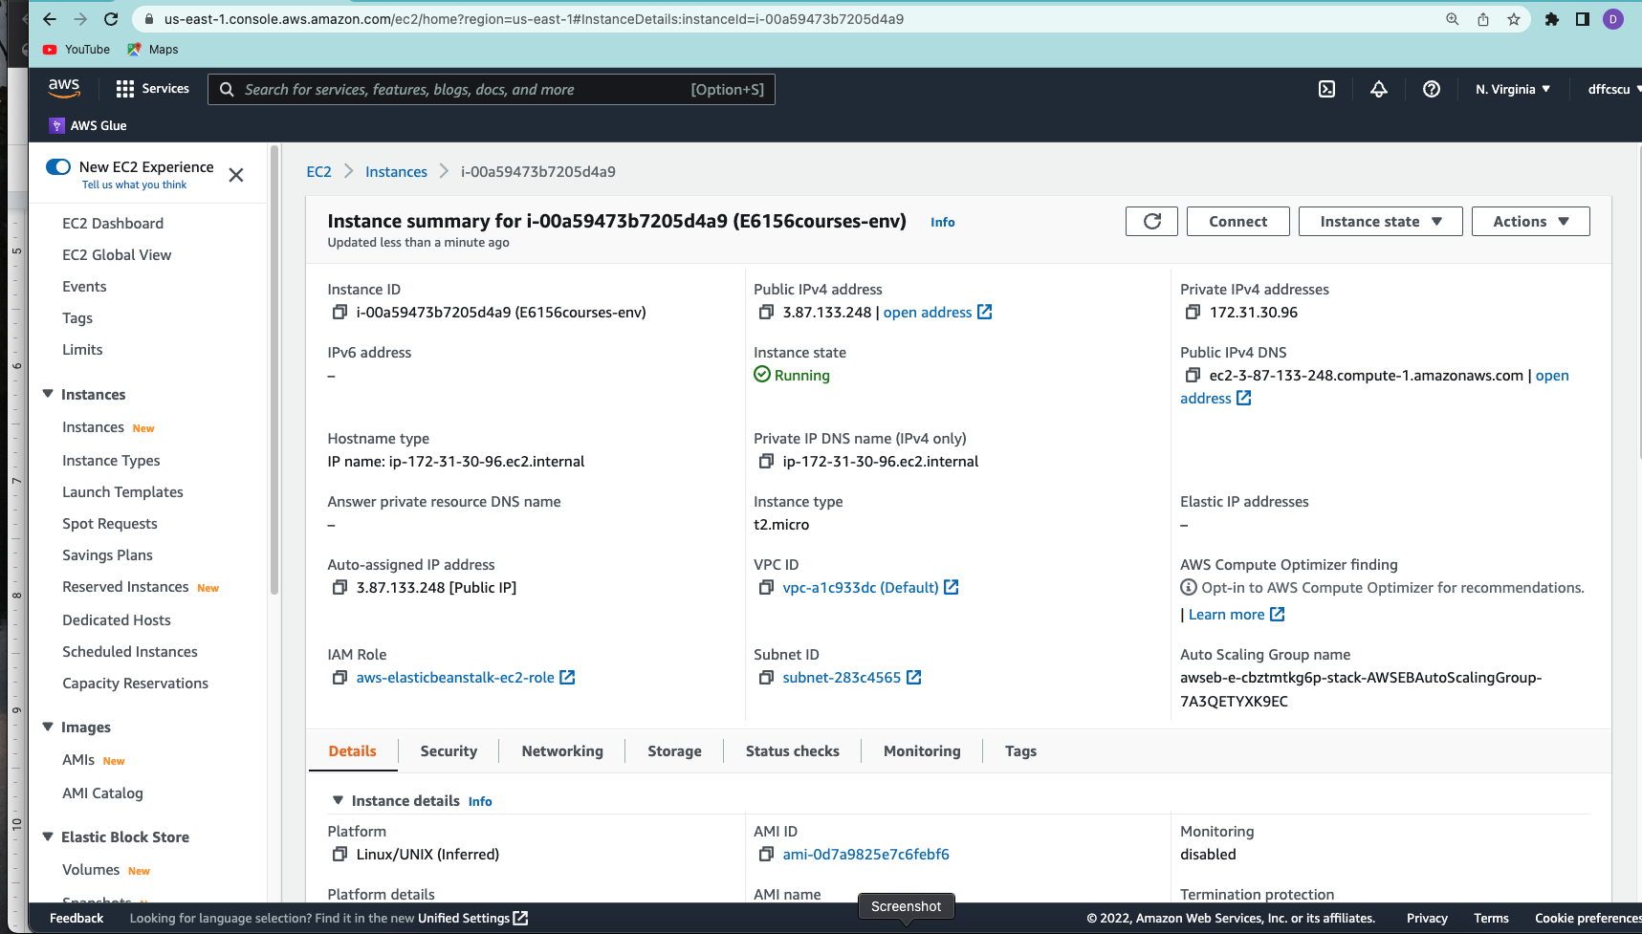

Show a screen capture of the terminal and your application executing.

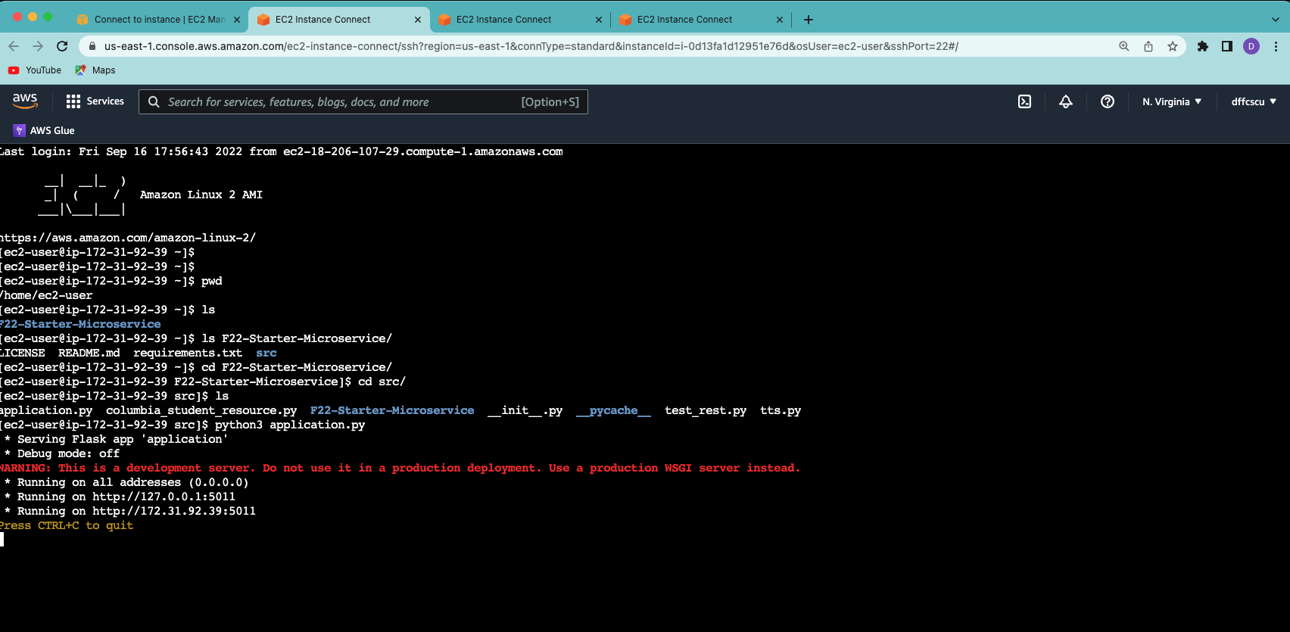

Show a screen capture of a browser window showing execution of the health path.

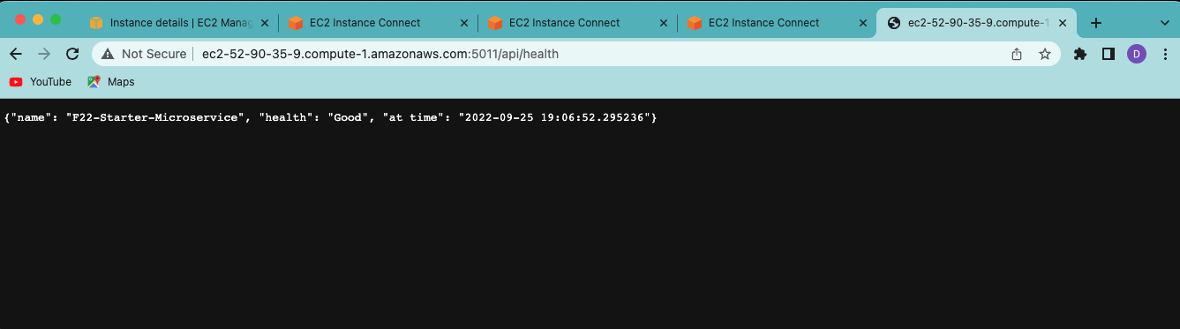

Show a screen capture of a browser window showing retrieving a student through the path /api/students/<uuid>.

Show a screenshot of your RDS instance.

