**Lab Task**

**Part 1**

Read data from the input file and create a linked list. Each node in your list must separately store the roll number, name and the e-mail address of a student. Each line in the input file has the format:

RollNo,"Name",EmailAddress

The three fields are separated by commas. The name field additionally contains commas. In order to remove confusion, the names are surrounded by double quotes.

**Part 2**

Add three other pointers to each node. The first set of added pointers maintains a sorted list with respect to roll numbers, the second with respect to name and the third with respect to e-mail address. Figure 1 that demonstrates a linked list with two sets of pointers (green and blue) used for sorting in addition to the usual set of pointers (red) needed for maintaining the raw list.

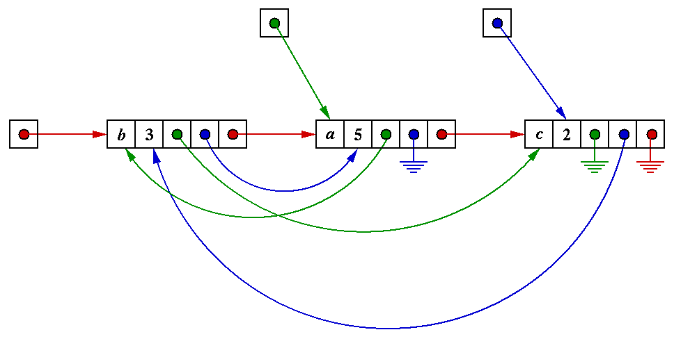

Figure 1

Print the three sorted lists by traversing along the three sets of links. Choose your own sorting algorithm.

**Note**

You may use the following data type for a node:

struct _student {

char rollNo[10];

char name[100];

char email[40];

struct _student *next;

struct _student *rNext;

struct _student *nNext;

struct _student *eNext;

};

typedef struct _student student;

typedef student *studentPointer;

The following built-in C library calls may be useful:

fscanf, fgets,

strcmp, strchr.