Name: Kanishka  
Course: B.Sc (H) Computer Science

Ping and tracert

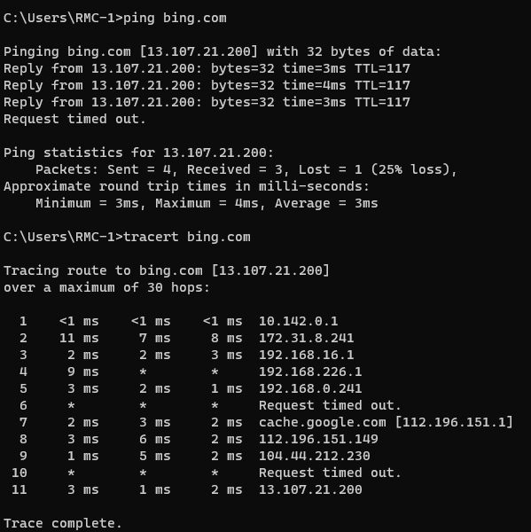

Ipconfig

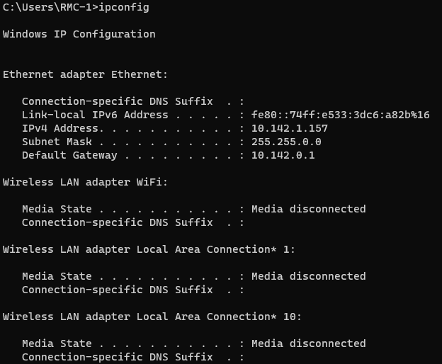

Netstat

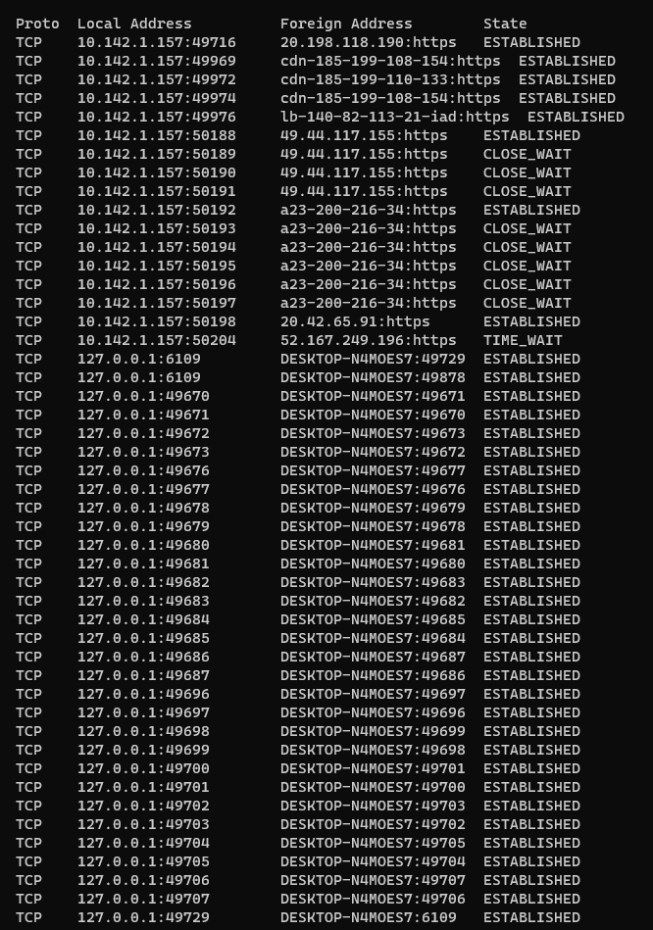

Nslookup

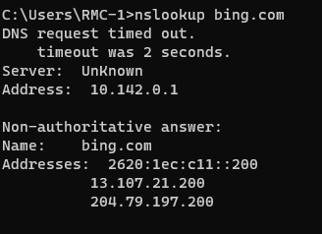

To study and perform PC to PC communication  
To create Star topology using Hub and Switch  
To create Bus, Ring, Tree, Hybrid, Mesh topologies  
Perform and initial Switch configuration  
Perform and initial Router configuration  
To implement Client Server Network

To implement connection devices using router  
To perform remote Desktop sharing within LAN connection