**Project3-Morphing**

一、运行环境

操作系统：Windows11

Python版本：3.8

第三方库：matplotlib 3.7.1、Pillow 9.4.0、numpy 1.24.2、scipy 1.10.1、imageio 2.26.0

二、过程分析

①选择特征点对并进行三角剖分

使用matplotlib库显示源图像与目标图像，并定义鼠标点击事件以通过鼠标点击获取特征点对，然后调用scipy库的Delaunay函数对源图像进行三角剖分。

②获取平均形状

在每一对特征点之间进行线性插值，以获得源图像与目标图像间的平均形状。

③变形warping

寻找每一个像素点在平均形状中所属三角形面片，并计算其重心坐标。利用重心坐标求出每一个像素点在源图像和目标图像中的对应位置，再通过后向变换将源图像和目标图像都变形到平均形状。

④Cross-Dissolve

对同一平均形状下的源图像和目标图像进行插值，得到最终的图像。

⑤生成GIF文件

使用imageio库将得到的一系列最终图像合成为一个GIF文件。

此外，为了提高计算速度，可以使用multiprocessing库创建多个进程，由各进程并行计算不同参数下的morphing图像。

三、运行结果

①选取特征点：

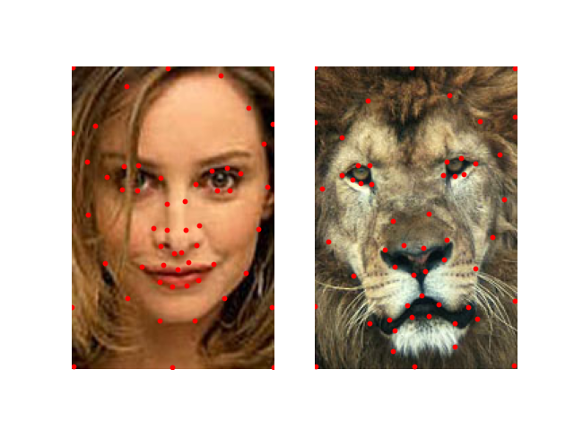

②Morphing后的图像：

  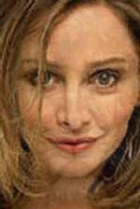 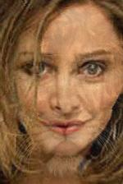 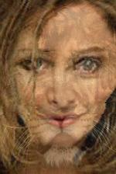 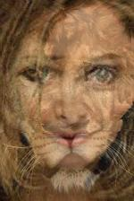

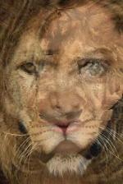 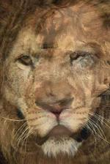 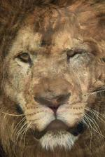 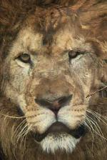 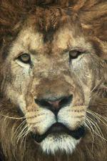 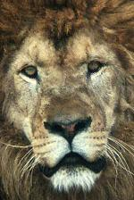

③GIF文件：



四、源代码

|  |
| --- |
| **import** matplotlib.pyplot **as** plt **from** PIL **import** Image **import** numpy **as** np **from** scipy.spatial **import** Delaunay **import** os **import** imageio.v2 **as** imageio **import** multiprocessing   **def** click_correspondences(im1, im2):  *# 判断两张图片是否为RGB三通道且大小相同* **assert** im1.mode == **'RGB' and** im2.mode == **'RGB'  assert** im1.size == im2.size   *# 创建窗口和两个子图* fig, (ax1, ax2) = plt.subplots(1, 2)  *# 显示图像* ax1.imshow(im1)  ax2.imshow(im2)  *# 设置子图坐标轴不可见* ax1.axis(**'off'**)  ax2.axis(**'off'**)   *# 创建两个列表，用于存放所选特征点坐标* im1_pts = []  im2_pts = []   *# 定义函数，获取鼠标点击位置* **def** on_press(event):  ix, iy = event.xdata, event.ydata  **if** ix **is not None and** iy **is not None**:  **if** event.inaxes == ax1:  im1_pts.append((int(ix), int(iy)))  ax1.scatter(ix, iy, s=10, color=**'red'**)  **elif** event.inaxes == ax2:  im2_pts.append((int(ix), int(iy)))  ax2.scatter(ix, iy, s=10, color=**'red'**)  fig.canvas.draw() *# 更新图像   # 绑定鼠标点击事件* cid = fig.canvas.mpl_connect(**'button_press_event'**, on_press)   **while True**:  *# 按下空格键退出程序* **if** plt.waitforbuttonpress(0):  **if** len(im1_pts) >= 3 **and** len(im1_pts) == len(im2_pts):  **break  else**:  print(**"ERROR: The number of feature points in both images must be the same and greater than 3!"**)   *# 解绑鼠标点击事件* fig.canvas.mpl_disconnect(cid)  *# 关闭图像* plt.close(fig)  *# 返回选取的特征点* **return** im1_pts, im2_pts   **def** morph(im1, im2, im1_pts, im2_pts, warp_frac, dissolve_frac):  *# 判断两张图片是否为RGB三通道且大小相同* **assert** im1.mode == **'RGB' and** im2.mode == **'RGB'  assert** im1.size == im2.size   *# 获取特征点的x坐标和y坐标* im1_pts_x, im1_pts_y = np.stack(im1_pts, axis=1)  im2_pts_x, im2_pts_y = np.stack(im2_pts, axis=1)   *# 对两张图片的特性点进行插值* x_mean = (1.0 - warp_frac) * im1_pts_x + warp_frac * im2_pts_x  y_mean = (1.0 - warp_frac) * im1_pts_y + warp_frac * im2_pts_y  pts_mean = np.column_stack((x_mean, y_mean))   *# 创建正则化网格点坐标* width, height = im1.size  im_mesh = np.zeros((width * height, 2))  **for** i **in** range(height):  **for** j **in** range(width):  im_mesh[i * width + j, 0] = i  im_mesh[i * width + j, 1] = j   *# 三角剖分* tri = Delaunay(im1_pts)  *# 寻找每个像素点所属三角形索引* t = tri.find_simplex(im_mesh)  *# tri_vertex的每一行表示一个三角形的三个顶点的索引* tri_vertex = tri.simplices   *# 计算重心坐标* barycentric = np.zeros((width * height, 3))  **for** i **in** range(width * height):  **if** t[i] < 0:  barycentric[i, :] = [np.nan, np.nan, np.nan]  **continue** ax = pts_mean[tri_vertex[t[i], 0], 0]  bx = pts_mean[tri_vertex[t[i], 1], 0]  cx = pts_mean[tri_vertex[t[i], 2], 0]  ay = pts_mean[tri_vertex[t[i], 0], 1]  by = pts_mean[tri_vertex[t[i], 1], 1]  cy = pts_mean[tri_vertex[t[i], 2], 1]  A = np.array([[ax, bx, cx], [ay, by, cy], [1, 1, 1]])  barycentric[i, :] = np.transpose(np.linalg.inv(A) @ np.array([[im_mesh[i, 0]], [im_mesh[i, 1]], [1]]))   *# 计算每个像素点对应于第一张图片的位置* im1_crsp = np.zeros((width * height, 2))  **for** i **in** range(width * height):  **if** t[i] < 0:  im1_crsp[i, :] = [np.nan, np.nan]  **continue** ax = im1_pts_x[tri_vertex[t[i], 0]]  bx = im1_pts_x[tri_vertex[t[i], 1]]  cx = im1_pts_x[tri_vertex[t[i], 2]]  ay = im1_pts_y[tri_vertex[t[i], 0]]  by = im1_pts_y[tri_vertex[t[i], 1]]  cy = im1_pts_y[tri_vertex[t[i], 2]]  A = np.array([[ax, bx, cx], [ay, by, cy], [1, 1, 1]])  X = A @ np.transpose(barycentric[i, :])  im1_crsp[i, :] = [X[0], X[1]]   *# 计算每个像素点对应于第二张图片的位置* im2_crsp = np.zeros((width * height, 2))  **for** i **in** range(width * height):  **if** t[i] < 0:  im2_crsp[i, :] = [np.nan, np.nan]  **continue** ax = im2_pts_x[tri_vertex[t[i], 0]]  bx = im2_pts_x[tri_vertex[t[i], 1]]  cx = im2_pts_x[tri_vertex[t[i], 2]]  ay = im2_pts_y[tri_vertex[t[i], 0]]  by = im2_pts_y[tri_vertex[t[i], 1]]  cy = im2_pts_y[tri_vertex[t[i], 2]]  A = np.array([[ax, bx, cx], [ay, by, cy], [1, 1, 1]])  X = A @ np.transpose(barycentric[i, :])  im2_crsp[i, :] = [X[0], X[1]]   *# 计算第一张图片变换后的结果* im1_morph = []  **for** i **in** range(height):  **for** j **in** range(width):  x = im1_crsp[i * width + j, 0]  y = im1_crsp[i * width + j, 1]  **if** np.isnan(x) **or** np.isnan(y):  pixel = im1.getpixel((j, i))  **else**:  **try**:  pixel = im1.getpixel((y, x))  **except** IndexError:  pixel = im1.getpixel((j, i))  im1_morph.append(pixel)   *# 计算第二张图片变换后的结果* im2_morph = []  **for** i **in** range(height):  **for** j **in** range(width):  x = im2_crsp[i * width + j, 0]  y = im2_crsp[i * width + j, 1]  **if** np.isnan(x) **or** np.isnan(y):  pixel = im2.getpixel((j, i))  **else**:  **try**:  pixel = im2.getpixel((y, x))  **except** IndexError:  pixel = im2.getpixel((j, i))  im2_morph.append(pixel)   *# 对变换后的两张图片进行插值* morphed_im = Image.new(**'RGB'**, (width, height), **'white'**)  **for** i **in** range(height):  **for** j **in** range(width):  r1, g1, b1 = im1_morph[i * width + j]  r2, g2, b2 = im2_morph[i * width + j]  r = (1.0 - dissolve_frac) * r1 + dissolve_frac * r2  g = (1.0 - dissolve_frac) * g1 + dissolve_frac * g2  b = (1.0 - dissolve_frac) * b1 + dissolve_frac * b2  morphed_im.putpixel((j, i), (int(r), int(g), int(b)))   **return** morphed_im   **def** create_gif(image_folder):  gif_name = **'morph.gif'** *# 当GIF文件已存在时将其删除* **if** os.path.exists(gif_name):  os.remove(gif_name)  *# 获取图片路径* file_name = [os.path.join(image_folder, f) **for** f **in** os.listdir(image_folder)]  *# 对图片进行排序* images = sorted(file_name, key=**lambda** x: int(x[len(image_folder)+1:-4]))  **with** imageio.get_writer(gif_name, mode=**'I'**) **as** writer:  **for** image **in** images:  writer.append_data(imageio.imread(image))  *# 最后一帧重复5次* **for** i **in** range(5):  writer.append_data(imageio.imread(images[-1]))   *# 子进程函数* **def** function(num, images, im1, im2, im1_pts, im2_pts, dir_name, k):  p = 1.0 / (num * images)  **for** i **in** range(images):  No = k * images + i  morphed_img = morph(im1, im2, im1_pts, im2_pts, p * No, p * No)  morphed_img.save(dir_name + **f'/{**No**}.jpg'**)   **if** __name__ == **'__main__'**:  *# 获取两张图片的特征点* img1 = Image.open(**'img1.jpg'**)  img2 = Image.open(**'img2.jpg'**)  img1_pts, img2_pts = click_correspondences(img1, img2)   *# 新建文件夹以存储morph图片* directory = **'Morphed_Images'  if** os.path.exists(directory):  files = [os.path.join(directory, f) **for** f **in** os.listdir(directory)]  **for** f **in** files:  os.remove(f)  **else**:  os.mkdir(directory)   *# 创建多进程执行不同参数的morph函数* process_num = 4  img_per_proc = 5  para_list = [(process_num, img_per_proc, img1, img2, img1_pts, img2_pts, directory, k) **for** k **in** range(process_num)]  pool = multiprocessing.Pool(process_num)  pool.starmap(function, para_list)  pool.close()  pool.join()   final_morphed_img = morph(img1, img2, img1_pts, img2_pts, 1, 1)  final_morphed_img.save(directory + **f'/{**process_num * img_per_proc**}.jpg'**)   *# 将创建的morph图片合成为GIF文件* create_gif(directory) |