

**Magento 2.3.4 Module for Plural XT by Pine Labs**

**Introduction**

This guide will show you how to Install and configure the Plural XT by Pine Labs module for payments on your Magento powered website.

**Steps to Integrate**

**1.** Extract the **magento2.3.4-pluralxt-pinelabs-v1.0.zip** file(Payment Module) and upload **PinelabsLtd** folder to Magento **<root>/app/code** .

**Note:** Please create a **code** folder under <root>/app if it doesn’t already exist.

**2**. Please create a **PluralXT** folder under <root>/var/log for logging purpose.

**3**. Disable the cache. To Disable the cache Go to Magento Admin Panel >**System** > **Cache Management** > **Select all cache type** from left side checkboxes > Select **Action** : **disable** from right top drop down > click **Submit**.

**4.** Run the magento commands:

* php bin/magento module:enable --clear-static-content PinelabsLtd_PluralXTGateway
* php bin/magento setup:upgrade
* php bin/magento setup:static-content:deploy

**5.** Configure the module in Magento Admin panel as shown in the

configuration section:

**Configuring the Plugin(**To show Payment Module on **Checkout** page**)**

**1**. Login to magento admin panel and Navigate to **Store** -> **Configuration-** >**Sales-** > **Payment Methods**

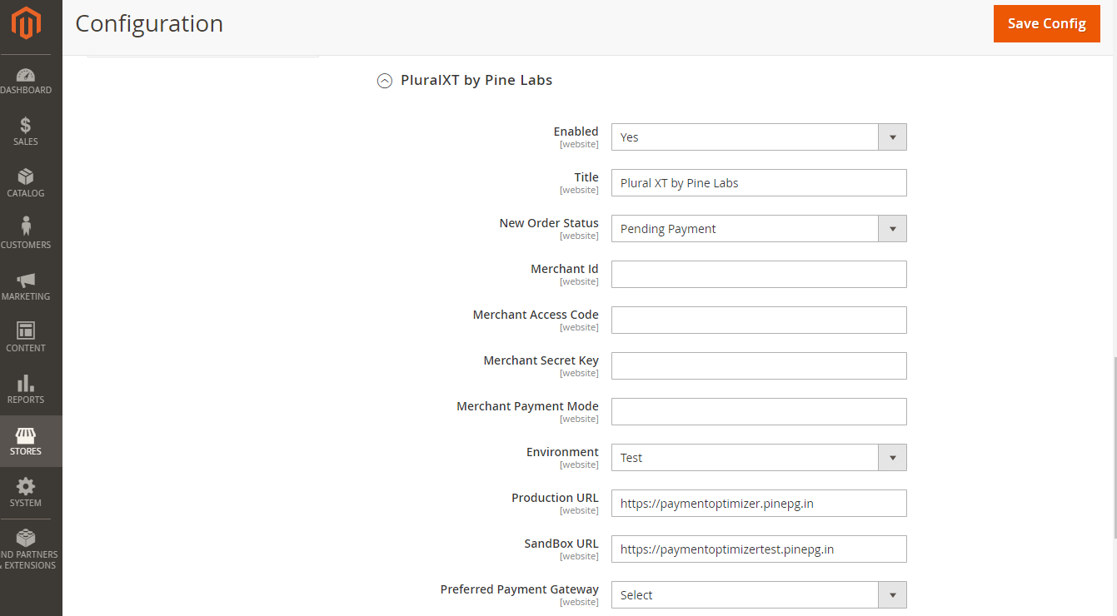

**2.** The page shown above should be displayed to you. If not, please clear the cache and then repeat this step.

**3**. Fill up the following configuration details:

**a) Enabled:** ‘Yes’ to enable the module.

**b)** **Title**: Name to be shown on checkout page

**c) Merchant Id ,Merchant Access Code, Merchant Secret Key** given by Pine Labs .

**d) Merchant Payment Mode**: Enter the Payment Modes as Comma Separated Values. These Payment Modes will be shown on the Payment Gateway transaction page.

**e) Environment:**

This field determines the gateway environment your payment will be

redirected to.

This field can have two values :

**1) Test –** This is a test environment.

**2) Live –** This is the live environment. Use this value only for your website in Production. Payments sent in production environment will actually get processed.

[For testing purposes only use **Test**.]

**e) Preferred Payment Gateway:** Select one of the payment gateways according to your preference, if any.

**4.** Once you are done click on **Save Config** and your customers can

make payment via the Plural XT by Pine Labs (title specified during configuration) will be displayed to the user.

**On Checkout Page**

Now, on the checkout page, customer can see the option for Plural XT by Pine Labs:

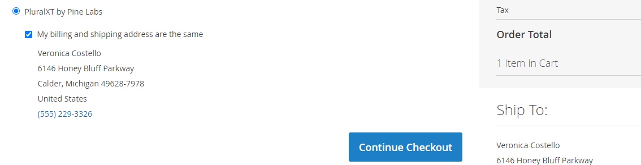

**a)** Once you click on Continue checkout button, it will redirect to payment gateway page.

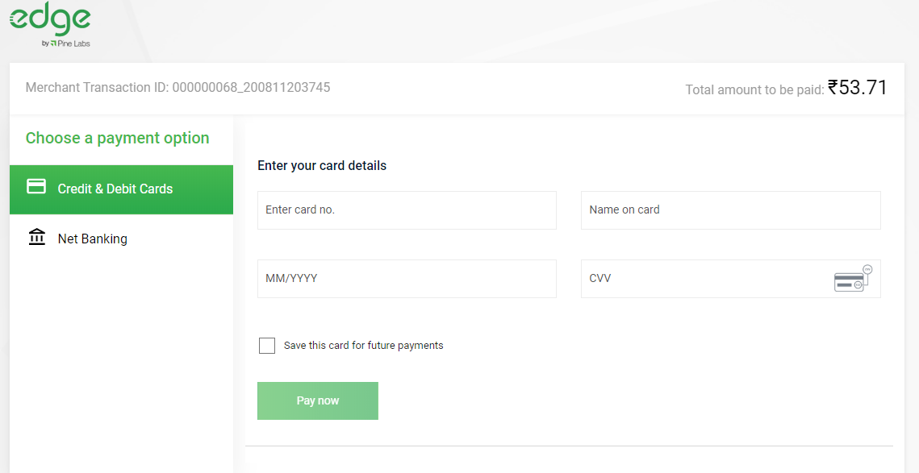

**b)** After successful transaction, a message similar to the following will be displayed on the return page of your website:

