PHP Integration Kit for Plural XT by Pine Labs

CONTENTS

1 Installation 3

2 Configuration………………………………………………………………………………………………………………………………………………...4 3 Creating order and redirecting to payment gateway……………………….…………………………………………………..………..7

# Installation

* Unzip the contents of the downloaded **pluralxt-pinelabs-php-v1.0.zip** file in a folder, say **pluralxt-pinelabs-php**.
* It has 4 files:
  + **index.php**
  + **process_order_payment.php**
  + **purchase_redirect.php**
  + **response_page.php**
* Deploy these files on your server.

File description:

* **index.php**
  + It is the sample application page/form where you enter all the order details for processing payment.
* **purchase_redirect.php**
  + This handles the POST request that is received by submitting the order details form.
* **process_order_payment.php**
  + This is the main file that contains all the required functions used for creating order request and then redirecting to the payment gateway.
* **response_page.php**
  + This is a sample page used in this application to handle the response.

Note: **process_order_payment.php** is the main file that contains all the required functions for integrating Plural XT. All other three files are just to create a sample application to show how these functions are being used. You can see we are including it using the following line of code:

*include 'process_order_payment.php';*

# Configuration

* Configure the merchant details by setting the **$merchant_config** variable in the file **process_order_payment.php**. The **$merchant_config** is an array that contains the following keys and you should set the appropriate values for each of these:
  + **merchant_id** – Set the Merchant Id provided by Pine Labs.
  + **merchant_access_code** – Set the Merchant Access Code provided by Pine Labs.
  + **merchant_secret_key** – Set the Merchant Secure Secret Key provided by Pine Labs.
  + **merchant_gateway_mode** – Set **'sandbox'** for sandbox/test operation and **'production'** for live operation.
  + **merchant_return_url** – The url of the page where you want to handle the response from payment gateway. For this application, assuming it is hosted at localhost in directory pluralxt-pinelabs-php, the value will be '[http://localhost/pluralxt-pinelabs-php/response_page.php](http://localhost/rapidpay-pinelabs-php/response_page.php)' .
  + **merchant_payment_modes_csv** – Enter the Payment Modes as Comma Separated Values. These Payment Modes will be shown on the Payment Gateway transaction page. Some of the valid individual payment modes are:

CREDIT_DEBIT

NETBANKING

EMI

UPI

WALLET

DEBIT_EMI

ALL (For all payment modes)

So, for example, you can set: "CREDIT_DEBIT,WALLET,UPI"

* + **merchant_preferred_gateway** – Set one of the following values as preferred payment gateway according to your preference:

"AMEX",

"AMEX_ENHANCED",

"AXIS",

"AXISB24",

"BANKTEK",

"BFL",

"BHARATQR_HDFC",

"BILLDESK",

"BOB",

"CCAVENUE_NET_BANKING",

"CITI",

"CITRUS_NET_BANKING",

"CORP",

"DEBIT_PIN_FSS",

"EBS_NETBANKING",

"EDGE",

"FEDERAL",

"FSS_NETBANKING",

"HDFC",

"HDFC_DEBIT_EMI",

"HDFC_PRIZM",

"HSBC",

"ICICI",

"ICICI_SHAKTI",

"IDBI",

"LVB",

"MASHREQ",

"OPUS",

"PAYTM",

"PayU",

"RAZOR_PAY",

"SBI",

"SBI87",

"SI_HDFC",

"SI_PAYNIMO",

"UBI",

"UPI_AXIS",

"UPI_HDFC",

"WALLET_PAYZAPP",

"WALLET_PHONEPE",

"YES",

"ZEST_MONEY"

If you don’t have any preferred gateway , set the value as "NONE".

Eg:

$merchant_config = array(

'merchant_id' => '1234',

'merchant_access_code' => '2c295f88-4277-1cd3-b5ec-e76148545a3e',

'merchant_secret_key' => '36AC6117F2104F81B554F1E35DCEFE41',

'merchant_return_url'=>'http://localhost/pluralxt-pinelabs-php/response_page.php',

'merchant_gateway_mode' => 'sandbox',

'merchant_payment_modes_csv' => 'ALL',

'merchant_preferred_gateway' => 'HDFC',

);

After correctly configuring the merchant data, you can open the **index.php** file in the browser. It should look something like this:

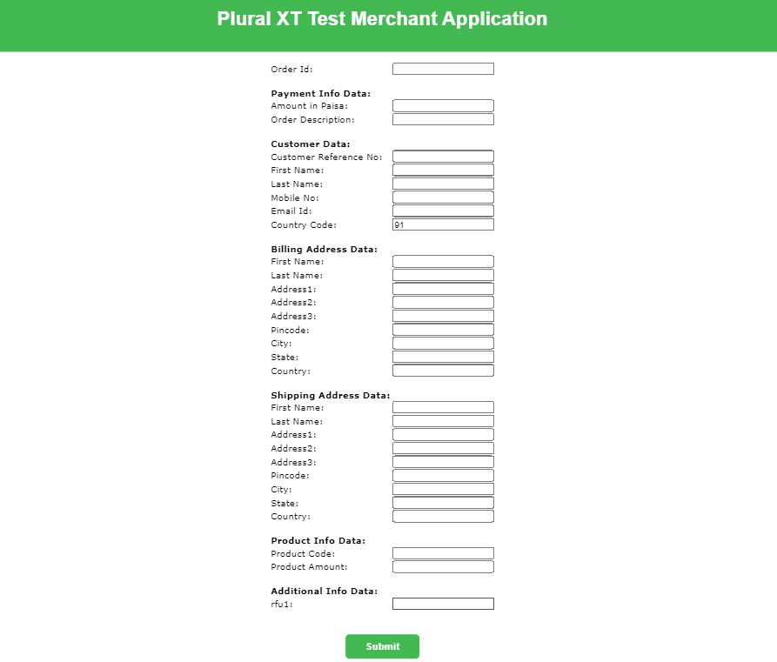

After filling the form and submitting the data, on successful order creation, you will be redirected to the payment gateway page:

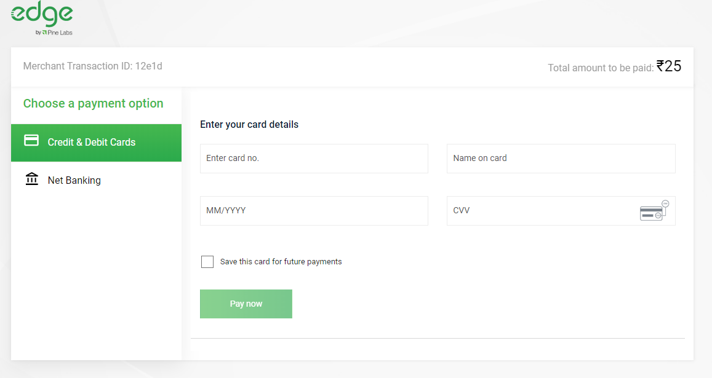

After filling the payment details, the payment will be processed and you will be redirected to the merchant_return_url page as specified in the merchant configuration previously.

# **Creating order and redirecting to payment gateway**

* Use function **pluralxt_create_order($params)** defined in file **process_order_payment.php**
  + The **$params** is an associative array that contains the order and payment data with the following keys:
    - order_id
    - amount_in_paisa
    - order_description
    - customer_ref_no
    - customer_first_name
    - customer_last_name
    - customer_mobile_number
    - customer_email_id
    - customer_country_code
    - bill_first_name
    - bill_last_name
    - bill_address1
    - bill_address2
    - bill_address3
    - bill_pincode
    - bill_city
    - bill_state
    - bill_country
    - ship_first_name
    - ship_last_name
    - ship_address1
    - ship_address2
    - ship_address3
    - ship_pincode
    - ship_city
    - ship_state
    - ship_country
    - product_code
    - product_amount_in_paisa
    - rfu1

For example:

$params = array (

order_id => 'abc1234',

amount_in_paisa => '2500',

order_description => 'sample order',

customer_ref_no => '12',

customer_first_name => 'pine',

customer_last_name => 'labs',

customer_mobile_number => '9191919191',

customer_email_id => 'abc@example.com',

customer_country_code => '91',

bill_first_name => 'Pine',

bill_last_name => 'Labs',

bill_address1 => 'Candor Techspace',

bill_address2 => 'Tower 6',

bill_address3 => 'Plot No. B2',

bill_pincode => '201309',

bill_city => 'Noida',

bill_state => 'Uttar Pradesh',

bill_country => 'India',

ship_first_name => 'Pine',

ship_last_name => 'Labs',

ship_address1 => 'Candor Techspace',

ship_address2 => 'Tower 6',

ship_address3 => 'Plot No. B2',

ship_pincode => '201309',

ship_city => 'Noida',

ship_state => 'Uttar Pradesh',

ship_country => 'India',

product_code => '456',

product_amount_in_paisa => '2500',

rfu1 => ''

);

* The function **pluralxt_create_order($params)** returns the order creation response object:
  + If the value of the parameter **response_code** of response object is **1**, then the order is successfully created and the response object will also have a parameter **token** that will be used as argument to the function **pluralxt_redirect_after_order_creation($token)** to redirect the customer to the payment gateway page.

Please check the contents of file **purchase_redirect.php** to see how the above flow is implemented.

You should also go through the **response_page.php** to check how the response is being handled.