Prestashop Payment Module for Plural XT by Pine Labs

CONTENTS

1 Installation 3

1.1 Installation via Module Manager in Back Office 3

2 Configuring the Module……………………………………………………………………………5

# Installation

**PrestaShop version: 1.7.6**

## **Installation via Module Manager in Back Office**

* Login to PrestaShop Account.
* Go to the PrestaShop Admin Back Office .
* Navigate to the **Modules** tab. Expand it and click on **Module Manager**.

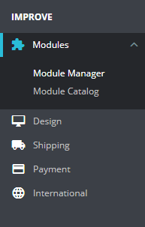

* Click on **Upload a module** button.

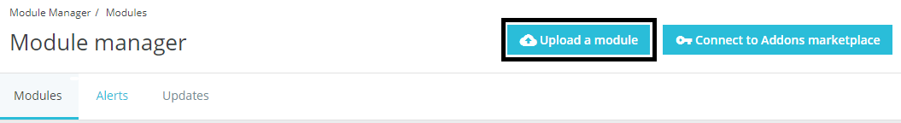

* The following popup will appear:
* 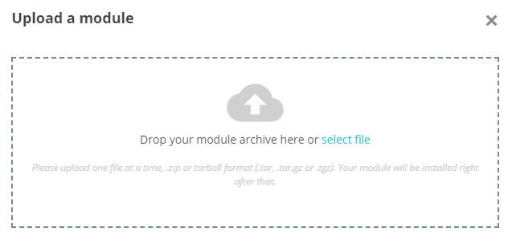Choose the downloaded **pluralxt-pinelabs-prestashop-v1.0.zip** file to upload.
* After successful installation, you will get the following popup:

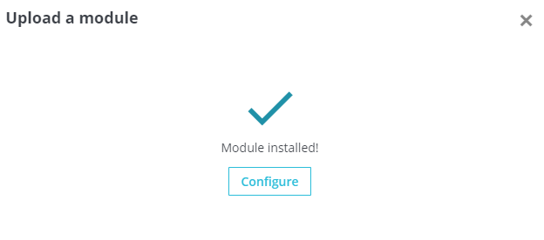

* Click on **Configure** button.
* Alternatively, you can go to **Modules** and locate the **Plural XT by Pine Labs** module:

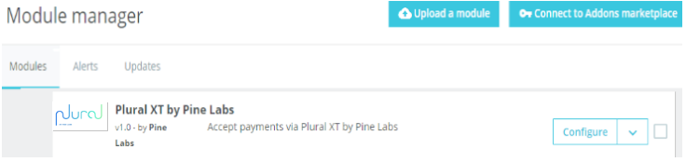

* Click the corresponding **Configure** button.

# **Configuring the Module**:

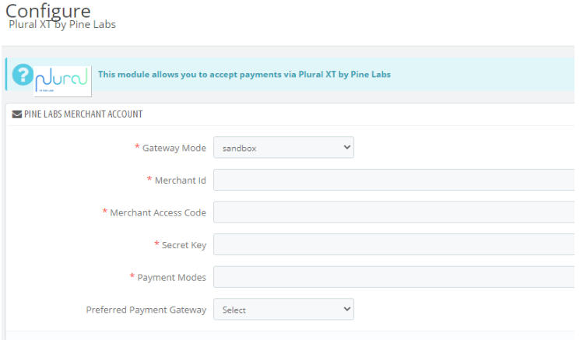

* + **Gateway Mode -** “sandbox” for sandbox/test operation and “production” for live operation.
  + **Merchant Id** – Enter the Merchant Id provided by Pine Labs.
  + **Merchant Access Code** – Enter the Merchant Access Code provided by Pine Labs.
  + **Secret Key** – Enter the Merchant Secret Key provided by Pine Labs.
  + **Payment Modes** – Enter the Payment Modes as Comma Separated Values. These Payment Modes will be shown on the Payment Gateway transaction page.
  + **Preferred Payment Gateway** – Select one of the payment gateways according to your preference, if any.
* Fill the required credentials and then click on **Save** button.
* Now, on the checkout page, customer can see the option for Plural XT by Pine Labs:

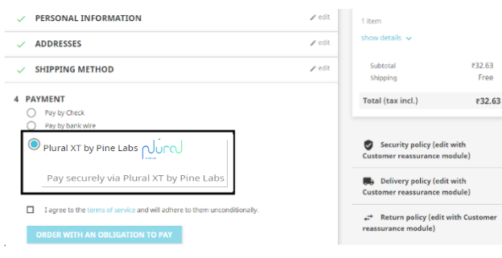

* After selecting the **Plural XT by Pine Labs** payment method and then proceeding to pay, customer will be redirected to the payment gateway page:

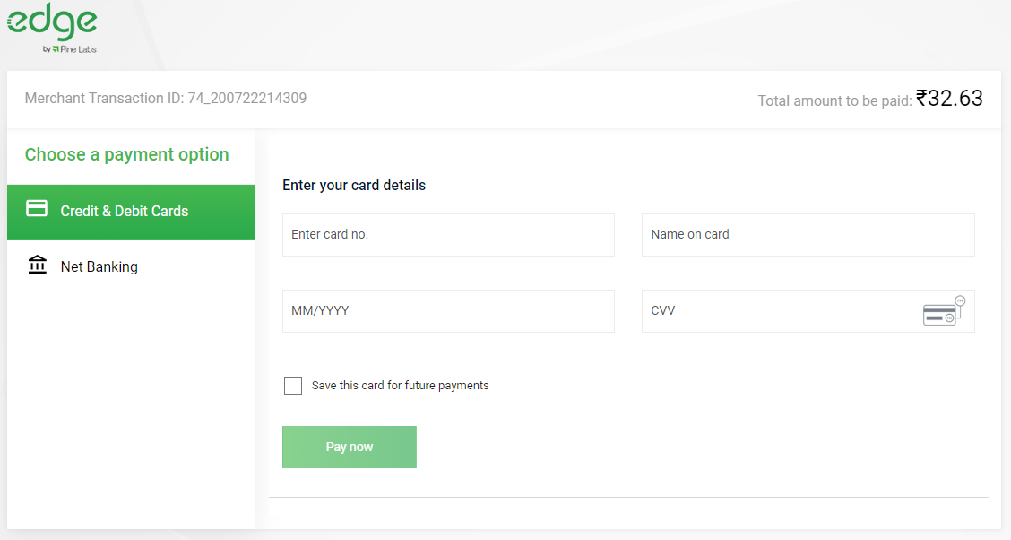

* After processing the transaction, customer will be redirected back to your website with order confirmation for successful transaction:

