Woocommerce Plugin for Plural XT by Pine Labs

CONTENTS

1 Installation 3

1.1 Installation via WordPress plugin Installer 3

1.2 Manual Installation 5

2 Configuring the plugin 6

# Installation

**Caution:** Always keep backup of your existing WooCommerce installation including MySQL Database, before installing a new module.

**WooCommerce version:** 3.6.3

Plugin can be installed by two ways:

* WordPress plugin installer
* Manual Installation

## **Installation via WordPress plugin Installer**

* Login to WordPress Admin panel.
* Click the Plugins Tab.

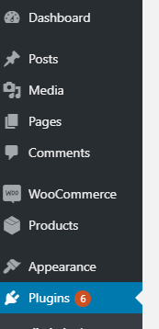

* Click add new plugin:



* Click upload Plugin:

## 

* Choose the downloaded pluralxt-pinelabs-woocommerce-v1.0.zip file.

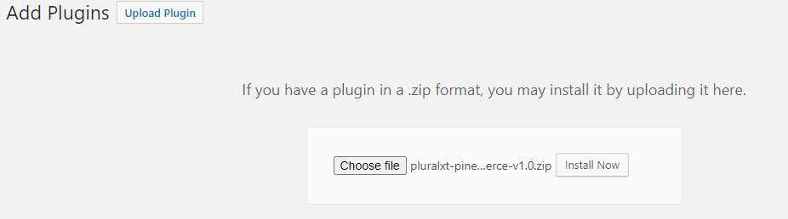

* Click install now.
* Then click on Activate Plugin.

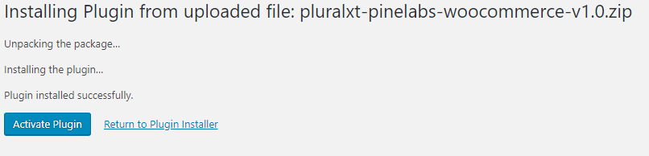

* You should get the plugin activated message and the installed plugin can be seen as Plural XT by Pine Labs for WooCommerce:

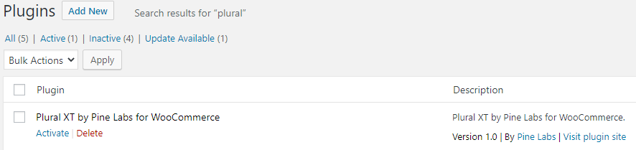

## Manual Installation

* Unzip the pluralxt-pinelabs-woocommerce-v1.0.zip file and then copy the folder pluralxt-pinelabs-woocommerce from this zip and paste/upload it to <wordpress root>\wp-content\plugins folder.
* Login to Woocommerce admin and go to Plugins.
* Activate the plugin Plural XT by Pine Labs for Woocommerce



# **Configuring the plugin**

* 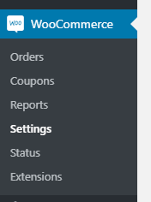Click on WooCommerce Settings tab.
* Go to the Payments/Checkout panel:

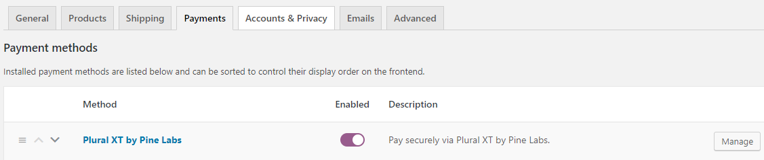

* Enable the Plural XT by Pine Labs method if not enabled already.
* Click Manage button corresponding to the Plural XT by Pine Labs method.

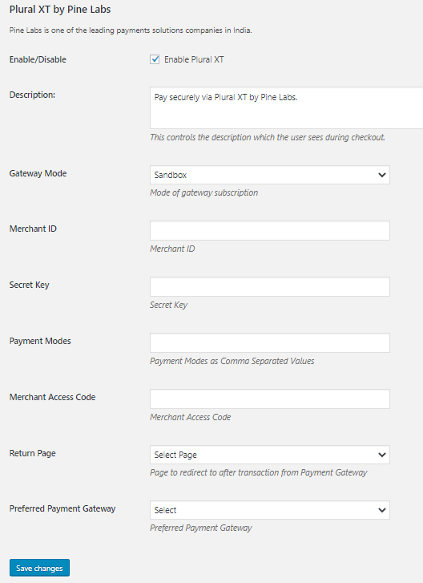

* + Enable/Disable – Tick to enable the module.
  + Description – Enter appropriate description to display at checkout.
  + Gateway Mode - “Sandbox” for sandbox/test operation and “Production” for live operation.
  + Merchant Id – Enter the Merchant Id provided by Pine Labs.
  + Secret Key – Enter the Merchant Secret Key provided by Pine Labs.
  + Payment Modes – Enter the Payment Modes as Comma Separated Values. These Payment Modes will be shown on the Payment Gateway transaction page. Valid individual payment modes are:

CREDIT_DEBIT

NETBANKING

EMI

UPI

WALLET

DEBIT_EMI

ALL (For all payment modes)

So, for example, you can enter: CREDIT_DEBIT,WALLET,UPI

* + Merchant Access Code – Enter the Merchant Access Code provided by Pine Labs.
  + Return Page – Use My Account as the default return page after payment response. You may create a custom page and select here. However, the custom page must contain appropriate WordPress / WooCommerce codes to show custom massages. Refer WordPress / WooCommerce development guide for custom pages.
  + Preferred Payment Gateway – Select one of the payment gateways according to your preference, if any.
* Fill the required credentials and then click save changes.
* Now, on the checkout page, customer can see the option for Plural XT by PineLabs:

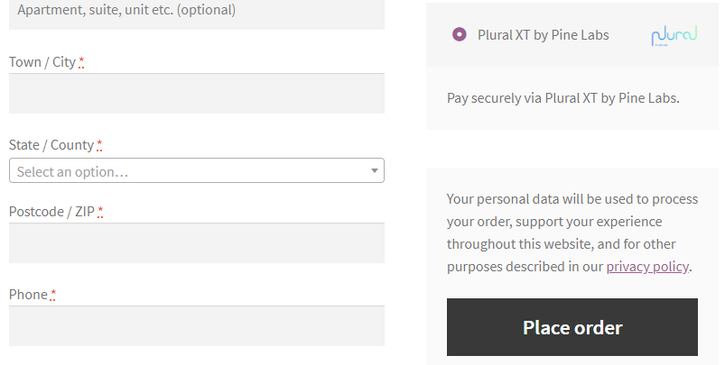

* On clicking Place Order, customer will be redirected to the payment gateway page.

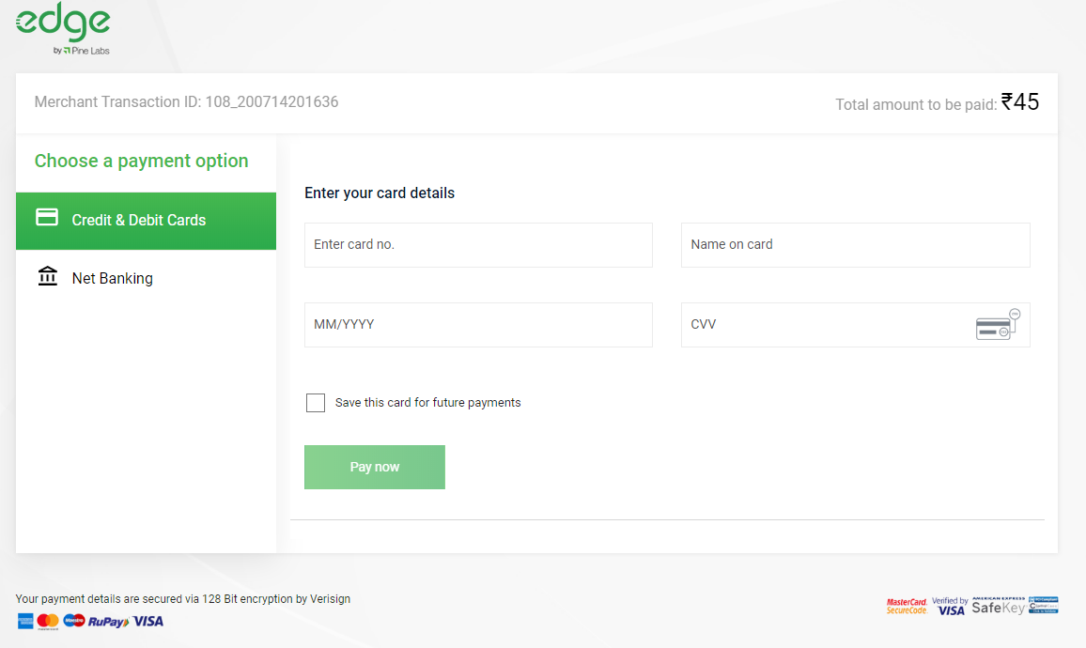

* After successful transaction, a message similar to the following will be displayed on the return page of your website

