Applied Regression II, Homework 2
- SAS codes and output:
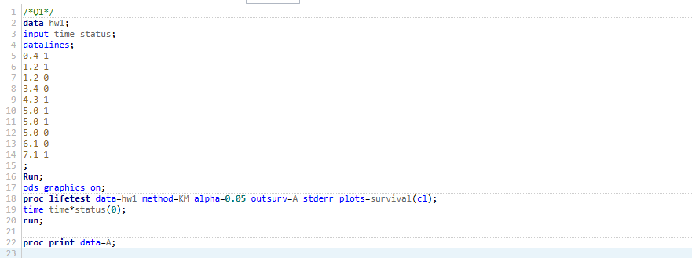



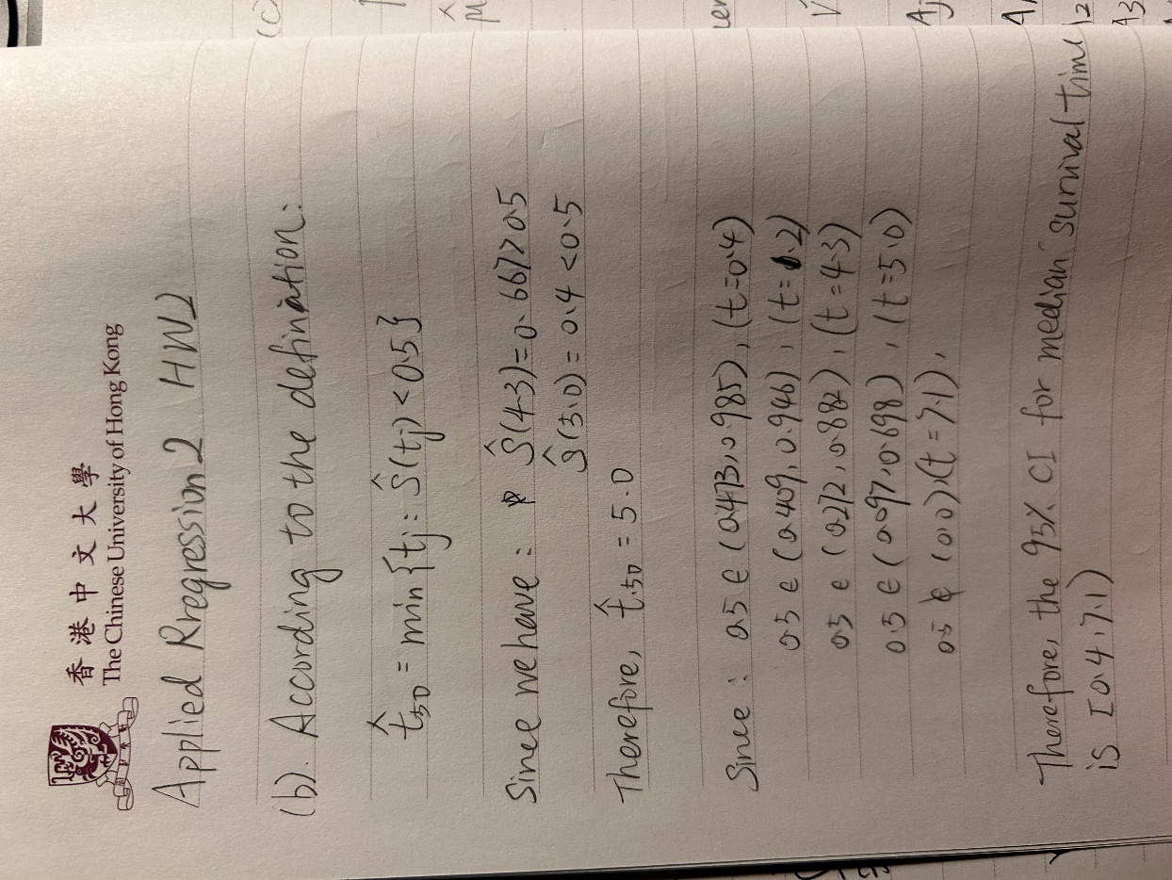

Therefore, the median survival time is 5.0 and its 95% confidence interval is [0.4, 7.1)

Interpretation: We estimate that 50 percent of patients will survive more than 5 weeks. We are 95% confident that the true value of the survival time lies in the interval [0.4, 7.1)

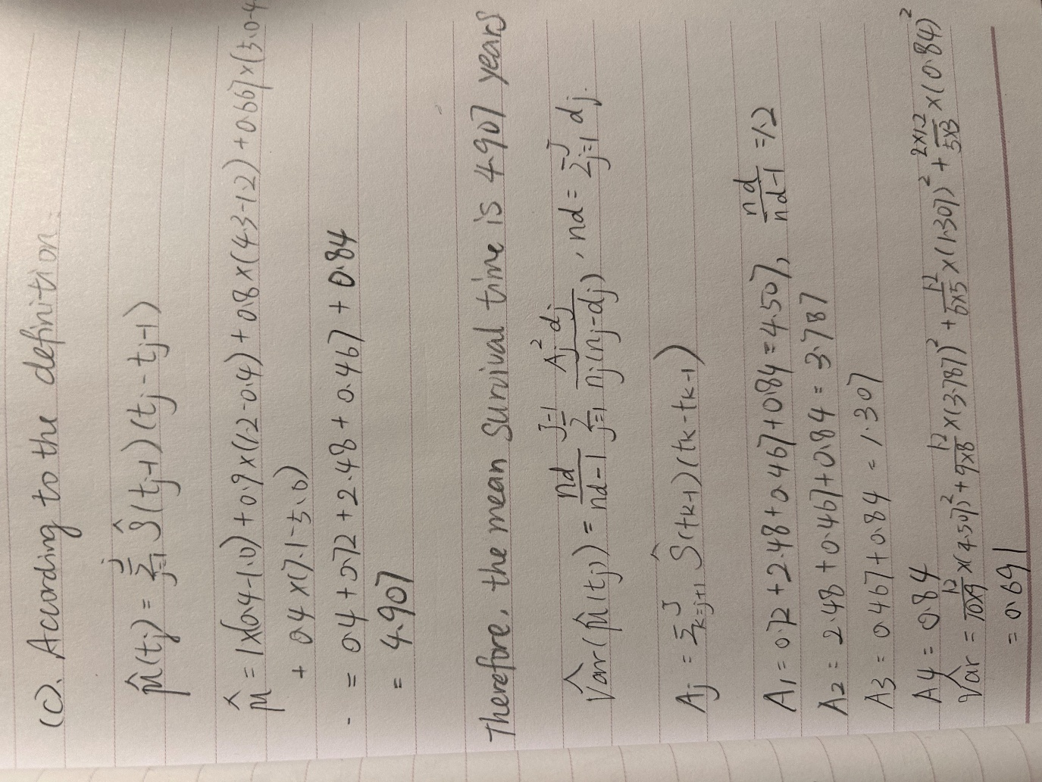
Therefore, the mean survival time is 4.907 years, and the estimated variance of it is 0.691.

Explanation: $\hat{μ_{1}}$ will be larger than $\hat{μ_{2}}$, because $\hat{μ_{1}}$ is the estimated survival time based on the original data, where the censored values are considered living at least until the censored time point. However, $\hat{μ_{2}}$ is based on the new data that suppose the patients die at the censored datapoint, which will artificially reduce the survival time of the patients who might live longer in the original dataset. Therefore, the survival curve will drop faster in the new dataset than the original dataset, and the area (mean value) under the curve will be less.

SAS code and output:
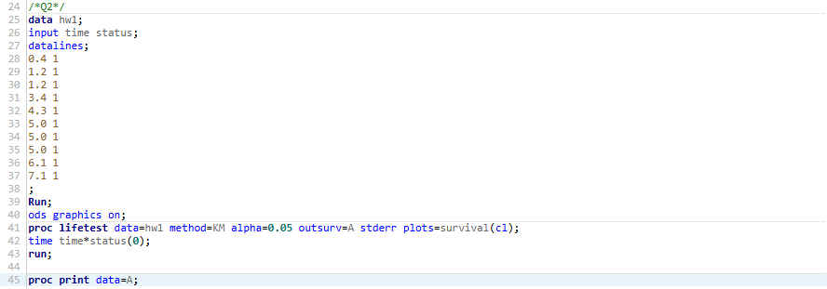
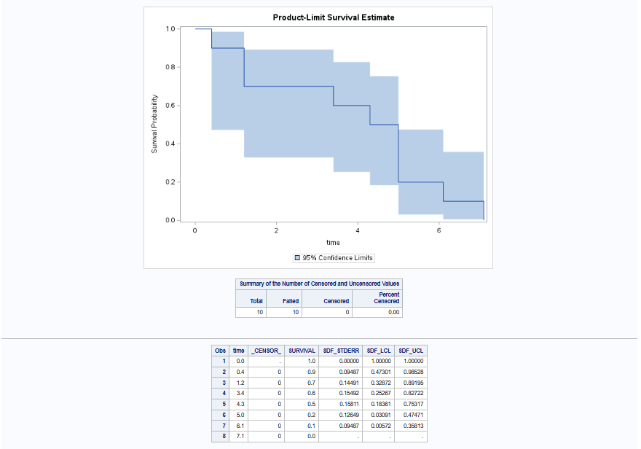

SAS codes and output:

