Applied Regression II, Homework 3
1. Use SAS to compute the Kaplan-Meier estimator and 95% CI of the survival function for the routine bathing group (only keep the K-M estimates for the unique event time points). Generate a graph of the survival functions in the two treatment groups. Interpret the graph. (hint: What do you observe on the difference of the survival functions between the two groups?) [2 points]
SAS output:
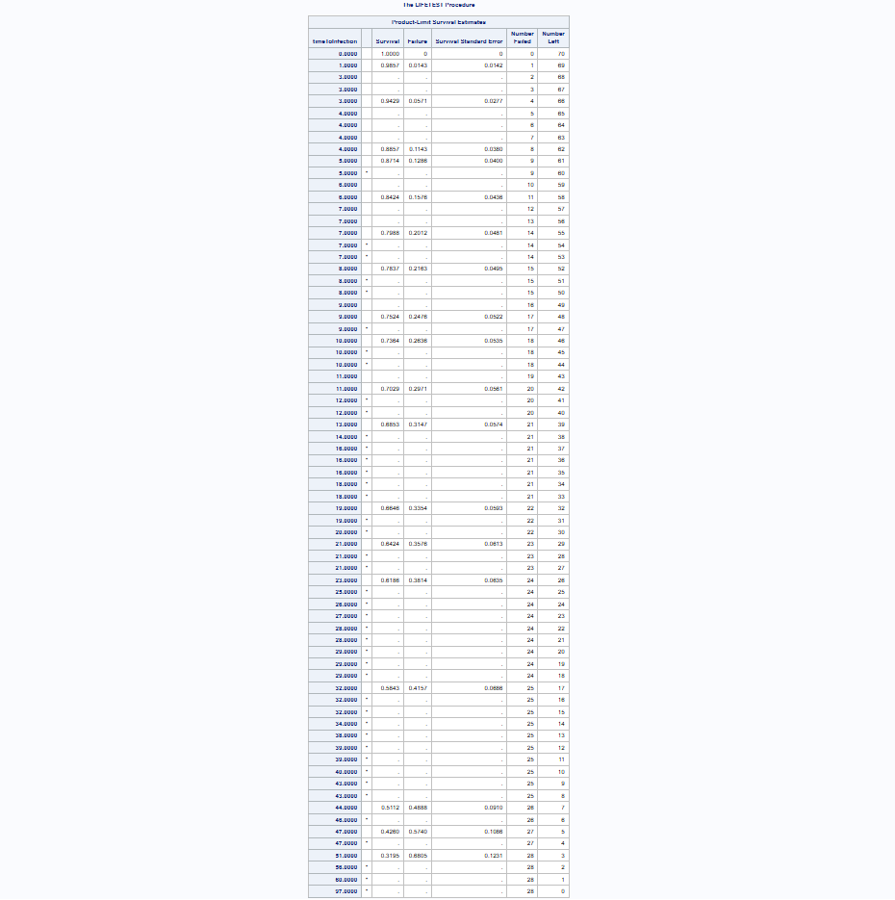

Kaplan-Meier estimator and 95% CI:
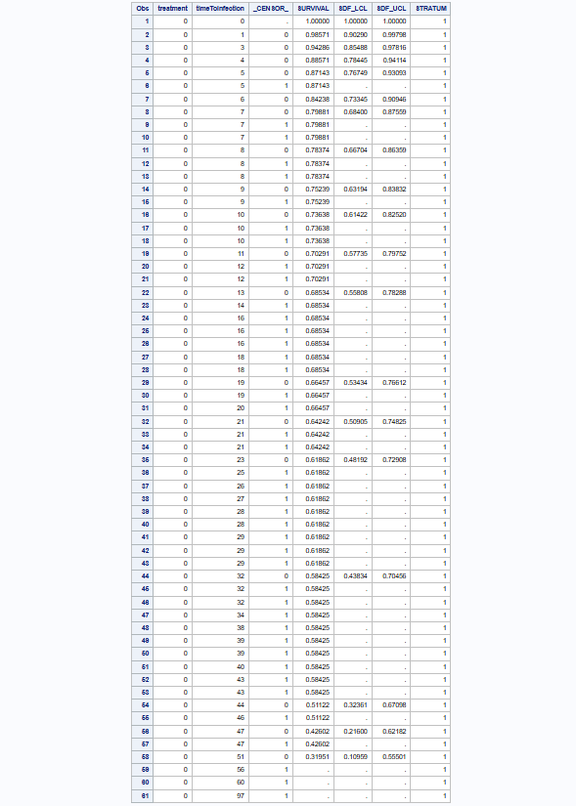

Graph of the survival functions in the two treatment groups:
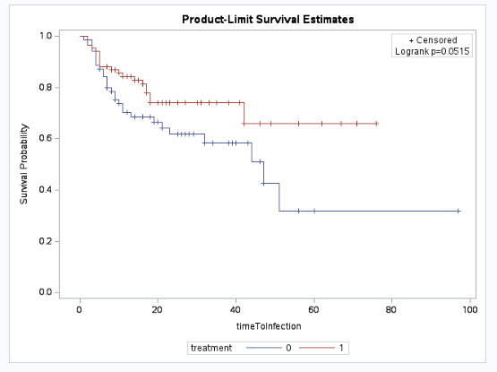
Interpretation of the graph: According to the graph above, the body-cleaning method appears to provide better protection than the routine bathing care, because the graph shows that the patients who use body-cleaning treatment have longer infection-free survival times.

2. Test whether the survival curves for the two treatment groups are the same using the log-rank test at α = 0.05. Give the null and alternative hypothesis, test statistic, degrees of freedom, p-value, and conclusion. Does the Wilcoxon test lead to the same conclusion? Briefly explain why the test statistic of the Wilcoxon test is smaller than that of the log-rank test in this application. [5 points]
Null Hypothesis: The survival functions for the two treatment groups are identical.
Alternative Hypothesis: The survival functions for the two treatment groups are not identical.
Log-Rank Test
Test statistics: $χ^{2}=3.7924$
Degrees of freedom: 1
P-value: 0.0515
Conclusion: because $p≥0.05$, we fail to reject the null hypothesis. Therefore, there is insufficient evidence of a difference in survival curves.
Wilcoxon Test
Test statistics: $χ^{2}=2.8639$
Degrees of freedom: 1
P-value: 0.0906
Conclusion: because $p≥0.05$, we fail to reject the null hypothesis. Therefore, there is insufficient evidence of a difference in survival curves.
The test statistics of Wilcoxon test is smaller than Log-Rank test because it gives more weight to earlier time points. According to the graph, the survival curves are more similar to each other in the early period. Therefore, the test statistic of the Wilcoxon test is smaller than that of the log-rank test in this application.

3. We can categorize the percentage of total surface area burned into four groups using the sample quartiles (< 12%, [12%, 20%), [20%, 30%), and ≥ 30%). Test whether the survival functions are the same among the four groups using the generalized log-rank test at α = 0.05. Give the null and alternative hypothesis, test statistic, degrees of freedom, p-value, and conclusion. [3 points]
Null Hypothesis: The survival functions are the same among the four treatment groups.
Alternative Hypothesis: The survival functions are not the same among the four treatment groups.
Log-Rank Test
Test statistics: $χ^{2}=5.4722$
Degrees of freedom: 3
P-value: 0.1403
Conclusion: because $p≥0.05$, we fail to reject the null hypothesis. Therefore, there is insufficient evidence of a difference in these four survival curves.

SAS code: 