Homework 6
- Ordinal logistic regression model
  - Write down the model

$$logit\left[P\left(Y≤k\right)\right]=α_{k}+β_{1}×sex+β_{2}×age_{2}+β_{3}×age_{3}$$

Where $k=1 \left(\text{No\backslash Little}\right), 2\left(\text{I}\text{mportant}\right)$, Y is the ordinal response variable, $α_{k}$ are the intercepts for each cumulative logit, $β_{1}$ is the coefficient for sex, $β_{2} β_{3}$ are coefficients for age.

  - Test the proportional odds assumption

$H_{0}:$ the proportional odds assumption holds (ordinal model is appropriate)
$H_{1}:$ the proportional odds assumption doesn’t hold

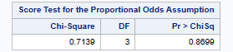

Test statistics: Score test (Chi-Square) $χ^{2}=$0.7139

Degrees of freedom: 3

P-value: 0.8699

Conclusion: We fail to reject the null hypothesis at $α$= 0.05. The proportional odds assumption is reasonable.

  - Estimate odds ratio and CI

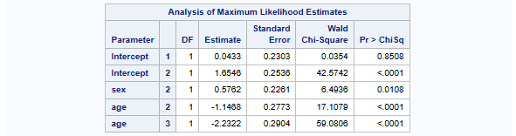

Odds ratio:
$$e^{0.5762}=1.7793$$

95% CI:
$$CI_{lower}=e^{0.5762-1.96×0.2261}=1.1421$$
$$CI_{upper}=e^{0.5762+1.96×0.2261}=2.772$$

Therefore, the 95% CI is $(1.1421 , 2.772)$.

Conclusion: Men have 1.7793 times the odds of giving a lower rating compared to women, adjusting for age. Because the 95% CI (1.1421, 2.772) doesn’t include 1, we are 95% confident to say that this is true. This means that women care more about air conditioning and power steering features compared to men.

  - Estimate the probability

$$P\left(Y≤2\right)=\frac{e^{1.6546}}{1+e^{1.6546}}=0.8396$$
$$P\left(Y=3\right)=1-P\left(Y≤2\right)=0.1604$$

Therefore, the probability of rating “Very important” regarding the features of air conditioning and power steering in cars for women aged 18-23 is 0.1604.

- Multinomial logistic regression model
  - Write down the model

$$logit\left(\frac{P\left(Y=k\right)}{P\left(Y=1\right)}\right)=β_{0k}+β_{1k}×sex+β_{2k}×age_{2}+β_{3k}age_{3}$$

Where $k=2, 3$ (Important or Very Important), Y is the ordinal response variable, $β_{0k}$ are the intercepts for each cumulative logit, $β_{1k}$ are the coefficients for sex, $β_{2}k β_{3k}$ are coefficients for age.

  - Estimate odds ratio and CI

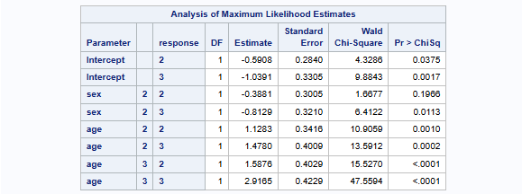

$$OR=e^{-0.813}=0.4435$$

$$CI=e^{-0.813±1.96×0.321}=(0.2364, 0.8321)$$

  - Estimate the probability

$$P=\frac{e^{-1.0391}}{1+e^{-1.0391}+e^{-0.5908}}=0.1854$$

Therefore, the probability of rating “Very important” regarding the features of air conditioning and power steering in cars for women aged 18-23 is 0.1854.

- Choosing model
I will choice the ordinal model because the proportional odds assumption is satisfied, and it is more simple. Also, since the response variable (importance rating) has a natural ordering, the ordinal model respects this structure and provides a more interpretable cumulative odds ratio across all levels.

