EIRVIO architecture
  - Interface interaction and user awareness
Version 0.3.1 • 7 November 2026 • MIT open source
EIRVIO gives an existing agent two capabilities: interact with a supported interface and understand activity happening there. It provides structured targets, allowed actions and observations without taking screenshots. The agent decides what to do; EIRVIO checks requests and dispatches supported operations.
This guide explains the shipped architecture, the responsibilities of the integrating application, and the environments used to test improvements. EIRVIO stands for Event-Instrumented Runtime for Verified Interface Operations. “Verified” refers to implemented checks, not formal verification.
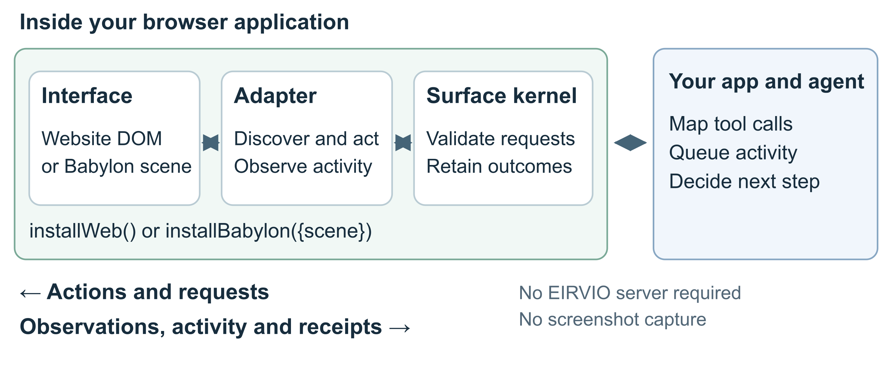
Figure 1 The default integration runs inside the browser and connects to the agent you already use.

Install and connect
npm install github:Pineapulse/eirvio#v0.3.1
import {installWeb} from 'eirvio/web';
const surface = installWeb();
Install after the page body exists, or pass a smaller DOM root. For a game, call installBabylon({scene}) from eirvio/babylon after creating the scene. Map surface.tools into your agent framework and route parsed calls through surface.callTool(name, arguments_). The GitHub release is the current installation channel; the package is not on the npm registry.
Tool | Purpose
surface_observe | Read supported targets, current revision and recent activity.
surface_act | Submit an action against the exact observed target and revision.
surface_get_outcome | Look up the retained receipt for a request ID.

How actions and observations flow

The adapter understands its interface
The web adapter samples supported DOM labels, roles, visible content, public form values and control state. It exposes click, fill, select, check, focus and scroll where supported. Stable references follow object identity, so a replacement element does not inherit an old element’s reference. Form operations use native setters and events.
The Babylon adapter samples supported scene objects and the active camera, observes picking, and offers camera focus and bounding-box highlighting. Animation positions are samples that can change without invalidating every action. Semantic state still participates in revision checks. Thin instances are represented as an aggregate; gameplay rules require application-defined operations.

The shared kernel checks each request
An observation supplies an adapter lifetime ID, revision, target references, action schemas and recent activity. The agent submits that basis with a unique request ID. Before dispatch, the kernel resamples, checks freshness and capability, validates arguments and checks lifecycle state. A user edit or replaced target can invalidate an earlier plan.
Receipt | What the integrating application should infer
rejected | The request was not admitted for execution; inspect the rejection code.
pending | The same admitted request is still in progress.
dispatched | The built-in adapter invoked the operation. Business success is separate.
uncertain | Execution began, but a reliable result is unavailable. Reconcile by ID.
The shared contract also allows completed for an adapter-defined operation. Current web and Babylon actions return dispatched. A click may be canceled, fail validation, navigate away or trigger asynchronous work. Neither status alone proves that a purchase, save or game objective succeeded.

Activity reaches the agent through the application
subscribe() supplies live events; observe().activity includes recent events; history() pages through retained history. Continue with nextCursor, inspect gap for eviction, and deduplicate by adapterId and cursor. Input events contain interaction metadata rather than typed values, although ordinary public field values can appear in snapshots.
The application forwards relevant events to its agent’s context queue. User, agent and system labels describe attribution, not authentication or human intent. Events never trigger an agent action by themselves. Queue work outside synchronous listeners because reentrant action calls are rejected.

Integration boundaries and guarantees

Retries have a bounded lifetime
Keep the full request until its outcome is known. An exact retry in the same adapter lifetime returns the retained receipt without repeating the effect; changed content under the same ID is rejected. A full receipt ledger rejects new requests instead of silently dropping old identities. After a missing reply, query the original ID before making a new attempt.
Receipts and history are bounded in-memory state. Reload, navigation or reinstall starts a new lifetime and can lose the old ledger. A null outcome does not prove that nothing happened. Disposal removes listeners and owned resources but cannot undo application effects. DOM and scene operations do not have transactional rollback.

Optional declared awareness
Applications with richer semantics can declare event schemas, publish events such as task.selected, and replace their current context explicitly. createEventStream and createInterfaceAwareness combine declared context with retained user activity. This is a separate API from the automatic adapter feed; it needs application wiring. Updating awareness does not authorize or invalidate a domain command by itself.

Optional authoritative domain operations
An interaction client can send application-defined commands through an application-supplied transport to a trusted Node host. The host obtains trusted permissions and confines operations to configured scene, scope and view boundaries. The core runtime applies registered domain validators and transactional state transitions, with scope cancellation, effect intents, delivery receipts and replay.
This path is separate from automatic adapter actions. The application owns business or game rules, authentication, transport, state rendering and effect handling. A committed state transition and a finished animation are separate milestones. The bundled MemoryStore is atomic in process but supplies no crash durability. The optional host requires Node 22 or newer.

Coverage and privacy
Install on the smallest useful root. Hidden, password and marked-private content is excluded, including content-visibility:hidden subtrees. Ordinary visible content and public field values remain observable. Babylon metadata is exposed only through selected namespaces. Review observations before forwarding them outside the application.
Automatic web discovery does not cover shadow trees, embedded frame contents, canvas drawings, custom-widget semantics or layout occlusion. Babylon discovery offers presentation actions, not game legality. Native desktop and mobile interfaces require another bridge. The containing page grants the adapter its authority; it is not a security sandbox. Treat interface content as data, and keep production authorization in the application.
Connection helpers for agent frameworks, additional engine and native adapters, and durable recovery remain extension work. Each product needs its own data review, domain operations and verification in the actual browser or game.

Testing and the improvement loop
Each lab attempt creates and cleans up a fresh jsdom website, Babylon NullEngine scene or kernel fixture. Expected rejection of an unsafe request is a successful assertion.
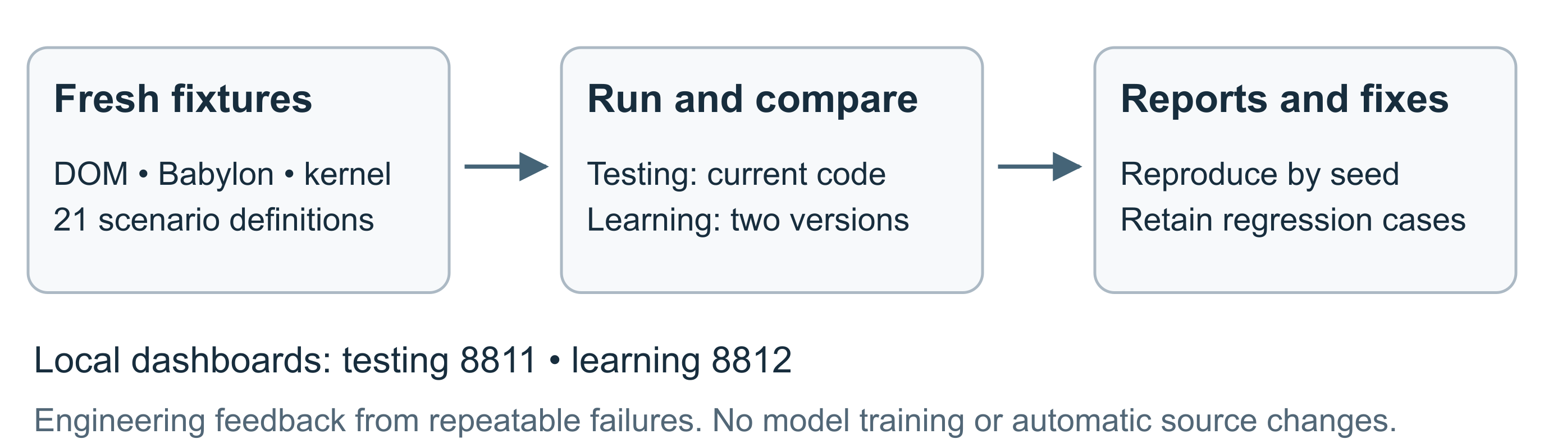
Figure 2 Repeatable scenarios turn discovered failures into regression cases for the next revision.
Recorded release evidence | Result
Automated tests in the v0.3.1 check | 154 passed
Testing curriculum | 21 scenarios passed
Learning baseline v0.3.0 at root seed 73 | 48 of 63 attempts passed
Learning candidate v0.3.1 at root seed 73 | 63 of 63 attempts passed
Comparison across three rounds | Five scenarios improved; zero regressions
The runner compares a pinned v0.3.0 commit with current source using identical scenarios and seeds. Local JSON reports retain case results, evidence and source hashes. Improvements cover dynamic privacy, preflight reentrancy and disposal, semantic sample keys and bounded history pages.

Run the environments
From a clone, npm run lab:test checks current code; npm run lab:learn compares versions; npm run lab:serve opens both dashboards. Dashboard runs use a fixed worker with a 60-second limit. CI runs tests and the testing lab on Node 22 and 24. Learning comparisons are on demand.
These synthetic results do not prove browser rendering, GPU behavior or arbitrary model performance. The lab does not train a model or modify source. Developers reproduce failures, fix code, retain regression cases and rerun comparisons.

Source and further reading
Architecture guide • Quickstart • Advanced integration • Testing guide
Implementation basis: v0.3.1, source commit 6bca7b3. Release checks

