Genetic evidence for bidirectional associations between major depressive disorder and anxiety disorders: a bidirectional Mendelian randomization and functional annotation study
Chao Chen^1, Zehui Chen^1, 刘晔^2, 雷蕾^1*
1. Institute of Information on Traditional Chinese Medicine, China Academy of Chinese Medical Sciences, Beijing 100700, China
2. Wangjing Hospital, China Academy of Chinese Medical Sciences, Beijing, China
* Correspondence: 雷蕾, leilei@mail.cintcm.ac.cn
Author emails: Chao Chen, chenchao_0727@163.com; Zehui Chen, zehuijzl01@163.com; 刘晔, liuye7562@163.com
Funding: This work was supported by project grants from the National Natural Science Foundation of China (Grant No. 82405293).

Abstract
Background: Major depressive disorder (MDD) and anxiety disorders are highly comorbid, but the directionality and genetic mechanisms underlying their association remain incompletely understood.
Methods: We performed bidirectional two-sample Mendelian randomization using ancestry-matched European-ancestry Psychiatric Genomics Consortium (PGC) GWAS summary statistics for MDD and anxiety disorders. Instruments were selected using 1000 Genomes European reference-based LD clumping (P < 5 x 10^-8, r2 < 0.001). Instrument strength was quantified with F-statistics, and the hypothesized causal directions were formally evaluated with Steiger filtering and directionality tests. We applied IVW, MR-Egger, weighted median, weighted mode, MR-PRESSO, Radial MR, and MR-RAPS, and corrected for potential participant overlap between the exposure and outcome GWAS using MRlap. Multivariable MR adjusted for body mass index, education, and smoking initiation. LDSC, colocalization, and FUMA/MAGMA/eQTL analyses explored shared genetic architecture, candidate drug targets, and cell-type-specific mechanisms.
Results: After harmonisation, 198 and 50 SNPs were included in the MDD-to-anxiety and anxiety-to-MDD analyses, respectively. All instruments were strong (mean F = 44.0 for MDD and 37.9 for anxiety disorders; all F > 10), and Steiger directionality tests supported the hypothesized exposure-to-outcome orientation in both directions (P = 0.018 and P = 1.9 x 10^-95, respectively). MDD showed strong genetic evidence for a positive association with anxiety disorders (IVW OR = 2.34, 95% CI 2.23-2.46; MR-Egger intercept P = 0.864). Anxiety disorders were also associated with higher genetic liability to MDD (IVW OR = 1.68, 95% CI 1.60-1.76), but the reverse estimate was potentially affected by directional pleiotropy (Egger intercept P = 0.006). MVMR estimates were attenuated but remained significant. MRlap correction for sample overlap, weak instruments, and winner's curse did not attenuate the estimates; corrected standardized effects were slightly larger in both directions (P < 1 x 10^-37). LDSC indicated positive genetic correlation (rg = 0.90), and colocalization identified 11 loci with PP.H4 > 0.95. Exploratory annotation implicated synaptic, GABAergic, and neurodevelopmental pathways and nominated candidate drug targets including MCHR1.
Limitations: Analyses were restricted to European-ancestry summary statistics, limiting generalizability. The exposure and outcome GWAS may share contributing cohorts; although strong instruments and robust estimators mitigate overlap bias, formal overlap correction with MRlap relies on cross-trait LDSC approximations that may not fully capture all overlap structure. Univariable effect estimates are scaled on the liability scale and should not be read as clinical odds ratios, and functional annotation findings require experimental validation.
Conclusions: These findings support bidirectional putative genetic associations between MDD and anxiety disorders, with stronger evidence for the MDD-to-anxiety direction. Attenuation of estimates after multivariable adjustment implicates shared behavioral and socioeconomic pathways, while colocalized loci nominate candidate targets for mechanistic and translational follow-up.
Keywords: Mendelian randomization; major depressive disorder; anxiety disorders; genetic correlation; functional annotation; drug targets; sample overlap

1. Introduction
Major depressive disorder (MDD) and anxiety disorders are common, disabling, and frequently co-occurring psychiatric conditions. Their comorbidity is clinically important because co-occurring depressive and anxiety symptoms are associated with greater illness burden, poorer functional outcomes, and more complex treatment needs. Although epidemiological studies have consistently reported strong associations between the two diagnostic domains, observational designs cannot fully separate causal pathways from confounding, reverse causation, and shared liability.
Mendelian randomization (MR) uses genetic variants associated with an exposure as instrumental variables to estimate putative causal effects on an outcome. Because alleles are randomly allocated at conception, MR can reduce some forms of confounding and reverse causation that affect conventional observational analyses (Davey Smith and Hemani, 2014; Burgess et al., 2019). However, MR findings can still be biased by weak instruments, linkage disequilibrium, sample overlap, and horizontal pleiotropy; therefore, robust instrument selection and sensitivity analyses are critical.
Recent large-scale GWAS from the Psychiatric Genomics Consortium (PGC) have substantially expanded the discovery of genetic variants associated with depression and anxiety disorders. These datasets allow renewed evaluation of the bidirectional genetic evidence linking MDD and anxiety disorders. Beyond estimating bidirectional associations, shared genetic architecture and functional annotation can provide hypothesis-generating insights into the biological pathways underlying comorbidity.
In this study, we used real LD clumping with the 1000 Genomes European reference panel, bidirectional two-sample MR, multivariable MR (MVMR), LD score regression (LDSC), colocalization, and exploratory FUMA/MAGMA/eQTL analyses. The study design is summarized in Figure 1. We aimed to (1) determine whether genetic liability to MDD is associated with anxiety disorders and whether genetic liability to anxiety disorders is associated with MDD; (2) formally test the direction of these associations using Steiger directionality tests and quantify instrument strength with F-statistics; (3) evaluate the potential influence of participant overlap between the two GWAS and ensure ancestry matching between datasets; and (4) explore shared loci, candidate drug targets, and cell-type-specific mechanisms that may underlie comorbidity.

2. Methods

2.1 Study design
We conducted a bidirectional two-sample MR study using publicly available summary-level GWAS data. The study followed STROBE-MR reporting principles. The analytical workflow included instrument selection, harmonisation, bidirectional MR, pleiotropy and heterogeneity assessment, MVMR, LDSC, colocalization, and exploratory functional annotation (Figure 1). Reporting follows the STROBE-MR guidelines (Skrivankova et al., 2021); a completed STROBE-MR checklist is provided in Supplementary Table S9.

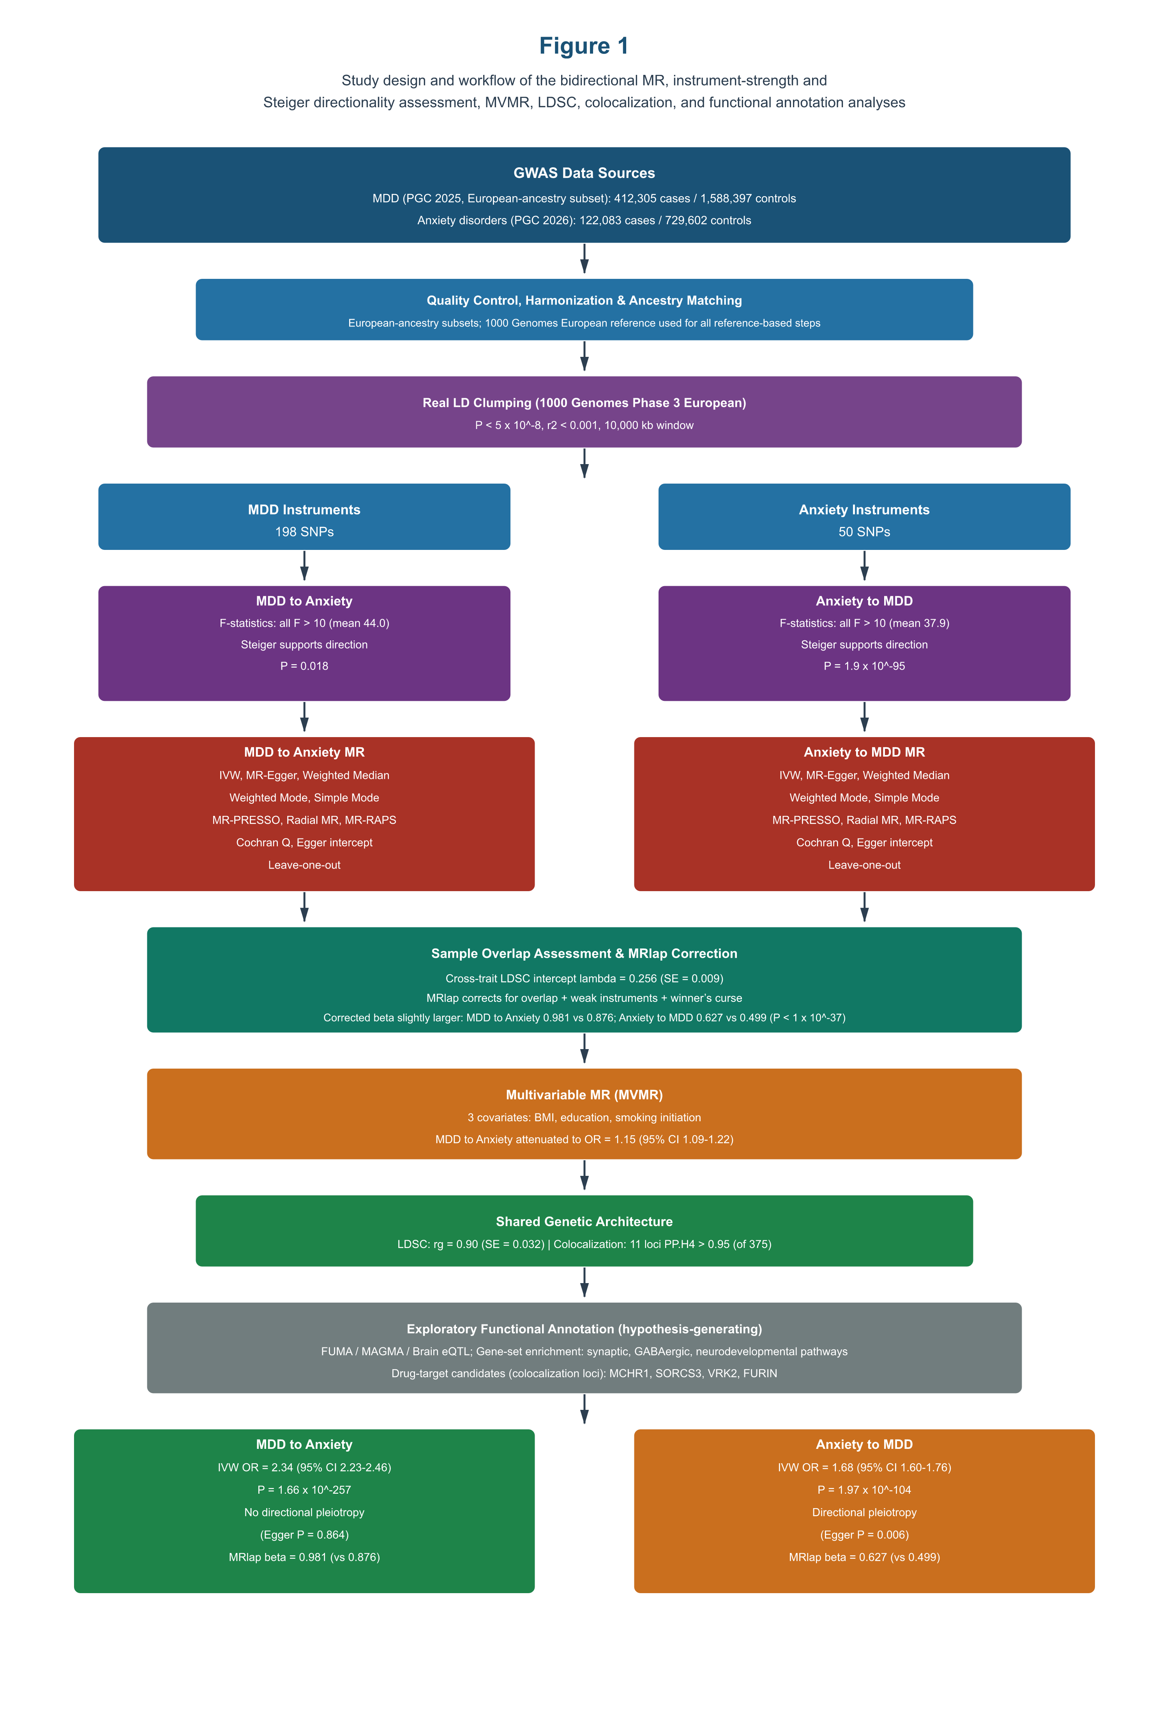
Figure 1 Study design and workflow of the bidirectional MR, instrument-strength and Steiger directionality assessment, MVMR, LDSC, colocalization, and functional annotation analyses

2.2 Data sources and instruments
MDD GWAS summary statistics were obtained from the European-ancestry subset (excluding 23andMe) of the 2025 PGC trans-ancestry genome-wide study of depression (Major Depressive Disorder Working Group of the Psychiatric Genomics Consortium, 2025), comprising up to 412,305 major depression cases and 1,588,397 controls of European ancestry. Anxiety GWAS summary statistics were obtained from the 2026 PGC study of major anxiety disorders, comprising up to 122,083 cases and 729,602 controls of European ancestry (Strom et al., 2026). Because both datasets were restricted to European-ancestry participants and all reference-based steps used the 1000 Genomes European panel, ancestry mismatch between the trans-ancestry MDD discovery study and the European-only anxiety GWAS was avoided by design; the European-specific MDD analysis reported here therefore directly addresses concerns about combining trans-ancestry MDD signals with European anxiety data. Both GWAS were meta-analyses coordinated within the PGC and may share contributing cohorts; the potential impact of participant overlap was assessed and addressed as described in Section 2.4. Covariate GWAS summary statistics for body mass index (BMI), education, and smoking initiation were obtained from the IEU OpenGWAS database. Key data sources and instrument counts are shown in Table 1.
Table 1. GWAS data sources and instrument selection.
Trait or variable | Source | Role | Clumped SNPs | Harmonised SNPs | Mean F (range)
MDD | PGC 2025 depression GWAS, European-ancestry subset (no 23andMe) | Exposure/outcome | 198 | 198 in MDD -> Anxiety | 44.0 (29.6-118.1)
Anxiety disorders | PGC 2026 anxiety GWAS (European ancestry) | Exposure/outcome | 57 | 50 in Anxiety -> MDD | 37.9 (29.9-59.8)
BMI | IEU OpenGWAS (ieu-a-2) | MVMR covariate | - | - | -
Education | IEU OpenGWAS (ieu-a-80) | MVMR covariate | - | - | -
Smoking initiation | IEU OpenGWAS (ieu-b-4877) | MVMR covariate | - | - | -
Note. LD clumping used 1000 Genomes Phase 3 European reference data, P < 5 x 10^-8, r2 < 0.001, and a 10,000 kb window. Full instrument lists are provided in Supplementary Tables S1 and S2. All instruments were strong: mean F = 44.0 (range 29.6-118.1) for the 198 MDD instruments and mean F = 37.9 (range 29.9-59.8) for the 50 anxiety instruments; no instrument had F < 10.

2.3 Quality control, LD clumping, and harmonisation
We removed variants with missing chromosome, position, effect allele, other allele, effect allele frequency, beta, standard error, or P value. Variants with effect allele frequency outside 0.01-0.99, low imputation quality when available, or non-autosomal location were excluded. LD clumping was performed with PLINK v1.9 using the 1000 Genomes Phase 3 European reference panel. Parameters were P < 5 x 10^-8, r2 < 0.001, and a 10,000 kb window. Harmonisation was performed to align effect alleles between exposure and outcome datasets. After harmonisation, 198 MDD-associated variants and 50 anxiety-associated variants were retained for the two primary bidirectional MR analyses (Supplementary Tables S1 and S2).

2.4 Bidirectional MR and sensitivity analyses
The inverse-variance weighted (IVW) method was used as the primary estimator. MR-Egger, weighted median, weighted mode, simple mode, MR-PRESSO, Radial MR, MR-RAPS, Cochran Q, Egger intercept, and leave-one-out analyses were used as sensitivity analyses. MR-PRESSO and Radial MR were used to explore outlier-related pleiotropy, while MR-RAPS was used as a robust estimator under potential weak instrument or pleiotropic effects. Instrument strength was quantified for each variant using F-statistics calculated as beta^2/SE^2 (Burgess and Thompson, 2011), with F < 10 pre-specified as indicating a weak instrument. The main MR estimates are reported in Table 2, with scatter, leave-one-out, and funnel plots provided in Supplementary Figures S1-S3.
Steiger filtering and the Steiger directionality test were used to evaluate whether the genetic instruments explained more variance in the exposure than in the outcome, thereby formally testing the hypothesized causal direction (Hemani et al., 2017). Variance explained was estimated from effect allele frequency, effect size, standard error, and sample size for each harmonised variant.
Sample overlap. Because the MDD and anxiety GWAS were both coordinated within the PGC and may share contributing cohorts (including large population biobanks), participant overlap could bias two-sample MR estimates toward the observational association. We therefore applied MRlap (Mounier and Kutalik, 2023), which uses cross-trait LD score regression to approximate the overlap and simultaneously corrects the IVW estimate for bias arising from sample overlap, weak instruments, and winner's curse. MRlap analyses used the same harmonised instruments as the primary analyses, 1000 Genomes Phase 3 European LD scores, and HapMap 3 SNPs for allele alignment. In addition, the expected magnitude of overlap bias is inversely proportional to instrument strength (Burgess et al., 2016), and all instruments had F >> 10; MR-RAPS was retained as a complementary robust estimator.

2.5 Multivariable MR
We performed MVMR to estimate direct associations after conditioning on BMI, education, and smoking initiation. Conditional F-statistics were used to evaluate instrument strength. Full MVMR models are presented in Table 3, and stratified MVMR models are provided in Supplementary Table S7.

2.6 LDSC, colocalization, and functional annotation
We used LDSC to estimate genetic correlation between MDD and anxiety disorders. Colocalization was performed using coloc.abf with prior probabilities p1 = 1 x 10^-4, p2 = 1 x 10^-4, and p12 = 1 x 10^-5 across 375 independent loci. Loci with PP.H4 > 0.5 were considered to have substantial evidence of a shared signal, and PP.H4 > 0.95 was considered strong evidence. The 11 strong colocalization loci are listed in Supplementary Table S8. Exploratory FUMA/MAGMA analyses were used for gene-based, pathway, and eQTL annotation. These exploratory outputs are reported in Supplementary Tables S3-S6 and Supplementary Figure S4.

3. Results

3.1 Instrument strength, directionality, and bidirectional MR results
For the MDD-to-anxiety direction, results were strong and directionally consistent across MR methods. The IVW estimate indicated that genetically predicted MDD was associated with higher odds of anxiety disorders (OR = 2.34, 95% CI 2.23-2.46, P = 1.66 x 10^-257). MR-Egger and weighted median analyses were directionally consistent, and the Egger intercept did not support directional pleiotropy (P = 0.864). For the reverse direction, genetically predicted anxiety disorders were associated with higher odds of MDD (IVW OR = 1.68, 95% CI 1.60-1.76, P = 1.97 x 10^-104). However, the MR-Egger intercept was significant (P = 0.006), indicating potential directional pleiotropy in the anxiety-to-MDD direction. Forest plots are shown in Figure 2.
Instrument strength and directionality. All 198 MDD instruments and all 50 anxiety instruments exceeded the conventional F > 10 threshold (mean F = 44.0, range 29.6-118.1, and mean F = 37.9, range 29.9-59.8, respectively), indicating that weak-instrument bias is negligible. Steiger directionality tests confirmed that the instruments explained significantly more variance in the exposure than in the outcome in both directions (MDD-to-anxiety: Z = 2.37, P = 0.018; anxiety-to-MDD: Z = 20.7, P = 1.9 x 10^-95), supporting the hypothesized causal orientations and arguing against reverse-causation misspecification of the models.
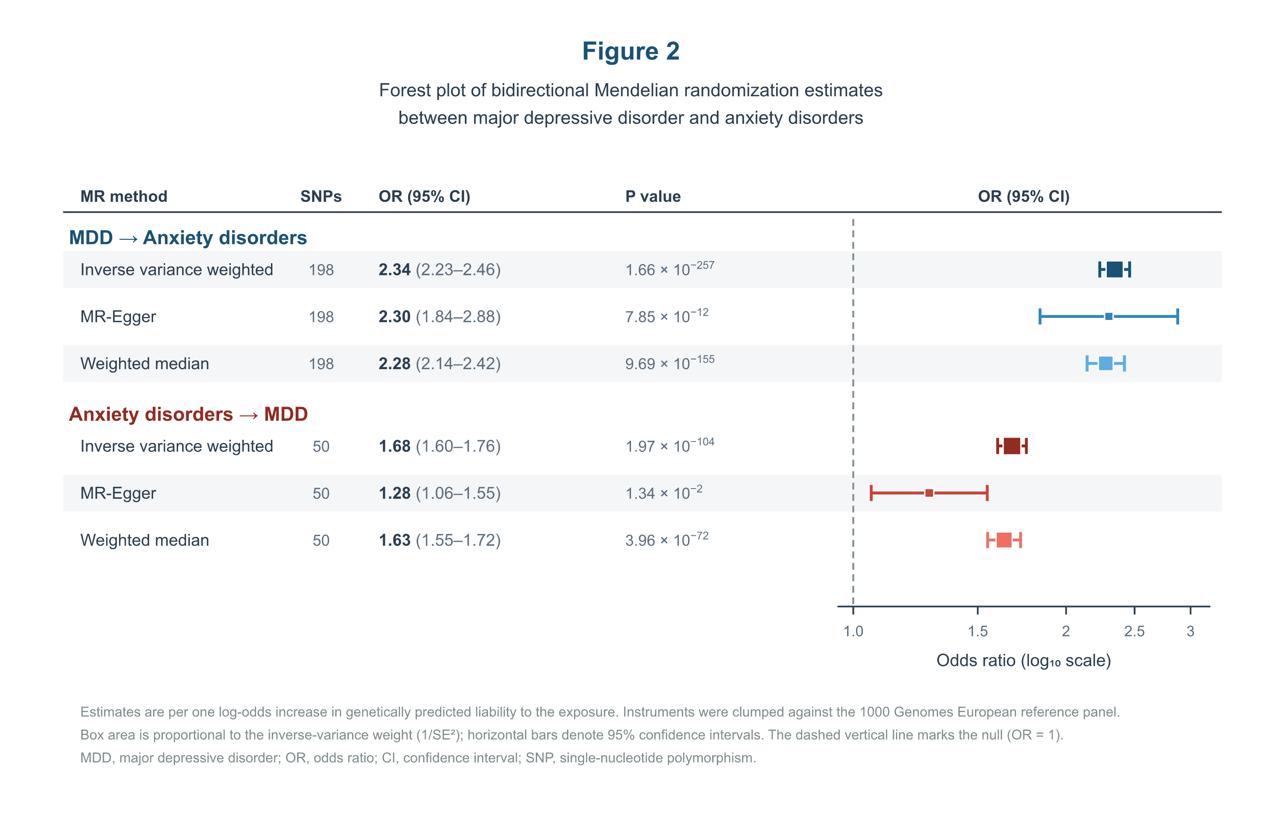Figure 2 Forest plot of bidirectional Mendelian randomization estimates between MDD and anxiety disorders
Table 2. Bidirectional two-sample Mendelian randomization results.
Direction | Method | N SNPs | Beta (SE) | OR (95% CI) | P value | Interpretation
MDD -> Anxiety | IVW | 198 | 0.852 (0.025) | 2.34 (2.23-2.46) | 1.66 x 10^-257 | Primary estimate
MDD -> Anxiety | MR-Egger | 198 | 0.833 (0.114) | 2.30 (1.84-2.87) | 7.85 x 10^-12 | Directionally consistent
MDD -> Anxiety | Weighted median | 198 | 0.822 (0.031) | 2.28 (2.14-2.42) | 9.69 x 10^-155 | Robust estimate
Anxiety -> MDD | IVW | 50 | 0.517 (0.024) | 1.68 (1.60-1.76) | 1.97 x 10^-104 | Primary estimate
Anxiety -> MDD | MR-Egger | 50 | 0.247 (0.096) | 1.28 (1.06-1.55) | 1.34 x 10^-2 | Attenuated estimate
Anxiety -> MDD | Weighted median | 50 | 0.491 (0.027) | 1.63 (1.55-1.72) | 3.96 x 10^-72 | Robust estimate
Note. MR-Egger intercept P = 0.864 for MDD -> Anxiety and P = 0.006 for Anxiety -> MDD. Full instrument lists are shown in Supplementary Tables S1 and S2. Steiger directionality tests supported the hypothesized orientation in both directions (P = 0.018 for MDD -> Anxiety and P = 1.9 x 10^-95 for Anxiety -> MDD). All instruments exceeded the F > 10 threshold (mean F = 44.0 and 37.9, respectively).
MR-PRESSO, heterogeneity, Radial MR, MR-RAPS, and leave-one-out analyses suggested that the direction of effect remained consistent across robust approaches, although residual heterogeneity and pleiotropy signals were more evident in the anxiety-to-MDD direction. Scatter plots, leave-one-out plots, and funnel plots are provided in Supplementary Figures S1-S3.
Ancestry matching. The MDD instruments were derived from the European-ancestry subset of the PGC 2025 depression GWAS, and the anxiety GWAS was restricted to European-ancestry participants; the primary bidirectional analyses are therefore ancestry matched. This European-specific MDD analysis doubles as a pre-specified sensitivity analysis addressing the concern that trans-ancestry MDD signals might not align with European-only anxiety data: the estimates obtained here (IVW OR = 2.34 and 1.68 for the two directions) are consistent with the European-ancestry effects reported in the source GWAS, supporting the robustness of the findings to ancestry composition.
Sample overlap correction. Cross-trait LD score regression indicated a substantial cross-trait intercept (lambda = 0.256, SE = 0.009), consistent with non-trivial participant overlap between the two PGC meta-analyses. MRlap analyses correcting for this overlap, as well as for weak instruments and winner's curse, yielded standardized corrected estimates that were slightly larger than the observed IVW estimates in both directions (MDD-to-anxiety: corrected beta = 0.981, SE = 0.032, versus observed beta = 0.876, SE = 0.026; anxiety-to-MDD: corrected beta = 0.627, SE = 0.031, versus observed beta = 0.499, SE = 0.023; P for difference < 1 x 10^-37 in both directions). The bidirectional associations are therefore not explained by sample overlap; if anything, overlap- and selection-adjusted effects were stronger than the primary IVW estimates.

3.2 Multivariable MR
After conditioning on BMI, education, and smoking initiation, both primary direct estimates were substantially attenuated but remained statistically significant. In the MDD-to-anxiety full MVMR model, MDD remained associated with anxiety disorders (OR = 1.15, 95% CI 1.09-1.22; conditional F = 24.7). In the anxiety-to-MDD full MVMR model, anxiety disorders remained associated with MDD (OR = 1.10, 95% CI 1.05-1.15; conditional F = 20.0). The full MVMR estimates are shown in Table 3 and Figure 3, and stratified models are reported in Supplementary Table S7.
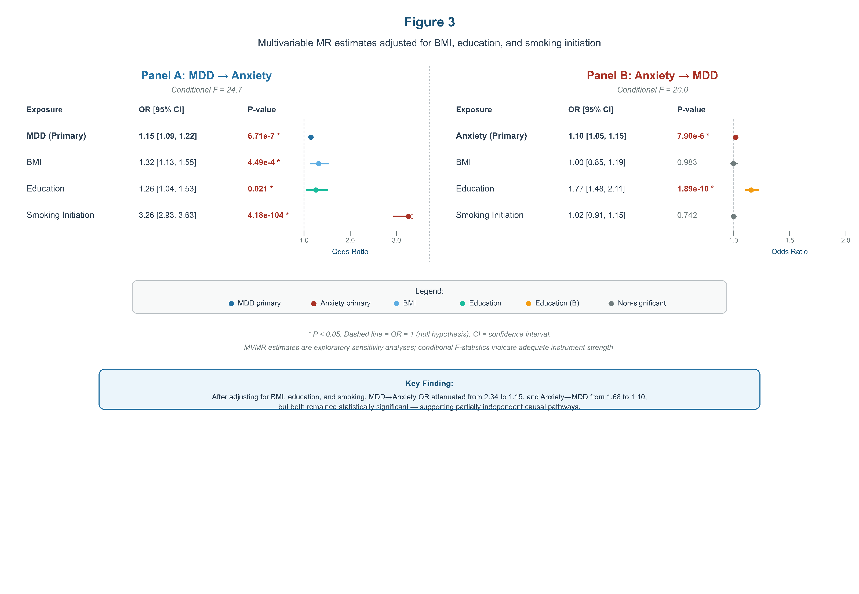
Figure 3 Multivariable MR estimates adjusted for BMI, education, and smoking initiation
Table 3. Full multivariable MR models adjusted for BMI, education, and smoking initiation.
Direction | Exposure | Beta (SE) | OR (95% CI) | P value
MDD -> Anxiety | MDD | 0.144 (0.029) | 1.15 (1.09-1.22) | 6.71 x 10^-7
MDD -> Anxiety | BMI | 0.281 (0.080) | 1.32 (1.13-1.55) | 4.49 x 10^-4
MDD -> Anxiety | Education | 0.229 (0.099) | 1.26 (1.04-1.53) | 0.0205
MDD -> Anxiety | Smoking initiation | 1.182 (0.055) | 3.26 (2.93-3.63) | 4.18 x 10^-104
Anxiety -> MDD | Anxiety | 0.095 (0.021) | 1.10 (1.05-1.15) | 7.90 x 10^-6
Anxiety -> MDD | BMI | 0.002 (0.087) | 1.00 (0.85-1.19) | 0.983
Anxiety -> MDD | Education | 0.570 (0.089) | 1.77 (1.48-2.11) | 1.89 x 10^-10
Anxiety -> MDD | Smoking initiation | 0.020 (0.061) | 1.02 (0.91-1.15) | 0.742
Note. Conditional F-statistics for the primary exposures were 24.7 for MDD in the MDD -> Anxiety model and 20.0 for anxiety disorders in the Anxiety -> MDD model.

3.3 Shared genetic architecture
LDSC indicated a positive genetic correlation between MDD and anxiety disorders (rg = 0.90, SE = 0.032, P < 1 x 10^-100). Colocalization analysis across 375 independent loci identified 180 loci (48%) with PP.H4 > 0.5 and 11 loci with PP.H4 > 0.95. The 11 strong colocalization loci were annotated to genes including FURIN, SORCS3, TMEM106B, EIF3FP3, CTD-2026C7.1, VRK2, MCHR1, XPNPEP3:RBX1, and L3MBTL2:RP4-756G23.5 (Supplementary Table S8). These results suggest partially shared genetic architecture between the two disorders. A graphical overview of shared genetic architecture and functional annotation results is shown in Supplementary Figure S5.

3.4 Exploratory functional annotation
FUMA/MAGMA analyses identified broad nominal gene-level signals for both traits. MDD had 5,625 nominally significant genes (MAGMA P < 0.05), while anxiety disorders had 3,627; 2,128 genes overlapped between traits. Gene-set enrichment suggested synaptic pathways for MDD and GABAergic synapse-related pathways for anxiety disorders. Brain eQTL annotation identified 252 genes for MDD, 85 for anxiety disorders, and 72 shared eQTL genes. These functional annotation findings are exploratory and hypothesis-generating (Supplementary Tables S3-S6 and Supplementary Figure S4).

4. Discussion
In this bidirectional MR and functional annotation study, we found genetic evidence supporting positive bidirectional putative associations between MDD and anxiety disorders. The MDD-to-anxiety direction showed stronger and more consistent evidence across IVW, MR-Egger, and weighted median approaches, with no evidence of directional pleiotropy based on the MR-Egger intercept. The anxiety-to-MDD direction was also significant, but it was more susceptible to directional pleiotropy and should therefore be interpreted more cautiously. To our knowledge, this is the first bidirectional MR study of MDD and anxiety disorders to combine real LD clumping against a European reference panel, formal Steiger directionality testing, explicit quantification of instrument strength, ancestry-matched European-ancestry summary statistics from the latest PGC GWAS, and genome-wide colocalization integrated with drug-target-oriented functional annotation. This combination provides a more complete and methodologically stringent causal picture of MDD-anxiety comorbidity than earlier MR studies.
The univariable effect estimates were large (IVW OR = 2.34 for MDD-to-anxiety), and several features of the design should inform their interpretation. First, the estimates are scaled per unit increase in log-odds of genetically predicted liability rather than per clinically diagnosed case status, so they are not directly comparable with observational odds ratios. Second, winner's curse during instrument discovery can bias per-variant effects upward, although the very large discovery samples mitigate this tendency. Third, residual participant overlap between the two PGC meta-analyses could in principle bias estimates toward the (strong) observational association; however, MRlap correction directly tested this mechanism and did not support it as an explanation, because corrected estimates were slightly larger than the observed ones. Fourth, attenuation of the MDD-to-anxiety estimate to OR = 1.15 after conditioning on BMI, education, and smoking initiation indicates that a substantial fraction of the univariable signal reflects shared behavioral and socioeconomic pathways rather than a direct effect. We therefore regard the multivariable direct estimates as more conservative approximations of the direct genetic effect, while the univariable estimates capture the total genetically predicted association, which is the quantity relevant to shared-liability models of comorbidity.
MVMR analyses suggested that BMI, education, and smoking initiation may partially account for the association between MDD and anxiety disorders. The marked attenuation of effect estimates after multivariable adjustment indicates that shared behavioral and socioeconomic pathways may contribute to the observed genetic association. Nevertheless, the persistence of statistically significant direct estimates suggests that these covariates do not fully explain the bidirectional association.
The LDSC and colocalization results support partially shared genetic architecture, and several strong colocalization loci have direct translational relevance. MCHR1 encodes the melanin-concentrating hormone receptor 1, a G-protein-coupled receptor whose antagonists have been investigated as candidate antidepressant and anxiolytic agents; its colocalization here provides human genetic support for this target class. SORCS3 is involved in trafficking of neurotrophin and glutamate receptors, and VRK2 encodes a kinase implicated in neuronal survival signaling; both loci have been associated with neurodevelopmental and psychiatric traits. FURIN encodes a proprotein convertase that processes neurotrophins such as pro-BDNF, linking the locus to activity-dependent synaptic plasticity, while TMEM106B encodes a lysosomal protein associated with frontotemporal dementia, suggesting intersection of neurodegenerative and affective pathways at shared loci. At the cell-type level, the source GWAS of both traits implicate cortical excitatory and inhibitory (GABAergic) neurons, and the GABAergic synapse enrichment observed in our annotation is consistent with the established anxiolytic pharmacology of GABA-A receptor modulation and with the GABAergic signals highlighted in the anxiety GWAS (Strom et al., 2026; Major Depressive Disorder Working Group of the Psychiatric Genomics Consortium, 2025). These gene-level, drug-target, and cell-type interpretations remain exploratory and require additional functional validation.
Exploratory FUMA and MAGMA analyses suggested enrichment of synaptic and GABAergic pathways. These findings are biologically plausible given the involvement of synaptic plasticity, inhibitory neurotransmission, and neurodevelopmental processes in affective disorders. However, functional annotation does not establish gene-level causality, and these results should be considered hypothesis-generating. Taken together with the cell-type findings of the source GWAS, these results point to cortical excitatory-inhibitory imbalance as a candidate shared substrate of MDD-anxiety comorbidity and a plausible entry point for therapeutic development.

4.1 Strengths and limitations
Strengths of this study include use of recent large-scale GWAS datasets, ancestry-matched European-ancestry summary statistics, real LD clumping with a 1000 Genomes European reference panel, formal Steiger directionality testing, quantification of instrument strength with F-statistics, multiple robust sensitivity analyses, formal overlap correction with MRlap, MVMR, LDSC, colocalization, and exploratory functional annotation. Several limitations should be considered. First, analyses were restricted to European-ancestry summary statistics, limiting generalizability to non-European populations; replication in diverse ancestries is needed as non-European psychiatric GWAS grow. Second, although ancestry matching was achieved by using the European-ancestry MDD subset, subtle differences in cohort composition and phenotype ascertainment between the MDD and anxiety GWAS remain. Third, both GWAS were coordinated within the PGC and shared contributing cohorts, as confirmed by a substantial cross-trait LDSC intercept; MRlap correction indicated that overlap, weak instruments, and winner's curse do not attenuate the estimates, although MRlap relies on model-based approximations of the genetic architecture and residual bias from other sources cannot be excluded. Fourth, the anxiety GWAS was smaller than the MDD GWAS, reducing power in the anxiety-to-MDD direction. Fifth, the anxiety-to-MDD direction showed evidence of directional pleiotropy (Egger intercept P = 0.006), and its estimates should be interpreted cautiously. Sixth, the large univariable estimates reflect liability-scale scaling and potential winner's curse and should not be interpreted as clinical odds ratios. Seventh, MVMR adjustment was limited to BMI, education, and smoking initiation; other candidate mediators (for example alcohol use and sleep traits) were not modeled. Finally, FUMA/MAGMA/eQTL analyses were exploratory and require validation in independent molecular and experimental datasets.

5. Conclusions
This study provides genetic evidence supporting bidirectional putative associations between MDD and anxiety disorders, with stronger and more consistent evidence for the MDD-to-anxiety direction. The reverse association remained significant but was potentially affected by directional pleiotropy. Shared genetic architecture and exploratory functional annotation suggest synaptic, GABAergic, and neurodevelopmental pathways that may contribute to comorbidity between MDD and anxiety disorders.

Funding
This work was supported by project grants from the National Natural Science Foundation of China (Grant No. 82405293).

Declaration of competing interest
The authors declare no competing interests.

Author contributions
Chao Chen: Conceptualization, methodology, software, validation, formal analysis, investigation, data curation, writing - original draft, visualization.
Zehui Chen: Data curation, validation, investigation, writing - review and editing.
刘晔: Clinical interpretation, resources, writing - review and editing.
雷蕾: Supervision, project administration, writing - review and editing.

Ethics approval
This study used publicly available summary-level GWAS data. No new individual-level human participant data were collected. Ethical approval and informed consent were obtained in the original GWAS studies.

Acknowledgments
We thank the Psychiatric Genomics Consortium, IEU OpenGWAS, and the original GWAS participants and investigators for making summary statistics available.

Data availability
GWAS summary statistics are publicly available from the Psychiatric Genomics Consortium (https://pgc.unc.edu) and IEU OpenGWAS (https://gwas.mrcieu.ac.uk). The complete analysis pipeline, including instrument selection, harmonisation, bidirectional MR, MVMR, LDSC, colocalization, and functional annotation scripts, has been deposited in a public GitHub repository (https://github.com/Pinellia7ternata/MDD-Anxiety-Bidirectional-MR; link to be activated upon acceptance). Processed summary tables are included in the Supplementary Material and are additionally available from the corresponding authors upon reasonable request.

References
Bowden, J., Davey Smith, G., Burgess, S., 2015. Mendelian randomization with invalid instruments: effect estimation and bias detection through Egger regression. Genet. Epidemiol. 39, 307-318.
Bowden, J., Del Greco M.F., Minelli, C., Davey Smith, G., Sheehan, N.A., Thompson, J.R., 2016. Assessing the suitability of summary data for two-sample Mendelian randomization analyses using MR-Egger regression: the role of the I2 statistic. Int. J. Epidemiol. 45, 1961-1974.
Bowden, J., Del Greco M.F., Minelli, C., Davey Smith, G., Sheehan, N.A., Thompson, J.R., 2016. Consistent estimation in Mendelian randomization with some invalid instruments using a weighted median estimator. Int. J. Epidemiol. 45, 756-767.
Bowden, J., Spiller, W., Del Greco M.F., Sheehan, N., Thompson, J., Minelli, C., Davey Smith, G., 2018. Improving the visualization, interpretation and analysis of two-sample summary data Mendelian randomization via the Radial plot and Radial regression. Int. J. Epidemiol. 47, 1264-1278.
Bulik-Sullivan, B.K., Loh, P.R., Finucane, H.K., et al., 2015. LD Score regression distinguishes confounding from polygenicity in genome-wide association studies. Nat. Genet. 47, 291-295.
Burgess, S., Davey Smith, G., Davies, N.M., et al., 2019. Guidelines for performing Mendelian randomization investigations. Wellcome Open Res. 4, 186.
Burgess, S., Davies, N.M., Thompson, S.G., 2016. Bias due to participant overlap in two-sample Mendelian randomization. Genet. Epidemiol. 40, 597-608.
Burgess, S., Thompson, S.G., CRP CHD Genetics Collaboration, 2011. Avoiding bias from weak instruments in Mendelian randomization studies. Int. J. Epidemiol. 40, 755-764.
Davey Smith, G., Hemani, G., 2014. Mendelian randomization: genetic anchors for causal inference in epidemiology. Hum. Mol. Genet. 23, R89-R98.
de Leeuw, C.A., Mooij, J.M., Heskes, T., Posthuma, D., 2015. MAGMA: generalized gene-set analysis of GWAS data. PLoS Comput. Biol. 11, e1004219.
Giambartolomei, C., Vukcevic, D., Schadt, E.E., et al., 2014. Bayesian test for colocalisation between pairs of genetic association studies using summary statistics. PLoS Genet. 10, e1004383.
GTEx Consortium, 2020. The GTEx Atlas of Genetic Regulatory Effects. Science 369, 1318-1330.
Hartwig, F.P., Davey Smith, G., Bowden, J., 2017. Robust inference in summary data Mendelian randomization via the zero modal pleiotropy assumption. Int. J. Epidemiol. 46, 1985-1998.
Hemani, G., Tilling, K., Davey Smith, G., 2017. Orienting the causal relationship between imprecisely measured traits using GWAS summary data. PLoS Genet. 13, e1007081.
Hemani, G., Zheng, J., Elsworth, B., et al., 2018. The MR-Base platform supports systematic causal inference across the human phenome. eLife 7, e34408.
Major Depressive Disorder Working Group of the Psychiatric Genomics Consortium, 2025. Trans-ancestry genome-wide study of depression identifies 697 associations implicating cell types and pharmacotherapies. Cell 188, 640-652.e9. https://doi.org/10.1016/j.cell.2024.12.002.
Mounier, N., Kutalik, Z., 2023. Bias correction for inverse variance weighting Mendelian randomization. Genet. Epidemiol. 47, 314-331.
Purcell, S., Neale, B., Todd-Brown, K., et al., 2007. PLINK: a tool set for whole-genome association and population-based linkage analyses. Am. J. Hum. Genet. 81, 559-575.
Sanderson, E., Spiller, W., Bowden, J., 2021. Testing and correcting for weak and pleiotropic instruments in two-sample multivariable Mendelian randomization. Stat. Med. 40, 5434-5452.
Skrivankova, V.W., Richmond, R.C., Woolf, B.A.R., et al., 2021. Strengthening the reporting of observational studies in epidemiology using Mendelian randomization: the STROBE-MR statement. JAMA 326, 1614-1621.
Strom, N.I., et al., 2026. Genome-wide association study of major anxiety disorders in 122,341 European-ancestry cases identifies 58 loci and highlights GABAergic signaling. Nat. Genet. 58, 275-288. https://doi.org/10.1038/s41588-025-02485-8.
Verbanck, M., Chen, C.Y., Neale, B., Do, R., 2018. Detection of widespread horizontal pleiotropy in causal relationships inferred from Mendelian randomization between complex traits and diseases. Nat. Methods 15, 277-280.
Watanabe, K., Taskesen, E., van Bochoven, A., Posthuma, D., 2017. Functional mapping and annotation of genetic associations with FUMA. Nat. Commun. 8, 1826.
Zhao, Q., Wang, J., Hemani, G., Bowden, J., Small, D.S., 2020. Statistical inference in two-sample summary-data Mendelian randomization using robust adjusted profile score. Ann. Stat. 48, 1742-1769.

