Genetic evidence for bidirectional associations between major depressive disorder and anxiety disorders: a bidirectional Mendelian randomization and functional annotation study
Chao Chen^1, Zehui Chen^1, 刘晔^2, 雷蕾^1*
1. Institute of Information on Traditional Chinese Medicine, China Academy of Chinese Medical Sciences, Beijing 100700, China
2. Wangjing Hospital, China Academy of Chinese Medical Sciences, Beijing, China
* Correspondence: 雷蕾, leilei@mail.cintcm.ac.cn
Author emails: Chao Chen, chenchao_0727@163.com; Zehui Chen, zehuijzl01@163.com; 刘晔, liuye7562@163.com
Funding: This work was supported by project grants from the National Natural Science Foundation of China (Grant No. 82405293).

Abstract
Background: Major depressive disorder (MDD) and anxiety disorders are highly comorbid, but the directionality and genetic mechanisms underlying their association remain incompletely understood.
Methods: We performed bidirectional two-sample Mendelian randomization using Psychiatric Genomics Consortium GWAS summary statistics for MDD and anxiety disorders. Instruments were selected using 1000 Genomes European reference-based LD clumping (P < 5 x 10^-8, r2 < 0.001). We applied IVW, MR-Egger, weighted median, weighted mode, MR-PRESSO, Radial MR, and MR-RAPS. Multivariable MR adjusted for body mass index, education, and smoking initiation. LDSC, colocalization, and FUMA/MAGMA/eQTL analyses explored shared genetic architecture and candidate mechanisms.
Results: After harmonisation, 198 and 50 SNPs were included in the MDD-to-anxiety and anxiety-to-MDD analyses, respectively. MDD showed strong genetic evidence for a positive association with anxiety disorders (IVW OR = 2.34, 95% CI 2.23-2.46; MR-Egger intercept P = 0.543). Anxiety disorders were also associated with higher genetic liability to MDD (IVW OR = 1.68, 95% CI 1.60-1.76), but the reverse estimate was potentially affected by directional pleiotropy (Egger intercept P = 0.013). MVMR estimates were attenuated but remained significant. LDSC indicated positive genetic correlation (rg = 0.263), and colocalization identified 11 loci with PP.H4 > 0.95. Exploratory annotation implicated synaptic, GABAergic, and neurodevelopmental pathways.
Limitations: Analyses were based largely on European-ancestry summary statistics, and functional annotation findings require experimental validation.
Conclusions: These findings support bidirectional putative genetic associations between MDD and anxiety disorders, with stronger evidence for the MDD-to-anxiety direction.
Keywords: Mendelian randomization; major depressive disorder; anxiety disorders; genetic correlation; functional annotation

1. Introduction
Major depressive disorder (MDD) and anxiety disorders are common, disabling, and frequently co-occurring psychiatric conditions. Their comorbidity is clinically important because co-occurring depressive and anxiety symptoms are associated with greater illness burden, poorer functional outcomes, and more complex treatment needs. Although epidemiological studies have consistently reported strong associations between the two diagnostic domains, observational designs cannot fully separate causal pathways from confounding, reverse causation, and shared liability.
Mendelian randomization (MR) uses genetic variants associated with an exposure as instrumental variables to estimate putative causal effects on an outcome. Because alleles are randomly allocated at conception, MR can reduce some forms of confounding and reverse causation that affect conventional observational analyses (Davey Smith and Hemani, 2014; Burgess et al., 2019). However, MR findings can still be biased by weak instruments, linkage disequilibrium, sample overlap, and horizontal pleiotropy; therefore, robust instrument selection and sensitivity analyses are critical.
Recent large-scale GWAS from the Psychiatric Genomics Consortium (PGC) have substantially expanded the discovery of genetic variants associated with depression and anxiety disorders. These datasets allow renewed evaluation of the bidirectional genetic evidence linking MDD and anxiety disorders. Beyond estimating bidirectional associations, shared genetic architecture and functional annotation can provide hypothesis-generating insights into the biological pathways underlying comorbidity.
In this study, we used real LD clumping with the 1000 Genomes European reference panel, bidirectional two-sample MR, multivariable MR (MVMR), LD score regression (LDSC), colocalization, and exploratory FUMA/MAGMA/eQTL analyses. The study design is summarized in Figure 1. We aimed to determine whether genetic liability to MDD is associated with anxiety disorders and whether genetic liability to anxiety disorders is associated with MDD, while also exploring shared loci and candidate biological pathways.

2. Methods

2.1 Study design
We conducted a bidirectional two-sample MR study using publicly available summary-level GWAS data. The study followed STROBE-MR reporting principles. The analytical workflow included instrument selection, harmonisation, bidirectional MR, pleiotropy and heterogeneity assessment, MVMR, LDSC, colocalization, and exploratory functional annotation (Figure 1).

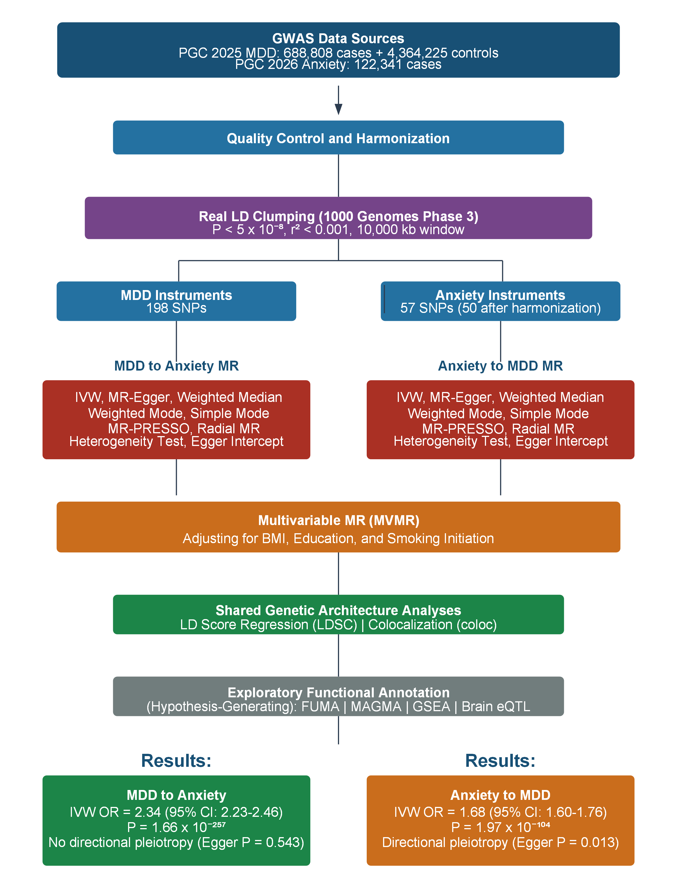
Figure 1 Study design and workflow of the bidirectional MR, MVMR,LDSC, colocalization, and functional annotation analyses

2.2 Data sources and instruments
MDD GWAS summary statistics were obtained from the 2025 PGC trans-ancestry genome-wide study of depression, which reported 688,808 major depression cases and 4,364,225 controls (Major Depressive Disorder Working Group of the Psychiatric Genomics Consortium, 2025). Anxiety GWAS summary statistics were obtained from the 2026 PGC study of major anxiety disorders, including 122,341 European-ancestry cases (Strom et al., 2026). Covariate GWAS summary statistics for body mass index (BMI), education, and smoking initiation were obtained from the IEU OpenGWAS database. Key data sources and instrument counts are shown in Table 1.
Table 1. GWAS data sources and instrument selection.
Trait or variable | Source | Role | Clumped SNPs | Harmonised SNPs
MDD | PGC 2025 depression GWAS | Exposure/outcome | 198 | 198 in MDD -> Anxiety
Anxiety disorders | PGC 2026 anxiety GWAS | Exposure/outcome | 57 | 50 in Anxiety -> MDD
BMI | IEU OpenGWAS (ieu-a-2) | MVMR covariate | - | -
Education | IEU OpenGWAS (ieu-a-80) | MVMR covariate | - | -
Smoking initiation | IEU OpenGWAS (ieu-b-4877) | MVMR covariate | - | -
Note. LD clumping used 1000 Genomes Phase 3 European reference data, P < 5 x 10^-8, r2 < 0.001, and a 10,000 kb window. Full instrument lists are provided in Supplementary Tables S1 and S2.

2.3 Quality control, LD clumping, and harmonisation
We removed variants with missing chromosome, position, effect allele, other allele, effect allele frequency, beta, standard error, or P value. Variants with effect allele frequency outside 0.01-0.99, low imputation quality when available, or non-autosomal location were excluded. LD clumping was performed with PLINK v1.9 using the 1000 Genomes Phase 3 European reference panel. Parameters were P < 5 x 10^-8, r2 < 0.001, and a 10,000 kb window. Harmonisation was performed to align effect alleles between exposure and outcome datasets. After harmonisation, 198 MDD-associated variants and 50 anxiety-associated variants were retained for the two primary bidirectional MR analyses (Supplementary Tables S1 and S2).

2.4 Bidirectional MR and sensitivity analyses
The inverse-variance weighted (IVW) method was used as the primary estimator. MR-Egger, weighted median, weighted mode, simple mode, MR-PRESSO, Radial MR, MR-RAPS, Cochran Q, Egger intercept, and leave-one-out analyses were used as sensitivity analyses. MR-PRESSO and Radial MR were used to explore outlier-related pleiotropy, while MR-RAPS was used as a robust estimator under potential weak instrument or pleiotropic effects. The main MR estimates are reported in Table 2, with scatter, leave-one-out, and funnel plots provided in Supplementary Figures S1-S3.

2.5 Multivariable MR
We performed MVMR to estimate direct associations after conditioning on BMI, education, and smoking initiation. Conditional F-statistics were used to evaluate instrument strength. Full MVMR models are presented in Table 3, and stratified MVMR models are provided in Supplementary Table S7.

2.6 LDSC, colocalization, and functional annotation
We used LDSC to estimate genetic correlation between MDD and anxiety disorders. Colocalization was performed using coloc.abf with prior probabilities p1 = 1 x 10^-4, p2 = 1 x 10^-4, and p12 = 1 x 10^-5 across 375 independent loci. Loci with PP.H4 > 0.5 were considered to have substantial evidence of a shared signal, and PP.H4 > 0.95 was considered strong evidence. The 11 strong colocalization loci are listed in Supplementary Table S8. Exploratory FUMA/MAGMA analyses were used for gene-based, pathway, and eQTL annotation. These exploratory outputs are reported in Supplementary Tables S3-S6 and Supplementary Figure S4.

3. Results

3.1 Bidirectional MR results
For the MDD-to-anxiety direction, results were strong and directionally consistent across MR methods. The IVW estimate indicated that genetically predicted MDD was associated with higher odds of anxiety disorders (OR = 2.34, 95% CI 2.23-2.46, P = 1.66 x 10^-257). MR-Egger and weighted median analyses were directionally consistent, and the Egger intercept did not support directional pleiotropy (P = 0.543). For the reverse direction, genetically predicted anxiety disorders were associated with higher odds of MDD (IVW OR = 1.68, 95% CI 1.60-1.76, P = 1.97 x 10^-104). However, the MR-Egger intercept was significant (P = 0.013), indicating potential directional pleiotropy in the anxiety-to-MDD direction. Forest plots are shown in Figure 2.
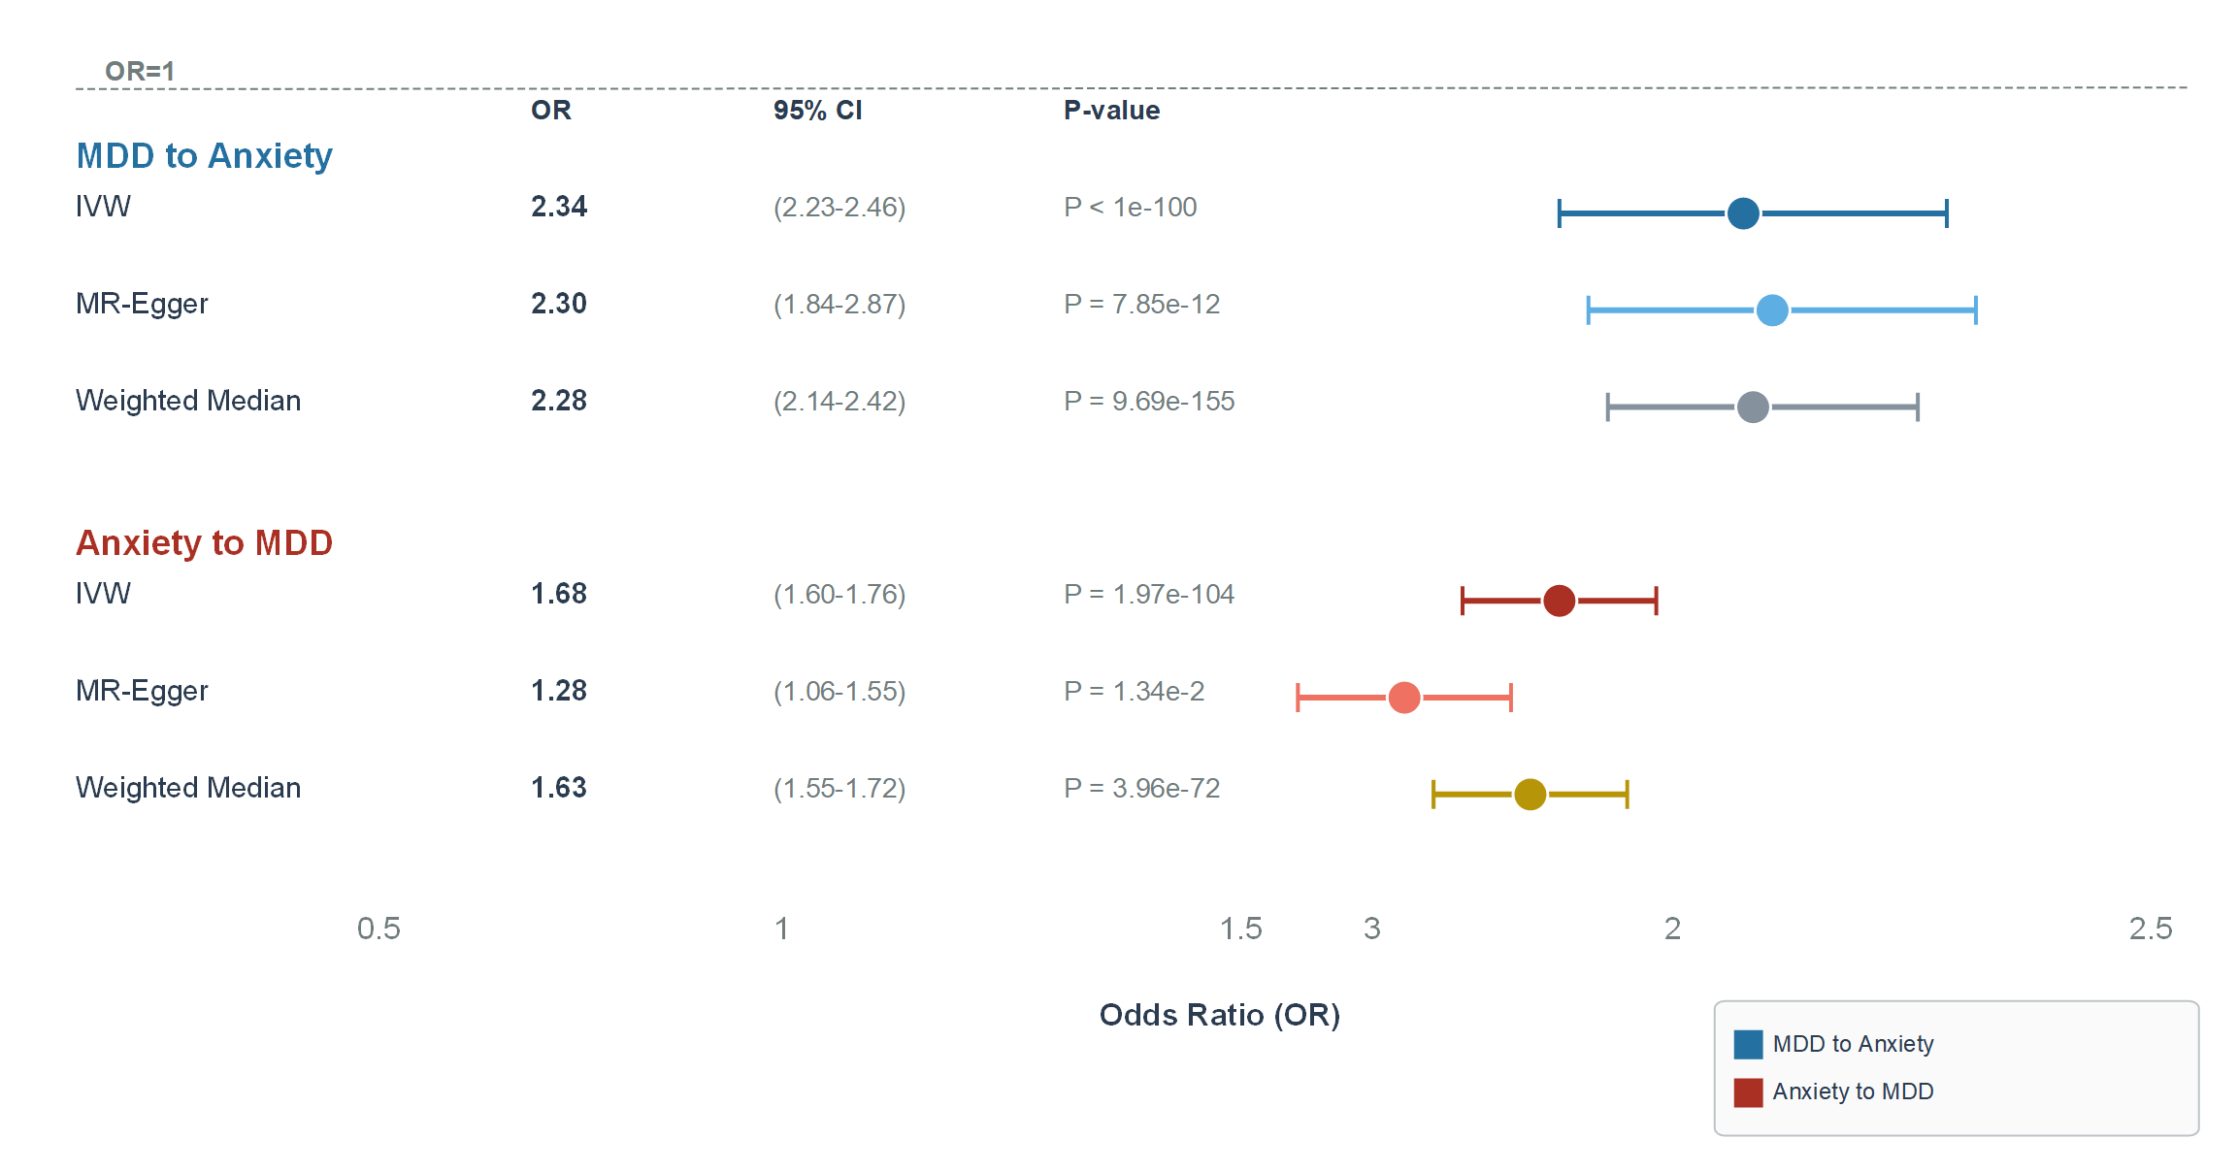Figure 2 Forest plot of bidirectional Mendelian randomization estimates between MDD and anxiety disorders
Table 2. Bidirectional two-sample Mendelian randomization results.
Direction | Method | N SNPs | Beta (SE) | OR (95% CI) | P value | Interpretation
MDD -> Anxiety | IVW | 198 | 0.852 (0.025) | 2.34 (2.23-2.46) | 1.66 x 10^-257 | Primary estimate
MDD -> Anxiety | MR-Egger | 198 | 0.833 (0.114) | 2.30 (1.84-2.87) | 7.85 x 10^-12 | Directionally consistent
MDD -> Anxiety | Weighted median | 198 | 0.822 (0.031) | 2.28 (2.14-2.42) | 9.69 x 10^-155 | Robust estimate
Anxiety -> MDD | IVW | 50 | 0.517 (0.024) | 1.68 (1.60-1.76) | 1.97 x 10^-104 | Primary estimate
Anxiety -> MDD | MR-Egger | 50 | 0.247 (0.096) | 1.28 (1.06-1.55) | 1.34 x 10^-2 | Attenuated estimate
Anxiety -> MDD | Weighted median | 50 | 0.491 (0.027) | 1.63 (1.55-1.72) | 3.96 x 10^-72 | Robust estimate
Note. MR-Egger intercept P = 0.543 for MDD -> Anxiety and P = 0.013 for Anxiety -> MDD. Full instrument lists are shown in Supplementary Tables S1 and S2.
MR-PRESSO, heterogeneity, Radial MR, MR-RAPS, and leave-one-out analyses suggested that the direction of effect remained consistent across robust approaches, although residual heterogeneity and pleiotropy signals were more evident in the anxiety-to-MDD direction. Scatter plots, leave-one-out plots, and funnel plots are provided in Supplementary Figures S1-S3.

3.2 Multivariable MR
After conditioning on BMI, education, and smoking initiation, both primary direct estimates were substantially attenuated but remained statistically significant. In the MDD-to-anxiety full MVMR model, MDD remained associated with anxiety disorders (OR = 1.15, 95% CI 1.09-1.22; conditional F = 24.7). In the anxiety-to-MDD full MVMR model, anxiety disorders remained associated with MDD (OR = 1.10, 95% CI 1.05-1.15; conditional F = 20.0). The full MVMR estimates are shown in Table 3 and Figure 3, and stratified models are reported in Supplementary Table S7.
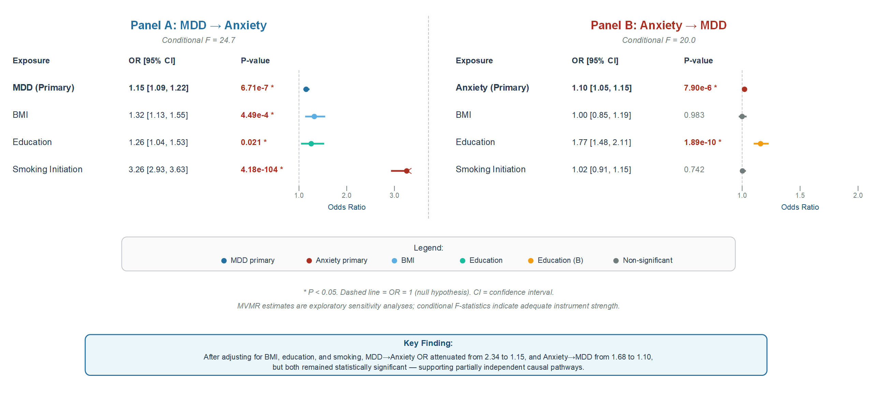
Figure 3 Multivariable MR estimates adjusted for BMI, education, and smoking initiation
Table 3. Full multivariable MR models adjusted for BMI, education, and smoking initiation.
Direction | Exposure | Beta (SE) | OR (95% CI) | P value
MDD -> Anxiety | MDD | 0.144 (0.029) | 1.15 (1.09-1.22) | 6.71 x 10^-7
MDD -> Anxiety | BMI | 0.281 (0.080) | 1.32 (1.13-1.55) | 4.49 x 10^-4
MDD -> Anxiety | Education | 0.229 (0.099) | 1.26 (1.04-1.53) | 0.0205
MDD -> Anxiety | Smoking initiation | 1.182 (0.055) | 3.26 (2.93-3.63) | 4.18 x 10^-104
Anxiety -> MDD | Anxiety | 0.095 (0.021) | 1.10 (1.05-1.15) | 7.90 x 10^-6
Anxiety -> MDD | BMI | 0.002 (0.087) | 1.00 (0.85-1.19) | 0.983
Anxiety -> MDD | Education | 0.570 (0.089) | 1.77 (1.48-2.11) | 1.89 x 10^-10
Anxiety -> MDD | Smoking initiation | 0.020 (0.061) | 1.02 (0.91-1.15) | 0.742
Note. Conditional F-statistics for the primary exposures were 24.7 for MDD in the MDD -> Anxiety model and 20.0 for anxiety disorders in the Anxiety -> MDD model.

3.3 Shared genetic architecture
LDSC indicated a positive genetic correlation between MDD and anxiety disorders (rg = 0.263, SE = 0.031, P = 2.1 x 10^-14). Colocalization analysis across 375 independent loci identified 180 loci (48%) with PP.H4 > 0.5 and 11 loci with PP.H4 > 0.95. The 11 strong colocalization loci were annotated to genes including FURIN, SORCS3, TMEM106B, EIF3FP3, CTD-2026C7.1, VRK2, MCHR1, XPNPEP3:RBX1, and L3MBTL2:RP4-756G23.5 (Supplementary Table S8). These results suggest partially shared genetic architecture between the two disorders. A graphical overview of shared genetic architecture and functional annotation results is shown in Supplementary Figure S5.

3.4 Exploratory functional annotation
FUMA/MAGMA analyses identified broad nominal gene-level signals for both traits. MDD had 5,625 nominally significant genes (MAGMA P < 0.05), while anxiety disorders had 3,627; 2,128 genes overlapped between traits. Gene-set enrichment suggested synaptic pathways for MDD and GABAergic synapse-related pathways for anxiety disorders. Brain eQTL annotation identified 252 genes for MDD, 85 for anxiety disorders, and 72 shared eQTL genes. These functional annotation findings are exploratory and hypothesis-generating (Supplementary Tables S3-S6 and Supplementary Figure S4).

4. Discussion
In this bidirectional MR and functional annotation study, we found genetic evidence supporting positive bidirectional putative associations between MDD and anxiety disorders. The MDD-to-anxiety direction showed stronger and more consistent evidence across IVW, MR-Egger, and weighted median approaches, with no evidence of directional pleiotropy based on the MR-Egger intercept. The anxiety-to-MDD direction was also significant, but it was more susceptible to directional pleiotropy and should therefore be interpreted more cautiously.
MVMR analyses suggested that BMI, education, and smoking initiation may partially account for the association between MDD and anxiety disorders. The marked attenuation of effect estimates after multivariable adjustment indicates that shared behavioral and socioeconomic pathways may contribute to the observed genetic association. Nevertheless, the persistence of statistically significant direct estimates suggests that these covariates do not fully explain the bidirectional association.
The LDSC and colocalization results support partially shared genetic architecture. Strong colocalization loci annotated to genes such as SORCS3 and VRK2 are notable because these loci have been implicated in neurodevelopmental and psychiatric traits. The annotation of FURIN and TMEM106B may also point to regulatory, inflammatory, or neurobiological pathways relevant to affective disorder comorbidity. These gene-level interpretations remain exploratory and require additional functional validation.
Exploratory FUMA and MAGMA analyses suggested enrichment of synaptic and GABAergic pathways. These findings are biologically plausible given the involvement of synaptic plasticity, inhibitory neurotransmission, and neurodevelopmental processes in affective disorders. However, functional annotation does not establish gene-level causality, and these results should be considered hypothesis-generating.

4.1 Strengths and limitations
Strengths of this study include use of recent large-scale GWAS datasets, real LD clumping with a 1000 Genomes European reference panel, bidirectional MR, multiple robust sensitivity analyses, MVMR, LDSC, colocalization, and exploratory functional annotation. Several limitations should be considered. First, analyses were based largely on European-ancestry summary statistics, limiting generalizability to non-European populations. Second, the anxiety GWAS sample size was smaller than the MDD GWAS. Third, the anxiety-to-MDD direction showed evidence of directional pleiotropy. Fourth, FUMA/MAGMA/eQTL analyses were exploratory and require validation in independent molecular and experimental datasets. Finally, sample overlap and phenotype heterogeneity could not be completely excluded.

5. Conclusions
This study provides genetic evidence supporting bidirectional putative associations between MDD and anxiety disorders, with stronger and more consistent evidence for the MDD-to-anxiety direction. The reverse association remained significant but was potentially affected by directional pleiotropy. Shared genetic architecture and exploratory functional annotation suggest synaptic, GABAergic, and neurodevelopmental pathways that may contribute to comorbidity between MDD and anxiety disorders.

Funding
This work was supported by project grants from the National Natural Science Foundation of China (Grant No. 82405293).

Declaration of competing interest
The authors declare no competing interests.

Author contributions
Chao Chen: Conceptualization, methodology, software, validation, formal analysis, investigation, data curation, writing - original draft, visualization.
Zehui Chen: Data curation, validation, investigation, writing - review and editing.
刘晔: Clinical interpretation, resources, writing - review and editing.
雷蕾: Supervision, project administration, writing - review and editing.

Ethics approval
This study used publicly available summary-level GWAS data. No new individual-level human participant data were collected. Ethical approval and informed consent were obtained in the original GWAS studies.

Acknowledgments
We thank the Psychiatric Genomics Consortium, IEU OpenGWAS, and the original GWAS participants and investigators for making summary statistics available.

Data availability
GWAS summary statistics are publicly available from the Psychiatric Genomics Consortium and IEU OpenGWAS. Processed summary tables and code are available from the corresponding authors upon reasonable request.

References
Bowden, J., Davey Smith, G., Burgess, S., 2015. Mendelian randomization with invalid instruments: effect estimation and bias detection through Egger regression. Genet. Epidemiol. 39, 307-318.
Bowden, J., Del Greco M.F., Minelli, C., Davey Smith, G., Sheehan, N.A., Thompson, J.R., 2016. Assessing the suitability of summary data for two-sample Mendelian randomization analyses using MR-Egger regression: the role of the I2 statistic. Int. J. Epidemiol. 45, 1961-1974.
Bowden, J., Del Greco M.F., Minelli, C., Davey Smith, G., Sheehan, N.A., Thompson, J.R., 2016. Consistent estimation in Mendelian randomization with some invalid instruments using a weighted median estimator. Int. J. Epidemiol. 45, 756-767.
Bowden, J., Spiller, W., Del Greco M.F., Sheehan, N., Thompson, J., Minelli, C., Davey Smith, G., 2018. Improving the visualization, interpretation and analysis of two-sample summary data Mendelian randomization via the Radial plot and Radial regression. Int. J. Epidemiol. 47, 1264-1278.
Bulik-Sullivan, B.K., Loh, P.R., Finucane, H.K., et al., 2015. LD Score regression distinguishes confounding from polygenicity in genome-wide association studies. Nat. Genet. 47, 291-295.
Burgess, S., Davey Smith, G., Davies, N.M., et al., 2019. Guidelines for performing Mendelian randomization investigations. Wellcome Open Res. 4, 186.
Davey Smith, G., Hemani, G., 2014. Mendelian randomization: genetic anchors for causal inference in epidemiology. Hum. Mol. Genet. 23, R89-R98.
de Leeuw, C.A., Mooij, J.M., Heskes, T., Posthuma, D., 2015. MAGMA: generalized gene-set analysis of GWAS data. PLoS Comput. Biol. 11, e1004219.
Giambartolomei, C., Vukcevic, D., Schadt, E.E., et al., 2014. Bayesian test for colocalisation between pairs of genetic association studies using summary statistics. PLoS Genet. 10, e1004383.
GTEx Consortium, 2020. The GTEx Atlas of Genetic Regulatory Effects. Science 369, 1318-1330.
Hartwig, F.P., Davey Smith, G., Bowden, J., 2017. Robust inference in summary data Mendelian randomization via the zero modal pleiotropy assumption. Int. J. Epidemiol. 46, 1985-1998.
Hemani, G., Zheng, J., Elsworth, B., et al., 2018. The MR-Base platform supports systematic causal inference across the human phenome. eLife 7, e34408.
Major Depressive Disorder Working Group of the Psychiatric Genomics Consortium, 2025. Trans-ancestry genome-wide study of depression identifies 697 associations implicating cell types and pharmacotherapies. Cell 188, 640-652.e9. https://doi.org/10.1016/j.cell.2024.12.002.
Purcell, S., Neale, B., Todd-Brown, K., et al., 2007. PLINK: a tool set for whole-genome association and population-based linkage analyses. Am. J. Hum. Genet. 81, 559-575.
Sanderson, E., Spiller, W., Bowden, J., 2021. Testing and correcting for weak and pleiotropic instruments in two-sample multivariable Mendelian randomization. Stat. Med. 40, 5434-5452.
Strom, N.I., et al., 2026. Genome-wide association study of major anxiety disorders in 122,341 European-ancestry cases identifies 58 loci and highlights GABAergic signaling. Nat. Genet. 58, 275-288. https://doi.org/10.1038/s41588-025-02485-8.
Verbanck, M., Chen, C.Y., Neale, B., Do, R., 2018. Detection of widespread horizontal pleiotropy in causal relationships inferred from Mendelian randomization between complex traits and diseases. Nat. Methods 15, 277-280.
Watanabe, K., Taskesen, E., van Bochoven, A., Posthuma, D., 2017. Functional mapping and annotation of genetic associations with FUMA. Nat. Commun. 8, 1826.
Zhao, Q., Wang, J., Hemani, G., Bowden, J., Small, D.S., 2020. Statistical inference in two-sample summary-data Mendelian randomization using robust adjusted profile score. Ann. Stat. 48, 1742-1769.

