Supplementary Tables
MDD-Anxiety Bidirectional Mendelian Randomization and Functional Annotation Study

Supplementary Data Quality Summary
Supplementary Tables S1 and S2 are derived directly from the final TwoSampleMR harmonised datasets used in the real-LD MR analyses. All listed variants have Included_in_MR = TRUE. S8 was updated using FUMA-derived gene annotations for the 11 loci with PP.H4 > 0.95. Missing annotation fields were not imputed.

Supplementary Table S1. MDD-to-anxiety harmonised lead SNPs
This table contains 198 harmonised MDD-associated instruments used in the MDD-to-anxiety MR analysis. All variants are marked Included_in_MR = TRUE.
SNP | Chr | Position | EA | OA | Beta_exposure | SE_exposure | P_exposure | Beta_outcome | SE_outcome | P_outcome | EAF_exposure | EAF_outcome | Palindromic | Ambiguous | Included_in_MR
rs10187826 | 2 | 208076936 | G | A | 0.0219 | 0.0031 | 1.87e-12 | 0.007095 | 0.0052 | 0.1728 | 0.323 | 0.332 | False | False | True
rs10199552 | 2 | 15427592 | T | G | -0.0172 | 0.0029 | 3.49e-09 | -0.0187 | 0.0048 | 8.42e-05 | 0.438 | 0.442 | False | False | True
rs1025145 | 15 | 47685306 | G | A | 0.0221 | 0.003 | 1.46e-13 | 0.026 | 0.0052 | 5.36e-07 | 0.333 | 0.33 | False | False | True
rs10282032 | 7 | 117628555 | T | C | 0.0158 | 0.0028 | 3.05e-08 | 0.009297 | 0.005 | 0.06093 | 0.443 | 0.442 | False | False | True
rs10401087 | 18 | 31320716 | G | A | 0.0188 | 0.0028 | 1.32e-11 | 0.0244 | 0.0047 | 2.43e-07 | 0.469 | 0.472 | False | False | True
rs10503496 | 8 | 14249200 | T | C | -0.0223 | 0.0031 | 1.15e-12 | -0.0122 | 0.0053 | 0.02193 | 0.271 | 0.274 | False | False | True
rs10756218 | 9 | 11274206 | C | T | -0.0243 | 0.0031 | 1.94e-15 | -0.0244 | 0.0051 | 1.90e-06 | 0.392 | 0.4 | False | False | True
rs10789340 | 1 | 72940273 | A | G | -0.0249 | 0.003 | 3.25e-17 | -0.0244 | 0.0051 | 1.88e-06 | 0.357 | 0.362 | False | False | True
rs10848631 | 12 | 2314825 | A | G | 0.0177 | 0.0029 | 5.15e-10 | 0.0142 | 0.0048 | 0.003057 | 0.383 | 0.383 | False | False | True
rs10891491 | 11 | 112898216 | T | C | 0.0249 | 0.0044 | 1.39e-08 | 0.0215 | 0.0074 | 0.003615 | 0.115 | 0.116 | False | False | True
rs10950392 | 7 | 12263538 | C | T | 0.025 | 0.0028 | 7.37e-19 | 0.0265 | 0.0048 | 2.75e-08 | 0.411 | 0.41 | False | False | True
rs11072674 | 15 | 78081658 | G | A | -0.0189 | 0.0029 | 1.38e-10 | -0.0176 | 0.0048 | 2.43e-04 | 0.421 | 0.431 | False | False | True
rs11246137 | 11 | 371325 | G | C | -0.0279 | 0.0049 | 9.04e-09 | -0.008702 | 0.0092 | 0.3442 | 0.103 | 0.105 | True | False | True
rs112535944 | 9 | 140278206 | A | C | 0.0363 | 0.0044 | 2.87e-16 | 0.019 | 0.0077 | 0.01321 | 0.126 | 0.127 | False | False | True
rs11257952 | 10 | 12756713 | C | A | 0.0179 | 0.0029 | 1.17e-09 | 0.0186 | 0.0048 | 9.68e-05 | 0.438 | 0.433 | False | False | True
rs11599236 | 10 | 106454672 | C | T | -0.0244 | 0.003 | 4.93e-16 | -0.0326 | 0.005 | 9.28e-11 | 0.413 | 0.412 | False | False | True
rs11605085 | 11 | 47831413 | T | C | 0.0436 | 0.0066 | 5.61e-11 | 0.0347 | 0.0113 | 0.002109 | 0.0484 | 0.0488 | False | False | True
rs1160682 | 1 | 73816564 | C | T | 0.0293 | 0.0029 | 4.94e-24 | 0.0271 | 0.0049 | 3.05e-08 | 0.369 | 0.368 | False | False | True
rs116310555 | 3 | 71814431 | C | T | 0.0298 | 0.0043 | 3.31e-12 | 0.0313 | 0.0072 | 1.42e-05 | 0.124 | 0.126 | False | False | True
rs11639885 | 16 | 77119543 | A | G | -0.0302 | 0.0052 | 5.83e-09 | -0.038 | 0.0086 | 1.12e-05 | 0.0793 | 0.0824 | False | False | True
rs11682175 | 2 | 57987593 | C | T | 0.0218 | 0.0028 | 3.14e-15 | 0.0256 | 0.0049 | 1.56e-07 | 0.463 | 0.458 | False | False | True
rs117723312 | 9 | 108904396 | G | C | 0.0669 | 0.011 | 1.04e-09 | 0.0189 | 0.0238 | 0.4267 | 0.0189 | 0.0177 | True | False | True
rs11775589 | 8 | 88273446 | C | A | 0.033 | 0.0057 | 8.07e-09 | 0.0286 | 0.0097 | 0.003105 | 0.0632 | 0.0644 | False | False | True
rs11877758 | 18 | 35138110 | G | T | 0.0238 | 0.0032 | 1.93e-13 | 0.0213 | 0.0054 | 8.26e-05 | 0.308 | 0.301 | False | False | True
rs11903494 | 2 | 157145541 | T | G | -0.0276 | 0.0035 | 2.26e-15 | -0.02599 | 0.006 | 1.24e-05 | 0.204 | 0.21 | False | False | True
rs12116805 | 1 | 214423797 | A | T | -0.0206 | 0.0031 | 4.67e-11 | -0.0141 | 0.0059 | 0.01638 | 0.274 | 0.274 | True | False | True
rs12116935 | 1 | 36789546 | G | A | -0.0157 | 0.0028 | 3.08e-08 | -0.0196 | 0.0048 | 4.98e-05 | 0.386 | 0.388 | False | False | True
rs12135327 | 1 | 52297961 | C | T | -0.0169 | 0.0028 | 1.35e-09 | -0.0171 | 0.0049 | 4.50e-04 | 0.471 | 0.471 | False | False | True
rs12405631 | 1 | 87946377 | T | G | -0.0171 | 0.003 | 9.48e-09 | -0.0136 | 0.0048 | 0.004727 | 0.396 | 0.396 | False | False | True
rs12498839 | 4 | 176731401 | A | G | 0.0358 | 0.0058 | 4.95e-10 | 0.0435 | 0.0097 | 6.92e-06 | 0.0615 | 0.0613 | False | False | True
rs12517438 | 5 | 30842054 | T | G | -0.0232 | 0.0028 | 9.97e-17 | -0.0189 | 0.0047 | 6.69e-05 | 0.465 | 0.471 | False | False | True
rs12520974 | 5 | 61514611 | T | C | -0.0241 | 0.0028 | 9.39e-18 | -0.0212 | 0.0047 | 6.96e-06 | 0.481 | 0.484 | False | False | True
rs12538281 | 7 | 8694926 | A | G | 0.0174 | 0.0031 | 1.67e-08 | -0.0004999 | 0.0053 | 0.9258 | 0.292 | 0.297 | False | False | True
rs1256044 | 14 | 64734027 | G | A | -0.0157 | 0.0028 | 1.66e-08 | -0.001499 | 0.0047 | 0.7432 | 0.444 | 0.445 | False | False | True
rs12579868 | 12 | 121207147 | T | C | 0.0182 | 0.0028 | 6.97e-11 | 0.0175 | 0.0048 | 2.28e-04 | 0.468 | 0.47 | False | False | True
rs12582031 | 12 | 61059081 | C | T | -0.0192 | 0.0033 | 4.59e-09 | -0.0217 | 0.0056 | 1.03e-04 | 0.235 | 0.238 | False | False | True
rs12630 | 3 | 193413502 | C | T | -0.0158 | 0.0028 | 1.29e-08 | -0.0159 | 0.0047 | 6.83e-04 | 0.482 | 0.481 | False | False | True
rs1267079 | 2 | 162033854 | C | T | -0.0192 | 0.003 | 1.74e-10 | -0.015 | 0.0051 | 0.003072 | 0.303 | 0.306 | False | False | True
rs12700541 | 7 | 24713291 | A | G | -0.0224 | 0.004 | 2.06e-08 | -0.0175 | 0.0066 | 0.008073 | 0.172 | 0.176 | False | False | True
rs12778915 | 10 | 77617557 | G | A | -0.017 | 0.003 | 1.66e-08 | -0.0111 | 0.0051 | 0.03045 | 0.315 | 0.317 | False | False | True
rs12805841 | 11 | 57443842 | A | G | 0.0218 | 0.0029 | 1.12e-13 | 0.025 | 0.005 | 5.06e-07 | 0.333 | 0.333 | False | False | True
rs1285248 | 17 | 77810444 | G | A | -0.025 | 0.0041 | 6.69e-10 | -0.0225 | 0.007 | 0.001346 | 0.151 | 0.154 | False | False | True
rs12958048 | 18 | 53101598 | A | G | 0.0262 | 0.003 | 1.76e-18 | 0.0258 | 0.0051 | 3.48e-07 | 0.322 | 0.325 | False | False | True
rs13043475 | 20 | 51209603 | G | A | -0.0239 | 0.0037 | 7.08e-11 | -0.0176 | 0.0064 | 0.005973 | 0.179 | 0.18 | False | False | True
rs13056300 | 22 | 41408754 | C | T | 0.0262 | 0.0032 | 1.96e-16 | 0.0313 | 0.0055 | 1.61e-08 | 0.27 | 0.271 | False | False | True
rs1311911 | 6 | 28705074 | T | G | -0.0451 | 0.0055 | 1.40e-16 | -0.0625 | 0.0091 | 5.62e-12 | 0.0942 | 0.0992 | False | False | True
rs13134858 | 4 | 115522306 | A | G | 0.0278 | 0.0042 | 2.37e-11 | 0.0196 | 0.0067 | 0.003565 | 0.144 | 0.144 | False | False | True
rs1333596 | 9 | 31264335 | A | G | -0.0164 | 0.0028 | 3.10e-09 | -0.0136 | 0.0047 | 0.004168 | 0.468 | 0.464 | False | False | True
rs13336147 | 16 | 72985338 | C | T | -0.0174 | 0.0032 | 4.42e-08 | -0.0124 | 0.0053 | 0.02005 | 0.267 | 0.269 | False | False | True
rs13402675 | 2 | 138339624 | C | T | 0.0155 | 0.0028 | 3.10e-08 | 0.005196 | 0.0049 | 0.2881 | 0.437 | 0.434 | False | False | True
rs13436693 | 5 | 167170953 | C | A | 0.0268 | 0.0045 | 2.71e-09 | 0.0308 | 0.0076 | 5.55e-05 | 0.106 | 0.105 | False | False | True
rs1345248 | 7 | 111315955 | T | C | -0.018 | 0.0032 | 1.33e-08 | -0.0161 | 0.0053 | 0.002252 | 0.346 | 0.353 | False | False | True
rs1355619 | 9 | 98270171 | G | A | 0.0201 | 0.0031 | 8.54e-11 | 0.0157 | 0.0051 | 0.002243 | 0.344 | 0.342 | False | False | True
rs13621 | 3 | 52558133 | C | T | -0.0182 | 0.0028 | 5.17e-11 | -0.0258 | 0.0047 | 4.24e-08 | 0.463 | 0.463 | False | False | True
rs1373285 | 13 | 54048078 | A | G | 0.0251 | 0.0031 | 8.62e-16 | 0.027 | 0.005 | 8.04e-08 | 0.339 | 0.335 | False | False | True
rs140427260 | 6 | 28415601 | C | T | 0.0383 | 0.0068 | 1.98e-08 | 0.0593 | 0.0119 | 6.55e-07 | 0.0433 | 0.0424 | False | False | True
rs1429428 | 2 | 185822703 | C | T | 0.0227 | 0.003 | 5.91e-14 | 0.02561 | 0.0051 | 6.68e-07 | 0.306 | 0.315 | False | False | True
rs144727871 | 5 | 51693979 | A | G | 0.0456 | 0.0079 | 9.20e-09 | 0.0271 | 0.0141 | 0.05423 | 0.0327 | 0.0308 | False | False | True
rs145678014 | 11 | 32927778 | T | G | -0.0546 | 0.0073 | 8.89e-14 | -0.047 | 0.0124 | 1.56e-04 | 0.0395 | 0.04 | False | False | True
rs1484145 | 4 | 80217741 | T | C | 0.0234 | 0.0029 | 1.16e-15 | 0.0172 | 0.0047 | 2.70e-04 | 0.476 | 0.475 | False | False | True
rs1527737 | 7 | 115095243 | A | G | -0.0177 | 0.003 | 2.92e-09 | -0.0191 | 0.0048 | 6.81e-05 | 0.482 | 0.48 | False | False | True
rs1540673 | 16 | 17891460 | G | A | -0.0186 | 0.0031 | 1.40e-09 | -0.0156 | 0.0051 | 0.002317 | 0.387 | 0.395 | False | False | True
rs1544689 | 2 | 51236359 | C | T | 0.0174 | 0.0029 | 1.37e-09 | 0.003195 | 0.0047 | 0.5048 | 0.44 | 0.435 | False | False | True
rs1562518 | 3 | 2322703 | T | C | 0.0168 | 0.003 | 3.39e-08 | 0.0137 | 0.0051 | 0.006707 | 0.381 | 0.379 | False | False | True
rs16958292 | 15 | 74097901 | G | T | -0.0249 | 0.0043 | 5.61e-09 | 0.001798 | 0.0069 | 0.7897 | 0.136 | 0.141 | False | False | True
rs17183201 | 14 | 75288697 | G | T | 0.0383 | 0.0054 | 1.03e-12 | 0.0332 | 0.0094 | 3.93e-04 | 0.0735 | 0.0702 | False | False | True
rs17219976 | 16 | 6328922 | A | G | 0.0259 | 0.0041 | 2.16e-10 | 0.0224 | 0.0066 | 7.30e-04 | 0.152 | 0.154 | False | False | True
rs1724728 | 3 | 157899163 | G | A | -0.0187 | 0.0028 | 2.15e-11 | -0.0256 | 0.0048 | 7.41e-08 | 0.418 | 0.423 | False | False | True
rs17255455 | 2 | 175239185 | A | C | -0.0187 | 0.0028 | 4.28e-11 | -0.016 | 0.005 | 0.00125 | 0.429 | 0.427 | False | False | True
rs174584 | 11 | 61610750 | A | G | 0.0191 | 0.0029 | 7.50e-11 | 0.0237 | 0.0049 | 1.37e-06 | 0.356 | 0.359 | False | False | True
rs17488531 | 18 | 50754996 | A | G | 0.0266 | 0.0028 | 1.70e-21 | 0.0216 | 0.0047 | 5.03e-06 | 0.459 | 0.453 | False | False | True
rs17621391 | 7 | 140176596 | C | T | -0.0185 | 0.0032 | 9.00e-09 | -0.018 | 0.0058 | 0.001992 | 0.275 | 0.278 | False | False | True
rs17651741 | 15 | 38869666 | A | G | 0.0229 | 0.0035 | 5.61e-11 | 0.0286 | 0.0059 | 1.49e-06 | 0.193 | 0.192 | False | False | True
rs1937787 | 1 | 80839278 | C | T | 0.0197 | 0.0031 | 2.80e-10 | 0.0199 | 0.0053 | 1.57e-04 | 0.279 | 0.277 | False | False | True
rs1950829 | 14 | 42097937 | A | G | 0.0217 | 0.0028 | 5.76e-15 | 0.0251 | 0.0047 | 1.00e-07 | 0.5 | 0.497 | False | False | True
rs1964654 | 1 | 197822130 | T | G | 0.02 | 0.0031 | 9.38e-11 | 0.0154 | 0.0051 | 0.002694 | 0.485 | 0.486 | False | False | True
rs2111530 | 19 | 31891006 | G | A | 0.0175 | 0.003 | 3.38e-09 | 0.01 | 0.0048 | 0.03924 | 0.408 | 0.401 | False | False | True
rs2339515 | 2 | 22564293 | T | G | 0.0236 | 0.0029 | 1.66e-16 | 0.03 | 0.0049 | 6.63e-10 | 0.382 | 0.385 | False | False | True
rs2357928 | 10 | 18549641 | G | A | -0.0155 | 0.0028 | 2.05e-08 | -0.0138 | 0.0047 | 0.00325 | 0.465 | 0.47 | False | False | True
rs2369818 | 16 | 21614009 | T | C | 0.0203 | 0.0031 | 4.57e-11 | 0.0309 | 0.0059 | 1.59e-07 | 0.433 | 0.423 | False | False | True
rs2408225 | 5 | 124262051 | C | T | -0.0192 | 0.0029 | 2.27e-11 | -0.014 | 0.0048 | 0.003389 | 0.447 | 0.451 | False | False | True
rs2418449 | 9 | 119731359 | C | T | -0.0239 | 0.0031 | 8.14e-15 | -0.005797 | 0.0052 | 0.2656 | 0.282 | 0.287 | False | False | True
rs2492051 | 9 | 127840721 | T | C | -0.0196 | 0.0031 | 1.44e-10 | -0.0203 | 0.0053 | 1.11e-04 | 0.293 | 0.289 | False | False | True
rs2522832 | 7 | 82450364 | G | A | 0.02 | 0.0028 | 5.74e-13 | 0.0251 | 0.0047 | 8.87e-08 | 0.471 | 0.472 | False | False | True
rs2551774 | 7 | 135119417 | A | G | 0.02 | 0.0028 | 1.69e-12 | 0.0197 | 0.0048 | 4.33e-05 | 0.401 | 0.401 | False | False | True
rs263130 | 6 | 142928295 | G | A | 0.0177 | 0.0028 | 2.67e-10 | 0.0164 | 0.0047 | 5.33e-04 | 0.448 | 0.445 | False | False | True
rs2680293 | 11 | 29775167 | C | G | 0.019 | 0.0032 | 2.57e-09 | 0.0256 | 0.0054 | 2.33e-06 | 0.339 | 0.347 | True | False | True
rs2740760 | 17 | 46643389 | A | G | 0.0155 | 0.0028 | 3.68e-08 | 0.0117 | 0.0048 | 0.01494 | 0.43 | 0.429 | False | False | True
rs2744475 | 6 | 50784880 | G | C | 0.0208 | 0.0033 | 2.58e-10 | -0.004601 | 0.0066 | 0.4866 | 0.297 | 0.298 | True | False | True
rs2756119 | 14 | 104001517 | A | G | -0.0232 | 0.0031 | 7.94e-14 | -0.0234 | 0.0052 | 6.78e-06 | 0.375 | 0.373 | False | False | True
rs28680958 | 1 | 173848808 | A | G | -0.0221 | 0.0035 | 2.58e-10 | -0.005495 | 0.0058 | 0.3429 | 0.208 | 0.212 | False | False | True
rs28711200 | 16 | 60730282 | T | G | 0.0181 | 0.0028 | 1.90e-10 | 0.005897 | 0.0047 | 0.2125 | 0.506 | 0.503 | False | False | True
rs2894699 | 7 | 114059156 | T | C | -0.022 | 0.0029 | 2.21e-14 | -0.0181 | 0.0049 | 2.48e-04 | 0.429 | 0.437 | False | False | True
rs2926863 | 5 | 153212832 | T | C | -0.0243 | 0.0037 | 5.99e-11 | -0.0159 | 0.0071 | 0.02484 | 0.167 | 0.176 | False | False | True
rs2947144 | 12 | 84624227 | C | G | 0.0191 | 0.0032 | 3.13e-09 | 0.009802 | 0.0059 | 0.09933 | 0.266 | 0.263 | True | False | True
rs2963662 | 5 | 175850820 | T | C | -0.0208 | 0.0034 | 1.58e-09 | -0.0143 | 0.0064 | 0.02514 | 0.269 | 0.271 | False | False | True
rs301806 | 1 | 8482078 | C | T | 0.0183 | 0.0029 | 2.64e-10 | 0.012 | 0.0048 | 0.01177 | 0.425 | 0.423 | False | False | True
rs314690 | 13 | 80008957 | T | C | -0.0192 | 0.0031 | 6.80e-10 | 0.005405 | 0.0051 | 0.2876 | 0.343 | 0.349 | False | False | True
rs34273179 | 5 | 107043068 | G | A | -0.0263 | 0.0047 | 2.88e-08 | -0.0117 | 0.0084 | 0.1645 | 0.103 | 0.104 | False | False | True
rs35277073 | 11 | 113350620 | G | C | -0.0326 | 0.003 | 2.23e-27 | -0.0272 | 0.0057 | 1.64e-06 | 0.356 | 0.331 | True | False | True
rs35625885 | 15 | 96957969 | G | A | 0.0273 | 0.0043 | 2.19e-10 | 0.0148 | 0.0073 | 0.04408 | 0.123 | 0.125 | False | False | True
rs35734493 | 3 | 77246944 | G | T | -0.0197 | 0.0032 | 1.04e-09 | -0.0118 | 0.0055 | 0.03208 | 0.245 | 0.241 | False | False | True
rs358667 | 5 | 143877756 | C | T | -0.0176 | 0.0031 | 8.12e-09 | -0.002102 | 0.0052 | 0.6802 | 0.301 | 0.301 | False | False | True
rs386409 | 6 | 64621869 | C | T | -0.0191 | 0.0031 | 1.00e-09 | -0.0114 | 0.0053 | 0.03087 | 0.271 | 0.281 | False | False | True
rs389265 | 17 | 31542491 | T | C | -0.0229 | 0.0034 | 9.89e-12 | -0.0208 | 0.0057 | 2.58e-04 | 0.257 | 0.267 | False | False | True
rs4044321 | 5 | 166989513 | A | G | 0.0217 | 0.003 | 1.07e-12 | 0.009798 | 0.005 | 0.04813 | 0.354 | 0.36 | False | False | True
rs4242242 | 5 | 92519387 | A | G | -0.0162 | 0.0029 | 3.12e-08 | -0.0167 | 0.0048 | 4.59e-04 | 0.419 | 0.423 | False | False | True
rs4259386 | 8 | 129814745 | G | T | -0.019 | 0.0034 | 1.48e-08 | -0.0101 | 0.0054 | 0.06266 | 0.289 | 0.303 | False | False | True
rs4442466 | 10 | 1803525 | C | T | 0.0172 | 0.003 | 1.14e-08 | 0.0246 | 0.005 | 9.45e-07 | 0.425 | 0.428 | False | False | True
rs4483247 | 9 | 37045825 | G | A | 0.0291 | 0.0037 | 4.73e-15 | 0.0268 | 0.0064 | 2.56e-05 | 0.179 | 0.18 | False | False | True
rs4510551 | 5 | 103729262 | T | C | 0.0273 | 0.0029 | 9.48e-21 | 0.0322 | 0.005 | 7.55e-11 | 0.348 | 0.346 | False | False | True
rs4532156 | 3 | 18783476 | T | C | -0.0191 | 0.0031 | 6.76e-10 | -0.0316 | 0.0052 | 1.60e-09 | 0.29 | 0.297 | False | False | True
rs45534736 | 4 | 123388893 | G | C | -0.0407 | 0.0062 | 5.98e-11 | -0.0246 | 0.0118 | 0.03634 | 0.0516 | 0.0521 | True | False | True
rs4617121 | 8 | 94587666 | A | G | -0.0181 | 0.0031 | 4.08e-09 | -0.022 | 0.005 | 1.19e-05 | 0.337 | 0.332 | False | False | True
rs4653218 | 1 | 37197319 | T | C | 0.0214 | 0.0028 | 3.18e-14 | 0.0186 | 0.0048 | 9.69e-05 | 0.428 | 0.428 | False | False | True
rs4702 | 15 | 91426560 | G | A | 0.023 | 0.0029 | 8.39e-16 | 0.0259 | 0.005 | 1.84e-07 | 0.445 | 0.446 | False | False | True
rs478048 | 11 | 83324320 | A | G | -0.0161 | 0.0029 | 2.05e-08 | -0.0139 | 0.0049 | 0.004503 | 0.371 | 0.373 | False | False | True
rs4799088 | 18 | 77573548 | G | A | 0.0209 | 0.0031 | 1.31e-11 | 0.0194 | 0.0062 | 0.00179 | 0.288 | 0.291 | False | False | True
rs4878721 | 9 | 28123720 | A | G | 0.0155 | 0.0028 | 2.22e-08 | 0.006101 | 0.0054 | 0.2569 | 0.504 | 0.509 | False | False | True
rs4948485 | 10 | 63646409 | A | G | 0.0174 | 0.0031 | 1.93e-08 | 0.0228 | 0.0051 | 8.86e-06 | 0.337 | 0.336 | False | False | True
rs4980365 | 6 | 17028673 | T | G | -0.0227 | 0.0033 | 1.26e-11 | -0.0185 | 0.0059 | 0.001849 | 0.251 | 0.25 | False | False | True
rs504122 | 13 | 80911525 | A | G | -0.0191 | 0.0029 | 4.45e-11 | -0.0167 | 0.0049 | 6.54e-04 | 0.349 | 0.354 | False | False | True
rs556798 | 4 | 17259101 | G | A | 0.0177 | 0.0031 | 1.24e-08 | 0.001499 | 0.0052 | 0.7811 | 0.347 | 0.341 | False | False | True
rs60054606 | 19 | 47764363 | T | C | 0.0173 | 0.0031 | 3.25e-08 | -0.002002 | 0.0054 | 0.7076 | 0.322 | 0.325 | False | False | True
rs6063085 | 20 | 45840459 | C | A | -0.0215 | 0.0032 | 1.15e-11 | -0.0212 | 0.005 | 2.10e-05 | 0.371 | 0.366 | False | False | True
rs612823 | 11 | 133834104 | C | T | -0.019 | 0.0029 | 7.47e-11 | -0.0199 | 0.0051 | 1.04e-04 | 0.408 | 0.416 | False | False | True
rs61785503 | 1 | 50458443 | T | C | 0.0238 | 0.0035 | 1.31e-11 | 0.001699 | 0.0057 | 0.7619 | 0.227 | 0.225 | False | False | True
rs61881745 | 11 | 16291213 | C | T | 0.0224 | 0.0038 | 4.68e-09 | 0.0224 | 0.0065 | 5.75e-04 | 0.162 | 0.16 | False | False | True
rs61904960 | 11 | 113481872 | T | C | 0.0238 | 0.004 | 4.11e-09 | 0.0274 | 0.0069 | 7.39e-05 | 0.137 | 0.134 | False | False | True
rs61943397 | 12 | 118828801 | G | A | 0.023 | 0.0039 | 4.19e-09 | 0.0242 | 0.0068 | 3.49e-04 | 0.162 | 0.162 | False | False | True
rs62034140 | 16 | 54131995 | A | G | 0.0176 | 0.0032 | 3.28e-08 | 0.0141 | 0.0052 | 0.006731 | 0.306 | 0.3 | False | False | True
rs62264868 | 3 | 114987644 | T | C | 0.0236 | 0.0037 | 2.34e-10 | 0.0252 | 0.0066 | 1.37e-04 | 0.179 | 0.175 | False | False | True
rs62460266 | 7 | 68406045 | C | T | 0.0167 | 0.003 | 2.39e-08 | 0.0232 | 0.005 | 2.91e-06 | 0.414 | 0.422 | False | False | True
rs628720 | 1 | 241806189 | C | T | -0.0182 | 0.0032 | 1.21e-08 | -0.0105 | 0.0056 | 0.05756 | 0.356 | 0.357 | False | False | True
rs6426935 | 1 | 154755639 | G | A | 0.0184 | 0.0031 | 3.61e-09 | 0.0148 | 0.0053 | 0.005317 | 0.28 | 0.279 | False | False | True
rs6430030 | 2 | 144166523 | C | T | 0.0159 | 0.0028 | 1.67e-08 | 0.0198 | 0.0048 | 3.14e-05 | 0.435 | 0.434 | False | False | True
rs6487370 | 12 | 24170368 | T | C | -0.0233 | 0.0031 | 2.67e-14 | -0.0262 | 0.005 | 1.62e-07 | 0.339 | 0.352 | False | False | True
rs6697431 | 1 | 227015198 | T | C | -0.0195 | 0.0028 | 3.14e-12 | -0.008496 | 0.0047 | 0.07185 | 0.469 | 0.474 | False | False | True
rs6732205 | 2 | 40632431 | T | C | -0.01929 | 0.0035 | 2.70e-08 | -0.0149 | 0.0057 | 0.008594 | 0.223 | 0.222 | False | False | True
rs6737187 | 2 | 226360417 | A | G | -0.019 | 0.003 | 3.69e-10 | -0.0134 | 0.0051 | 0.008938 | 0.293 | 0.296 | False | False | True
rs67958427 | 14 | 33778247 | C | T | -0.0191 | 0.0032 | 3.24e-09 | -0.0113 | 0.0052 | 0.03091 | 0.299 | 0.296 | False | False | True
rs682290 | 11 | 88615667 | C | T | -0.0203 | 0.0031 | 4.98e-11 | -0.0127 | 0.0054 | 0.01805 | 0.321 | 0.327 | False | False | True
rs6863440 | 5 | 120084621 | C | G | 0.0239 | 0.003 | 4.08e-15 | 0.0321 | 0.0057 | 1.55e-08 | 0.299 | 0.301 | True | False | True
rs6925661 | 6 | 39995063 | C | T | -0.0222 | 0.0033 | 1.67e-11 | -0.0161 | 0.0053 | 0.002469 | 0.264 | 0.27 | False | False | True
rs6927047 | 6 | 131146102 | A | G | -0.0166 | 0.003 | 2.06e-08 | -0.006598 | 0.0048 | 0.1681 | 0.414 | 0.416 | False | False | True
rs6942750 | 7 | 70209943 | T | C | -0.0314 | 0.0057 | 4.13e-08 | -0.0175 | 0.0092 | 0.0576 | 0.0694 | 0.0727 | False | False | True
rs7008736 | 8 | 65543401 | G | C | -0.0194 | 0.003 | 1.43e-10 | -0.0284 | 0.0058 | 1.00e-06 | 0.302 | 0.296 | True | False | True
rs7023933 | 9 | 96225478 | T | A | 0.0309 | 0.0039 | 2.24e-15 | 0.0113 | 0.0069 | 0.1014 | 0.168 | 0.167 | True | False | True
rs7083196 | 10 | 134954751 | C | T | 0.0184 | 0.0029 | 4.53e-10 | 0.0216 | 0.0051 | 2.26e-05 | 0.41 | 0.409 | False | False | True
rs7127383 | 11 | 28591587 | C | T | -0.0246 | 0.003 | 5.12e-16 | -0.013 | 0.0051 | 0.01044 | 0.397 | 0.408 | False | False | True
rs7135240 | 12 | 103535020 | A | G | 0.0174 | 0.0029 | 2.33e-09 | 0.0249 | 0.0047 | 1.62e-07 | 0.496 | 0.499 | False | False | True
rs7147873 | 14 | 47275276 | T | C | 0.0167 | 0.0029 | 9.99e-09 | 0.02599 | 0.0047 | 3.69e-08 | 0.47 | 0.476 | False | False | True
rs7174069 | 15 | 66393606 | T | C | 0.0252 | 0.0035 | 9.92e-13 | 0.0253 | 0.0061 | 3.79e-05 | 0.207 | 0.208 | False | False | True
rs72820274 | 2 | 104412924 | A | G | 0.0185 | 0.0028 | 6.59e-11 | 0.008702 | 0.005 | 0.08136 | 0.417 | 0.414 | False | False | True
rs72881281 | 2 | 50392938 | G | A | -0.0333 | 0.006 | 2.33e-08 | -0.0174 | 0.0098 | 0.07546 | 0.0627 | 0.0628 | False | False | True
rs72931605 | 2 | 212693775 | C | T | 0.0223 | 0.0038 | 3.70e-09 | 0.0239 | 0.0064 | 1.97e-04 | 0.166 | 0.165 | False | False | True
rs73046339 | 7 | 1889300 | A | G | -0.0312 | 0.0034 | 1.36e-19 | -0.0168 | 0.0058 | 0.00356 | 0.205 | 0.209 | False | False | True
rs73046641 | 7 | 3362230 | C | G | 0.0199 | 0.0031 | 1.11e-10 | 0.0181 | 0.0058 | 0.001779 | 0.283 | 0.279 | True | False | True
rs7461469 | 8 | 3328265 | T | C | 0.0181 | 0.0032 | 1.44e-08 | 0.0077 | 0.0053 | 0.1437 | 0.312 | 0.319 | False | False | True
rs74894820 | 10 | 114952447 | C | A | 0.0695 | 0.0105 | 4.38e-11 | 0.045 | 0.0177 | 0.011 | 0.0196 | 0.0205 | False | False | True
rs74927570 | 15 | 63802297 | G | T | 0.0205 | 0.0036 | 7.68e-09 | 0.0228 | 0.006 | 1.59e-04 | 0.191 | 0.191 | False | False | True
rs7617959 | 3 | 16862555 | C | G | 0.0207 | 0.0031 | 1.47e-11 | 0.008603 | 0.0059 | 0.1491 | 0.374 | 0.376 | True | False | True
rs76615912 | 8 | 60516403 | A | G | -0.0358 | 0.0059 | 1.56e-09 | -0.013 | 0.0099 | 0.1908 | 0.0596 | 0.0603 | False | False | True
rs76784355 | 6 | 165081297 | A | G | 0.0208 | 0.0033 | 2.93e-10 | 0.0164 | 0.0056 | 0.003614 | 0.227 | 0.227 | False | False | True
rs7685686 | 4 | 3207142 | G | A | -0.0158 | 0.0028 | 1.71e-08 | -0.008899 | 0.0047 | 0.06052 | 0.43 | 0.435 | False | False | True
rs7698089 | 4 | 140910848 | T | C | 0.0219 | 0.0028 | 2.73e-15 | 0.0217 | 0.0047 | 4.10e-06 | 0.462 | 0.46 | False | False | True
rs7716437 | 5 | 7401266 | C | A | -0.01929 | 0.0034 | 1.32e-08 | -0.0143 | 0.0057 | 0.01225 | 0.216 | 0.219 | False | False | True
rs77392446 | 8 | 92662244 | A | G | -0.016 | 0.0029 | 2.53e-08 | -0.0158 | 0.0048 | 8.50e-04 | 0.42 | 0.425 | False | False | True
rs780024 | 2 | 125052996 | A | T | 0.0212 | 0.003 | 7.27e-13 | 0.0239 | 0.0057 | 2.89e-05 | 0.346 | 0.345 | True | False | True
rs78944362 | 1 | 181591756 | T | C | 0.0348 | 0.0057 | 1.01e-09 | 0.0166 | 0.0097 | 0.08637 | 0.0637 | 0.0618 | False | False | True
rs7930907 | 11 | 73309421 | A | G | 0.0212 | 0.0037 | 7.55e-09 | 0.0137 | 0.0064 | 0.03071 | 0.173 | 0.187 | False | False | True
rs7962128 | 12 | 121907336 | A | G | 0.0178 | 0.003 | 1.92e-09 | 0.0135 | 0.0049 | 0.005898 | 0.455 | 0.449 | False | False | True
rs7973992 | 12 | 39168233 | C | T | -0.0179 | 0.003 | 2.26e-09 | -0.0188 | 0.0049 | 1.16e-04 | 0.417 | 0.409 | False | False | True
rs8081517 | 17 | 65845697 | T | A | 0.0221 | 0.0034 | 1.06e-10 | 0.0305 | 0.0066 | 4.32e-06 | 0.207 | 0.213 | True | False | True
rs8129315 | 21 | 46498863 | A | G | -0.0192 | 0.003 | 9.98e-11 | -0.011 | 0.005 | 0.02963 | 0.38 | 0.387 | False | False | True
rs865020 | 4 | 102319286 | G | A | 0.0165 | 0.003 | 2.90e-08 | 0.0187 | 0.0051 | 2.08e-04 | 0.475 | 0.482 | False | False | True
rs875519 | 20 | 31091235 | C | T | 0.0172 | 0.003 | 1.27e-08 | 0.0243 | 0.0053 | 4.47e-06 | 0.327 | 0.329 | False | False | True
rs884285 | 18 | 52733905 | T | C | 0.0206 | 0.0031 | 3.35e-11 | 0.0108 | 0.005 | 0.03261 | 0.334 | 0.331 | False | False | True
rs9074 | 20 | 44688665 | A | G | 0.0265 | 0.0031 | 2.38e-17 | 0.0301 | 0.0053 | 1.27e-08 | 0.265 | 0.265 | False | False | True
rs925499 | 8 | 139363072 | T | C | -0.0181 | 0.0032 | 1.40e-08 | -0.002297 | 0.0061 | 0.7042 | 0.332 | 0.355 | False | False | True
rs9301872 | 13 | 94012298 | C | T | 0.0214 | 0.0033 | 1.41e-10 | 0.0189 | 0.0065 | 0.003721 | 0.225 | 0.225 | False | False | True
rs9322213 | 6 | 101248480 | C | T | 0.021 | 0.0028 | 3.46e-14 | 0.0162 | 0.0047 | 5.76e-04 | 0.501 | 0.499 | False | False | True
rs9324851 | 5 | 140884527 | T | C | 0.0162 | 0.0029 | 2.49e-08 | 0.007297 | 0.0047 | 0.1206 | 0.496 | 0.491 | False | False | True
rs9350182 | 6 | 19780879 | G | A | -0.0174 | 0.0032 | 3.33e-08 | -0.0133 | 0.0053 | 0.01201 | 0.262 | 0.267 | False | False | True
rs9377381 | 6 | 103146074 | G | T | 0.0175 | 0.0031 | 1.19e-08 | 0.0106 | 0.0052 | 0.0409 | 0.459 | 0.46 | False | False | True
rs9479138 | 6 | 152215199 | T | G | 0.0294 | 0.003 | 3.82e-23 | 0.0178 | 0.0052 | 5.73e-04 | 0.354 | 0.359 | False | False | True
rs9538492 | 13 | 60228658 | C | T | -0.0236 | 0.0034 | 4.45e-12 | -0.0106 | 0.0055 | 0.05499 | 0.278 | 0.274 | False | False | True
rs9540742 | 13 | 66988586 | T | G | 0.0165 | 0.0029 | 8.71e-09 | 0.0129 | 0.0049 | 0.008096 | 0.386 | 0.385 | False | False | True
rs957906 | 6 | 162969924 | G | T | 0.0206 | 0.0037 | 2.54e-08 | 0.0181 | 0.0061 | 0.003127 | 0.213 | 0.214 | False | False | True
rs9586 | 3 | 49213637 | C | T | 0.0302 | 0.0034 | 3.24e-19 | 0.018 | 0.0059 | 0.002422 | 0.224 | 0.232 | False | False | True
rs9627391 | 22 | 46447097 | T | C | -0.0179 | 0.0031 | 5.20e-09 | -0.0289 | 0.0054 | 1.13e-07 | 0.326 | 0.323 | False | False | True
rs9653302 | 2 | 184483836 | G | A | -0.018 | 0.0033 | 4.18e-08 | -0.008002 | 0.0051 | 0.1157 | 0.319 | 0.318 | False | False | True
rs9671376 | 14 | 103370163 | T | C | 0.0198 | 0.0033 | 2.33e-09 | 0.0149 | 0.0058 | 0.009684 | 0.228 | 0.23 | False | False | True
rs9842435 | 3 | 117517339 | A | G | -0.0257 | 0.0042 | 5.82e-10 | -0.0299 | 0.007 | 1.96e-05 | 0.136 | 0.147 | False | False | True
rs9855433 | 3 | 44468065 | A | C | -0.0185 | 0.003 | 6.03e-10 | -0.0203 | 0.0049 | 3.28e-05 | 0.4 | 0.406 | False | False | True
rs9908995 | 17 | 8087353 | G | A | -0.0171 | 0.0029 | 4.16e-09 | -0.0269 | 0.0051 | 1.46e-07 | 0.388 | 0.392 | False | False | True
rs992731 | 4 | 90917853 | A | T | -0.0172 | 0.0031 | 4.44e-08 | -0.0144 | 0.0059 | 0.0141 | 0.376 | 0.371 | True | False | True
rs9964679 | 18 | 26569901 | A | G | 0.0205 | 0.0031 | 4.36e-11 | 0.0259 | 0.0056 | 3.22e-06 | 0.319 | 0.319 | False | False | True

Supplementary Table S2. Anxiety-to-MDD harmonised lead SNPs
This table contains 50 harmonised anxiety-associated instruments used in the anxiety-to-MDD MR analysis. All variants are marked Included_in_MR = TRUE.
SNP | Chr | Position | EA | OA | Beta_exposure | SE_exposure | P_exposure | Beta_outcome | SE_outcome | P_outcome | EAF_exposure | EAF_outcome | Palindromic | Ambiguous | Included_in_MR
rs10476497 | 5 | 164588817 | A | G | 0.0335 | 0.0047 | 1.53e-12 | 0.0192 | 0.0029 | 4.39e-11 | 0.54 | 0.544 | False | False | True
rs10959883 | 9 | 11519984 | C | T | -0.0421 | 0.0059 | 8.46e-13 | -0.0215 | 0.0034 | 4.09e-10 | 0.204 | 0.203 | False | False | True
rs10961649 | 9 | 14670949 | T | C | 0.0327 | 0.0051 | 1.56e-10 | 0.0153 | 0.0032 | 1.41e-06 | 0.315 | 0.318 | False | False | True
rs11241568 | 5 | 120140556 | C | T | 0.036 | 0.0051 | 9.54e-13 | 0.0215 | 0.003 | 3.66e-13 | 0.329 | 0.33 | False | False | True
rs11580539 | 1 | 73896218 | G | A | -0.0294 | 0.0048 | 9.18e-10 | -0.0266 | 0.0028 | 5.50e-21 | 0.602 | 0.599 | False | False | True
rs11592506 | 10 | 1793300 | T | C | -0.0276 | 0.005 | 3.82e-08 | -0.0141 | 0.003 | 2.48e-06 | 0.552 | 0.563 | False | False | True
rs11599236 | 10 | 106454672 | C | T | -0.0326 | 0.005 | 9.28e-11 | -0.0244 | 0.003 | 4.93e-16 | 0.412 | 0.413 | False | False | True
rs12588874 | 14 | 75254073 | A | G | 0.0291 | 0.0047 | 6.61e-10 | 0.0166 | 0.0029 | 8.68e-09 | 0.526 | 0.533 | False | False | True
rs12624433 | 20 | 44680853 | A | G | 0.0322 | 0.0056 | 7.87e-09 | 0.0265 | 0.0032 | 1.64e-16 | 0.256 | 0.257 | False | False | True
rs13056300 | 22 | 41408754 | C | T | 0.0313 | 0.0055 | 1.61e-08 | 0.0262 | 0.0032 | 1.96e-16 | 0.271 | 0.27 | False | False | True
rs17407658 | 2 | 145703652 | G | A | -0.029 | 0.0047 | 8.10e-10 | -0.0107 | 0.0028 | 1.29e-04 | 0.504 | 0.502 | False | False | True
rs174560 | 11 | 61581764 | C | T | 0.0317 | 0.0058 | 3.85e-08 | 0.0189 | 0.003 | 2.22e-10 | 0.322 | 0.316 | False | False | True
rs2066928 | 5 | 30843787 | A | G | -0.0268 | 0.0049 | 3.43e-08 | -0.019 | 0.003 | 2.12e-10 | 0.495 | 0.494 | False | False | True
rs2070865 | 21 | 40715519 | T | C | -0.0287 | 0.0047 | 1.38e-09 | -0.007196 | 0.003 | 0.01427 | 0.473 | 0.474 | False | False | True
rs2071754 | 11 | 31812582 | T | C | -0.0326 | 0.0059 | 2.60e-08 | -0.0194 | 0.0035 | 1.94e-08 | 0.782 | 0.799 | False | False | True
rs2165077 | 2 | 124932847 | T | C | 0.0315 | 0.005 | 2.97e-10 | 0.0158 | 0.003 | 1.32e-07 | 0.48 | 0.484 | False | False | True
rs2289590 | 17 | 8110764 | A | C | 0.0282 | 0.0049 | 7.39e-09 | 0.016 | 0.0029 | 2.16e-08 | 0.591 | 0.597 | False | False | True
rs2371365 | 7 | 82506898 | C | T | 0.0276 | 0.0049 | 1.47e-08 | 0.0202 | 0.0029 | 7.21e-12 | 0.376 | 0.376 | False | False | True
rs2710323 | 3 | 52815905 | C | T | -0.0304 | 0.0047 | 1.02e-10 | -0.0153 | 0.0028 | 3.44e-08 | 0.483 | 0.484 | False | False | True
rs28474857 | 9 | 98247204 | T | C | 0.047 | 0.0078 | 1.35e-09 | 0.0289 | 0.0046 | 3.42e-10 | 0.1 | 0.102 | False | False | True
rs285011 | 16 | 77086431 | G | A | 0.0275 | 0.0048 | 8.19e-09 | 0.0133 | 0.0029 | 5.54e-06 | 0.534 | 0.538 | False | False | True
rs2888367 | 3 | 44242929 | A | G | 0.0315 | 0.0052 | 9.25e-10 | 0.0186 | 0.0031 | 2.57e-09 | 0.329 | 0.329 | False | False | True
rs3007061 | 14 | 47238606 | C | T | 0.0307 | 0.0051 | 1.34e-09 | 0.0169 | 0.0031 | 4.40e-08 | 0.623 | 0.624 | False | False | True
rs34723450 | 1 | 72724409 | C | A | -0.0369 | 0.0063 | 3.74e-09 | -0.0277 | 0.0037 | 4.35e-14 | 0.18 | 0.177 | False | False | True
rs36119415 | 13 | 69579612 | T | G | -0.0478 | 0.0082 | 5.36e-09 | -0.0188 | 0.0048 | 9.52e-05 | 0.0949 | 0.0925 | False | False | True
rs3847960 | 12 | 120271100 | A | T | 0.0359 | 0.0058 | 5.64e-10 | 0.007004 | 0.003 | 0.01868 | 0.631 | 0.624 | True | False | True
rs4382947 | 12 | 60475057 | A | G | -0.031 | 0.005 | 6.17e-10 | -0.0143 | 0.0029 | 6.90e-07 | 0.415 | 0.414 | False | False | True
rs4395923 | 8 | 65569387 | A | G | 0.0303 | 0.0048 | 3.09e-10 | 0.016 | 0.0028 | 1.29e-08 | 0.589 | 0.593 | False | False | True
rs4801024 | 18 | 52396321 | G | T | 0.0376 | 0.0057 | 4.82e-11 | 0.0267 | 0.0033 | 1.27e-15 | 0.747 | 0.765 | False | False | True
rs4856929 | 3 | 68030736 | T | C | 0.0454 | 0.0082 | 3.01e-08 | 0.0112 | 0.0046 | 0.0153 | 0.873 | 0.891 | False | False | True
rs4976976 | 8 | 143311653 | A | G | -0.0357 | 0.005 | 1.51e-12 | -0.0112 | 0.003 | 2.24e-04 | 0.4 | 0.4 | False | False | True
rs5015511 | 2 | 22546852 | A | G | 0.0313 | 0.0049 | 2.32e-10 | 0.0187 | 0.003 | 2.31e-10 | 0.52 | 0.515 | False | False | True
rs58825580 | 6 | 26365679 | G | T | -0.0588 | 0.0076 | 1.02e-14 | -0.0307 | 0.0046 | 2.48e-11 | 0.12 | 0.116 | False | False | True
rs6047130 | 20 | 20868094 | T | C | -0.0433 | 0.0073 | 3.37e-09 | -0.0166 | 0.0045 | 2.58e-04 | 0.119 | 0.116 | False | False | True
rs61928096 | 12 | 53780633 | A | G | 0.0955 | 0.0152 | 3.60e-10 | 0.0376 | 0.0079 | 2.08e-06 | 0.0356 | 0.0348 | False | False | True
rs61990288 | 14 | 42074726 | A | G | -0.027 | 0.0047 | 9.47e-09 | -0.0216 | 0.0028 | 7.51e-15 | 0.495 | 0.491 | False | False | True
rs6574271 | 14 | 76580655 | C | T | -0.0281 | 0.005 | 1.79e-08 | -0.009596 | 0.003 | 0.001422 | 0.447 | 0.446 | False | False | True
rs7110863 | 11 | 112843138 | G | A | 0.0383 | 0.005 | 2.22e-14 | 0.018 | 0.0032 | 1.34e-08 | 0.435 | 0.396 | False | False | True
rs72704544 | 4 | 176853286 | G | A | 0.0427 | 0.0068 | 3.12e-10 | 0.0172 | 0.0038 | 5.23e-06 | 0.208 | 0.209 | False | False | True
rs7290074 | 22 | 30922642 | A | G | 0.0907 | 0.0165 | 3.55e-08 | 0.0249 | 0.0097 | 0.01011 | 0.0225 | 0.023 | False | False | True
rs73034295 | 11 | 133822133 | A | G | -0.0374 | 0.006 | 6.25e-10 | -0.0167 | 0.0035 | 1.49e-06 | 0.215 | 0.213 | False | False | True
rs7570682 | 2 | 104983267 | A | G | 0.0348 | 0.0056 | 6.48e-10 | 0.018 | 0.0033 | 6.47e-08 | 0.23 | 0.228 | False | False | True
rs79556790 | 2 | 63480537 | A | C | -0.1272 | 0.0231 | 3.87e-08 | -0.0234 | 0.0122 | 0.05424 | 0.984 | 0.9838 | False | False | True
rs8091977 | 18 | 31359414 | C | T | 0.0282 | 0.0049 | 9.75e-09 | 0.0162 | 0.0028 | 4.70e-09 | 0.461 | 0.501 | False | False | True
rs870764 | 13 | 84973006 | A | G | 0.031 | 0.0055 | 1.99e-08 | 0.009596 | 0.0033 | 0.004236 | 0.73 | 0.744 | False | False | True
rs9373363 | 6 | 143150043 | G | A | -0.0321 | 0.0057 | 1.35e-08 | -0.0173 | 0.0034 | 3.26e-07 | 0.263 | 0.26 | False | False | True
rs9534593 | 13 | 47879549 | G | A | -0.0273 | 0.0047 | 7.39e-09 | -0.0078 | 0.0028 | 0.005193 | 0.435 | 0.434 | False | False | True
rs9556979 | 13 | 99241507 | G | T | 0.0312 | 0.0054 | 7.48e-09 | 0.014 | 0.0033 | 1.84e-05 | 0.317 | 0.323 | False | False | True
rs9867083 | 3 | 18804734 | C | T | 0.034 | 0.0052 | 7.19e-11 | 0.0196 | 0.0032 | 1.25e-09 | 0.698 | 0.71 | False | False | True
rs989657 | 12 | 24166426 | C | T | 0.0302 | 0.0048 | 3.19e-10 | 0.021 | 0.0029 | 1.08e-12 | 0.564 | 0.57 | False | False | True

Supplementary Table S3. MAGMA gene-level results
MAGMA P < 0.05 results are interpreted as exploratory unless corrected for multiple testing. Full machine-readable MAGMA output should be provided as CSV if required by the journal.
Trait/analysis | Gene count | Top genes | Top P value | Interpretation
MDD | 5,625 nominal genes | DCC | 5.75 x 10^-27 | Synaptic/axon guidance signal
Anxiety disorders | 3,627 nominal genes | NCAM1 | 9.78 x 10^-15 | Synaptic adhesion signal
Shared genes | 2,128 overlapping genes | DCC, SORCS3, DRD2, TCF4, RBFOX1, NRXN1, ANKK1, NCAM1 | - | Exploratory shared gene-level signal

Supplementary Table S4. Gene-set enrichment results
Trait/analysis | Summary | Pathway | P value | Interpretation
MDD | 64 nominal pathways (P < 0.001) | GOCC_PRESYNAPTIC_MEMBRANE | 1.38 x 10^-7 | Synapse-related
MDD | - | GOCC_SYNAPTIC_MEMBRANE | 3.65 x 10^-7 | Synapse-related
MDD | - | GOCC_SYNAPSE | 8.11 x 10^-7 | Synapse-related
Anxiety disorders | 23 nominal pathways (P < 0.001) | GOCC_GABAERGIC_SYNAPSE | 7.2 x 10^-6 | GABAergic synapse
Shared | Nominal overlap | GOCC_GABAERGIC_SYNAPSE | MDD P = 3.2 x 10^-4; Anxiety P = 7.2 x 10^-6 | Exploratory shared pathway

Supplementary Table S5. eQTL annotation results
Analysis | Significant eQTLs | Unique genes | Top genes | Top FDR | Interpretation
MDD | 110,524 | 252 | ZNF660 | 7.68 x 10^-49 | Brain cerebellum; significant across 13 brain tissues
Anxiety disorders | 21,668 | 85 | ZNF660 | 7.68 x 10^-49 | Shared candidate regulatory signal
Shared eQTL genes | - | 72 | ZNF660, RFT1, CYP2D6, SYCE1L, RPS18 | - | Exploratory brain regulatory overlap

Supplementary Table S6. Gene overlap analysis
Category | Count | Overlap proportion vs MDD | Overlap proportion vs anxiety
MDD nominal genes | 5,625 | - | -
Anxiety nominal genes | 3,627 | - | -
Shared nominal genes | 2,128 | 37.8% of MDD genes | 58.7% of anxiety genes
MDD-only genes | 3,497 | - | -
Anxiety-only genes | 1,499 | - | -

Supplementary Table S7. Full stratified MVMR models
The table below reports the final full MVMR model adjusted for BMI, education years and smoking initiation. Stratified Model 1-5 outputs should be supplied as machine-readable CSV if requested by the journal.
Direction | Exposure | Beta (SE) | OR (95% CI) | P value | Conditional F
MDD -> Anxiety | MDD | 0.144 (0.029) | 1.15 (1.09-1.22) | 6.71 x 10^-7 | 24.7
MDD -> Anxiety | BMI | 0.281 (0.080) | 1.32 (1.13-1.55) | 4.49 x 10^-4
MDD -> Anxiety | Education | 0.229 (0.099) | 1.26 (1.04-1.53) | 0.0205
MDD -> Anxiety | Smoking initiation | 1.182 (0.055) | 3.26 (2.93-3.63) | 4.18 x 10^-104
Anxiety -> MDD | Anxiety | 0.095 (0.021) | 1.10 (1.05-1.15) | 7.90 x 10^-6 | 20.0
Anxiety -> MDD | BMI | 0.002 (0.087) | 1.00 (0.85-1.19) | 0.983
Anxiety -> MDD | Education | 0.570 (0.089) | 1.77 (1.48-2.11) | 1.89 x 10^-10
Anxiety -> MDD | Smoking initiation | 0.020 (0.061) | 1.02 (0.91-1.15) | 0.742

Supplementary Table S8. Colocalization results: 11 loci with PP.H4 > 0.95
Locus | Lead SNP | Chr | Position | PP.H0 | PP.H1 | PP.H2 | PP.H3 | PP.H4 | Top gene | Functional annotation
1 | rs8039305 | 15 | 91422543 | 0.000000 | 0.000307 | 0.000000 | 0.001084 | 0.998609 | FURIN | intronic
2 | rs4532962 | 10 | 106417957 | 0.000000 | 0.000000 | 0.000000 | 0.001580 | 0.998420 | SORCS3 | intronic
3 | rs34303669 | 10 | 106669028 | 0.000000 | 0.000000 | 0.000000 | 0.001580 | 0.998420 | SORCS3 | intronic
4 | rs35978090 | 10 | 106950787 | 0.000000 | 0.000000 | 0.000000 | 0.001580 | 0.998420 | SORCS3 | intronic
5 | rs79175454 | 7 | 12085812 | 0.000000 | 0.000042 | 0.000000 | 0.002202 | 0.997756 | TMEM106B | intergenic
6 | rs11686281 | 2 | 58478157 | 0.000000 | 0.000282 | 0.000000 | 0.002333 | 0.997385 | EIF3FP3 | upstream
7 | rs13025126 | 2 | 57956088 | 0.000000 | 0.000282 | 0.000000 | 0.002366 | 0.997351 | CTD-2026C7.1 | intergenic
8 | rs6732310 | 2 | 58210239 | 0.000000 | 0.000282 | 0.000000 | 0.002419 | 0.997299 | VRK2 | intronic
9 | rs80533 | 22 | 41085969 | 0.000000 | 0.000018 | 0.000000 | 0.003483 | 0.996499 | MCHR1 | intergenic
10 | rs2413631 | 22 | 41359786 | 0.000000 | 0.000019 | 0.000000 | 0.004014 | 0.995967 | XPNPEP3:RBX1 | intronic
11 | rs9611519 | 22 | 41613188 | 0.000000 | 0.000019 | 0.000000 | 0.004030 | 0.995951 | L3MBTL2:RP4-756G23.5 | exonic
End of Supplementary Tables
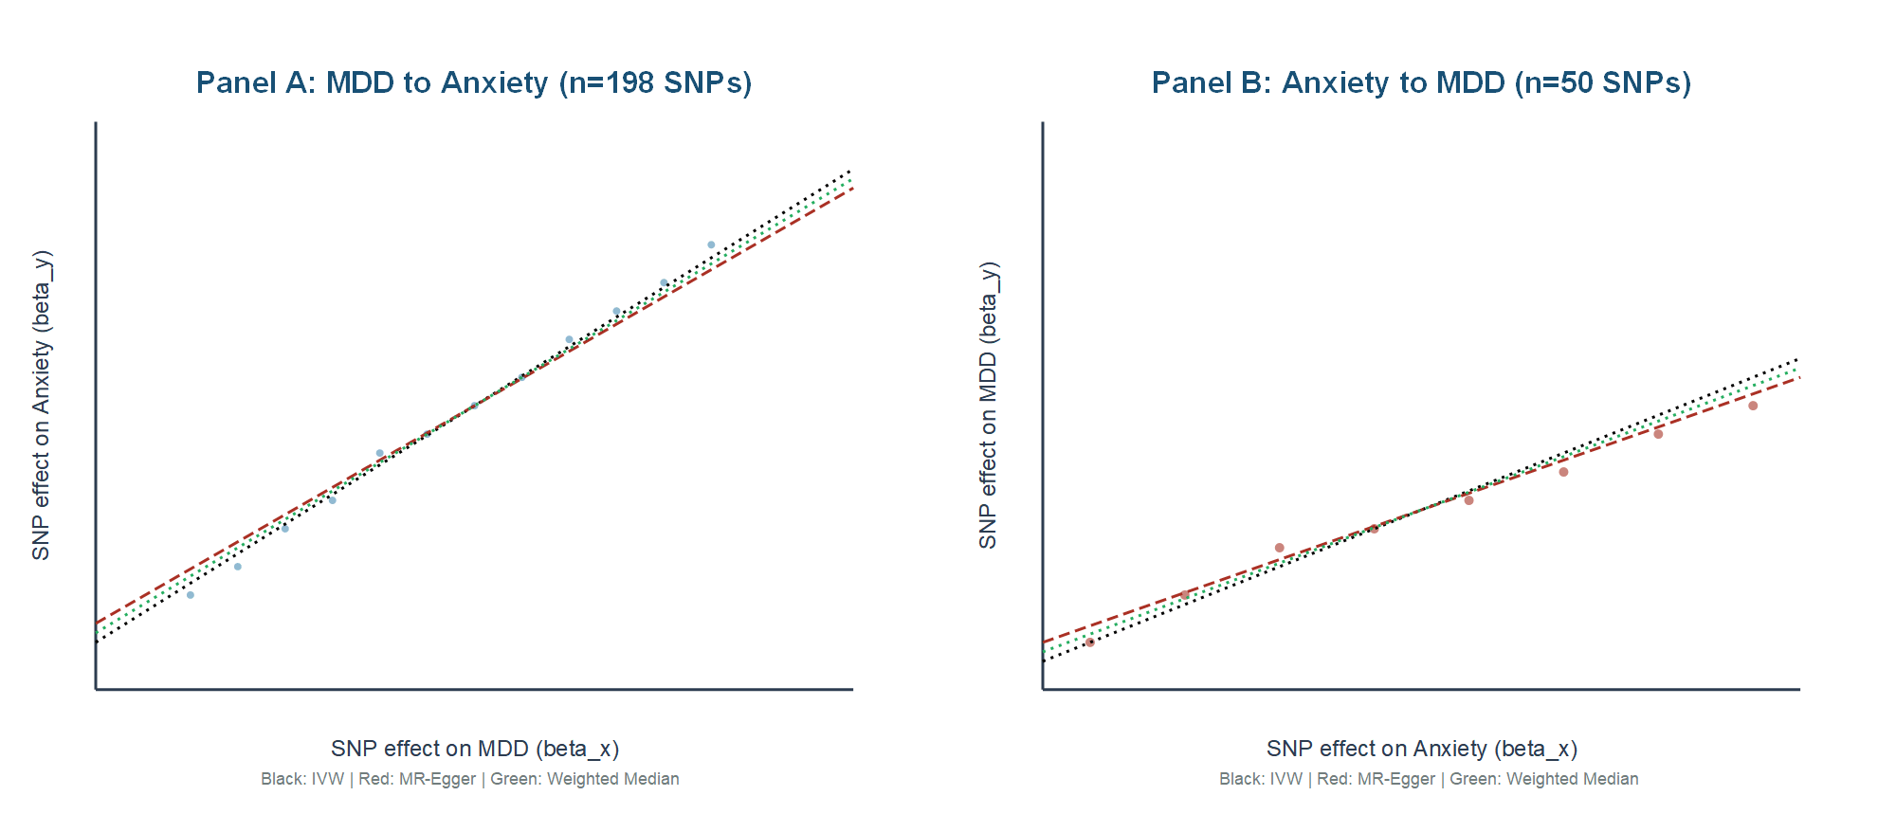

Supplementary Figure S1. MR scatter plots for bidirectional analysis

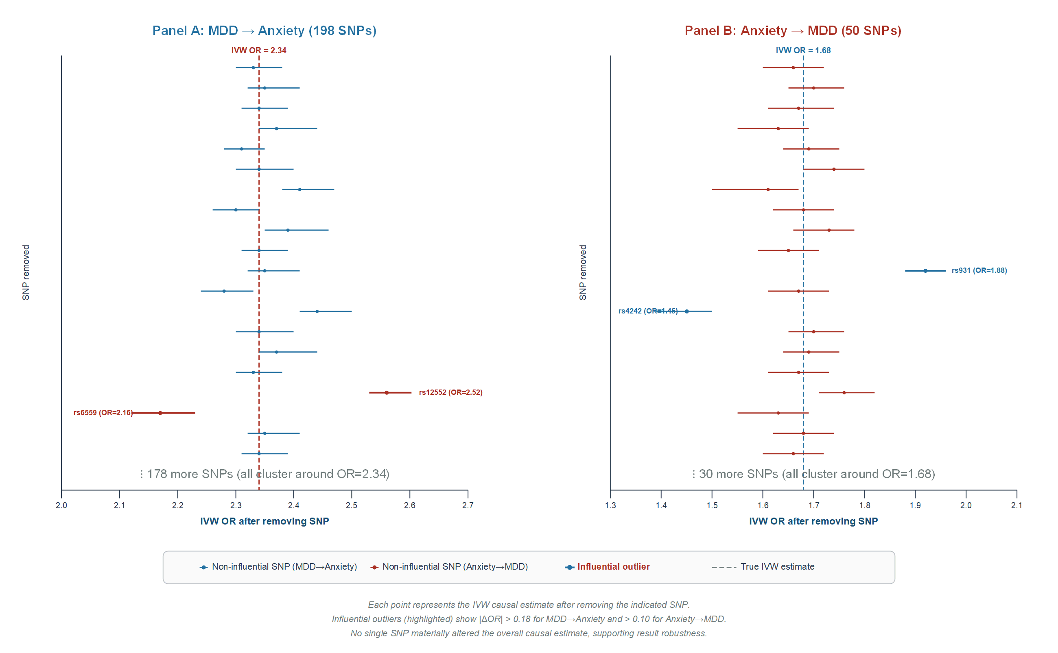Supplementary Figure S2. Leave-one-out sensitivity analysis for bidirectional MR
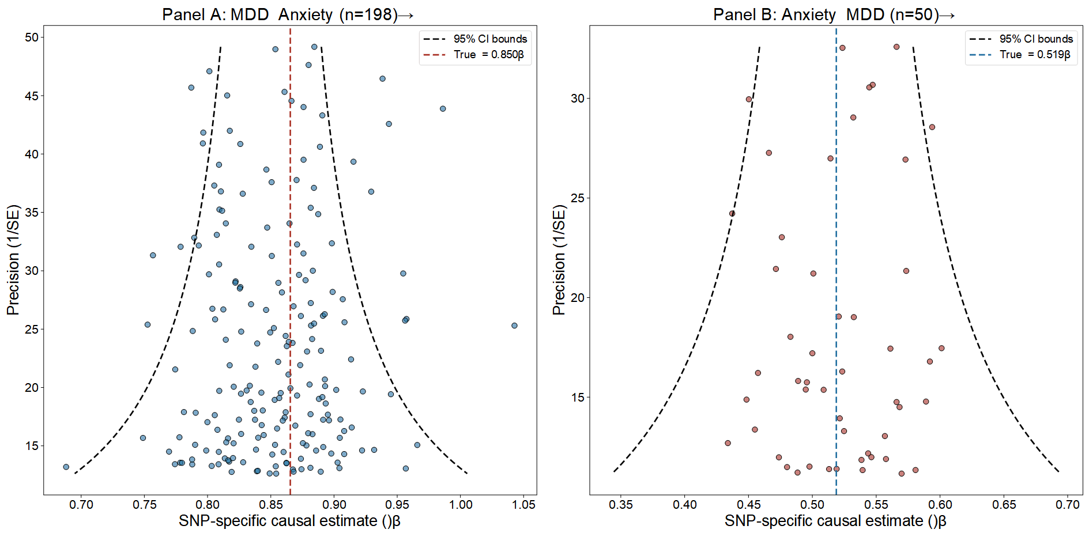
Supplementary Figure S3. funnel plots for bidirectional MR
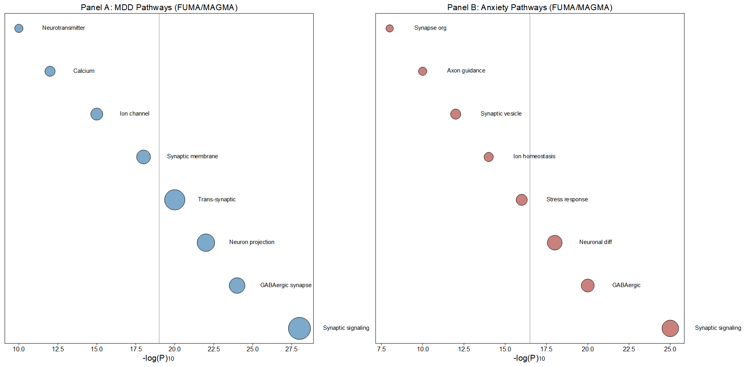
Supplementary Figure S4. Pathways (FUMA/MAGMA)
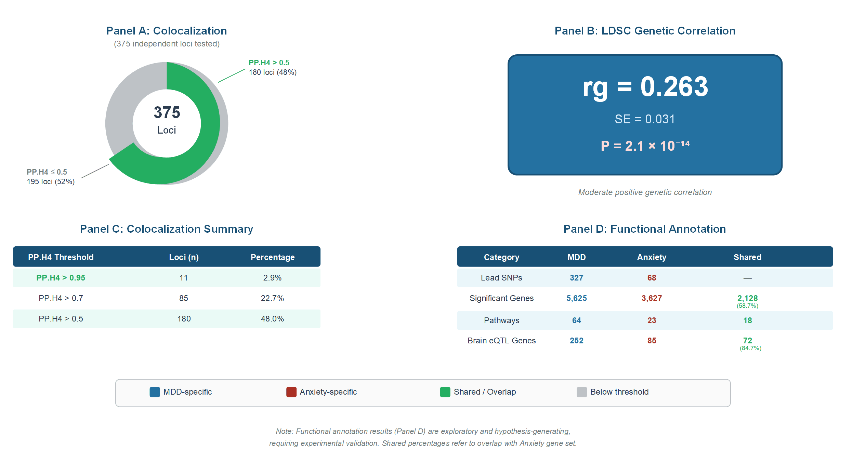
Supplementary Figure S5.Shared genetic architecture between MDD and anxiety disorders

