1. vc-relac and relax hBN unit cell
2. Use Xcrysden to open the optimized structure
3. Click “File” → “Save XSF Structure” (e.g. the file name is hBN.xsf)
4. Use VESTA to open file hBN.xsf
5. Click “Edit” → “Edit Data” → “Unit Cell” → “Remove Symmetry” → “Transform...” → change Rotation Matrix Pto expand unit cell to supercell, e.g. to get 6x6 monolayer hBN

|  |  |  |
| --- | --- | --- |
| 1 | 0 | 0 |
| 0 | 1 | 0 |
| 0 | 0 | 1 |

`

↓

|  |  |  |
| --- | --- | --- |
| 6 | 0 | 0 |
| 0 | 6 | 0 |
| 0 | 0 | 1 |

1. Click “OK”, save the structure as 6x6_hBN.vesta and close the window
2. Use VESTA to open file 6x6_hBN.vesta
3. Double click an atomic position in the supercell where you want to create a defect

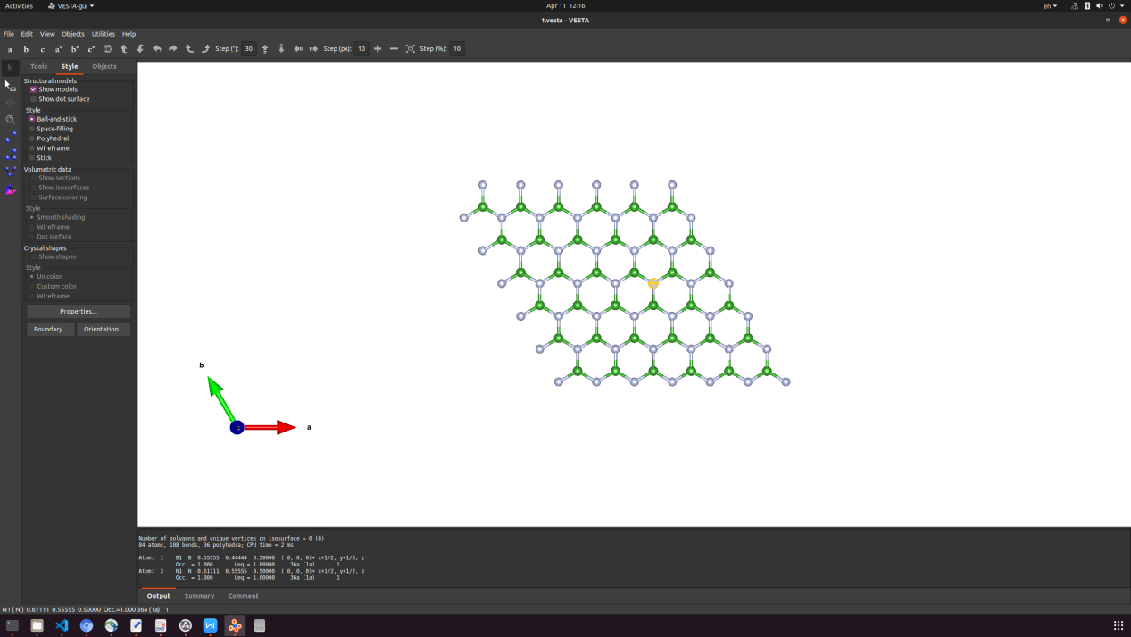

1. Click “Edit” → “Edit Data” → “Unit Cell” → “Remove Symmetry”
2. Then go to Structure parameters, and replace the objective atoms with vacancy (vacancy defects) or other atoms (substitution defects)

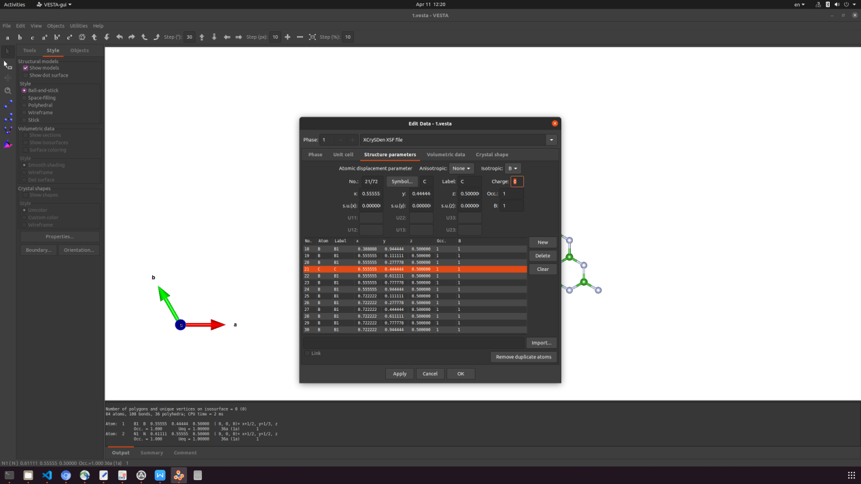

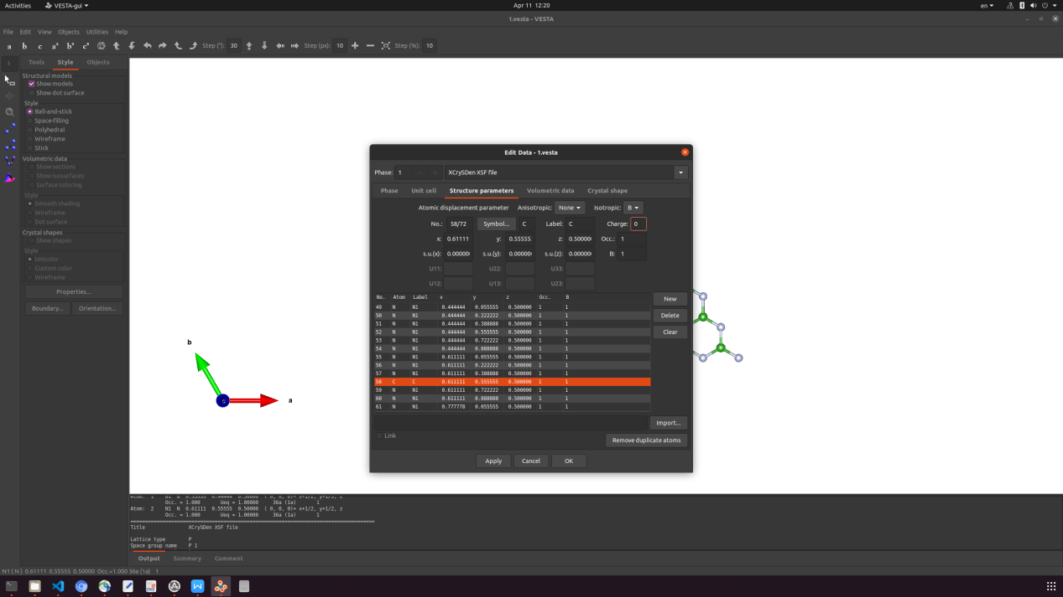

1. Click “OK”, save file as 6x6_CBCN.vesta and close the window
2. Use VESTA to open file 6x6_CBCN.vesta. Now you can see the defect CBCN is created

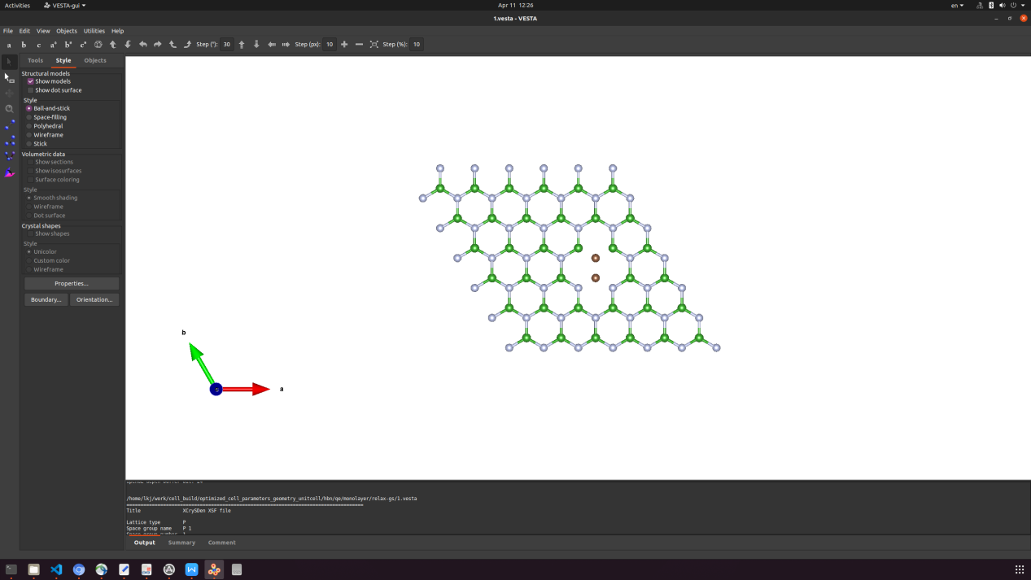

1. Click “File” → “Export Data...” → “P1 Structure” for QE input (VASP for VASP input)

Tips:

1. vi with option -p can open multiple files in a terminal (e.g. vi -p *out *in)
2. Then Ctrl+Shift+↑ or Ctrl+Shift+↓ can switch files to files
3. In vi, one press v can select content, press y to copy, and press p to paste