Task 1 Data Science Careers:

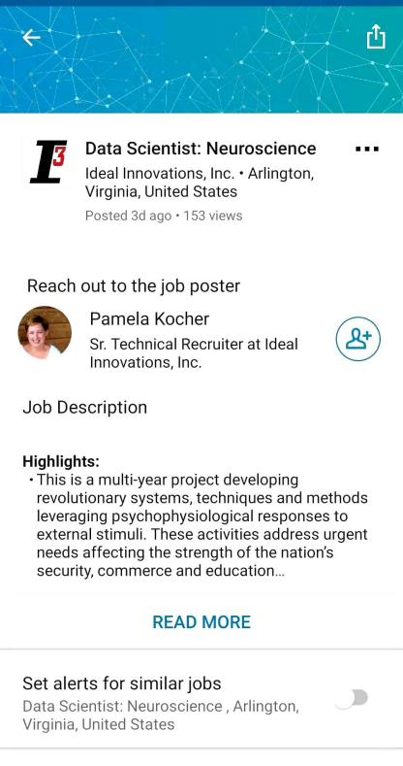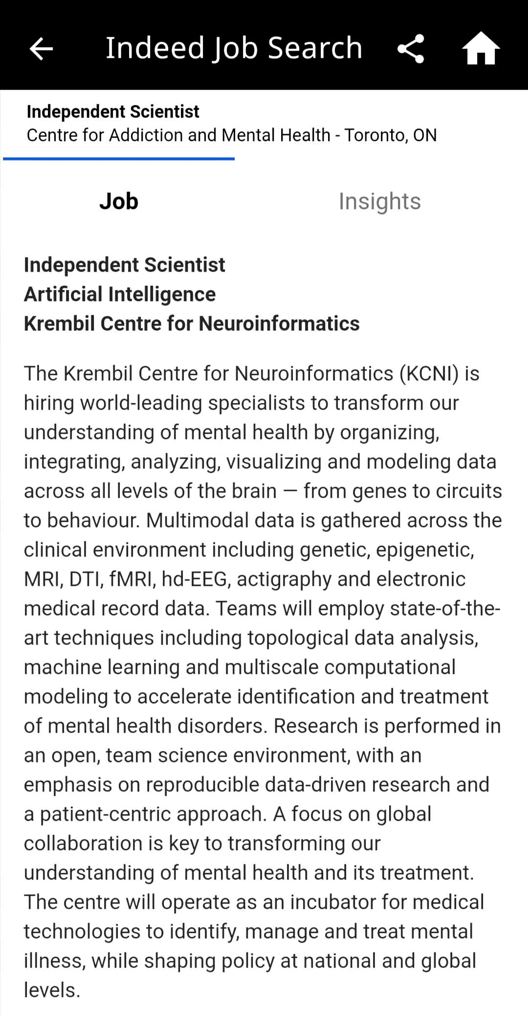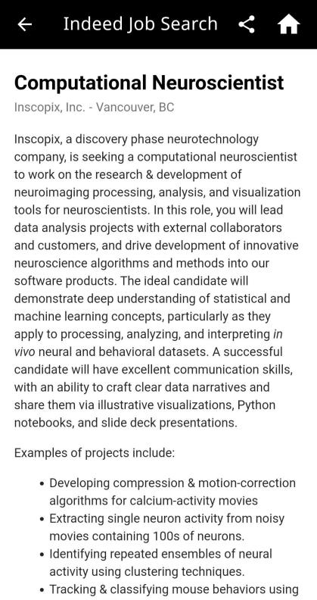

My ideal career is a scientist studying biological system (more specifically neurological system) via quantitative data analysis. Recent years, brain science and brain-inspired artificial intelligence has drawn a lot of attention and there is a subject called Computational Neuroscience which utilizes various data analysis skills to offer innovative insights into the mechanism of intelligence system (the brain). The brain itself can be viewed as a highly sophisticate but efficient data processing machine that has many marvelous characteristics, such as learning from limited data sets, selective oppression of noise, multitasking, creativity, etc. This career allows me to explore the secret mechanism of brain functions and intelligence system. I believe this field has great potential, and I would possibly have many very interesting discoveries, which is the greatest happiness for a scientist.

Task 2 Highs and Lows:

- What were the highlights of the class for you?

HW3 gives me a sense of how complex can data analysis can be. All the assignments are interesting and useful, so I would say that the assignments are very valuable. Also, social media data collection is very interesting, and I’ve collected many food pics for personal use. :)

- What could have been done better? how?

Everything is good for me.

- How did this course impact the future you see for yourself(if at all)?

Now I understand better what skills I need to reach the goal of my career, and I think I need a PhD having specialized skills in data analysis and modeling.