Assignment2 Report
Name: 張孔懷
Institution (school): NTHU
Student ID: 114065535
Platform (Colab/Kaggle/Local): Local
Python version: 3.11.0
Operating system: Windows 11
CPU: AMD R7 7800X3D
GPU: Nvidia RTX 4090
Remark: For ease of grading, you are encouraged to present data in textual form rather than as images.
Present your hyper-parameters in training, including learning rate, batch size, hidden size, epochs(steps), etc. (5%)
Answer:
- Batch_size = 512
- Epoch = 4
- embed_dim = hidden_dim = 256
- learning_rate = 0.002
- gradient_clip = 1
- Loss function = Cross Entropy
- Optimizer = Adam
If you use RNN or GRU instead of LSTM, what will happen to the quality of your answer generation? Why? (10%)
Answer: The accuracy of the model’s prediction drastically decreased. Also, the computed loss in each training epoch was much higher than the model built on LSTMs. RNNs have worse capability on handling long sequences of data, and this is due to the exploding gradient or vanishing gradient problem that RNNs currently suffer from. It means that some distant inputs may become too trivial or too dominant and thus cause degradation on the performance of a RNN model, and this is also related to the value of the hyper-param learning rate in some extent.
On the other hand, LSTMs can better cope with the aforementioned problems by utilizing “forget gate”. In this approach, a LSTM model can more effectively calculate the long-term dependencies between different input tokens.

If we construct an training set using three-digit numbers while the evaluation set is constructed from two-digit numbers, what will happen to the quality of your answer generation? (10%)
Answer: The quality of the model’s prediction is not worth mentioning. The accuracy score dropped to approximately 0. I think it’s because 3-digit numbers were treated as completely different data from those 2-digit ones which we used. The model we’re using in this assignment basically processes each arithmetic equation as a simple string, and each operand as well as operator is considered a plain character. Thus, although the model produced a rather good result on 2-digit prediction, it seemed that it failed to comprehend the “homogeneity” behind these two training datasets.

If we construct a training set that includes 20% incorrect answers, how will this affect the quality of the generated responses? Present some examples. (10%)
Answer: I used randint() to generate false answers in the training data. This change had considerably negative impact on the prediction quality. The reason for this is that, based on my understandings, random numbers confuse the model when it tries to guess the next token. Since the model learns the correct answer of an arithmetic equation by analyzing the exact occurrence of each operator/operand in it, equations with same operands/operators but totally different target values add noises during the training phase, consequently lower the accuracy.
Below is the validation result, with the model trained on dataset consisting of 20% false values.
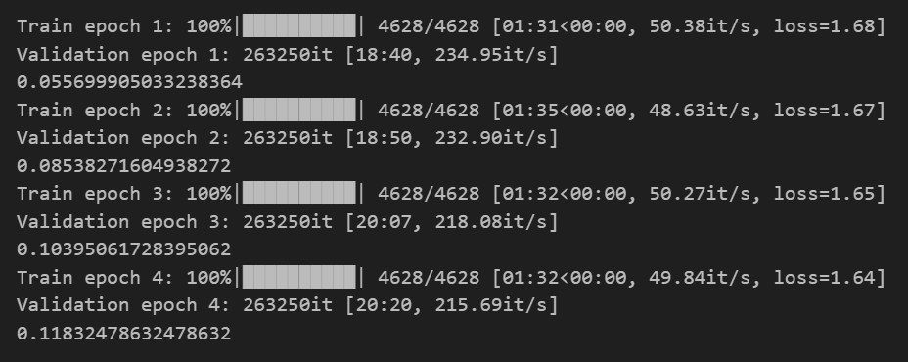

Why do we need gradient clipping during training? (5%)
Answer: In order to prevent the exploding gradient problem from happening, as it is a common issue in RNN-based models.

… Anything that can strengthen your report. (5%)
Answer: Through this assignment, I learned a lot about the use of Pytorch library, as well as the different data types and their purposes. Also, I realized that although neural networks like RNN and LSTM can work well on applications like language processing and text generation. It does not automatically suggest that they truly understand the meanings behind or the relations between the symbols, words, and sentences used in human languages.

The screenshot of your training logs and evaluation accuracy. (One Figure only) (10%)
